Machine Learning (Assignment # 2)

Murali Yaswanth Motamarri -700741647

Github link: <https://github.com/Yaswanthmm/machine-learning#machine-learning>

Video: demonstrated the code in class

1. **Use a python code to display the following star pattern using the for loop**

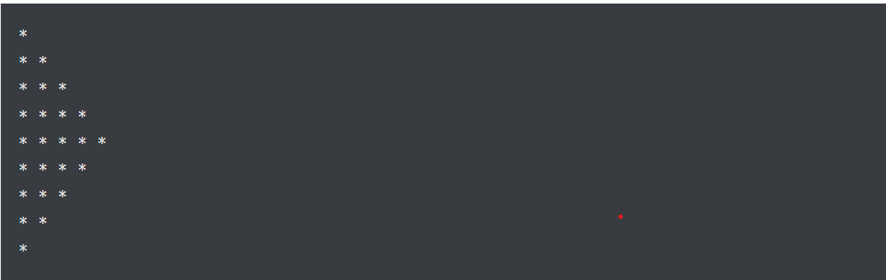

Solution Screenshot:

Description: In this question I used first for loop to print the first 5 rows of the stars and second loop to print the next 4 rows of the star.

1. **Use looping to output the elements from a provided list present at odd indexes.**

**my_list = [10, 20, 30, 40, 50, 60, 70, 80, 90, 100]**

Solution Screenshot:

Description: In this question I used the for loop and if statement to check the index of the element in the list. Printed the elements if the index of the element is odd.

1. **Write a code that appends the type of elements from a given list.**

Input

x = [23, ‘Python’, 23.98]

Expected output

[23, 'Python', 23.98]

[<class 'int'>, <class 'str'>, <class 'float'>]

Solution Screenshot:

Description: in this question I first created an empty list and used for loop and append method to add the datatypes of elements to the empty list ‘l’ and printed the list.

**4.Write a function that takes a list and returns a new list with unique items of the first list. Sample List: [1,2,3,3,3,3,4,5]**

Unique List: [1, 2, 3, 4, 5]

Solution Screenshot:

Description: In this question converted the list to set to get the unique elements and next converted the set back to the list to print the list of unique elements.

**5.Write a function that accepts a string and calculate the number of upper-case letters and lower-case letters.**

Input String: 'The quick Brow Fox' Expected Output:

No. of Upper-case characters: 3 No. of Lower-case Characters: 12

**Solution Screenshot:**

Description: In this question used for loop and built-in methods islower() and isupper() to find whether the elements in the list are either lower or uppercase and count the upper and lowercase letters.