Spring 2023: CS5710 – Machine Learning

**In-Class Programming Assignment-3**

**Murali Yaswanth Motamarri - 700741647**

**Video link: https://drive.google.com/file/d/1LaXREJVl4i2Bu_raYHMPYm0ZV4LhMPdT/view?usp=share_link**

# Numpy:

* 1. **Using NumPy create random vector of size 15 having only Integers in the range 1-20.**
     1. **Reshape the array to 3 by 5**
     2. **Print array shape.**
     3. **Replace the max in each row by 0**

In this problem, I have imported numpy library and random package from numpy library and using the randint class generated random vector of size 15. Using reshape method converted the shape of array to 3 by 5. Using arr.shape function printed the shape of the array, using the argmax function got the index of the max element in each row and using the loop replaced the max value by 0 and printed the array.

**Create a 2-dimensional array of size 4 x 3 (composed of 4-byte integer elements), also print the shape, type and data type of the array.**

In this problem, I created a random array of size 4 by 3 using randint method and using int32 for 4-byte integers. Printed the shape using shape methos and type using type() method and datatype using dtype method.

* 1. **Write a program to compute the eigenvalues and right eigenvectors of a given square array given below: [[ 3 -2]**

**[ 1 0]]**

In this problem, I first created an array and found the Eigenvalues, Eigenvectors using eig() and printed them.

* 1. **Compute the sum of the diagonal element of a given array. [[0 1 2]**

**[3 4 5]]**

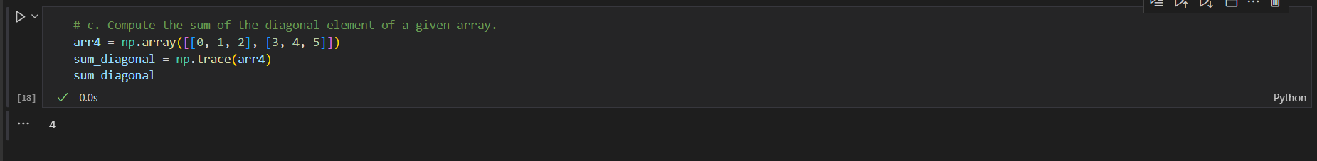

In this problem, using the trace function found the sum of the diagonal elements.

* 1. **Write a NumPy program to create a new shape to an array without changing its data. Reshape 3x2:**

**[[1 2]**

**[3 4]**

**[5 6]]**

**Reshape 2x3:**

**[[1 2 3]**

**[4 5 6]]**

in this problem, using reshape method reshaped the given matix to 2 by 3 and 3 by 2 respectively.

# Matplotlib

1. **Write a Python programming to create a below chart of the popularity of programming Languages.**
2. **Sample data:**

**Programming languages: Java, Python, PHP, JavaScript, C#, C++ Popularity: 22.2, 17.6, 8.8, 8, 7.7, 6.7**

In this problem, I imported plyplot package matplotlib library. Created a list of Programming_languages, Popularity, colors, and exlopde. Using pie method plotted the pie chart, show method to directly show the plot.