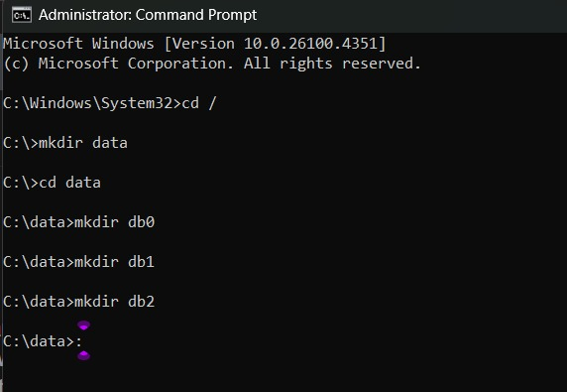

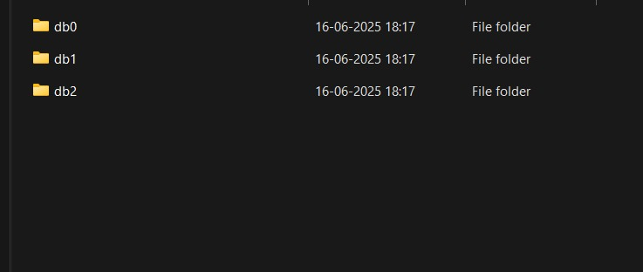

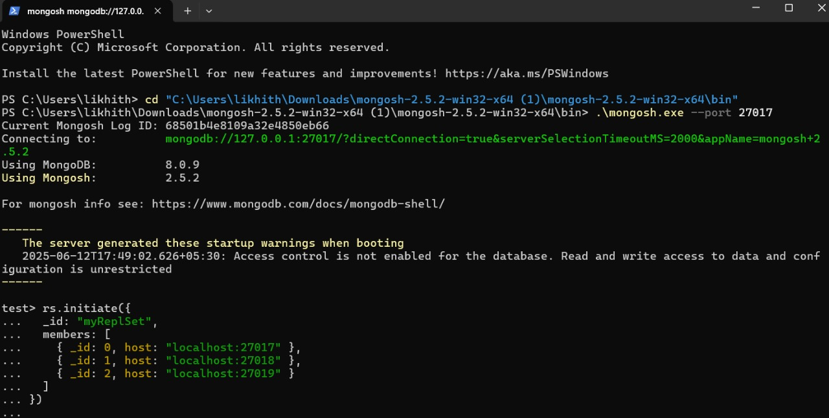

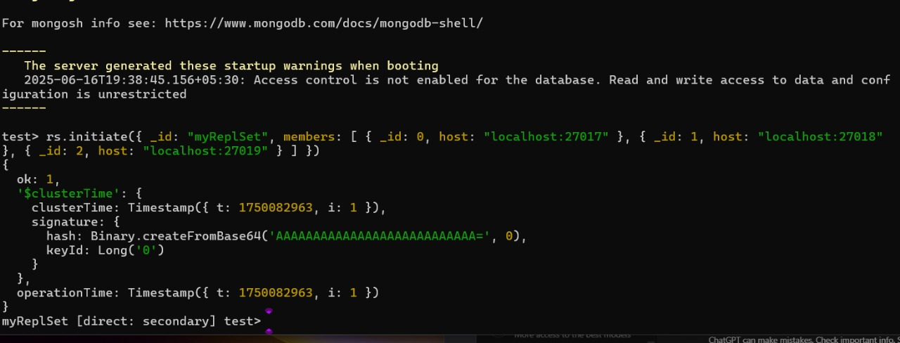

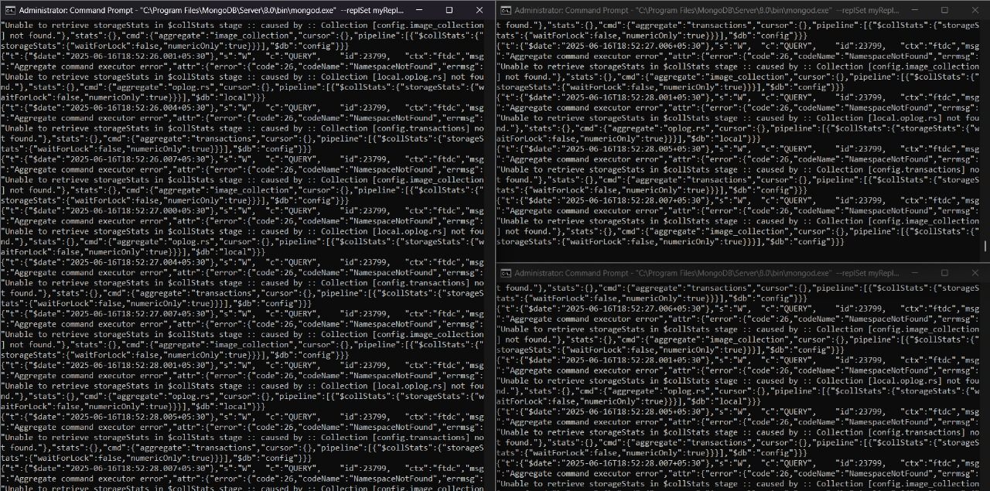

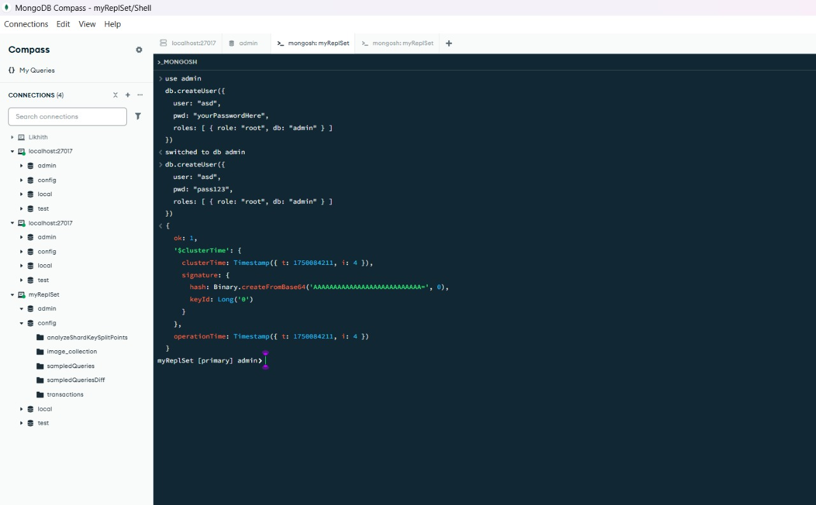

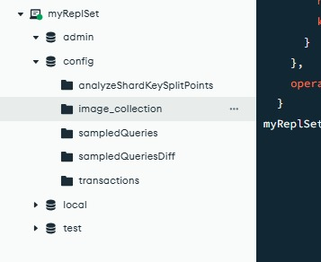

db.products.insertMany([
{ name: "xPhone", price: 799, category: "Mobile", stock: 50 },
{ name: "SmartTV", price: 1199, category: "Electronics", stock: 20 },
{ name: "xLaptop", price: 1499, category: "Computers", stock: 10 },
{ name: "Tablet", price: 499, category: "Mobile", stock: 35 },
{ name: "Headphones", price: 199, category: "Accessories", stock: 75 }
])
{
acknowledged: true,
insertedIds: {
'0': ObjectId('68502b3979beb44f11e4080f'),
'1': ObjectId('68502b3979beb44f11e40810'),
'2': ObjectId('68502b3979beb44f11e40811'),
'3': ObjectId('68502b3979beb44f11e40812'),
'4': ObjectId('68502b3979beb44f11e40813')
}
}
db.products.find({ price: { $gt: 500 } })
{
_id: ObjectId('68502b3979beb44f11e4080f'),
name: 'xPhone',
price: 799,
category: 'Mobile',
stock: 50
}
{
_id: ObjectId('68502b3979beb44f11e40810'),
name: 'SmartTV',
price: 1199,
category: 'Electronics',
stock: 20
}
{
_id: ObjectId('68502b3979beb44f11e40811'),
name: 'xLaptop',
price: 1499,
category: 'Computers',
stock: 10
}
db.products.updateOne({ name: "xPhone" }, { $set: { stock: 40 } })
{
acknowledged: true,
insertedId: null,
matchedCount: 1,
modifiedCount: 1,
upsertedCount: 0
}
myReplSet [primary] test

