1.Show that you have IDE installed on your machine

**Visual studio code**

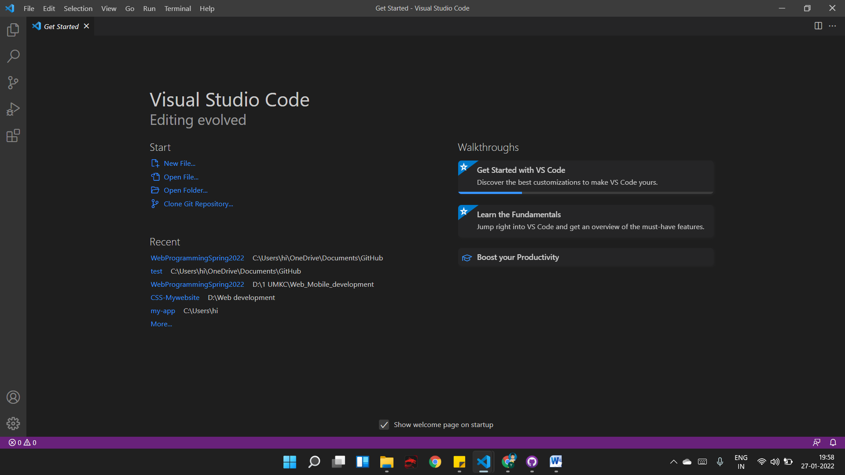

VS Code is an open source cross-platform source code editor and is well known mainly in the web development community. It's fast, extensible, customizable, and has lots of features. Visual Studio Code combines the simplicity of a source code editor with powerful development tools such as IntelliSense code completion and debugging. It has so many different types of extensions that we need. Implementing Git and Github is easy and free. It is highly customizable and provides a very fast programming and debugging experience. The auto save feature and Compare the two files are one of VS Code's best features. Code highlighting and autocomplete will help you write your code easily.

2. Create a GitHub account. Create a repository in remote GitHub. Clone it to the local machine. Create 2 (Source and Documentation) directories in local GitHub .

Github:

GitHub is a code hosting platform for version control and collaboration. It allows you and others to collaborate on a project from anywhere. GitHub features include creating repositories, branches, commits, and pull requests. It makes it easier to contribute to open source projects. To be honest, almost all open source projects use GitHub to manage their projects. GitHub encourages teams to work together to create and edit website content. Git is a command line tool, but GitHub provides a web-based graphical interface. It also provides access control and multiple collaboration features, including: Wiki for each project and basic task management tools. GitHub makes it easy to get great documentation. Their help center and guides have articles on almost every Git-related topic you can think of. Millions of developers and businesses build, ship, and maintain software on GitHub, the world's largest and most advanced development platform.

Created a Github account -Yaswanthypfm7

Created a repository in Remote Github - WebDevCourse

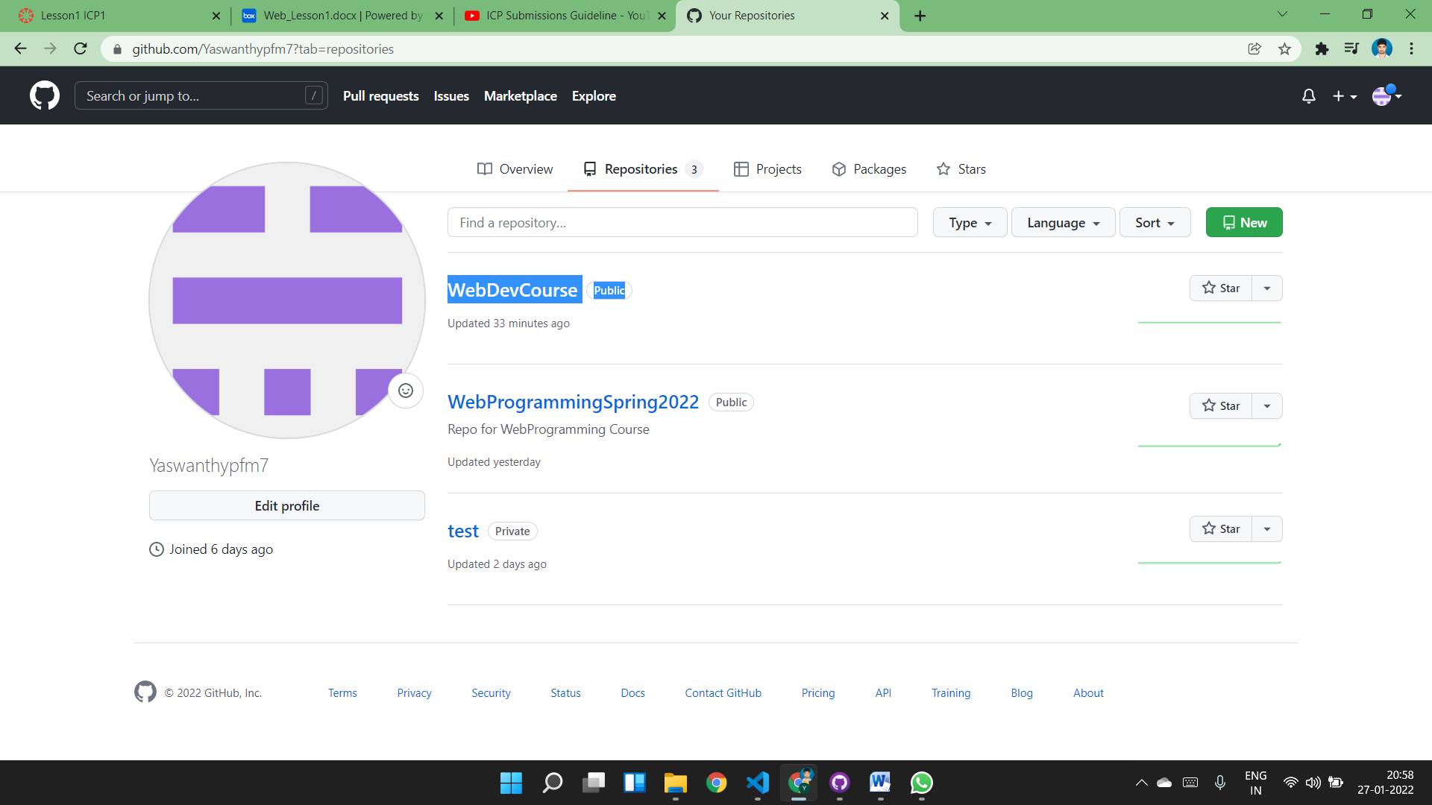

Cloned the Repository in local and created two local folders Source and Documentation

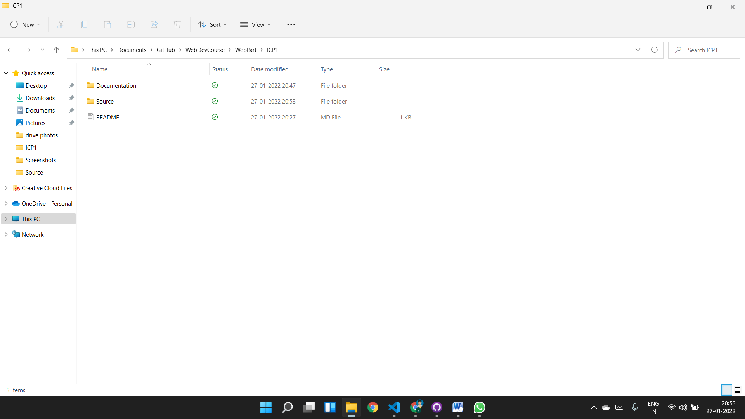

Takescreenshots of a repository creation and put them in the documentation folder in the local repository,and sync it to the remote repository

Creating a new file Index.html in Source folder and locating the changes in Github desktop

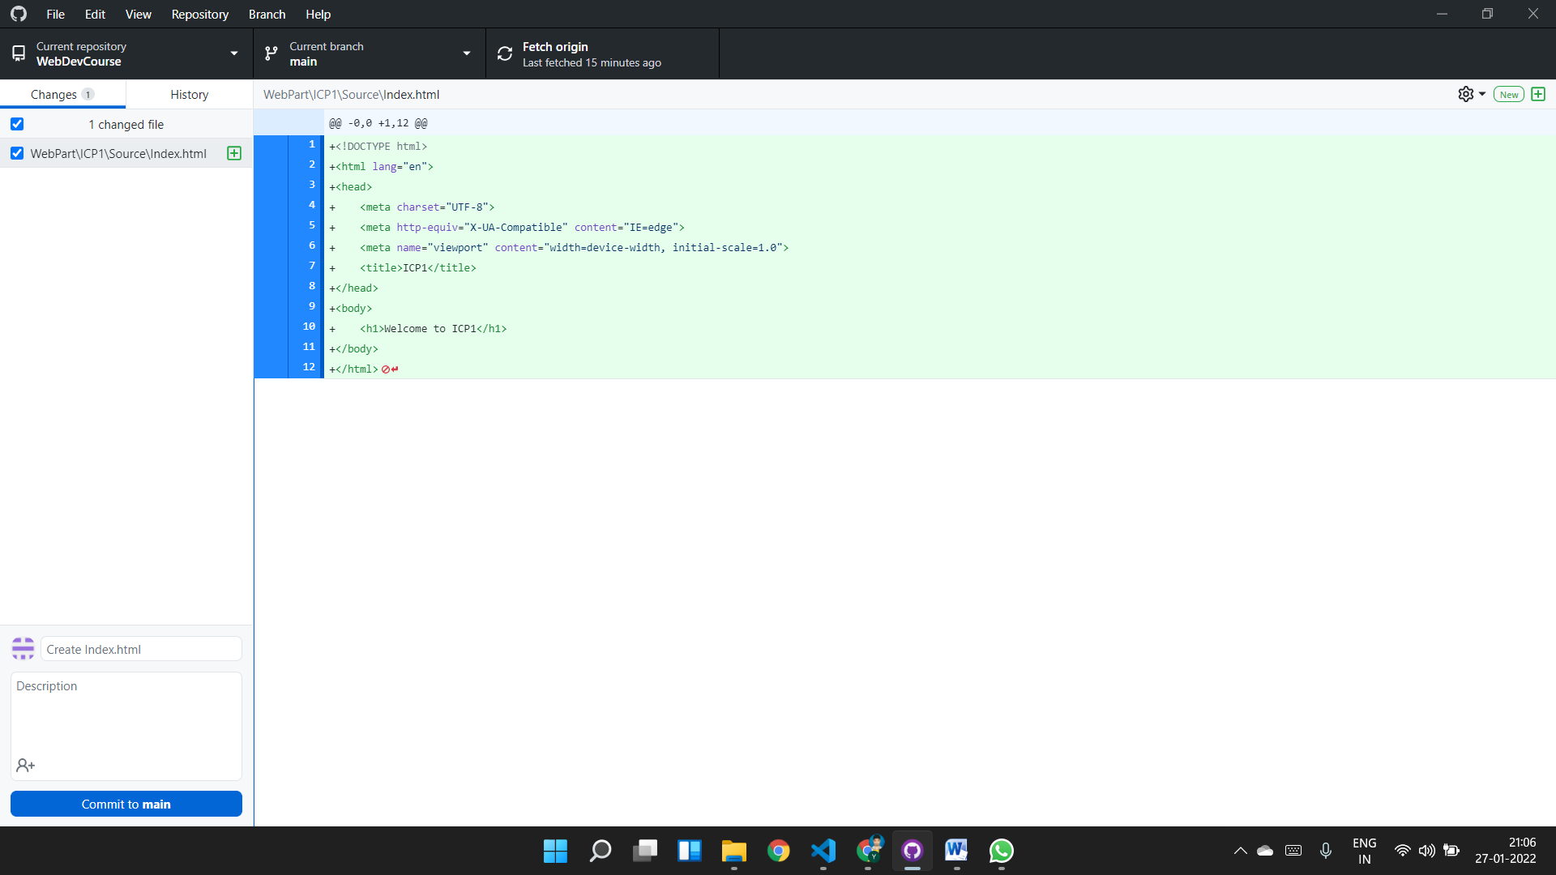

Write about your repository in README.MD file

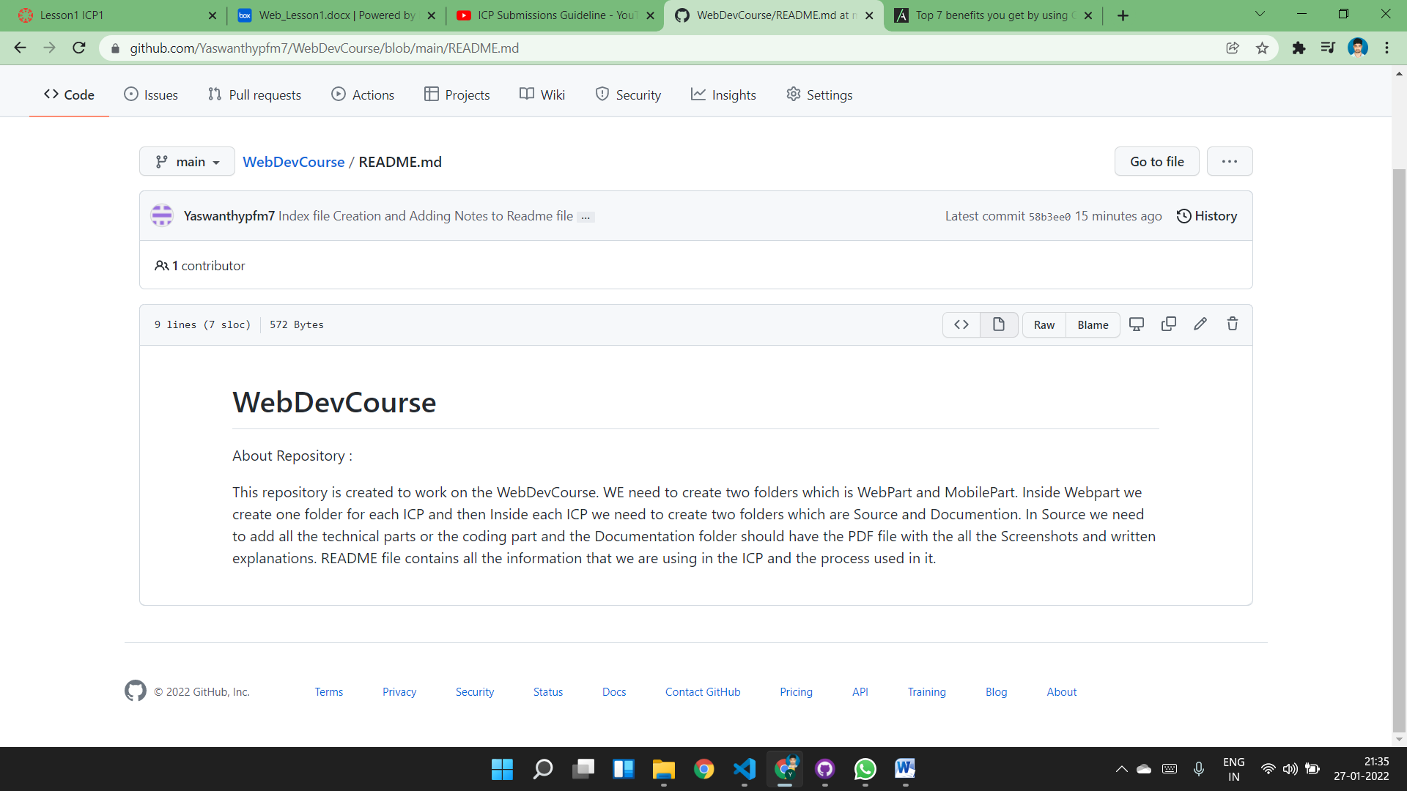

Create a branch for your repo and make a pull request

New branch created : icpbranch is the new branch created from main

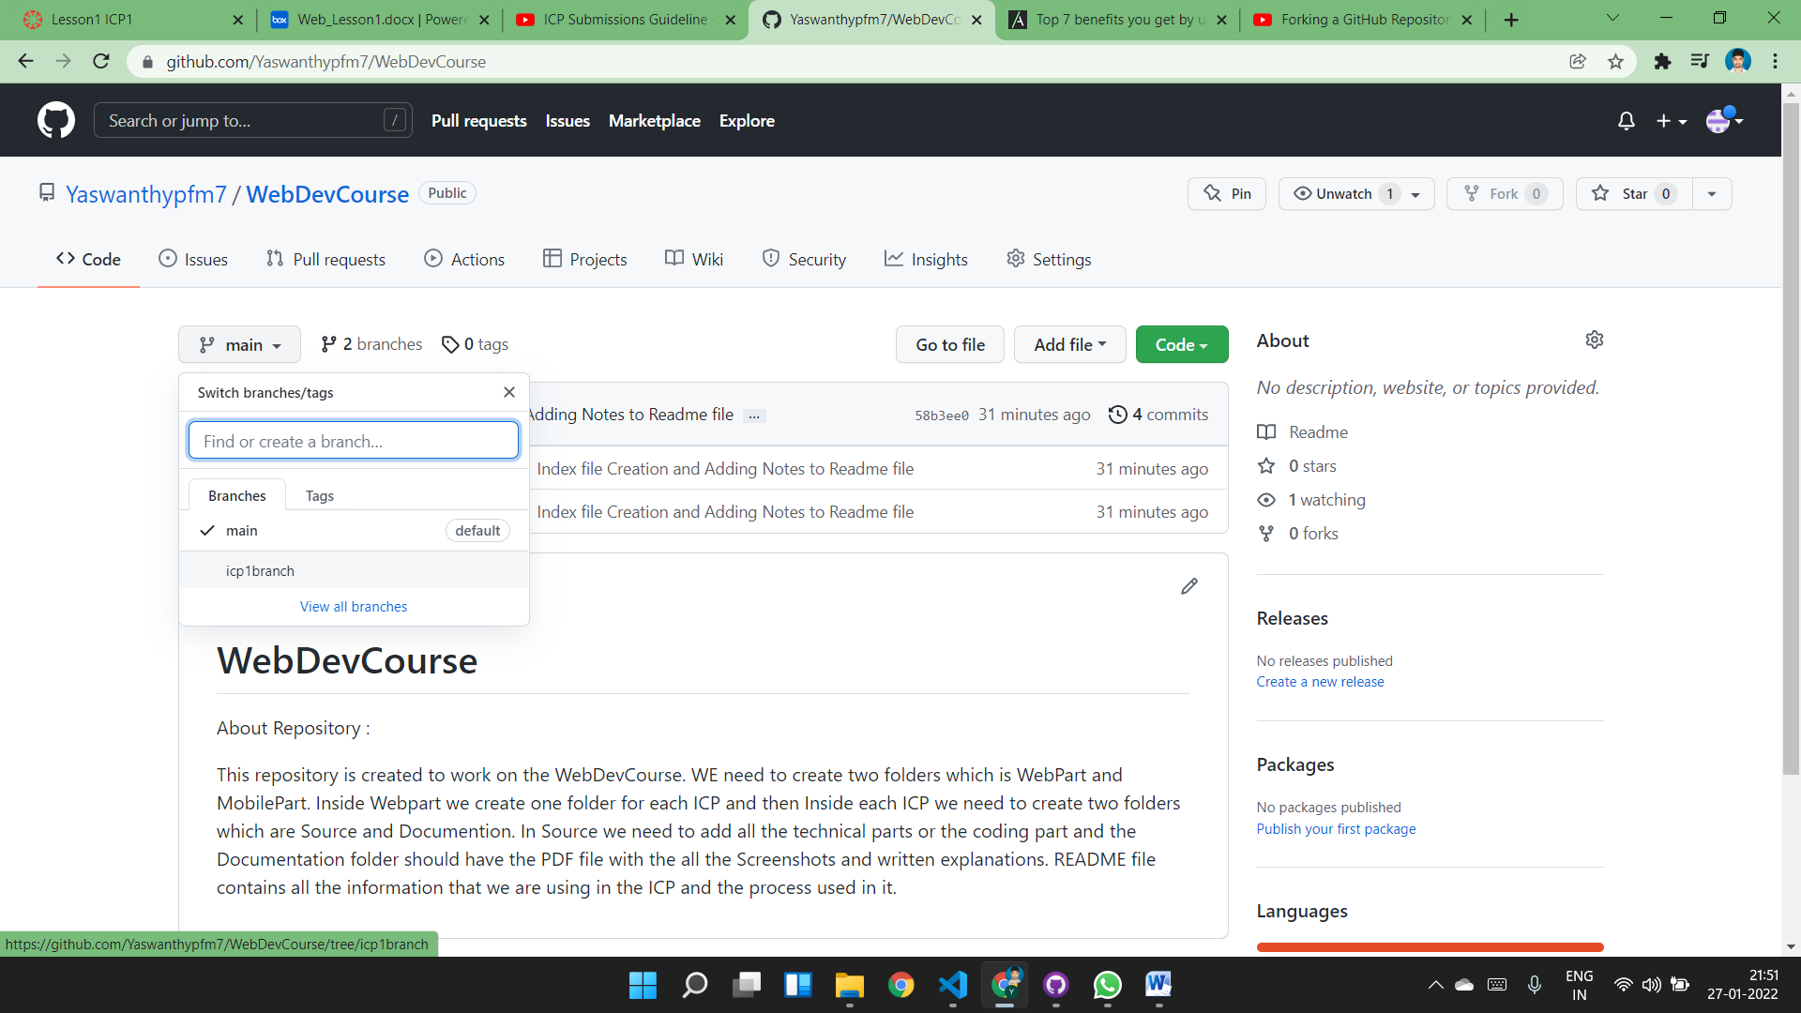

Create an issue and describe your pull request

