**ICP-3**

**Name** :Yaswanth Paruchuri

**Email**: [ypfm7@umsystem.edu](mailto:ypfm7@umsystem.edu)

**GitHub Repo link** : <https://github.com/Yaswanthypfm7/WebDevCourse/tree/main/WebPart/ICP3>

**Name** : Tej Deep Parvatha Reddy

**Email**: [tpgkd@umsystem.edu](mailto:tpgkd@umsystem.edu)

**GitHub Repo Link:** <https://github.com/TejdeepP/WebProgrammingSpring2022/tree/main/WebPart/ICP3>

**Introduction**

JavaScript is a scripting or programming language that lets in you to put into effect complicated functions on internet pages — each time an internet web page does extra than simply take a seat down there and show static facts so as to appearance at — showing well timed content material updates, interactive maps, lively 2D/three-D graphics, scrolling video jukeboxes, etc. — you may wager that JavaScript might be involved. It is the 0.33 layer of the layer cake of wellknown internet technologies, of which (HTML and CSS) we've included in a whole lot extra element in different components of the Learning Area.

JavaScript is a scripting language that lets you create dynamically updated content, manage media, animate images, and more. (If not all, it's amazing what you can achieve with a few lines of JavaScript code.)

When the browser loads a web page, it is executing code (HTML, CSS, and JavaScript) within the runtime (the browser tab). It is like a factory that receives raw materials (code) and releases products (web pages).

Bootstrap is a free front-end framework for faster and easier web development. It includes HTML and CSS based design templates and additional JavaScript plugins for typography, forms, buttons, tables, navigation, modals, carousels of images, and more. It also provides features that make it easy to create responsive designs.

**Tasks**

**Module-1**

In this ICP we have developed a logic for Rock, Paper & Scissor game where we have written logic for the same using JavaScript. We created a web page having the three icons Rock, Paper & Scissor. When user clicks on any of the icon the system will generate the respective code for it and the logic will give us Win , loose or tie based on the input.

**Code Explanation:**

In Index.html we have given defined the buttons for Rock,Paper& Scissor and used sources for the same from the source and defined height and width of images .We have used onClick Javascript function with 0,1&2 game codes .

We have linked the logic javascript file with script tag and type as Javascript.

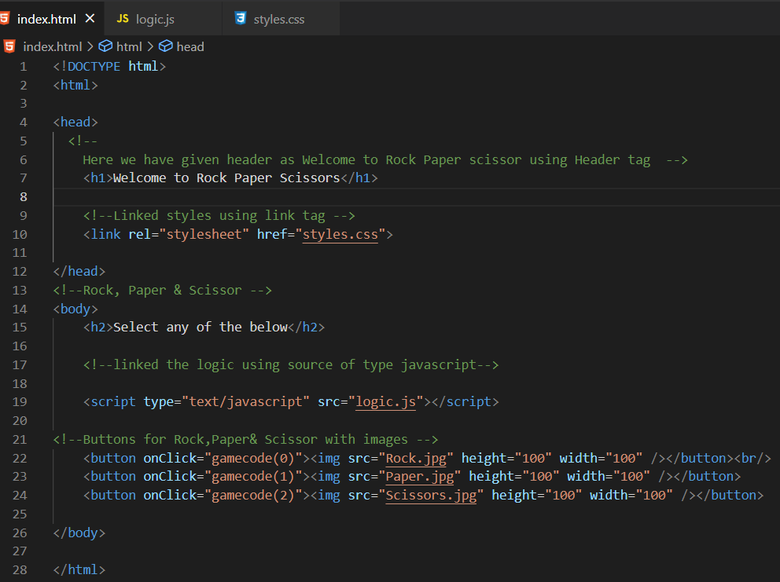

**Logic Explanation for the game :**

We have defined the words as let words and given function named game code passed argument as value. Defined var for rock, Paper & Scissor. Taken the input from computer, getting the length of words and getting the word count for number.

Getting the computer value from the count of words from cnumber.

* If the user if the value is less than computer number then it will go inside the loop and later if computer number is 2 and user value is 0 then we are keeping it as User win.Else computer wins.
* If user value is greater than computer value and if user value is equal to 2 and computer value is equal to 0 then we are alerting as Computer win else User wins
* Else it’s a Tie

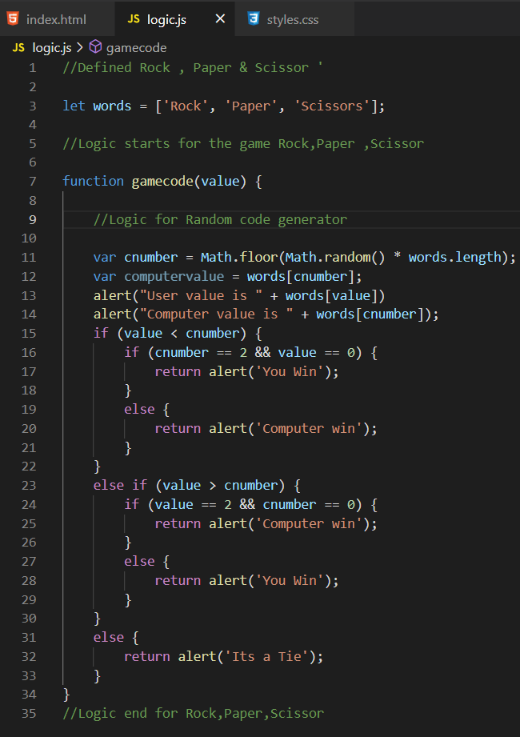

Styles are kept for the center as images placed at the center

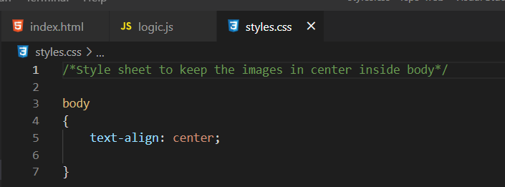

**Output:**

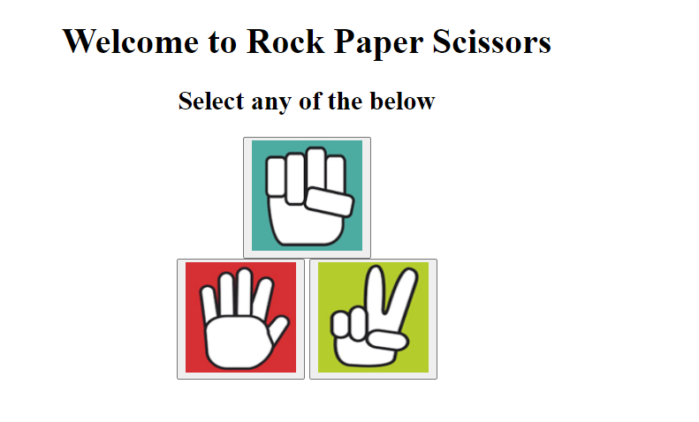

Selected Rock

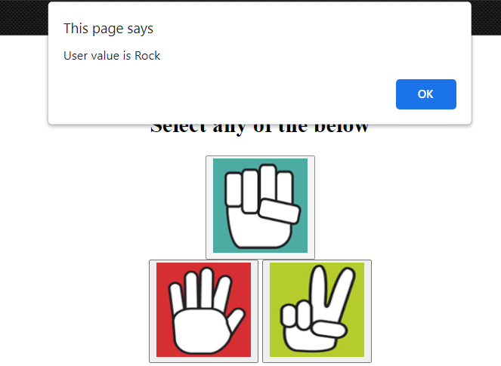

Now system will generate a value from any of the three.System value is also Rock

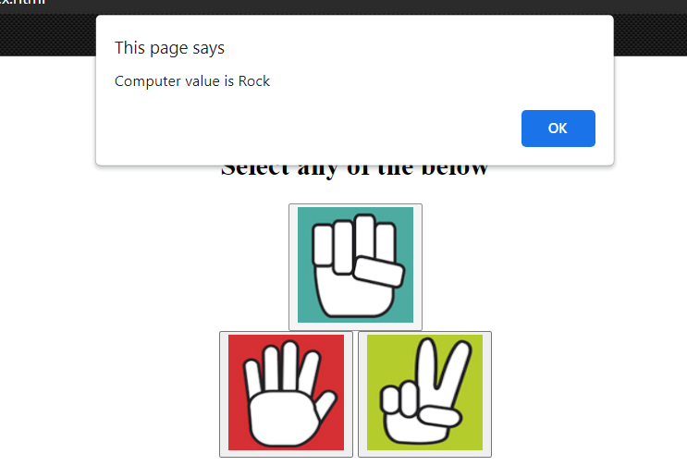

Now as System and user values are Same it’s a Tie

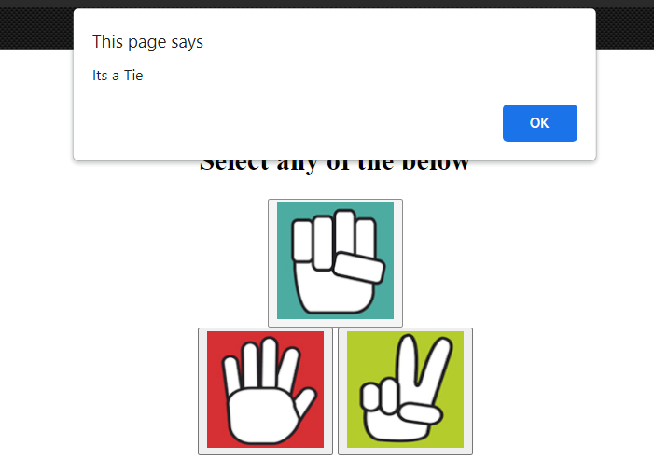

**Case :2 User value is Scissor**

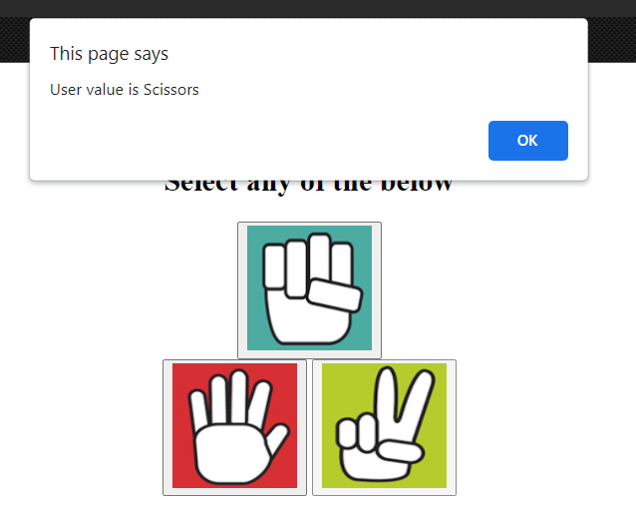

System/Computer value is Rock

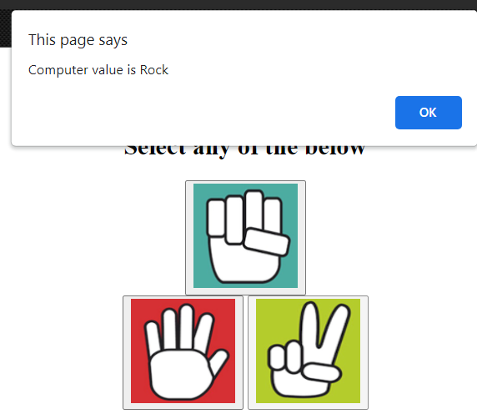

Result is Computer wins

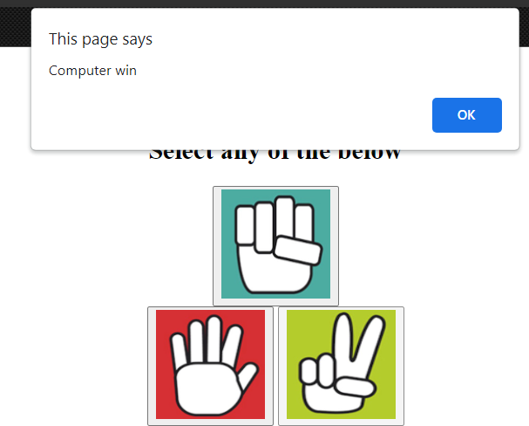

Case:3 User value is Paper

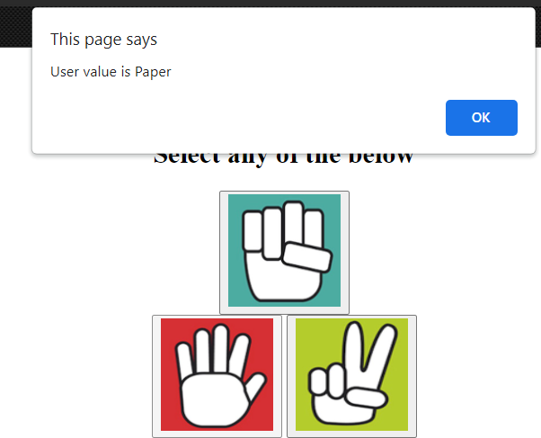

Computer Value is Rock

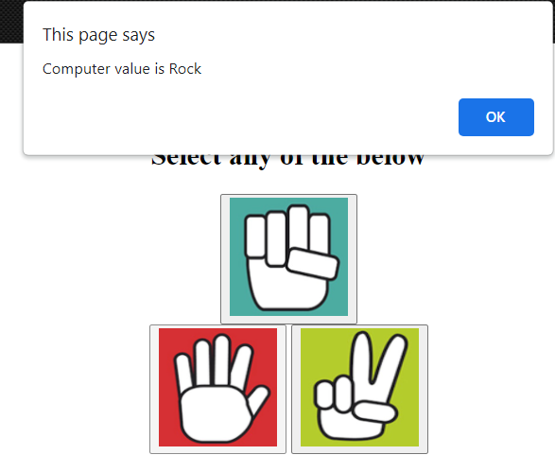

Result is User Win

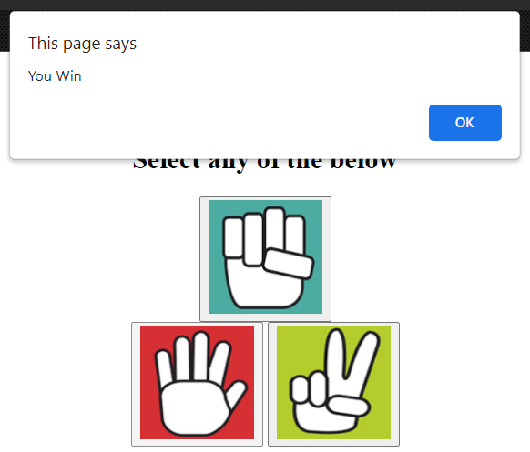

**Module-2**

In this module we have created a web page that exactly looks like the mock given .

**Code Explanation:**Here we didn’t downloaded any bootstrap instead we have linked the reference of the bootstrap and linked the style sheet for the same.

We have done the split for the webpage with the column size of 6 in both for the header images and also kept the place holder image using image alt tag and source path given from the code.

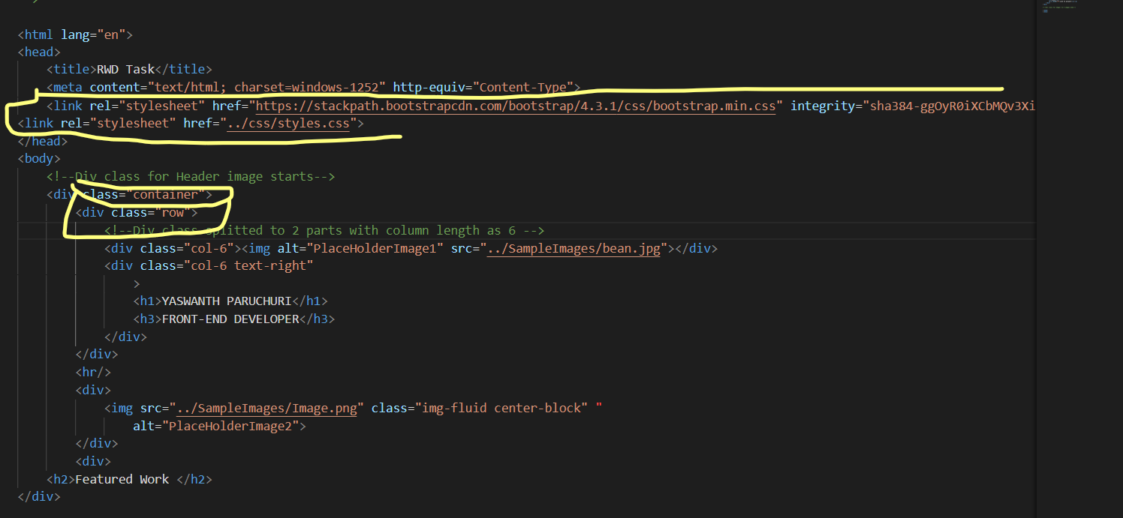

All the webpage is divided into Div with a class=’row’ and column size of 6.Each image has a place holder for it and an image source.

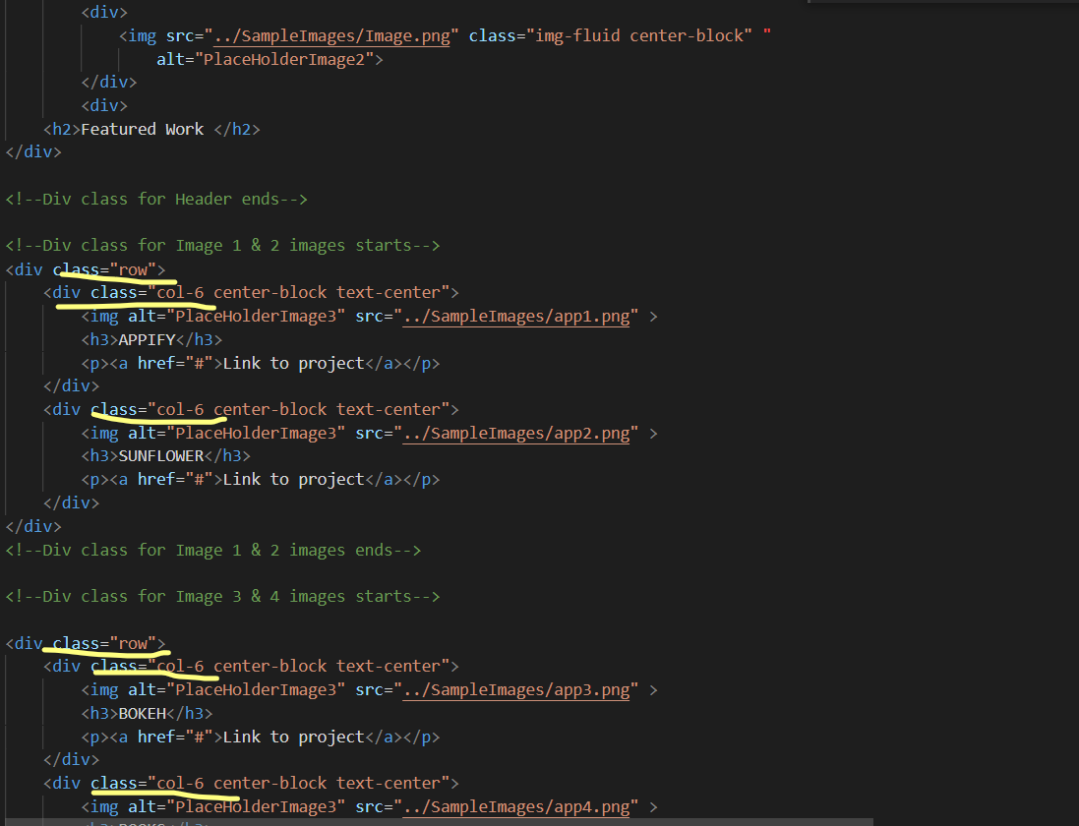

**Output**: The page is responsive and compatible to all the devices and fits to the screens.All the images are kept with the dimensions that are provided in the demo screens and aligned to the sizes.

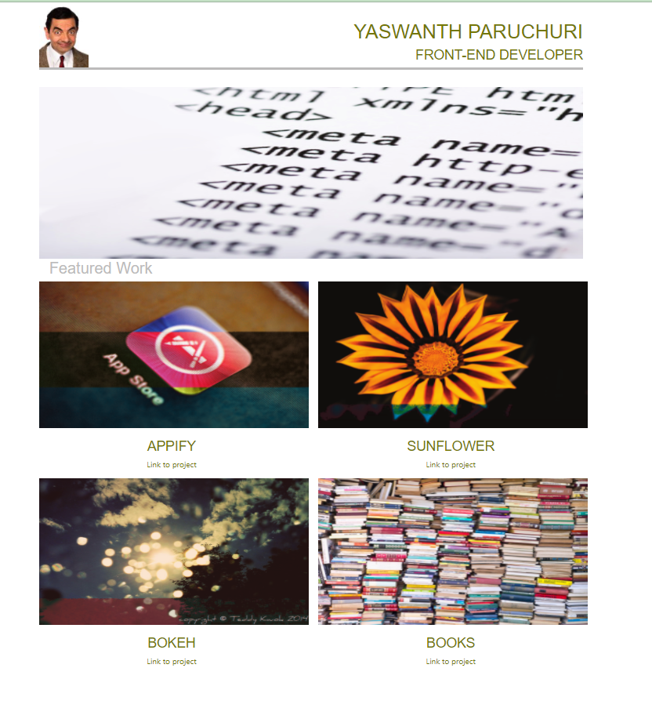

The styling for the webpage is given in a style.css where we have given styling for each and every div and images and headers

