**ICP-5**

**Name**: Yaswanth Paruchuri

**Email**:ypfm7@umsystem.edu

**GitHub Repo link** : <https://github.com/Yaswanthypfm7/WebDevCourse/tree/main/WebPart/ICP5>

**Name**: Tej Deep Parvatha Reddy

**Email**:tpgkd@umsystem.edu

**GitHub Repo link** : <https://github.com/TejdeepP/WebProgrammingSpring2022/tree/main/WebPart/ICP5>

**Introduction:**

Angular is an JavaScript framework written in TypeScript. It is maintained by Google, and its primary purpose is to develop single-page applications. Angular has clear advantages as a framework while also providing a standard structure for developers to work with. It enables users to create large applications in a manageable manner.

TypeScript defines a set of JavaScript types that assist users in writing more understandable JavaScript code. All TypeScript code is JavaScript compliant and can run on any platform. TypeScript is not required for creating an Angular application. It is, however, highly recommended because it improves syntactic structure while making the codebase easier to understand and maintain.

Simple to use: All you need to know to work with AngularJs are the fundamentals of HTML, CSS, and Javascript; you don't need to be an expert in these technologies. Time-saving: Because AngularJs allows us to work with components, we can reuse them, saving time and unnecessary code. Ready to use a template: AngularJs is mostly plain HTML, and it mostly uses plain HTML templates, which it passes to the DOM and then to the AngularJS compiler. It goes through the templates and then they're ready to use.

Bottom of Form

**Tasks:**

In this ICP we have worked on two modules one is creating a To-do list and other is the count down timer using Angular components and Type scripting. We are using node modules to do this operations. By this we learnt about Type scripting and node modules.

**Code:**

Appcomponent.html

In Appcomponent.html we have designed a Webpage that contains the Countdown timer and To-do list. We have linked the bootstrap and appcomponent.css classes using link tag. We have taken a <div> class named container-xxl for entire web page and has splitted the webpage into <div.’s>. We are using click () function for Add task, upon clicking it will be appended to the list.

We have created a class named “Counter_Section” and table for TODO list with Sl.no , Task & Action and the other div contains the table with Days , Hours , Minutes & Seconds and calendar date.

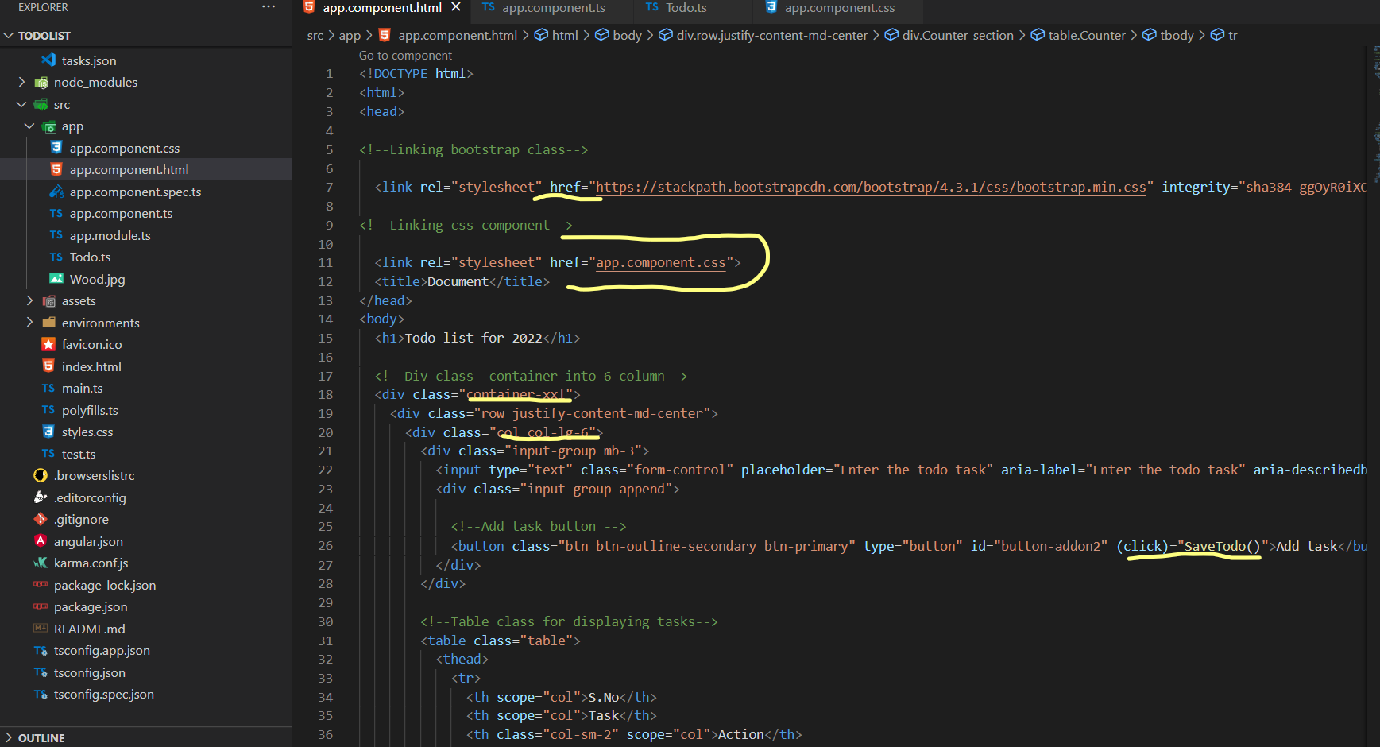

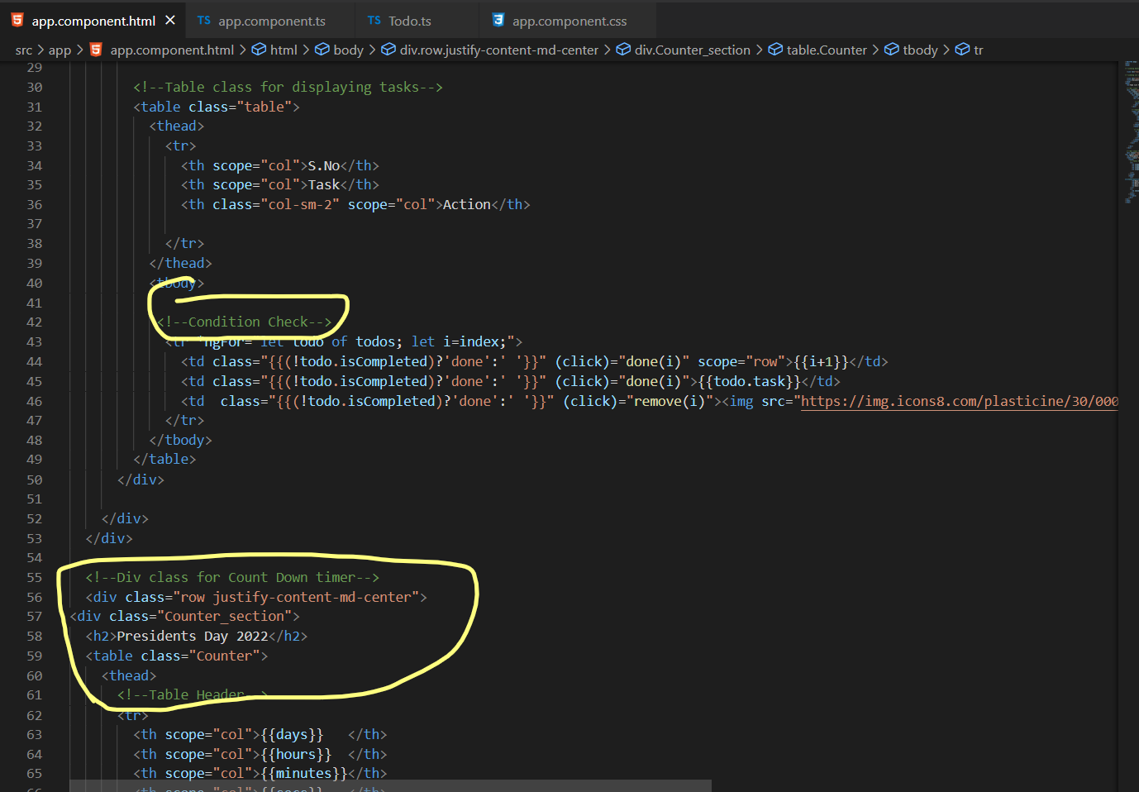

**Styling:**

The styling for the webpage is given in stylesheet named appcomponent.css

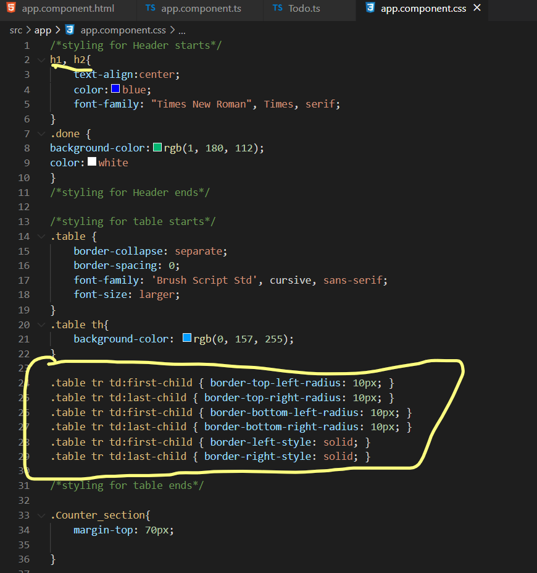

The logic is written in Type script as below:

To-do list : For Todo list we have created a class with string and iscompleted as Boolean which is true or false.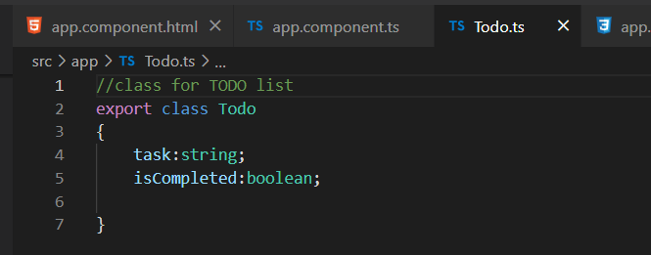

Appcomponent.ts

We have created multiple methods , one for calling both html and css components with @component.The other is for the Todolist with title and taken it as empty array.With Days , hours , minutes and seconds defined with number.

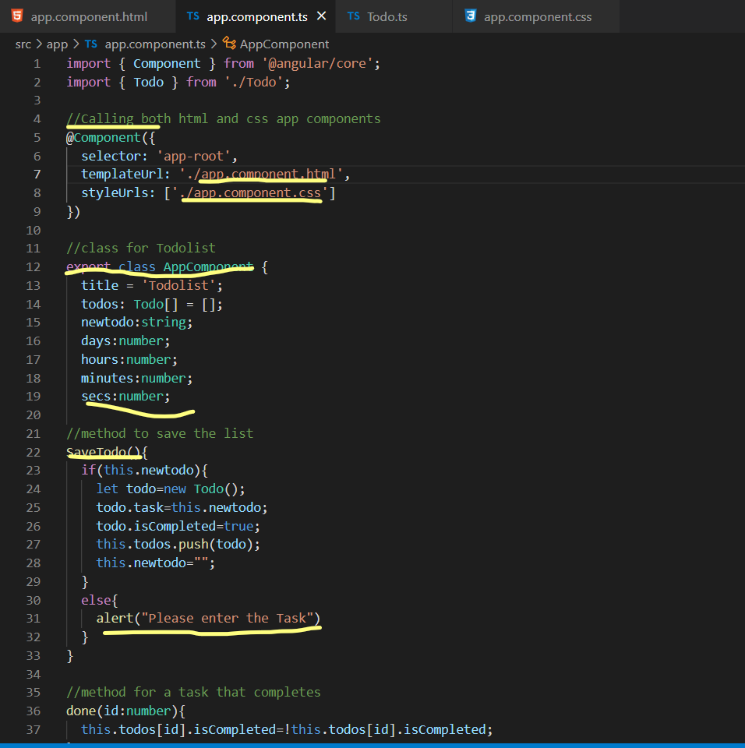

The SaveTodo() method is used here to save the list upon addtask.If user didn’t enter anything an clicked on add task it will throw a popup like “Please enter the Task”.

Method for task completed once added to the list. The remove method is used to remove the task from the list. The event calendar method has the formula set the date for the particular time with days, hours, minutes and seconds.

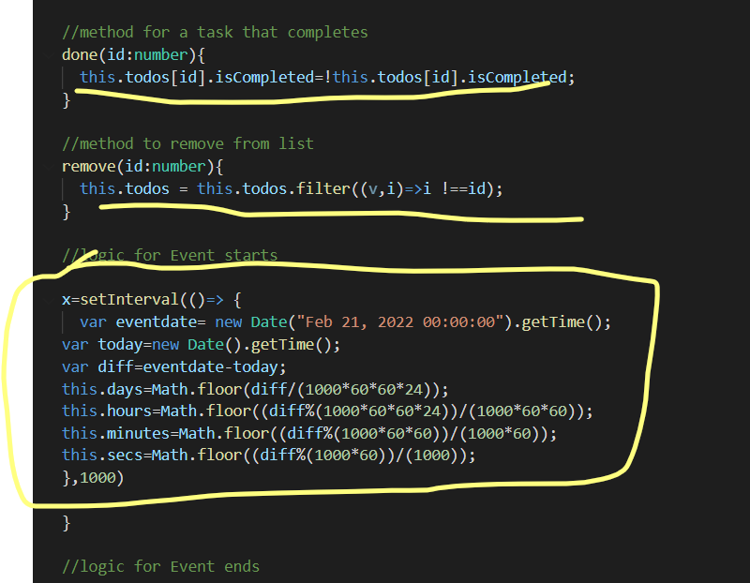

**Output**:

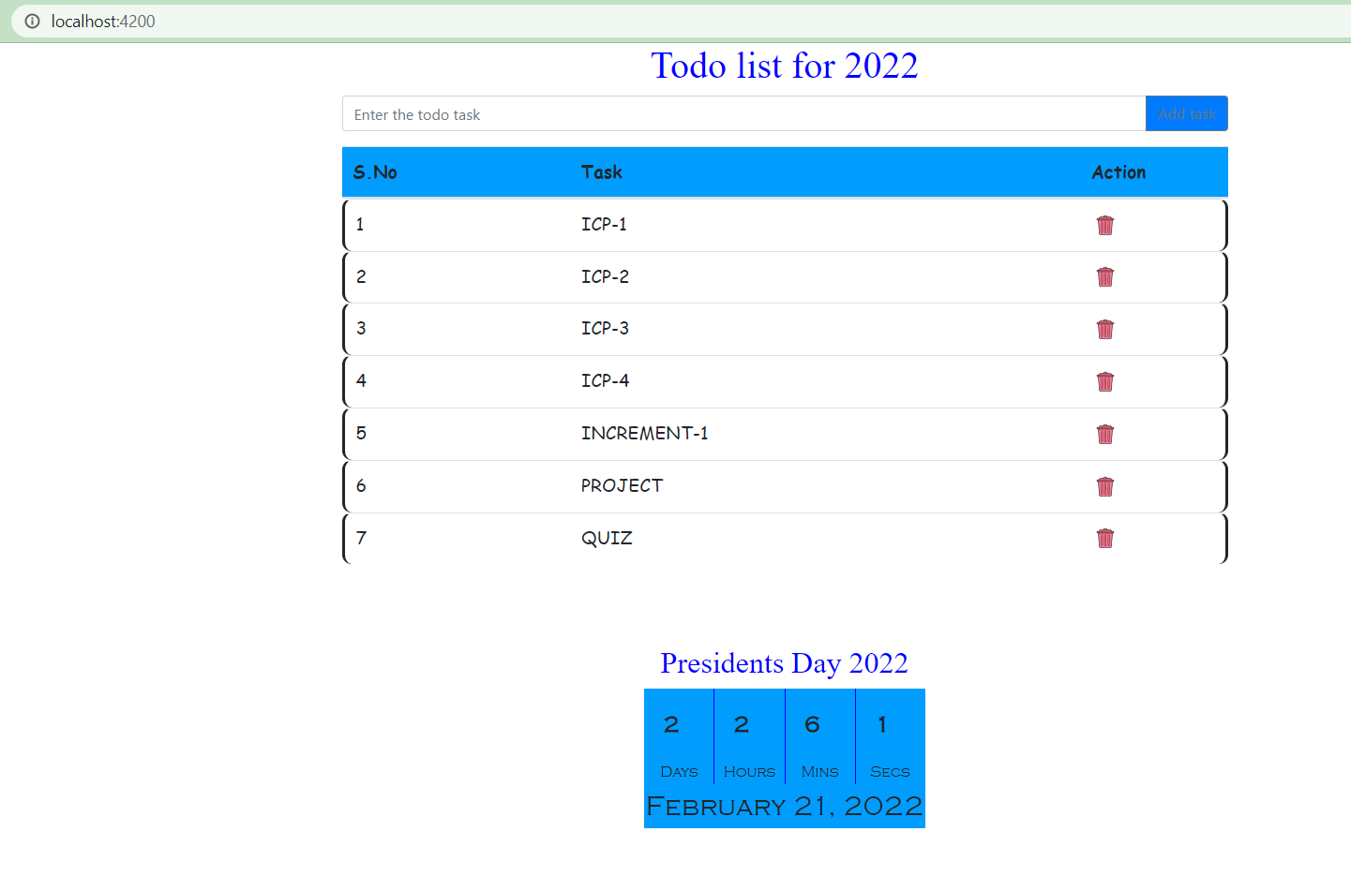

If user didn’t enter anything and clicked on Addtask it will show a popup like please enter task.

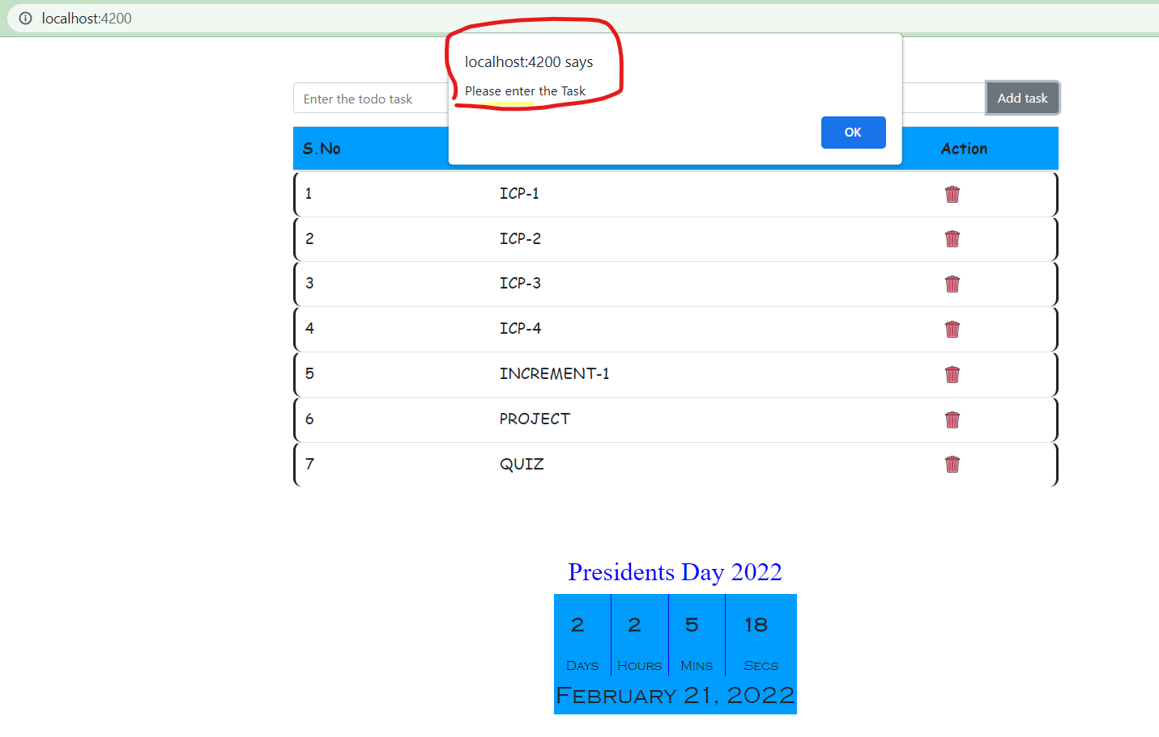

There is operation to delete as an Action .Now we are deleting ICP-1 and the result will be without ICP-1 post deletion

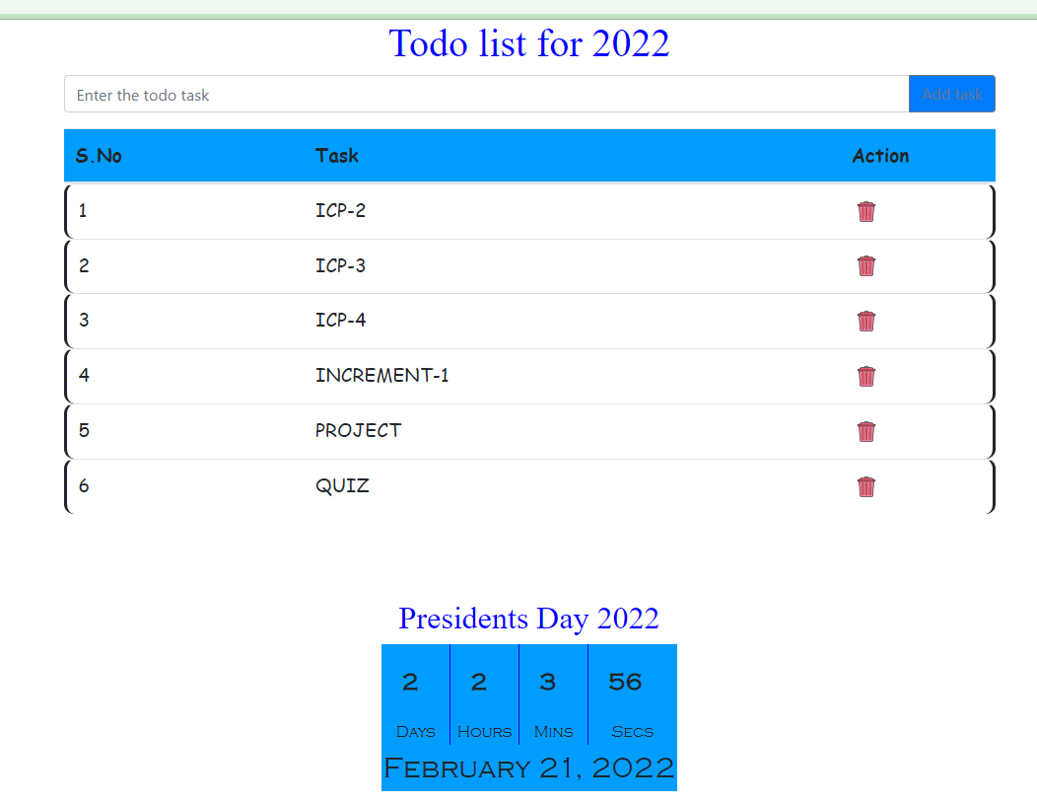

Adding ICP-1 again to the list

