**LIBRARY MANAGEMENT SYSYTEM**

For the Library Management System I have created 8 major tables that could help perform all the activities needed in a library and manage all the issuing and returning of the books. For now I have inserted limited values up to 5 to 6 entries in each table to understand and see all the operations that needs to be performed in the library using the Library Database Management System. The tables are:

* **book table** [containing the details of book such as id, name, category, published year]

🡪The category for now includes 3 major categories namely Fiction, Travel, Business more c categories can be added in the tables

* **author table** [containing the details of author such as id,name of author]
* **book_author** **table** [contains book_id author_id]

🡪since there can be multiple authors for a book and multiple books for a single author, thus we create a book_author table to connect the book_id and author_id

* **lend table** [its records get updated when a member lends a book and contains unique id for each record]
* **fine table** [contains records of the fine which is imposed on a member if the book is not returned within 7 days]
* **member table** [contains details of the library member along with their id and status that can be Active or Inactive]
* **reservation table** [contains details for the reservation of books by the member if the book is not available at that time, this also has a unique id for each record]
* **payment table** [contains details of payments made by each member this payment can be of both the fine and the lending amount]

Now some activities that needs to be carried out by library staff members can be carried out with help of some queries. The cases are as follows.

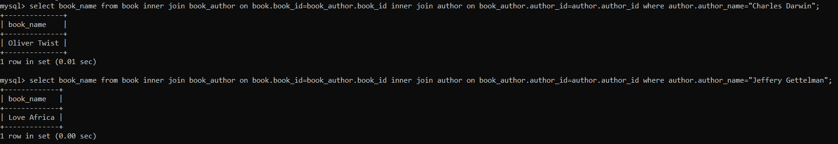* Suppose if user wants to know what all books by some author that are available in the library. The following query can be used to do so: **select book_name from book inner join book_author on book.book_id=book_author.book_id inner join author on book_author.author_id=author.author_id where author.author_name="author_name";**

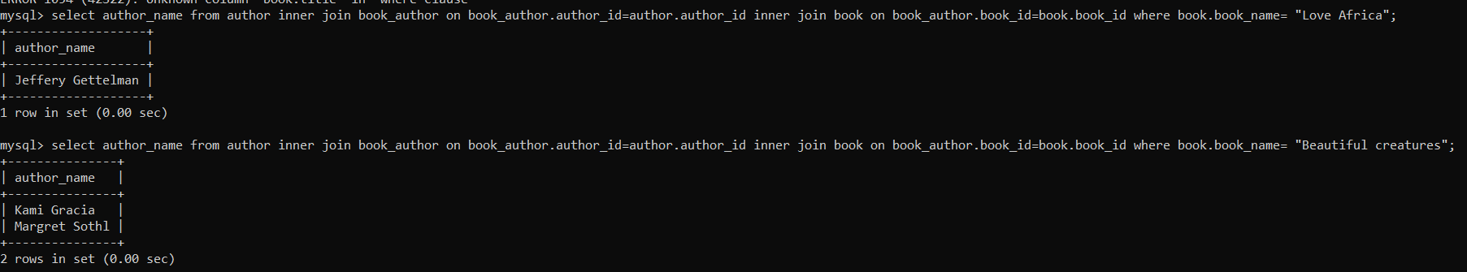* Suppose if user wants to know the author of the book before lending it they can get the author’s name with the help of the name of the book with the help of following query: **select author_name from author inner join book_author on book_author.author_id=author.author_id inner join book on book_author.book_id=book.book_id where book.book_name= "book_name";**

* In order for the staff member to check a library member’s fine details, the following query can be used that gives all the details related to fine if there is one. If the member does not have any fine imposed on him the query will return an empty set. **select * from fine inner join member on fine.member_id=member.member_id where member.full_name="full_name";**

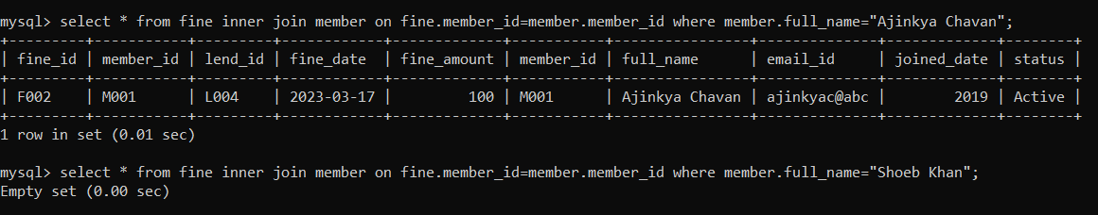

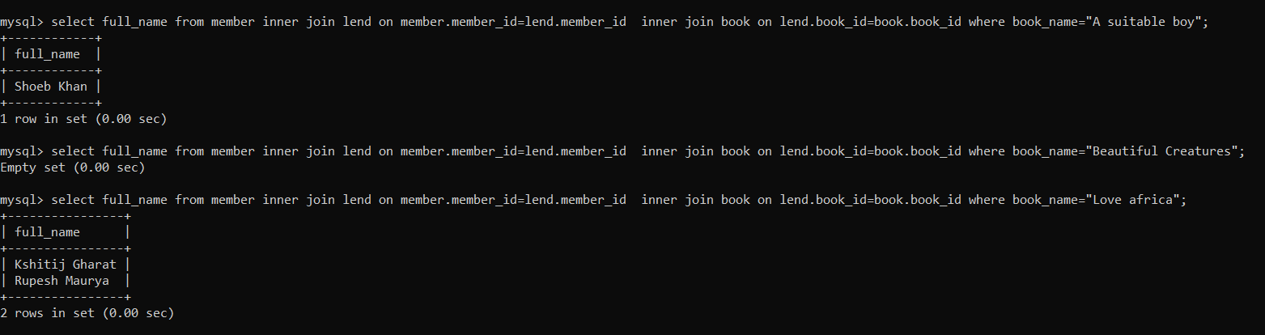* If the staff member need to know the name of the members who have lend a particular book this query can be used that returns the name of users. If a particular book is not lend by anyone for the moment it returns an empty set **select full_name from member inner join lend on member.member_id=lend.member_id inner join book on lend.book_id=book.book_id where book_name="book_name";**

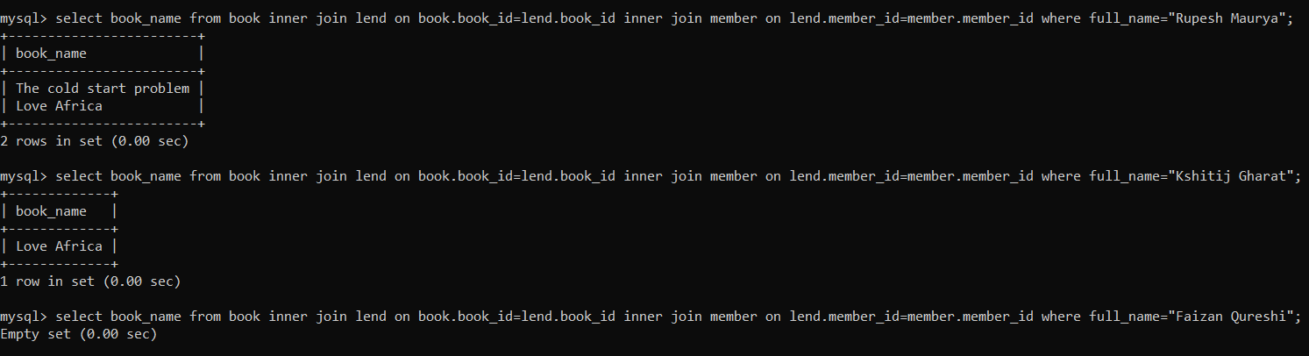* The vice versa of the above case i.e. to get the name of the books lend by a particular member the following query can be used **select book_name from book inner join lend on book.book_id=lend.book_id inner join member on lend.member_id=member.member_id where full_name="full_name";**

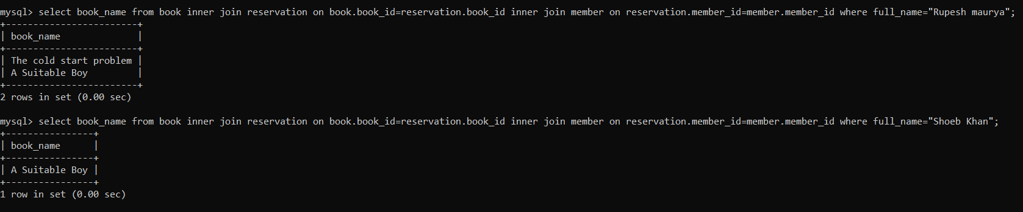**\*** If the member comes down for enquiry about their reservation and the staff members wants to know the name of the book reserved y their name the following query can be used  **select book_name from book inner join reservation on book.book_id=reservation.book_id inner join member on reservation.member_id=member.member_id where full_name="Full_name";**

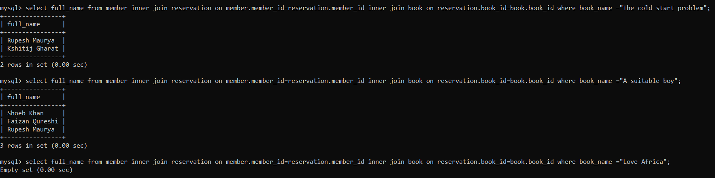* The opposite of the above case which means to know the name of the member who lend a particular book can be done using the following query **select full_name from member inner join reservation on member.member_id=reservation.member_id inner join book on reservation.book_id=book.book_id where book_name =”book_name";**

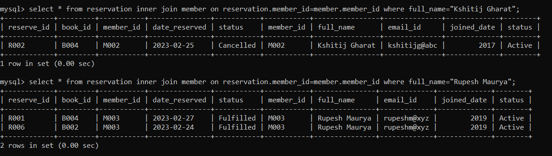**\*** For the staff members to know the entire reservation details of a particular member the following query can be used: **select * from reservation inner join member on reservation.member_id=member.member_id where full_name="full_name";**

* To display the payment details made by the members the library the following query can be used: **select * from payment inner join member on payment.member_id=member.member_id where full_name="full_name";**

This query and many of the above queries can be executed for multiple names using **IN** operator: **select * from payment inner join member on payment.member_id=member.member_id where full_name in (“full_name1”,”full_name2”,….);**

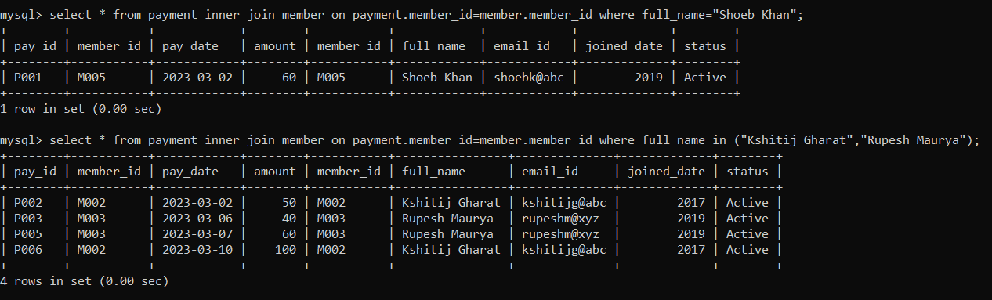

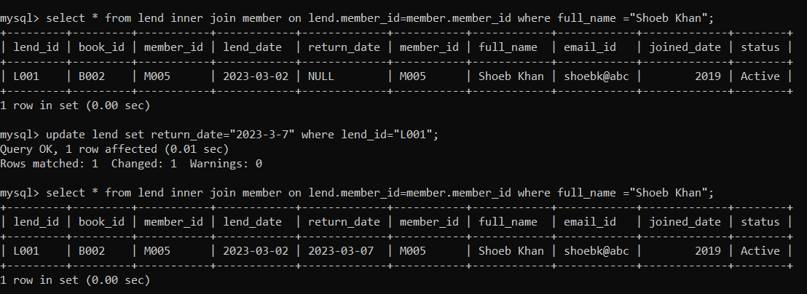 * For the staff member to update the lend table once the book have been returned by the member i.e. to enter the return_date the following set of queries can be implemented **select * from lend inner join member on lend.member_id=member.member_id where full_name ="full_name"; update lend set return_date="date fromat" where lend_id="id returned from above query";**