Project Proposal: "Cost of Smile"
Student Name: HUANG Yifei
Student ID: 58520376
1. Project Overview
"Cost of Smile" is an installation artwork based on my own experience with Invisalign clear aligners. During treatment, I collected used aligners, original packaging with my name and stage number printed on each, intraoral scan images, and progress records. These are objects that normally get thrown away in a clinic. This work uses them to show the financial cost and physical changes of orthodontic treatment in a direct way, and leaves space for viewers to think on their own.
2. Conceptual Framework
This project starts from one specific but common experience. In my third year, a dentist told me that not correcting my teeth would affect my bite and health. The clinic happened to have a discount at the time, so I decided to start treatment. Around the same time, I noticed that a large number of my classmates had also had orthodontic treatment. This made me realise that orthodontics is no longer a medical need for a small group. It has become a common, almost generational bodily experience.
This experience is not special. And because it is not special, it is worth asking: when body modification shifts from "treating a problem" to "everyone is doing it," what happens in between?
To answer this, I need to look at how orthodontic treatment turns the body into a project. The logic of treatment goes like this: scan, digital model, diagnosis, stage plan, numbering, regular check-ups, gradual adjustment, completion. The body is broken into manageable units. It is given numbers. It is tracked and compared. The body is no longer just "my body." It becomes something measurable, plannable, purchasable, and completable. My aligners — each one linked to a number, a time point, a measurable state — are the physical product of this process. The name on the packaging reminds us this is a specific person. The number reminds us this person has been put into a management system.
This "body as project" logic is driven by two forces that are tied together.
The first is medicalisation. The history of orthodontics is a clear case of medicalisation. Teeth alignment used to be seen as cosmetic. Over time it was brought into medical language about "bite health" and "oral function." Peter Conrad points out that one core mechanism of medicalisation is redefining a non-medical problem as something that needs medical intervention. In orthodontics this is especially tricky. Treatment has both a functional side (improving bite) and a cosmetic side (improving appearance). But functional language often gives a reason for a cosmetic choice. When the dentist told me "not correcting will affect your bite and health," that could have been a real clinical judgement. It could also have been a narrative that turns cosmetic consumption into medical necessity. Foucault's concept of the "medical gaze" in The Birth of the Clinic describes a way of seeing that turns the body into something observable, recordable, and comparable. In orthodontic treatment, intraoral scans turn teeth into digital models. Stage numbers cut the treatment process into separate units. Regular check-ups keep confirming "progress" through before-and-after comparison. Nettleton argued in the 1990s that the mouth became "an object of surveillance, a subject of the mechanisms of discipline which were inherent in the twentieth century public health movement".
The second is consumerisation. At the same time, orthodontic treatment has become a highly commercial service. It is priced, marketed, paid in instalments, and framed as "self-investment." Maxine Leeds Craig's research shows that in the United States, the "perfect smile" gained through orthodontic treatment has shifted from a middle-class symbol to a bodily condition for social belonging. Irregular teeth are seen as signs of poverty, parental neglect, or foreign birth. A perfect smile becomes part of what counts as "normative American childhood and good parenting." Teeth, like other parts of the body, have become a commodity that displays and projects class difference in an embodied way.
Medicalisation and consumerisation are not separate. They are wrapped up in the same decision. A young person may choose orthodontics because of a medical suggestion about bite health, because of aesthetic pressure on social media, because most of their peers are doing it, and because there is a discount. These factors do not stand alone. They are tangled together. Medical language gives legitimacy to a consumer choice. Consumer logic gives market drive to medical intervention. This project uses the installation space to make this tangle visible. Aligners (medical objects) form a "$" shape (consumer symbol). Packaging (medical products) contain prop money (commodity exchange). Sticky notes about daily inconvenience (bodily experience) sit next to global cost data (economic difference). The viewer is not told what to think. They are invited into a space where they can find these relations themselves.
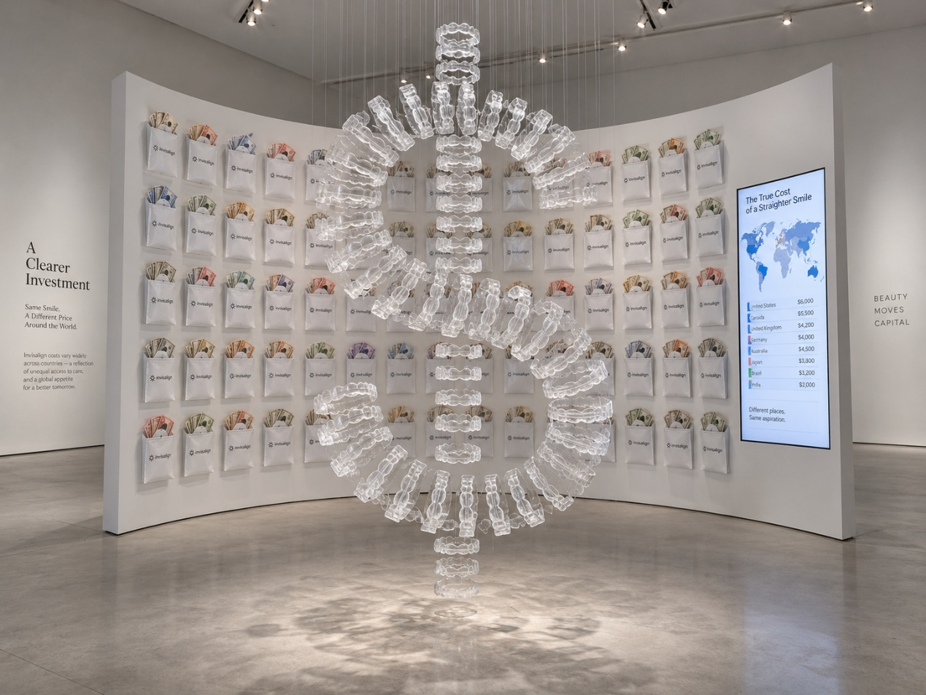

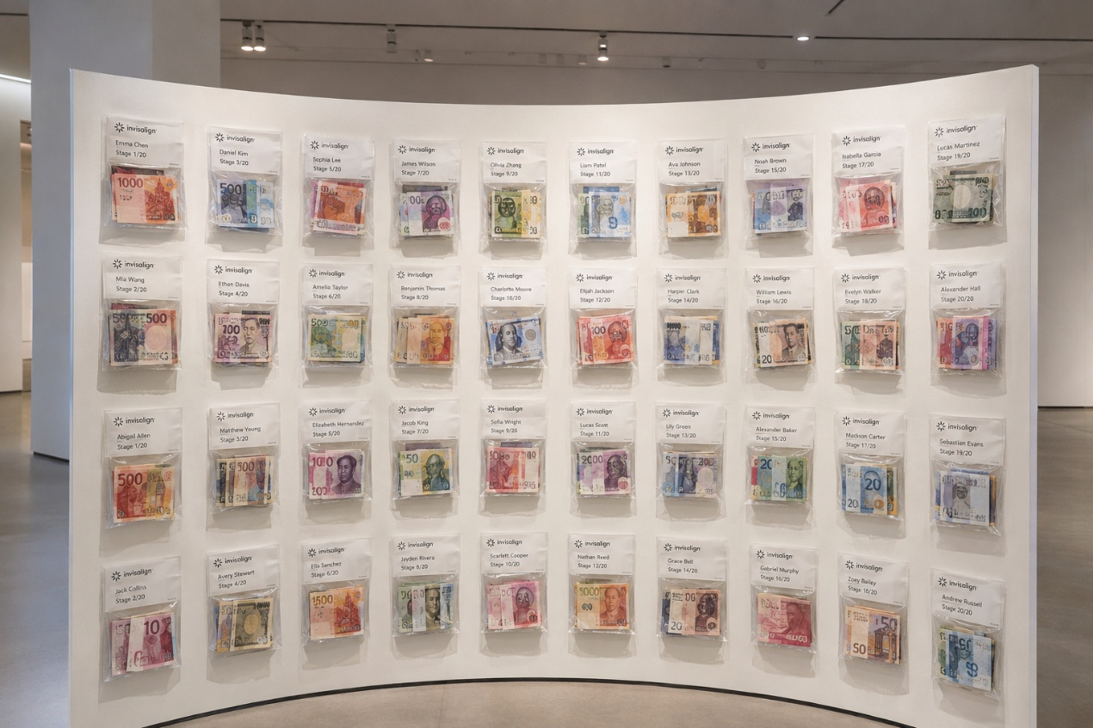
3. Materials
- Used Invisalign aligners. About 40 sets collected so far. Each is about 5.5 cm in horizontal width and semi-circular. 40 sets = 80 individual trays for upper and lower arches. Note: 40 is not the end point of treatment. It is the number of used aligners I expect to have when I start making the work.
- Original packaging envelopes. Each printed with my name and aligner stage number. Note: the numbers are Invisalign's own stage numbers, not a complete sequence from 1 to 40.
- Intraoral scan images and progress photos from dental check-ups. To be requested from my orthodontist.
- Prop money in various currencies. To be placed inside the packaging envelopes.
- Global orthodontic cost data. For information panel or visualisation.
- Display structures. Suspension system for the main installation and a curved back panel for the packaging display.
- Sticky notes. To record daily inconveniences of wearing aligners, such as having to take them out before eating, not being able to eat anytime anywhere, losing them easily after removal, cleaning them like dentures, and not being able to eat hard food because parts may fall off. These will be written on sticky notes and attached to the display panel.
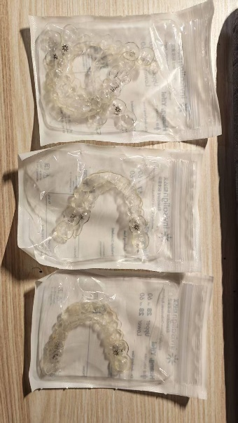
4. Installation Design
The installation has two integrated parts that speak to each other in space.
4.1 Main Structure: The "$" Sign (Central Focal Point)
The used aligners (each individual tray) will form a visual pun. It stands for money and cost. It also stands for smile through its S-like curve. This ambiguity is central to the meaning of the work.
Arrangement: The aligners will be placed randomly as material to form the "$" shape. They will not be numbered in a specific order. The packaging bags, on the other hand, will be arranged in a linear order.
Scale: Each aligner is about 5.5 cm in horizontal width. The finished "$" will be compact and intimate rather than monumental. This encourages close viewing and careful attention.
Material quality: The transparent medical-grade plastic of the aligners catches light and casts subtle shadows when layered and suspended. This creates a sense of fragility and accumulation.
4.2 Curved Back Panel: Packaging + Prop Money (Context Wall)
A semi-enclosing curved panel will be placed behind the "$" structure. It serves as the informational and material context for the central symbol.
Packaging + Prop Money Display: The original packaging envelopes, each printed with my name and stage number, will be arranged in linear order and attached directly to the panel. Inside each envelope, prop money in various currencies — Hong Kong dollars, US dollars, euros, renminbi, yen — will be placed. This symbolises the financial cost of each treatment stage. The use of multiple currencies also hints at the global reach of the "perfect smile" industry and the differences in cost across countries.
Global Smile Price Index: Next to the packaging display, a simple board or printed sheet may show comparative data on orthodontic treatment costs across countries and regions based on existing academic research. For example, the US around $6,200, Japan/Korea/New Zealand around $5,000–$8,000, mainland China around $1,500–$2,400, and India around $350. My personal total treatment cost will be highlighted next to these numbers, placing the individual experience as one data point in a larger global picture. This part is a preliminary option. Whether to include it is for the supervisor to decide.
Progress Photos (Optional): Small-scale reprints of intraoral scan images, treated in black-and-white or negative effect to anonymise and aestheticise, may be arranged along the lower edge of the panel as visual footnotes to the aligner sequence.
Sticky Notes: Sticky notes will be attached to the display panel to record daily inconveniences of wearing aligners. These include having to take them out before eating, not being able to eat anytime anywhere, losing them easily after removal, cleaning them like dentures, and not being able to eat hard food because parts may fall off.
Assembly Details: The current preliminary idea is to glue the aligners together and suspend them with thin wire. But the actual effect needs to be tested through experiments to clarify the final visual result.
5. Spatial Experience and Viewer Path
- First impression: Entering the space, the viewer sees the suspended "$" shape. It is a familiar symbol presented in an unfamiliar, intimate material.
- Close reading: Moving closer, the viewer notices the individual aligners and their material details. Realising this "$" is made of real, used aligners turns the symbol from abstraction into lived experience.
- Contextual turn: The viewer turns to the curved back panel. The packaging envelopes with prop money inside, the sticky notes, and the global cost comparison data expand the personal story into a social and economic commentary.
- Reflection: The complete installation — central symbol plus context wall — invites the viewer to think about the hidden costs behind their own body, choices, and ideals.

References
Conrad, P. (2007). The medicalization of society: On the transformation of human conditions into treatable disorders. Johns Hopkins University Press. https://doi.org/10.56021/9780801885846
Craig, M. L. (2024). Perfect smiles, aesthetic citizenship, and the U.S. State. Citizenship Studies, *28*(1), 16–32. https://doi.org/10.1080/13621025.2024.2348865
Foucault, M. (1994). The birth of the clinic: An archaeology of medical perception (A. Sheridan, Trans.). Vintage Books. (Original work published 1963)
Khalid, A., & Quiñonez, C. (2015). Straight, white teeth as a social prerogative. Sociology of Health & Illness, *37*(5), 782–796. https://doi.org/10.1111/1467-9566.12238
Kim, J., Han, D.-H., & Song, Y. (2022). Power in dentistry: A Foucauldian shift in South Korea. Community Dental Health, *39*(2), 131–136. https://doi.org/10.1922/CDH_JADR22Junhewk06
Nettleton, S. (1992). Power, pain and dentistry. Open University Press.

