Cost of Smile Project Proposal
Supervisor Meeting Draft
Student HUANG Yifei Student ID 58520376

Project Focus
Cost of Smile is an installation project based on my experience of Invisalign treatment. It examines how orthodontic treatment turns the body into a project that can be scanned, divided into stages, monitored, purchased and declared complete. The work does not present orthodontics as simply harmful, unnecessary or deceptive. It focuses on the ambiguity between health, appearance, social expectation, consumer choice and personal agency.

Personal Starting Point
In my third year, a dentist advised me that leaving my teeth untreated could affect my bite and oral health. A clinic discount was available, and I chose to begin treatment. I also noticed that many people around me had undergone orthodontic treatment. This experience led me to ask how a personal decision about the body is shaped by clinical advice, aesthetic norms, peer experience, price and the wish to care for oneself. I treat this as a question rather than evidence that orthodontics is a universal or generational experience.

Research Questions
• How does clear-aligner treatment turn the body into a measurable and staged project?
• How do health claims, aesthetic norms, market logic and personal choice overlap in the decision to alter the body?
• How can the material traces of treatment make these relations visible without becoming an overloaded information display?

Current Position
The used aligners and their original packaging are not illustrations added after the idea. They are the physical residue of repeated wearing, cleaning, replacement, monitoring and payment. Their accumulation links an intimate bodily process to a system of stages and records. These two materials will remain the core of the work even if the final spatial form changes.
Working title note The project name remains Cost of Smile. The Cost of a Smile is a more natural English alternative and can be considered with the supervisor.

Conceptual Framework

Body as Project
Body as project is the main organizing idea. Clear-aligner treatment begins with an intraoral scan and a digital model, then proceeds through diagnosis, a planned sequence, numbered stages, regular checks and a projected endpoint. In this process, teeth become visible as data and the body becomes something to manage over time. Each aligner corresponds to a temporary state between the present body and a planned result. The installation will use the accumulated aligners and packaging to make this sequence materially present.

Medicalisation
Peter Conrad's concept of medicalisation provides one supporting lens. I use it to ask how dental difference can be described through the language of diagnosis, risk, bite and oral function, while treatment may also promise aesthetic improvement. I do not treat medicalisation as a complete explanation or a dentist's clinical judgment as merely a sales narrative. Orthodontic treatment is useful here because medical need and cosmetic choice can be difficult to separate in practice.

Medical Gaze and Dental Surveillance
Foucault's medical gaze helps me consider how the body becomes legible through specialist ways of seeing: scans, measurements, comparison and diagnosis. Nettleton's work on dentistry brings this question closer to the mouth by examining dental knowledge, surveillance, discipline and preventive self-management. In my treatment, stage numbers, check-ups and expected wearing time organize both the teeth and everyday behaviour. Surveillance here does not mean that the dentist literally watches me at all times. It describes a system of norms and records that encourages me to monitor myself.

Consumerisation and Aesthetic Norms
Consumerisation is a supporting context rather than the project's only argument. Orthodontic treatment is priced, promoted and sometimes framed as an investment in the self. Craig's account of the perfect smile and aesthetic citizenship concerns the United States. Khalid and Quiñonez examine straight, white teeth as a social prerogative in North America. These studies show how dental appearance can carry meanings of class, normality, care and belonging in those settings. I will not treat their findings as universal or assume that they apply directly to Hong Kong. If this social dimension remains central, further research on Hong Kong or East Asian contexts will be needed.

Patient Agency and Care of the Self
Kim, Han and Song's discussion of dentistry in South Korea helps prevent the project from treating the patient as a passive victim. Their Foucauldian shift gives greater attention to care of the self, self-determination, empowerment, health literacy and shared decision-making. My own experience also contains this tension. I was influenced by professional advice, commercial conditions and aesthetic expectations, but I also chose treatment and performed the daily work required to change my body. The project therefore asks how power and agency operate together rather than choosing one simple explanation.

Materials and Installation Direction
The revised installation begins with two core materials and keeps other information subordinate. This should allow the work to remain an installation rather than become a wall of explanations.
Element | Status | Role in the Work
Used aligners | Core | About 40 sets or 80 trays expected when making begins. Their repetition records bodily time and daily discipline.
Original packaging | Core | The printed name and stage number connect a specific person to a treatment system and preserve chronology.
Support structure | Required test | A suspension or mounting system must hold the materials safely without hiding their transparency and detail.
Dollar sign form | Open question | It makes financial cost legible but may be too literal and may overpower the body-as-project framework.
Scans and progress images | Optional | Use only if they clarify measurement and staging. They should not become a compulsory documentary strip.
Daily notes or sticky notes | Optional | Use only if one concise layer of lived experience is needed. A loose note wall may create visual noise.
Global cost comparison | Optional | Include only with comparable sources, years and treatment types. It may be removed if it distracts from the personal material.
Prop money | Optional | This may repeat the meaning of cost too directly and should be retained only if material tests justify it.

Proposed Spatial Structure
1. Primary material field The used aligners form the visual and spatial focus. Their arrangement should show accumulation, repetition and changing stages. Alternatives to test include a chronological line, a suspended accumulation, a staged grid and the current dollar-sign study.
2. Secondary archive The original packaging is arranged in a restrained sequence or grid. Its printed name and stage numbers provide the documentary structure without needing a dense information wall.
3. One contextual layer at most After the supervisor meeting, I will select no more than one optional layer if it is necessary: clinical images, a short account of daily routines, or carefully sourced cost information.
The current dollar-sign arrangement remains a study rather than the final form. Its advantage is immediate readability; its risk is that the viewer may reduce the project to the message that orthodontics costs money. I would like the supervisor's opinion on whether this symbol is too literal and whether a less predetermined arrangement would better express the body as project.

Spatial Experience and Development
The viewer should first encounter the physical accumulation of transparent aligners, then notice the individual impressions of teeth, and finally read the stage information on the packaging. This movement shifts from an overall form to intimate material detail and then to the treatment system. Any explanatory information should remain secondary to that encounter.
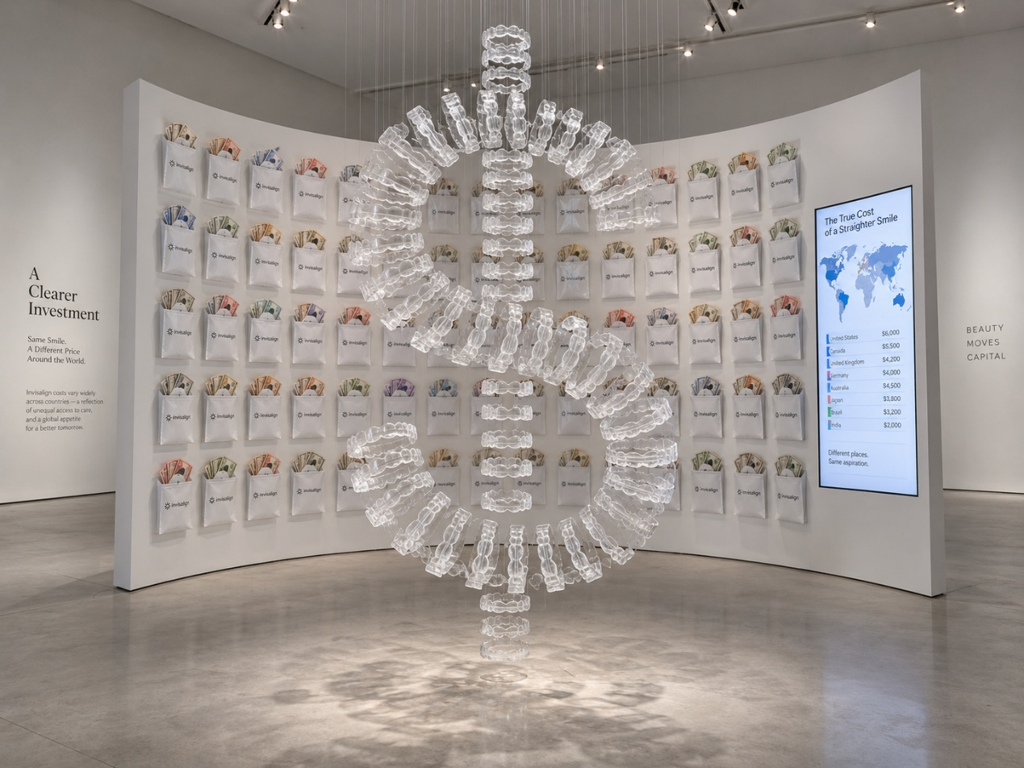
Earlier installation study The dollar sign and context wall remain open to revision

Material and Practical Tests
• Cleaning and hygiene Establish a safe cleaning and sealing method for used aligners before display.
• Fixing, suspension and light Test removable joins, transparent supports and lighting before deciding whether glue is appropriate.
• Order and legibility Compare chronological and non-chronological arrangements, especially because the saved stage numbers are not a complete sequence from 1 to 40.
• Privacy Decide whether my printed name should remain visible as evidence of a specific patient or be partially obscured.

Questions for the Supervisor
1. Conceptual priority Is body as project a sufficiently clear central framework, with medicalisation, surveillance, aesthetic norms and agency kept as supporting ideas?
2. Degree of literalness Does the dollar sign make the project too direct, and should I test a form based more closely on sequence, repetition or bodily measurement?
3. Amount of context Should the final installation include one contextual layer, and if so, which would contribute most without turning the work into an information display?
4. Cultural scope How much Hong Kong or East Asian research is needed if I retain the discussion of aesthetic norms and social class?
5. Personal identification Should the name on the packaging remain visible as part of the work, or should privacy take priority?

Next Steps After the Meeting
I will use the supervisor's response to choose the final spatial form, limit the contextual material, and define the research scope. I will then produce small material tests for suspension, order and lighting; confirm the cleaning and privacy approach; and request scans or treatment records only if they remain necessary.

References
Conrad, P. (2007). The medicalization of society: On the transformation of human conditions into treatable disorders. Johns Hopkins University Press. https://doi.org/10.56021/9780801885846
Craig, M. L. (2024). Perfect smiles, aesthetic citizenship, and the U.S. State. Citizenship Studies, 28(1), 16-32. https://doi.org/10.1080/13621025.2024.2348865
Foucault, M. (1994). The birth of the clinic: An archaeology of medical perception (A. Sheridan, Trans.). Vintage Books. (Original work published 1963).
Khalid, A., & Quiñonez, C. (2015). Straight, white teeth as a social prerogative. Sociology of Health & Illness, 37(5), 782-796. https://doi.org/10.1111/1467-9566.12238
Kim, J., Han, D.-H., & Song, Y. (2022). Power in dentistry: A Foucauldian shift in South Korea. Community Dental Health, 39(2), 131-136. https://doi.org/10.1922/CDH_JADR22Junhewk06
Nettleton, S. (1992). Power, pain and dentistry. Open University Press.

Framework Summary for the Meeting
The main framework is body as project. Medicalisation helps me ask how treatment is framed as a health intervention. Foucault and Nettleton help me examine how the body becomes visible, measured and self-monitored. Craig and Khalid and Quiñonez help me consider dental aesthetics and class while remaining attentive to their U.S. and North American scope. Kim, Han and Song help me retain the patient's agency and the possibility that treatment is also a chosen practice of self-care.

