
DRONACHARYA GROUP OF INSTITUTIONS
Greater Noida
DEPARTMENT OF COMPUTER SCIENCE & INFORMATION TECHNOLOGY
SECOND YEAR MINI PROJECT REPORT
VENTORA
A Smart Founder–Investor Connection Platform

Submitted by:
Name | Roll No. | Role
Roshan Kumar Jha | 20320 | Database & Research
Yatharth Saini | 20343 | AI and Feed Algorithm
Yash Kulshreshtha | 20342 | Back-end
Shivam Jha | 20327 | Front-end

Submitted to:
Prof. Manisha Rai

Declaration
We hereby declare that the Mini Project Report entitled “VENTORA – A Smart Founder–Investor Connection Platform” submitted by us in partial fulfilment of the requirements for the award of the degree of Bachelor of Technology in Computer Science & Information Technology from Dronacharya Group of Institutions, Greater Noida, is an authentic work carried out by us.
This project work has not been submitted by us for the award of any other degree or diploma.
Date: _____________
Place: ____________
Submitted by:
Roshan Kumar Jha (Roll No. 20320)
Yatharth Saini (Roll No. 20343)
Yash Kulshreshtha (Roll No. 20342)
Shivam Jha (Roll No. 20327)

Certificate
This is to certify that the Mini Project Report entitled “VENTORA – A Smart Founder–Investor Connection Platform” submitted by Roshan Kumar Jha, Yatharth Saini, Yash Kulshreshtha and Shivam Jha, Roll Nos 20320, 20343, 20342 and 20327 respectively, in partial fulfilment for the award of the degree of Bachelor of Technology in Computer Science & Information Technology from Dronacharya Group of Institutions, Greater Noida, is a bona fide work carried out under my guidance.
The work embodied in this report has not been submitted to any other University or Institution for the award of any degree or diploma.
______________________
Project Guide: Prof. Manisha Rai

Acknowledgement
We would like to express our sincere gratitude to our project guide, Prof. Manisha Rai, for her valuable guidance, constant encouragement and constructive feedback throughout this mini project. Her suggestions helped us refine our ideas and approach the work in a more structured and disciplined manner.
We are also thankful to the Head of the Department of Computer Science & Information Technology and to all the faculty members of Dronacharya Group of Institutions, Greater Noida, for providing the academic environment and resources required to carry out this work.
Finally, we thank our families and friends for their support, and every member of the team for the cooperation, effort and commitment shown while working on Ventora.
Roshan Kumar Jha, Yatharth Saini, Yash Kulshreshtha and Shivam Jha

Abstract
Early-stage founders often find it difficult to reach investors who match their domain and stage, while investors struggle to discover relevant ideas among large volumes of unstructured pitches. Sharing an idea openly also exposes it to the risk of theft, and open communication channels invite spam and fake profiles. This report presents Ventora, a web-based platform that connects founders and investors through a structured and privacy-conscious process.
In Ventora, a founder submits a startup idea as a PDF document. An AI-based completeness analysis checks whether essential sections such as the problem statement, proposed solution, target audience, business model, market opportunity, revenue model and funding requirement are adequately described, and produces a completeness score. Ideas that meet the threshold are published to the investor feed; the others are returned to the founder for revision. Investors register, complete a KYC verification step and state their preferences, after which they receive a personalised, card-based feed showing only limited previews of ideas. A token-based system, with three free tokens per month, discourages low-intent outreach, and a private chat opens only after the founder accepts a connection request. Investment negotiations and financial transactions remain outside the platform.
The system adopts React.js and Tailwind CSS for the frontend, Node.js with Express.js for the backend, MongoDB for data storage, a Python FastAPI service for the AI layer, Socket.IO for real-time messaging, and JWT-based authentication with hashed passwords. This report describes the background, requirements, architecture, methodology, outcomes and future scope of the project.
Keywords: startup ecosystem, founder–investor matching, idea completeness analysis, personalised feed, token-based communication, controlled disclosure.

Table of Contents
Declaration ii
Certificate iii
Acknowledgement iv
Abstract v
List of Figures vii
Chapter 1: Introduction 1
1.1 Background 1
1.2 Problem Statement 1
1.3 Objectives 2
1.4 Scope 2
1.5 Organisation of the Report 3
Chapter 2: System Requirement & Design 4
2.1 Software Requirements 4
2.2 System Architecture 5
2.3 Flowchart / UML Diagram 7
Chapter 3: Implementation 10
3.1 Tools & Technology Used 10
3.2 Proposed Methodology 11
3.3 Major Modules 14
3.4 Team Structure and Work Distribution 14
Chapter 4: Results & Discussion 16
4.1 Objective-wise Outcomes 16
4.2 Testing Approach and Test Cases 16
4.3 Discussion 17
4.4 Limitations 17
Chapter 5: Conclusion & Future Work 19
5.1 Conclusion 19
5.2 Future Work 19
Code and Data availability statement 20
References 20

List of Figures
Figure 2.1: System architecture of Ventora 6
Figure 2.2: Proposed database collections and relationships 7
Figure 2.3: Flowchart of the founder and investor workflows 9

Chapter 1: Introduction

1.1 Background
Startups depend on two things at their very beginning: a promising idea and the right people to back it. In practice, the two groups that need each other most – founders with early-stage ideas and investors looking for opportunities – often find it hard to meet. Founders, especially students and first-time entrepreneurs, may not have the networks, mentors or credibility that make investors pay attention. Investors, on the other hand, receive pitches through many unstructured channels such as e-mail, social media and personal referrals, and it takes considerable effort to filter out the ideas that match their preferred industries, stages and investment ranges.
A second difficulty is trust. A founder who describes the complete idea in public risks having it copied, whereas a founder who reveals too little may never be noticed. Open communication channels create the opposite problem for investors, who can be flooded with irrelevant or low-quality messages and may also face fake profiles. A useful platform therefore has to balance discoverability with privacy, and openness with quality control.
Ventora is an attempt to address this gap. It is a web-based platform in which founders present ideas in a structured form, an AI-assisted check ensures that each submission is reasonably complete, investors see ideas that match their stated preferences, and detailed information is revealed only after both sides show interest. The platform acts as a connection and insight layer; it does not process or guarantee investments.

1.2 Problem Statement
Many founders have promising ideas but face difficulty in finding suitable investors, mentors, or people who can give meaningful feedback. Investors find it equally difficult to discover relevant startup ideas that match their preferred industries, investment stages and investment ranges. Existing channels also tend to expose too much information about an idea publicly, which leads to the following problems:
- Discovery gap: good ideas and interested investors do not reach each other efficiently.
- Incomplete pitches: ideas are often shared without clearly stating the problem, solution, market and funding need, which makes them hard to evaluate.
- Idea-theft risk: publicly posting complete details can allow others to copy the idea.
- Spam and fake profiles: unrestricted messaging leads to unsolicited and low-intent communication and makes verification difficult.
The problem addressed in this project is how to build a platform that lets founders present ideas safely and completely, lets investors find relevant opportunities quickly, and keeps communication verified, limited and intentional.

1.3 Objectives
The main objectives of the project are as follows:
- To provide founders with a platform to submit their startup idea as a document (PDF) for review.
- To use AI to check the completeness of each submitted idea document and to accept it or flag it for revision based on a completeness score.
- To create personalised feeds for investors based on their stated preferences.
- To verify investors through a KYC / identity-verification process.
- To prevent unnecessary exposure of sensitive startup information.
- To provide controlled, phased access to detailed startup information.
- To reduce spam and low-intent outreach through a token-based communication system.
- To allow founders to approve or reject investor connection requests.
- To facilitate communication between interested parties before they proceed with an offline deal.

1.4 Scope
The scope of Ventora covers the following areas:
- Two main user types – Founder and Investor – along with an administrator who manages moderation and platform settings.
- Idea submission as a PDF, AI-assisted completeness analysis and scoring, and publication of accepted ideas to an investor feed.
- Investor registration, KYC verification (a mock or sandbox workflow for the academic prototype), preference management and a personalised feed.
- Controlled disclosure of idea information, a token-based connection mechanism, founder approval of requests and real-time chat between connected users.
- Notifications, reporting and blocking features, and an admin dashboard.
The following are outside the scope of the project: processing or guaranteeing financial transactions, legal or valuation advice, and any guarantee about the success or profitability of a startup. The completeness score measures only how completely an idea has been described; it is not a judgement of the idea’s quality or potential. Once an investor and a founder have established mutual interest, further negotiations, due diligence, agreements and payments take place offline between the parties.

1.5 Organisation of the Report
Chapter 2 lists the software requirements and presents the system architecture, database design and flowchart. Chapter 3 describes the tools and technologies used, the proposed methodology, the major modules and the work distribution among team members. Chapter 4 discusses how the objectives are met, the testing approach, and the limitations of the current work. Chapter 5 concludes the report and outlines future work.

Chapter 2: System Requirement & Design

2.1 Software Requirements
Ventora is a web application, so users need only a device with a modern web browser and an internet connection. The software requirements below refer to the development and deployment environment of the prototype.

2.1.1 Software Requirements
Table 2.1: Software requirements
Category | Software / Tool
Operating system | Windows 10 / 11, Linux or macOS
Runtime environments | Node.js (LTS version) and Python 3.x
Database | MongoDB (local installation or cloud-hosted)
Frontend libraries | React.js, Tailwind CSS
Backend libraries | Express.js, Socket.IO, FastAPI
Development tools | Visual Studio Code, Git and GitHub, Postman
Web browser | Latest version of Google Chrome, Microsoft Edge or Mozilla Firefox

2.1.2 Functional Requirements
- Users can register, log in and manage a profile as a founder or an investor.
- Founders can upload an idea document in PDF format and receive an AI-generated completeness score with the list of missing or weak sections.
- Investors can complete identity verification, set preferences and view a personalised feed of idea previews.
- Investors can use tokens to send connection requests; founders can accept, reject or ignore them.
- Accepted connections can exchange messages in real time, and users receive notifications about important events.
- Users can report or block other users, and the administrator can moderate content and adjust platform settings.

2.1.3 Non-Functional Requirements
- Security: hashed passwords, token-based authentication, role-based access control and validated inputs.
- Privacy: only limited idea information is public; confidential documents are accessible through permission only.
- Usability: a responsive interface that works on desktops and mobile browsers, with a simple swipe-style feed.
- Performance: quick loading of the feed and low-latency messaging.
- Maintainability and scalability: a modular architecture with separate services for the API, AI analysis and real-time communication.

2.2 System Architecture
Ventora follows a layered, service-oriented architecture, shown in Figure 2.1. Users interact with a React-based frontend, which communicates with a Node.js and Express.js application layer through REST APIs. Real-time features such as chat and notifications are handled by a Socket.IO service. The application layer stores structured data in MongoDB, keeps uploaded documents in a cloud file store, sends idea PDFs to a Python FastAPI service for completeness analysis, and calls a KYC verification component for investors.
The architecture separates responsibilities clearly. The presentation layer deals only with display and user interaction. The application layer contains the business rules such as authentication, role-based access, feed generation, token handling and connection requests. The AI service is isolated so that its analysis method can be improved or replaced – for example by an external AI API – without affecting the rest of the system. The REST design follows the architectural principles described by Fielding (2000).
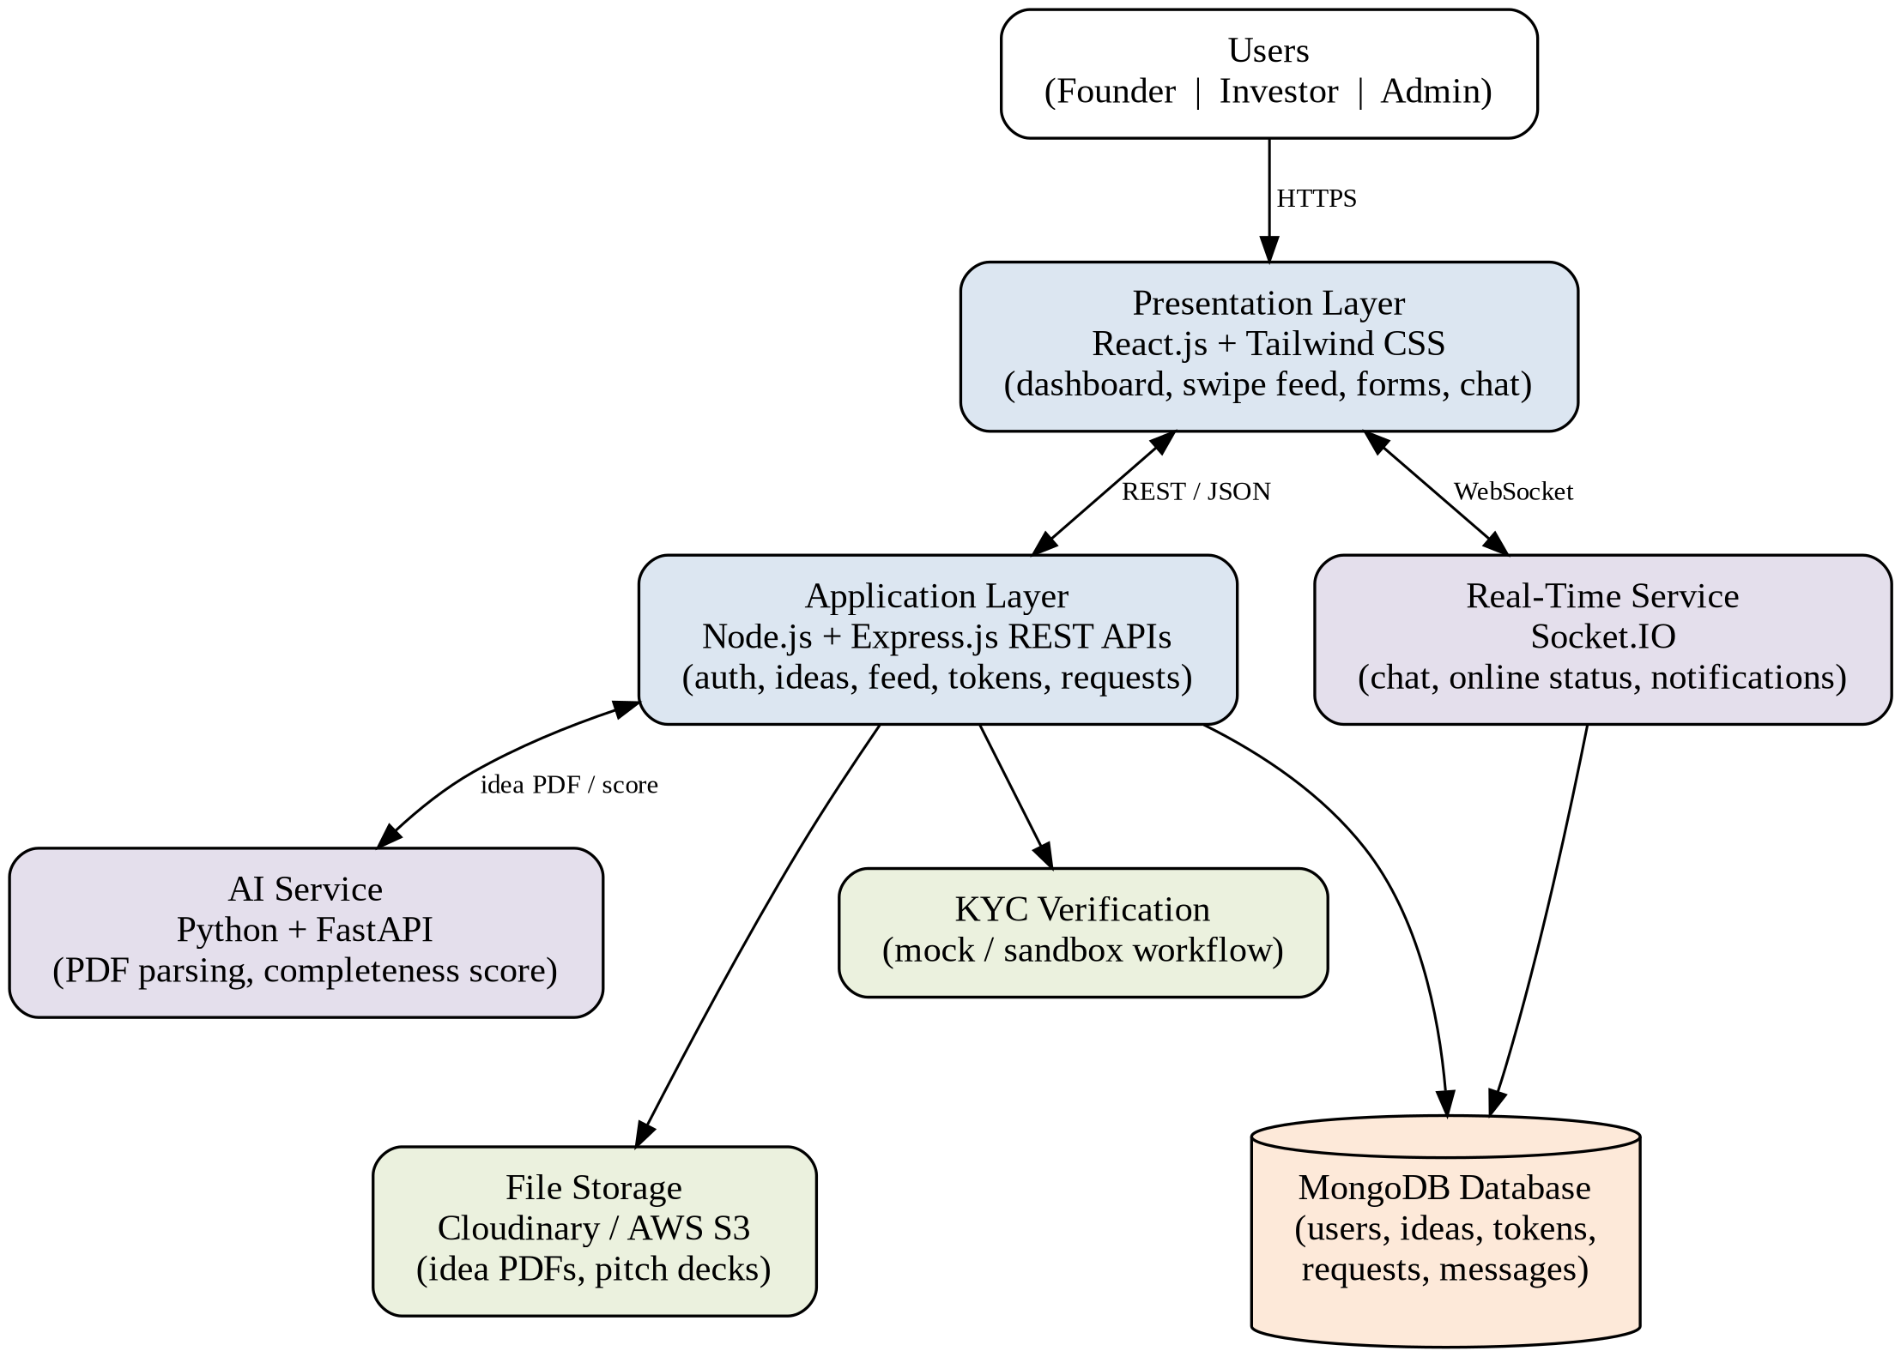
Figure 2.1: System architecture of Ventora

Database Design
Ventora uses MongoDB, a document database, because idea records, profiles and messages are naturally represented as flexible documents. The proposed collections and their relationships are shown in Figure 2.2. Founder and investor profiles extend the common user record; ideas belong to founders; a connection request links an investor, an idea and a founder; and messages belong to an accepted connection. A separate token ledger records every credit and debit of an investor’s tokens so that balances can always be verified.
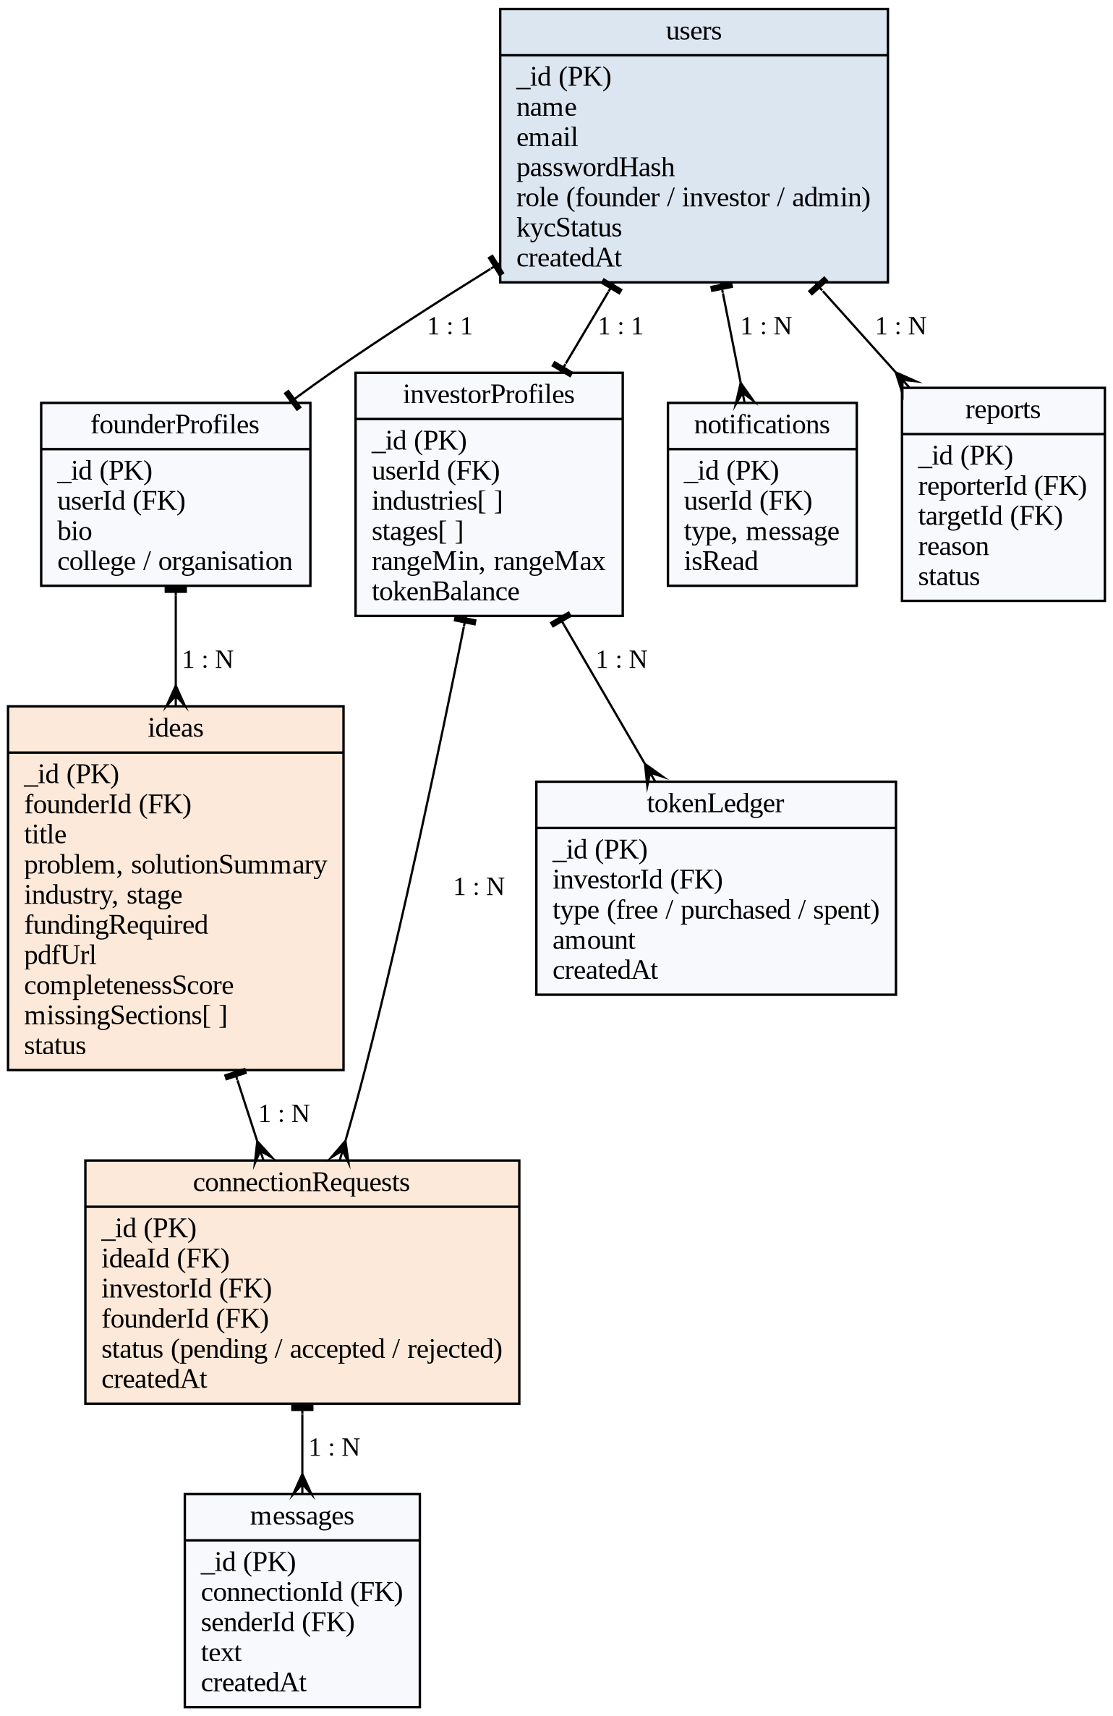
Figure 2.2: Proposed database collections and relationships

2.3 Flowchart / UML Diagram
Figure 2.3 shows the end-to-end workflow of the platform for the two main user types. On the founder side, an idea document goes through the AI completeness check and is either published or returned for revision. On the investor side, a verified investor receives a personalised feed, spends a token to request a connection, and opens a private chat only if the founder accepts. The dashed connection between the two flows indicates that published ideas are the content of the investor feed. The main actors of the system and their use cases are summarised in Table 2.2.
Table 2.2: Actors and use cases
Actor | Main use cases
Founder | Register and manage profile; upload idea PDF; view completeness score and missing sections; revise and resubmit; control public visibility; accept, reject or ignore connection requests; chat with accepted investors.
Investor | Register; complete KYC verification; set investment preferences; browse personalised feed; view limited idea previews; use tokens to send requests; chat after acceptance; report or block users.
Administrator | Review reports; moderate users and ideas; manage token settings and pricing; monitor platform activity through the admin dashboard.
AI service | Parse uploaded idea PDFs; detect missing sections; generate the completeness score.

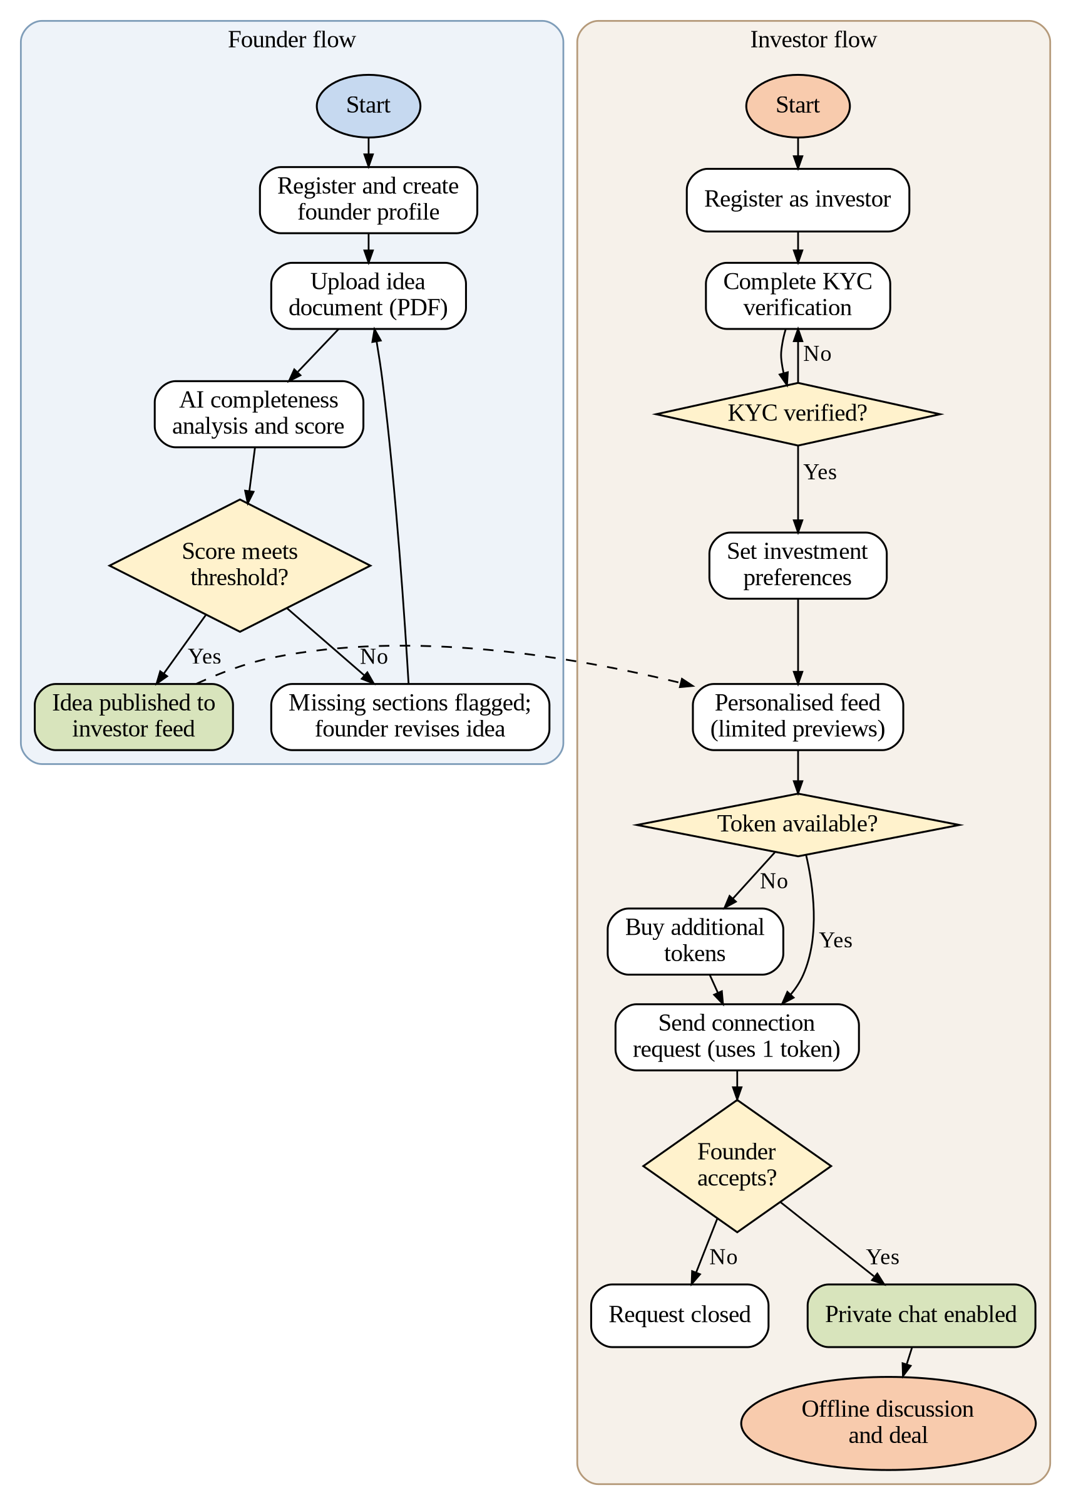
Figure 2.3: Flowchart of the founder and investor workflows

Chapter 3: Implementation

3.1 Tools & Technology Used
The technology stack of Ventora is chosen so that every layer uses a widely adopted and well-documented tool. Table 3.1 summarises the stack, and the sections that follow explain the purpose of each component.
Table 3.1: Technology stack of Ventora
Layer | Technology | Purpose
Frontend | React.js, Tailwind CSS | Responsive UI, swipe-style feed, dashboards, forms, chat interface
Backend | Node.js, Express.js | REST APIs for authentication, users, ideas, feed, tokens, requests, messaging
Database | MongoDB | Profiles, preferences, ideas, AI scores, tokens, requests, messages, notifications
AI layer | Python, FastAPI | PDF parsing, completeness analysis, missing-section detection, scoring
Security | JWT, bcrypt / Argon2, RBAC | Authentication, password hashing, authorisation, input validation
File storage | Cloudinary / AWS S3 | Idea PDFs, pitch decks and profile documents with restricted access
Real-time | Socket.IO | Instant messaging, online status and notifications
KYC | Mock / sandbox workflow | Investor verification without storing raw government ID data

3.1.1 Frontend
React.js (Meta Platforms, n.d.) is used to build a component-based user interface, including the scrollable, swipe-style investor feed, the founder dashboard, forms, profile management and the chat interface. Tailwind CSS (Tailwind Labs, n.d.) provides utility classes for consistent styling and responsive layouts across screen sizes.

3.1.2 Backend
Node.js with Express.js (OpenJS Foundation, n.d.) implements the REST APIs that cover authentication, user management, idea management, feed generation, the token system, connection requests and messaging. Business rules, such as deducting a token when a request is sent, are enforced here and not in the client.

3.1.3 Database
MongoDB (MongoDB, Inc., n.d.) stores user profiles, founder information, investor preferences, startup ideas, AI scores, tokens, connection requests, messages and notifications. Its flexible document model suits idea records whose fields may evolve as the platform grows.

3.1.4 AI Layer
A Python service built with FastAPI (Ramírez, n.d.) parses uploaded idea PDFs, analyses completeness, detects missing sections and calculates the completeness score. Where required, the same function can be provided by an external AI API, because the AI service is kept separate from the main backend.

3.1.5 Authentication and Security
Users are authenticated with JSON Web Tokens (Jones et al., 2015). Passwords are never stored in plain text; they are hashed using bcrypt (Provos & Mazières, 1999) or Argon2 (Biryukov et al., 2016). Role-based access control decides which actions a founder, investor or administrator may perform, and all inputs are validated against common risks listed by the OWASP Foundation (n.d.).

3.1.6 File Storage, Real-Time Communication and KYC
Uploaded PDFs, pitch decks and profile documents are kept in Cloudinary or AWS S3 with permission-based access, so that files are not publicly reachable. Socket.IO (Socket.IO, n.d.) provides real-time messaging, online or offline status and message notifications. For the academic prototype, a mock KYC or sandbox verification workflow is used instead of storing raw government ID information.

3.2 Proposed Methodology
The project follows an iterative, incremental development approach in which the team works on layers in parallel and integrates them at regular intervals. The main phases are described below.
- Research and requirement analysis: studying how founders and investors currently find each other, identifying problems such as idea theft and spam, and converting them into objectives and features.
- Design: preparing wireframes for the screens, designing the database collections and defining the REST API endpoints and the workflow shown in Figure 2.3.
- Development: building the frontend, backend, database layer and AI service in parallel against the agreed API contracts.
- Integration: connecting the layers, so that an uploaded PDF flows from the frontend through the API to storage and the AI service and back to the founder as a score.
- Testing and refinement: verifying each module and the complete workflows, fixing defects and improving usability.
- Documentation: preparing the synopsis, this report and the user-facing explanation of the platform.

3.2.1 AI-Based Idea Completeness Analysis
When a founder uploads an idea document, the AI service extracts the text from the PDF and checks whether the required sections – problem statement, proposed solution, target audience, business model, market opportunity, competitor information, revenue model, funding requirement and growth potential – have been sufficiently described. Each section is given a coverage value between 0 and 1, and the completeness score is calculated as a weighted average of these values, expressed as a percentage:
Completeness Score = ( Σ wᵢ × cᵢ ) / ( Σ wᵢ ) × 100
where cᵢ is the coverage of section i and wᵢ is its weight. If the score meets a configurable threshold, the idea is accepted and published to the investor feed. Otherwise, the missing or weak sections are listed and the founder can revise and resubmit the document. The score measures only the completeness of the submitted information; it is not a guarantee of the startup’s success or profitability.

3.2.2 Personalised Investor Feed
During profile creation, investors state their preferences: industry, startup stage, investment range, location, business model and preferred sectors. Ventora uses these preferences to filter published ideas and to rank them by how closely they match, so that the most relevant ideas appear first. The feed is shown as a scrollable, card-based experience, similar to short-form content feeds, which allows investors to browse many pitches quickly and message the founders they are interested in.

3.2.3 Controlled Idea Disclosure
To reduce the risk of idea theft, founders are not required to disclose the complete business idea in public. The public feed shows only the startup title, the problem being addressed, a high-level solution, the industry, the startup stage, the funding requirement and the AI completeness score. A disclaimer reminds founders not to publish confidential intellectual property or sensitive business information. Detailed documents stay under the founder’s control and are revealed only after mutual interest is established.

3.2.4 Token-Based Communication and Connection Workflow
Every investor receives three free tokens each month, which allows them to start conversations with up to three founders. An investor who wants to contact more founders in the same month can purchase additional tokens. The typical flow is: the investor finds a relevant idea, uses one token to send a connection request, the founder accepts, and communication is unlocked. The founder may also reject or ignore a request. The number of free tokens and the price of additional tokens can be changed by the platform administrator. Because every request costs a token, spam and low-intent outreach become less attractive.

3.2.5 Security and Privacy Measures
- Secure authentication and role-based authorisation for every protected API.
- Password hashing using bcrypt or Argon2.
- KYC or identity verification for investors before they can view the feed.
- Controlled, permission-based access to confidential documents and secure file storage.
- Reporting and blocking mechanisms to handle abusive or fake accounts.
- Input validation and protection against unauthorised access.
- Minimal data storage: sensitive information is not stored or exposed beyond what each feature strictly requires.

3.3 Major Modules
The platform is divided into the modules listed in Table 3.2. Each module has a clear responsibility, which makes parallel development and testing easier.
Table 3.2: Major modules of Ventora
No. | Module | Description
1 | Authentication & User Management | Registration, login, JWT sessions and role-based access
2 | Founder Profile Management | Creation and editing of founder profiles
3 | Investor Profile & KYC | Investor profile and identity verification
4 | Startup Idea Submission | PDF upload, storage and management of ideas
5 | AI Completeness Analysis | PDF parsing, section detection and scoring
6 | Investor Preference Management | Industry, stage, range, location and sector preferences
7 | Personalised Feed & Matching | Filtering and ranking ideas for each investor
8 | Controlled Idea Access | Limited public preview and phased access to details
9 | Token Management | Free monthly tokens, purchases and the token ledger
10 | Connection Requests | Sending, accepting, rejecting and ignoring requests
11 | Real-Time Chat | Messaging between connected users
12 | Notifications | Alerts for requests, acceptances and messages
13 | Reporting & Moderation | Reporting and blocking of users and content
14 | Admin Dashboard | Moderation, settings and monitoring

3.4 Team Structure and Work Distribution
The work was divided among the four team members according to the layers of the system, as shown in Table 3.3. Documentation, testing and review of the project were shared by all members.
Table 3.3: Team members and responsibilities
Member | Role | Responsibilities
Roshan Kumar Jha | Database & Research | Domain research; MongoDB collections, relationships and indexes; team coordination and progress tracking.
Yatharth Saini | AI | AI service for PDF parsing, completeness checking, missing-section detection and scoring.
Yash Kulshreshtha | Backend | REST APIs for authentication, ideas, feed, tokens and requests; real-time messaging service.
Shivam Jha | Frontend | React interface: founder dashboard, investor feed, forms, profile pages and chat screen.

Chapter 4: Results & Discussion

4.1 Objective-wise Outcomes
Table 4.1 relates each objective of the project to the feature of Ventora that addresses it.
Table 4.1: Mapping of objectives to features
Objective | Addressed by
1. Founders submit ideas as PDF | Idea submission module with secure file storage
2. AI completeness check and accept / flag | AI service that produces a completeness score and lists missing sections
3. Personalised investor feeds | Preference management and feed filtering and ranking
4. Investor verification | KYC verification step before access to the feed (mock / sandbox for the prototype)
5. Avoid exposure of sensitive information | Limited public preview and disclaimer for founders
6. Phased access to details | Permission-based access to documents after mutual interest
7. Reduce spam and low-intent outreach | Token system with three free tokens per month
8. Founder approval of connections | Accept, reject or ignore workflow for requests
9. Communication before an offline deal | Real-time private chat unlocked on acceptance

4.2 Testing Approach and Test Cases
Testing is carried out at several levels. Individual API endpoints are tested with Postman; modules are then tested together to check complete workflows, such as uploading an idea and receiving a score; the user interface is checked on different screen sizes and browsers; and access-control tests confirm that users can reach only the data and actions permitted to their role. Table 4.2 lists representative test cases and the behaviour expected from the platform.
Table 4.2: Representative test cases
ID | Test scenario | Expected result
T1 | Register and log in with valid credentials | Account is created; a valid token is issued; user reaches the correct dashboard
T2 | Log in with a wrong password | Access is denied with an error message
T3 | Founder uploads a non-PDF file | Upload is rejected with a validation message
T4 | Founder uploads a complete idea PDF | Completeness score meets the threshold; idea is published to the feed
T5 | Founder uploads an incomplete idea PDF | Score is below the threshold; missing sections are listed for revision
T6 | Unverified investor opens the feed | Access is blocked until verification is completed
T7 | Investor sends a request with tokens available | One token is deducted and the founder is notified
T8 | Investor sends a request with zero tokens | Request is blocked and the option to buy tokens is shown
T9 | Founder accepts a request | Private chat opens and messages are delivered in real time
T10 | User tries to open another user’s confidential document | Access is denied by role-based and permission checks

[Team to add: screenshots of the working screens (landing page, founder dashboard, idea score view, investor feed and chat) and the observed results of the tests above.]

4.3 Discussion
Ventora’s main design decision is to separate discovery from disclosure. Because the public feed carries only a limited preview, investors can browse widely while founders keep control of the sensitive details. The completeness score adds a basic quality gate: investors see ideas that have at least described their problem, solution, market and funding need, and founders receive specific guidance on what to improve before publishing. Keeping the role of AI limited to completeness checking, and not judging the merit of an idea, avoids false confidence in an automated verdict.
The token mechanism turns each connection request into a deliberate action. Compared with unrestricted messaging on social media or e-mail, a limited monthly allowance encourages investors to contact only the founders they are genuinely interested in, while the founder’s approval step protects founders from unwanted contact. Verification of investors and the reporting and blocking features add further protection against fake profiles and abuse.

4.4 Limitations
- The completeness score checks whether sections are described, not whether the idea is original, feasible or profitable.
- The quality of the analysis depends on how well text can be extracted from the uploaded PDF; scanned or image-only documents may be analysed poorly.
- KYC in the academic prototype is a mock or sandbox workflow and is not a substitute for regulated identity verification.
- The platform does not handle payments or investment transactions, and the purchase of additional tokens is limited to the prototype’s scope.
- The prototype is designed for a limited number of users; large-scale deployment would need further performance, security and legal review.

Chapter 5: Conclusion & Future Work

5.1 Conclusion
Ventora aims to create a structured and secure environment in which founders can present startup opportunities and investors can discover ideas aligned with their interests. By combining AI-powered idea completeness analysis, personalised investor feeds, controlled information disclosure, investor verification, token-based communication and permission-based connections, the platform provides a focused solution for early-stage startup discovery.
Ventora acts as a connection and insight platform and not as a financial transaction platform. Actual investment negotiations and financial transactions are intended to take place outside the platform, between the concerned parties. The project also gave the team practical experience in full-stack development, database design, AI integration, security practices and teamwork.

5.2 Future Work
The platform can be extended in several directions:
- Advanced AI-based startup analysis: deeper analysis of ideas beyond completeness.
- AI-generated investor recommendations: smarter suggestions based on investor behaviour and interests.
- Mentor matching: connecting founders with suitable mentors.
- Startup valuation assistance: supportive tools to help founders understand valuation.
- Verified investor networks: trusted groups of verified investors.
- Automated pitch-deck analysis: extending the analysis from PDF documents to pitch decks.
- Advanced fraud detection: detecting suspicious accounts and behaviour.
- Legal and document verification: checking supporting documents.
- Integration with authorised investment platforms: a regulated route for completing investments.
- Analytics for investors and founders: insights on views, interest and engagement.

Code and Data availability statement
Code and dataset (if any) can be found here: [GitHub link to be added].

References
Biryukov, A., Dinu, D., & Khovratovich, D. (2016). Argon2: New generation of memory-hard functions for password hashing and other applications. In 2016 IEEE European Symposium on Security and Privacy (EuroS&P) (pp. 292–302). IEEE. https://doi.org/10.1109/EuroSP.2016.31
Fielding, R. T. (2000). Architectural styles and the design of network-based software architectures [Doctoral dissertation, University of California, Irvine].
Jones, M., Bradley, J., & Sakimura, N. (2015). JSON Web Token (JWT) (RFC 7519). Internet Engineering Task Force. https://doi.org/10.17487/RFC7519
Meta Platforms, Inc. (n.d.). React documentation. https://react.dev
MongoDB, Inc. (n.d.). MongoDB documentation. https://www.mongodb.com/docs/
OpenJS Foundation. (n.d.). Express – Node.js web application framework. https://expressjs.com
OWASP Foundation. (n.d.). OWASP Top Ten. https://owasp.org/www-project-top-ten/
Provos, N., & Mazières, D. (1999). A future-adaptable password scheme. In Proceedings of the 1999 USENIX Annual Technical Conference, FREENIX Track (pp. 81–91). USENIX Association.
Ramírez, S. (n.d.). FastAPI. https://fastapi.tiangolo.com
Socket.IO. (n.d.). Socket.IO documentation. https://socket.io/docs/
Tailwind Labs. (n.d.). Tailwind CSS documentation. https://tailwindcss.com/docs

