# ASG 01

**Name:** Yatharth Thakare

**Roll No:** 51

**PRN:** 12111403

**Subject:** OS

**Execution of basic LINUX commands**

1. General Purpose Commands
   1. date: To display current date & time of the system.

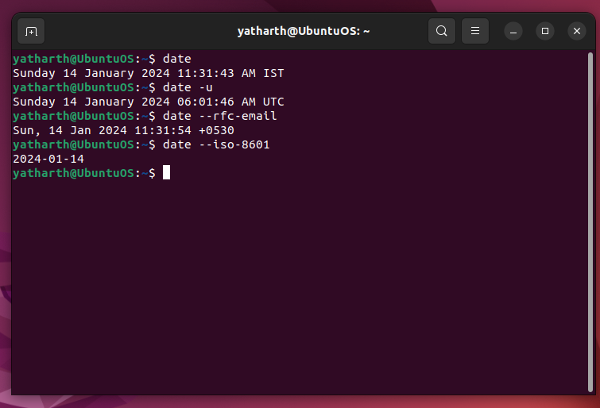-I[FMT], --iso-8601[=FMT]

output date/time in ISO 8601 format. FMT='date' for date only (the default), 'hours', 'minutes', 'seconds', or 'ns' for date and time to the indicated precision. ]

Example:

2006-08-14T02:34:56-06:00

-R, --rfc-email

output date and time in RFC 5322 format. Example: Mon, 14 Aug

2006 02:34:56 -0600

--rfc-3339=FMT

output date/time in RFC 3339 format. FMT='date', 'seconds', or

'ns' for date and time to the indicated precision. Example:

2006-08-14 02:34:56-06:00

-u, --utc, --universal

print or set Coordinated Universal Time (UTC)

* 1. cal :To display the calendar of the current month.

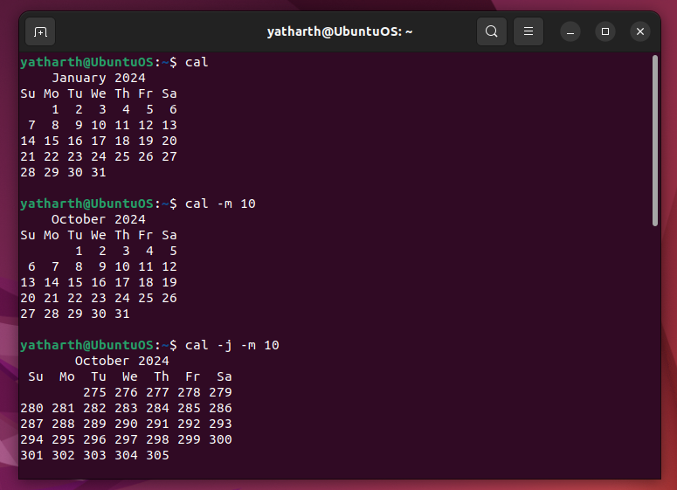

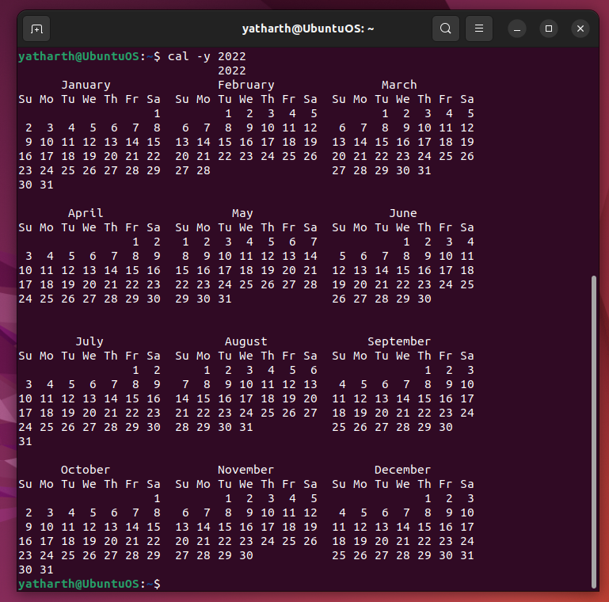

The options are as follows:

-m month

Display the specified month. If month is specified as a decimal

number, appending ‘f’ or ‘p’ displays the same month of the fol‐

lowing or previous year respectively.

-j Display Julian Calendar

-y Display a calendar for the specified year. This option is implied

when a year but no month are specified on the command line.

* 1. who:List who is currently logged on to the system.

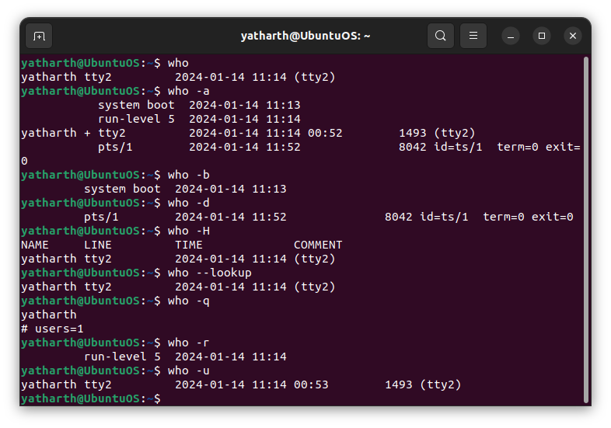

Print information about users who are currently logged in.

-a, --all

same as -b -d --login -p -r -t -T -u

-b, --boot

time of last system boot

-d, --dead

print dead processes

-H, --heading

print line of column headings

--lookup

attempt to canonicalize hostnames via DNS

-q, --count

all login names and number of users logged on

-r, --runlevel

print current runlevel

-u, --users

list users logged in

* 1. Whoami:Report what user you are logged on as.

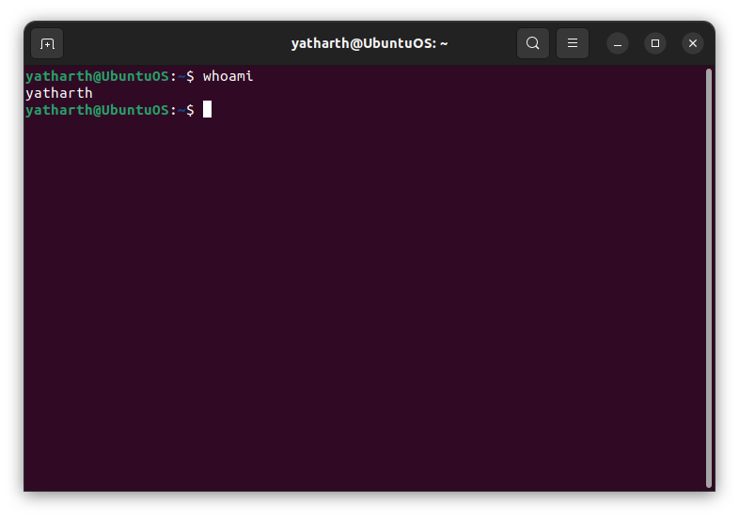 No options

* 1. echo :Echo a string (or list of arguments) to the terminal

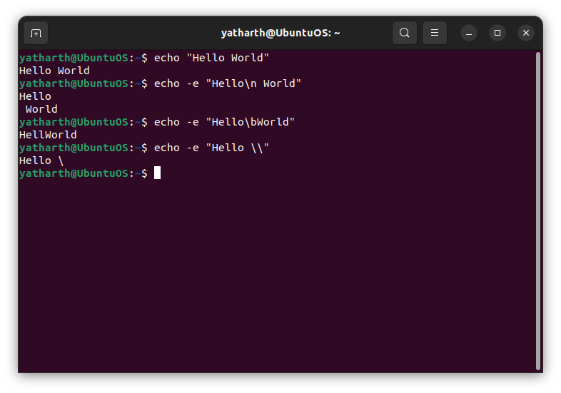

Echo the STRING(s) to standard output.

-n do not output the trailing newline

-e enable interpretation of backslash escapes

-E disable interpretation of backslash escapes (default)

If -e is in effect, the following sequences are recognized:

\\ backslash

\b backspace

\n new line

* 1. bc:To perform mathematical operations

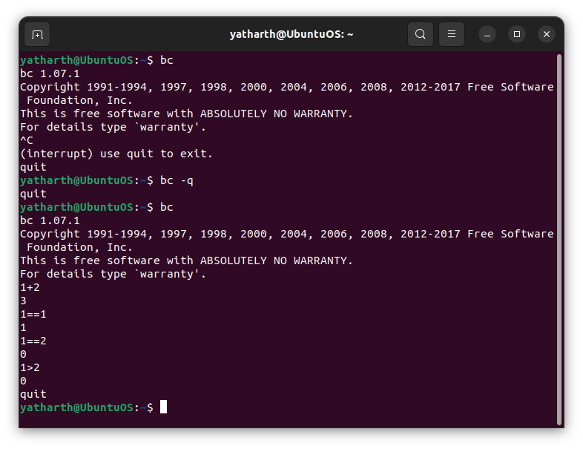

OPTIONS

-h, --help

Print the usage and exit.

-i, --interactive

Force interactive mode.

-l, --mathlib

Define the standard math library.

-w, --warn

Give warnings for extensions to POSIX bc.

-s, --standard

Process exactly the POSIX bc language.

-q, --quiet

Do not print the normal GNU bc welcome.

-v, --version

Print the version number and copyright and quit.

* 1. clear:To clear the screen
  2. alias : Used to tailor commands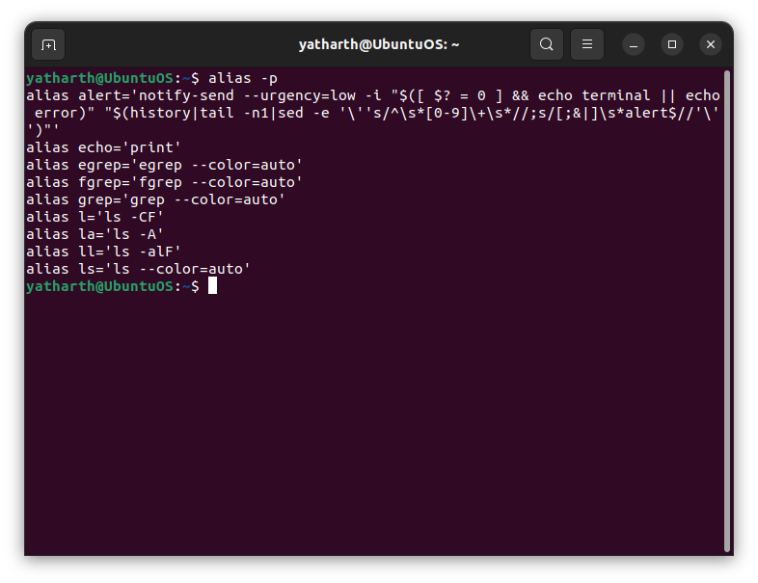
  3. man <cmd name>: To get help for any command

man ls

Display the manual page for the item (program) ls.

man man.7

Display the manual page for macro package man from section 7.

(This is an alternative spelling of "man 7 man".)

man 'man(7)'

Display the manual page for macro package man from section 7.

(This is another alternative spelling of "man 7 man". It may be

more convenient when copying and pasting cross-references to manual

pages. Note that the parentheses must normally be quoted to pro‐

tect them from the shell.)

man -a intro

Display, in succession, all of the available intro manual pages

contained within the manual. It is possible to quit between suc‐

cessive displays or skip any of them.

man -k printf

Search the short descriptions and manual page names for the keyword

printf as regular expression. Print out any matches. Equivalent

to apropos printf.

man -f smail

Lookup the manual pages referenced by smail and print out the short

descriptions of any found. Equivalent to whatis smail.

* 1. passwd: To change the password

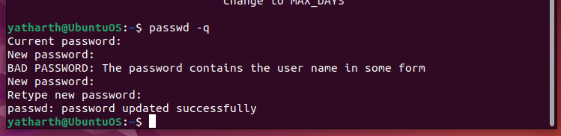

* 1. exit: To logout from the terminal

1. File and Directory Related Commands
2. cp <fromfile> <tofile>: Copy from the <fromfile> to the <tofile>

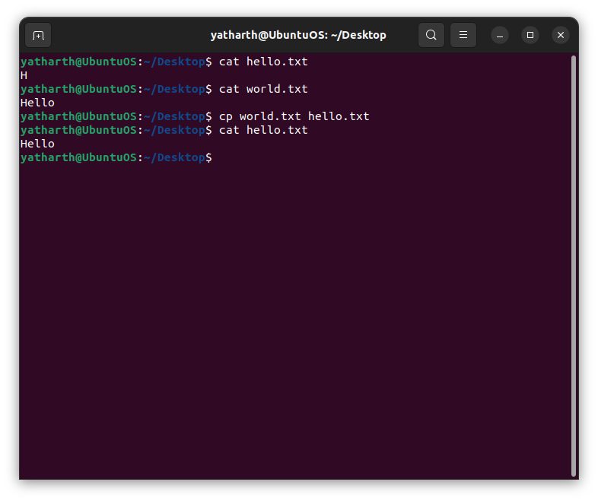

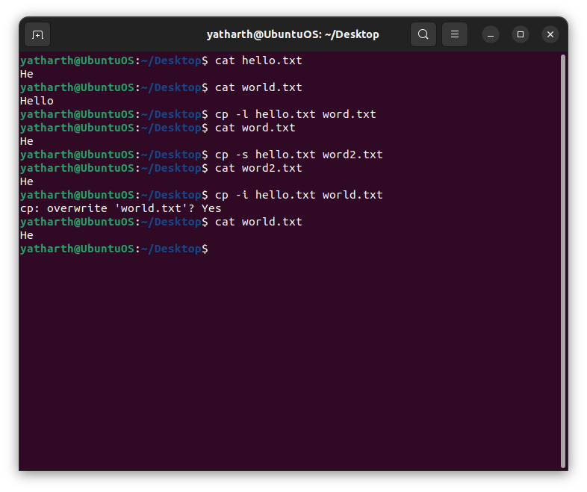



-l, --link

hard link files instead of copying

-i, --interactive

prompt before overwrite (overrides a previous -n option)

-s, --symbolic-link

make symbolic links instead of copying

1. mv <fromfile> <tofile> : Move/rename the <fromfile> to the <tofile>

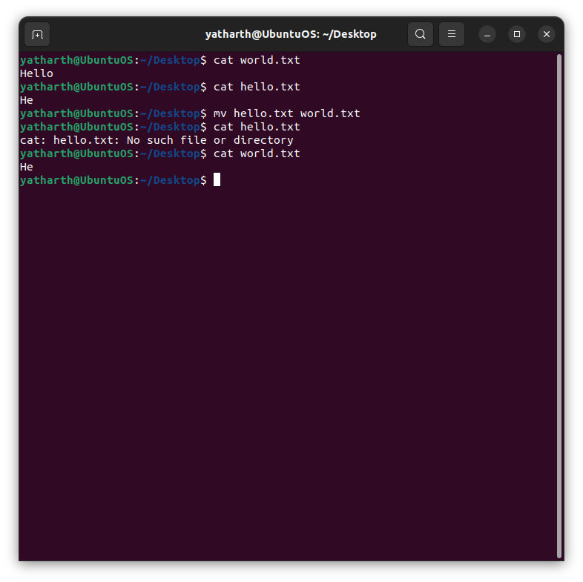

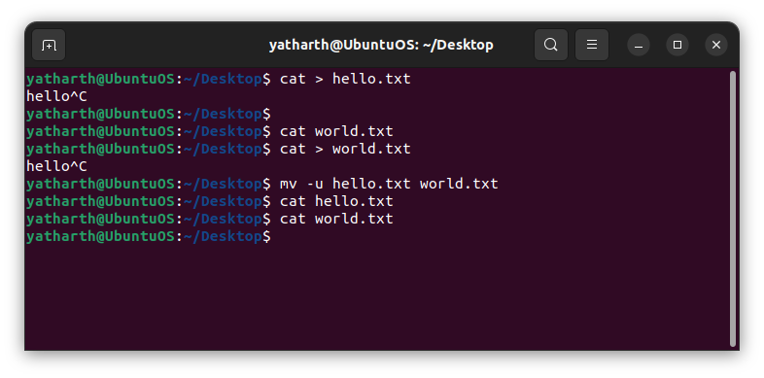

-i, --interactive

prompt before overwrite

-u, --update

move only when the SOURCE file is newer than the destination

file or when the destination file is missing

1. rm <file>:Remove the file named <file>

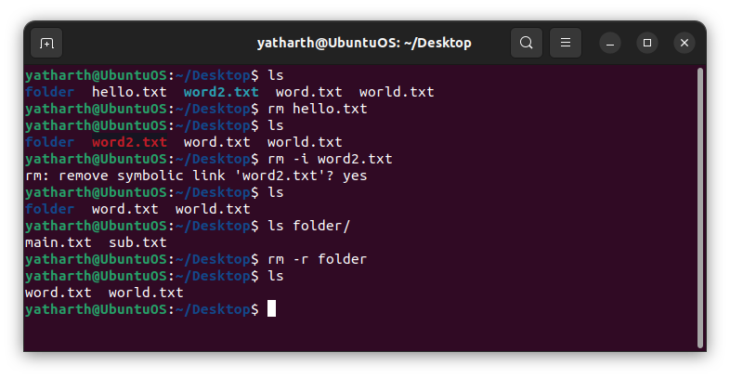

-i prompt before every removal

-r, -R, --recursive

remove directories and their contents recursively

-d, --dir

remove empty directories

1. mkdir <newdir>:Make a new directory called <newdir>

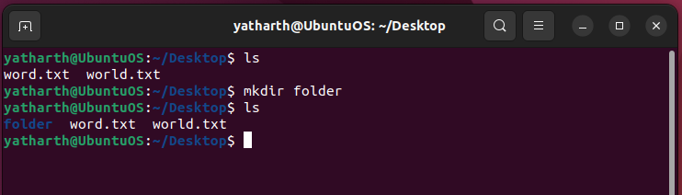

1. rmdir <dir>:Remove an (empty) directory

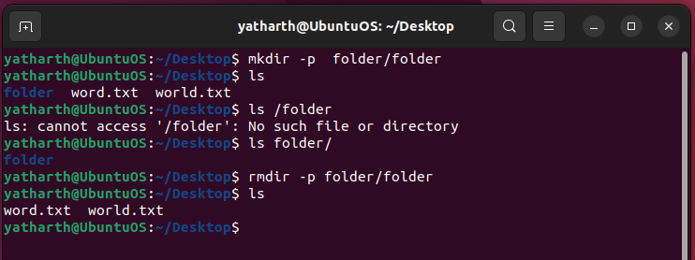

1. cd <dir> :Change the current working directory to dir

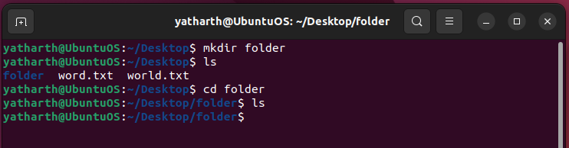

1. pwd : Print (display) the working directory

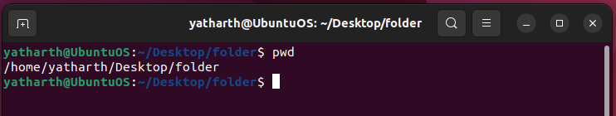

1. cat > <file> :To create new file n save it by pressing ^d

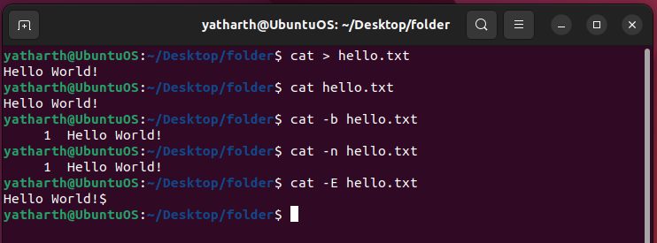

1. more <file>:Paging out the contents of file

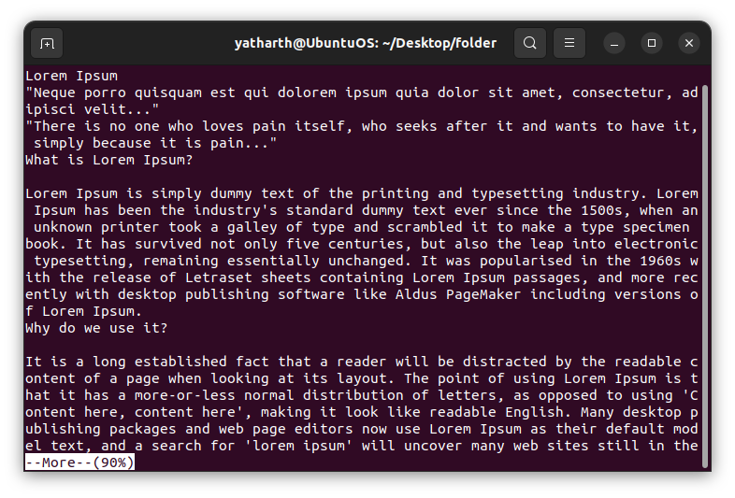

1. file <file>:To check the type of file

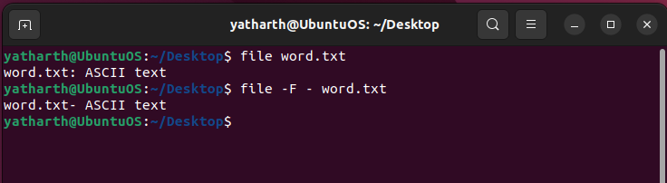

1. wc <file>:To count lines,words,characters of file

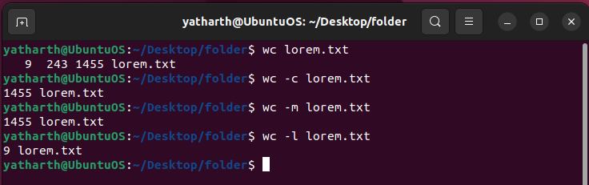

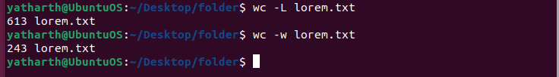

1. cmp <file1> <file2>:To compare two files

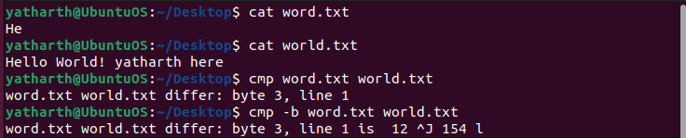

1. comm <file1> <file2>:To display common values between two files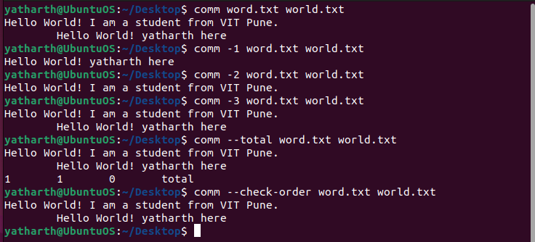
2. diff <file1> <file2>:To convert one file to another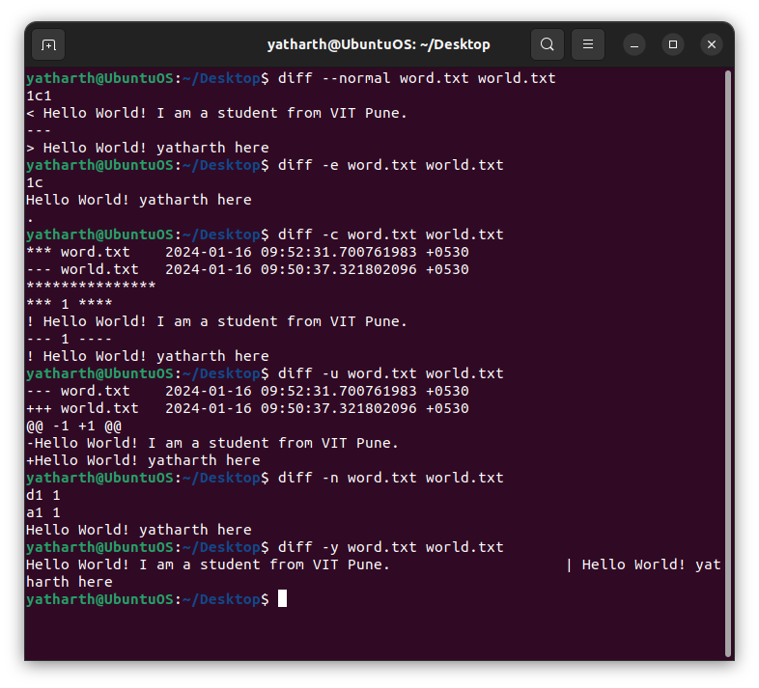
3. gzip <file>:To compress the file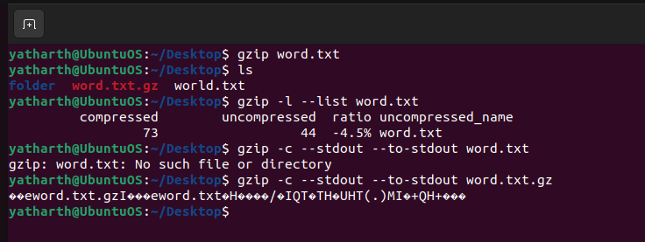
4. gunzip <file>:To unzip the contents of zipped file

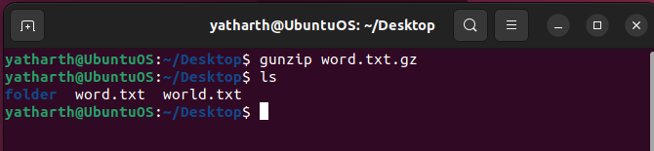

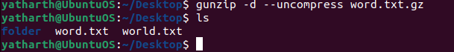

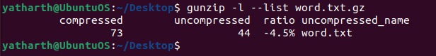

1. ls :List the files in the current working directory

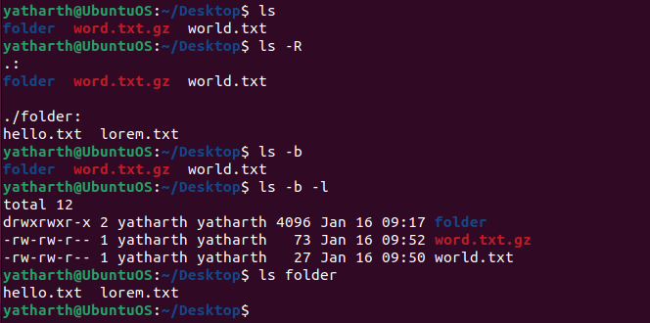

1. ln <fromfile><tofile>: Creates a symbolic link to a file

