ASG 02

**Advance Linux Commands.**

**Problems to be solved in the lab:**

1. Change your password to a password you would like to use for the remainder of the

Semester.

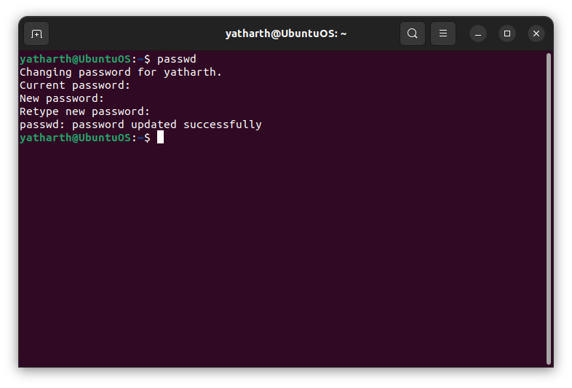

2. Display the system’s date.

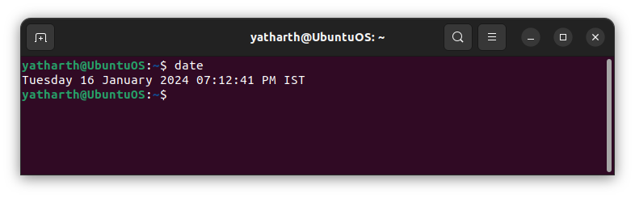

3. Count the number of lines in the /etc/passwd file.

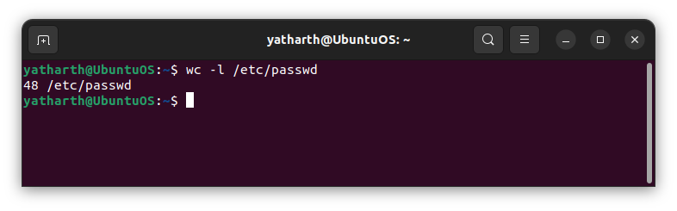

4. Find out who else is on the system.

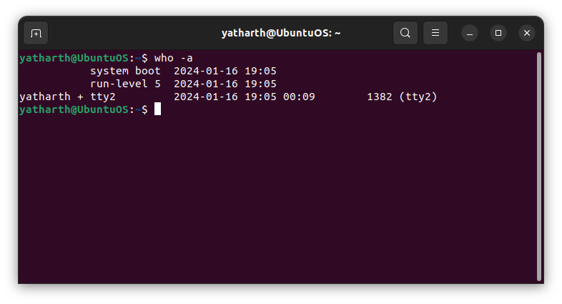

5. Direct the output of the man pages for the date command to a file named mydate.

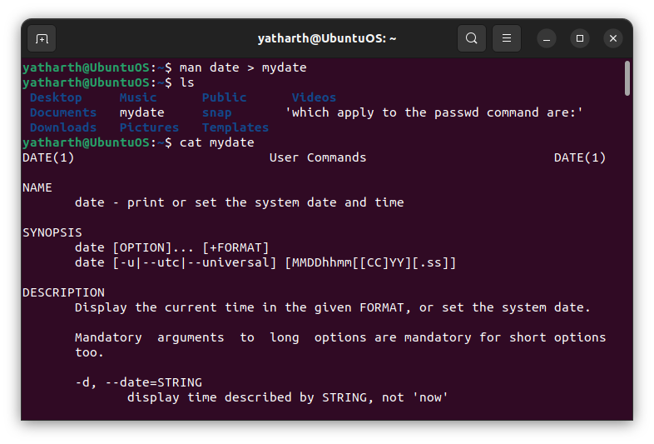

6. Create a subdirectory called mydir.

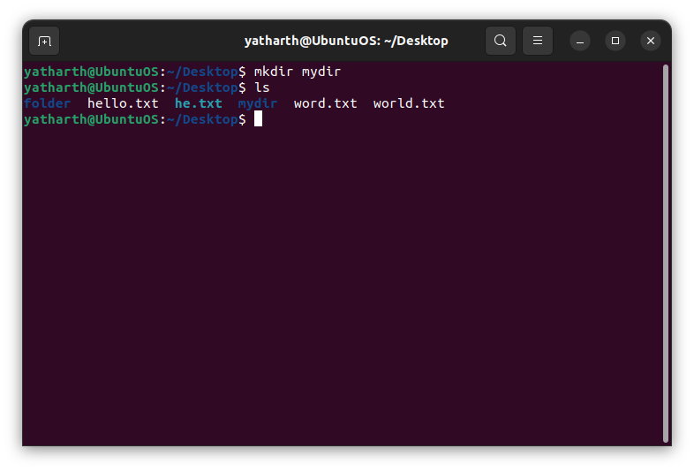

7. Move the file mydate into the new subdirectory.

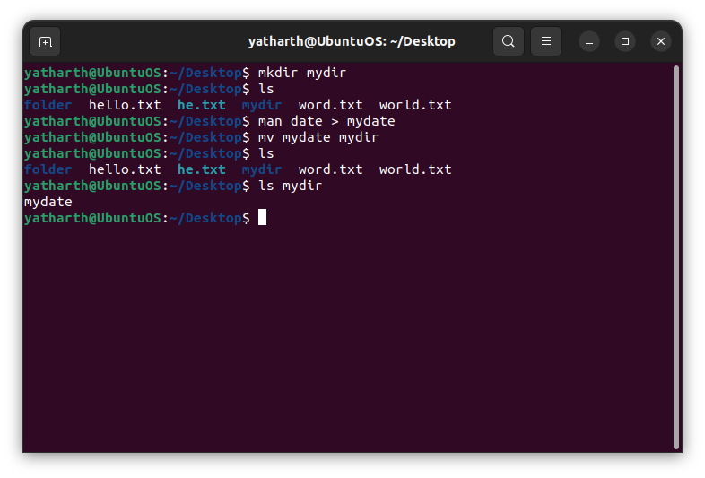

8. Go to the subdirectory mydir and copy the file mydate to a new file called ourdate

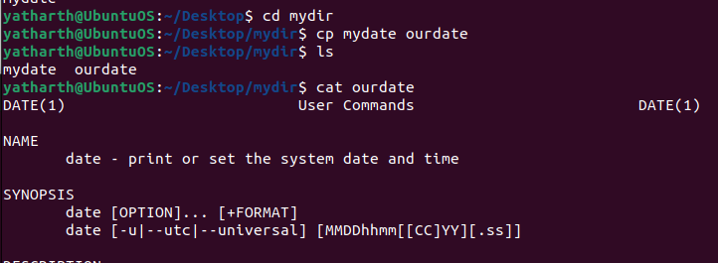

9. List the contents of mydir.

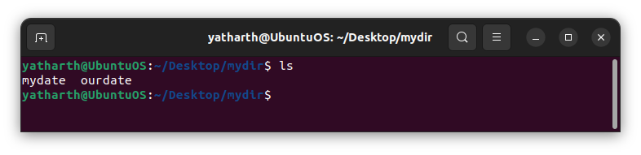

10. Do a long listing on the file ourdate and note the permissions.

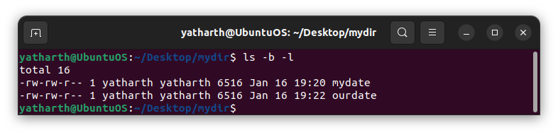

11. Display the name of the current directory starting from the root.

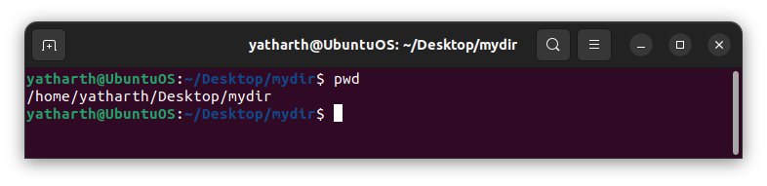

12. Move the files in the directory mydir back to the HOME directory.

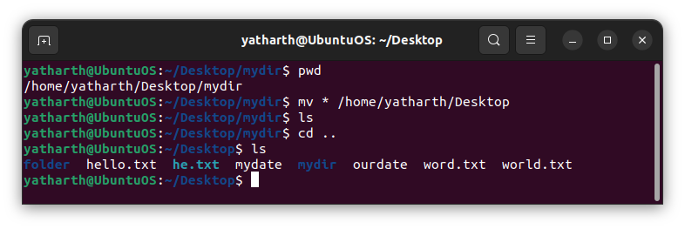

13. List all the files in your HOME directory.

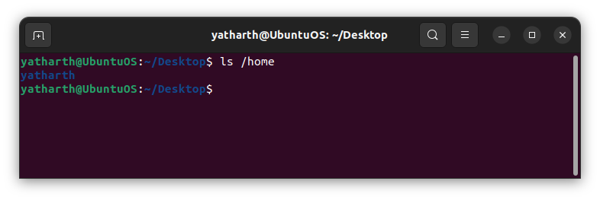

14. Display the first 5 lines of mydate.

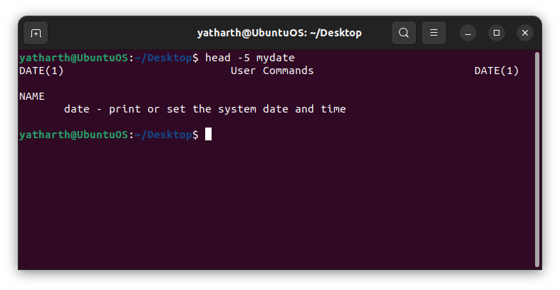

15. Display the last 8 lines of mydate.

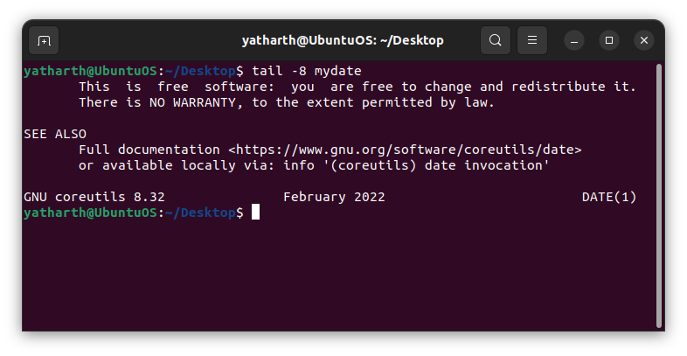

16. Remove the directory mydir.

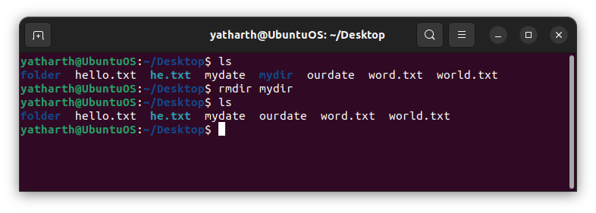

17. Redirect the output of the long listing of files to a file list.

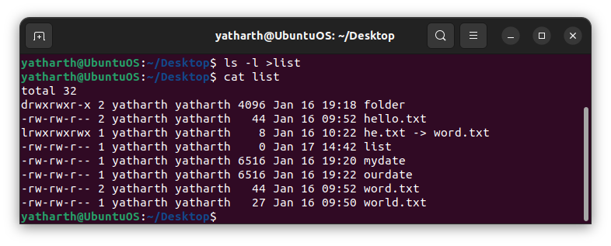

18. Select any 5 capitals of states in India and enter them in a file named capitals1. Choose 5 more capitals and enter them in a file named capitals2. Choose 5 more capitals and enter them in a file named capitals3. Concatenate all 3 files and redirect the output to a file named capitals.

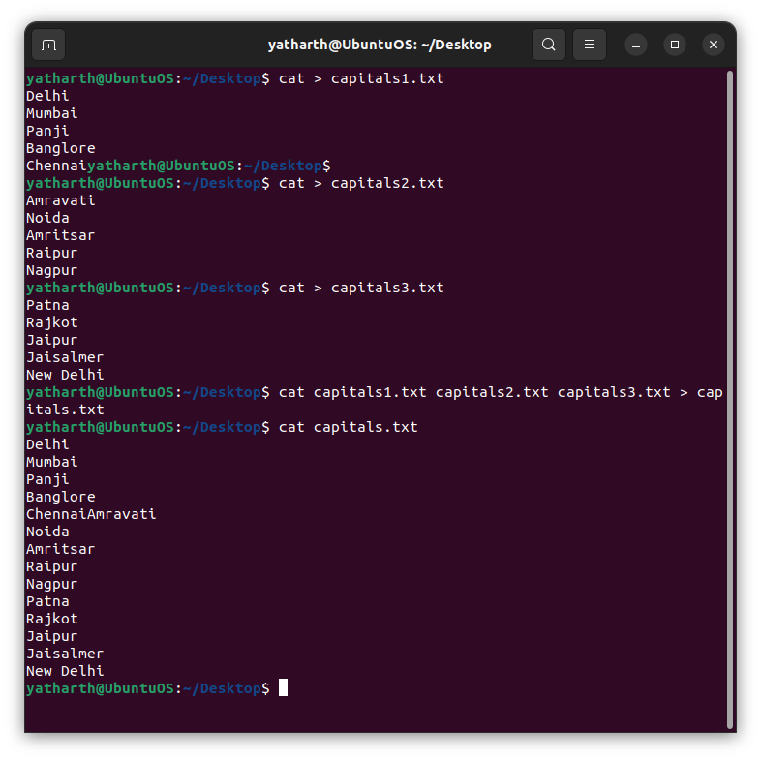

19. Concatenate the file capitals2 at the end of file capitals.

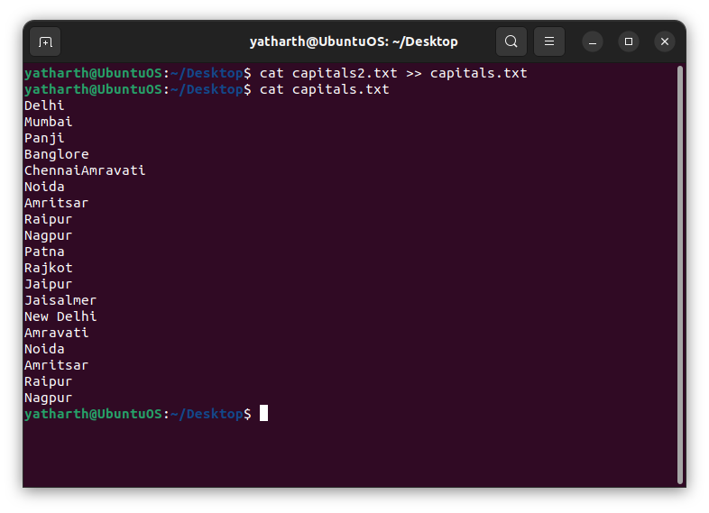

20. Redirect the file capitals as an input to the command “wc –l”.

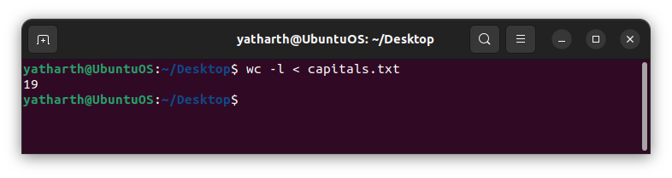

21. Give read and write permissions to all users for the file capitals.

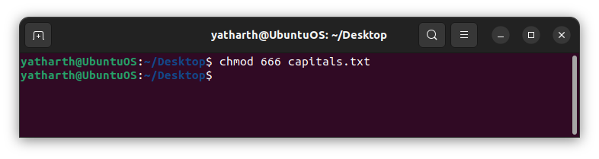

22. Give read permissions only to the owner of the file capitals. Open the file, make some

changes and try to save it. What happens ?

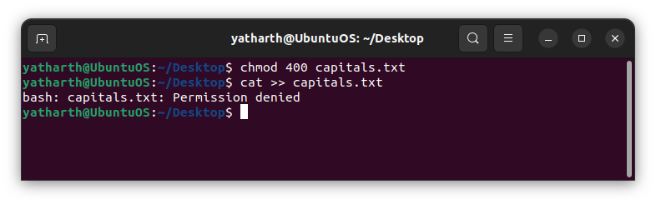

23. Create an alias to concatenate the 3 files capitals1, capitals2, capitals3 and redirect the

output to a file named capitals. Activate the alias and make it run.

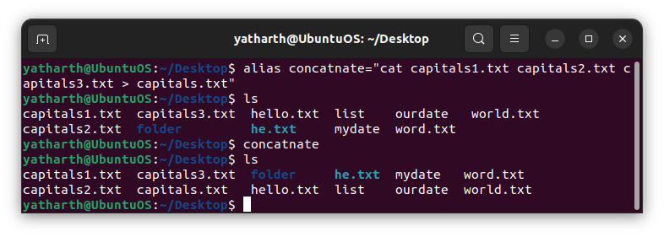

24. What are the environment variables PATH, HOME and TERM set to on your terminal ?

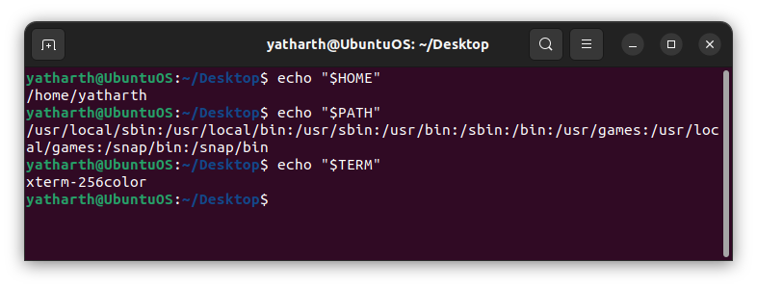

25. Find out the number of times the string “the” appears in the file mydate.

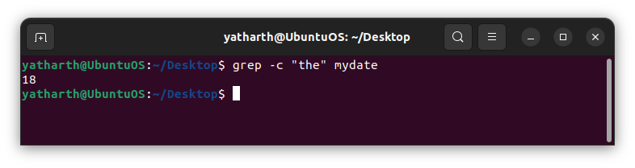

26. Find out the line numbers on which the string “date” exists in mydate.

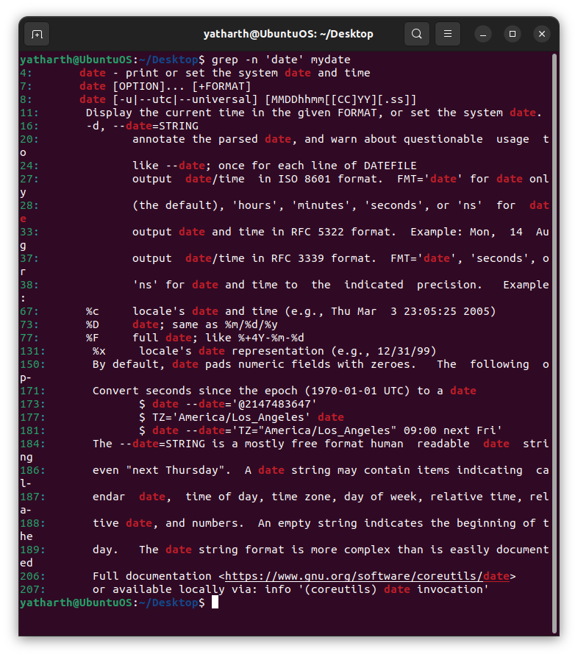

27. Print all lines of mydate except those that have the letter “i” in them.

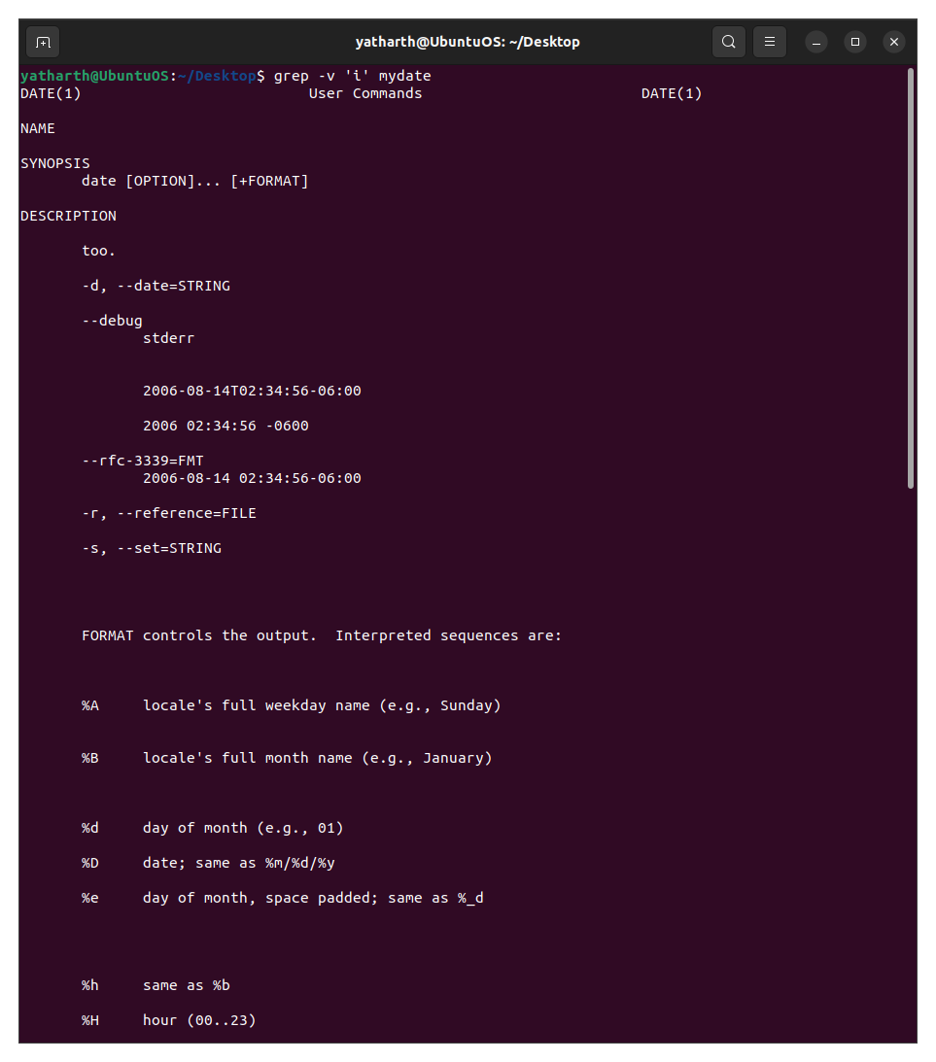

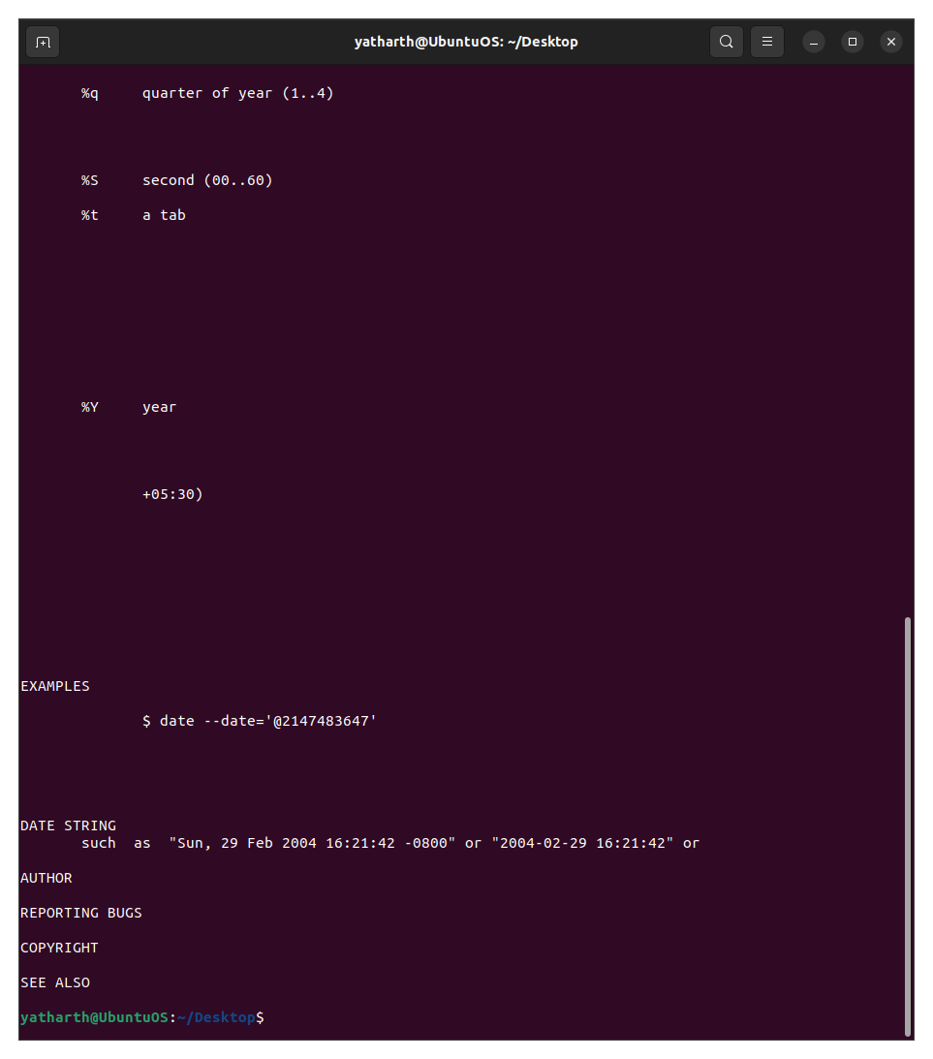

28. Create the file monotonic as follows:

^a?b?b?c? .................x?y?z$

Run the egrep command for monotonic against /usr/dict/words and search for all 4 letter

Words.

29. List 5 states in north east India in a file mystates. List their corresponding capitals in a file

mycapitals. Use the paste command to join the 2 files.

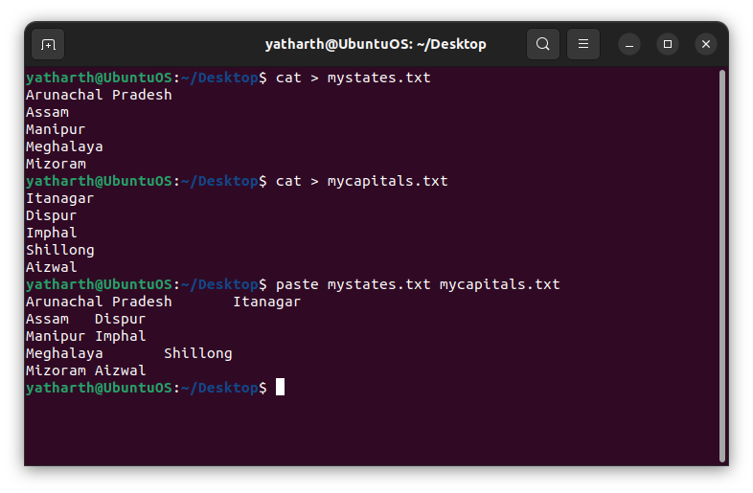

30. Use the cut command to print the 1st and 3rd columns of the /etc/passwd file for all

students in this class.

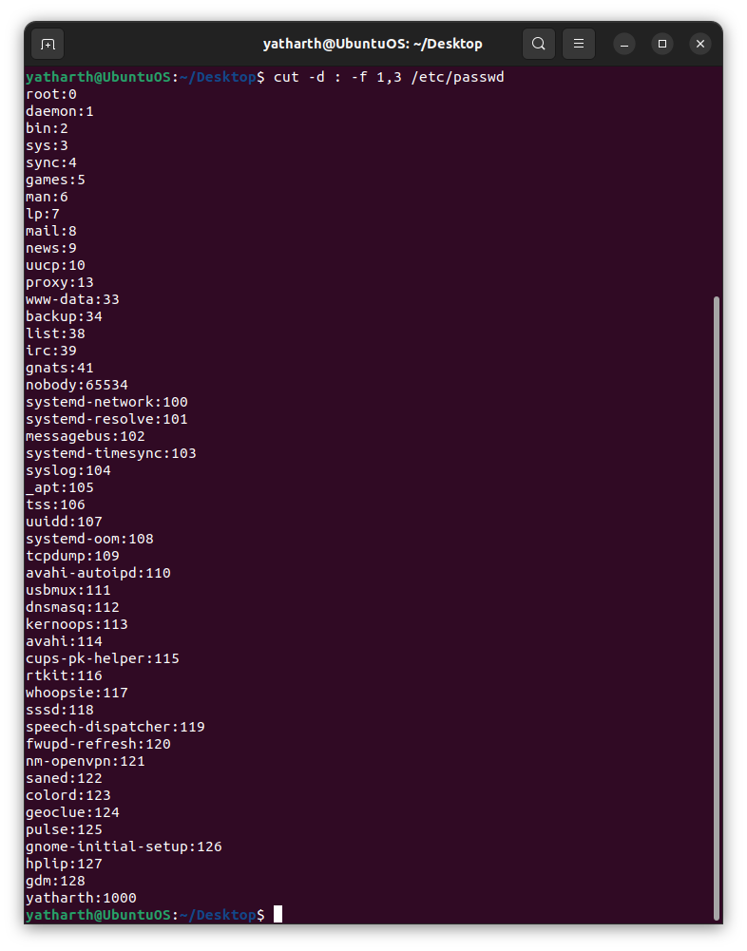

31. Count the number of people logged in and also trap the users in a file using the tee

Command.

