TASK 1

By: Yatharth Thakare  
[thakareyatharth31@gmail.com](mailto:thakareyatharth31@gmail.com)

+91-9921143147

Linked-In: <https://www.linkedin.com/in/yatharththakare/>

GitHub: <https://github.com/Yatharth31/Zeotap-Data-Science-Assignment/>

Business Insights

1. The dataset contains a diverse set of customers distributed across regions, with **'South America' and 'Asia' showing the highest customer concentration**, as illustrated in the bar plot below. These regions contribute significantly to the overall customer base and are **likely key drivers for revenue**. Businesses operating in these regions can focus on region-specific marketing strategies to further tap into their potential.

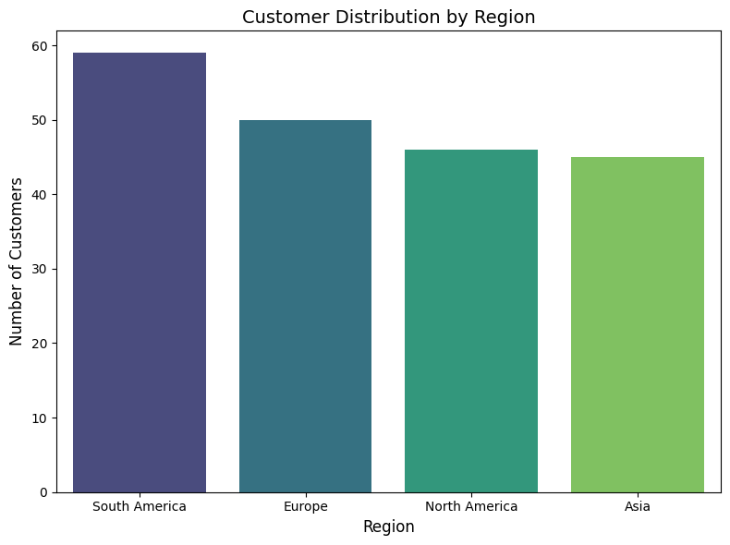

1. The analysis of product data reveals a **bimodal distribution in product prices**, indicating the presence of two distinct pricing clusters one for lower-priced and another for higher-priced products. This suggests a **market segmentation** where customers are drawn to either budget-friendly or premium products. Additionally, the quantile plot below provides a detailed view of the price distribution across different product categories, highlighting **variations in pricing strategies and consumer preferences**. Understanding these trends can help optimize pricing models, tailor marketing strategies, and identify **opportunities for introducing mid-range products** to bridge the gap between the two pricing clusters.

1. Analysis reveals strong **seasonality in sales**, with certain months experiencing peak demand. This suggests consumer purchasing behavior is **influenced by** factors like **holidays and seasonal sales**. Businesses can capitalize on this by strategically aligning inventory, marketing, and promotions. Furthermore, identifying the best-selling products through sales analysis enables targeted strategies to maximize their impact on revenue and customer retention.

1. The Sales Distribution by Region and Product Category analysis highlights **the most in-demand product categories across different regions**, providing valuable insights into consumer preferences. Regions where specific product categories perform exceptionally well indicate strong market demand, making them ideal for targeted marketing and inventory expansion. Conversely, **low-performing product categories present opportunities for growth** through improved promotional strategies, localized marketing, and possible product repositioning.

1. The bar chart below reveals significant regional disparities in average transaction values. **Europe and South America consistently demonstrate higher spending across most product categories, particularly for Clothing and Electronics**. In contrast, **North America exhibits lower spending, notably in Home Decor**. **Asia presents highest spending in clothing**. This analysis highlights the importance of regional market segmentation and tailored strategies to capitalize on varying consumer behavior and spending habits.

