
DATA SCIENCE PART II REPORT

Subject: Data Science
Subject Code: COMP5122M
Module Teacher: Duygu Sarikaya
Assignment Type: Coursework II



GROUP NAME: Zigzagoon

Group Members:
Gaurav Dubey (mznq0903)
Tusshar Kashyap (nccm0794)
Shreya Singh (trbd0672)
Yatharth Bali (pmdz0960)

A) Predictive Modelling
The aim of this section was to develop a supervised machine learning model to predict whether survey respondents support strengthening climate commitments.
Target: Should your country strengthen or weaken its commitments to address climate change?
Responses were mapped as:
Response | Target
Strengthen | 1
Weaken / Keep same / Don’t know | 0

Data Preparation & Feature Engineering
Demographic and attitudinal factors were selected as predictors:
Feature | Type | Description | Data Type
Age | Demographic | Age group category | Categorical
Education | Demographic | Education level | Categorical
Country | Demographic | National location | Categorical
Weighted Mean | Attitude | Mean calculated from survey | Numerical
Category | Attitude | Tells about people’s opinion | Categorical

- From the above charts we can see that the columns have both categorical and numerical data types, so we use one-hot encoding to convert categorical to numerical. Later we used the StandardScaler technique so that all values lie on the same plane and there are no more outliers.
- The dataset was split using an 80-20 stratified train-test split, which means 80% of the dataset is used to train the dataset and the rest, 20%, for testing.

Model Development
Four supervised learning models were trained and evaluated:
- Logistic Regression
- Decision Tree
- Random Forest
- XGBoost

Evaluation Results
Model | Accuracy | F1-Score
Logistic Regression | 0.77 | 0.66
Random Forest | 0.713 | 0.53
Decision Tree | 0.717 | 0.532
XGBoost | 0.744 | 0.625
After performing modelling, we have seen that there is no good accuracy, and we are not clear about underfitting and overfitting. So, let us check for train and test sample accuracy. Train accuracy = 0.86, and test accuracy was 0.88, which states that the model is a best fit, so let’s proceed with hyperparameter tuning (we did GridSearchCV and RandomizedSearchCV), focusing on F1 score for positive support due to class imbalance.
Model | Accuracy | F1-Score | Remarks
Logistic Regression | 0.88 | 0.76 | Strong Improvement
Decision Tree | 0.76 | 0.67 | Reasonable but weaker
Random Forest | 0.76 | 0.67 | Interpretable, less stable
XGBoost | 0.90 | 0.77 | Best overall performance

- XGBoost outperformed all other models, demonstrating strong generalization and balanced classification ability.

Feature Importance & Interpretation
Both XGBoost feature importance and logistic regression coefficients were consistently ranked:
- Weighted Mean (most influential)
- Education group indicators
- Age groups
- Country
- Category (minor influence)
This demonstrates that attitude-based variables are stronger predictors of climate support than demographic factors.
People expressing stronger pro-climate sentiment were significantly more likely to support Strengthening commitments.
Demographics (age, education, nationality) contribute, but to a smaller degree.

Insights from Predictive Modelling
The modelling results show that the respondents' attitude strength, not their demographic features, is what drives support for climate action. XGBoost was chosen as the final model since it had the best prediction accuracy (around 90%). Policies that want to get more people to care about climate change should focus on changing people's attitudes about climate change through education campaigns, awareness programs, and communication tactics.

B) Clustering Analysis
To construct a typology of countries based on aggregated climate attitudes using an unsupervised learning METHOD.

Method
Variable | Meaning
Average Weighted Mean: | Climate attitude intensity
Support Rate | % of respondents voting “Strengthen

- These aggregated features were standardized and clustered using K-means (k=3).

Results
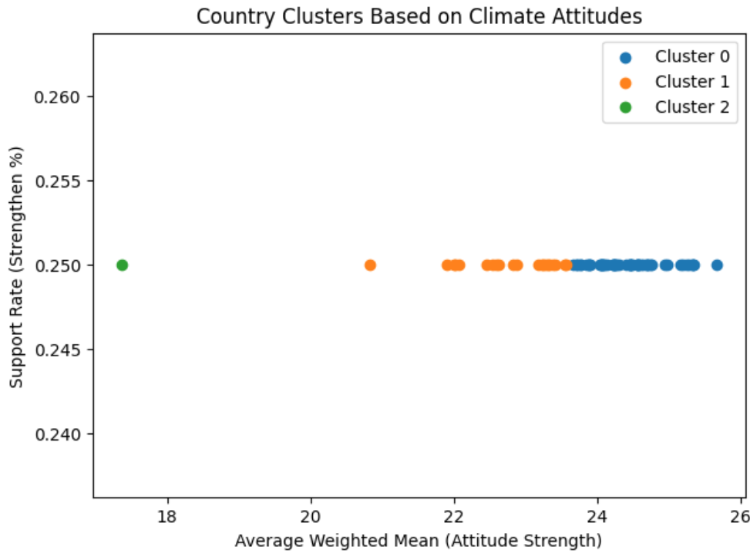
Cluster | Attitude Characteristics | Interpretation
Cluster 0 – Majority Group | High average sentiment | Most countries fall here, consistent global support
Cluster 1 – Moderate Group | Slightly lower weighted mean | Neutral/medium climate attitude intensity
Cluster 2 – Low-Attitude Outlier | Significantly lower average values | Weakest climate sentiment

PCA
The PCA visualizations confirm distinct separation for low-attitude nations, while most countries group closely, indicating a globally similar baseline of climate support. | 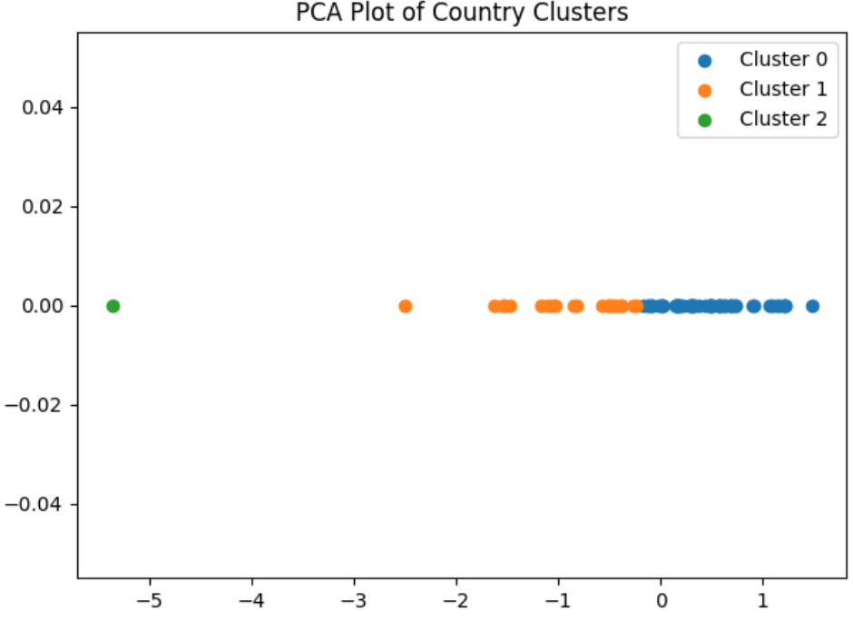

Insights from Clustering
A significant country typology was established, revealing a predominant worldwide support cluster accompanied by a limited number of weaker-attitude outliers. The analysis indicates that while regional differences were not prominently evident, there exists a nuanced cross-country variance in climate sentiment, corroborating the conclusion that global climate support is predominantly positive.

C) Conclusions
- Attitudes are more important than demography. In all models, the strongest factor that affected climate support was the weighted mean.
- The best prediction model is XGBoost, which has about 90% accuracy and a high F1-score
- Country clustering revealed three significant categories, with most nations exhibiting comparable levels of support. The evidence indicates that climate commitment support is prevalent, with only a small fraction of countries constituting a low-support category.

REFERENCING
- Çolak, M., Dogan, R., & Dogan, S. (2025). Effect of Climate Change and Health Course on Global Warming Knowledge and Attitudes, Environmental Literacy, and Eco‐Anxiety Level of Nursing Students: A Quasi‐Experimental Study. Public Health Nursing, 42(3), 1315–1324. https://doi.org/10.1111/phn.13536
- Schwartz, S. E. O., Benoit, L., Clayton, S., Parnes, M. F., Swenson, L., & Lowe, S. R. (2022). Climate change anxiety and mental health: Environmental activism as a buffer. Current Psychology, 42(20), 16708–16721. https://doi.org/10.1007/s12144-022-02735-6

