Smt. Chandaben Mohanbhai Patel Institute of Computer Applications
CHARUSAT, Changa
University Elective (UG) Semester-3
CA 224 - Introduction to Web Designing
Final Practical Exam
SET-1
Date: 25th September, 2021 Time: 09:30 a.m. to 12:30 a.m. Maximum Marks: 70

Q.1 | MCQ |  | [20]
Q.2 |  | Design and develop the web pages for following image.  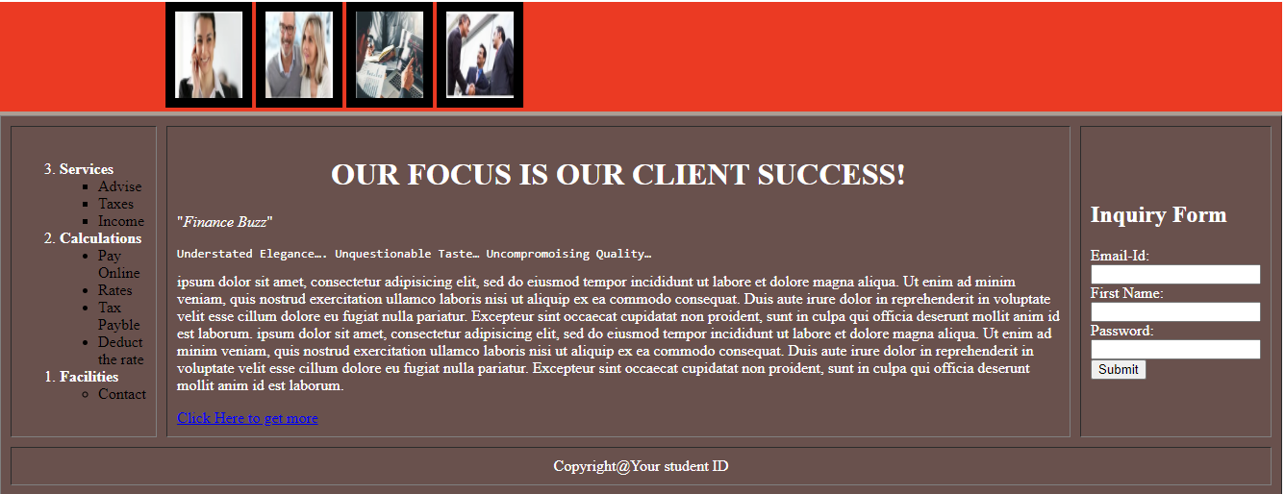  When user click on “Click here to get more” link then it move on next page which display question-3 table. | [30]
Q.2 |  | 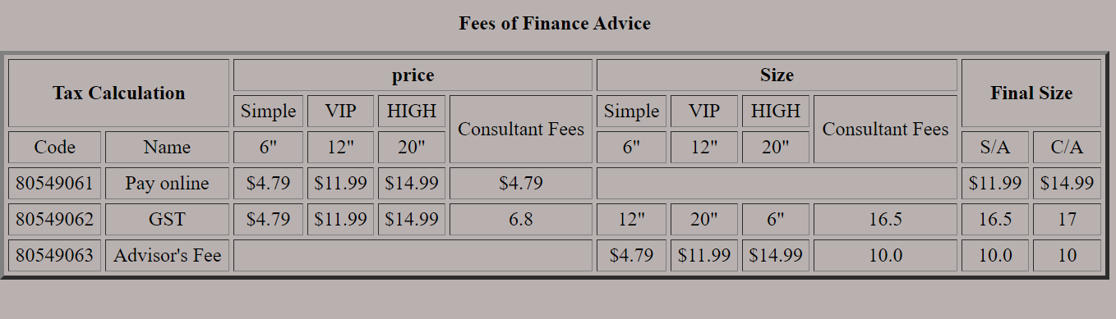 | [20]
Content
OUR FOCUS IS OUR CLIENT SUCCESS!
Use lorem tag <Lorem> ipsum dolor sit amet, consectetur adipisicing elit, sed do eiusmod
tempor incididunt ut labore et dolore magna aliqua. Ut enim ad minim veniam,
quis nostrud exercitation ullamco laboris nisi ut aliquip ex ea commodo
consequat. Duis aute irure dolor in reprehenderit in voluptate velit esse
cillum dolore eu fugiat nulla pariatur. Excepteur sint occaecat cupidatat non
proident, sunt in culpa qui officia deserunt mollit anim id est laborum.</Lorem>
<Lorem> ipsum dolor sit amet, consectetur adipisicing elit, sed do eiusmod
tempor incididunt ut labore et dolore magna aliqua. Ut enim ad minim veniam,
quis nostrud exercitation ullamco laboris nisi ut aliquip ex ea commodo
consequat. Duis aute irure dolor in reprehenderit in voluptate velit esse
cillum dolore eu fugiat nulla pariatur. Excepteur sint occaecat cupidatat non
proident, sunt in culpa qui officia deserunt mollit anim id est laborum.</Lorem>

Color Code:
Marquee background: #eb3a23
Table Background color: #69514d
Second page background color: #b8b1b0

