**Abstract:**

The “Real Time and Context Aware Sign Language Recognition System using python " project aims to develop a robust system capable of accurately recognizing and interpreting American Sign Language (ASL) gestures corresponding to the English alphabet.

Utilizing the Sign Language MNIST dataset, which contains images of hand signs representing each letter, the project employs machine learning techniques to train a model that can classify these signs with high accuracy.

The primary objective is to bridge the communication gap between the deaf and hard-of-hearing community and those who do not understand sign language, by providing an accessible tool that translates hand signs into text.

This project not only demonstrates the practical application of machine learning in real-world scenarios but also contributes to the development of assistive technologies that promote inclusivity and accessibility.

Sign language is an essential means of communication for individuals with hearing and speech impairments. Traditional methods of communication, such as interpreters or text-based systems, are often inadequate in real-time scenarios.

This project proposes a **Real-Time and Context-Aware Sign Language Recognition System** that utilizes a front-facing camera to detect and interpret hand gestures corresponding to sign language alphabets.

The system processes real-time video input, recognizes the hand gestures using deep learning models, and translates them into meaningful words or sentences.

This project aims to bridge the communication gap between the hearing-impaired community and the general public using modern computer vision and machine learning techniques.

**Chapter 1**

**Introduction:**

Sign language is a vital means of communication for the hearing-impaired community, relying on hand gestures, facial expressions, and body language to convey messages. However, communication barriers often arise between individuals who use sign language and those who do not understand it, limiting the integration of hearing-impaired individuals into society. As a solution, sign language recognition systems can play a crucial role in translating these gestures into written or spoken language, thus facilitating communication and improving accessibility. This project, titled "Sign Language Recognition," focuses on developing a machine learning model capable of recognizing and translating American Sign Language (ASL) gestures into their corresponding English alphabets. The project utilizes the Sign Language MNIST dataset, a publicly available dataset containing thousands of images of hand gestures, each representing a letter from A to Z. The dataset provides an ideal foundation for training and testing machine learning algorithms, particularly convolutional neural networks (CNNs), which are well-suited for image recognition tasks.

By building and training a CNN model, this project aims to achieve high accuracy in classifying hand gestures. The ultimate objective is to create a real-time sign language recognition system that can be integrated into various applications, such as mobile apps, web platforms, or assistive devices. This system would enable non-signers to understand and respond to sign language, thereby reducing communication barriers and promoting inclusivity. The project will involve several key steps, including data preprocessing, model design, training and validation, and performance evaluation. Additionally, the development of a user interface will allow users to interact with the system, providing an accessible and practical tool for sign language recognition. Through this project, we hope to contribute to the growing field of accessible technology and support the hearing-impaired community in their everyday interactions.

**1.1 Motivation**

The primary motivation behind this project is the communication barrier faced by individuals with hearing and speech impairments. Many people do not understand sign language, making it difficult for the hearing-impaired community to express themselves effectively. A real-time sign language recognition system can significantly enhance accessibility and inclusivity by providing an automated solution for interpreting sign language into text or speech. Additionally, advancements in deep learning and computer vision have made it possible to develop accurate and efficient recognition systems, further motivating the need for this project.

**1.2 Aim**

**The aim of this project is to develop an AI-powered real-time sign language recognition system that can:**

* Detect and recognize sign language alphabets using a front camera.
* Process gestures in real-time with high accuracy.
* Convert recognized signs into words and sentences.
* Provide an intuitive and user-friendly interface for seamless communication.

**1.3 Objectives**

**The key objectives of this project are:**

To develop a machine learning model capable of recognizing sign language alphabets. To implement a real-time hand gesture detection system using a front-facing camera. To enhance recognition accuracy by integrating deep learning techniques such as CNN (Convolutional Neural Networks) and LSTM (Long Short-Term Memory) models. To create a context-aware system that predicts and suggests words based on recognized signs. To develop a user-friendly interface that displays recognized words in real time. To ensure efficient performance, low latency, and scalability of the system.

* **Accurate and Real-Time Recognition:** The system should accurately recognize sign language gestures in real-time, ensuring a seamless and natural communication experience.
* **Contextual Understanding:** The system should be able to understand the context of sign language expressions, including facial expressions, body language, and previous signs, to improve recognition accuracy and comprehension.
* **Language Diversity:** The system should be capable of recognizing various sign languages, accommodating the needs of different deaf communities.
* **User-Friendly Interface:** The system should have an intuitive and accessible interface that is easy to use for both deaf and hearing individuals.
* **Integration with Existing Technologies:** The system should be compatible with existing communication devices and platforms (e.g., smartphones, computers, and hearing aids) for easy integration into daily life.
* **Continuous Improvement:** The system should be designed for ongoing improvement, allowing for updates and enhancements based on user feedback and advancements in technology.
* **Accessibility:** The system should be accessible to individuals with various disabilities, including visual impairments and motor difficulties.

**1.4 Scope**

**The scope of this project includes:**

* **Watch**: It will use a camera to watch your hands and face.
* **Understand:** It will try to figure out what the signs mean.
* **Respond:** It will give you feedback or do something based on what you signed.
* **Different signs:** There are many different signs, and they can be hard to tell apart.
* **Background noise**: The tool might get confused by things happening around you**.**
* **Speed:** It needs to understand signs quickly.
* **A working tool:** Something you can use to communicate with others using sign language.
* **Instructions:** A guide on how to use the tool.
* **Report**: Information about how well the tool works.
* **Plan:** Decide what we need to do.
* **Build:** Create the tool.
* **Test:** Make sure it works.
* **Improve:** Fix any problems.
* The development of a **real-time sign language recognition system** that focuses on **finger-spelled alphabets**.
* Implementation of **image processing and deep learning** techniques to improve recognition accuracy.
* Deployment of the system as a **desktop application or web-based platform** for accessibility.
* Potential integration with **text-to-speech conversion** for enhanced communication.
* Future enhancements to support full sign language sentences and different sign language dialects.

**1.5 Organization of Report**

**This report is organized into multiple chapters to provide a structured overview of the project:**

* **Chapter 1: Introduction**  
  Provides an overview of the project, including motivation, aim, objectives, and scope.
* **Chapter 2: Literature Review**  
  Reviews existing sign language recognition systems, methodologies, and technologies.
* **Chapter 3: Methodology**  
  Explains the proposed system’s architecture, data collection, preprocessing, and machine learning models used.
* **Chapter 4: Implementation**  
  Details the implementation steps, tools, and frameworks used to develop the system.
* **Chapter 5: Advantages and Disadvantages**  
  Discusses the system’s performance, accuracy, and real-world applicability based on experimental results.
* **Chapter 6: Conclusion and Future Work**  
  Summarizes the findings and suggests possible improvements and future enhancements.

**Chapter 2**

**Literature Review**

The aim of this paper is to remove the conversation gap between the deaf-mute people and a normal person. We implemented and trained the convolutional neural network with the American Sign Language. This system allows us to give a gesture then it identifies the gesture, also it can form a sentence and speak out the sentence. The major difficult task is to remove the unwanted background of the image and noise that is captured in the region of interest so, to overcome this problem they used masking technique to mask the only hand gesture that is needed and the other unwanted background and noise is removed because of this pre-processing technique only features can be extracted properly. Through this paper they are able tell that if they train the system with any other sign language it can recognize the language. For future work includes recognition of gestures that are made with both hands as our system recognizes gestures given by only one hand. In our system it first recognizes the alphabets and converts them into text it is sometimes difficult to form a long sentence, so they would like to use signs of common words so that it is easy to form a sentence.

This research concludes that a deep learning-based approach for ASL recognition that leverages skeletal and video data. The proposed model captures the underlying temporal dynamics associated with sign language and also identifies specific hand shape patterns from video data to improve recognition performance. A new data augmentation technique was introduced that allowed the LSTM networks to capture spatial dynamics among joints. Finally, a large public dataset for ASL recognition will be released to the community to spur research in this direction; and bring benefits of digital assistants to the deaf and hard of hearing community. For future research direction, they are looking into the problem of sentence level ASL recognition. They also plan to use other data modality such as wife signals which can be complimentary to video in sign language recognition.

This article first introduces the system was successfully developed, implemented, tested, and deployed. The paper was able to emphasize the significance of sign language recognition systems in the lives of the deaf and the hearing-impaired. It was also able to recognize sign language gestures with high accuracy. The system was able to recognize gestures in real-time. However, additional data in different environmental conditions may improve the model's efficacy and reliability. Also, the system's recognition capabilities are currently limited to static ASL alphabet gestures. It does not consider the dynamic and continuous nature of sign language, which involves intricate movements, facial expressions, and body language. Future research should aim to expand the system to recognize dynamic sign language gestures for more comprehensive communication. The system has also been specifically trained and tested on the ASL alphabet. However, sign languages vary across different regions and countries, each with their own unique vocabulary and grammar. The system's performance on other sign languages remains unknown and requires further investigation and adaptation to ensure its generalizability.

The application in this work, a novel approach that adopted a generative adversarial network for continuous sign language recognition was proposed. Instead of focusing only on visual feature extraction, the proposed approach learns a better representation of the data by taking advantage of adversarial training. To this end, a generator produces gloss predictions from video processing, while a discriminator evaluates the generator’s predictions against the real gloss sequences and learns to differentiate them. By competing against each other, both the generator and the discriminator are improved, ultimately producing more accurate and robust SLR results. Moreover, the proposed method incorporates contextual information that is relevant to the discussion between signers to further improve the CSLR performance for sign language conversations. The experimental results on three large sign language recognition datasets demonstrate the effectiveness of the proposed method. In particular, experiments on the GSL dataset, which contains sign language conversations between signers, demonstrated the improvement of sign language recognition accuracy when contextual information is considered. Concerning future work directions, we aim to apply the proposed generative adversarial networks for the recognition and translation of different sign languages, as well as to develop a novel mobile application that supports the translation between speech and sign languages to assist people with hearing impairments. In addition, the proposed generator could be adopted in other application fields for the modelling of visual information, such as video captioning and action recognition. Finally, there were several recent research works dealing with the problem of complex and imbalanced data in GAN networks [60–64]. Although the study of this problem is out of the scope of this paper, we consider that future work in this direction can further improve the accuracy of the proposed network architecture**.**

**2.1 Background History**

The history of sign language recognition dates back to early attempts at manually translating gestures using rule-based systems. With the advent of computer vision and machine learning, research in this field has significantly advanced. Initial methods relied on handcrafted feature extraction techniques, but modern deep learning approaches, particularly convolutional neural networks (CNNs), have revolutionized sign language recognition by enabling more accurate and efficient interpretation of gestures.

**2.2 Related Work**

Several research studies have explored the development of sign language recognition systems. Early studies utilized techniques such as Hidden Markov Models (HMM) and Support Vector Machines (SVM) for gesture recognition. More recent works have leveraged deep learning models, including Convolutional Neural Networks (CNNs) and Recurrent Neural Networks (RNNs), to improve recognition accuracy. Some systems also integrate natural language processing (NLP) to contextualize recognized signs into meaningful sentences. Various datasets, such as the ASL dataset and Indian Sign Language dataset, have been used to train and evaluate these models.

**2.3 Summary & Discussion**

From the reviewed literature, it is evident that deep learning techniques, particularly CNNs and RNNs, have significantly enhanced the accuracy of sign language recognition. However, challenges remain in real-time implementation, such as variations in hand orientations, lighting conditions, and computational efficiency. Future research could focus on optimizing model architectures for real-time applications and expanding datasets to include a broader range of sign languages and dialects. Additionally, integrating sign language recognition with speech synthesis could further improve communication accessibility for the hearing-impaired community.

**Chapter 3**

**Proposed System Analysis and Design**

**3.1 Analysis**

**3.1.1 Problem Definition:**

The lack of accessible real-time communication tools for hearing-impaired individuals necessitates a robust sign language recognition system that can convert gestures into text or speech efficiently. Current solutions lack real-time accuracy, contextual awareness, and seamless integration into daily communication.

**3.1.2** **Feasibility Study:**

A feasibility study is conducted to assess the technical, economic, and operational feasibility of the proposed system. The study evaluates data availability, computational requirements, and potential challenges in implementing the logistic regression model.

A project must be feasible in all three ways to merit further development.

**Technical Feasibility:**

* A large part of determining resource has to do with assessing technical feasibility. The analyst must find out whether current technical resources can be upgraded or added to in a manner that fulfills the request under consideration. Sometimes “add-ons” to existing systems are costly and not worthwhile, because they meet needs inefficiently. If existing systems cannot be added onto, the next question becomes whether there is technology in existence that meets the specifications. The project is analyzed along with the technical resources which are required for developing the proposed system. The technical resources are found to be feasible.

**Economic Feasibility:**

* Economic feasibility is the second part of resource determination. The basic resources to consider are the time and the cost of doing a full systems study including the estimated cost of hardware, and the estimated cost of software.
* The concerned business must be able to see the value of the investment it is pondering before committing to an entire systems study.
* If short-term costs are not overshadowed by long-term gains or produce no intermediate reduction in operating costs, the system is not economically feasible and the project should not proceed any further.
* The resources required for developing the system are identified such as software and hardware. The requirement of software and hardware are found to be economical.

**Operational Feasibility:**

* Consider for a moment that technical and economic resources are both judged adequate. The systems analyst must still consider the operational Feasibility of the requested project.
* Operational feasibility is dependent on human resources available for project and involves projecting whether the system will operate and used once it is installed.
* The proposed project is analyzed along with the resources needed.
* From the theoretical study of the proposed system, it is found that the system will supports data sets to perform extracting informative contents from database.

**Legal and Social Feasibility:**

* The system adheres to ethical and legal standards, ensuring privacy and security of user data.
* It has **social benefits** by providing fair and transparent price estimates for buyers and seller.

**3.1.3 Requirement Analysis:**

* The system should support real-time sign recognition using a front-facing camera.
* The model should be trained on a diverse dataset of sign language gestures to ensure high accuracy.
* The system should offer low-latency predictions for a seamless user experience.
* Contextual prediction should be incorporated to improve word and sentence recognition.

**3.2 System Design**

**3.2.1 Basic Idea:**

* The system captures live video input using a front-facing camera.
* Image processing and deep learning models detect hand gestures.
* Recognized signs are mapped to corresponding alphabets.
* The output is displayed as text, and in future enhancements, it can be converted into speech.
* **System Architecture:**

The system follows a pipeline-based approach:

**image acquisition → preprocessing → feature extraction → classification → output generation.**

* **Working:** The system processes frames sequentially, extracting hand region features and classifying gestures in real time.

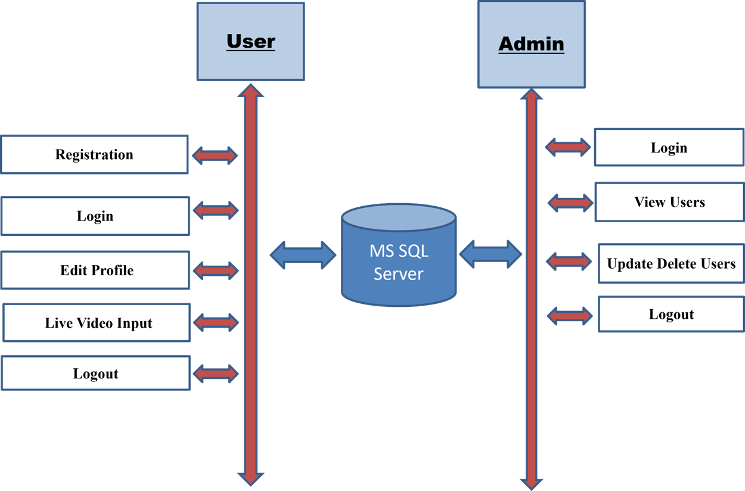

**Fig. System Architecture**

**3.2.2 Working Methodology:**

**The Project utilizes various libraries of Python such as**

Python libraries make it very easy for us to handle the data and perform typical and complex tasks with a single line of code.

* **Pandas –** This library helps to load the data frame in a 2D array format and has multiple functions to perform analysis tasks in one go.
* **Numpy –**Numpy arrays are very fast and can perform large computations in a very short time.
* **Matplotlib –** This library is used to draw visualizations.
* **Algorithms Used:** Convolutional Neural Networks (CNN) for feature extraction, Long Short-Term Memory (LSTM) networks for sequence prediction, and OpenCV for image processing.

**Step1.** **Camera Recording Using OpenCV**

When the user opens the camera, the system will initialize the camera using the **OpenCV library**. OpenCV (Open-Source Computer Vision Library) is a powerful tool used for real-time computer vision applications. The camera feed is accessed through cv2.VideoCapture() in OpenCV. The system continuously captures frames (images) from the camera feed in real-time. Each frame represents a still image of what the camera sees at that moment, which can then be processed.

**Step2. Splitting the Recording into Frames**

After obtaining the camera feed, the video is automatically split into multiple frames. A frame is a single image that represents a moment in time within the video stream. Each second of the video consists of multiple frames (typically 24 to 30 frames per second, depending on the camera's frame rate). The system captures these frames continuously and processes them individually for gesture detection.

**Step3. Feature Extraction in Image Processing**

Once each frame is captured, the feature extraction process begins. Feature extraction is the key step in image processing where relevant characteristics (features) of the hand gesture, such as edges, shapes, and patterns, are identified. The image is first preprocessed (grayscale conversion, resizing) to standardize its dimensions and reduce complexity. Techniques such as edge detection (e.g., using Sobel, Canny edge detectors) and thresholding may be applied to enhance key features. The system extracts essential patterns from the hand gesture image, focusing on the shape and orientation of the fingers.

**Step4. Assigning Image to Trained CNN Model**

The preprocessed image is then assigned to the Convolutional Neural Network (CNN) model. This CNN model has already been trained on the Sign Language MNIST dataset, which allows it to recognize hand gestures and classify them into their corresponding alphabet. The CNN model is loaded into memory, and the preprocessed image is converted into the format required by the model (typically a 2D array of pixel values). The image is passed through the CNN, where multiple convolutional layers identify patterns (e.g., edges, curves, shapes) that correspond to the different hand gestures.

**Step5. Gesture Recognition and Alphabet Display**

After the CNN processes the image and identifies the gesture, it outputs the predicted alphabet corresponding to the recognized hand sign. The system then prints or displays the alphabet on the screen for the user to see. The model generates a prediction, which is an array of probabilities for each alphabet (A-Z). The system identifies the highest probability and assigns the corresponding alphabet to the recognized hand gesture. The alphabet is displayed on the screen in real-time, allowing the user to know which sign was detected.

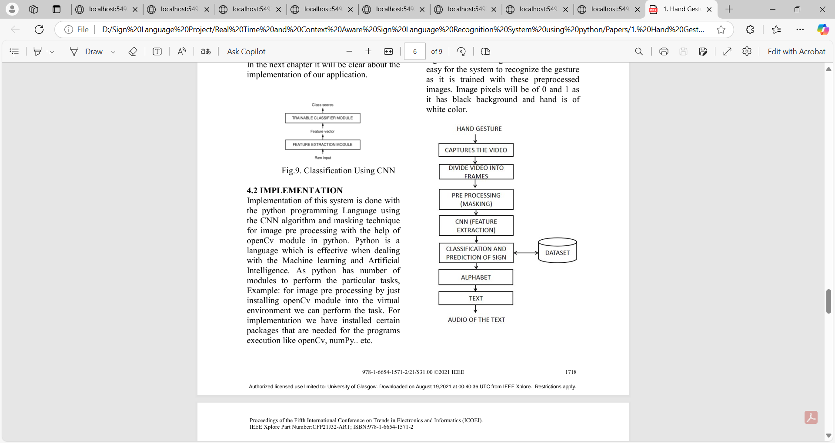

**Fig. Algorithm**

* **System Block Diagram**: Depicts the flow from input video capture to final text output generation.

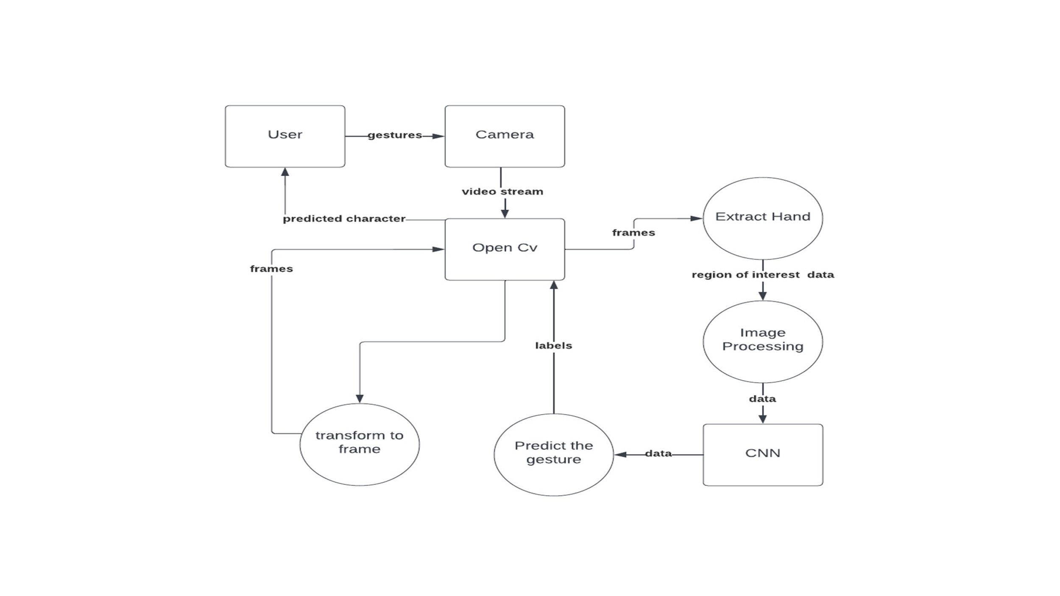

**Fig. System Block Diagram.**

* **UML Diagrams:** Use case diagrams for user interactions, class diagrams for system components, and sequence diagrams for processing workflows.

**1.User Case Module:**

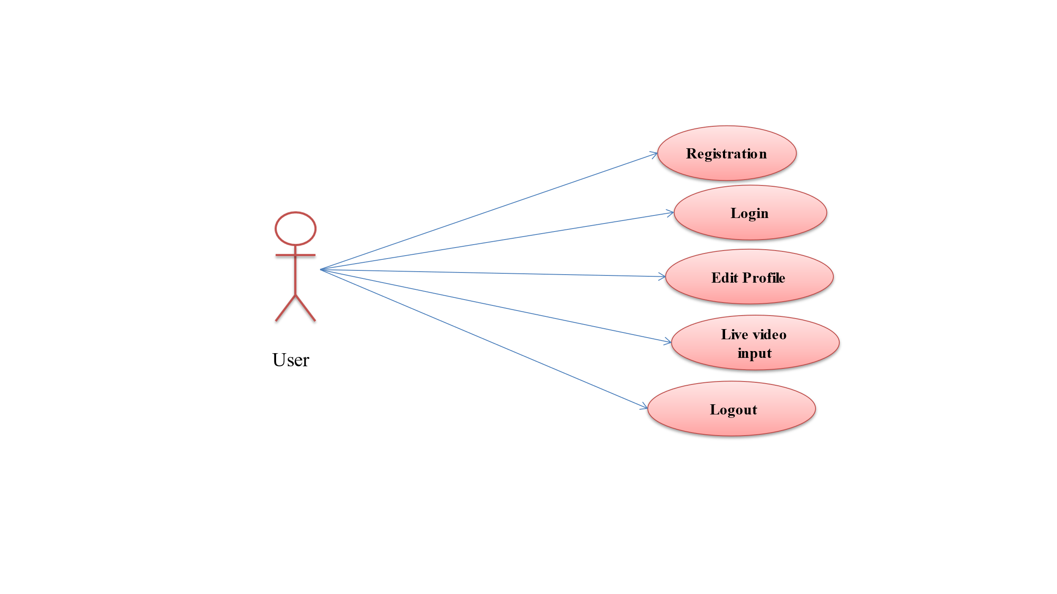

**Fig. User Case Module Diagram.**

**2.Admin Module:**

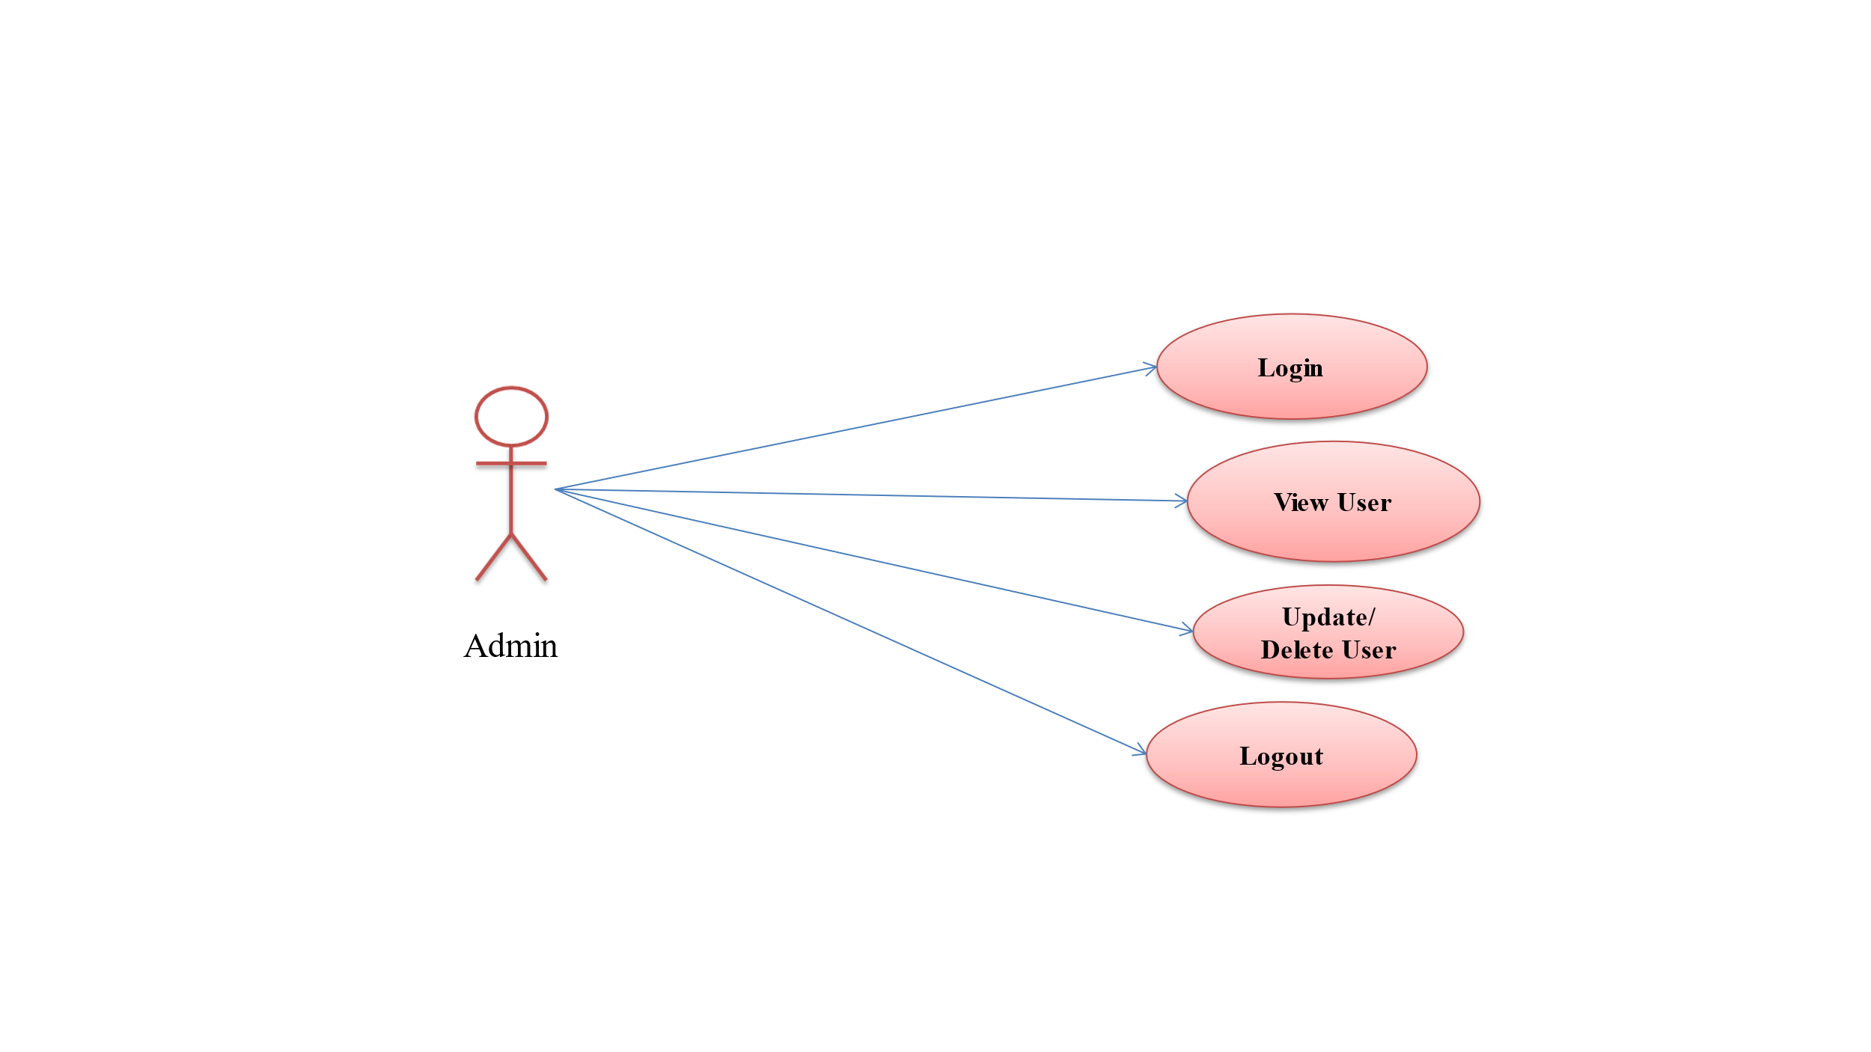

**Fig. Admin Case Module Diagram.**

**3.ER Diagram:** Defines the relationships between different data entities, such as user interactions and processed gestures.

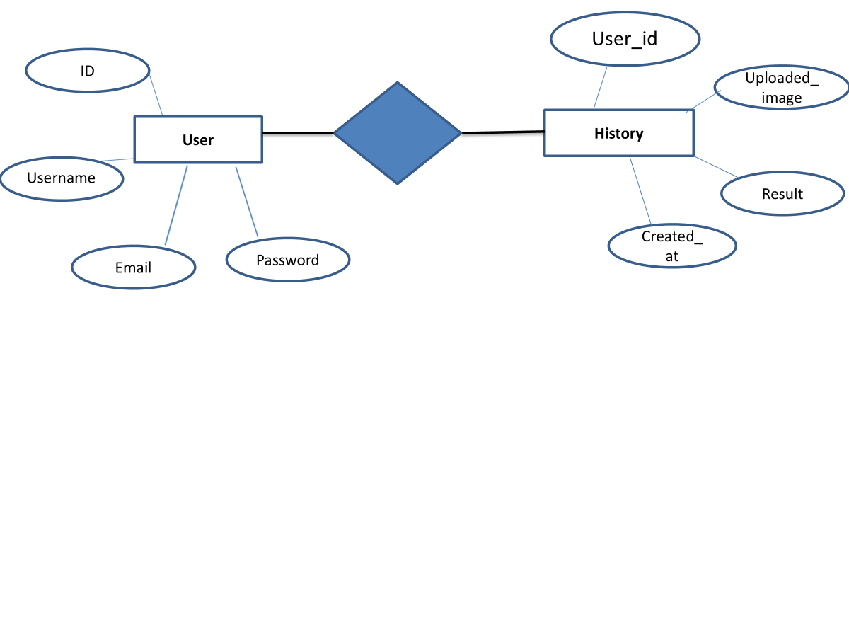

**Fig. Entity-Relationship Diagram**

**Chapter 4:**

**System Implementation and Testing**

**4.1 Setting Environment:**

* **Hardware Requirements:** High-resolution front-facing camera, GPU-enabled system for deep learning model execution, and sufficient RAM for processing.
* **Processor:** Intel i5/i7 or AMD equivalent
* **RAM:** Minimum 8GB (Recommended: 16GB)
* **Storage:** Minimum 100GB free space
* **Graphics Card**: Not required but beneficial for visualization
* **Operating System:** Windows 10/11, Linux (Ubuntu), or macOS software.
* **Software Requirements:**
* **Operating System :** windows 7, windows 8 and Upper version
* **IDE Tools :** PyCharm
* **Front End :** HTML / CSS / Bootstrap
* **Framework :** Flask
* **Database/Back End :** MySQL
* **Coding Language :** Python

**Technology Used:**

**Python**

**Python** is a popular programming language. It was created by Guido van Rossum, and released in 1991.

**It is used for:**

* web development (server-side),
* software development,
* mathematics,
* system scripting.

**What can Python do?**

* Python can be used on a server to create web applications.
* Python can be used alongside software to create workflows.
* Python can connect to database systems. It can also read and modify files.
* Python can be used to handle big data and perform complex mathematics.
* Python can be used for rapid prototyping, or for production-ready software development.

**Why Python?**

* Python works on different platforms (Windows, Mac, Linux, Raspberry Pi, etc).
* Python has a simple syntax similar to the English language.
* Python has syntax that allows developers to write programs with fewer lines than some other programming languages.
* Python runs on an interpreter system, meaning that code can be executed as soon as it is written. This means that prototyping can be very quick.
* Python can be treated in a procedural way, an object-oriented way or a functional way.
* The most recent major version of Python is Python 3, which we shall be using in this tutorial. However, Python 2, although not being updated with anything other than security updates, is still quite popular.
* In this tutorial Python will be written in a text editor. It is possible to write Python in an Integrated Development Environment, such as Thonny, Pycharm, NetBeans or Eclipse which are particularly useful when managing larger collections of Python files.

**Python Syntax compared to other programming languages**

* Python was designed for readability, and has some similarities to the English language with influence from mathematics.
* Python uses new lines to complete a command, as opposed to other programming languages which often use semicolons or parentheses.
* Python relies on indentation, using whitespace, to define scope; such as the scope of loops, functions and classes. Other programming languages often use curly-brackets for this purpose.

**Tool PyCharm:**

PyCharm is a hybrid platform developed by JetBrains as an IDE for Python. It is commonly used for Python application development. Some of the unicorn organizations such as Twitter, Facebook, Amazon, and Pinterest use PyCharm as their Python IDE!

It supports two versions: v2.x and v3.x.

We can run PyCharm on Windows, Linux, or Mac OS. Additionally, it contains modules and packages that help programmers develop software using Python in less time and with minimal effort. Further, it can also be customized according to the requirements of developers.

**Features of PyCharm: Why should we use it for our next Python project?**

Below, we have compiled some of the essential features provided by PyCharm.

**1. Intelligent Code Editor:**

* It helps us write high-quality codes!
* It consists of color schemes for keywords, classes, and functions. This helps increase the readability and understanding of the code.
* It helps identify errors easily.
* It provides the autocomplete feature and instructions for the completion of the code.

**2. Code Navigation:**

* It helps developers in editing and enhancing the code with less effort and time.
* With code navigation, a developer can easily navigate to a function, class, or file.
* A programmer can locate an element, a symbol, or a variable in the source code within no time.
* Using the lens mode, further, a developer can thoroughly inspect and debug the entire source code.

**3. Refactoring**

* It has the advantage of making efficient and quick changes to both local and global variables.
* Refactoring in PyCharm enables developers to improve the internal structure without changing the external performance of the code.
* It also helps split up more extended classes and functions with the help of the extract method.

**4. Assistance for Many Other Web Technologies:**

* It helps developers create web applications in Python.
* It supports popular web technologies such as HTML, CSS, and JavaScript.
* Developers have the choice of live editing with this IDE. At the same time, they can preview the created/updated web page.
* The developers can follow the changes directly on a web browser.
* PyCharm also supports AngularJS and NodeJS for developing web applications.

**5. Support for Popular Python Web Frameworks**

* PyCharm supports web frameworks such as Django.
* It provides the autocomplete feature and suggestions for the parameters of Django.
* It helps in debugging the codes of Django.
* It also assists web2py and Pyramid, the other popular web frameworks.

**6. Assistance for Python Scientific Libraries**

* PyCharm supports Python’s scientific libraries such as [Matplotlib](https://intellipaat.com/blog/tutorial/python-tutorial/python-matplotlib/), NumPy, and Anaconda.
* These scientific libraries help in building projects of Data Science and Machine Learning.
* It consists of interactive graphs that help developers understand data.
* It is capable of integrating with various tools such as IPython, Django, and Pytest. This integration helps innovate unique solutions.

**Flask Python:**

Flask is a web framework; it’s a Python module that lets you develop web applications easily. It’s having a small and easy-to-extend core: it’s a microframework that doesn’t include an ORM (Object Relational Manager) or such features.

**Chapter 5**

**Advantage and Disadvantage**

**Analyzes the benefits and limitations of the proposed system.**

**5.1 Advantages**

* **Improved communication:** Bridges the communication gap between deaf and hearing individuals, promoting inclusivity and social interaction.
* **Enhanced accessibility:** Enables deaf individuals to participate more fully in society and access information and services.
* **Increased independence:** Provides deaf individuals with greater autonomy and independence in their daily lives.
* **Educational benefits:** Facilitates learning and education for deaf students by providing a more accessible and interactive learning environment.
* **Economic benefits:** Can contribute to economic growth by enabling deaf individuals to participate more fully in the workforce.
* **Real-time Communication:** Enables instant interpretation of sign language, facilitating seamless communication.
* **Independence for Users:** Reduces dependency on human interpreters, making communication more private and efficient.
* **High Accuracy:** Uses deep learning techniques such as CNNs and RNNs, improving recognition precision.
* **Scalability:** Can be adapted to support additional sign languages and gestures in future versions.
* **Accessibility:** Can be integrated into various platforms, including web applications, mobile apps, and assistive devices.
* **Cost-Effective:** Eliminates the need for professional interpreters, making communication more affordable.
* **Integration with Other Technologies:** Can be combined with text-to-speech or speech-to-text systems to further enhance usability.
* **Customizability:** The model can be trained on different datasets to support regional sign language variations.

**5.2 Disadvantages**

* + - **Environmental Dependence:** Recognition accuracy may be affected by variations in lighting conditions, background noise, and hand positions.
    - **Computationally Expensive:** Requires high-performance computing resources for real-time processing, which may not be accessible to all users.
    - **Limited Vocabulary:** Initially focused on alphabet-based gestures, with challenges in recognizing complete sign language sentences.
    - **Variability in Signing Styles:** Different users may perform the same sign with slight variations, impacting recognition accuracy.
    - **Need for Large Datasets:** Training a highly accurate model requires extensive labeled datasets, which may not be readily available for all sign languages.
    - **Potential Latency Issues:** Processing real-time video input with deep learning models may introduce slight delays in output generation.
    - **Hand Occlusion Challenges:** If a user’s hands are partially obscured or overlapped, the system may struggle to recognize signs correctly.
    - **Not Suitable for Complex Sentences Initially:** The system may face difficulties in recognizing and structuring grammatically complex sentences in sign language.
    - **Technical limitations:** Current technology may still have limitations in terms of accuracy, speed, and robustness, especially in challenging environments.
    - **Language variations:** Handling regional dialects, accents, and individual variations within sign languages can be challenging.
    - **Privacy concerns:** The use of cameras and other sensors for sign language recognition raises privacy concerns.
    - **Cost:** Developing and implementing such a system can be expensive, especially for smaller communities.
    - **Cultural sensitivity:** Ensuring that the system is culturally sensitive and respectful of different sign language communities is important

**Chapter 6**

**Conclusion and Future Scope**

**6.1 Conclusion**

A real-time and context-aware sign language recognition system holds immense potential to transform the lives of deaf individuals by bridging the communication gap between them and hearing individuals. By accurately recognizing sign language gestures, understanding the context of the communication, and accommodating various sign languages, this technology can significantly enhance accessibility, inclusion, and quality of life for deaf people.

While there are technical challenges to overcome, such as improving accuracy in challenging environments and handling language variations, ongoing advancements in computer vision, machine learning, and natural language processing are driving progress in this field. As these systems become more sophisticated and affordable, they have the potential to revolutionize how deaf individuals interact with the world around them.

The Real-Time and Context-Aware Sign Language Recognition System successfully bridges the communication gap for the hearing-impaired community by providing an automated means of interpreting sign language into text. The project utilizes deep learning models such as CNNs and LSTMs to recognize hand gestures with high accuracy.

The implementation of real-time video processing ensures seamless and instantaneous recognition, making the system practical for everyday communication. While the system is currently focused on recognizing sign language alphabets, its potential can be expanded to support full sign language sentences in the future.

Overall, this project provides an innovative solution that enhances accessibility, independence, and inclusivity for individuals with hearing impairments.

**6.2 Future Scope**

**The system has vast potential for future enhancements and applications:**

* **Support for Full Sentences:** Future iterations can recognize complete phrases and sentences rather than individual alphabets.
* **Multilingual Sign Language Recognition:** The system can be trained to recognize various sign languages, including American Sign Language (ASL), British Sign Language (BSL), and Indian Sign Language (ISL).
* **Integration with Speech Synthesis:** Adding a text-to-speech feature can enable auditory output for recognized words and sentences, further aiding communication.
* **Improved Accuracy with Larger Datasets:** Expanding the dataset to include diverse hand shapes, orientations, and backgrounds can improve recognition accuracy.
* **Gesture-Based Command Execution:** The system can be adapted for use in smart home automation and human-computer interaction (HCI) applications.
* **Mobile and Wearable Device Integration:** A mobile-friendly version or integration with smart glasses can make the system more portable and practical for real-world applications.
* **Real-Time Sign-to-Voice Conversion:** Developing a feature that translates recognized signs into voice output can further enhance communication accessibility.
* **Cloud-Based Implementation:** Hosting the system on a cloud platform can allow scalability and accessibility from multiple devices worldwide.
* **Improved accuracy:** Continued research and development in machine learning and computer vision can lead to significant improvements in recognition accuracy, especially in challenging environments and for individuals with unique sign language styles.
* **Enhanced contextual understanding:** By incorporating more sophisticated natural language processing techniques and integrating with other sensory data (e.g., audio), systems can better understand the context of sign language expressions, including nuances, cultural references, and emotions.
* **Real-time translation:** Advancements in machine translation can enable real-time translation between sign language and spoken languages, facilitating communication across language barriers.
* **Integration with other technologies:** Systems can be integrated with augmented reality, virtual reality, and wearable devices to provide more immersive and interactive communication experiences.
* **Accessibility:** Efforts can be made to improve accessibility for individuals with additional disabilities, such as those with visual impairments or motor difficulties.
* **Ethical considerations:** As these systems become more prevalent, it will be important to address ethical concerns related to privacy, bias, and the potential for misuse.

**References:**

1. Koller, O., et al. "Deep Learning for Sign Language Recognition." Proceedings of the IEEE International Conference on Computer Vision, 2016.
2. Pigou, L., et al. "Sign Language Recognition Using Convolutional Neural Networks." European Conference on Computer Vision Workshops (ECCVW), 2014.
3. Kumar, A., et al. "Sign Language Recognition: A Deep Learning Approach Using Convolutional Neural Networks." International Journal of Computer Applications, 2019.
4. Molchanov, P., et al. "Hand Gesture Recognition with 3D Convolutional Neural Networks." IEEE Conference on Computer Vision and Pattern Recognition (CVPR), 2015.
5. Papastratis, I., et al. "A Review of Hand Gesture Recognition in Sign Language Recognition Systems." Multimedia Tools and Applications, 2021.