**CHAPTER - 1**

**INTRODUCTION**

**1.1 Internet of Things**

The Internet of Things refers to the network of interconnected devices embedded with sensors, software, and other technologies that enable them to collect and exchange data with other devices and systems over the internet. It encompasses a wide range of objects, from household appliances and wearable devices to industrial machines and smart city infrastructure. By enabling devices to communicate and collaborate, IoT has the potential to revolutionize industries, enhance efficiency, and improve quality of life. In your project report, you can delve into various aspects of IoT, including its applications, benefits, challenges, and future prospects.

The purpose of IoT is to provide the IT-infrastructure for the secure and reliable exchange of “Things” . The IoT explains how a variety of physical items and devices can be integrated with the Internet to permit those objects to cooperate and communicate with each other to reach common goals.

The Smart Helmet for Alcohol Detection and Helmet Presence aims to address the escalating issue of road accidents caused by individuals not wearing helmets and driving under the influence of alcohol. In an effort to enhance road safety, this project integrates advanced sensor technologies. A limit switch is employed to determine whether the user is wearing a helmet, ensuring that the rider is adequately protected. Additionally, a gas sensor is incorporated to detect the presence of alcohol in the rider's breath.

The innovative system is designed to restrict the bike's ignition, allowing it to start only when the rider is both wearing a helmet and shows no signs of alcohol intoxication. By combining sensor operations, this practical and potentially life-saving smart helmet seeks to contribute to a significant reduction in road accidents, ultimately safeguarding lives and promoting responsible riding habits.

**1.2 Objective**

So, our aim is to Develop an IoT powered smart helmet to enhance road safety by delivering real-time data and potential hazards, effectively preventing accidents and reducing collision risks for vehicle riders.

**1.3 Problem Definition**

Now a days Accidental rate among motorcyclists is the highest compared to other road users. The main factor for accidents involving motorcycles is the difficulty of other vehicles to predict the motorcyclists moves on the road. Signal box that usually located at the back of motorcycles make it hard to be in the vision of approaching vehicles that comes from the back. The impact when a motorcyclist involves in a high speed accident without wearing a helmet is very dangerous and cause fatality. Wearing a helmet can reduce shock from the impact and may save a life

# CHAPTER-2

# LITERATURE SURVEY

The authors Jannatul Ferdous and Md. Tanvir Hossain [1]., have proposed a system in which the entire process using GPS and GSM Module. Besides, using the GSM and GPS Module, author used Arduino Uno which does the limited processing power and memory might compared to more microprocessors. Which makes the design complex and not much cost effective. And the Solar energy is not provide a consistent power supply and solar panel efficiency or battery could effect the system. This study proposes a smart helmet design utilizing an Arduino micro controller, Bluetooth module, and various sensors like gyroscope, accelerometer, and gas sensor. The focus is on detecting accidents through sudden changes in motion and preventing alcohol-induced accidents by monitoring the rider's breath. It highlights the potential for cost- effective.

The authors Md. Atiqur Rehman, S.M Ahsanuzzaman[2], have proposed a system in which the entire process of Accident Identification System is divided into two parts, one is the automobile circuit has a 3-axis accelerometer and the second one is the helmet circuit has IR and alcohol detection sensor. Despite of all the advantages of this system, the author used database which will reduce Data Security Concerns of the system and Scalability Issues. To overcome the drawbacks of it, we are going to use Ignition KEY and TILT Sensor. Which the Sensor offers Reliability. This study focuses on preventing accidents caused by cellphone usage while riding. It proposes a smart helmet and vehicle connection system that detects phone usage through Bluetooth and transmits a signal to the vehicle, potentially limiting acceleration or engine functions. This raises ethical concerns and potential safety risks associated with automated vehicle control.

The system, is tells about two sets of control rider to motorcycle and motorcycle to operation control. Communication occurs wirelessly via Bluetooth from the helmet to the motorcycle control device. If alcohol is detected in the air by the helmet, the motorcycle won't start. However, this setup doesn't ensure helmet usage by the rider. Addressing cost concerns, a more economical solution is presented in [5]. This ZigBee-based wireless system forms a network with sensors like gas and speed sensors, notifying the rider of over speed and alcohol presence. While effective, Zig Bee technology entails high initial costs and limited coverage. Another innovative proposal in [6] focuses on bike accident protection, aiming to minimize life-threatening injuries. An IR sensor confirms the rider's smart helmet usage. In the event of an accident, the system detects it and relays the accident location to a database, accessible to law enforcement for monitoring individuals or groups, thus enhancing traffic safety.

The author Pranav Prathik[3], implemented Smart Helmet System in modes. one is LIDAR sensor and ESP8266 Wi-Fi module. The force-sensitive resistor also used to develop the Smart Helmet for Vehicle. At the same time, the smart helmet has two units, the helmet unit(HU) and a motorbike unit(MU). The force-sensitive resistor is not provide precise information about the riders posture or sitting position on the motorbike. While conventional systems often use IR, PIR, or switches for helmet detection, these methods are prone to false activation and can be easily bypassed. Additionally, many systems rely on the rider carrying a mobile phone, which may not always be the case. The ideal system should detect accidents and issue alerts even when the rider isn't carrying a phone. Furthermore, there's a lack of systems that warn riders of reckless driving behaviors, which could significantly reduce accidents if implemented effectively.

**CHAPTER-3**

**PLANNING**

**3.1 Existing System**

In the existing system, we can start the bike by the using as a key and we can stop the bike when the rider doesn’t wear the helmet. Even though we can’t lock the ignition when the rider is drinking mode or during an accident, but we can locate the bike. The helmet is the protective gear to prevent and avoid head injuries in an environment and saves the life of bike riders. This existing idea addresses three main objectives: [1] To ensure the safety of the rider, [2] To the rising modern needs of technological innovations, and [3] To overcome the accident rate. The smart helmet allows vehicle ignition only when the helmet is worn only. An RF Module can be used as a wireless link for communication between transmitter and receiver.

Road accidents are a human tragedy. They involve high human suffering and monetary costs in terms of untimely deaths, injuries and loss of potential income. There are so many new techniques such as Anti lock Braking System (ABS), Adaptive Cruise Control (ACC), and Anti-Collision System (ACS) to avoid accidents and in spite of all this, such large number of accidents takes place. Hence this project presents a system which gives an idea about what can be done to provide medical help and other facilities after accident as soon as possible.

**3.1.1 Software Arduino IDE:**

• Arduino IDE is an open source software which makes easy to write code micro controller Atmega 328 and allows to upload on board. The environment is written in java and based on processing and other source software.

• Arduino IDE can be used on Windows, Linux (Both 32 and 64 bits), and Mac OS. Current versions are Arduino 1.0x or Arduino 1.5x Beta Version.

The driver tends to wear a helmet only where they anticipate checking may take place or else they don't wear a helmet.

**3.1.2 Disadvantages**

• The disadvantage of current technology is due to the negligence of riders and the difficulty of implementation of traffic rules by traffic police.

• Riders do not wear a helmet in regions where traffic checking is not done.

• The driver tends to wear a helmet only where they anticipate checking may take place or else they don't wear a helmet.

• The vehicle can be turned on and stolen by bypassing the ignition switch.

**3.2 Proposed system**

The proposed system of our smart Helmet system includes hardware and Software requirements. Hardware components include sensors, transmitters, Arduino boards, GSM, and GPS devices, all essential for the functionality of the smart helmet system.In the event of an accident, our smart helmet is equipped with sensors to detect impacts and vibrations, triggering an alert to predefined contacts on the rider's emergency list. This ensures prompt assistance in case of emergencies.

We're developing a smart helmet using IoT technology to enhance cyclist safety. To reduce motorcycle accidents, we're implementing features like a helmet detection system that prevents the motorcycle from starting unless the rider is wearing protective headgear. Utilizing IoT technology allows for advanced methods of traffic regulation enforcement and vehicle warning systems. Helmets are crucial for cyclists' safety, and our device integrates various sensors including micro limit switches, alcohol sensors, and vibration sensors.

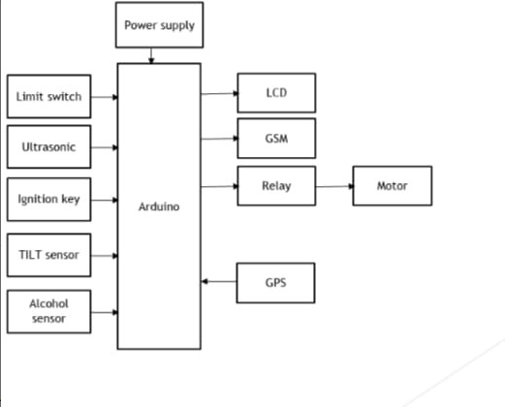**3.2.1 System Architecture**

**Fig 3.1: Architecture of the proposed system**

**3.2.2 Advantages**

• It is a smart helmet which helps to control the ignition on and off.

• MQ-3 sensor used to find whether the riders are alcohol consumed or not.

• LED strips used in this helmet to indicate the presence of the rider and it is very useful to bike riders in the night.

• It detects fall detection by using a vibrating sensor.

• This smart helmet helps to Locate the bike and rider in accident cases.

**3.3 Hardware Requirements**

**3.3.1 Ultrasonic Sensor**

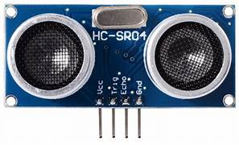An ultrasonic sensor is a device that uses ultrasonic sound waves to measure distance to an object. It typically consists of a transmitter and a receiver. The transmitter emits ultrasonic waves, which travel through the air, hit an object, and then bounce back to the receiver. By measuring the time it takes for the waves to return, the sensor can calculate the distance to the object.

**Fig 3.2 Ultrasonic sensor**

**3.3.2 Tilt Sensor**

A tilt sensor, also known as an in clinometer or a tilt switch, is a device that can detect changes in orientation or tilt. It typically consists of a conductive metal ball or a pendulum suspended within a housing. When the sensor is tilted, the ball or pendulum moves, causing it to make or break electrical connections, thereby signaling a change in orientation.

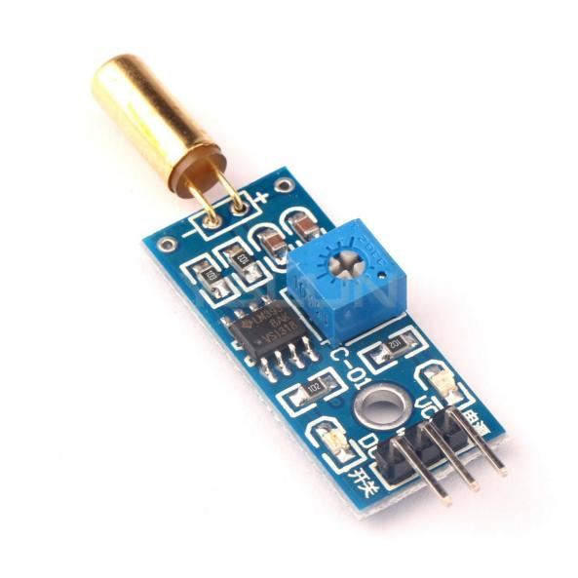

**Fig 3.3 Tilt sensor**

**3.3.3 Alcohol Sensor**

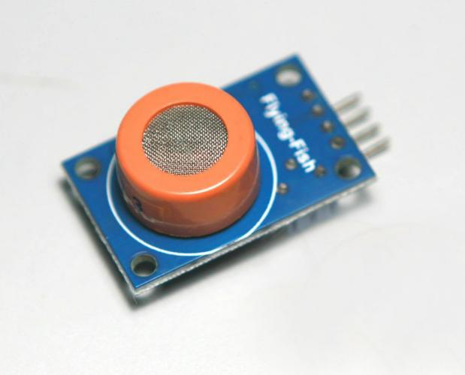An alcohol sensor, also known as a breathalyzer or alcohol detector, is a device used to detect alcohol vapors in a person's breath. These sensors have various applications, including law enforcement for checking drivers' alcohol levels, safety to ensure sobriety in hazardous environments, and personal use for monitoring alcohol consumption. The most common type of alcohol sensor is the electrochemical sensor, which measures the electric current produced when alcohol molecules in the breath react with a chemical solution.

**Fig 3.4 Alcohol Sensor**

**3.3.4 GPS**

GPS for smart helmets is a technology integration aimed at enhancing safety and functionality for helmet users, particularly in activities such as cycling, motorcycling, and industrial work. By incorporating GPS (Global Positioning System) technology into the helmet, users can benefit from features like navigation, tracking, and emergency assistance.



**Fig 3.5 GPS**

**3.3.5 GSM Module**

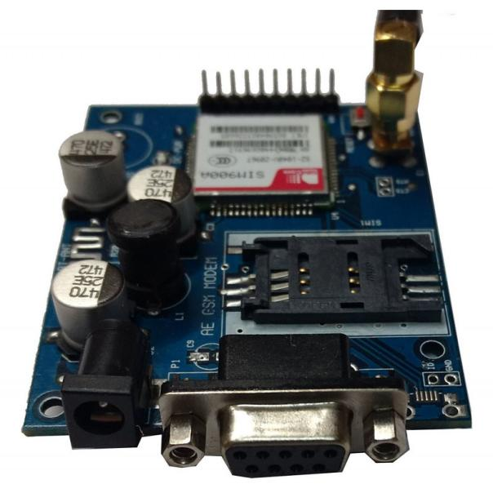A GSM (Global System for Mobile Communications) module is a component that enables devices to establish communication over mobile networks. These modules contain a GSM modem along with other necessary components such as an antenna, SIM card slot, and interfaces for connecting to other electronic devices.

**Fig 3.6 GSM Module**

**3.3.6 Buzzer**

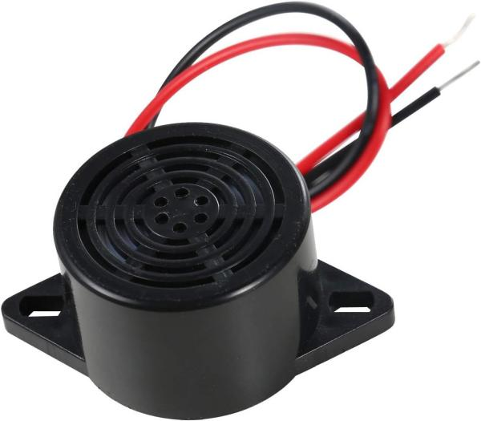 A buzzer or beeper is an audio signaling device, which may be mechanical, electro mechanical, or piezoelectric (piezo for short). Typical uses of buzzers and beepers include alarm devices, timers, train and confirmation of user input such as a mouse click or keystroke.

**Fig 3.7 Buzzer**

**3.3.7 LCD Display**

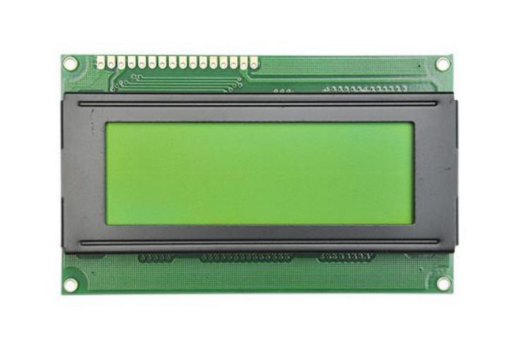 LCD (Liquid Crystal Display) into a smart helmet enhances its functionality by providing wearers with vital information and features, thereby augmenting safety and convenience. The LCD display serves multiple purposes, including navigation assistance, real-time status updates, communication facilitation, and even health and fitness tracking.

**Fig 3.8 LCD Display**

**3.4 Software**

**Arduino IDE**

The Arduino Uno software, often referred to as the Arduino IDE (Integrated Development Environment), is a software application that allows you to write, compile, and upload code to the Arduino board. The Arduino IDE provides a simple code editor where you can write your programs using the Arduino programming language, which is based on a simplified version of C++.

The following are some of the primary features of Arduino IDE:

* A vast collection of libraries simplifies integration of pre written code for various sensors, modules, and functionalities into projects.
* The IDE compiles human-readable code into machine code and facilitates easy uploading to Arduino boards via USB.
* Users can select the specific Arduino board model and the communication port before uploading code, ensuring compatibility.
* The IDE is open-source, fostering collaboration and allowing developers to contribute to its improvement and customization.
* The IDE includes a simple code editor for writing Arduino programs using a simplifies version of C++.

**Pros of Arduino IDE:**

* The IDE offers a simple and intuitive environment, making it accessible for beginners and those new to programming and electronics.
* Arduino IDE is available for Windows, mac OS, and Linux, allowing users on different operating systems to write and upload code to Arduino boards.
* The built-in Serial Monitor facilitates debugging and monitoring of program output, helping users troubleshoot their projects effectively.

**Cons of Arduino IDE:**

* The IDE may be resource-intensive for some older or less powerful computers, leading to slower performance in certain cases.
* Advanced debugging features are somewhat limited in comparison to more professional IDEs, making it challenging to diagnose complex issues.

**3.5 Functional Requirements**

**3.5.1 Sensor Integration**

Sensor integration is crucial for enhancing the functionality and safety features of a smart helmet. By incorporating various sensors, the helmet can gather real-time data about the wearer's environment, movements, and vital signs.

**3.5.2 Alcohol Detection**

The primary purpose of integrating alcohol detection capabilities into a smart helmet is to enhance safety by preventing accidents caused by alcohol impairment. This feature aims to provide real-time monitoring of the wearer's blood alcohol concentration (BAC) levels through a breathalyzer sensor integrated into the helmet.

**3.5.3 Arduino Integration**

The solution shall be based on the Arduino platform for sensor data processing, motor control, and overall system coordination.

**3.6 Non Functional Requirements**

**3.6.1 Cost**

The overall cost of implementing the obstacle detection and avoidance system shall be within a specified budget.

**3.6.2 Safety**

Safety is of utmost importance when designing a smart helmet, as it serves to safeguard the wearer from potential dangers while offering added functionalities.

**3.7 Scope**

The Scope of Smart helmets is to be designed specifically for bikers offer a broad scope of innovative features aimed at enhancing safety,communication, and overall riding experience.These helmets integrate advanced technologies to address the unique challenges and needs faced by bikers on the road. By incorporating features such as impact protection, visibility enhancements, and crash detection systems, they significantly improve rider safety.Built-in LED lights, reflective elements, and rear-view cameras enhance visibility, while crash sensors automatically alert emergency services in the event of an accident.

**3.8 Performance**

The performance of a smart helmet encompasses multiple factors crucial to its effectiveness, reliability, and user satisfaction. Chief among these is its safety features, ensuring the wearer's protection in accidents through impact resistance and compliance with safety standards. Additionally, the helmet's functionality plays a pivotal role, encompassing communication systems, navigation aids, health monitoring, and device integration. Performance also hinges on accuracy, reliability, and ease of use, with precise sensor readings, dependable communication, and intuitive controls being paramount. Long battery life enhances performance by extending usability, while robust connectivity ensures uninterrupted communication. Durability and weather resistance are vital for maintaining performance in various conditions, alongside customization options for fit and preferences. Security measures for data protection and privacy further bolster performance, while accessible support and maintenance services contribute to user satisfaction and helmet longevity. Overall, a smart helmet's performance is defined by its ability to deliver safety, functionality, reliability, and user satisfaction across all aspects of its design and operation.

**3.9 Methodology**

The methodology for implementing a smart helmet for vehicles using IoT for accident avoidance typically involves several key steps:

1.Literature Review:- Conduct a thorough review of existing literature on IoT-based accident avoidance systems and smart helmets. Identify relevant technologies, methodologies, and challenges faced by similar projects.

2.System Design:- Define the system architecture, including hardware and software components. Specify the sensors to be used for accident detection (e.g., accelerometer, gyroscopes, proximity sensors).Design the communication framework for IoT integration.

3.Sensor Integration:-Acquire and integrate the chosen sensors into the helmet. Ensure proper calibration and alignment for accurate data collection.

4.Data Processing and Analysis: - Develop algorithms to process and analyze sensor data in real time. Implement accident detection logic based on abnormal patterns or predefined criteria.

5.IoT Integration:- Set up the communication infrastructure to enable data transmission between the smart helmet and a central IoT platform. Ensure secure and reliable data transfer, considering factors like latency and bandwidth.

6.Testing and Validation: Conduct rigorous testing under various simulated scenarios to evaluate the system's accuracy and responsiveness. Validate the system's effectiveness in preventing or mitigating potential accidents.

7.Performance Optimization:- Optimize the system for efficiency, considering factors like power consumption and response time. Address any identified issues through continuous improvement.

This methodology provides a structured approach to implementing a smart helmet for vehicle accident avoidance using IoT, ensuring a systematic and effective development process.

**3.9.1 Advantages**

* It is easily acceptable to ever-changing needs of the project.
* Testing and debugging during smaller iteration is easy.
* A parallel development can plan.

**3.10 Cost Estimation**

|  |  |
| --- | --- |
| **Components** | **Cost** |
| LCD Display | 627 |
| Arduino UNO | 967 |
| GPS | 1121 |
| GSM | 1003 |
| Ultrasonic sensors(2) | 1320 |
| MQ3 Alcohol sensor | 320 |
| Buzzer | 141 |
| Limit Switch | 129 |
| Helmet | 1416 |
| Jumpers(4) | 340 |
| Glue gun +5 Glue Sticks | 649 |
|  | **Total cost-**8033 |

**Table 3.1 Cost Estimation**

**3.11 Time Estimation**

|  |  |
| --- | --- |
| Week 1 | Domain & Title |
| Week 2 | Literature Survey |
| Week 3 | Requirements Specification |
| Week 4 | Planning |
| Week 5 | Design |
| Week 6 | Gathering the Requirements |
| Week 7&8 | Software Development |
| Week 9 | Hardware Development |
| Week 10 | Testing |
| Week 11 | Implementation |

**Table 3.2 Time Estimation**

**CHAPTER-4**

**DESIGN**

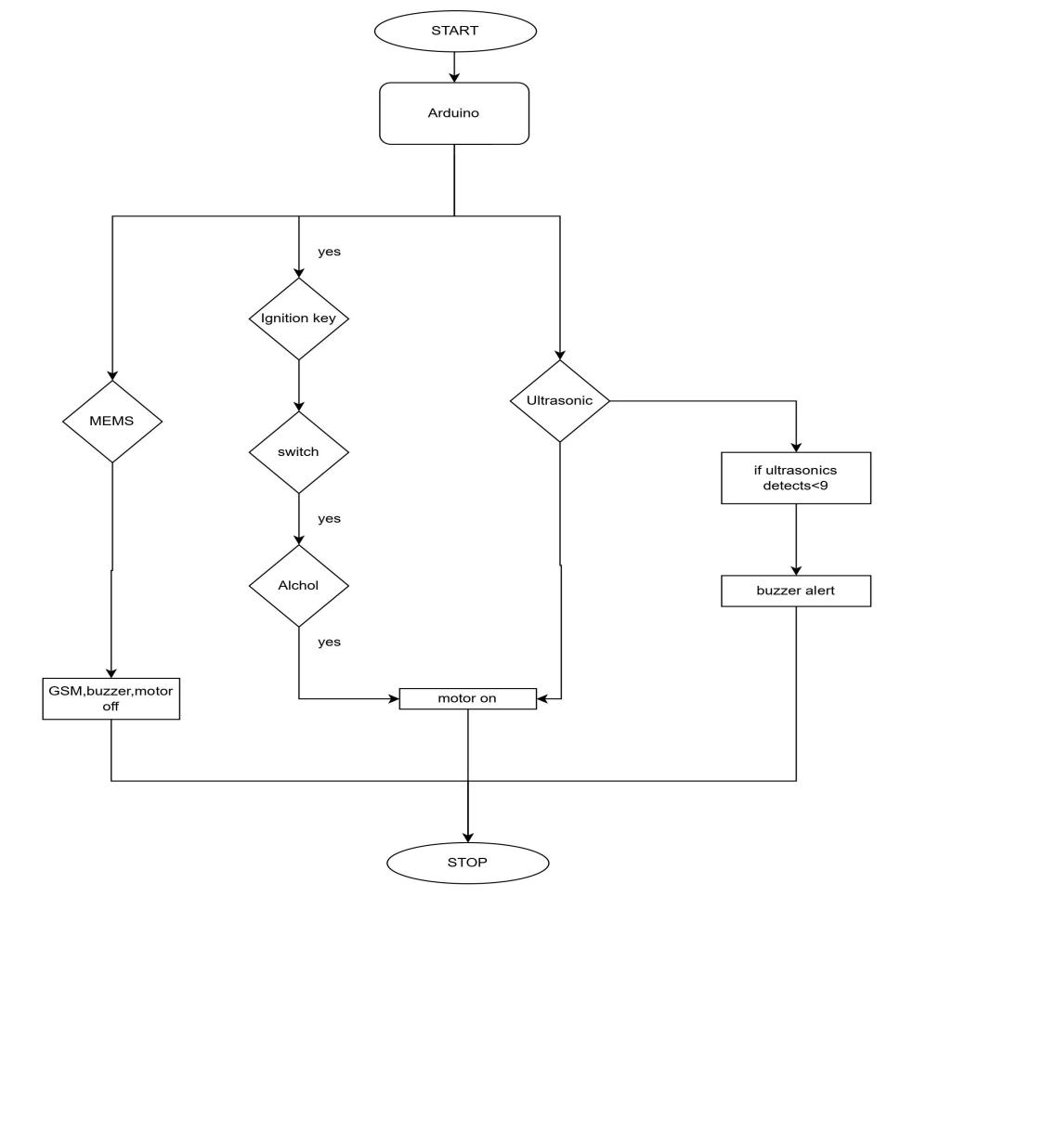**4.1 Workflow**

**Fig 4.1 work flow**

The above flow chart describes how the smart helmet system works. Initially Whenever the rider try to start vehicle ,It will check these condition whether the helmet is wear or not ,If the rider wear helmet then it sent to next condition to verify whether the rider drunken alcohol or not if he didn’t then the bike will start and the output will be displayed on LCD display ,If he drunk then the will won’t start and also it won’t start when the rider didn’t wear helmet.

**4.2 Helmet Unit**

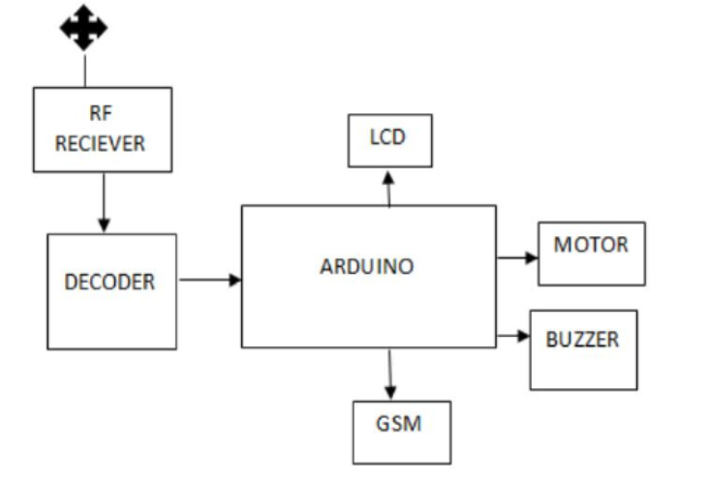

**Fig 4.2 block diagram of Helmet Unit**

The helmet unit comprises of an alcohol sensor, helmet on detection circuit, a tilt sensor, GSM module, LCD display, micro controller ATMega328-PU, accelerometer for accident detection and a RF module. The sensors installed in the helmet provide analog output. This output is fed to a comparative that acts as an ADC. The output signal from the comparative and the sensor lock is encoded in binary signals, which are transmitted via the RF transmitter. RF Module consists of a transmitter with a 5 meter range. It is used to transmit control signals to the bike module for implementation.

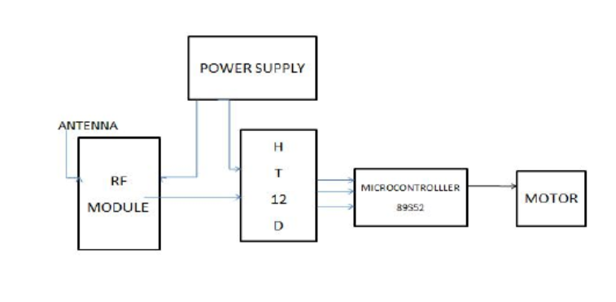**4.3 Bike Unit**

**Fig 4.3 Block diagram of Bike Unit**

This section consists of a receiving part and a control signal. The receiver section is located on a bike; It consists of radio frequency receiver, decoder, micro controller, LED as an indicator, DC motor. The RF receiver receives the encoded binary data transmitted by the RF transmitter and provides it to the decoder. The decoder decodes the incoming digital data and provides four bits in the MCU, only if the address bit of the encoder and the decoder match. This is done to ensure the safety and security of the system. Thus matching of encoder and decoder increases the security and integrity of the system. The MCU controls the DC motor upon receiving data. If the sensor detects that the rider is wearing the helmet, then the engine is turned on and also if the MQ6 sensor detects alcohol, the module installed on the bike turns off the engine to avoid any accidents

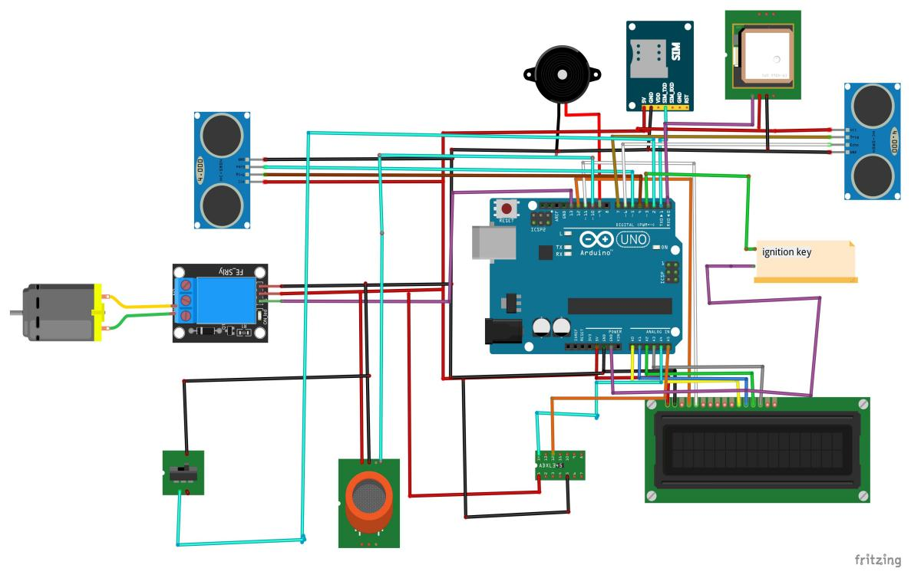**4.4 System Architecture**

**Fig 4.4 System Architecture**

The proposed smart helmet supports variety of functions. First it checks whether the driver is wearing a helmet using a magnetic clip. It also checks if the driver is in an abbreviated state or not. MQ6 sensor is used for this purpose. Only if the driver is sober and wearing a helmet the bike starts. This helps reduce chances of rash and drunk driving. The helmet also employs various sensors. A LDR(light detection resistor) is used to detect the presence of fog. An accelerometer is employed to detect accidents by measuring the tilt of the helmet. The data from the accelerometer is also transmitted to the Arduino micro controller. All the data from the sensors is fed into comparators to check against pre-set threshold values. If a breach is detected the micro controller 89S52 issues commands to switch off the engine in case of an accident otherwise to sound a buzzer to caution the driver**.**

The other features are implemented via the Arduino Uno micro controller which is connected to a LCD to provide information to the user. Data from the RF tags of speed boards is fed into the Arduino. These values are used to set threshold values used for speed tracking and keeping a check on speeding on roads in different settings for example highways, alleys etc. If speed values from the potentiometer are found to be exceeding the speed limits a warning sign appears on the LCD with sounding of the buzzer. A toll booth is also provided with a unique RF tag. As soon as the helmet comes in range of the booth, toll is deducted from the user’s virtual wallet. Arduino has been programmed to show the remaining balance on the screen and give a low balance warning if funds reach a predefined minimum value. A recharge point has also been provided within the circuit to load the wallet with money. The updated value is fed back in the Arduino for future use. In case of accidents a GPS module sends emergency messages to 2 preloaded contacts informing them of the dire situation. This helps in mobilizing quick relief operations for the person involved in the accident.

**CHAPTER-5**

**IMPLEMENTATION**

**5.1 Hardware Implementation**

**5.1.1 Embedded system:**

An embedded system is one kind of a computer system mainly designed to perform several tasks like to access, process, store and also control the data in various electronics-based systems. Embedded systems are a combination of hardware and software where software is usually known as firmware that is embedded into the hardware.

**5.1.2 Embedded System Hardware**

As with any electronic system, an embedded system requires a hardware platform on which it performs the operation. Embedded system hardware is built with a microprocessor or microcontroller. The embedded system hardware has elements like input output (I/O) interfaces, user interface, memory and the display. Usually, an embedded system consists of:

* Power Supply
* Processor
* Memory
* Timers
* Serial communication ports
* Output/Output circuits
* System application specific circuits

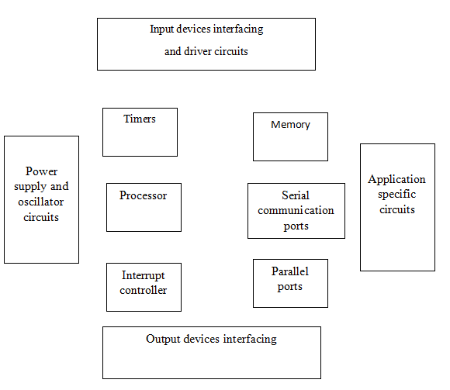

**Fig 5.1 Block Diagram of Embedded System Hardware**

**5.1.3 Over Alcohol detection system**

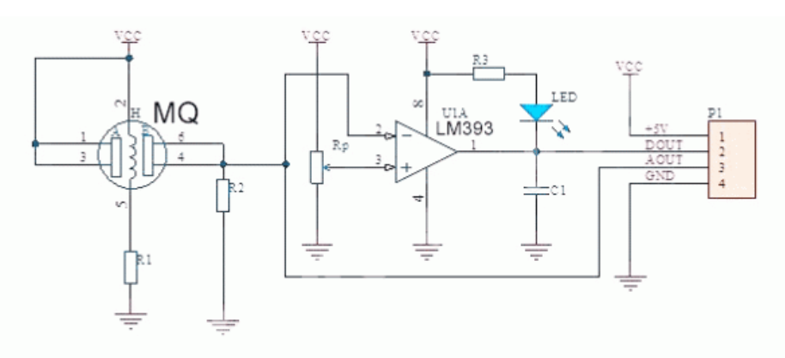we are here going to use MQ-3 because it is best for detecting alcohol. The working of most of the MQ sensors is the same. They all contain a heating element that heats up a layer of conducting material whose resistance is continuously measured. Its resistance changes when fumes or smell from alcohol comes in contact with the MQ-3 sensor.

## Fig 5.2 Schematic Diagram of MQ3 Sensor

First take the power lines onto the breadboard from the micro controller VCC/5v–>+ line and GND–> – line.Then connect the sensor onto the breadboard and connect power to the sensor from power lines using jumper wires.Now connect D0 PIN OF SENSOR TO MICROCONTROLLER DIGITAL PIN 3.Now connect led to the breadboard + to digital pin 13 of Arduino and – to gnd in series with 220-ohm resistor. Moreover, we can enhance this version by adding a buzzer to it also like in the above diagram. Connect -tive of the buzzer to GND on a breadboard, and +tive to 5V on a breadboard.

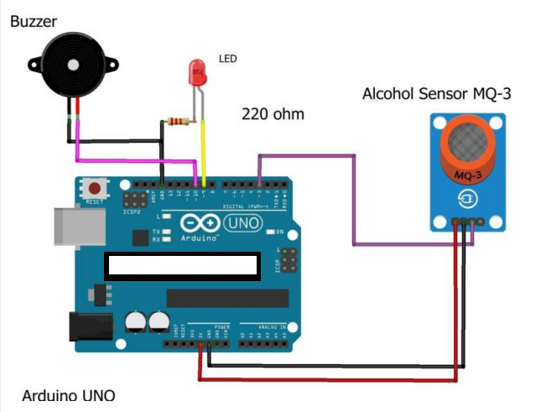

**Fig 5.3 Circuit diagram of Arduino MQ3**

**5.2 Software Implementation**

**5.2.1 Installation of Arduino IDE**

To install Arduino on your Windows PC, follow the next instructions

* Insert the CD-ROM or PENDRIVE which Contains the software and then Copy the Setup File to your desired location.
* After Copying, now click on the setup you will see an window shown below
* Click On NO, not this time. Then after NEXT
* 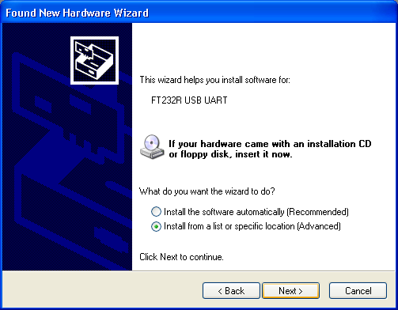Another Window opens –select Install from a list of specific location and Next

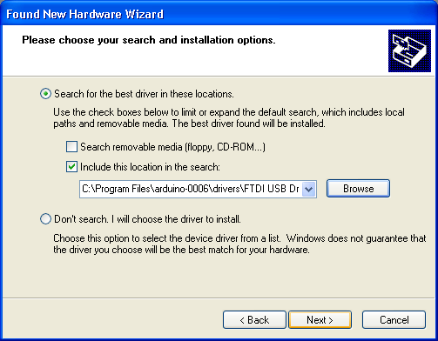

* Select “include this location in the search” and then click Browse option available in it
* Now it will Automatically check the USB driver and the software is installed click Finish
* Now click Finish, the Software will be downloaded.

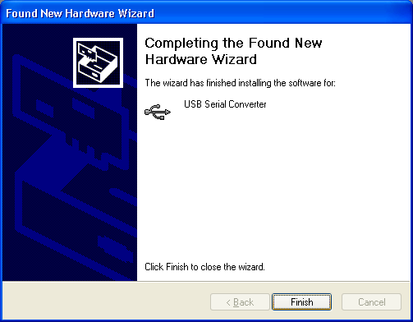

* Now click on the Arduino IDE icon present on your Desktop. A window will appear like this.

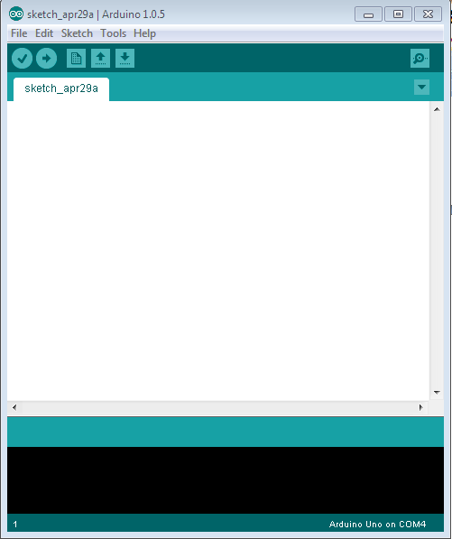

* For any sample programs, select FILE option🡪Examples.

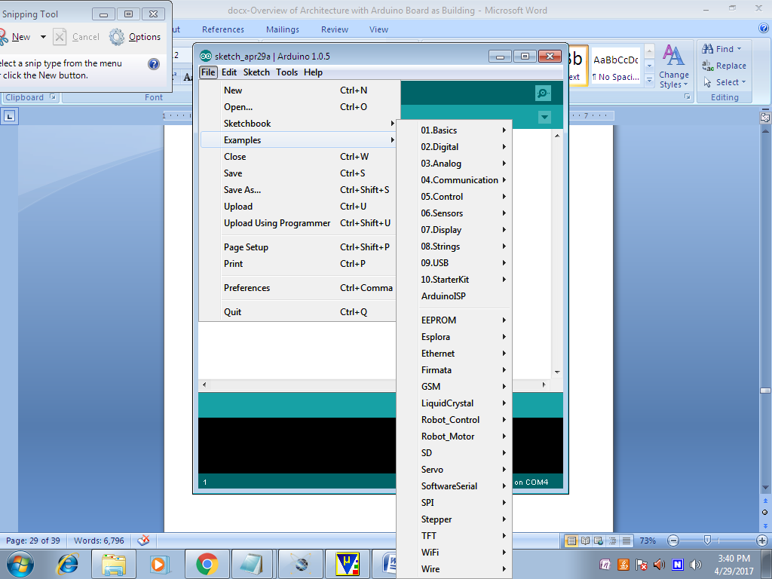

* After Entering the Sample Code in the file, it would look like this

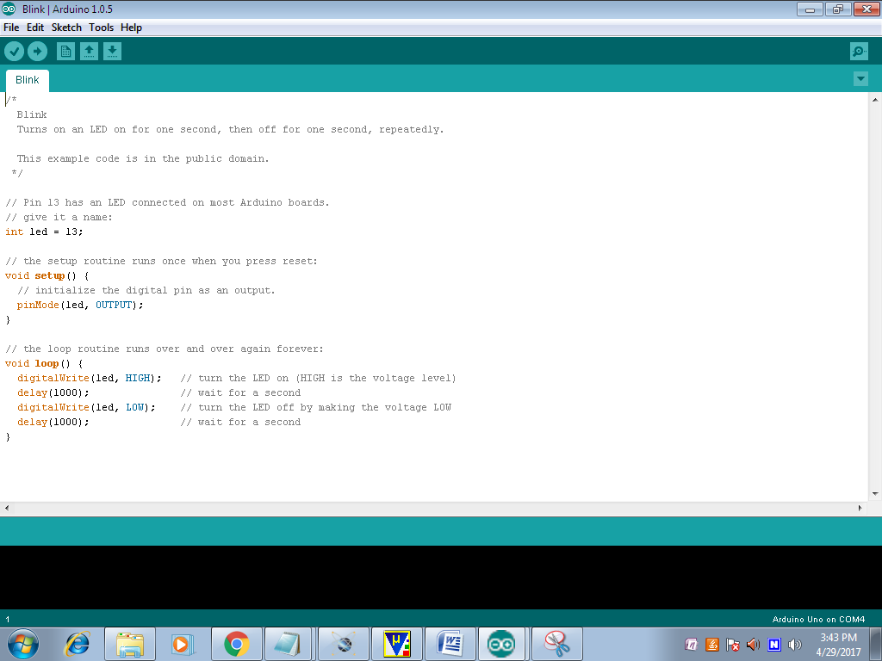

* Before Connecting we have to select which Board is used by the user, Basically UNO. By selecting TOOLS🡪Board🡪ARDUINO UNO

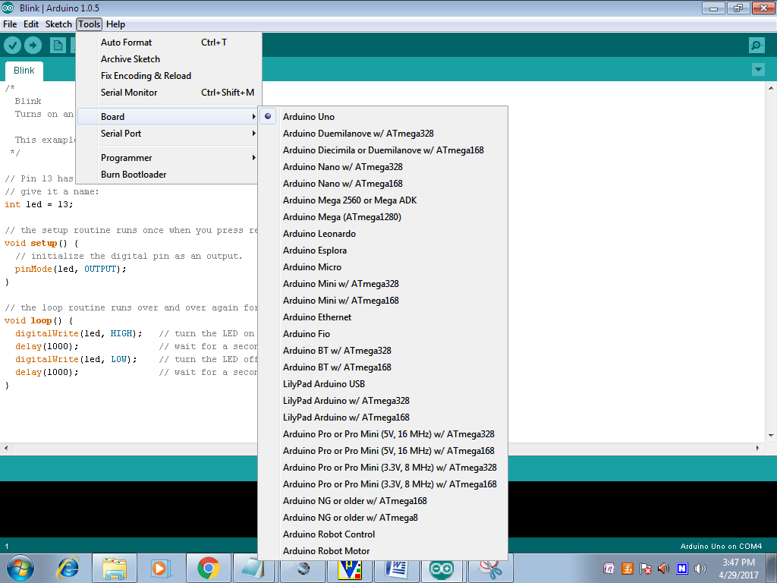

* Now to dump the in the board Connect the Arduino to the PC through the USB port available in it. Like this TOOLS🡪SERIAL PORT🡪COMM4,COMM8 etc;

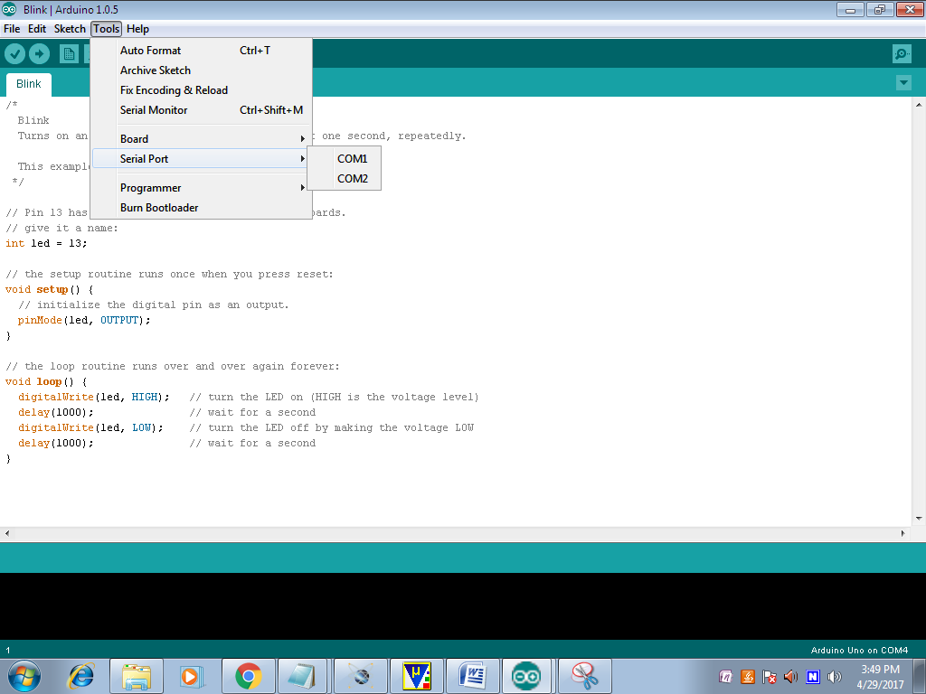

* To verify the written Program select COMPILE option available in the software ().
* Now Connect the Board and select the COMM port and then UPLOAD the file in ARDUINO(🡪)
* To OPEN the Previous ARDUINO FILE selects option.
* To enter new files select NEW option.
* To Save the Existing File, Click on the.
* To Send the Data Through Serial Monitor, Click on the (Ǫ).

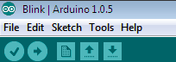

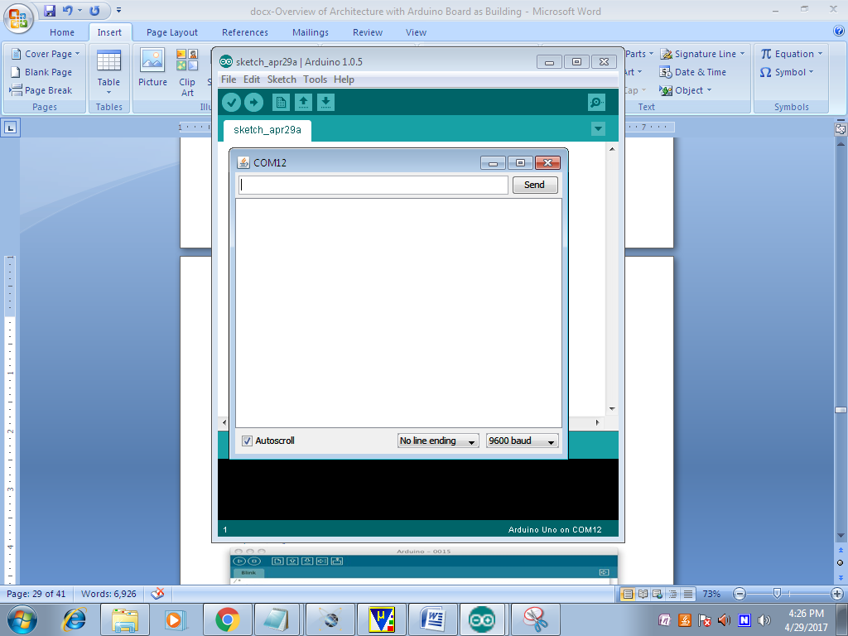

* Here we can see the Serial Data.

**5.2.2 Source code**

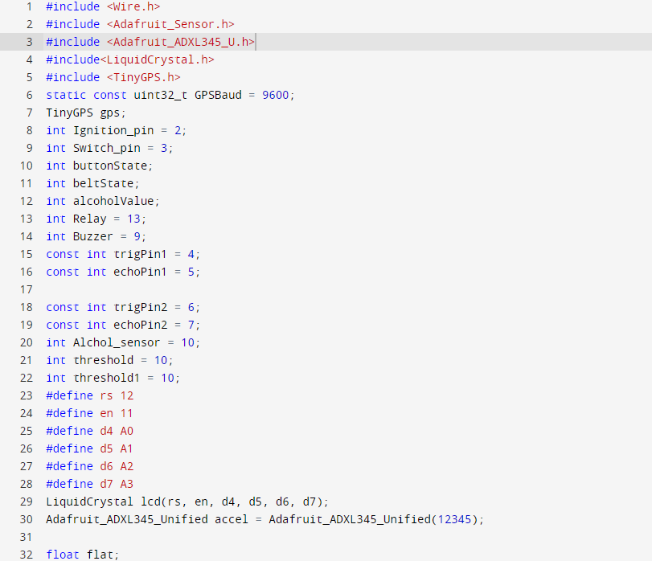

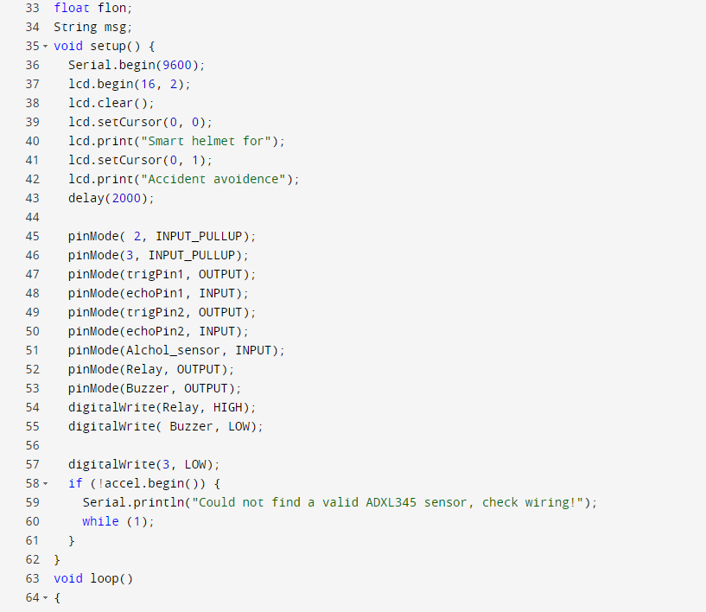

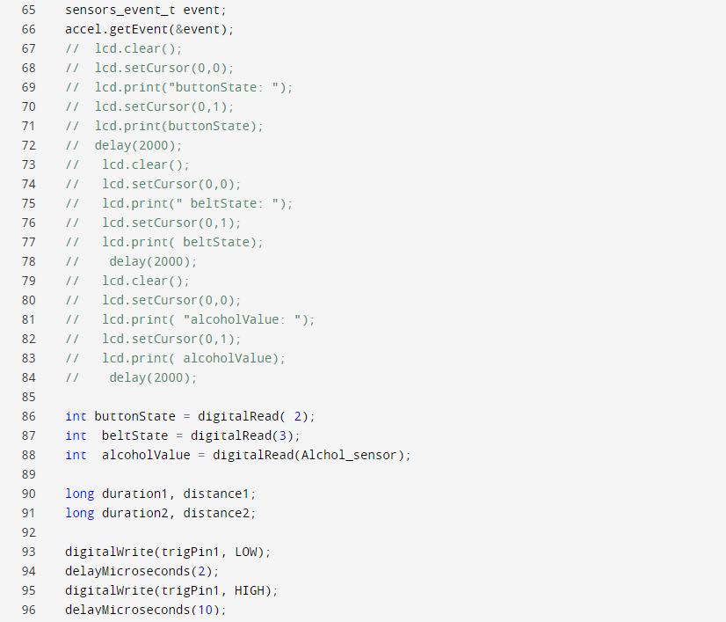

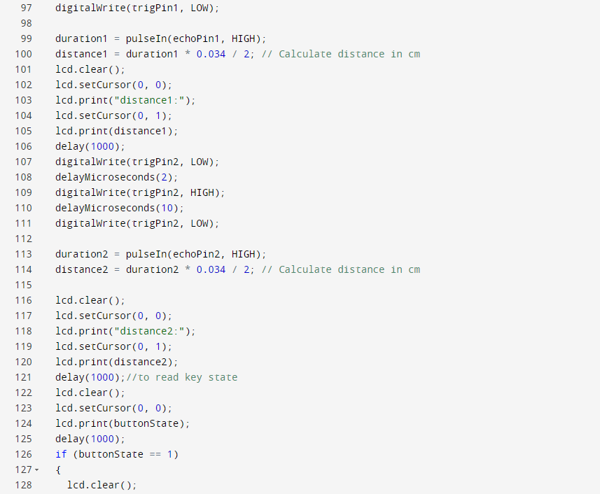

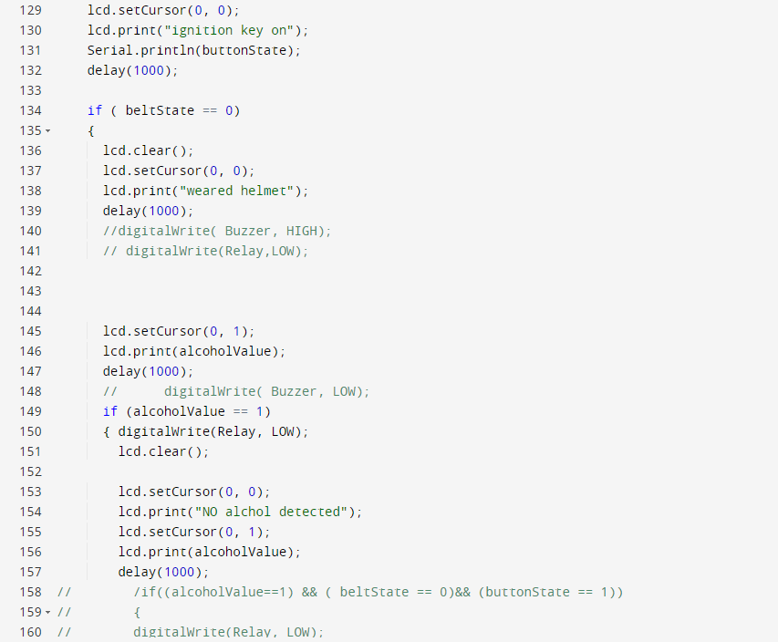

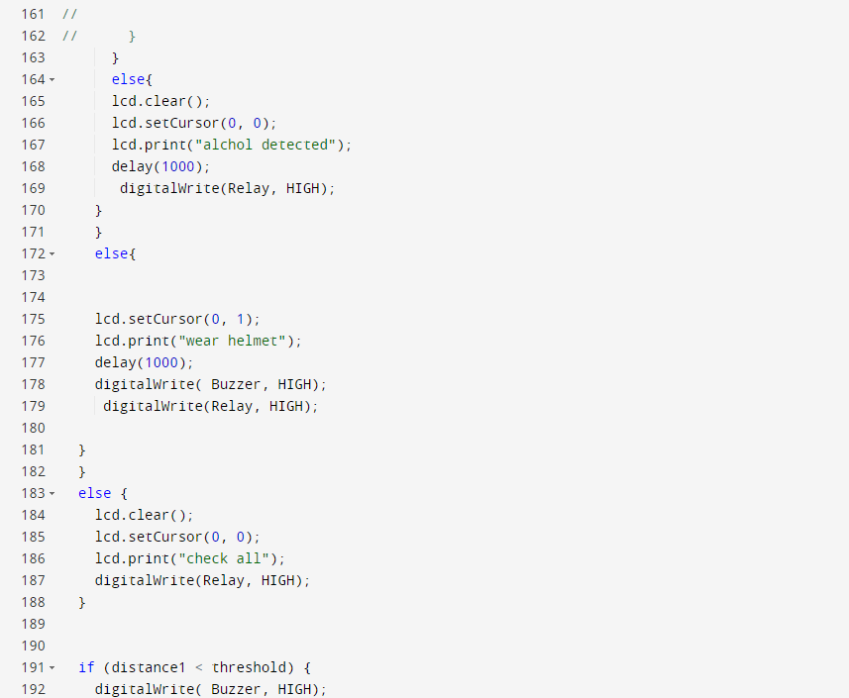

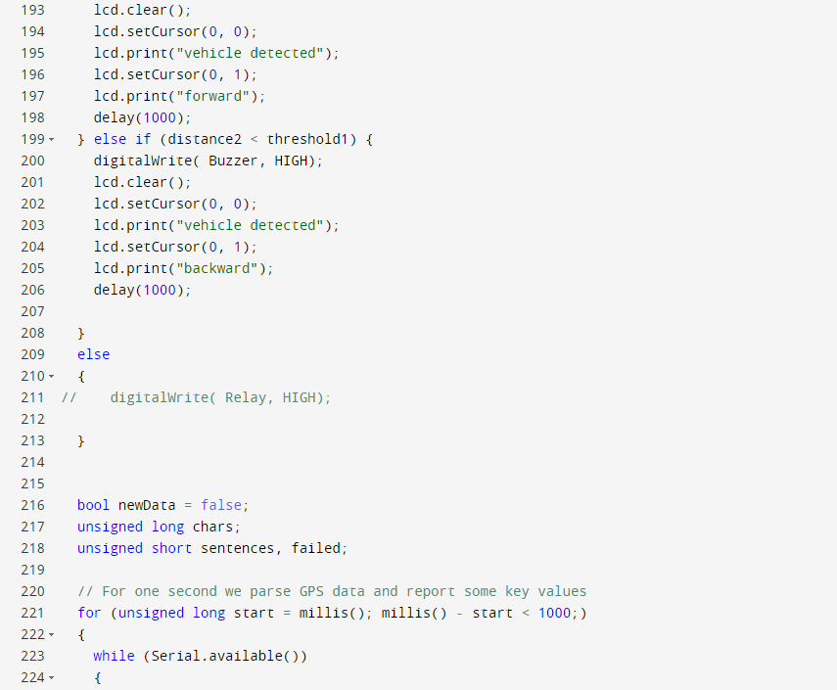

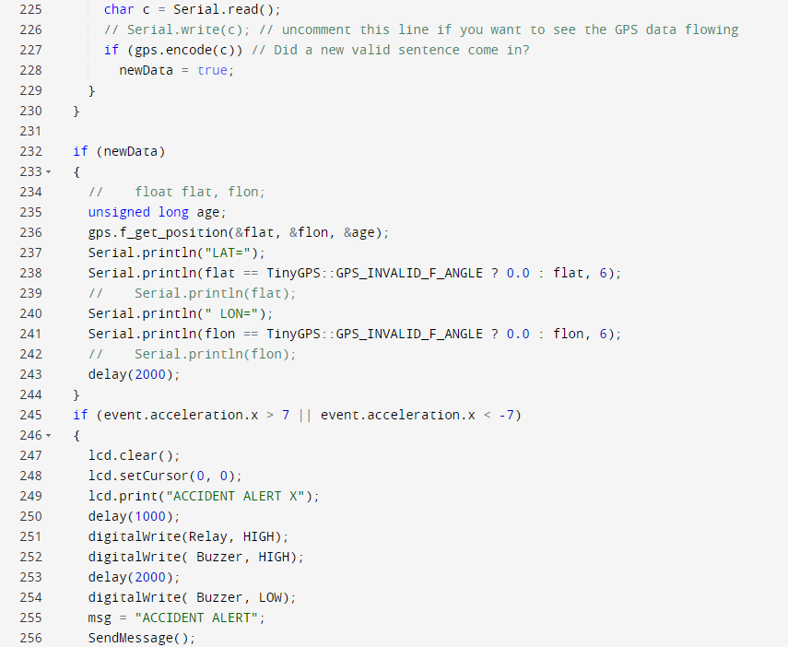

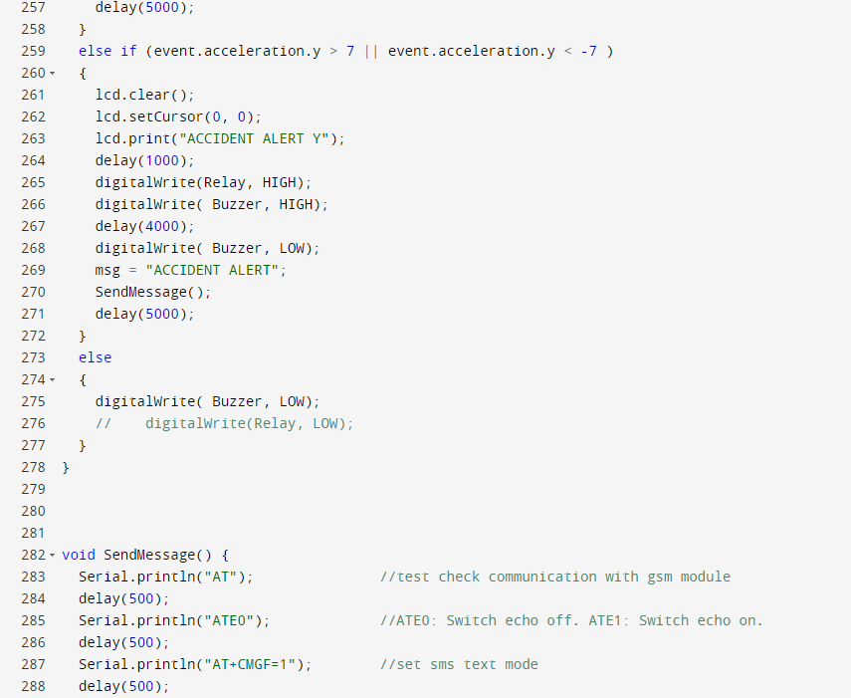

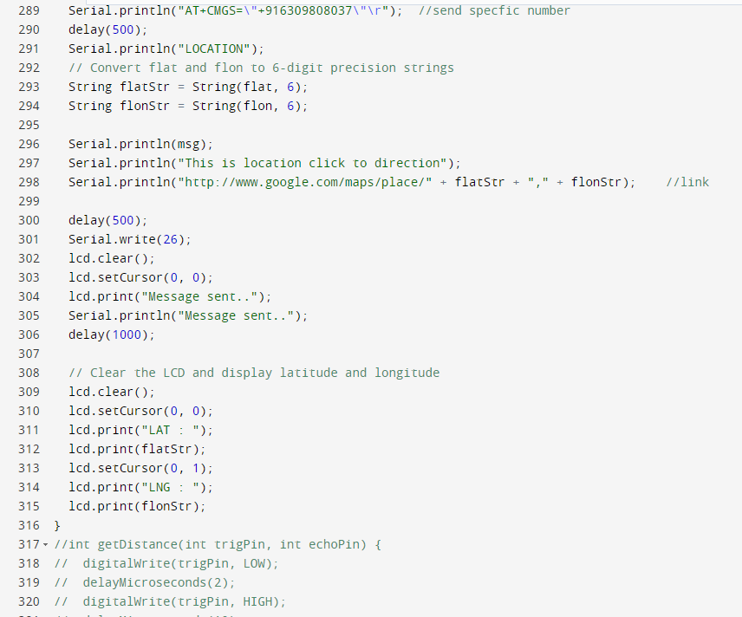

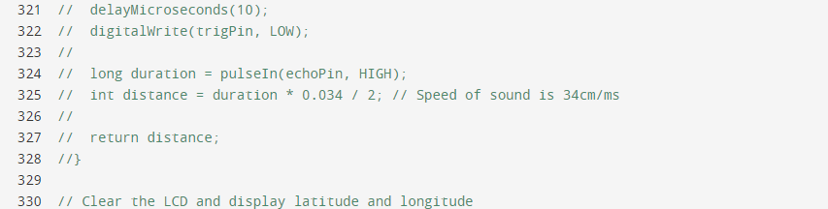

**CHAPTER-6**

**TESTING**

**6.1 Testing Approach**

We will test the project in two stages: software and hardware. The software part is to be tested via the Arduino IDE, whereas the hardware part has to be tested physically. It is necessary to check whether the system is working properly or not

.

**6.2 Features to be tested**

After building the whole circuit we test it, This project should satisfy some features. Features to be tested as follows:

* Impact Protection: Verify that the helmet provides adequate protection against impacts by conducting impact tests according to safety standards.
* The Alcohol sensor should give proper output, to detects whether the rider consumed alcohol or not.
* Crash Detection and Alert Systems: Test crash detection sensors and automatic alert systems to ensure timely detection and notification of accidents, simulating crash scenarios and verifying alert transmission.
* Integration Testing: Test the integration of the LED display with other components of the smart helmet, such as sensors, micro controllers, and communication modules. Verify that the display functions seamlessly with the rest of the helmet's features.

**6.3 Testing tools and Environment**

For testing of the project we require some tools, like to test Arduino program we require software called Arduino IDE. Using this we can check the program that program is working properly or not.

**6.4 Test Cases**

In this section we discuss about the inputs, expected output, testing procedure.

**6.4.1 Inputs**

This project requires several inputs.

1.Power supply: Power supply is the basic need of any electronic circuit. Here we use 3.3v power directly from the Motor vehicle.

2.Sensor Inputs: Verify accuracy of built-in sensors like accelerometer and gyroscopes. Here we use sensor like Alcohol to detect.

3.Physical Inputs: Test buttons, switches, or touch controls for responsiveness.

4.Power Inputs: Test charging port and battery performance.

5.User Interface Inputs: Ensure intuitive interaction with LED indicators or displays.

##### 6.4.2 Expected Output

The expected output of this project should be a LCD display . The output should also be seen on the serial monitor of the Arduino IDE.

##### 6.4.3 Testing Procedure

Testing procedures for smart helmets typically involve several steps to ensure the functionality, safety, and reliability of the device.

* Functional Testing: Ensure all features (Bluetooth, GPS, etc.) operate correctly.
* Durability Testing: Evaluate impact resistance and durability under different conditions.
* Battery Performance: Assess battery life and charging efficiency.
* Safety Testing: Confirm adherence to safety standards and effectiveness of safety features.
* Comfort Testing: Verify comfort during extended wear.
* Software Testing: Test firmware, mobile app, and user interface for functionality and usability.
* Field Testing: Gather feedback from users in real-world situations.
* Quality Assurance: Implement rigorous quality control measures throughout production to maintain consistency and reliability.

# CHAPTER-7 RESULT

The IoT-based smart helmet designed for two- wheeler safety offers a high level of reliability and security. Its primary objective is to safeguard users during their usage. When the helmet is worn, it initiates beneficial outcomes. Specifically, it effectively prevents drunk driving accidents. Through advanced technology, the system accurately identifies accident locations with a precision rate of 90%, promptly notifying pre-selected contacts to ensure appropriate responses to the user's needs.

The system also monitors helmet tilt and compares it against preset threshold values to detect potential mishaps such as falls. Additionally, it incorporates an alcohol detection feature, ensuring that the motorcycle won't start if the rider is intoxicated. Notably, this device operates based on the driver's actions, prioritizing safety measures and promoting responsible riding habits

Fig 7.1 shows that the rider/user wears the helmet and the circuit is detected .The Result is displayed on LCD display.

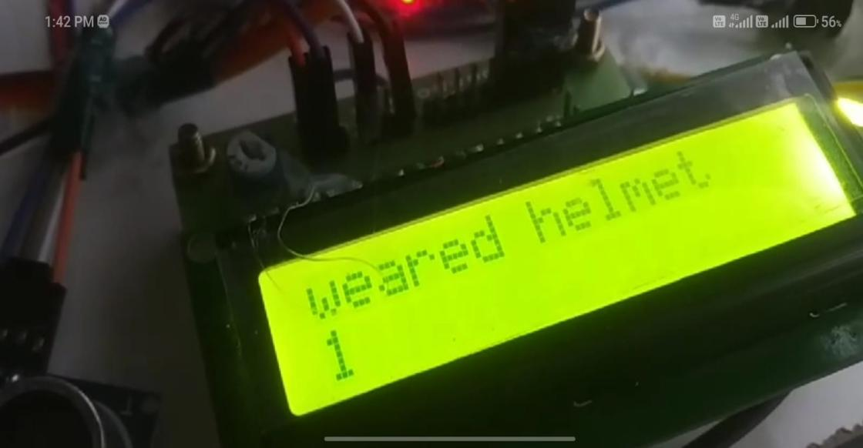

**Fig 7.1 LCD display with Helmet Detection**

Fig 7.2 shows that the detection of alcohol through alcohol sensor,whether the rider or the user drank alcohol.The Result is displayed in LCD display .

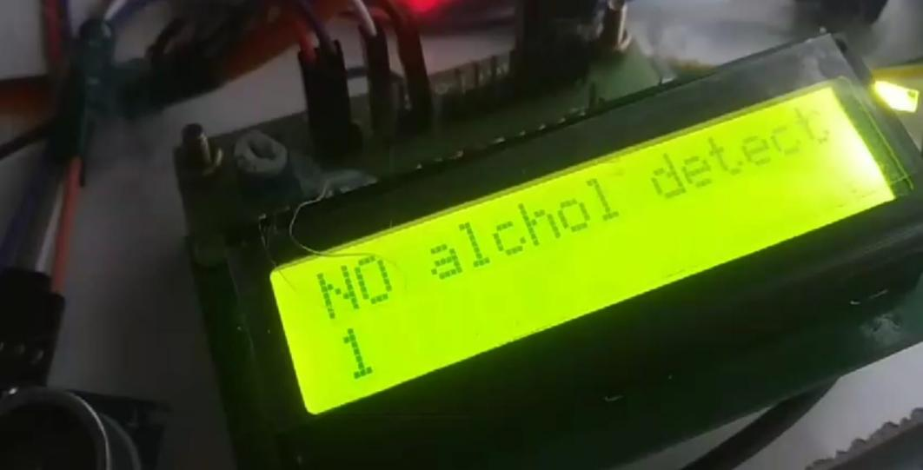

**Fig 7.2 LCD display with Alcohol Detection**

Fig 7.3 shows that the detection of ignition of helmet whether the user wear helmet properly or not,This detect the rider or the user wear helmet ,The ignition key will be on and the bike will start after the detection.The Result is displayed in LCD display.

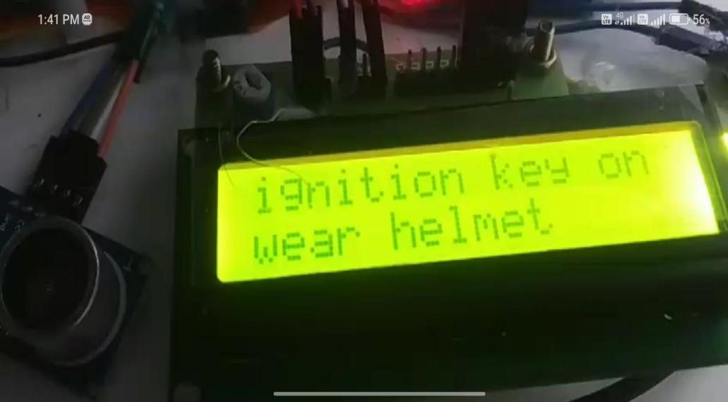

**Fig 7.3 LCD display with Ignition Key**

Fig 7.4 shows that the alert message whether the rider went under accident , this will be shared to the recipient and near by hospital to rescue the patient . The Result is displayed in LCD display

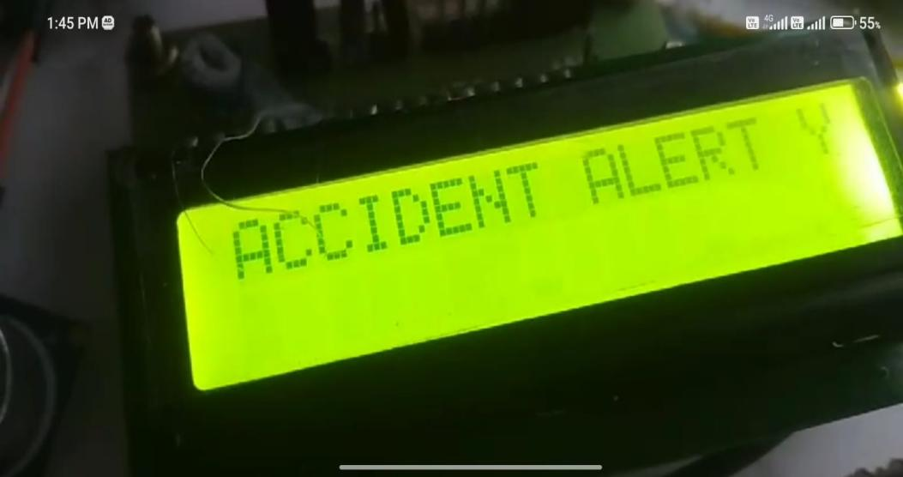

**Fig 7.4 LCD display with Alert Message**

Fig 7.5.1 and Fig 7.5.2 shows that the vehicle is detected on forward and backward, It means while riding the bike the system will detect whether any vehicles are moving on forward and backward,The Result is displayed in LCD display.

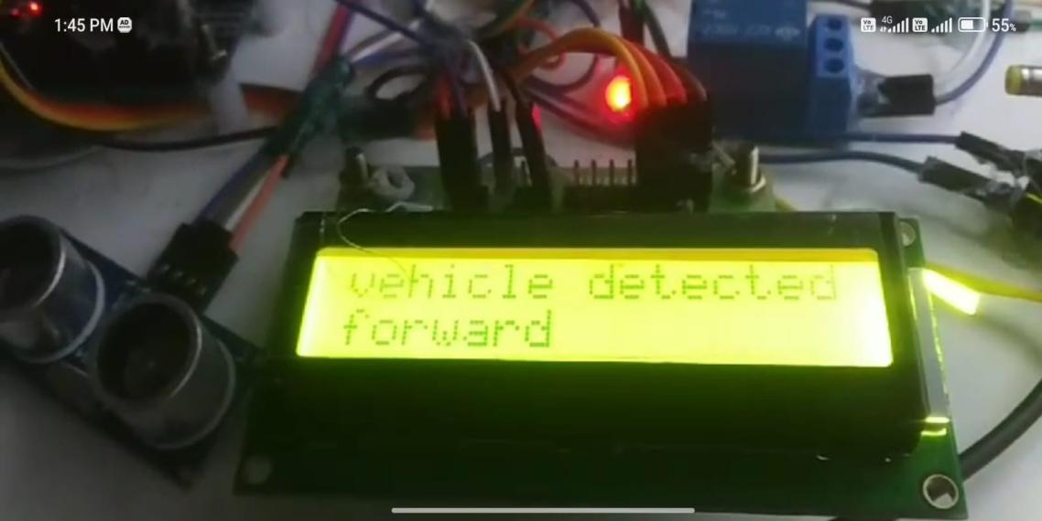

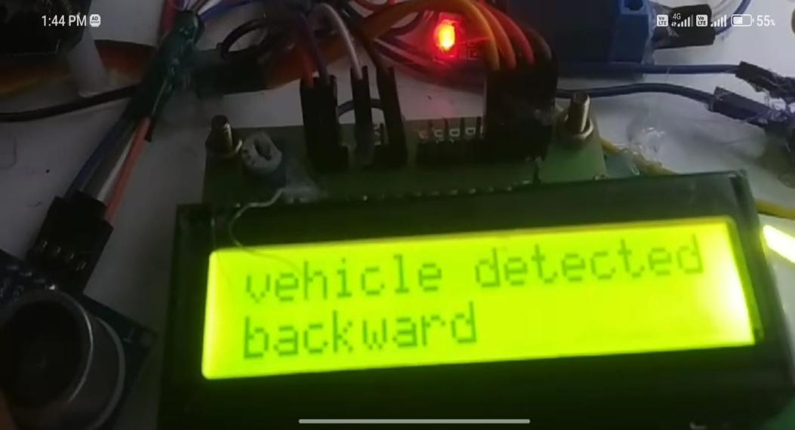 **Fig 7.5.1 LCD display with vehicle detection forward**

**Fig 7.5.1 LCD display with vehicle detection Backward**

**CONCLUSION AND FUTURE WORK**

The proposed system aims to ensure user safety by promptly notifying registered contacts in the event of an accident and providing immediate safety measures at the accident scene. Additionally, the system addresses the issue of alcohol consumption by preventing instances of drinking and driving. Moreover, it ensures compliance with safety measures by enforcing the wearing of helmets at all times.the smart helmet project aims to significantly improve road safety by incorporating features to detect alcohol consumption and ensure helmet usage. With a limit switch confirming helmet presence and a gas sensor detecting alcohol in the rider's breath, the helmet prevents the motorcycle from starting unless both conditions are met. This innovative approach not only targets common causes of accidents but also aligns with the broader goal of reducing global road fatalities. As the project progresses, careful attention to user interface, durability, regulatory compliance, and user acceptance will be crucial for successful integration, promising a safer and more responsible motorcycle culture.

The smart helmet technology could include advancing sensor capabilities to detect various forms of impairment beyond alcohol, integrating further with vehicle systems for enhanced safety features, analyzing rider behavior for early warning signs of accidents, improving user interfaces for real-time feedback, utilizing collected data for analytics and machine learning, ensuring regulatory compliance and standardization, and addressing accessibility and affordability concerns

# REFERENCES

[1] Jannatual Ferdous Riya & Md. Tanvir Hossain Chowdhury(2023) on “https://A Smart Helmet: Ensuring Safety for Bike Riders” in 2023International Conference on Robotics, Electrical Signal Proceesing Techniques (ICREST)

[2] Md. Atiqur Rahman, S.M Ahsanuzzamam and Ishman Rahman(2022)“IOT Based Smart Helmet and Accident Identification System” 2022IEEE Region 10 Symposium (TENSYMP), 5-7 June 2022

[3] Pranav Pathak on “Smart Helmet with Motorbike Unit for Enhanced Safety”, in 2020 International Conference on Advances in Computing,Communication Control and Networks(ICACCN) in 2020

[4] S. Shafiulla Basha , B. P. Santosh Kumar, Syed. Jahangir Badashah “Smart Helmet for Bike Riders Safety” ISSN: 2321-9653; IC Value:45.98; SJ Impact Factor: 7.538 in Feb 2022.

[5] D Dhanalakshmi; Vuppulapu Sai Sripath; Shanmugasundaram Hariharan; Poluka Vanitha; S. V. Vasantha “Intelligent human lifesaver using smart helmet with IoT” application International Conference on Research Methodologies in Knowledge Management, Artificial Intelligence and Telecommunication Engineering (RMKMATE) in 2023.

[6] Somantri; Indra Yustiana “Smart Helmet Integrated with Motorcyclesto Support Rider Awareness and Safety Based Internet of Things” International Conference on ICT for Smart Society (ICISS) in 2022.

[7] Mohammad Ehsanul Alim; Sarosh Ahmad; Marzieh Naghdi Dorabati; Ihab Hassoun “Design & Implementation of IoT Based Smart Helmet for Road Accident Detection” IEEE Annual Information Technology, Electronics and Mobile Communication Conference (IEMCON) in2020.