2016 Feb 03

Developer Interview Problems

1. Find the highest valued data point in a given data set.
2. Find the second highest valued data point in a data set.
3. Find the lowest valued data point in a data set
4. Find the zero based centroid value (explained below)

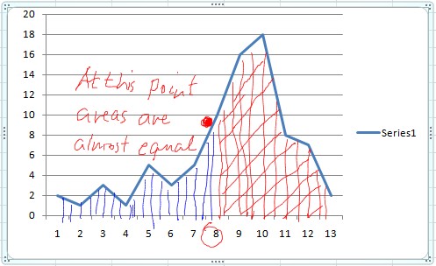

The centroid value can be thought of as the “balance point”. Think of drawing the peak on a piece of cardboard, and cutting it out, and then balancing it on a knife’s edge. The point where it balances is the centroid value we are looking for.

Assume the indexes are 0 based. Also assume that the point you want is the one where the accumulated area is still less than half the total area.

Assume that the height is equal to the area.