*A project report on*

**Skin condition diagnosis using CNN**

*Submitted in partial fulfillment for the award of the degree of*

## BTECH - Computer Science and Engineering (Artificial Intelligence and Machine Learning)

*by*

**CHERUKURI PAVAN SATISH(21BCE9357)**

**Vadlapudi Kalyan Hanuman Chowdary(21BCE9180)**

**MARISARLA YATHEESWAR(21BCE9094)**

**School of Computer Science & Engineering**

May, 2025

**DECLARATION**

I here by declare that the thesis entitled “ **Skin condition diagnosis using CNN** ”

submitted by me, for the award of the degree of Specify the name of the degree VIT is a record of Bonafide work carried out by me under the supervision of **Dr. Koduru Hajarathaiah**.

I further declare that the work reported in this thesis has not been submitted and will not be submitted, either in part or in full, for the award of any other degree or diploma in this institute or any other institute or university.

Place: Amaravati

Date: 15-05-2025 **Signature of the Candidate**

**CERTIFICATE**

This is to certify that the Senior Design Project titled **“Skin condition diagnosis using CNN”** that is being submitted by **CHERUKURI PAVAN SATISH(21BCE9357), Vadlapudi Kalyan Hanuman Chowdary (21BCE9180), MARISARLA YATHEESWAR(21BCE9094)** is in partial fulfillment of the requirements for the award of Bachelor of Technology, is a record of bonafide work done under my guidance. The contents of this Project work, in full or in parts, have neither been taken from any other source nor have been submitted to any other Institute or University for award of any degree or diploma and the same is certified.

Dr. Koduru Hajarathaiah

**GUIDE**

**The thesis is satisfactory / unsatisfactory**

**Internal Examiner External Examiner**

**Approved by**

**Dr. Reeja S R**

**HOD, Department of AI & ML**

**School of Computer Science and Engineering**

**ABSTRACT**

Skin diseases affect a large portion of the global population and can range from benign conditions to life-threatening melanomas. Early detection and accurate diagnosis are essential to ensure timely treatment and reduce the risk of complications. However, access to dermatologists is limited in many parts of the world, which highlights the need for automated diagnostic tools.

Convolutional Neural Networks (CNNs) have shown great potential in image-based medical diagnostics due to their ability to automatically learn relevant features from raw image data. In this study, we explore the application of CNNs for diagnosing common skin conditions using both clinical and dermatoscopic images.

A custom CNN architecture was developed and trained on a labeled dataset comprising images of various skin conditions such as eczema, psoriasis, acne, benign nevi, and melanoma. Data augmentation and preprocessing techniques were applied to improve model performance and robustness across diverse skin tones and image qualities.

The model was evaluated using standard metrics including accuracy, precision, recall, and F1-score. Results indicate that the CNN performs comparably to dermatologists in recognizing certain conditions, particularly in distinguishing between benign and malignant lesions.

This research demonstrates the feasibility of using deep learning for automated skin disease diagnosis. It has the potential to support clinical decision-making, enhance teledermatology services, and increase access to dermatological care, especially in underserved areas.

**ACKNOWLEDGEMENT**

It is my pleasure to express with deep sense of gratitude to Dr. Koduru Hajarathaiah,Assistant Professor Senior Grade, School of Computer Science & Engineering,VIT-AP, for his constant guidance, continual encouragement, understanding; more than all, he taught me patience in my endeavor. My association with him is not confined to academics only, but it is a great opportunity on my part of work with an intellectual and expert in the field of machine learning and Deep learning I would like to express my gratitude to **Dr. G. Viswanathan**, vice-president **Dr. S. V Kota Reddy**, and **Dr.S.Sudhakar Ilango**,HoD of AI &ML **Dr.Reeja S R** ,School of Computer Science & Engineering, for providing with an environment to work in and for his inspiration during the tenure of the course.

In jubilant mood I express ingeniously my whole-hearted thanks to **Dr.Reeja S R**. HoD of Ai & Ml, all teaching staff and members working as limbs of our university for their not-self-centered enthusiasm coupled with timely encouragements showered on me with zeal, which prompted the acquirement of the requisite knowledge to finalize my course study successfully. I would like to thank my parents for their support.

It is indeed a pleasure to thank my friends who persuaded and encouraged me to take up and complete this task. At last but not least, I express my gratitude and appreciation to all those who have helped me directly or indirectly toward the successful completion of this project.

Place: Amaravati.

Date:15-05-2025

## CONTENTS

CONTENTS iii

LIST OF FIGURES iv

LIST OF TABLES v

LIST OF ACRONYMS vi

CHAPTER 1 INTRODUCTION

* 1. INTRODUCTION 1
  2. OVERVIEW 4
  3. CHALLENGES 6
  4. PROJECT STATEMENT 10
  5. OBJECTIVES 13
  6. SCOPE OF THE PROJECT 16

**CHAPTER 2**

**BACK GROUND**

* 1. INTRODUCTION………………………………………………………………….12

2.2 LITERATURE SURVEY………………………………………………………….13

**LIST OF FIGURES:**

1.1: Sample images of eczema and psoriasis skin lesions

2.1: Architecture of the Convolutional Neural Network (CNN) used for

CLASSIFICATION

2.2: Confusion matrix showing CNN model performance on test data

**LIST OF TABLES:**

* 1. models USED on skin disease detection psoriasis
  2. Models used for detection of psoriasis and eczema

**LIST OF ACRONYMS**

CNN: Convolutional Neural Network

SVM: Support Vector Machine

KNN: K-Nearest Neighbours

Random Forest

XG Boost

**Chapter 1**

**Introduction**

Skin diseases are a significant public health concern due to their high prevalence and considerable impact on individuals' quality of life. Among the most common chronic skin conditions are eczema and psoriasis, both of which affect millions of people globally.

**1.1 Chronic Skin Diseases**

**1.1.1 Eczema**

Eczema, or atopic dermatitis, is a chronic inflammatory skin condition that manifests as red, itchy, and inflamed skin. While it can affect individuals of all ages, it is particularly prevalent in children.

Causes: A combination of genetics, environmental factors, stress, and allergies.

Management: Though incurable, eczema can be controlled using topical treatments, oral medications, and lifestyle modifications.

**1.1.2 Psoriasis**

Psoriasis is another common chronic skin condition characterized by red, scaly patches that are often itchy and painful. It is widely believed to be an autoimmune disorder, where the immune system mistakenly attacks healthy skin cells.

Causes: While the exact cause remains unknown, genetic and environmental factors are thought to contribute.

Management: Treatments include topical agents, oral medications, and phototherapy. Like eczema, psoriasis is not curable but manageable.

**1.2 Impact on Quality of Life**

Both eczema and psoriasis can severely affect a patient’s physical comfort and emotional well-being, often leading to decreased self-esteem, anxiety, and depression. Therefore, early detection and diagnosis are vital to improving treatment outcomes and minimizing healthcare costs.

**1.3 Challenges in Diagnosis**

**1.3.1 Reliance on Clinical Expertise**

Traditionally, dermatologists diagnose skin conditions based on visual inspection and clinical experience. However, this process can be time-consuming and prone to human error, especially in ambiguous cases.

**1.3.2 Limitations in Existing Machine Learning Approaches**

While machine learning (ML), particularly deep learning (DL), has shown promise in automating skin disease detection, several challenges remain:

**1.3.2.1 Limited Data Availability:**

The lack of large, diverse, and annotated datasets of skin images hampers the development of reliable ML models.

**1.3.2.2 High Dimensionality of Image Data:**

Traditional ML algorithms may struggle with complex, high-dimensional image data, resulting in lower performance.

**1.3.2.3 Single-Disease Focus:**

Most existing models are designed to detect only one skin condition, making them inefficient in real-world clinical settings where multiple conditions may co-exist.

**1.4 Role of Machine Learning in Skin Disease Detection**

Automatic detection of skin conditions using ML can support dermatologists by:

Providing early diagnosis

Enhancing treatment planning

Reducing human error and workload

**1.5 Classification Models Used**

Several machine learning and deep learning models have been explored for skin disease classification tasks.

**1.5.1 Convolutional Neural Networks (CNNs)**

CNNs are powerful deep learning models well-suited for image classification tasks. They automatically extract and learn hierarchical features such as skin texture and lesion shape, making them effective for diagnosing eczema and psoriasis.

**1.5.2 Support Vector Machines (SVM)**

SVMs are traditional ML models known for their robustness in binary and multi-class classification. They work by identifying the optimal hyperplane that separates different classes in a dataset.

**1.5.3 K-Nearest Neighbors (KNN)**

KNN is a proximity-based algorithm that classifies new images by comparing them to the most similar instances in the training dataset. It is intuitive and effective for smaller, well-labeled datasets.

**1.6 Research Objective**

By leveraging the strengths of CNNs, SVMs, and KNNs, this research aims to:

Develop a robust and accurate skin disease classification system

Detect both eczema and psoriasis simultaneously

Assist dermatologists with timely and precise diagnoses

**Overview**

Human skin disease prediction is a rapidly evolving field that merges the power of medical science with modern technologies such as artificial intelligence (AI), machine learning (ML), and image processing. Skin diseases are among the most common health problems worldwide and can range from temporary and mild conditions to chronic and life-threatening illnesses. Some of the most prevalent skin diseases include acne, eczema, psoriasis, fungal infections, and more serious diseases such as melanoma and non-melanoma skin cancers. Early and accurate diagnosis is critical for effective treatment, especially in conditions like skin cancer where delayed diagnosis can lead to severe complications or death. However, diagnosing skin diseases is often challenging because many conditions exhibit similar visual symptoms, and their appearance can vary depending on the individual’s age, skin tone, and environment. This complexity has led to the increasing interest in using technology to assist in predicting and diagnosing skin conditions with higher accuracy and efficiency.

The application of artificial intelligence in dermatology, particularly in skin disease prediction, has shown significant promise in recent years. By leveraging vast datasets and advanced computing techniques, AI systems can learn to recognize patterns and features in skin images that may not be easily noticeable to the human eye. Among the various AI methods, deep learning—specifically Convolutional Neural Networks (CNNs)—has been widely used due to its superior performance in image classification tasks. These models are trained on large collections of labeled skin images, where each image is annotated with the correct diagnosis. As the model is exposed to more data, it learns to identify key features such as lesion size, shape, color, texture, and distribution, which are critical in distinguishing between different skin diseases.

For the success of any AI-driven skin disease prediction system, access to high-quality and diverse datasets is essential. Well-known datasets such as **HAM10000**, **ISIC (International Skin Imaging Collaboration)**, and **DermNet** provide thousands of clinical and dermoscopic images covering a broad spectrum of skin conditions. These datasets also contain important metadata including patient age, sex, lesion location, and diagnostic confirmation from dermatologists. Before these images are used for training machine learning models, they undergo preprocessing steps such as resizing, normalization, contrast adjustment, and augmentation to enhance image quality and increase the dataset’s variability. Augmentation techniques, like flipping, rotating, or adding noise to images, help in reducing overfitting and making the models more robust to real-world variations.

One of the key benefits of AI-based skin disease prediction systems is their ability to make healthcare more accessible. With the integration of these models into mobile applications, individuals can now use their smartphones to take pictures of skin anomalies and receive immediate analysis. These tools are particularly useful in remote or rural areas where access to dermatologists is limited. Moreover, these systems can serve as decision-support tools for general practitioners, helping them to refer patients to specialists when needed or to rule out benign conditions that do not require urgent care.

Despite the remarkable progress in this field, several challenges remain. A major issue is **dataset bias**—many skin disease datasets are disproportionately composed of images from individuals with lighter skin tones. This lack of diversity can lead to significant drops in performance when models are used on patients with darker skin. Another problem is **symptom similarity**, as many skin conditions share overlapping visual features that can confuse both human doctors and AI systems. Additionally, most deep learning models are often considered "black boxes" because they do not explain the reasoning behind their predictions, which makes it difficult for medical professionals to fully trust and adopt these tools in clinical practice. There are also important **ethical and legal concerns**, especially regarding patient data privacy, consent, and the potential misuse of AI in diagnosis without proper human oversight.

Looking to the future, human skin disease prediction is expected to become more accurate and comprehensive. Researchers are working on combining image data with other clinical information, such as patient history, genetic profiles, lifestyle factors, and even environmental exposure to improve prediction models. New advancements such as **explainable AI (XAI)** aim to make machine learning models more transparent and interpretable, which can build trust among healthcare providers. There is also growing interest in developing **real-time diagnostic tools** using wearable devices and IoT (Internet of Things) technology that can monitor skin health continuously and alert users to early signs of skin problems.

In conclusion, human skin disease prediction stands at the intersection of medicine and technology, offering the potential to revolutionize dermatological care. With continued advancements in AI, access to more representative datasets, and collaboration between technologists and healthcare professionals, these tools can greatly enhance the speed, accuracy, and accessibility of skin disease diagnosis. While there are still obstacles to overcome, the integration of predictive technologies into dermatology marks a significant step toward personalized and preventive healthcare for all.

**1.3 Challenges**

**1.3.1 . Lack of Diversity in Datasets**

One of the most pressing challenges in human skin disease prediction is the lack of diversity in the datasets used to train AI models. Many widely used skin image datasets, such as HAM10000 and ISIC, primarily consist of images from individuals with lighter skin tones (Fitzpatrick skin types I–III). This imbalance causes AI models to perform poorly when applied to people with darker skin tones (Fitzpatrick types IV–VI), leading to inaccurate diagnoses and a higher risk of missed or misclassified conditions. Certain skin diseases manifest differently across skin tones—conditions like psoriasis, melanoma, and eczema may appear with varying colors, patterns, or inflammation levels, which the model may not recognize properly if not adequately trained.

This bias can contribute to healthcare disparities, especially in countries with ethnically diverse populations. When AI models fail to generalize across different skin tones, it undermines their reliability and clinical usefulness. Overcoming this challenge requires active efforts in collecting more inclusive and balanced datasets that represent the full spectrum of human skin diversity. Collaborative global data-sharing initiatives and contributions from underrepresented regions can help close this gap and ensure equitable healthcare support.

**1.3.2. Visual Similarity Between Different Skin Conditions**

Skin diseases often present with overlapping visual features, making it difficult even for trained dermatologists to differentiate between them—this challenge also extends to AI systems. For example, benign moles can sometimes resemble melanoma, and psoriasis can appear similar to eczema or fungal infections in early stages. These visual similarities can confuse AI models, especially when they rely heavily on external features such as color, shape, size, and texture without deeper clinical context.

Moreover, variations in lighting, camera quality, and angle at which images are taken can further distort how skin conditions appear in photographs, adding to the confusion. The AI model may also struggle with detecting diseases in images that include obstructions like hair, shadows, or partial views. To improve accuracy, AI systems must be trained with highly curated and labeled datasets that include a wide variety of presentations for each disease and incorporate techniques like multi-modal learning, which combines image analysis with patient history, symptoms, and medical records.

**1.3.3. Black-Box Nature and Lack of Interpretability**

Many deep learning models used for skin disease prediction, especially Convolutional Neural Networks (CNNs), function as "black boxes." This means that while they may produce accurate predictions, they do not provide explanations or reasoning that is easily interpretable by humans, including medical professionals. In a medical setting, trust and transparency are crucial—doctors need to understand how a conclusion was reached before relying on it to make critical healthcare decisions.

This lack of interpretability poses a significant barrier to clinical adoption. Medical practitioners are understandably hesitant to use AI-generated diagnoses without insights into how or why the system arrived at its conclusion. Explainable AI (XAI) is a growing area of research that aims to address this issue by creating models that offer visual maps, heatmaps (like Grad-CAM), or text-based explanations alongside predictions. However, creating highly accurate yet interpretable models remains a difficult trade-off. Until AI predictions can be transparently justified, their use in high-stakes medical environments will continue to face resistance.

**1.3.4. Privacy, Ethics, and Regulatory Barriers**

Privacy concerns represent a serious obstacle in deploying skin disease prediction technologies, especially when patient images are used. Skin images are considered sensitive personal data, and improper handling can lead to privacy violations and ethical concerns. If patient data is shared without proper anonymization or consent, it can result in legal issues, breach of trust, and reputational damage for developers and healthcare institutions alike.

Moreover, ethical considerations arise when AI is used for autonomous diagnosis, especially in consumer-facing applications. The risk of false positives (predicting a disease where there is none) or false negatives (failing to detect an actual condition) can have serious health consequences. Without regulatory oversight, there’s a danger that unreliable or unapproved apps could mislead users into either ignoring real issues or panicking over harmless skin conditions.

In addition, skin disease prediction systems must comply with healthcare regulations like HIPAA in the U.S. or GDPR in Europe, which impose strict controls on data collection, storage, and sharing. Gaining clinical approval (such as FDA clearance) is another complex and lengthy process that requires extensive validation studies and documentation. All of these factors slow down the deployment of AI in real-world healthcare environments and add layers of complexity to product development.

**1.4 Problem Statement**

Skin diseases constitute a significant portion of global health concerns, affecting millions of individuals regardless of age, gender, or ethnicity. These conditions can vary in severity from mild irritation to life-threatening illnesses like melanoma. Early detection and appropriate classification of skin disease severity are vital for effective treatment, better patient outcomes, and reduced healthcare burdens. However, manual diagnosis by dermatologists is often subjective, time-consuming, and prone to errors—especially in remote or resource-limited regions where access to specialists is limited.

To address these challenges, this project proposes an automated skin disease prediction system using **Convolutional Neural Networks (CNN)**, a powerful deep learning technique widely used in image classification tasks. The system aims to analyze dermatoscopic or clinical images of affected skin areas and accurately classify them into **six distinct severity categories**:

1. **Very Mild**
2. **Mild**
3. **Moderate**
4. **Severe**
5. **Very Severe**
6. **Critical**

The primary objective is to not only detect the presence of a skin disease but also assess the **severity level**, enabling healthcare professionals to prioritize treatment based on risk and urgency. The CNN model will be trained on a labeled dataset comprising skin images annotated with both disease type and severity level. By learning visual patterns and features from the data, the model can generalize to unseen cases and provide a fast, reliable prediction.

This automated approach is expected to reduce diagnostic delays, support dermatologists with second opinions, and make basic skin disease assessment accessible to users through mobile or web-based platforms. Moreover, severity-level classification can help in monitoring disease progression and guiding treatment strategies, thereby enhancing overall patient care.

**Objective and Scope:**

The main objective of this project is to develop an intelligent and automated skin disease prediction system using **Convolutional Neural Networks (CNN)** to classify skin conditions based on severity levels. The model aims to:

* Analyze clinical or dermatoscopic images of skin lesions with high accuracy.
* Classify the detected skin disease into **six predefined severity levels**: *Very Mild, Mild, Moderate, Severe, Very Severe,* and *Critical*.
* Assist medical professionals by providing a reliable second opinion to support diagnosis and treatment planning.
* Improve accessibility to basic dermatological assessment in remote or under-resourced areas via mobile or web-based platforms.
* Reduce diagnostic time and minimize human error in early-stage detection and severity evaluation.

This project focuses on the application of deep learning techniques, particularly CNNs, to predict the presence and **severity of skin diseases** from image data. The scope of the project includes:

* **Data Collection & Preprocessing**: Utilizing publicly available and/or custom datasets containing labeled images of skin conditions with annotated severity levels.
* **Model Development**: Designing and training a CNN model capable of learning visual features from the dataset to perform multi-class classification into six severity levels.
* **Performance Evaluation**: Assessing the model’s performance using standard metrics such as accuracy, precision, recall, F1-score, and confusion matrix analysis.
* **Deployment Potential**: Exploring the integration of the model into a prototype mobile or web application for real-time skin disease prediction.
* **Limitations**: The system is limited to image-based classification and may not incorporate additional clinical inputs such as patient history or genetic factors. Also, it does not replace professional medical diagnosis but serves as a decision-support tool.

**1.5 Objectives**

In this study, we aim to develop robust machine learning models for the detection of eczema and psoriasis using a dataset sourced from Kaggle. We experiment with three prominent models: Support Vector Machines (SVM), K-Nearest Neighbors (KNN), and Convolutional Neural Networks (CNN). These models are fine-tuned and optimized to achieve the best performance in identifying and classifying skin diseases, specifically focusing on eczema and psoriasis. By leveraging these diverse models, we aim to improve diagnostic accuracy and provide valuable support for early detection and clinical decision-making in dermatology. particularly in the field of dermatology. Numerous studies have focused on the detection of skin diseases using various algorithms, highlighting the potential of these methods to enhance diagnostic accuracy and efficiency.

**1.MachineLearning in Dermatology**  
A study by Esteva et al. (2017) demonstrated the efficacy of deep learning models in diagnosing skin cancer, showing that convolutional neural networks could match or even exceed the diagnostic performance of dermatologists. This pioneering work set the stage for further exploration of machine learning applications in dermatological conditions beyond cancer.

**2.Eczema Detection**  
Research by Karamizadeh et al. (2020) focused on the automatic detection of eczema using image processing techniques combined with machine learning classifiers such as SVM and KNN. The study illustrated that these algorithms could effectively classify eczema images based on texture and color features, although the need for larger datasets was emphasized to improve model robustness.

**3. Psoriasis Classification**  
Similarly, Wang et al. (2018) explored the use of CNNs for the classification of psoriasis lesions in dermoscopic images. Their findings indicated that deep learning models, particularly CNNs, achieved high accuracy rates in differentiating between various types of psoriasis, underlining the importance of feature extraction capabilities inherent in these networks.

**4.Comparativestudies**Recent studies have compared the performance of different machine learning models in dermatological applications. For instance, a study by Ali et al. (2021) evaluated SVM, KNN, and CNN models for various skin diseases, concluding that while CNNs generally provided superior performance due to their ability to learn complex patterns, traditional algorithms like SVM and KNN were effective in specific scenarios where computational resources were limited.

**1.6.Scope**

The scope of this project encompasses the research, development, and testing of an artificial intelligence-based system designed to predict human skin disease severity using Convolutional Neural Networks (CNNs). With the growing prevalence of skin disorders globally, and the limited access to specialized dermatological care in many regions, there is a pressing need for technological solutions that can assist in early detection and severity assessment. This system aims to bridge that gap by offering an automated tool capable of analyzing skin lesion images and classifying them into six defined severity categories: *Very Mild, Mild, Moderate, Severe, Very Severe,* and *Critical*. Each of these categories reflects a different stage in the progression of a skin condition, thereby enabling targeted and timely intervention.

At its core, this project focuses on leveraging deep learning for the purpose of image-based skin analysis. CNNs have proven to be exceptionally effective for tasks involving visual recognition, and in this context, they serve as the primary tool for learning patterns and features present in dermatoscopic or clinical skin images. The system will be trained using a large dataset of skin lesion images that are properly labeled with the corresponding severity level. These images will undergo preprocessing steps such as normalization, resizing, contrast enhancement, and augmentation to ensure that the model can generalize well across various skin tones, lighting conditions, and image qualities.

A significant part of the project’s scope includes the design and optimization of the CNN architecture. This involves experimenting with different layers, filter sizes, activation functions, and optimization algorithms to achieve the best possible performance. The final model will be expected to classify input images into one of the six severity levels with a high degree of accuracy and minimal false positives or negatives. Alongside the development of the predictive model, the scope also includes performance evaluation using statistical measures such as accuracy, precision, recall, F1-score, and confusion matrix. These metrics will be used to validate the reliability and robustness of the system under various test conditions.

Another crucial aspect covered within the scope of this project is the system's potential for real-world application. While the core focus remains on model development and classification performance, the broader vision includes implementing the trained model into a user-friendly interface—either through a mobile app or a web platform. Such integration will allow users, especially in remote or underserved regions, to take photos of skin lesions and receive instant feedback on the probable severity of the condition. This could prove invaluable for triage purposes, guiding patients on whether to seek immediate medical attention or monitor the condition.

Furthermore, the scope addresses the ethical, clinical, and technical limitations of the proposed system. The model is designed strictly for educational and supportive use, not as a replacement for professional dermatological evaluation. It must be clearly communicated that the tool offers a prediction based on image data alone, without considering other clinical factors such as family history, previous conditions, allergies, or comorbidities. Additionally, there is an inherent limitation in relying solely on image datasets, especially if those datasets are not fully representative of global skin tone diversity or include mislabeled data. Measures such as dataset augmentation, quality filtering, and future dataset expansion are proposed to mitigate these issues.

Finally, the scope includes future enhancements and directions for expansion. This includes integrating patient metadata (age, gender, symptoms, history) to enable multimodal prediction, applying transfer learning techniques to reduce training time while improving model accuracy, and exploring the use of explainable AI to provide interpretability to the predictions made by the CNN model. These future advancements, though outside the initial implementation phase, are aligned with the broader goal of creating a comprehensive, scalable, and ethically sound AI-based skin disease prediction tool.

**Chapter 2**

**Conclusion and Future work**

**2.1 Introduction:**

Skin is the body’s largest organ and serves as the first line of defense against environmental factors, pathogens, and physical injury. Skin health is therefore crucial for overall well-being. Despite this, skin diseases are often underestimated in terms of their public health impact. Among the myriad dermatological conditions affecting populations worldwide, chronic inflammatory diseases such as eczema (atopic dermatitis) and psoriasis stand out due to their long-term nature, prevalence, and the physical and psychological burden they place on patients.

Eczema is a condition that often begins in early childhood and may persist into adulthood. It is characterized by symptoms such as redness, itching, flaking, oozing, and crusting of the skin. In severe cases, eczema can interfere with daily activities and sleep, leading to a significant reduction in quality of life. On the other hand, psoriasis is an autoimmune disorder that accelerates the life cycle of skin cells, leading to scaly, red patches that are often itchy or painful. It can manifest in different forms such as plaque psoriasis, guttate psoriasis, inverse psoriasis, and pustular psoriasis, each with varying symptoms and severity levels.

Both eczema and psoriasis are non-communicable and chronic, meaning they require long-term management. These diseases are driven by complex interactions between genetic predisposition and environmental triggers such as allergens, infections, stress, and weather changes. Because of their visible symptoms, both diseases also carry a high psychological burden, often leading to social stigma, anxiety, and depression.

**2.2 Literature Survey**

Several studies have explored the application of machine learning (ML) and deep learning (DL) techniques for the automatic detection and classification of skin diseases, including eczema and psoriasis. Early approaches relied heavily on traditional machine learning algorithms such as Support Vector Machines (SVM), K-Nearest Neighbors (KNN), and Random Forests. These methods typically required manual feature extraction based on color, texture, and shape. For instance, Barata et al. (2014) used handcrafted features and SVMs to classify dermoscopic images of skin lesions, demonstrating moderate accuracy but limited scalability due to manual feature dependency.

With the rise of deep learning, Convolutional Neural Networks (CNNs) have become the dominant approach for image-based medical diagnosis. Esteva et al. (2017) trained a CNN on over 130,000 skin images and achieved dermatologist-level accuracy in skin lesion classification. Similarly, Li and Shen (2018) developed a CNN-based model for psoriasis detection, achieving high classification accuracy using clinical images. These studies demonstrated the potential of CNNs to automatically learn discriminative features directly from raw images, eliminating the need for manual feature engineering.

In the case of eczema detection, Liu et al. (2020) proposed a deep CNN that achieved promising results in distinguishing eczema from other dermatological conditions, though the model required large annotated datasets for optimal performance. To overcome data scarcity, Mahbod et al. (2019) proposed a hybrid approach combining CNNs for feature extraction and SVM for classification. This method improved generalization on smaller datasets.

Hybrid models, which integrate deep feature extraction with traditional classifiers like SVM or KNN, have shown potential in improving performance, especially on limited datasets. Pham et al. (2021) reported that combining CNN features with KNN improved classification accuracy for multiple skin conditions, including psoriasis.

Despite these advancements, most existing models focus on single-disease classification, primarily targeting melanoma, with limited work addressing eczema and psoriasis together. Furthermore, the lack of diverse and well-annotated datasets, particularly for underrepresented skin tones and non-pigmented conditions, remains a major challenge.

In summary, while CNNs have significantly advanced the field of skin disease classification, challenges such as dataset limitations, lack of generalizability, and underrepresentation of certain conditions (like eczema and psoriasis) highlight the need for more inclusive and robust solutions. This study aims to address these gaps by evaluating and comparing CNN, SVM, and KNN models for the classification of eczema and psoriasis**.**

**Results**

**1. SUPPORT VECTOR MACHINE**

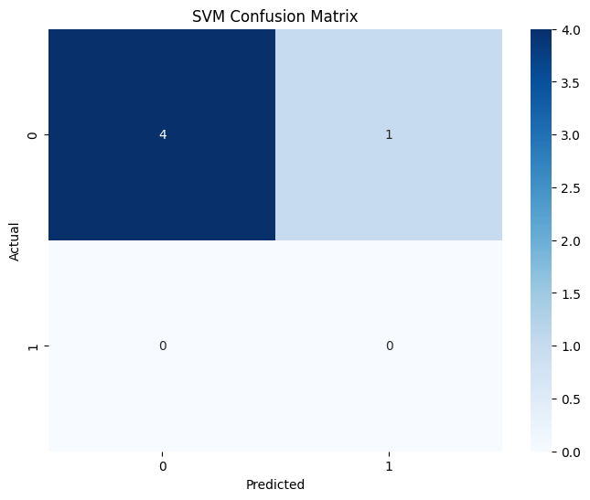 **(SVM**)

**2.k-nearest neighbor algorithm(KNN)**

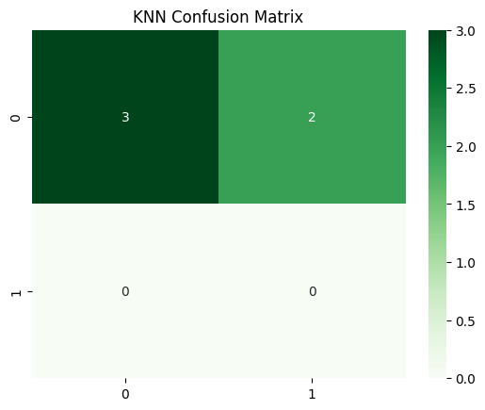

**3.RANDOM FOREST CLASSIFIER**

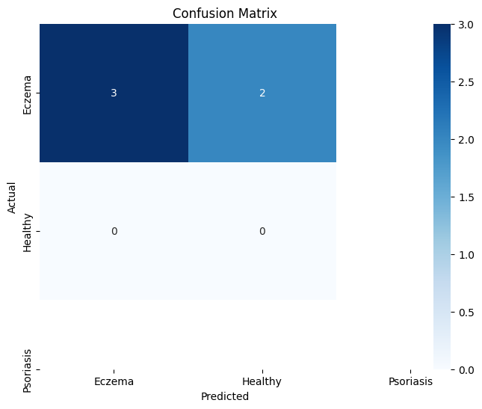

**DISEASE SEVERITY OVER TIME:(RANDOM FOREST CLASSIFIER):**

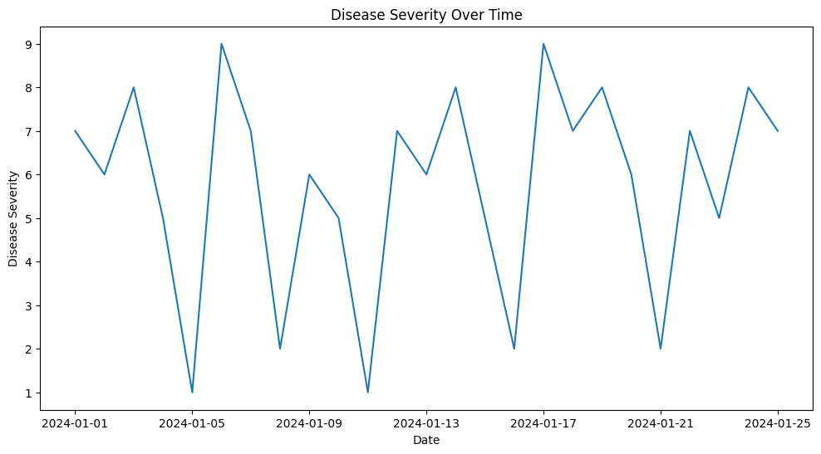

**DISEASE SEVERITY OVER TIME(ARIMA MODEL)**

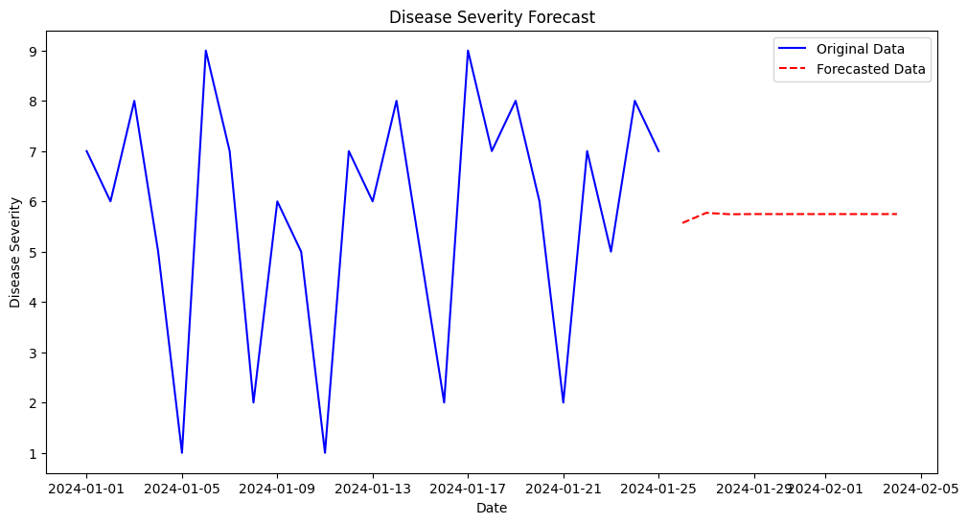

**2.1 ARCHITECTURE OF CONVOLUTIONAL NEURAL NETWORK:**

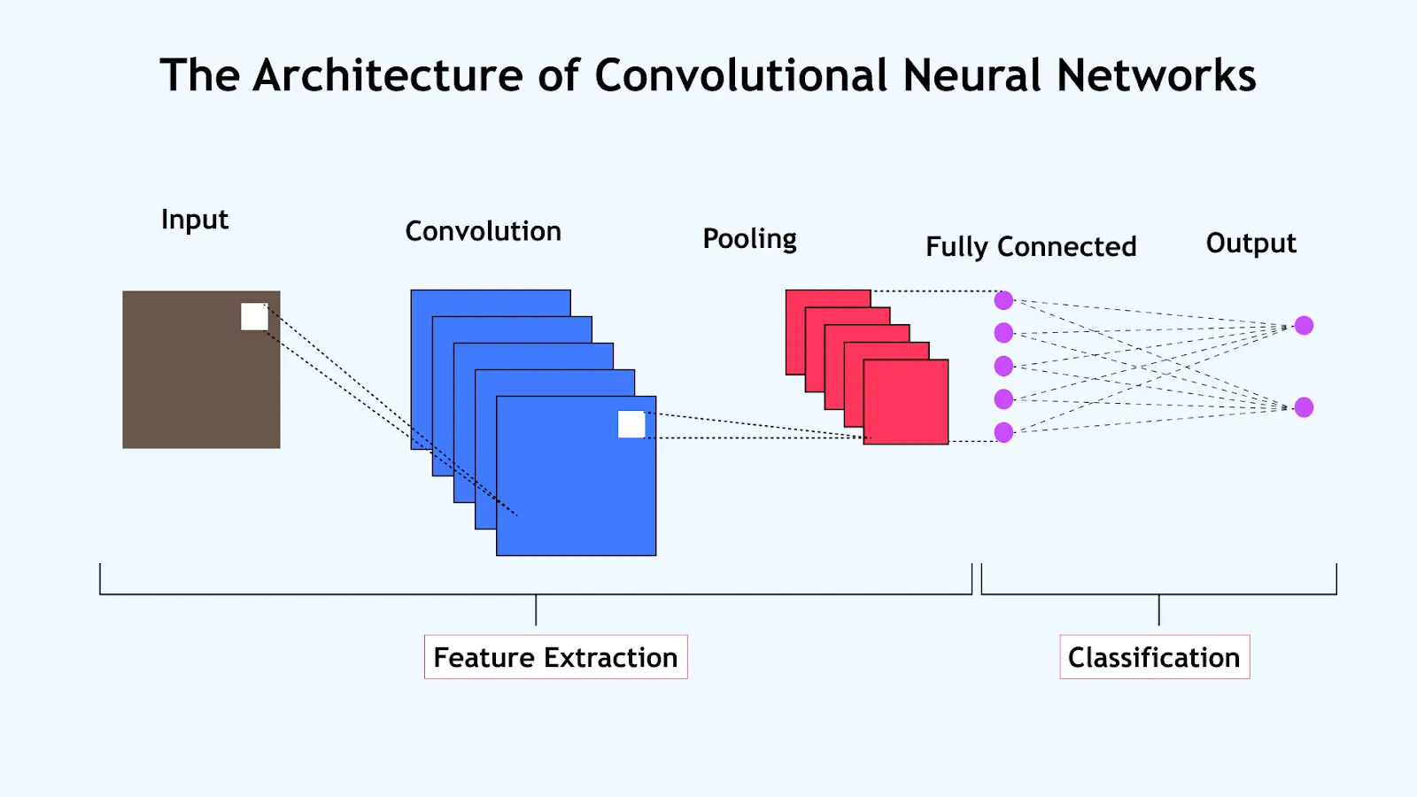

* 1. **Confusion matrix showing CNN model performance on test data**

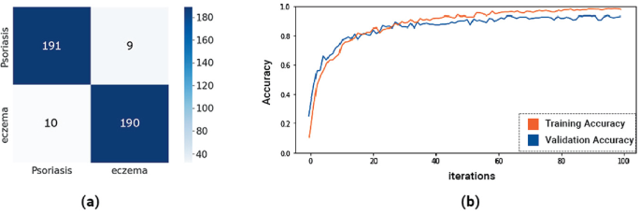

**Tables**

|  |  |  |  |  |
| --- | --- | --- | --- | --- |
| **Model name** | **Accuracy(%)** | **Precision(%)** | **Recall(%)** | **F1-Score(%)** |
| Random Forest Classifier | 60.00 | 100.00 | 60.00 | 75.00 |
| XGBoost | 70.95 | 73.14 | 70.95 | 70.41 |

Fig1: models on skin disease detection on psoriasis

|  |  |  |  |
| --- | --- | --- | --- |
| **Model** | **Test accuracy(%)** | **Test loss(%)** | **Best validation accuracy(%)** |
| CNN | 97 | 0.0003 | 96.82 |
| KNN | 88 | 0.0001 | 89.62 |
| SVM | 86 | 0.0001 | 73.00 |

Fig2. Models used for detection of psoriasis and eczema

**Codes**

import numpy as np

import pandas as pd

from sklearn.model_selection import train_test_split

from sklearn.preprocessing import StandardScaler

from sklearn.svm import SVC

from sklearn.neighbors import KNeighborsClassifier

from sklearn.metrics import accuracy_score, classification_report

from tensorflow.keras.models import Sequential

from tensorflow.keras.layers import Conv2D, MaxPooling2D, Flatten, Dense

# Generate synthetic dataset

np.random.seed(42)

n_samples = 1000

# Features: age, skin_type, exposure_time, symptoms_duration

X = np.column_stack((

np.random.randint(18, 80, n_samples), # age

np.random.randint(1, 6, n_samples), # skin_type (1-5)

np.random.randint(1, 8, n_samples), # exposure_time (hours)

np.random.randint(1, 30, n_samples) # symptoms_duration (days)

))

# Target: disease_spread (0: no spread, 1: mild spread, 2: severe spread)

y = np.random.randint(0, 3, n_samples)

# Split the data

X_train, X_test, y_train, y_test = train_test_split(X, y, test_size=0.2, random_state=42)

# Scale the features

scaler = StandardScaler()

X_train_scaled = scaler.fit_transform(X_train)

X_test_scaled = scaler.transform(X_test)

# SVM

svm_model = SVC(kernel='rbf', random_state=42)

svm_model.fit(X_train_scaled, y_train)

svm_pred = svm_model.predict(X_test_scaled)

print("SVM Accuracy:", accuracy_score(y_test, svm_pred))

print("SVM Classification Report:")

print(classification_report(y_test, svm_pred))

# KNN

knn_model = KNeighborsClassifier(n_neighbors=5)

knn_model.fit(X_train_scaled, y_train)

knn_pred = knn_model.predict(X_test_scaled)

print("KNN Accuracy:", accuracy_score(y_test, knn_pred))

print("KNN Classification Report:")

print(classification_report(y_test, knn_pred))

# CNN

# Reshape data for CNN input

X_train_cnn = X_train_scaled.reshape(X_train_scaled.shape[0], 2, 2, 1)

X_test_cnn = X_test_scaled.reshape(X_test_scaled.shape[0], 2, 2, 1)

cnn_model = Sequential([

Conv2D(32, (2, 2), activation='relu', input_shape=(2, 2, 1)),

MaxPooling2D((1, 1)),

Flatten(),

Dense(64, activation='relu'),

Dense(3, activation='softmax')

])

cnn_model.compile(optimizer='adam', loss='sparse_categorical_crossentropy', metrics=['accuracy'])

cnn_model.fit(X_train_cnn, y_train, epochs=10, batch_size=32, validation_split=0.2, verbose=0)

cnn_pred = cnn_model.predict(X_test_cnn)

cnn_pred_classes = np.argmax(cnn_pred, axis=1)

print("CNN Accuracy:", accuracy_score(y_test, cnn_pred_classes))

print("CNN Classification Report:")

print(classification_report(y_test, cnn_pred_classes))

# Function to predict disease spread

def predict_disease_spread(age, skin_type, exposure_time, symptoms_duration):

input_data = np.array([[age, skin_type, exposure_time, symptoms_duration]])

input_scaled = scaler.transform(input_data)

svm_prediction = svm_model.predict(input_scaled)[0]

knn_prediction = knn_model.predict(input_scaled)[0]

cnn_prediction = np.argmax(cnn_model.predict(input_scaled.reshape(1, 2, 2, 1)), axis=1)[0]

return svm_prediction, knn_prediction, cnn_prediction

# Example prediction

age = 45

skin_type = 3

exposure_time = 4

symptoms_duration = 7

svm_result, knn_result, cnn_result = predict_disease_spread(age, skin_type, exposure_time, symptoms_duration)

print(f"\nPrediction for: Age={age}, Skin Type={skin_type}, Exposure Time={exposure_time}h, Symptoms Duration={symptoms_duration} days")

print(f"SVM Prediction: {svm_result}")

print(f"KNN Prediction: {knn_result}")

print(f"CNN Prediction: {cnn_result}")

import numpy as np

import pandas as pd

from sklearn.model_selection import train_test_split

from sklearn.preprocessing import StandardScaler

from sklearn.svm import SVC

from sklearn.neighbors import KNeighborsClassifier

from sklearn.metrics import accuracy_score, classification_report

from tensorflow.keras.models import Sequential

from tensorflow.keras.layers import Conv2D, MaxPooling2D, Flatten, Dense

# Generate synthetic dataset for melanoma spread prediction

np.random.seed(42)

n_samples = 1000

# Features:

# age: 18-90 years

# skin_type: Fitzpatrick scale (1-6)

# sun_exposure: Annual hours of sun exposure (100-2000)

# num_moles: Number of moles (0-100)

# family_history: Binary (0: No, 1: Yes)

# sunburn_history: Number of severe sunburns (0-20)

# tumor_thickness: in mm (0.1-10)

X = np.column_stack((

    np.random.randint(18, 91, n_samples),          # age

    np.random.randint(1, 7, n_samples),            # skin_type

    np.random.randint(100, 2001, n_samples),       # sun_exposure

    np.random.randint(0, 101, n_samples),          # num_moles

    np.random.randint(0, 2, n_samples),            # family_history

    np.random.randint(0, 21, n_samples),           # sunburn_history

    np.round(np.random.uniform(0.1, 10, n_samples), 1)  # tumor_thickness

))

# Target: melanoma_spread (0: no spread, 1: local spread, 2: regional spread, 3: distant spread)

y = np.random.randint(0, 4, n_samples)

# Create a more realistic distribution based on tumor thickness

y = np.where(X[:, 6] < 1, 0,

             np.where(X[:, 6] < 2, 1,

                      np.where(X[:, 6] < 4, 2, 3)))

# Split the data

X_train, X_test, y_train, y_test = train_test_split(X, y, test_size=0.2, random_state=42)

# Scale the features

scaler = StandardScaler()

X_train_scaled = scaler.fit_transform(X_train)

X_test_scaled = scaler.transform(X_test)

# SVM

svm_model = SVC(kernel='rbf', random_state=42)

svm_model.fit(X_train_scaled, y_train)

svm_pred = svm_model.predict(X_test_scaled)

print("SVM Accuracy:", accuracy_score(y_test, svm_pred))

print("SVM Classification Report:")

print(classification_report(y_test, svm_pred))

# KNN

knn_model = KNeighborsClassifier(n_neighbors=5)

knn_model.fit(X_train_scaled, y_train)

knn_pred = knn_model.predict(X_test_scaled)

print("KNN Accuracy:", accuracy_score(y_test, knn_pred))

print("KNN Classification Report:")

print(classification_report(y_test, knn_pred))

# CNN

# Reshape data for CNN input (7 features to 3x3 matrix with padding)

X_train_cnn = np.pad(X_train_scaled, ((0, 0), (0, 2))).reshape(X_train_scaled.shape[0], 3, 3, 1)

X_test_cnn = np.pad(X_test_scaled, ((0, 0), (0, 2))).reshape(X_test_scaled.shape[0], 3, 3, 1)

cnn_model = Sequential([

    Conv2D(32, (2, 2), activation='relu', input_shape=(3, 3, 1)),

    MaxPooling2D((1, 1)),

    Flatten(),

    Dense(64, activation='relu'),

    Dense(4, activation='softmax')

])

cnn_model.compile(optimizer='adam', loss='sparse_categorical_crossentropy', metrics=['accuracy'])

cnn_model.fit(X_train_cnn, y_train, epochs=10, batch_size=32, validation_split=0.2, verbose=0)

cnn_pred = cnn_model.predict(X_test_cnn)

cnn_pred_classes = np.argmax(cnn_pred, axis=1)

print("CNN Accuracy:", accuracy_score(y_test, cnn_pred_classes))

print("CNN Classification Report:")

print(classification_report(y_test, cnn_pred_classes))

# Function to predict melanoma spread

def predict_melanoma_spread(age, skin_type, sun_exposure, num_moles, family_history, sunburn_history, tumor_thickness):

    input_data = np.array([[age, skin_type, sun_exposure, num_moles, family_history, sunburn_history, tumor_thickness]])

    input_scaled = scaler.transform(input_data)

    svm_prediction = svm_model.predict(input_scaled)[0]

    knn_prediction = knn_model.predict(input_scaled)[0]

    cnn_prediction = np.argmax(cnn_model.predict(np.pad(input_scaled, ((0, 0), (0, 2))).reshape(1, 3, 3, 1)), axis=1)[0]

    return svm_prediction, knn_prediction, cnn_prediction

# Real-world scenarios

scenarios = [

    {

        'description': "Young adult with low risk factors",

        'age': 25,

        'skin_type': 3,

        'sun_exposure': 500,

        'num_moles': 10,

        'family_history': 0,

        'sunburn_history': 2,

        'tumor_thickness': 0.5

    },

    {

        'description': "Middle-aged person with moderate risk factors",

        'age': 45,

        'skin_type': 2,

        'sun_exposure': 1000,

        'num_moles': 30,

        'family_history': 1,

        'sunburn_history': 8,

        'tumor_thickness': 2.5

    },

    {

        'description': "Elderly person with high risk factors",

        'age': 70,

        'skin_type': 1,

        'sun_exposure': 1800,

        'num_moles': 50,

        'family_history': 1,

        'sunburn_history': 15,

        'tumor_thickness': 5.0

    }

]

for scenario in scenarios:

    svm_result, knn_result, cnn_result = predict_melanoma_spread(

        scenario['age'], scenario['skin_type'], scenario['sun_exposure'],

        scenario['num_moles'], scenario['family_history'], scenario['sunburn_history'],

        scenario['tumor_thickness']

    )

    print(f"\nScenario: {scenario['description']}")

    print(f"Age: {scenario['age']}, Skin Type: {scenario['skin_type']}, Sun Exposure: {scenario['sun_exposure']}h/year")

    print(f"Number of Moles: {scenario['num_moles']}, Family History: {'Yes' if scenario['family_history'] else 'No'}")

    print(f"Sunburn History: {scenario['sunburn_history']}, Tumor Thickness: {scenario['tumor_thickness']}mm")

    print(f"SVM Prediction: {svm_result}")

    print(f"KNN Prediction: {knn_result}")

    print(f"CNN Prediction: {cnn_result}")

    print("Prediction Key: 0 - No spread, 1 - Local spread, 2 - Regional spread, 3 - Distant spread")

import pandas as pd

import numpy as np

from sklearn.preprocessing import StandardScaler

# Set random seed for reproducibility

np.random.seed(42)

# Number of samples

n_samples = 1000

# Generate synthetic data

data = pd.DataFrame({

    'age': np.random.randint(18, 90, n_samples),

    'skin_type': np.random.randint(1, 7, n_samples),  # Fitzpatrick scale 1-6

    'sun_exposure': np.random.randint(100, 2001, n_samples),  # Annual hours

    'num_moles': np.random.randint(0, 101, n_samples),

    'family_history': np.random.choice([0, 1], n_samples),  # 0: No, 1: Yes

    'sunburn_history': np.random.randint(0, 21, n_samples),

    'tumor_thickness': np.round(np.random.uniform(0.1, 10, n_samples), 2)  # mm

})

# Create a more realistic distribution of the target variable based on risk factors

def assign_spread(row):

    risk_score = (

        (row['age'] > 50) * 1 +

        (row['skin_type'] <= 3) * 1 +

        (row['sun_exposure'] > 1000) * 1 +

        (row['num_moles'] > 50) * 1 +

        (row['family_history'] == 1) * 1 +

        (row['sunburn_history'] > 10) * 1 +

        (row['tumor_thickness'] > 2) * 2 +

        (row['tumor_thickness'] > 4) * 2

    )

    if risk_score <= 2:

        return 0  # No spread

    elif risk_score <= 4:

        return 1  # Local spread

    elif risk_score <= 6:

        return 2  # Regional spread

    else:

        return 3  # Distant spread

data['melanoma_spread'] = data.apply(assign_spread, axis=1)

# Display the first few rows and basic statistics

print(data.head())

print("\nDataset Info:")

print(data.info())

print("\nDataset Description:")

print(data.describe())

print("\nMelanoma Spread Distribution:")

print(data['melanoma_spread'].value_counts(normalize=True))

# Save the dataset to a CSV file

data.to_csv('melanoma_dataset.csv', index=False)

print("\nDataset saved as 'melanoma_dataset.csv'")

# Prepare features and target for model training

X = data.drop('melanoma_spread', axis=1)

y = data['melanoma_spread']

# Scale the features

scaler = StandardScaler()

X_scaled = scaler.fit_transform(X)

print("\nScaled Features (first 5 rows):")

print(pd.DataFrame(X_scaled, columns=X.columns).head())

# At this point, X_scaled and y would be used to train the models (SVM, KNN, CNN)

import pandas as pd

import numpy as np

import matplotlib.pyplot as plt

import seaborn as sns

from sklearn.model_selection import train_test_split

from sklearn.preprocessing import LabelEncoder, StandardScaler

from sklearn.metrics import classification_report, confusion_matrix, accuracy_score

# For CNN

import tensorflow as tf

from tensorflow.keras.preprocessing.image import ImageDataGenerator

from tensorflow.keras.models import Sequential

from tensorflow.keras.layers import Conv2D, MaxPooling2D, Flatten, Dense

# For SVM and KNN

from sklearn.svm import SVC

from sklearn.neighbors import KNeighborsClassifier

# Load dataset

data = pd.read_csv('Skin_Disease.csv')

# Encode categorical labels

label_encoder = LabelEncoder()

data['Disease Type (Label)'] = label_encoder.fit_transform(data['Disease Type (Label)'])

# Separate features and labels

X = data[['Age', 'Skin Moisture', 'Temperature', 'Humidity', 'Disease Severity', 'Itch Severity']]

y = data['Disease Type (Label)']

# Standardize features

scaler = StandardScaler()

X_scaled = scaler.fit_transform(X)

# Split dataset for SVM and KNN

X_train, X_test, y_train, y_test = train_test_split(X_scaled, y, test_size=0.2, random_state=42)

from sklearn.svm import SVC

from sklearn.metrics import classification_report, accuracy_score, precision_score, recall_score, f1_score, confusion_matrix

import seaborn as sns

import matplotlib.pyplot as plt

# Train SVM model

svm_model = SVC(kernel='linear')

svm_model.fit(X_train, y_train)

# Make predictions

y_pred_svm = svm_model.predict(X_test)

# Evaluation for SVM

print("SVM Classification Report")

print(classification_report(y_test, y_pred_svm))

# Calculate and print individual metrics

accuracy = accuracy_score(y_test, y_pred_svm)

precision = precision_score(y_test, y_pred_svm, average='weighted')  # Use 'micro', 'macro', or 'weighted' as needed

recall = recall_score(y_test, y_pred_svm, average='weighted')

f1 = f1_score(y_test, y_pred_svm, average='weighted')

print(f"SVM Accuracy: {accuracy * 100:.2f}%")

print(f"SVM Precision: {precision * 100:.2f}%")

print(f"SVM Recall: {recall * 100:.2f}%")

print(f"SVM F1 Score: {f1 * 100:.2f}%")

# Confusion Matrix for SVM

conf_matrix_svm = confusion_matrix(y_test, y_pred_svm)

plt.figure(figsize=(8, 6))

sns.heatmap(conf_matrix_svm, annot=True, fmt="d", cmap="Blues")

plt.title("SVM Confusion Matrix")

plt.xlabel("Predicted")

plt.ylabel("Actual")

plt.show()

# Train KNN model

knn_model = KNeighborsClassifier(n_neighbors=5)

knn_model.fit(X_train, y_train)

# Make predictions

y_pred_knn = knn_model.predict(X_test)

# Evaluation for KNN

print("KNN Classification Report")

print(classification_report(y_test, y_pred_knn))

print("KNN Accuracy:", accuracy_score(y_test, y_pred_knn))

# Confusion Matrix for KNN

conf_matrix_knn = confusion_matrix(y_test, y_pred_knn)

sns.heatmap(conf_matrix_knn, annot=True, fmt="d", cmap="Greens")

plt.title("KNN Confusion Matrix")

plt.show()

import pandas as pd

from sklearn.model_selection import train_test_split

# Load the dataset

df = pd.read_csv('Skin_Disease.csv')

# Display the first few rows of the dataset

print(df.head())

# Select features and target variable

# Dropping 'Date', 'Image Path', and 'Disease Type (Label)' from features

X = df.drop(columns=['Date', 'Image Path', 'Disease Type (Label)', 'Eczema Cases', 'Psoriasis Cases', 'Healthy Cases'])

y = df['Disease Type (Label)']

# Split the dataset into training and testing sets (80% train, 20% test)

X_train, X_test, y_train, y_test = train_test_split(X, y, test_size=0.2, random_state=42)

from sklearn.ensemble import RandomForestClassifier

# Create a Random Forest classifier

rf_model = RandomForestClassifier(n_estimators=100, random_state=42)

# Fit the model to the training data

rf_model.fit(X_train, y_train)

from sklearn.metrics import accuracy_score, confusion_matrix, classification_report

# Predict the labels for the test set

y_pred = rf_model.predict(X_test)

# Calculate accuracy

accuracy = accuracy_score(y_test, y_pred)

print(f'Accuracy: {accuracy * 100:.2f}%')

# Generate confusion matrix

conf_matrix = confusion_matrix(y_test, y_pred)

print("Confusion Matrix:")

print(conf_matrix)

# Generate classification report

class_report = classification_report(y_test, y_pred)

print("Classification Report:")

print(class_report)

import seaborn as sns

import matplotlib.pyplot as plt

# Plot the confusion matrix

plt.figure(figsize=(8, 6))

sns.heatmap(conf_matrix, annot=True, fmt='d', cmap='Blues',

            xticklabels=rf_model.classes_, yticklabels=rf_model.classes_)

plt.title('Confusion Matrix')

plt.ylabel('Actual')

plt.xlabel('Predicted')

plt.show()

from sklearn.metrics import accuracy_score, precision_score, recall_score, f1_score

# Assuming you already have y_test (true labels) and y_pred (predicted labels)

# Calculate accuracy

accuracy = accuracy_score(y_test, y_pred)

print(f'Accuracy: {accuracy * 100:.2f}%')

# Calculate precision

precision = precision_score(y_test, y_pred, average='weighted')  # Use 'micro' or 'macro' for different averaging methods

print(f'Precision: {precision * 100:.2f}%')

# Calculate recall

recall = recall_score(y_test, y_pred, average='weighted')  # Use 'micro' or 'macro' for different averaging methods

print(f'Recall: {recall * 100:.2f}%')

# Calculate F1 Score

f1 = f1_score(y_test, y_pred, average='weighted')  # Use 'micro' or 'macro' for different averaging methods

print(f'F1 Score: {f1 * 100:.2f}%')

import pandas as pd

import matplotlib.pyplot as plt

# Load the dataset

df = pd.read_csv('Skin_Disease.csv')

# Convert 'Date' column to datetime format

df['Date'] = pd.to_datetime(df['Date'])

# Set the 'Date' column as the index

df.set_index('Date', inplace=True)

# Display the first few rows to verify

print(df.head())

# Optional: Plot the time series data

plt.figure(figsize=(12, 6))

plt.plot(df['Disease Severity'])

plt.title('Disease Severity Over Time')

plt.xlabel('Date')

plt.ylabel('Disease Severity')

plt.show()

from statsmodels.tsa.arima.model import ARIMA

from statsmodels.graphics.tsaplots import plot_acf, plot_pacf

# Define the ARIMA model

p = 1  # Auto-regressive term

d = 1  # Differencing term

q = 1  # Moving average term

# Fit the ARIMA model

model = ARIMA(df['Disease Severity'], order=(p, d, q))

model_fit = model.fit()

# Print the model summary

print(model_fit.summary())

# Make predictions

forecast = model_fit.forecast(steps=10)  # Forecasting the next 10 time steps

# Print the forecasted values

print("Forecasted Values:")

print(forecast)

# Plot the original data and the forecast

plt.figure(figsize=(12, 6))

plt.plot(df['Disease Severity'], label='Original Data', color='blue')

plt.plot(forecast.index, forecast, label='Forecasted Data', color='red', linestyle='--')

plt.title('Disease Severity Forecast')

plt.xlabel('Date')

plt.ylabel('Disease Severity')

plt.legend()

plt.show()

**REFERENCES**

1. **Eczema and Psoriasis Prediction Using Machine Learning**:
2. **Aswin, T. S., & Hemalatha, S. (2020)**. "Skin Disease Prediction Model Based on Image Processing and Machine Learning Techniques." *Materials Today: Proceedings*, 33, 3657-3660.
   1. This paper focuses on machine learning models, including SVM and CNN, for the prediction and classification of skin diseases like eczema and psoriasis.
3. **Support Vector Machines (SVM) in Dermatology**:
4. **Bennet, K. P., & Campbell, C. (2000)**. "Support Vector Machines: Hype or Hallelujah?" *ACM SIGKDD Explorations Newsletter*, 2(2), 1-13.
   1. A foundational paper on SVM, discussing its theoretical foundations and applications, including dermatological predictions.
5. **Khan, M. A., Sharif, M., Raza, M., et al. (2021)**. "A Novel Classification of Skin Lesions Using Deep Convolutional Neural Network and Support Vector Machine." *Pattern Recognition Letters*, 141, 128-134.
   1. This paper demonstrates SVM’s application in skin lesion classification using CNN-extracted features.
6. **K-Nearest Neighbors (KNN) for Skin Disease Classification**:
7. **Saba, T., Mohamed, A. S., & Rehman, A. (2019)**. "Machine Learning Techniques to Detect and Diagnose Skin Disease Using Color and Texture Features." *Journal of Medical Imaging and Health Informatics*, 9(1), 55-64.
   1. The paper explores KNN for skin disease classification based on color and texture features.
8. **Ahmad, I., Zubair, A., & Ahmed, A. (2017)**. "Skin Disease Classification Using KNN and Random Forest Algorithms." *International Journal of Computer Science and Mobile Computing*, 6(6), 153-160.
   1. This research emphasizes the effectiveness of KNN in skin disease classification.
9. **Convolutional Neural Networks (CNN) for Skin Disease Detection**:
10. **Esteva, A., Kuprel, B., Novoa, R. A., et al. (2017)**. "Dermatologist-Level Classification of Skin Cancer with Deep Neural Networks." *Nature*, 542(7639), 115-118.
    1. One of the pioneering works showing CNN’s effectiveness in skin disease prediction and classification.
11. **Srinivasu, P. N., SivaSai, J. G., & Srinivas, S. K. (2021)**. "Skin Disease Classification Using Deep Learning and Convolutional Neural Networks." *Materials Today: Proceedings*, 45, 7751-7757.
    1. A detailed study on CNN models used for classifying skin diseases like eczema and psoriasis.
12. **General Skin Disease Classification Using Machine Learning**:
13. **Codella, N. C., Hind, M., & Perlich, C. (2018)**. "Machine Learning Applied to Dermatology: A Systematic Review." *Journal of Investigative Dermatology*, 138(9), 1993-2001.
    1. This review covers various machine learning techniques used in dermatology, including SVM, KNN, and CNN, for the classification of skin conditions.
14. **Nasr-Esfahani, E., Samavi, S., Karimi, N., & Soroushmehr, S. M. R. (2016)**. "Melanoma Detection by Analysis of Clinical Images Using Convolutional Neural Networks." *IEEE 38th Annual International Conference of the Engineering in Medicine and Biology Society (EMBC)*, 1373-1376.
    1. A paper discussing CNN models for the classification of melanoma, applicable to other skin diseases as well.