**ZOMATO RESTAURANTS BANGLORE DATA ANALYSIS AND VIZUALIZATION**

**By: Yatin Bajaj**

Table of Contents

|  |  |  |
| --- | --- | --- |
| S.No |  | Page No. |
| 1. | Project Description |  |
| 2. | Problem Statement |  |
| 3. | Analysis  3.1 Hardware Requirements  3.2 Software Requirements |  |
| 4. | Design  4.1 Data/Input Output Description:  4.2 Algorithmic Approach / Algorithm / DFD / ER diagram/Program Steps |  |
| 5. | Implementation and Testing (stage/module wise) |  |
| 6. | Output (Screenshots) |  |
| 7. | Conclusion and Future Scope |  |

**INTRODUCTION**

Bengaluru, being the IT hub of India, is also very famous for its food. Restaurants from all over the world can be found here. From the United States to Japan, Russia to Antarctica, you get all types of cuisines here. Bengaluru is the best place for foodies with restaurants ranging from dine-outs to pubs and desserts to buffet. With a current restaurant population of 12000, and the constant increase in the number, the market hasn’t been saturated yet. New restaurants are opening every day. However, it has become difficult for them to break the entry barriers created by the established restaurants. The key issues that continue to pose a challenge to them include high real estate costs, rising food costs, shortage of quality manpower, fragmented supply chain and over-licensing.

This project aims at analysing demography, and the food culture of the location. It also aims at finding similarity between neighbourhoods of Bengaluru on the basis of food. The project will mainly try to answer the question based on restaurants and foodies interest. And factors should be kept in mind if someone wants to open a restaurant and in choosing the best place to eat based on several other factors.

With the help of tableau desktop, we will try to answer based on the demography, food, location and the rating/voting of a restaurant, hence determining the overall food quality index of the location.

**PROJECT DESCRIPTION**

Bangalore, being the IT hub of India, has several restaurants according to the people’s needs. People flow from all over the country to Bangalore looking for opportunities.

The analysis of this project aims at helping two sets of people. The domains are:

1. Opening a new restaurant in Bangalore

Opening a restaurant in Bangalore could be a hectic task. Analyzing the questions based on the rating, cuisines types, food cost, food quality rating/votes, facility of table booking and online ordering adds to the benefit of attracting customers.

2. Choosing a restaurant to eat

With over 12,000 restaurants alone in Bangalore, it becomes difficult to choose the best restaurant for yourself. This project provides the best of restaurants according to the needs based on various factors including ratings, votes, delivery options or quick bite option and cost of eating. New to a restaurant and don’t know what to eat? The tableau project solves it all for your better experience.

With over 56000 rows and 17 columns, the project aims at finding the best restaurant for you when you step out in Bangalore.

**PROBLEM STATEMENT**

The basic idea of analysing the Zomato dataset is to get a fair idea about the factors affecting the establishment of different types of restaurant at different places in Bengaluru, aggregate rating of each restaurant, Bengaluru being one such city has more than 12,000 restaurants with restaurants serving dishes from all over the world. With each day new restaurants opening the industry has not been saturated yet and the demand is increasing day by day. In spite of increasing demand, it has become difficult for new restaurants to compete with established restaurants. Most of them serve the same food. Bengaluru being an IT capital of India. Most of the people here are dependent mainly on restaurant food as they don’t have time to cook for themselves. With such an overwhelming demand for restaurants it has therefore become important to study the demography of a location. What kind of food is more popular in a locality? These kind of analysis can be done using the data, by studying the factors such as

• Approximate price of food

 • Location of the restaurant

 • Theme based restaurant or not

 • Which locality of that city serves that cuisines with maximum number of restaurants

 • The needs of people who are striving to get the best cuisine of the neighbourhood

 • Is a particular neighbourhood famous for its own kind of food.

**ANALYSIS**

Software Requirements

TABLEAU 2021.3.3 is a visual analytics platform transforming the way we use data to solve problems –empowering people and organizations to make the most of their data.

KNIME Analytics Platform is the open source software for creating data science. Intuitive, open, and continuously integrating new developments, KNIME makes understanding data and designing data science workflows and reusable components accessible to everyone.

**DESIGN**

Before injecting data into the KNIME software, some data preparing was done to make the dataset suitable for the proper functioning of KNIME.

Dropping unnecessary attributes

Changing the format of rate attribute

**IMPLEMENTATION AND TESTING**

NUMBER OF DIFFERENT RESTAURANTS IN BENGALURU

Silicon Valley and the hub of IT in India, Bangalore is a city of people, colours, and culture. It is also the city of sumptuous and mouth-watering delicacies that you just can’t say no to! The society welcomes international food chains. All international fast food chains open their first Indian outlets in Bangalore. How many different restaurants are there in Bengaluru? Let’s check it out.

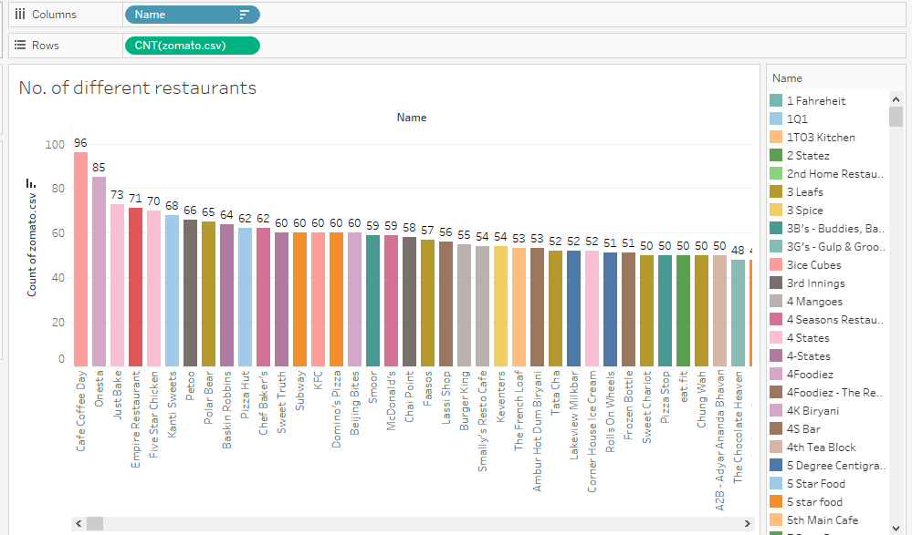

Fig. Top 30 restaurants with highest branches across Bengaluru.

OPENING OF A RESTAURANT

CUISINES MOST LIKED

Bangalore, being in the southern region of India, has a unique, powerful taste for North Indian food followed by Chinese, South Indian and Cafes. This observation is quite obvious as Bangalore resides immigrants from all over the northern Indian region in it.

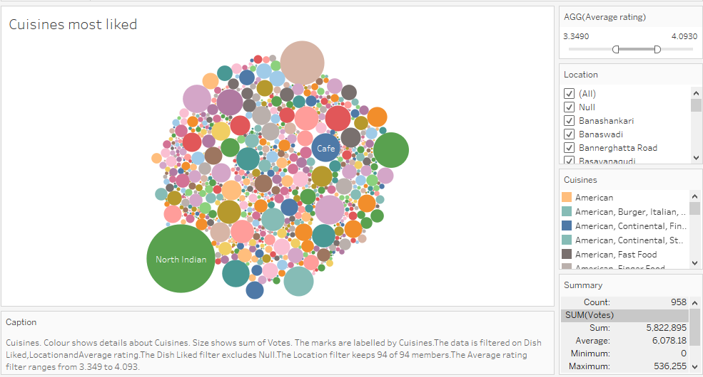

Fig. Most liked cuisine in Bangalore

NEIGHBOURHOOD BY COST OF FOOD

The average cost of food for 2 people ranges from ₹401.6 in Banashankari to ₹772 in Church Street. Analysing whether the cost of food is higher in the posh areas, we pulled out a map demonstrating the cost of two people in a Bangalore restaurant. The cluster around Residency Road marks the posh area, with prices going up at 700 as an average cost.

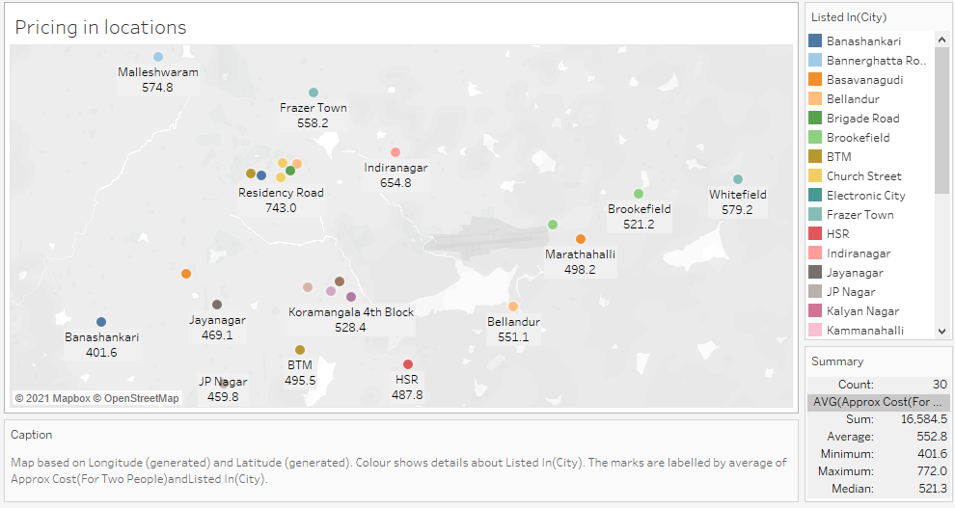

Fig. Neighbourhood with the average cost of food for two.

Neighbourhoods like Church Street, Residency Road, Lavelle Road are considered to be posh around Bangalore, thus offering higher prices for two seating arrangements.

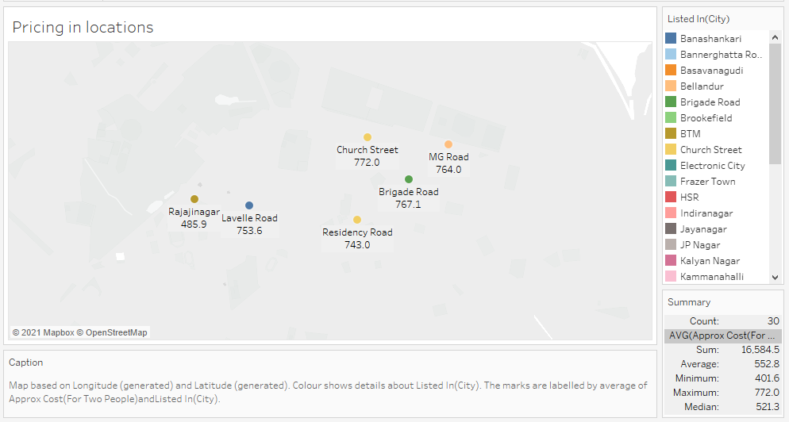

Fig. The posh area with highest food price.

NUMBER OF RESTAURANTS IN A NEIGHBOURHOOD

Whitefield has the highest number of the restaurants followed by BTM and Electronic City. But is it true? Verifying the results, we found out that Koramangala has over 945 restaurants in Bangalore as it is divided into 8 blocks starting from 1st to 8th.

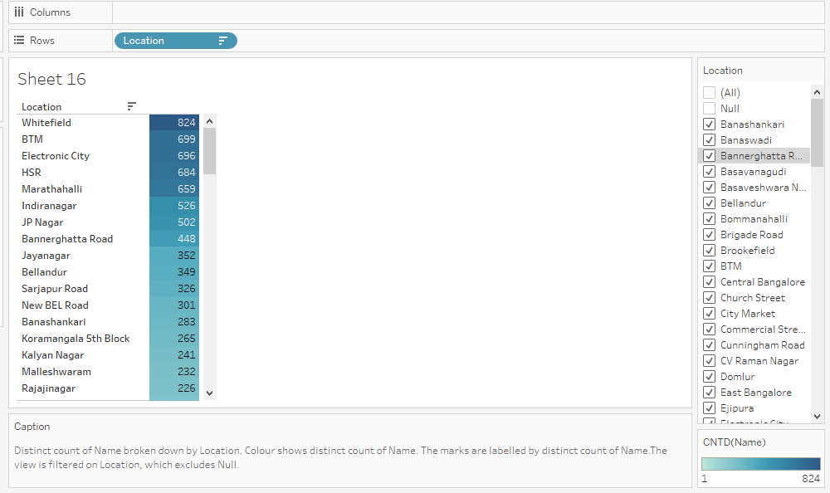

Fig. Total number of restaurants in the neighbourhood.

MOST PREFERRED RESTAURANT TYPE

Casual Dining restaurants have received the most votes followed by Quick bites and Café.

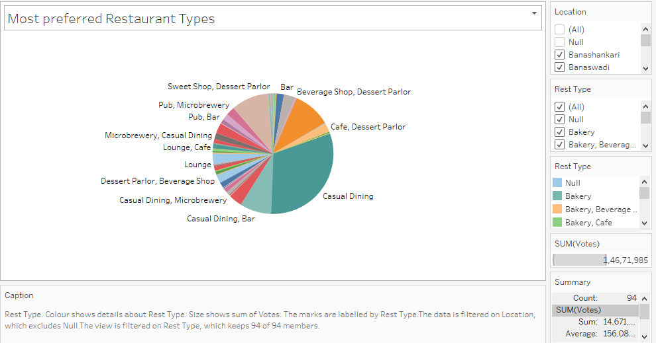

Fig. The most preferred restaurant type based on the votes.

DELIVERY AND DINE-OUT RESTAURANTS

There are many more delivery restaurants in Bangalore than Dine-out. Being an IT capital of India, here people (particularly bachelors) don’t have much time to prepare food for them. The best option for them seems to be mess or restaurants. Most of the working personnel do not want to waste their time in preparing food so restaurants do play a major role here, which can also be verified with the ground reality.

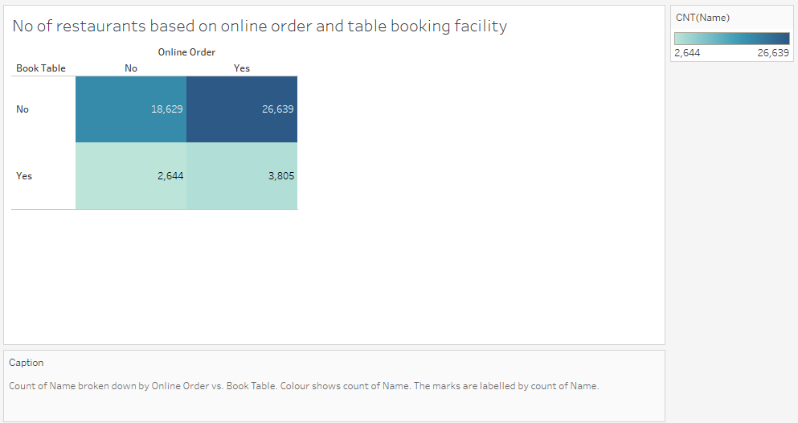

Fig. Confusion matrix between online order and booking table.

**KNIME ANALYSIS**

The dataset, after pre-processing, was fed into Knime. Taking all the necessary columns, predictive analysis of delivery system and reservation policy was calculated. We used the following classification algorithms which gave upto to 93% accuracy.

LOGISTIC REGRESSION

Logistic regression is a statistical analysis method used to predict a data value based on prior observations of a data set. A logistic regression model predicts a dependent data variable by analyzing the relationship between one or more existing independent variables.

RANDOM FOREST

Random Forest is a classifier that contains several decision trees on various subsets of the given dataset and takes the average to improve the predictive accuracy of that dataset.

NAÏVE BAYES

A naive Bayes classifier is an algorithm that uses Bayes' theorem to classify objects. Naive Bayes classifiers assume strong, or naive, independence between attributes of data points.

**Reservation facility**

The Random Forest has the highest accuracy of 75% with Logistic Regression and Naïve Bayes giving the accuracies of 62% each.

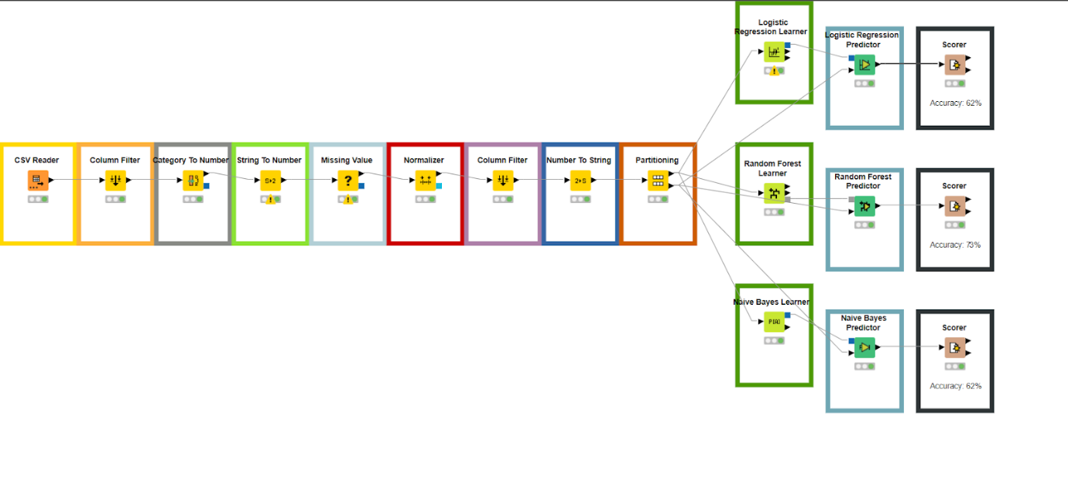

Fig. The KNIME model for Reservation facility.

**Delivery System**

With the accuracy of 87.5% and 88.8% given by Logistic regression and Naïve Bayes, the Random Forest, yet again, gave the highest accuracy of 93.25%.

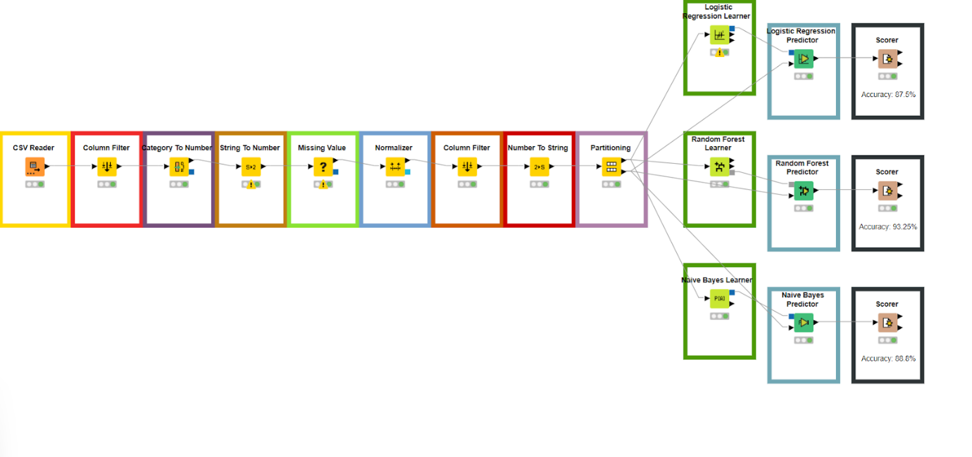

Fig. The KNIME model for Online order.

NUMBER OF RESTAURANTS FOR EACH TYPE

Bangalore offers more Quick Bites restaurants followed by Casual Dining and Delivery which is quite obvious as Bangalore is a home to many working individuals that prefer quick bites rather than dining.

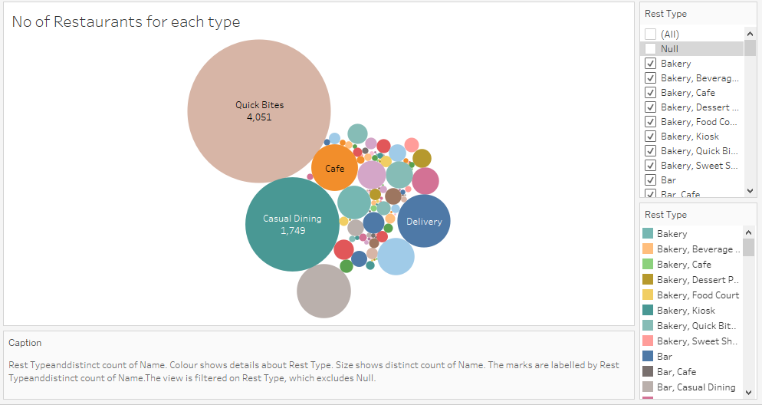

Fig. The number of restaurants of each type.

CHOOSING A RESTAURANT TO EAT IN BANGALORE

RATING OF RESTAURANTS

Asia Kitchen By Mainland China, Sante spa Cuisine, Byg Brewski Brewing Company has acquired a rating of 4.9 in Bangalore. Of course, different neighbourhoods offer different restaurants of higher ratings.

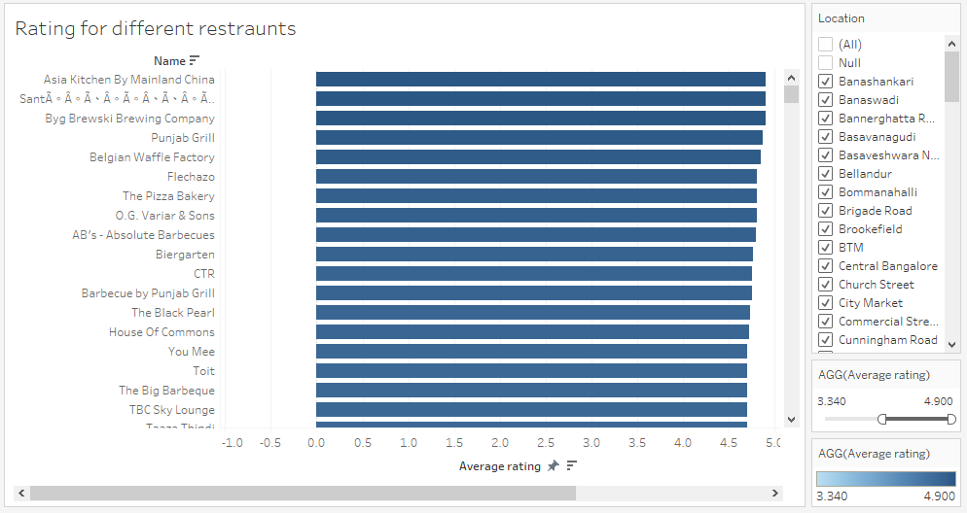

Fig. Rating of restaurants.

For Instance, Lavelle Road offers the highest rating of 4.6 for the restaurant Smoke House Deli followed by Caperberry.

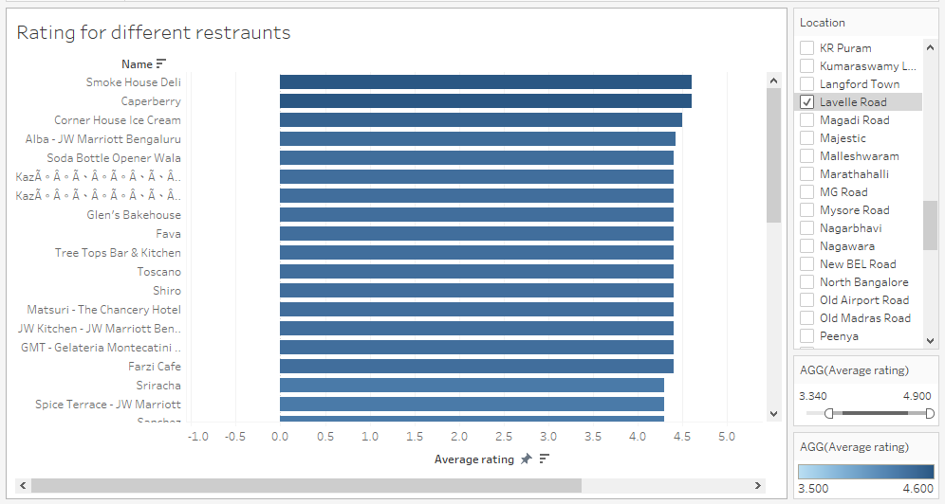

Fig. Average rating at Lavelle Road.

PRICING BY TABLE BOOKING OPTION

With the average difference of almost ₹909, it is evident from the visualization that the restaurants which offer options for table booking have a higher pricing range than those who do not offer that option.

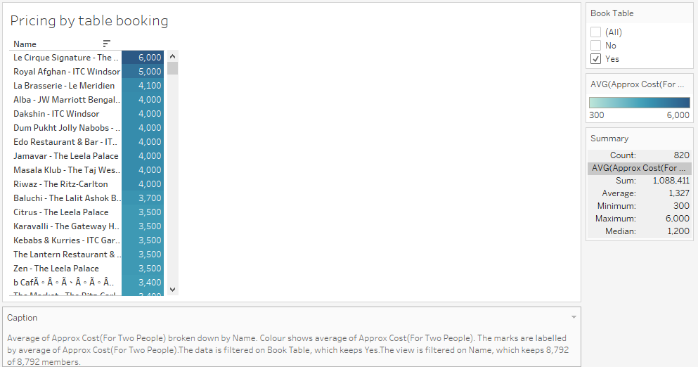

Fig. Food price for restaurants offering reservation facility.

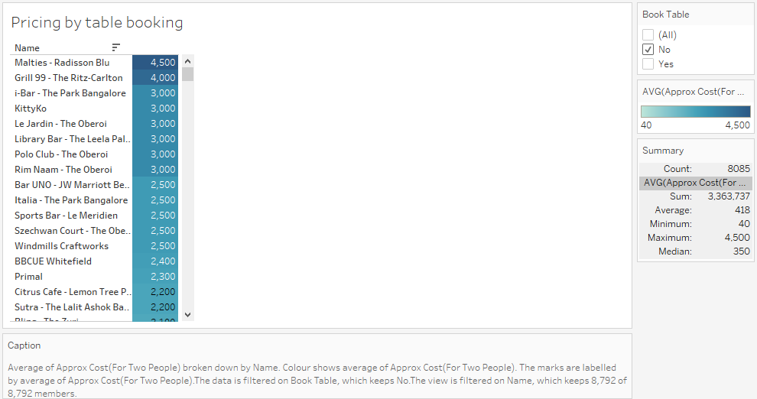

Fig. Food price for restaurants not offering reservation facility.

MOST LIKED CUISINE IN A RESTAURANT

How about going to a restaurant and not knowing what to eat! Chef’s special or the most liked cuisine in a restaurant plays an important role in an enriching experience of a new restaurant.

Based on the restaurant, we have the best dish rated by the people, ensuring you get the best experience at any restaurant.

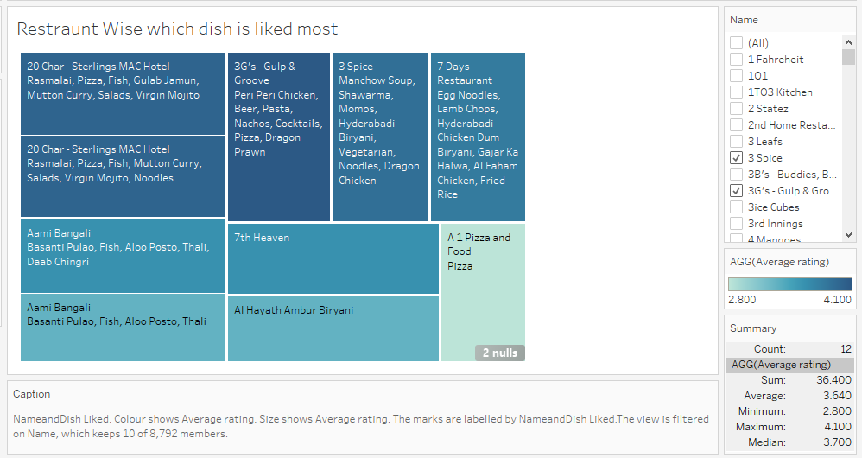

Fig. The most liked dish at a restaurant.

DO EXPENSIVE RESTAURANTS HAVE HIGH RATINGS?

Le Cirque Signature – The Leela Palace is the most expensive place in Bangalore with an average cost of food of ₹6000 (2 people) but offers the rating of 4.3 whereas Byg Brewski Brewing Company offers a rating of 4.9 with the average costing of ₹1600.

The following visualization concludes that an expensive restaurant does not necessarily have high ratings.

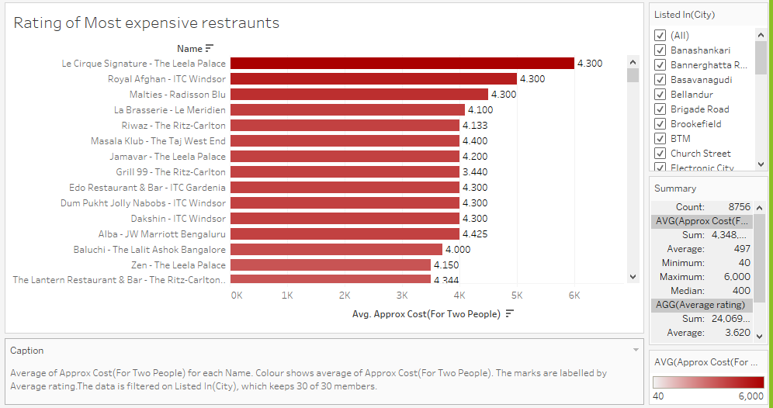

Fig.

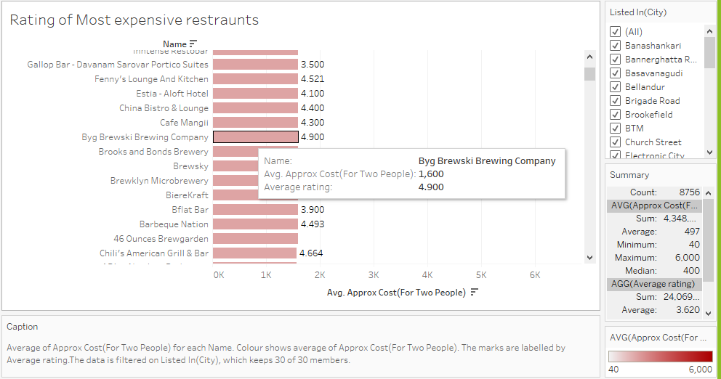

On a further note, out of top 12 restaurants, based on their rating, only 2 of them have an approx. cost of more than ₹2000.

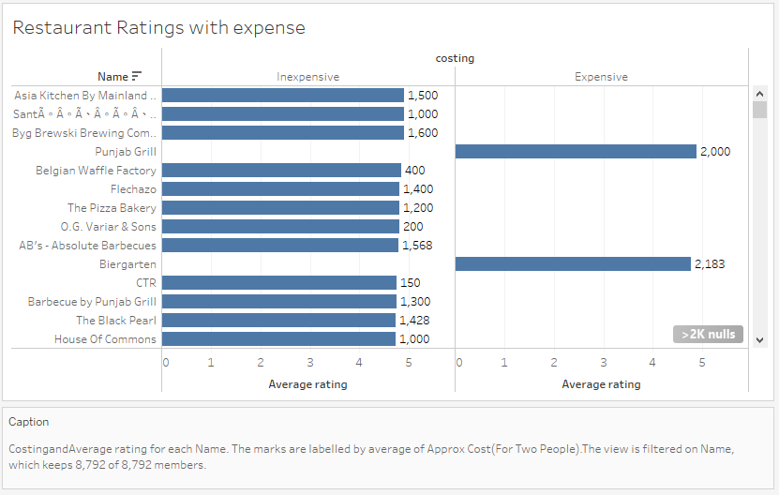

IS THE RATING AFFECTED BY THE PRICE OF THE RESTAURANT?

It is observable from the scatter plot, there is no observable relationship between the two factors. There are good and bad restaurants for every rating.

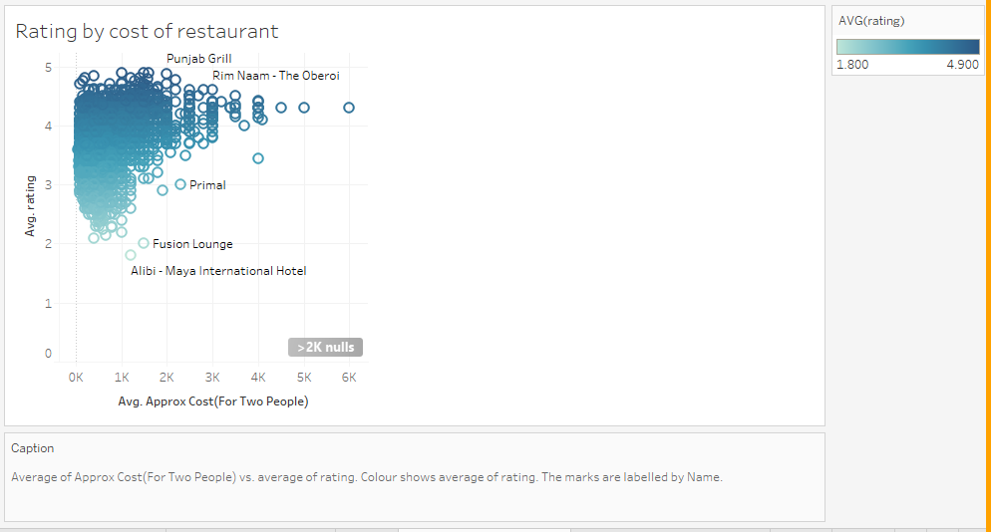

GROUPING NEIGHBOURHOODS BY TYPE OF RESTAURANT

Koramangala has the highest number of bars and delivery restaurants, with BTM and Whitefield having the highest number of Quick bites restaurants. Whitefield and Koramangala offer a high number of Casual Dining, Bakery and Lounge. Koramangala and Indiranagar have a large number of Cafes, Pubs and Dessert Parlours. It would not be wrong to say that Koramangala is the central hub for foodies in Bangalore.

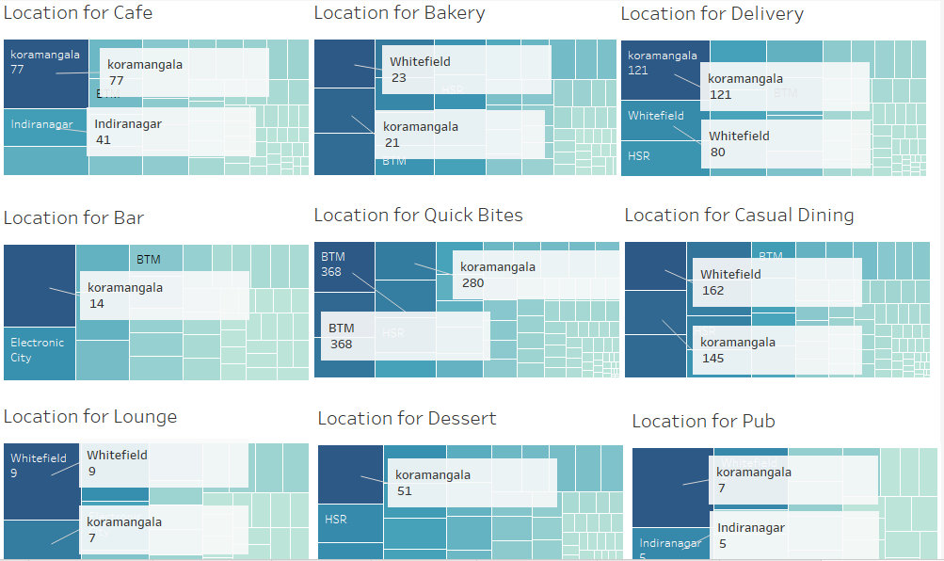

**RESULTS**

It was worth noting that all the top 5 restaurants of Bangalore were foreign restaurant chains. What are Indian restaurants lacking in terms of the food, cuisine which will be worth studying about in future.

Bangalore, being in south India, has a more unique and loving taste for North Indian food. One of the possible reasons can be the huge migration of people in search of good jobs from north India. It has all price ranges varying from $401.6 in Banashankari to $772 in Church Street for two seating arrangements. Also, it was noted that higher costing of food resulted in identifying the area as posh. Whitefield which is also a software industrial area houses more restaurants of Bangalore and can be said to be heaven for foodies. Even though the Quick Bites restaurants are more than the Casual Dining restaurants, people prefer Casual Dining a bit more than the Quick Bites. More than 60% of the restaurants in Bangalore offer online delivery, clearly most of the population are working here. It is, therefore, interesting to note that while Bangalore has many restaurants with delivery facilities, it only has 12% restaurants that offer the option of booking tables. The random forest ensemble technique gave the best accuracy, 93.23%, 75%, for the delivery and reservation system among Logistic regression and Naïve Bayes.

Asian Kitchen by Mainland China, Sante Spa Cuisine and Byg brewski Company have the highest rating of 4.9 in Bangalore. It is seen that the higher rating does not necessarily mean higher cost of food. The top 3 restaurants with the highest rating have the cost of food ranging from ₹1000 to ₹1600, whereas The most expensive restaurant of Bangalore, Le Cirque Signature – The Leela Palace offers food at ₹6000 with the rating of 4.6. However, it was discovered that rating had no observable relationship with the price of the food for a restaurant. Koramangala and Whitefield with a large number of Casual Dining, Bakery and Lounges, Koramangala and Indiranagar with a large number of Cafes, Pubs and Dessert parlours and Koramangala and Whitefield with higher Quick Bites restaurants than others. Koramangala can be considered as the central hub of restaurants.

**CONCLUSION**

After all the analysis we did some of the points which were worth noting that there are more number foreign food chains than Indian restaurants in Bengaluru. Cafe Coffee Day has its outlet in most of the neighbourhood of Bengaluru. The Indian food service market has come a long way from the early Nineties when it was dominated by unorganised players and few brands. The revolution began in 1996 with McDonalds, Pizza Hut, Domino’s Pizza, Subway and Yo China, among others, setting up shop in the country. Since then, the food services market has been continuously growing. Quick service restaurants are a mainstay of the Indian food service market, and are growing fast. Fine dining is gaining prominence too. Both multi-cuisine and single-cuisine establishments have shown tremendous growth. Gone are the days when you would go to Bangalore and only indulge in dosas or at best Kodava food from the region of Coorg. Bangalore is an inspiring mishmash of old and new, and has plenty of options on offer, regardless of whether you are visiting only for a few days or live there.

**LINKS FOR FURTHER INFORMATION**

Research Paper: <https://docs.google.com/document/d/15SoymETwFLfTJDPunBxYQTGm2JfSH2taPWeH1DhyfzU/edit?usp=sharing>

Tableau Online Workbook: <https://prod-apnortheast-a.online.tableau.com/#/site/shrutigupta/workbooks/358958?:origin=card_share_link>