* 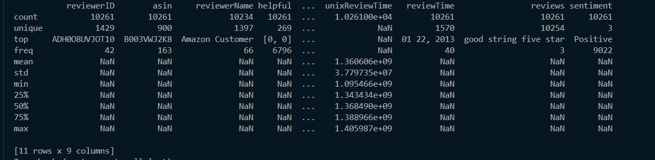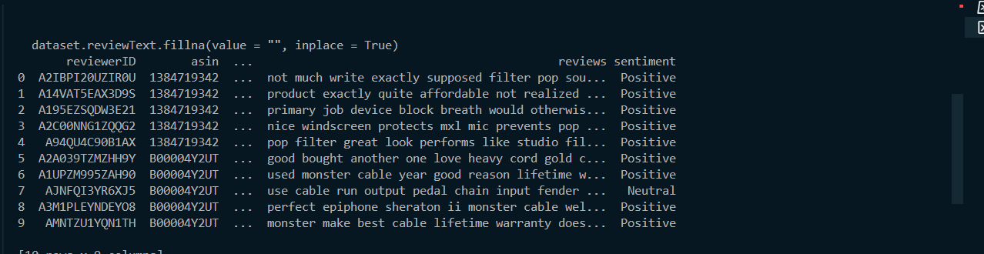**Data Preprocessing:**
* **DATA VISUALIZATION USING PYTHON LIBRARIES:**

**>>**Percentage of Ratings given from the customers.

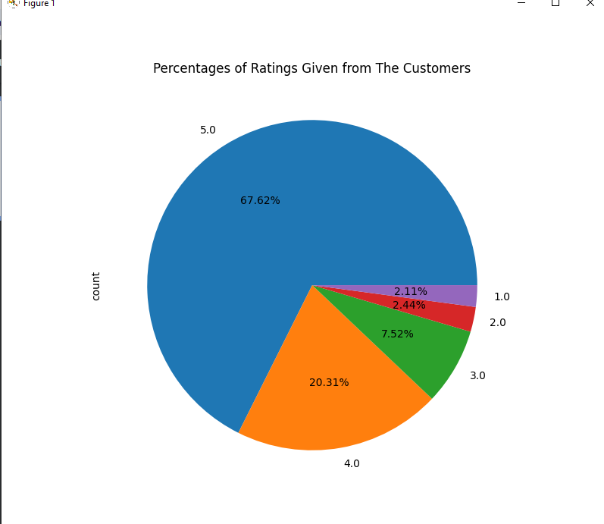

>>Amount of each sentiment(positive, negative, neutral) based on rating given.

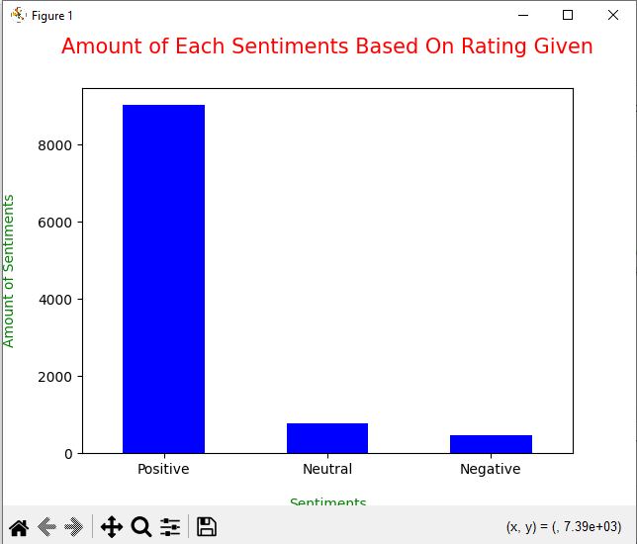

>>Polarity Score on Reviews:

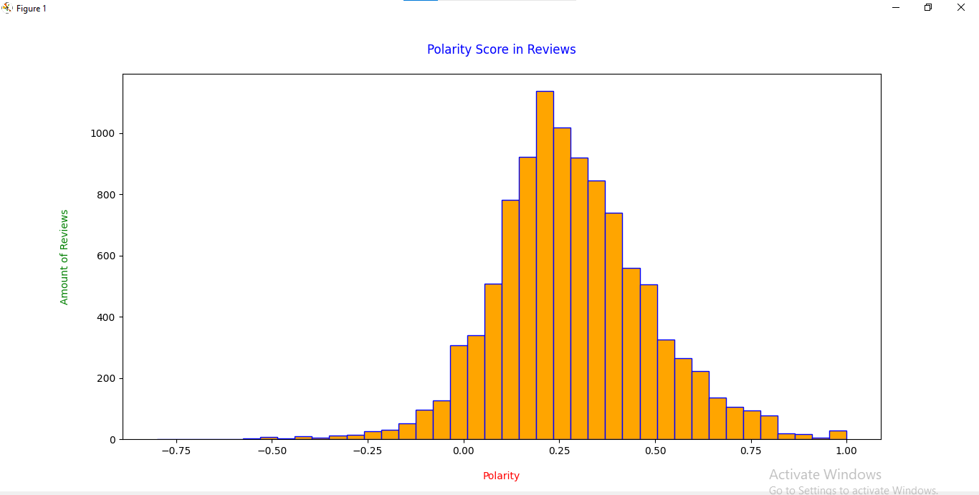

>>Length of Reviews:

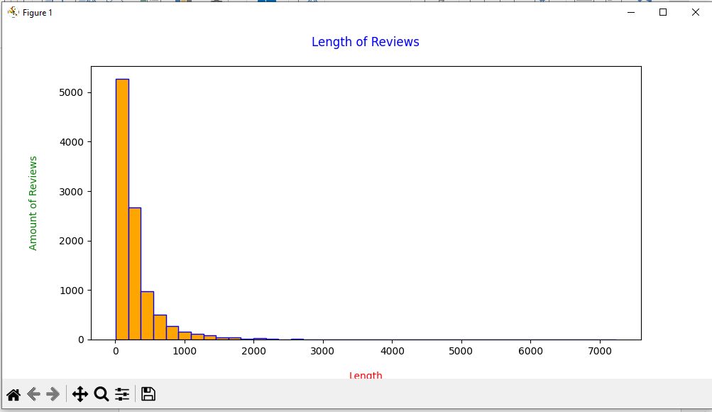

>>Word Count in Reviews

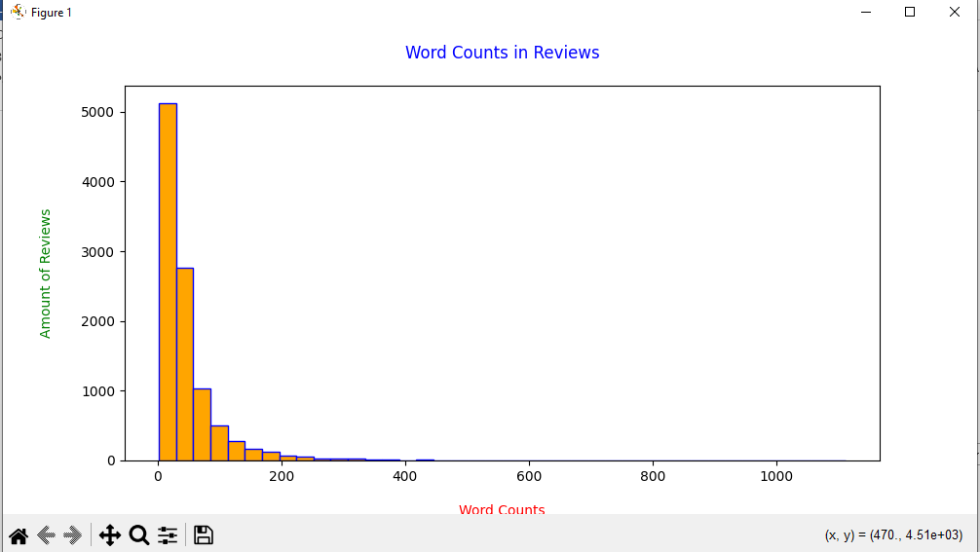

>>Unigram of Reviews with Positive Sentiments:

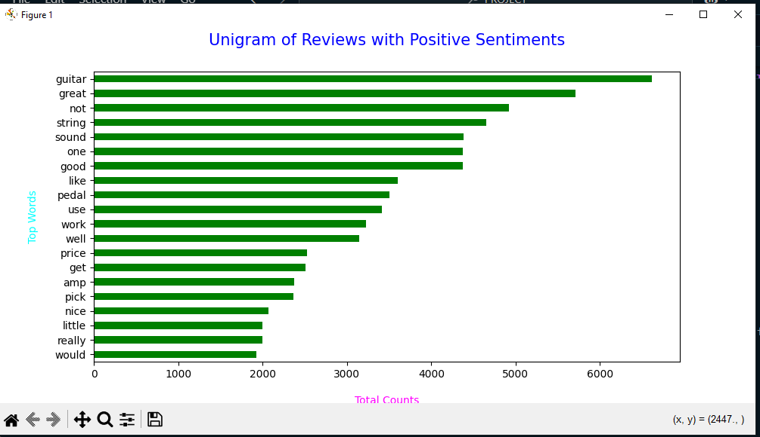

>>Unigram of Reviews with Neutral Sentiments:

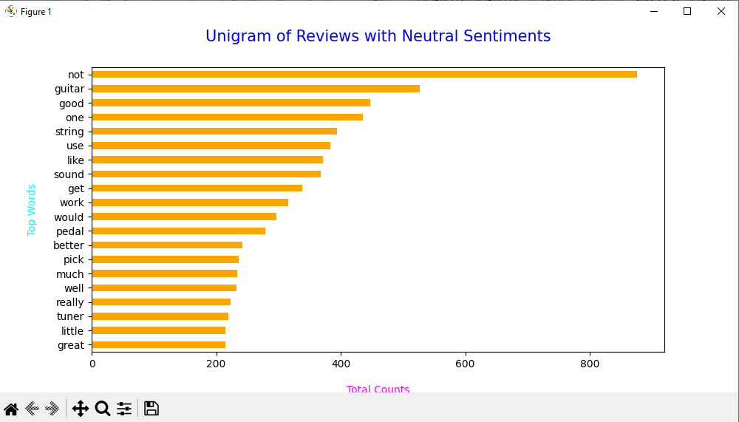

>> Unigram of Reviews with Negative Sentiments:

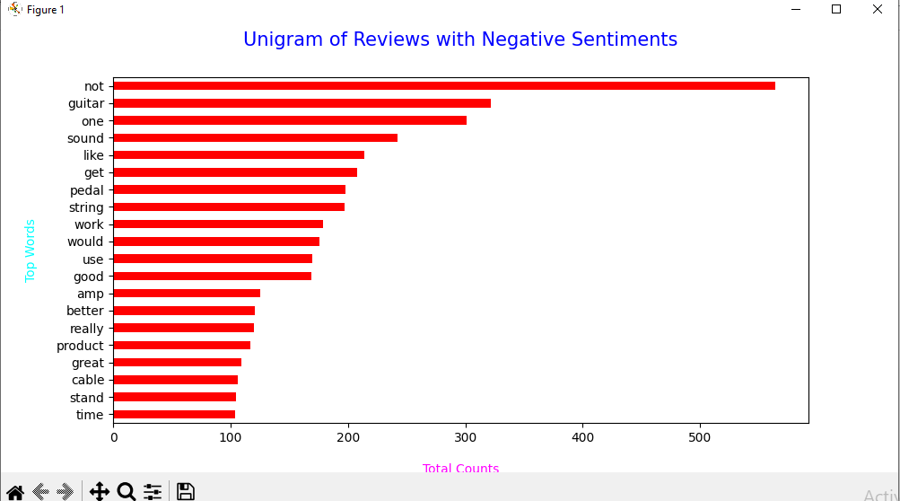  
  
  
>>Model Creation And Testing.

