One Intellectt
Technical Design Document
Candidate Onboarding & Approval Portal

System | One Intellectt — Candidate Onboarding & Approval Portal
Components | Backend OneIntellectt (Spring Boot) · Frontend onboarding-portal (React) · PostgreSQL
Version | 0.0.1-SNAPSHOT
Status | Built and tested; pre-production
Last updated | 27 Oct 2026

Contents

(If the list above is empty, right-click it in Word and choose Update Field.)

1. Purpose and scope

1.1 Problem
When a recruiter places a candidate with a client, several departments must review and sign off before the candidate starts work: the recruiter's Sales Lead (or the Sales Manager over the team), HR and Contracts, then Payroll and Accounts. This used to be handled by email and spreadsheets, with no single record of who approved what and when.

1.2 Goals
- One record per placed candidate that moves through a defined approval workflow.
- Each role sees only the candidates it needs to see, and can act only at its own stage.
- Automatic email at every stage to the right mailboxes of the candidate's legal entity.
- A complete, tamper-resistant history of every decision and every data change.
- Usable by about 1000 concurrent users. Secure enough for personal data (SSN), and aligned with ISO/IEC 27001.

1.3 Out of scope (current version)
- Single sign-on (SSO) and multi-factor sign-in (MFA planned for admins; see §11).
- Editing a candidate after submission is limited to HR (any details, any time) and, for the bill and pay rates only, the Sales Lead / Manager / Super Admin. A decline is resolved by the Sales Lead / Manager re-routing.
- Standalone comments outside a workflow action.
- Data retention / automatic deletion (needs a business decision first).

1.4 Glossary
Term | Meaning
Candidate | A person placed with a client; the record that moves through the workflow.
Placement Entity | The Intellectt legal entity employing the candidate (e.g. novozen). Decides which email domain notifications go to.
DOJ | Date of Joining. Supplied by the recruiter at intake, approved by the Sales Lead or Sales Manager.
Sales Manager | Oversees several teams; has the same approval powers as a team's Sales Lead over them. Either one is enough.
Branch | HR, Contracts, Payroll and Accounts each make their own decision ("branch"): HR and Contracts in parallel, then Payroll and Accounts in parallel.
Payroll company | Optional: the company running the candidate's payroll (one of the ten entities, or "Other" with a typed name). When it differs from the Placement Entity, stage emails also go to its mailboxes.
Project end date | When the engagement ends; set by the Sales Lead / Manager after the DOJ is approved.
Override | A final approve/reject by the Super Admin that ends the normal workflow.
Session | A server-side sign-in record; every token is tied to one.

2. Users and roles
Role | Responsibility | Sees | Can do
RECRUITER | Submits placed candidates | Own submissions | Submit
SALES_LEAD | First approval gate for their team | Their team's candidates; their team | Approve / decline / re-route; approve DOJ; set project end date; change rates; add/remove recruiters in own team
SALES_MANAGER | Same gate, over several teams | Candidates and teams of every team under them | Same as a Sales Lead for those teams. Either one is enough
HR | Reviews (parallel with Contracts) | Candidates past Sales Lead / Manager approval | Approve / decline; may revise until DOJ approved; edit the candidate's details at any time
CONTRACTS | Reviews (parallel with HR) | Candidates past Sales Lead / Manager approval | Approve / decline
PAYROLL | Payroll setup | Candidates HR and Contracts have both approved | Approve / decline (comment on decline)
ACCOUNTS | Billing setup | Candidates HR and Contracts have both approved | Approve / decline (comment on decline)
ADMIN | User & team administration | Users and teams, no candidates | Manage users (except Super Admin) and teams; put a Sales Manager over teams
SUPER_ADMIN | Oversight (CEO/President) | Everything, incl. audit log | Override any candidate; change rates; manage everything

Authorization is enforced in the service layer of the backend on every request. The frontend hides buttons and pages only for convenience. The rules are tested role-by-endpoint in RoleAccessApiTest.

3. Architecture overview
A three-tier web application:
Browser (React SPA) ──HTTPS/JSON, JWT──► Spring Boot REST API ──JDBC──► PostgreSQL
└──SMTP (async)──► Mail server

- Frontend: a single-page app (React 19, Vite 8, Ant Design 6). Holds no business rules that matter for security, and talks to the API only through src/api/*.js.
- Backend: a stateless REST API (Spring Boot 4.1, Java 17). It enforces every rule, owns the workflow state machine, sends email, and writes the audit trail.
- Database: PostgreSQL 16. Operational tables plus Hibernate Envers *_aud history tables.
Detailed diagrams (context, containers, components, sequences, deployment): ARCHITECTURE.md.
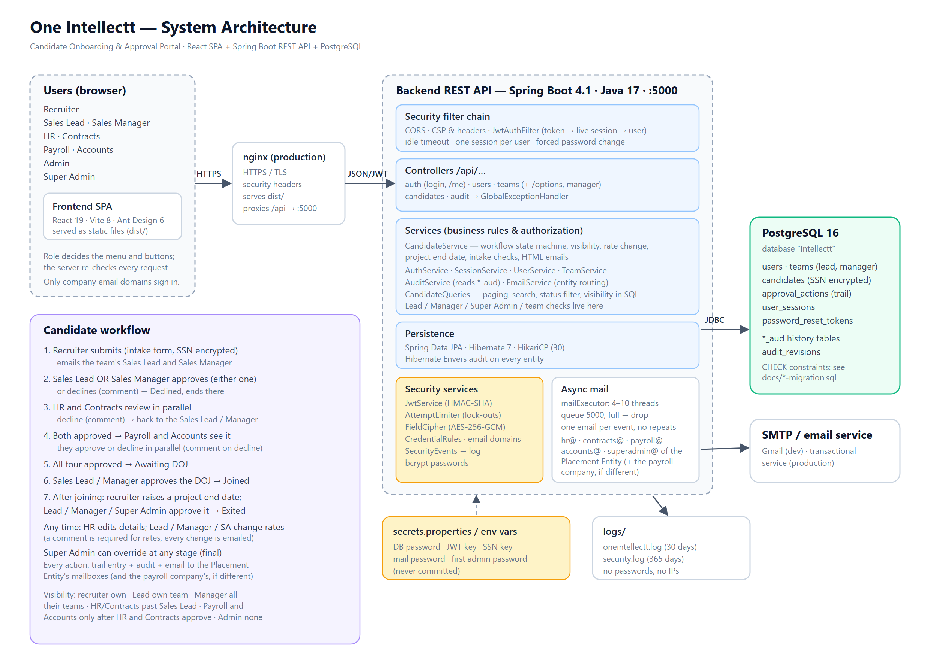
Figure: system architecture

3.1 Key design decisions
# | Decision | Rationale | Alternatives considered
D1 | Separate SPA + REST API | Independent development of UI and API; the API can serve other clients later | Server-rendered pages (the original prototype)
D2 | JWT tied to a server-side session (sid claim → user_sessions) | Stateless tokens can't be revoked. Session rows give real logout, idle timeout, one session per user, and immediate effect of deactivation | Pure stateless JWT; HTTP sessions with cookies (would need CSRF protection)
D3 | Parallel HR/Contracts review with per-branch decisions | Matches how the departments actually work, and shortens time-to-start | Strictly sequential chain (the original frontend design)
D4 | Entities used directly as request/response bodies (no DTO layer) | Small team, simple model. JSON is shaped with Jackson annotations (WRITE_ONLY, READ_ONLY, @JsonIgnoreProperties) | DTOs + mappers (more code; reconsider if the API grows)
D5 | Hibernate Envers for auditing | Every change to every table is recorded automatically, with before/after state, and nothing can be forgotten | Hand-written audit rows (error-prone); DB triggers (no user identity)
D6 | Server-side paging, search and filtering | Response size is independent of data volume (6.2 MB → 13 KB for the Super Admin dashboard) | Send all and filter in the browser (the original design)
D7 | Field-level encryption of the SSN (AES-256-GCM via a JPA AttributeConverter) | Protects the most sensitive field in the DB, backups and audit history. The key lives outside the DB | Full-disk/TDE only (doesn't protect dumps or DB users)
D8 | Emails routed by Placement Entity to role mailboxes (hr@<domain> …) | Each entity has its own departments; no need to keep portal users in sync with mailboxes | Email individual portal users (kept as the fallback)
D9 | Async email with a bounded queue | An approval never waits for, or fails because of, the mail server | Synchronous send (slow; a mail outage would break approvals)
D10 | Interface + *Impl services in one package; no Lombok | Project convention; the target IDE doesn't run the Lombok processor | —
D11 | Sales Manager as a role pointing at teams (teams.sales_manager_id), not a second approval step | A manager oversees 3–5 teams (no hard limit). "Either the Lead or the Manager" keeps the flow short: whoever acts first wins, the other is told | Requiring both (slower); a manager-of-managers hierarchy (more than needed)
D12 | Payroll and Accounts decide after HR and Contracts (status IN_PAYROLL_ACCOUNTS_REVIEW) | They only need to see a candidate once the earlier checks are done | View-only roles (the first version)
D13 | Terminal Sales Lead / Manager decline (SALES_LEAD_DECLINED) | A decline at the first gate stops the candidate; only the Super Admin can override it | Returning it to the recruiter (needs a candidate-edit feature)
D14 | After submit only HR can edit details; the rates can also be changed by Lead / Manager / Super Admin (comment mandatory). Every edit is listed on the trail and emailed | HR owns data quality; rates change mid-engagement | Letting recruiters edit (they would change what the approvers saw)
D15 | Emails go to the Placement Entity's mailboxes, plus the payroll company's when it differs (one email, no duplicates) | Payroll for a candidate can be run by a sister company | Emailing portal users

4. Functional design

4.1 Candidate workflow (state machine)
A candidate carries one status plus five sub-states: hrDecision, contractsDecision, payrollDecision, accountsDecision (each PENDING / APPROVED / DECLINED) and dojStatus (NOT_RAISED / RAISED / APPROVED). The status is re-derived from the decisions after every action (recomputeStatus).
!Candidate workflow
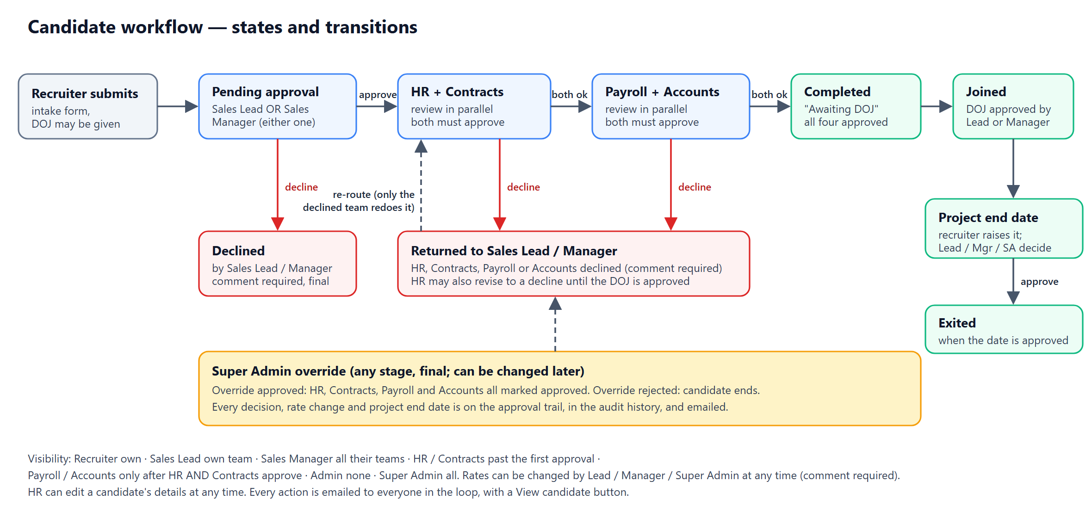
Figure: candidate workflow (states and transitions)
Rules (implemented in CandidateServiceImpl):
Action | Who | Allowed when | Effect
Submit | Recruiter | — | PENDING_SALES_LEAD_APPROVAL; dojStatus = RAISED if a DOJ was given. Team and submitter come from the server, never the request
Sales Lead / Manager approve | Lead of the candidate's team or the Sales Manager over it (either one) | PENDING_SALES_LEAD_APPROVAL or RETURNED_TO_SALES_LEAD | Declined branches reset to PENDING (approved ones keep their approval); status re-derived (IN_HR_CONTRACTS_REVIEW or later)
Sales Lead / Manager decline | Same people | Same statuses; comment required | SALES_LEAD_DECLINED: nothing reaches HR; not re-approvable (Super Admin can override)
HR approve / decline | HR | Past Sales Lead approval, not overridden, DOJ not approved | Sets hrDecision; status re-derived. A decline also resets Payroll/Accounts to PENDING. HR may change its mind until the DOJ is approved
Contracts approve / decline | Contracts | IN_HR_CONTRACTS_REVIEW and contractsDecision = PENDING | Sets contractsDecision; decline → RETURNED_TO_SALES_LEAD
Payroll / Accounts approve / decline | Payroll, Accounts (each for itself) | IN_PAYROLL_ACCOUNTS_REVIEW and own decision PENDING | Both approve → COMPLETED; a decline (comment required) → RETURNED_TO_SALES_LEAD; on re-route only the declined team redoes it
DOJ approve | Lead / Manager of the team | Candidate past Sales Lead approval and dojStatus = RAISED | dojStatus = APPROVED (locks HR)
Raise project end date | The candidate's recruiter | dojStatus = APPROVED; date not before the DOJ date; not yet approved | projectEndStatus = RAISED (waits for approval; the candidate is not exited yet); the Lead and Manager are emailed
Approve / decline project end date | Lead / Manager of the team, or the Super Admin | projectEndStatus = RAISED; decline needs a comment | Approve → APPROVED and the candidate is Exited; decline → DECLINED (the recruiter can raise a new date). Entering the date directly as a Lead / Manager / Super Admin is the approval itself
(old) Project end date | Lead / Manager of the team, or the Super Admin | dojStatus = APPROVED; date not before the DOJ date | Sets projectEndDate and the candidate becomes Exited; may be changed again (each change on the trail)
Edit details | HR | Candidate visible to HR (past the first approval, any status); must change something | Full replace of the intake fields (blank/masked SSN keeps the stored one); approvals are not reset; trail entry EDIT lists old → new; email to everyone in the loop
Change rates | Lead / Manager of the team, Super Admin | Not for declined/rejected candidates; comment required; must change something | Updates billRate / payRate; trail entry old → new
Override approve / decline | Super Admin | Any time | OVERRIDE_APPROVED (all four branches approved) / OVERRIDE_REJECTED; final

A comment is required on every decline and on an override decline. Every action writes an ApprovalAction row (the approval trail) and, except the submit, an email.

4.2 Display status
The UI shows one status tag, derived by the same rule on the server (CandidateQueries.statusKey) and in the browser (utils/status.js#getStatusKey). The two must agree. First match wins:
Key | Condition
ADMIN_REJECTED / ADMIN_APPROVED | Overridden
DECLINED | RETURNED_TO_SALES_LEAD or SALES_LEAD_DECLINED
PENDING_SALES_LEAD | PENDING_SALES_LEAD_APPROVAL
EXITED | The project end date is approved (projectEndStatus = APPROVED)
JOINED | DOJ approved and no project end date yet
AWAITING_DOJ | COMPLETED (HR, Contracts, Payroll and Accounts all approved)
PENDING_PAYROLL_ACCOUNTS | IN_PAYROLL_ACCOUNTS_REVIEW
PENDING_CONTRACTS / PENDING_HR | In review: Contracts still pending / only HR left

Dashboard counters: pending = the four PENDING_* keys · approved = AWAITING_DOJ + ADMIN_APPROVED · declined = DECLINED + ADMIN_REJECTED · joined = JOINED · exited = EXITED (the Super Admin dashboard shows an Exited card).

4.3 Visibility (row-level access)
Applied as a JPA Specification (CandidateQueries.visibleTo) to lists and counts, and as canView to single reads:
Role | Rows visible
Super Admin | All
Recruiter | submitted_by_id = me
Sales Lead | team_id = my team
Sales Manager | team.sales_manager_id = me (every team under them)
HR, Contracts | Status past Sales Lead approval
Payroll, Accounts | hr_decision = APPROVED and contracts_decision = APPROVED
Admin | None

4.4 Email notifications
Event | Recipients
Recruiter submits | The team's Sales Lead and Sales Manager only (no Super Admin copy)
Sales Lead / Manager approves | hr@, contracts@, payroll@, accounts@ + superadmin@ *entity domain*, the team's other approver, and the recruiter. Payroll and Accounts are told now but only see the candidate in the portal once HR and Contracts have both approved
Sales Lead / Manager declines | The recruiter and the other approver + superadmin@
HR approves, and Contracts approves (each one, separately) | hr@, contracts@, payroll@, accounts@ + superadmin@. The email that completes the pair says Payroll and Accounts can now act
HR / Contracts / Payroll / Accounts declines | The Sales Lead and Sales Manager + superadmin@
Payroll and Accounts both approved | The Sales Lead, Sales Manager and the recruiter + superadmin@ ("the DOJ can be approved")
DOJ approved | payroll@, accounts@, the recruiter + superadmin@
Project end date raised by the recruiter | The team's Sales Lead and Sales Manager + superadmin@ ("please approve or decline")
Project end date approved / changed by an approver (candidate exits) | hr@, contracts@, payroll@, accounts@, the recruiter, the other approver + superadmin@
Details edited by HR | hr@, contracts@, payroll@, accounts@, the Lead, the Manager, the recruiter + superadmin@; the email lists the changes (old → new)
Rates changed | hr@, contracts@, payroll@, accounts@, the Lead, the Manager, the recruiter + superadmin@ (not the person who changed them)
Super Admin override | hr@, contracts@, accounts@, payroll@, the Sales Lead and Manager + superadmin@
Password reset | The user only

Payroll company. If the candidate's payroll company is a different one of the ten entities than the Placement Entity, the same email also goes to that entity's mailboxes (e.g. hr@novozen.com and hr@kennedysoft.com, with superadmin@ of both) in one message; a recipient is never listed twice. The same entity, "Other" or none → the Placement Entity only (CandidateServiceImpl.emailEntities).
Testing switches. app.entity-mail.mailbox-routing (default true) and app.entity-mail.super-admin-address (default blank) exist for testing. With mailbox-routing=false the hr@<domain> … mailboxes are ignored and HR, Contracts, Payroll and Accounts emails go to the portal users who hold those roles; a non-blank super-admin-address sends every "copy the Super Admin" email to that one address. Normal operation: true and blank (the current setting).
Entity → domain and role → mailbox mappings are configuration (app.entity-mail.*, bound by EntityMailProperties). For a blank or unknown entity, emails fall back to the active portal users holding those roles. Each email is one HTML message, with the SSN masked, and ends with a View candidate button that opens /candidates/{id} in the portal (app.frontend.base-url); if the person isn't signed in they sign in first and are sent straight to that candidate, where their Approve / Decline buttons are. Sending is asynchronous on the mailExecutor pool (4–10 threads, queue of 5000). If the queue is full, the email is dropped and logged; the approval is never affected.

4.5 Candidate intake form
Filled in by the recruiter. Mandatory in the form (not enforced by the API, which only checks dropdown values): everything except CC company, Date of joining, SSN, Client reporting manager, Manager email, Manager contact, Sourcing recruiter, Sourcing recruiter lead, Referral, Referral amount and Payroll company. CC company becomes mandatory when the employment type is C2C.
Group | Fields
Candidate & Recruiter | name, personal email, direct number, recruiter (from login), sourcing recruiter and sourcing recruiter lead (both optional), recruiter location (read-only: set on the recruiter's profile by an admin from Hyderabad, Vijayawada, Banglore, Indore, Noida, USA, and copied onto each candidate by the server), team / Sales Lead / Sales Manager (read-only, from the team), team type (Sales, Req or Sales & Req), Placement Entity (renamed from Internal Entity), payroll company (optional; ten entities or Other + name)
Client | client name, client state and client location (two separate mandatory fields), reporting manager / email / contact (optional)
Engagement & Compliance | vendor, job title, location, employment type (W2, C2C, Full-time, Self), internal company placement Yes/No (+ "To which company?": the ten, Intellectt, NewMEK Software Solutions), shared placement Yes/No (+ which team, never the recruiter's own), bill / pay rate, optional discount price in dollars (discounted bill rate = bill rate − discount price, shown read-only) and the vendor percentage (pay rate ÷ bill rate × 100, using the discounted bill rate when there is a discount; worked out, never stored), start date, DOJ (optional), CC company (optional), referral (optional), referral amount (optional), SSN (optional), visa status, work authorization expiry (not for US Citizen / Green Card), relocation expenses, pay cycle (Weekly, Bi-weekly, Semi-monthly, Monthly, Other), existing employee, H1 transfer details (H1 Transfer only), job description

The "which company / which team" answers are cleared when the Yes/No is No. Sharing a placement does not give the shared team access to the candidate (a decision still open).

4.6 User, team and account lifecycle
- Only company email ids are accepted (create, edit, sign-in): the domains in app.allowed-email-domains; anything else gets "use your correct company email id" (AllowedEmailDomains).
- Only Super Admin / Admin create users. They set a temporary password (mustChangePassword = true), and the user must choose their own at first sign-in.
- Deactivate (soft, keeps history, ends sessions immediately) or permanently delete (refused if the user submitted candidates).
- A recruiter belongs to at most one team. A Sales Lead becomes their team's lead. A Sales Manager has no team of their own: Admin / Super Admin put them over teams (PUT /api/teams/{id}/sales-manager/{userId}). Deactivating, deleting or re-roling a manager releases their teams.
- Forgot/reset password: single-use emailed link, valid for 60 minutes. A reset ends every session.

5. Data design
Entities: User, Team (with salesLead and salesManager), Candidate, ApprovalAction, UserSession, PasswordResetToken, plus Envers' AuditRevision. Each has a <table>_aud history table. Full schema, ER diagram and indexes: DATA_MODEL.md.
Notable choices:
- Enums are stored as strings (@Enumerated(STRING)).
- candidates.ssn_no is stored encrypted: enc:v1: + base64(IV + ciphertext).
- Indexes on every column the candidate list filters or sorts by (submitted_by_id, team_id, status, updated_at), and on the trail and session foreign keys.
- Schema evolution uses ddl-auto=update. It adds tables and columns but never changes constraints or drops anything, so those need manual SQL: docs/sales-manager-migration.sql, payroll-accounts-migration.sql, project-end-migration.sql, rate-change-migration.sql (see DATA_MODEL §5).
- Names of the team's Sales Lead / Sales Manager on a candidate are computed for each response, not stored.

6. Interface design
REST/JSON under /api, authenticated with Authorization: Bearer <JWT> (except the public auth endpoints). Errors use one shape: { status, error, message, timestamp }, plus fieldErrors or reason where relevant. Workflow actions take an optional ?comment= query parameter. Lists are paged: { content, totalElements, totalPages, number, size }.
Full reference: API.md.

7. Security design
Summary only; detail and test evidence in SECURITY.md and COMPLIANCE.md.
Area | Design
Authentication | bcrypt password hashes. Password rule: 8–72 characters with a letter and a digit. A temporary password must be changed at first sign-in. Lock-out after 5 failures per account+IP, 20 per account, 50 per IP (15 min)
Session | HS-signed JWT (24 h max) with an sid claim → user_sessions row checked on each request; 30 min idle timeout; one session per user
Authorization | Role and team checks in services; row-level visibility via Specifications. The role is loaded from the DB on each request, not trusted from the token
Input | Bound SQL parameters only; escaped LIKE patterns; length/format validation; unknown enum values → 400
Output | JSON only; React escaping; email HTML escaped; CSP + security headers; generic error messages
Data protection | SSN encrypted at rest and never returned in full (ssnMasked). Secrets kept outside the code (secrets.properties / environment variables)
Accountability | Envers audit of every change (who/when, before/after). Security event log (logs/security.log, 365 days). No IP addresses stored

8. Non-functional requirements
Requirement | Target | Achieved / how
Concurrent users | 1000 | 1000 simulated users, 68,296 requests, 0 failures (RESULTS.md)
Latency (p95) | < 500 ms | 71 ms (all requests), single laptop running everything
Payload size | Independent of data volume | Server-side paging; list ≈ 8.5 KB
Availability | Business hours, single site | One instance; sessions in the DB allow a second instance behind a load balancer
DB connections | Never exhausted | HikariCP pool 30, open-in-view=false, @EntityGraph to avoid N+1
Overload behaviour | Degrade, don't sign users out | DB errors → 503 "busy", never 401
Auditability | Every change traceable | Envers on all tables
Browser support | Current Chrome/Edge/Firefox/Safari, desktop-first | Responsive Ant Design layout

9. Error handling
Situation | HTTP | Body / behaviour
Not signed in / session ended | 401 | {reason, message}; the browser returns to login and shows the reason
Must change password first | 403 | reason: PASSWORD_CHANGE_REQUIRED; the browser opens /change-password
Not allowed | 403 | Logged as ACCESS_DENIED in the security log
Bad input / wrong state | 400 | Readable message (e.g. "Candidate is not awaiting Contracts review")
Not found | 404
Rate limited | 429 | Retry-After header
Database busy | 503 | "The server is busy right now…"
Unexpected | 500 | Generic message; details only in the server log

10. Testing strategy
Level | What | Where
API tests (JUnit 5, real HTTP, real PostgreSQL intellectt_test) | Auth & sessions, users & teams, full workflow incl. Sales Manager / Payroll / Accounts, paging/filters, audit, attacks, role matrix, compliance controls, rate change, project end date | src/test/java/com/intellectt/api/* — 108 tests in total
Unit tests | Email routing (incl. several entities in one email), JWT filter behaviour under DB failure | service/, security/
Load test | 1000 concurrent users, role-appropriate actions | load-test/load_test.py, results in RESULTS.md
Frontend | Lint (oxlint), production build, npm audit | npm run lint, npm run build

Tests use separate databases and can't send real email. Run them with ./mvnw test (see the README).

11. Risks, limitations and future work
Item | Notes
No MFA | Highest-value next step, for Super Admin and Admin
JWT in localStorage | Mitigated by CSP and the absence of HTML-injection sinks; an HttpOnly cookie + CSRF is the alternative
Rate limits in memory | Per instance; move to Redis/DB if scaled out
Reset tokens stored unhashed | Single-use, 60-minute TTL
ddl-auto=update | Adequate now; adopt Flyway/Liquibase before frequent schema changes in production
Only HR edits details | Recruiters can't fix their own typos; a decline is fixed by re-routing. HR edits don't reset approvals (decide if some fields should)
Shared placement gives the shared team no access | Decide whether its Lead / Manager should see the candidate
Data retention | Needs a business decision (§1.3)
Migrations are hand-run SQL files | One per feature; adopt Flyway/Liquibase
Gmail SMTP limits | Use a transactional email service in production
Growth of user_sessions and *_aud | Plan an archival policy

