  - 1st Assignment
  - Profiling Data Breaches

Profile

Organization affected: | Organization logo:
HCA | 
Sector/industry:
Health
Date of breach (or discovery):
07/2023
Estimated number of records/victims:
11,270,000 | Technical image (from references or external sources):
Type of data compromised: | 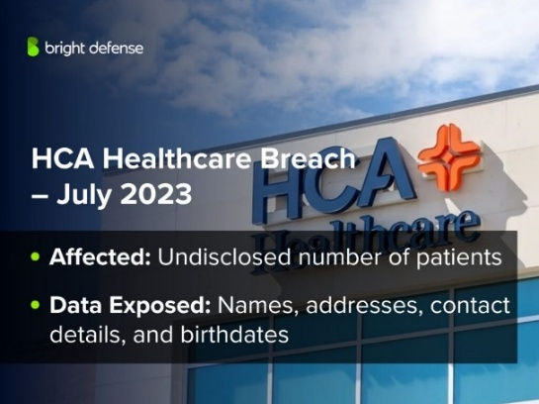
Patient personal information (full names, dates of birth, gender, city, state and ZIP code, contact information and appointment/service information)
Attack vector / method:
Hacking / unauthorized access to an external storage location
Main cause:
Technical
How was the breach discovered? | Representative image using GenAI (e.g., DALL-E2):
External disclosure / hacker activity | 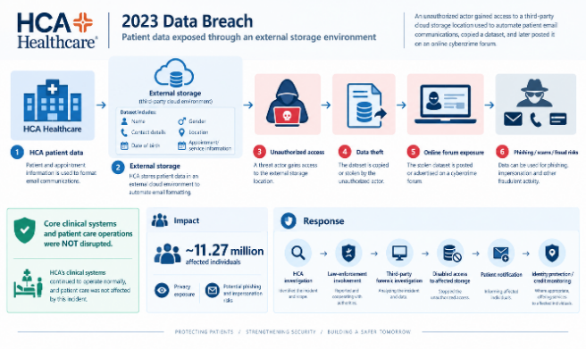
Immediate impact on the organization:
Operational
Impact on victims:
Privacy loss and increased exposure to phishing attacks and scams
Regulatory/legal consequences:
Law-enforcement notification/involvement | Prompts used to the representative image and video:
Company’s public response: | Image prompt  Video prompt
Confirmation, investigation and containment | Image prompt  Video prompt
Sources used for this profile: | Image prompt  Video prompt
https://investor.hcahealthcare.com/news/news-details/2023/HCA-Healthcare-Reports-Data-Security-Incident/  https://www.sec.gov/Archives/edgar/data/860730/000119312523184269/d522417dex991.htm  https://databreachcost.com/breach-database/tennessee/hca-healthcare-2023  https://www.sec.gov/Archives/edgar/data/860730/000095017023037237/hca-20230630.htm  https://www.sec.gov/Archives/edgar/data/860730/000095017024016524/hca-20231231.htm  Technical image source | Image prompt  Video prompt
Link to the 2-min video (accessible to anyone with the link): | Image prompt  Video prompt
Video link | Image prompt  Video prompt

1-Page Executive Summary

In July 2023, HCA Healthcare, one of the largest healthcare providers in the United States, experienced a cybersecurity incident involving unauthorized access to an external storage location used to automate the formatting of email messages.
Before HCA's own announcement, a threat actor had begun advertising a dataset described as HCA patient information for sale on a cybercrime forum. HCA publicly disclosed the incident on July 10, 2023, after discovering that a list containing information relating to its patients had been obtained by an unknown, unauthorized party and made available on an online forum. The incident ultimately affected approximately 11.27 million individuals, according to the breach information reported to the U.S. Department of Health and Human Services (HHS) Office for Civil Rights. The compromised information consisted of personal and appointment-related details used in communications with patients, including names, city, state, and ZIP code, email addresses, telephone numbers, dates of birth, gender, service dates, service locations, and next appointment dates. HCA explained that this information was used for purposes such as appointment reminders and communications concerning healthcare programs and services. HCA stated that the compromised list did not contain clinical information, including patients’ treatments, diagnoses, or medical conditions; payment information such as credit card or account numbers; or highly sensitive information such as passwords, driver’s license numbers, or Social Security numbers.
The available information indicates that the incident was a theft of data from an external storage location rather than a compromise of HCA’s core clinical systems. HCA described the affected location as being used exclusively to automate the formatting of email messages. At the time of its initial disclosure, the company stated that its forensic investigation was ongoing and that it had not identified evidence of malicious activity on HCA’s own networks or systems related to the incident. The specific technical vulnerability and initial entry mechanism used by the unauthorized party were not publicly established in HCA’s disclosures. The breach was subsequently recorded as a Hacking/IT Incident in the HHS breach records. Following discovery of the incident, HCA reported the event to law enforcement and retained third-party forensic and threat-intelligence advisors to investigate the incident and assist with the response. As an immediate containment measure, HCA disabled user access to the affected storage location. The company also began notifying affected patients in accordance with its legal and regulatory obligations and offered credit-monitoring and identity-protection services where appropriate. HCA’s SEC filing further disclosed that the company had been named as a defendant in multiple purported class-action lawsuits related to the data security incident. These actions formed part of the organization’s broader response, which included investigation, containment, patient notification, legal involvement, and continued assessment of the incident’s potential consequences.
For affected patients, the primary impact was the exposure of personal information and the associated loss of privacy. Because the exposed information included contact details, dates of birth, and appointment or service information, the incident also created potential opportunities for phishing attacks, scams, impersonation, and other forms of fraud using information associated with HCA patients. These represent potential risks arising from the type of information exposed rather than consequences that HCA reported as having occurred in every affected case. For HCA Healthcare, the incident created additional investigation and response requirements, patient-notification obligations, law-enforcement involvement, and litigation. Nevertheless, the company reported that the incident did not disrupt patient care, the healthcare services it provides, or its day-to-day operations.
HCA's Form 10-K for fiscal year 2023 indicates that the incident also contributed to additional cybersecurity measures. The company reported that it reinforced its cybersecurity systems, protocols, and monitoring procedures, with particular attention to data interfaces involving third-party storage locations. This was intended to mitigate cybersecurity risks and prevent similar incidents. This response is relevant because the incident involved information stored outside HCA’s core systems and highlights the security risks associated with external storage and third-party technology interfaces.
Overall, the HCA Healthcare incident was a large-scale exposure of patients’ personal information resulting from unauthorized access to an external storage location. Although the breach affected approximately 11.27 million individuals, HCA reported no interruption to patient care or healthcare operations, and the exposed information did not include clinical information, payment information, Social Security numbers, driver’s license numbers, or passwords.

VIDEO BRIEF — paste this into CapCut's Script-to-Video / AI Video Generator Title: HCA Healthcare 2023 Data Breach — Explainer Format: 16:9, Duration: 1:55 (must land between 1:50 and 1:59) Tone: factual, neutral, educational, non-sensational Palette: dark navy, white, cool gray; red/orange used only as restrained alert accents Voice: calm, neutral, professional narrator (not dramatic or alarmist) Music: low-key corporate/ambient underscore, no suspense stings or dramatic hits VISUAL FORMAT — read before generating: - STATIC IMAGES ONLY. Every shot is a still photo or still graphic held on screen. - No animated diagrams, no moving arrows, no moving data nodes, no elements that move, pulse, or flow within a frame, and no pan/zoom (Ken Burns) motion on any still image. - Motion is allowed ONLY as a transition between one static image and the next: crossfade, dissolve, simple slide, or soft wipe. Keep transitions short and clean. - Each scene below lists 2–3 static images to cut/crossfade between in sequence. TEXT FORMAT — read before generating: - NO ON-SCREEN TEXT ANYWHERE IN THE VIDEO. No titles, no captions baked into an image, no numbers, no labels, no lists, no diagram text, no readable signage, no logos with legible text, nothing spelled out in any still image. - The ONLY text allowed in the final video is the auto-generated subtitle track transcribing the spoken narration. Turn on subtitles/captions in CapCut and use that as the sole text layer. - Since nothing can be labeled, every still image must communicate through generic, widely recognizable icon or photo imagery alone — the narration (and its subtitles) carries the specific facts, not the image. HARD CONSTRAINTS — do not generate or select imagery showing any of the following: - Phishing emails, password-entry screens, or credential theft - Malware code, ransomware lock screens, or exploit visuals - A hacker in a hoodie, dark-web marketplace, or "green code" hacker cliché - Cloud misconfiguration screens or a specific named vulnerability - Clinical records, diagnoses, treatments, or hospital operating rooms in distress - Hospital shutdowns, disrupted care, or panicked staff/patients The initial access mechanism was never publicly confirmed — do not depict or imply phishing, stolen credentials, ransomware, malware, a software exploit, or cloud misconfiguration as the entry method. Keep "unauthorized access" imagery abstract (a plain, non-threatening generic figure or a glowing warning icon — not a human attacker shown acting). SCENE 1 (0:00–0:12) Narration: "In July 2023, HCA Healthcare disclosed a data security incident affecting approximately 11.27 million patients." Static image 1: Calm, wide exterior shot of a large modern healthcare campus at dusk, clean architecture, no readable signage or branding. Static image 2: Still abstract graphic of a blue digital node/network grid, no text, representing a healthcare information system. Transition: slow crossfade between the two. SCENE 2 (0:12–0:27) Narration: "The affected information was stored in an external storage location used to automate the formatting of email messages." Static image 1: Clean minimal icon-style still of a server/cloud-storage shape in blue tones, no text. Static image 2: Still, neutral image of an envelope/email icon, no readable text visible anywhere in frame. Transition: soft crossfade between stills. SCENE 3 (0:27–0:43) Narration: "An unknown and unauthorized party obtained information from the external storage location. The precise initial access mechanism was not publicly established." Static image 1: Abstract still of a single glowing red/orange warning icon against a dark navy background, no text. Static image 2: A plain, neutral silhouette figure icon (non-threatening, generic "unidentified person" shape — not a hooded hacker) against a muted background. Static image 3: Abstract still of scattered particle/dot graphic suggesting data, frozen/static composition, no text. Transition: quick crossfades, tight pacing to match short narration. SCENE 4 (0:43–0:59) Narration: "The exposed information included patients' names, locations, contact information, dates of birth, gender, and appointment or service information. HCA said the data did not include clinical information, passwords, Social Security numbers, driver's license numbers, or credit card and account information." Static image 1: Clean still icon collage in white/light blue — generic person silhouette, map pin, envelope, phone handset, calendar — no text anywhere. Static image 2: A second still icon collage in muted gray — medical cross, padlock, ID card, credit card — rendered subdued/desaturated to read visually as "not included," no text, no strikethrough lettering. Transition: simple slide from the light-blue collage to the gray collage. SCENE 5 (0:59–1:12) Narration: "The information was subsequently made available by the unauthorized party on an online forum." Static image 1: Abstract still of a plain blank interface window/panel shape (just outline/chrome, no readable text inside), rendered in cool blue/closed tone. Static image 2: The same panel shape rendered in a red-tinted, "open/exposed" tone. Transition: crossfade from the closed blue version to the exposed red-tinted version. SCENE 6 (1:12–1:33) Narration: "HCA reported the incident to law enforcement, engaged third-party forensic and threat-intelligence advisors, and disabled access to the affected storage location as an immediate containment measure. Affected patients were notified and offered credit monitoring and identity-protection services where appropriate." Static images (6, one per beat, cut/crossfade in sequence, flat icon style, blue/gray, no text under any of them): 1. Scales-of-justice or badge icon (law enforcement) 2. Magnifying glass over a document icon (forensic investigation) 3. Radar/signal icon (threat intelligence) 4. Closed padlock over a server icon (storage access disabled) 5. Envelope-with-checkmark icon (patient notification) 6. Shield-with-checkmark icon (credit monitoring / identity protection) Transition: quick, even crossfades timed to narration pacing. SCENE 7 (1:33–1:47) Narration: "For patients, the incident created a loss of privacy and increased potential exposure to phishing, scams, and identity-related fraud. For HCA, the consequences included investigation and response activities, patient-notification obligations, law-enforcement involvement, and litigation." Static image 1 (left half / first still): Icon collage in blue/orange — an eye-with-slash icon (privacy), an alert/exclamation icon (risk), an envelope-with-warning icon (phishing risk). No text. Static image 2 (right half / second still): Icon collage in muted blue/gray — magnifying glass over document (investigation), envelope icon (notification), badge icon (law enforcement), plain document/scale icon for litigation (not a courtroom scene). No text. Transition: soft slide/wipe from the first still to the second. SCENE 8 (1:47–1:55) Narration: "HCA reported no disruption to patient care, healthcare services, or day-to-day operations. The incident shows how unauthorized access to an external storage location can expose personal information even when core healthcare operations continue." Static image 1: Warm, calm still photo of a healthcare environment operating normally (reception area or clinician at ease), reinforcing "no disruption," no signage text visible. Static image 2: Simple abstract geometric still in dark navy tones as a closing frame, no text. Transition: gentle crossfade into the final navy frame; fade out. FULL VOICEOVER SCRIPT (paste into the voiceover/TTS field as one block): "In July 2023, HCA Healthcare disclosed a data security incident affecting approximately 11.27 million patients. The affected information was stored in an external storage location used to automate the formatting of email messages. An unknown and unauthorized party obtained information from the external storage location. The precise initial access mechanism was not publicly established. The exposed information included patients' names, locations, contact information, dates of birth, gender, and appointment or service information. HCA said the data did not include clinical information, passwords, Social Security numbers, driver's license numbers, or credit card and account information. The information was subsequently made available by the unauthorized party on an online forum. HCA reported the incident to law enforcement, engaged third-party forensic and threat-intelligence advisors, and disabled access to the affected storage location as an immediate containment measure. Affected patients were notified and offered credit monitoring and identity-protection services where appropriate. For patients, the incident created a loss of privacy and increased potential exposure to phishing, scams, and identity-related fraud. For HCA, the consequences included investigation and response activities, patient-notification obligations, law-enforcement involvement, and litigation. HCA reported no disruption to patient care, healthcare services, or day-to-day operations. The incident shows how unauthorized access to an external storage location can expose personal information even when core healthcare operations continue."

