**Test Plan**

*100Carrots*

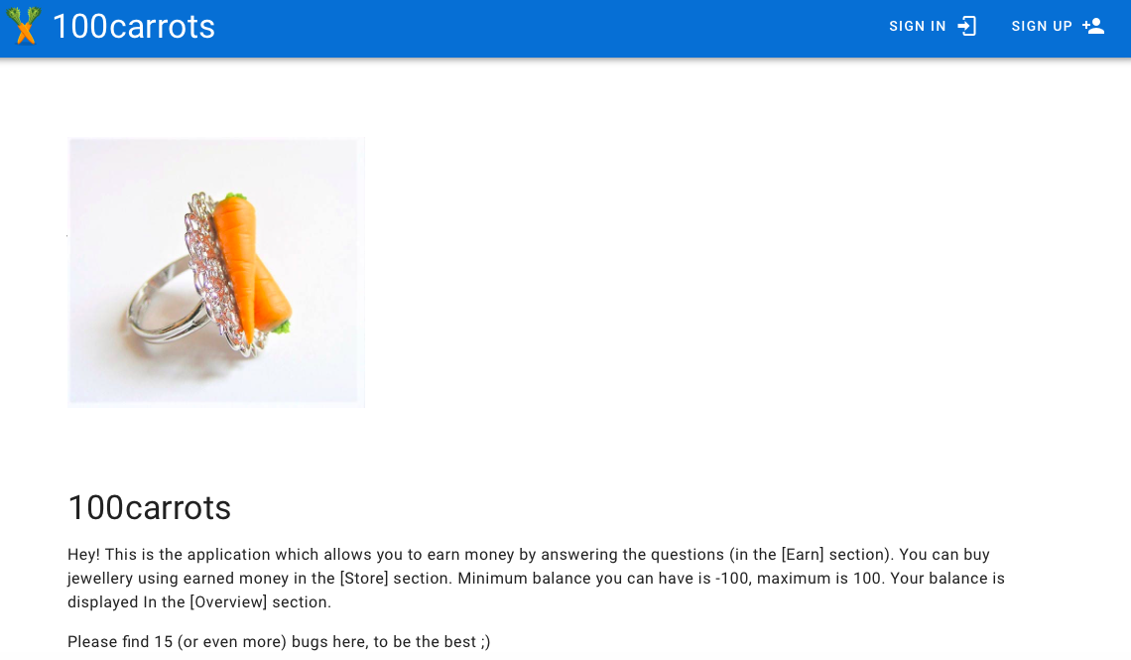

1. Introduction

*100carrots is an application that allows you to earn money by answering questions and buying jewelry with the money you earned.*

*The audience is private sector, people who want to improve their knowledge and earn money to buy jewelry.*

*This document describes all the information.*

2. Scope of work

2.1 Components and functions to be tested

|  |  |  |  |
| --- | --- | --- | --- |
| **#** | **Application/ component name** | **Function name** | **Reference/Comment** |
| 1 | 100Carrots | Home Page |  |
| 2 | Tab icon and title |  |
| 3 | Sign up |  |
| 4 | Sign in |  |
| 5 | Earn |  |
| 6 | Store |  |
| 7 | Overview |  |

2.2 Components and functions not to be tested

|  |  |  |  |
| --- | --- | --- | --- |
| **#** | **Application/ component name** | **Function name** | **Reference/Comment** |
| 1 | - | - | - |

2.3 Third-party components

|  |  |  |  |
| --- | --- | --- | --- |
| **#** | **Component name** | **Component role** | **Reference/Comment** |
| 1 | Telegram | Place for communicate with the team |  |
| 2 | Jira | Place to record bugs |  |

3. Quality and acceptance criteria

* 3 defects with low priority (visual) are allowed
* Acceptance criteria: more than 95% of the bugs found during the previous iteration have been fixed.

4. Critical success factors

Availability of access:

* to the Internet
* Jira

Successful communication with the customer.

5. Risk management

|  |  |  |  |
| --- | --- | --- | --- |
| **Risk** | **Probability** | **Impact** | **Actions** |
| Personel (illness, dismissal) | M | Delays in project implementation | Recruitment of new people to the team |
| Time | H | Late fulfillment of the terms of the contract with the Customer | It is recommended to perform step-by-step tasks before the established deadlines |
| Lack of Internet | VH | Project suspension | Set up a VPN for team access |

Legend:

VH – Very High

H – High

M – Medium

L - Low

6. Resources

6.1 Key project resources

|  |  |  |
| --- | --- | --- |
| **#** | **Project Role** | **Name, e-mail, location** |
| 1 | Manager | Maria, [Maria.sobol20@gmail.com](mailto:Maria.sobol20@gmail.com) , Belarus, Minsk |

6.2 Test team

|  |  |  |  |  |
| --- | --- | --- | --- | --- |
| **#** | **Project Role** | **Name** | **Location** | **Responsibilities** |
|  | QA-Engineer | Tatsiana Dzerabina | Poland, Warsaw | Creating Test Plan, Test cases, testing, writing Test Report |
|  | QA-Engineer | Evgenia Boyarenko | Minsk, Belarus | Creating Test Plan, Test cases, testing, writing Test Report |

6.3 Test hardware

|  |  |  |  |  |
| --- | --- | --- | --- | --- |
| **#** | **Role** | **Resource** | **Hardware configuration** | **Software configuration** |
| 1 | Laptop | MacBook Air (13-inch, Mid 2013) | 4 GB 1600 MHz DDR3 | Mac OS Catalina 10.15.7 (19H15) |
| 2 | Laptop | HDQ6M9SL Intel(R) Core(TM) i5-8265U CPU | 1.60GHz 1.80 GHz | Windows 10, 21H1,19043.1645 |
| 3 | Desktop | LUCRIA, ntel(R) Core(TM) i5-9600K CPU | 3.70GHz 3.70 GHz | Windows 11 Pro, 21H2. 22000.613 |

6.4 Test tools

|  |  |  |
| --- | --- | --- |
| **#** | **Tool** | **Comment** |
| 1 | QuickTime Player | For screen-video recording |
| 2 | Microsoft Word | For creating documentation |
| 3 | Microsoft Excel | For creating documentation |

7. Test documentation

|  |  |  |  |  |
| --- | --- | --- | --- | --- |
| **#** | **Title** | **Responsible person(s)** | **Frequency (delivery time)** | **Method of delivery** |
| 1 | Test Plan | QA-Engineer | Before testing | Email |
| 2 | Test Cases | QA-Engineer | Before testing | Email |
| 3 | Bug reports | QA-Engineer | After testing | Jira |
| 4 | Test Report | QA-Engineer | After testing | Docs.google |

8. Test strategy

*The applications will be tested using a “grey box” approach without knowledge of the internal structure or program source code.*

8.1 Entry criteria

Availability of a test environment

Access to the test environment

8.2 Test methods

Gray box

8.3 Test types

Manual testing – test-cases are done manually without automatization instruments.

Alpha testing – testing inside the developer organization.

GUI Testing - testing through graphical user interface.

Compatibility Testing – testing of working efficiency of the product in different environments (cross-browser or cross-platforms).

Localization testing – testing of adaptation of product to language and cultural features on exact region, which is opposite to region, where product is created.

8.4 Test levels

Smoke testing – testing of default functionalities on positive scenarios.

Extended (AT) – testing of all functionality on both positive and negative checks.

Critical path testing (MAT) – testing of all functionality on positive checks.

8.5 Bug and documentation tracking

Will be provided by Jira.

**8.5.1 Bug severity definition**

*Indicates the severity of the defect in terms of functionality:*

***Highest*** blocks all or key functionality;

***High***crashes normal work of 1 or several functionalities of site and do not interfere further testing;

***Medium***is when defect partly affects on main functions, but making scenario while testing is possible within minimal changes;

***Low***is insignificant functional bug or graphical defect of interface;

***Lowest*** is small defect not requiring mandatory correction.

9. Testing schedule

|  |  |  |  |  |  |  |
| --- | --- | --- | --- | --- | --- | --- |
| **#** | **Activity** | **Begin Date** | **End Date** | **Assignment** | **Location** | **Work content** |
| 1 | Test-Plan | 25.03.2022 | 29.03.2022 | QA-Engineer | Word |  |
| 2 | Test-cases | 25.05.2022 | 29.05.2022 | QA-Engineer | Excel | a set of input data, execution conditions, and expected results designed to test a particular property or behavior of a software tool. |
| 4 | Testing | 26.05.2022 | 29.05.2022 | QA-Engineer | Site, Jira | Make tests, recording into Jira |
| 5 | Defect report | 29.05.2022 | 29.05.2022 | QA-Engineer | Word | description and prioritization of detected defects |

|  |  |  |  |  |  |
| --- | --- | --- | --- | --- | --- |
| **Revision history** | | | | | |
| **Ver.** | **Description of Change** | **Author** | **Date** | **Approved** | |
| **Name** | **Effective Date** |
| 1 |  |  |  |  |  |
|  |  |  |  |  |  |
|  |  |  |  |  |  |