

**REPORT ON DESIGN THINKING PROJECT**

**BACHELOR OF TECHNOLOGY**

**In**

**INFORMATION TECHNOLOGY**

**ENGINEERING**

**Report submitted**

**by**

|  |  |  |
| --- | --- | --- |
| **Sr No.** | **Name** | **Library ID** |
| **1** | **Mohd Yavar** | **2428it1415** |
| **2** | **Pushkar Garg** | **2428it1021** |
| **3** | **Harshit Gupta** | **2428it1341** |

**1st YEAR 1st SEMESTER 2024-25 Batch**

“An indoor vertical farming system for growing fresh produce in urban environments”

**DEPARTMENT OF INFORMATION TECHNOLOGY ENGINEERING**

**KIET GROUP OF INSTITUTION**

Delhi-NCR, Ghaziabad-Meerut Road

GHAZIABAD 201206

**ACKNOWLEDGEMENT**

We, Mohd Yavar **(2428it1415),**Puskar Garg **(2428it1021)** and Harshit Gupta **(2428csit1556)** would like to express our sincere gratitude to our subject teacher **Prof. Aadesh Pandey**,**,HOD**

**IT Department**, for their guidance and support throughout the Design Thinking class and related project..

His expertise and encouragement have been instrumental in shaping our understanding and approach towards the project.

We would also like to extend our heartfelt thanks to the Dean of the DEPARTMENT OF COMPUTER

SCIENCE AND INFORMATION TECHNOLOGY ENGINEERING, **Dr. Abhinav Juneja** and the

Additional Head of Department, **Dr. Ankur Garg** , for their constant support and for fostering environment that encourages innovation and academic excellence. Their leadership has greatly contributed to the successful implementation of this work.

Our sincere appreciation also goes to the Director General Mam of the College, **Prof. (Dr.) Preeti Bajaj**, for providing the resources and infrastructure that enabled us to carry out this work effectively.

We are truly grateful for the opportunities and guidance we have received from each one of you, and look forward to continue to learn and grow with your support.

|  |  |  |
| --- | --- | --- |
| INDEX | | |
| S NO. | TOPIC | PAGE NO |
| 1 | INTRODUCTION | 4 |
| 2 | SYSTEM DESIGN | 5 |
| 3 | SUSTAINABLE FEATURES |  |
| 4 | Technology Application |  |
| 5 | SDG Mapping |  |
| 6 | Scalability |  |
| 7 | Future Potential of Indoor Farming: |  |
| 8 | Conclusion |  |

**Introduction :**

As the global population continues to grow and urbanization accelerates, the demand for sustainable food production systems has never been greater. Indoor vertical farming is a groundbreaking approach that addresses these challenges by reimagining agriculture within urban environments.

Affordable and Scalable Indoor Vertical Farming System for Urban Environment Indoor vertical farming marks a revolutionary approach to new agriculture, allowing fresh produce to be grown in urban areas with little land. This proposal details a low-cost system design that emphasizes scalability, sustainability, and technology incorporation, thus ideal for an urban environment.

Echnological innovations, including smart sensors and AI optimization, ensure that crops grow in ideal conditions with minimal human intervention. The system also benefits from being located in urban spaces such as rooftops or vacant lots, reducing the carbon footprint associated with transportation and making cities more self-sufficient in food production.

In essence, this proposal offers a sustainable, flexible, and scalable solution for urban food production, contributing to resilient, eco-friendly cities.

**System Design:**

The vertical farming system uses stacked layers in a controlled indoor environment for maximum space efficiency. A modular framework allows for easy expansion as the operation grows. Lightweight, durable materials such as PVC or metal racks form the structural base, while hydroponic or aeroponic systems replace the traditional use of soil, reducing water and space usage. Each layer incorporates LED grow lights optimized for photosynthesis to enable crops to thrive throughout the year irrespective of adverse external weather conditions.

The irrigation is simple drip style, powered by a central reservoir and pump. Water recycling and nutrient recycling are integral, so waste is minimized by the design. This system is modular and resource efficient, such that the initial setup cost is low, starting at $200-$500, for a small operation, thereby opening the way for eventual upgrades.

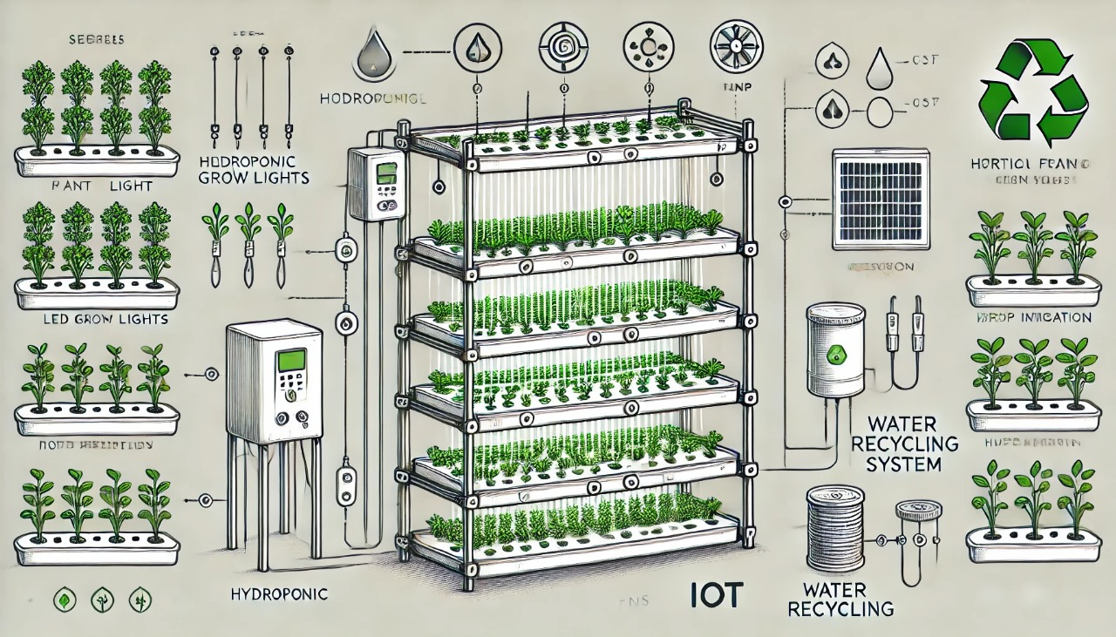

**Sustainability Features:**

This vertical farming system is a sustainable innovation that meets the needs of urban locals for local and eco-friendly food production.

1.Water Usage:

The hydroponic method used involves circulating water in a closed-loop, which reduces its consumption to up to 90% when compared to traditional farming. Any water that is in excess is filtered and recycled to ensure it does not waste. This innovation is particularly crucial in urban areas where water resources are often limited and sustainability is a pressing concern. Excess water in vertical farms undergoes a multi-step filtration process to remove impurities and maintain its quality. This ensures that plants consistently receive clean, nutrient-enriched water, free from waste or contamination.

2. Energy Usage:

Indoor farming, including vertical farming systems, relies on controlled environments to optimize plant growth. While this approach ensures consistent yields and high-quality produce, energy usage is a critical factor that influences its sustainability and cost- effectiveness .LED grow lights provide targeted wavelengths for optimal crop growth while consuming significantly less energy than conventional lighting. As the system scales, renewable energy sources, such as rooftop solar panels, can be integrated to reduce reliance on the grid.

3. Urban Integration:

Indoor farming is becoming an integral part of urban landscapes, transforming how cities address food security, sustainability, and community well-being. By embedding agricultural systems within urban environments, indoor farming offers a forward-thinking solution to meet the needs of growing populations. Land use is avoided by making use of unused urban spaces like basements, rooftops, or shipping containers. On the other hand, carbon footprint associated with transporting produce from rural farms to cities decreases.

4. Waste Reduction:

Indoor farming systems are designed to minimize waste at every stage of the production process, making them a sustainable alternative to traditional agricultural practices. The controlled environment and advanced technologies used in these systems significantly reduce various types of waste, including water, energy, and organic matter. The amount of waste produced is minimized by nutrient recycling and input control. Organic plant residues may be composted for added benefit in sustainability.

5. Lower Usage of Pesticides:

Reducing pesticide usage is crucial for improving food safety, minimizing environmental impact, and promoting long-term sustainability in agricultural practices.The absence of pesticides in the controlled environment leads to wholesome produce and lesser environmental pollution. By implementing a combination of IPM strategies, biological controls, and technological innovations, indoor farming can significantly reduce its reliance on pesticides.

**Technology Application:**

Technology is key in optimizing performance, managing resources more effectively and scaling up:

1.Monitoring Systems:

Sensors keep tabs on pH, nutrient levels, temperature, humidity, as well as light intensity.

Data from sensors is presented on mobile or web-based dashboards, providing immediate insight for adjusting the field

2.Automation:

Timers manage irrigation and lighting programs, applying uniform crop care, Automated nutrient dosing systems balance the nutrient solution based on data from sensor feedback and thus saves on labor costs

3.IoT and Connectivity:

IoT-based devices link the farm directly to a central hub for streamlined remote monitoring and control

Alerts of potential troubles, including equipment failure or nutrient imbalance

4.Renewable Energy Integration:

Smart energy management systems optimize power usage via solar panels and battery storage systems Energy produced during periods of off-peak hours can be stored for later use, further reducing operating costs.

5.Artificial Intelligence (AI)

AI algorithms analyze historical data to enhance yield predictions and optimize resource usage.Machine learning models can even suggest planting schedules and crop rotations based on market demand trends.

**SDG Mapping & Discussion**

This project makes a meaningful contribution to multiple United Nations Sustainable Development Goals (SDGs), demonstrating its impact across sustainability, resource conservation, and community empowerment.

* **SDG 2: Zero Hunger** The system promotes food security by enabling fresh food production in urban environments, particularly in areas where traditional farming is unfeasible. By supporting local economies and reducing dependency on external food sources, the project fosters self-sufficiency and resilience.
* **SDG 6: Clean Water and Sanitation** Hydroponic technology significantly reduces water consumption through a closed-loop recycling system, using up to 90% less water than traditional farming. This approach addresses water scarcity and exemplifies sustainable water management practices.
* **SDG 11: Sustainable Cities and Communities** The modular design of the system enables food cultivation in limited spaces, such as apartments, schools, and offices. By turning underutilized urban areas into productive growing zones, it reduces the environmental footprint and supports the development of resilient, self-sustaining communities.
* **SDG 12: Responsible Consumption and Production** Local food production reduces environmental impacts associated with transportation, packaging, and waste. By facilitating on-demand harvesting, the system minimizes food waste and encourages responsible consumption practices.
* **SDG 13: Climate Action** The project mitigates the carbon footprint of food production by eliminating long transportation chains and adopting sustainable farming methods. Integration of renewable energy sources, such as solar power, can further enhance its role in combating climate change.
* **SDG 4: Quality Education** This system serves as an educational tool, offering practical knowledge of urban farming and hydroponics. By fostering awareness and equipping individuals with sustainable farming skills, it inspires broader adoption of innovative agricultural practices.

In summary, the Indoor Hydroponic Vertical Farming Project addresses food security, promotes resource efficiency, reduces carbon emissions, and supports urban resilience. By aligning with key SDGs, it serves as a scalable and impactful model for creating sustainable urban food systems while encouraging responsible environmental stewardship and education.

**Scalability and Future Potential:**

This is a scalable system, as one might imagine, which starts small with 2–3 layers. Additional layers can be added to existing racks in order to increase the production capacity. Future upgrades will feature full automation, advanced climate controls, and renewable energy systems in order to make the system more efficient and save cost. Introduce the use of AI/ IoT and predictive analytics capabilities to maintain quality and optimize yield for competitive urban agriculture solution.

**Scalability of Indoor Farming:**

1. **Space Efficiency and Urban Integration:**
   * Indoor farming allows for the use of limited space in urban areas, such as rooftops, warehouses, and abandoned buildings. Vertical farming, in particular, maximizes space by growing crops in stacked layers, making it suitable for cities with high population density and limited arable land.
   * The scalability of indoor farming is also enhanced by its ability to be integrated into existing urban infrastructure, allowing farms to be set up in areas with proximity to markets, reducing transportation costs and carbon footprints.

**2.Automation and Technology:**

* + The adoption of automation, AI, and robotics in indoor farming is key to scaling operations. Technologies such as automated irrigation systems, climate control, and harvest robots can increase efficiency, reduce labor costs, and enhance crop yields.
  + With improved technology, larger-scale operations can be more easily managed, increasing the overall production capacity of indoor farms.

**3.Modular Farming Systems:**

* + Indoor farming can be scaled modularly, meaning that small systems can be expanded as demand increases. Modular systems allow for flexibility, enabling farmers to start with a small setup and gradually scale up as they acquire more resources or access to markets.
  + This scalability is particularly attractive for entrepreneurs and companies looking to enter the market with relatively low initial investments.

**4.Resource Efficiency:**

* + Indoor farming systems are highly efficient in terms of resource use, particularly water and nutrients. With recirculating systems like hydroponics and aquaponics, water usage can be reduced by up to 90% compared to traditional farming.
  + The ability to optimize light, temperature, and humidity ensures crops grow faster and more consistently, leading to higher productivity and making indoor farming more viable on a larger scale.

**Future Potential of Indoor Farming:**

1. **Increased Global Food Security:**
   * As the global population continues to grow, indoor farming offers a solution to meet the demand for food, especially in areas with limited access to arable land or water. By producing crops locally and in urban environments, indoor farming can reduce the reliance on traditional agriculture and long-distance food transportation, enhancing food security.
2. **Climate Change Adaptation:**
   * Indoor farming is less vulnerable to climate-related disruptions such as droughts, floods, and temperature fluctuations. This resilience makes it an attractive option for regions facing unpredictable weather patterns and agricultural challenges due to climate change.
   * The ability to grow food indoors in a controlled environment also means that crops can be grown year-round, irrespective of external climate conditions, ensuring consistent food production.
3. **Sustainability and Environmental Benefits:**
   * The future of indoor farming is closely tied to sustainability. With reduced water usage, decreased pesticide reliance, and minimal land requirements, indoor farming presents a more environmentally friendly alternative to traditional agriculture.
   * As energy-efficient technologies and renewable energy sources (e.g., solar, wind) become more accessible, indoor farms will become even more sustainable, minimizing their environmental footprint.

**4.Economic Opportunities and Job Creation:**

* + The expansion of indoor farming could stimulate new economic opportunities, from technology development and manufacturing to the operation of large-scale indoor farms. The creation of jobs in urban areas, especially in technology, engineering, and farming sectors, will contribute to the economic vitality of cities.

**5.Diversification of Crop Production:**

* + Indoor farming allows for the cultivation of a wide variety of crops, including leafy greens, herbs, and even certain fruits. The future potential lies in expanding the range of crops grown indoors, including more complex and high-value crops like strawberries, tomatoes, and mushrooms, which could further increase the profitability of indoor farming.

**6.Integration with Other Technologies:**

* + Indoor farming will likely be integrated with other technological advancements, such as AI-driven crop monitoring, blockchain for supply chain transparency, and advancements in plant breeding. These innovations will enhance productivity, traceability, and crop quality, further improving the potential of indoor farming.

**Conclusion:**

Indoor farming represents a transformative shift in the way we approach agriculture, offering a sustainable and efficient solution to the challenges of urbanization, climate change, and food security. By utilizing controlled environments such as vertical farms, hydroponics, and aeroponics, indoor farming enables year-round production of high-quality crops with minimal resource use. The ability to grow food in urban spaces, combined with advancements in automation, technology, and resource efficiency, makes indoor farming a scalable and viable alternative to traditional farming methods.

While challenges remain, such as high initial setup costs and energy consumption, the ongoing evolution of technology, renewable energy adoption, and optimized farming practices point to a promising future. Indoor farming has the potential to significantly reduce the environmental impact of agriculture, enhance food security, and contribute to local economies.

As the industry continues to mature, indoor farming will play an increasingly pivotal role in providing fresh, healthy food to urban populations while supporting the broader goals of sustainability and resilience in global food systems.

This affordable, scalable, and sustainable indoor vertical farming system utilizes technology to meet the demands of urban food production. Optimizing space, water, and energy while reducing waste and environmental impact, it is a practical and future-ready solution for growing fresh produce in urban environments.