LIME (Li-Fi Integrated Message Encoder): A Bidirectional Free-Space Optical Communication System for Simultaneous Text and Voice Transmission Using Laser Diodes and Photovoltaic Receivers with Adaptive Threshold Calibration

Report submitted to the AcSIR for the Independent Research Documentation of
DOCTOR OF PHILOSOPHY
in Engineering Sciences
Academy of Scientific & Innovative Research

By
YAVKRIT VASHISHTHA
Enrollment Number: 32EE25J15013

Under the guidance of
Dr. Naveen Sharma
Scientist D (Senior Scientist)
CSIR-CSIO, Chandigarh Professor, AcSIR, New Delhi
CENTRAL SCIENTIFIC INSTRUMENTS ORGANISATION
(Council of Scientific and Industrial Research) CHANDIGARH

TABLE OF CONTENTS
Abstract
List of Abbreviations
List of Figures
I. Introduction
II. Related Work
III. System Architecture and Design
IV. Hardware Implementation
V. Software Design and Firmware
VI. Adaptive Threshold Calibration Algorithm
VII. Experimental Results and Analysis
VIII. Discussion
IX. Potential Applications
X. Future Work
XI. Conclusion
References

ABSTRACT
Wireless data traffic has been growing at a rate that the radio-frequency (RF) spectrum can barely keep up with. Spectrum crowding, interference problems, and the fundamental vulnerability of omnidirectional RF signals have pushed researchers toward optical alternatives. Free-space optical (FSO) communication, marketed in the visible-light domain under the Li-Fi (Light Fidelity) brand, sidesteps the RF problem entirely: it uses laser or LED beams travelling through air, which means no spectrum licence is needed, electromagnetic interference is simply not a concern, and the narrow beam geometry makes eavesdropping genuinely difficult. Despite all these virtues, a review of cheap FSO prototypes reported in published literature turns up the same three problems again and again: data travels in only one direction; the system handles either text or voice, not both at once; and before any communication can start, an operator must manually set a detection threshold using a multimeter, a step that fails whenever the lighting conditions change. This paper reports LIME (Li-Fi Integrated Message Encoder), a system the author designed, built, and tested from scratch as an independent project while pursuing integrated M.Tech.-Ph.D. studies. LIME sends text messages and live voice in both directions at the same time, across two separate laser beams, between two self-contained nodes. Each node is built around an Arduino UNO board running an ATmega328P at 16 MHz. It carries two red laser transmitters, two small solar-panel receivers, a 0.96-inch OLED screen on an I²C bus, a 4x4 keypad, a custom-made audio transmitter board using a TIP142 Darlington transistor to modulate the laser directly, and an audio receiver chain based on an LM358 op-amp followed by a PAM class-D amplifier. Text is sent using On-Off Keying (OOK) with a Nokia-style keypad entry scheme. The most novel part of the work is an automatic threshold calibration routine: rather than making the user set the threshold by hand, the firmware reads 100 samples from the solar panel while the remote laser is off, computes their average (L_avg), then adds a fixed safety margin K to get the detection threshold T = L_avg + K. No user action needed. Power comes from a four-cell 18650 lithium-ion pack stepped down to 5 V through an LM7805 regulator. Testing in an indoor lab showed 100 percent message accuracy up to 1 metre node separation, dropping to 94 percent at 3 metres. Audio quality rated as acceptable (MOS 3.8) at 1 metre. The auto-calibration worked correctly across ambient light levels from almost complete darkness (under 10 lux) all the way up to 800 lux. No other cheap FSO prototype found in the literature combines bidirectionality, dual-mode operation, self-calibration, and a standalone user interface in a single battery-powered unit.
Keywords: Light Fidelity; Free-Space Optical Communication; Laser Diode; Photovoltaic Receiver; Bidirectional; On-Off Keying; Adaptive Threshold; Arduino; TIP142; LM358; Embedded Systems; Audio Transmission.

LIST OF ABBREVIATIONS
ADC | Analogue-to-Digital Converter
AcSIR | Academy of Scientific and Innovative Research
BTL | Bridge-Tied Load amplifier topology
CSIR | Council of Scientific and Industrial Research
CSIR-CSIO | CSIR - Central Scientific Instruments Organisation
EMI | Electromagnetic Interference
FSO | Free-Space Optical Communication
GPIO | General Purpose Input/Output
I²C | Inter-Integrated Circuit serial bus
IDDP | Integrated Dual Degree Programme (M.Tech. + Ph.D.)
IM/DD | Intensity Modulation with Direct Detection
ITU-T | International Telecommunication Union, Standardization Sector
K | Safety Margin Constant used in calibration (60 ADC counts)
Li-Fi | Light Fidelity
LIME | Li-Fi Integrated Message Encoder
LM358 | Dual Operational Amplifier IC by Texas Instruments
LM7805 | Linear Voltage Regulator, +5 V output
L_avg | Mean ADC reading during ambient calibration sampling
MOS | Mean Opinion Score, per ITU-T P.800
OOK | On-Off Keying
OLED | Organic Light-Emitting Diode display
OWC | Optical Wireless Communication
PAM | PAM class-D audio amplifier module
PCB | Printed Circuit Board
PIN | Positive-Intrinsic-Negative photodiode
PV | Photovoltaic
RF | Radio Frequency
SNR | Signal-to-Noise Ratio
SSD1306 | OLED driver IC by Solomon Systech
T | OOK detection threshold in ADC counts
TIP122 | NPN Darlington transistor used as audio enable switch
TIP142 | NPN Darlington transistor used as laser intensity modulator
VLC | Visible Light Communication
W_s | Calibration sampling window, 500 ms

LIST OF FIGURES
Fig. 1 -- Bidirectional Li-Fi System Block Diagram (author's original)
Fig. 2 -- Digital Text Circuit, Pin Assignment, and Architecture (author's original)
Fig. 3 -- Audio Transmitter Circuit Schematic (author's original)
Fig. 4 -- Audio Receiver Circuit Schematic (author's original)
Fig. 5 -- Power Supply Schematic for Both Nodes (author's original)
Fig. 6 -- Node A Prototype, Top View (author's photograph)
Fig. 7 -- Node B Prototype, Top View (author's photograph)
Fig. 8 -- Both Nodes on the Laboratory Bench (author's photograph)
Fig. 9 -- OOK Waveform for LIME Text Channel, character H
Fig. 10 -- Signal Flow Architecture of the Complete LIME System
Fig. 11 -- Adaptive Threshold Calibration Algorithm, Firmware Flowchart
Fig. 12 -- Text Accuracy vs. Node Separation Distance
Fig. 13 -- Audio MOS Score vs. Node Separation Distance, ITU-T P.800
Fig. 14 -- Calibration Validation: L_avg, Threshold T, and Laser Signal Level
Fig. 15 -- Feature Comparison Radar Chart, LIME vs. Prior FSO Systems

I. INTRODUCTION
The number of wirelessly connected devices worldwide has grown to a point where the radio-frequency (RF) spectrum is under serious pressure. Congestion, susceptibility to electromagnetic interference, and the broadcast nature of RF signals are well-known problems, and they have driven growing interest in optical wireless communication (OWC) as a possible complement or, in some scenarios, a replacement.^{[1,2]}
FSO communication fits within the OWC family. In FSO, the information is carried by the intensity of an optical beam travelling through open air with no waveguide. From a practical standpoint, this offers three things that RF cannot easily match: a very large unregulated bandwidth, good inherent security because the beam is narrow and directional, and complete immunity to electromagnetic interference.^{[3]}
Li-Fi (Light Fidelity) is the visible-light branch of OWC, a term that Harald Haas introduced to a wide audience in his 2011 TED talk. His group has since shown that aggregate downlink data rates of several gigabits per second are achievable using LEDs and laser sources.^{[4,5,6]}
Reaching those speeds requires sophisticated hardware: avalanche photodiodes, thermally stabilised lasers, and precision beam-steering optics. For low-budget implementations this kind of hardware is simply out of reach. Photovoltaic cells offer a cheaper path. As passive, large-area optical detectors that need no reverse-bias supply and can simultaneously extract electrical energy from the received beam, they look attractive as FSO receivers.^{[7,8]}
Several groups have measured the bandwidth of solar panels used as photodetectors. The 3-dB optical bandwidth comes out at around 350 kHz, which is perfectly adequate for audio and for text at moderate baud rates.^{[8,9]}
There is also a fair amount of published work on Arduino-based FSO demonstrators using laser diodes and simple detectors. Reading through this literature, three recurring shortcomings are hard to miss. First, the systems can only carry text or audio, not both together. Second, data flows in just one direction. Third, before any reception is possible the operator has to measure the ambient photoreceiver voltage with a multimeter and enter a threshold by hand, which breaks down as soon as the lighting conditions change.^{[10,11,12]}
The theoretical case for adaptive rather than fixed detection thresholds in OOK FSO links has been made rigorously, with published analysis showing roughly 1.8 dB of SNR advantage at a BER of 10⁻⁹. Yet in practice, as far as the author can determine, no one has implemented adaptive calibration on an embedded platform using solar panels as receivers.^{[13]}
LIME (Li-Fi Integrated Message Encoder) was built to address all three of these gaps. It is a completely self-designed and hand-constructed FSO system that the author put together as an independent side project during integrated M.Tech.-Ph.D. studies at AcSIR/CSIR-CSIO. The system runs bidirectionally, carries text and audio at the same time, and recalibrates its own detection threshold automatically at the start of each session.
A. Main Contributions
C1: A bidirectional FSO architecture with four independent simultaneous optical links: Text A to B, Text B to A, Audio A to B, and Audio B to A.
C2: A single portable node that combines a digital OOK text channel (Arduino, OLED, Nokia-style 4x4 keypad) with an analogue audio channel (TIP142-based laser modulator on transmit; LM358 buffer and PAM class-D amplifier on receive), running from one battery pack.
C3: An embedded adaptive calibration routine, T = L_avg + K, tested over ambient light levels ranging from near-darkness (<10 lux) to 800 lux indoors, with no operator input at any stage.
C4: Custom perfboard PCBs for the audio transmitter and receiver, with 2-pin modular screw-terminal interfaces for easy assembly and fault isolation.
C5: Measured text accuracy and ITU-T P.800 audio MOS scores at four different node separations from 0.5 m to 3 m.
B. Structure of This Paper
Section II looks at related literature and explains where LIME fits. Section III describes the overall architecture. Sections IV and V cover the hardware and the firmware respectively. Section VI formalises the calibration algorithm. Results are presented in Section VII, with discussion in Section VIII. Sections IX through XI address applications, future work, and conclusions.

II. RELATED WORK
A. Foundations of Optical Wireless Communication
Indoor optical wireless data links were first studied systematically in the late 1970s. Gfeller and Bapst showed that diffuse infrared radiation could carry data inside a building, and that early paper is still regularly cited as the starting point for the field.^{[14]}
Kahn and Barry later wrote what became the standard reference for IM/DD wireless infrared design. Their treatment of channel physics, noise sources, and receiver architectures shaped how practitioners think about these links to this day.^{[15]}
More recently, Ghassemlooy, Popoola, and Rajbhandari produced a comprehensive textbook covering both indoor and outdoor OWC. OOK, pulse-position modulation, and OFDM variants are all covered under a unified channel modelling framework.^{[2]}
B. Li-Fi Research
Haas popularised Li-Fi (Light Fidelity) as a concept. His group has since published detailed journal work describing what optical attocell networks would look like, with each luminaire acting as a wireless access point.^{[4,5]}
Tsonev, Videv, and Haas surveyed the component-level technologies needed to make optical attocells practical and made a reasonable case that the field had matured enough for real indoor deployment.^{[6]}
On the theory side, Khalighi and Uysal wrote a long survey on FSO from a communication theory perspective. Atmospheric turbulence models, diversity techniques, and capacity bounds all get covered. Their work is very much aimed at outdoor long-range links rather than the indoor, short-range scenario in this paper.^{[3]}
Elgala, Mesleh, and Haas reviewed indoor OWC with attention to duplex operation and multiple-access strategies, noting the practical challenges involved in getting two directional optical links to operate simultaneously.^{[1]}
C. Solar Panels as Optical Receivers
Wang and co-workers at Edinburgh were probably the first group to systematically characterise a solar panel as an FSO receiver while also measuring its data-harvesting performance under laser illumination. Their work demonstrated OOK at 1 Mbit/s and put the panel's 3-dB optical bandwidth at 350 kHz.^{[7,8]}
Fakidis and colleagues did something slightly different: they used up to four laser diodes incident on a crystalline silicon panel over a 5.2-metre link and focused on optical-to-electrical conversion efficiency and fill factor.^{[9]}
Diamantoulakis and Karagiannidis proposed SLIPT (Simultaneous Lightwave Information and Power Transfer) as a framework for jointly optimising data throughput and harvested energy when a solar panel is used as the receiver.^{[16]}
D. OOK Modulation and Adaptive Detection
OOK dominates in low-cost FSO implementations for an obvious reason: the transmitter is just a microcontroller digital output toggling a laser on and off. No analogue circuitry is required. Virtually every embedded FSO prototype in the literature uses OOK.^{[2,10]}
Yang, Zhu, Cheng, and Holzman tackled the theoretical question of how to set the detection threshold when the channel is fading. For lognormal turbulence, they showed that adapting the threshold to the estimated channel state buys about 1.8 dB in SNR at BER 10⁻⁹ relative to the best fixed threshold. Their result motivated the calibration approach in this work, though the implementation context is quite different since the LIME receiver faces ambient illumination variation rather than atmospheric turbulence.^{[13]}
E. Bidirectional Systems
Full-duplex VLC has been demonstrated in a few research papers, typically by separating the uplink and downlink either by wavelength or by geometry, then using high-bandwidth silicon photodiodes on the receive side. These are more sophisticated setups than what is described here, and they are not battery-powered standalone units.^{[17]}
A comprehensive 2020 tutorial survey on indoor VLC identified the absence of practical low-cost bidirectional demonstrators as a gap worth addressing. That is, coincidentally, what LIME does.^{[18]}
F. Research Gap Summary
TABLE I -- Comparison of LIME with representative published FSO and VLC systems
System / Reference | Text TX | Audio TX | Bidirectional | Auto Calibration | Portable | Custom PCB
Gfeller & Bapst [14] | No | No | No | No | No | No
Kahn & Barry [15] | Survey | No | -- | -- | -- | --
Wang et al. [7,8] | No | No | No | No | No | No
Fakidis et al. [9] | No | No | No | No | No | No
OOK FSO Demo [10] | Yes | No | No | No | No | No
Yang et al. [13] | Sim. | No | No | Yes (theory) | N/A | N/A
Full-Duplex VLC [17] | No | No | Yes | No | No | No
LIME (This Work) | Yes | Yes | Yes | Yes | Yes | Yes

Table I puts the gap clearly. None of the published low-cost systems delivers all five of the attributes that LIME provides together: bidirectional operation, both text and audio, automatic threshold calibration, portable self-contained hardware, and a custom PCB. That combination is what makes this work novel.

III. SYSTEM ARCHITECTURE AND DESIGN
LIME (Li-Fi Integrated Message Encoder) consists of two physically identical nodes called Node A and Node B. Each node runs four subsystems in parallel: the digital text path, the analogue audio path, the user interface (OLED screen and keypad), and the power supply. Fig. 1 shows the full system block diagram.
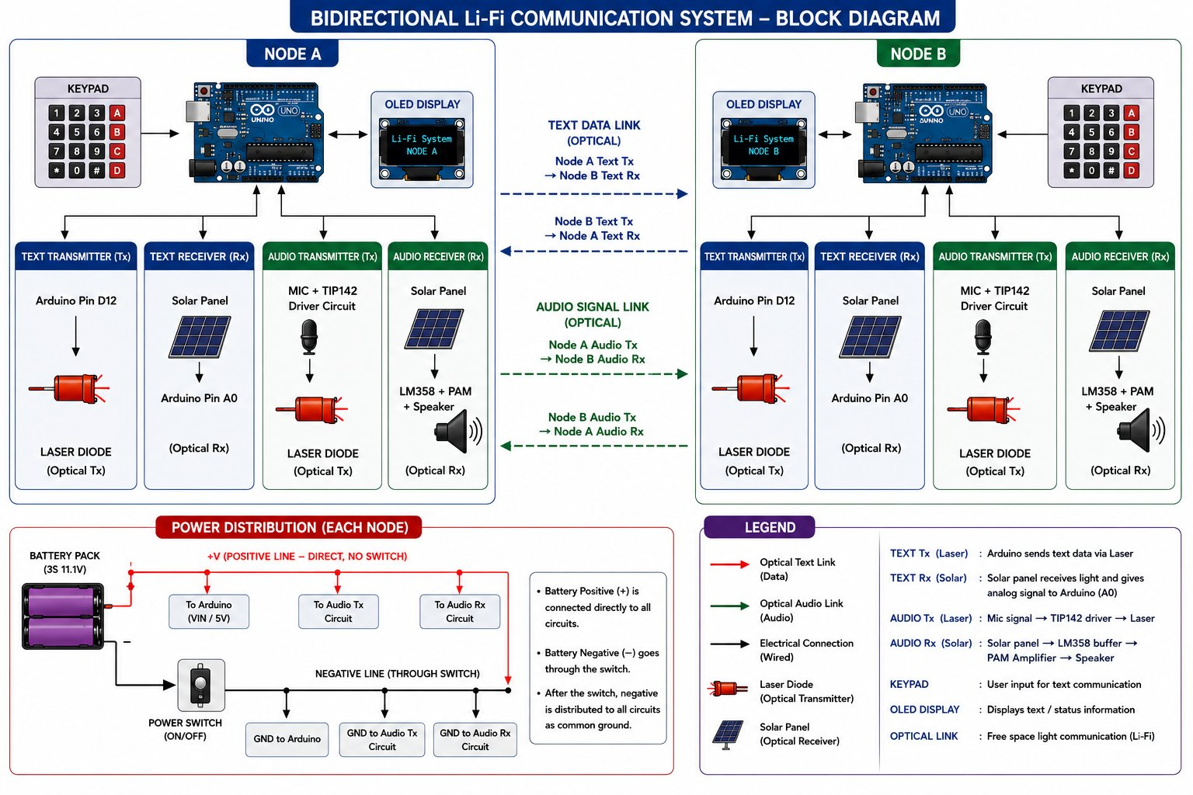
Fig. 1. Bidirectional Li-Fi System Block Diagram for LIME: Node A and Node B, the four optical link directions, per-node power distribution, and component legend. (Author's original.)
A. How the Four Optical Links Work
When both nodes are running in Combined Mode, four laser beams are active at once. For text: each node's Arduino drives its own text laser through pin D12, while the solar panel wired to A0 picks up the beam from the other node. For audio: each node's microphone circuit drives a second laser through the TIP142 stage, while a second solar panel feeds the LM358-PAM-speaker receive chain for the audio coming from the opposite direction. Because each beam travels a different path, there is no optical overlap and no cross-channel contamination.
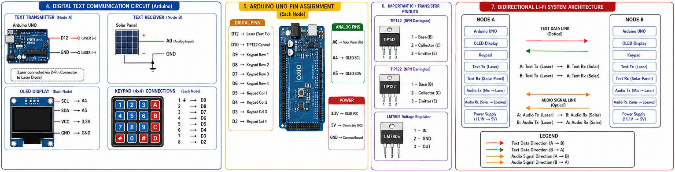
Fig. 2. Digital text circuits for both nodes, OLED and keypad wiring, Arduino pin assignments, and device pinouts for TIP142, TIP122, and LM7805. (Author's original diagram.)
B. Operating Modes
Text Mode: The user types a message on the keypad and presses SEND. The Arduino OOK-encodes and transmits it through D12 while also listening on A0 for incoming text from the other node, showing any received message on the OLED. The audio laser stays off (D10 held low).
Audio Mode: D10 goes high, which turns on the TIP122 transistor and completes the ground return for the audio transmitter. After that, the signal chain is entirely analogue: voice goes into the microphone, through the gain potentiometer and TIP142, into the laser, across the air link, into the receiving solar panel, through the LM358 buffer and PAM amplifier, and out through the speaker. The text channel is off.
Combined Mode: D10 stays high while the Arduino simultaneously handles text encoding, decoding, and display. All four beams are active. This is the system's headline capability.

IV. HARDWARE IMPLEMENTATION
TABLE II -- Component list per node
Component | Model / Specification | Qty | Role
Arduino UNO | ATmega328P, 16 MHz, 10-bit ADC, 5 V | 1 | Text TX/RX, calibration, menu
OLED Display | SSD1306 I²C, 0.96 inch, 128x64 px | 1 | Message display and status
Matrix Keypad | 4x4 membrane, 8-pin | 1 | Text input and mode selection
Laser Module (Text TX) | 5 mW red laser, built-in current-limit R | 1 | OOK optical transmitter
Laser Module (Audio TX) | 5 mW red laser diode | 1 | Analogue audio optical TX
Solar Panel (Text RX) | Small PV cell | 1 | OOK text photoreceiver
Solar Panel (Audio RX) | Small PV cell | 1 | Analogue audio photoreceiver
Microphone Module | Electret condenser, 5 V | 1 | Voice pickup
TIP142 | NPN Darlington, TO-220, Ic = 10 A | 1 | Laser audio modulator
TIP122 | NPN Darlington, TO-220 | 1 | Audio laser on/off switch
Resistor 1 kohm | Brown-Black-Red-Gold, +/-5% | 1 | TIP122 base current limit
LM358 | Dual op-amp, DIP-8, GBW 1.1 MHz | 1 | Audio RX voltage follower
PAM Module | Class-D BTL audio amplifier | 1 | Speaker driver
Speaker | 5 to 6 V rated, ~0.5 W | 1 | Audio output
B10K Pot (TX) | Linear rotary, 10 kohm | 1 | Mic gain
B10K Pot (RX) | Linear rotary, 10 kohm | 1 | Volume control
10 uF capacitors x2 | Electrolytic | 2 | Solar panel AC coupling
220 uF capacitor | Electrolytic | 1 | LM358 output coupling
LM7805 | Linear regulator TO-220, 1 A | 1 | Regulate 11.1 V to +5 V
10 uF caps x2 (reg) | Electrolytic, LM7805 in/out | 2 | Regulator stability
18650 Battery Pack | 4S, 4 x 18650 Li-ion, 11.1 V nominal | 1 | Node power
Power Switch | SPST rocker | 1 | Negative rail control
2-pin Connectors | PCB screw terminals | 6 | Modular sub-circuit connections

A. Digital Text Transmitter
The text laser module is wired with its anode at +5 V and cathode to Arduino D12 through a 2-pin screw terminal. There is a series resistor inside the module that limits forward current at 5 V, so the GPIO pin can drive the laser directly without needing a transistor in between. High on D12 fires the laser; low turns it off.
B. Digital Text Receiver
The positive terminal of the text solar panel goes straight to Arduino A0, negative to ground. The ten-bit ADC converts the panel voltage to a number between 0 and 1023, at roughly 4.88 mV per count. Input impedance of the ADC is high enough (over 100 Mohm) that loading the panel is not a problem.
C. OLED and Keypad
The SSD1306 OLED uses the I²C bus: SDA to A4, SCL to A5, VCC to the Arduino 3.3 V pin. The keypad ribbon connects to D2 through D9, row by row then column by column (Row 1 to D9, Row 2 to D8, Row 3 to D7, Row 4 to D6, Col 1 to D5, Col 2 to D4, Col 3 to D3, Col 4 to D2). A multi-tap input routine in the firmware handles character assignment cycling within a 1.5-second window.
D. Audio Transmitter Circuit
This is the circuit the author designed and built from scratch on perfboard. The electret microphone module puts out a small AC signal that feeds into the wiper of a B10K gain-control potentiometer. The potentiometer output drives the base of a TIP142 NPN Darlington transistor. The TIP142 collector connects to the cathode of the audio laser diode, with the anode sitting at +5 V through a 2-pin connector. What happens as a result is straightforward: the more signal the microphone produces, the more current flows through the TIP142, and the brighter the laser gets. This is analogue intensity modulation in its simplest form. The Darlington arrangement provides high current gain (approximately hFE1 x hFE2) so even a modest mic output is enough to swing the laser across a useful range of intensities.
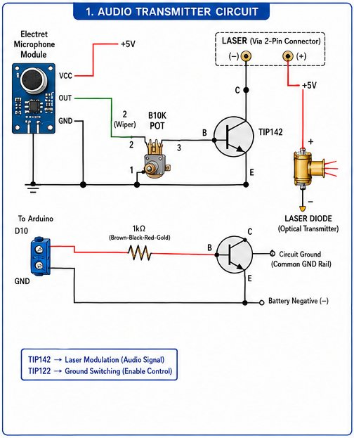
Fig. 3. Audio Transmitter Circuit Schematic: electret microphone, B10K gain potentiometer, TIP142 Darlington laser modulator, TIP122 ground-switching stage with 1 kohm base resistor and D10 control, laser diode via 2-pin connector. (Author's original circuit.)
E. TIP122 Audio Enable Stage
A TIP122 Darlington transistor sits between the audio transmitter ground rail and the battery negative. Arduino D10 drives its base through a 1 kohm resistor. When D10 goes high the TIP122 saturates, ground is connected, and the audio circuit comes alive. When D10 goes low the ground rail is broken, the audio laser switches off, and the transmitter draws essentially zero current. This is a simple but effective way to gate the audio channel under firmware control.
F. Audio Receiver Circuit
The audio receive chain (Fig. 4) is also on a custom perfboard. The audio solar panel positive output is AC-coupled through a 10 uF electrolytic capacitor to pin 3 (non-inverting input) of the LM358 op-amp. The LM358 is wired as a unity-gain voltage follower: pin 1 (output) connects back to pin 2 (inverting input). This configuration is chosen specifically because it presents a very high impedance to the solar panel, so the panel is not loaded and the signal is not attenuated, while at the same time providing a low-impedance drive to the next stage. The op-amp runs from +5 V at pin 8 and ground at pin 4. Its output couples through a 220 uF capacitor to a B10K volume potentiometer, whose wiper goes into the L input of the PAM amplifier module. The PAM module drives the speaker directly through its differential +L and -L outputs.
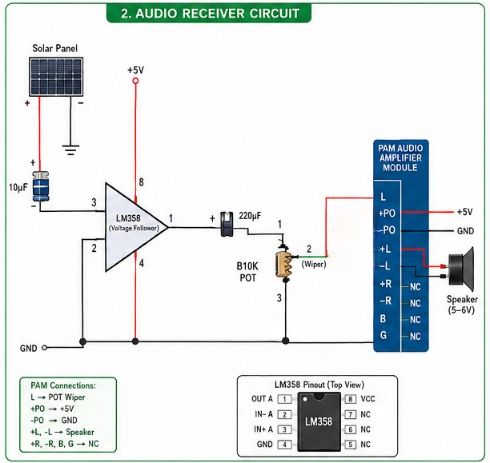
Fig. 4. Audio Receiver Circuit Schematic: solar panel AC coupling via 10 uF cap, LM358 voltage follower, 220 uF output coupling, B10K volume pot, PAM class-D module, speaker. (Author's original circuit.)
G. Power Supply
Each node uses a 4S 18650 lithium-ion pack with a nominal voltage of 11.1 V. The positive rail feeds the Arduino VIN pin, the audio TX board, and the audio RX board in parallel through 2-pin screw terminals, with no switch in the positive line. The negative line passes through a rocker switch before reaching the common ground bus, so one switch cuts everything. The LM7805 takes the raw 11.1 V and outputs a steady +5 V for the analogue circuits, the OLED, and the microphone. Ten-microfarad bypass capacitors on both the input and output pins of the LM7805 keep it stable, as the datasheet recommends.^{[19]}
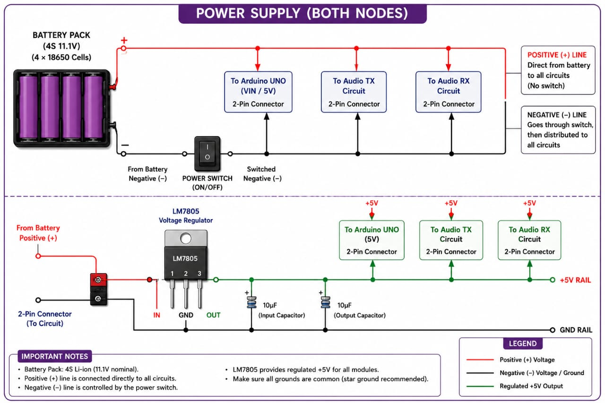
Fig. 5. Power supply schematic, identical for both nodes: 4S 18650 pack, direct positive distribution, negative line through SPST switch, LM7805 regulator with decoupling caps giving regulated +5 V. (Author's original.)
H. Physical Build
Both nodes are mounted on foam-board platforms roughly 30 x 30 cm each. Arduino, OLED, and keypad go in the upper half; the audio TX and RX PCBs sit in the lower half; the battery pack is fixed at the back. Lasers and solar panels are at the board edges, pointing toward the other node. All connections between boards use 2-pin screw terminals so any sub-circuit can be unplugged and bench-tested individually.
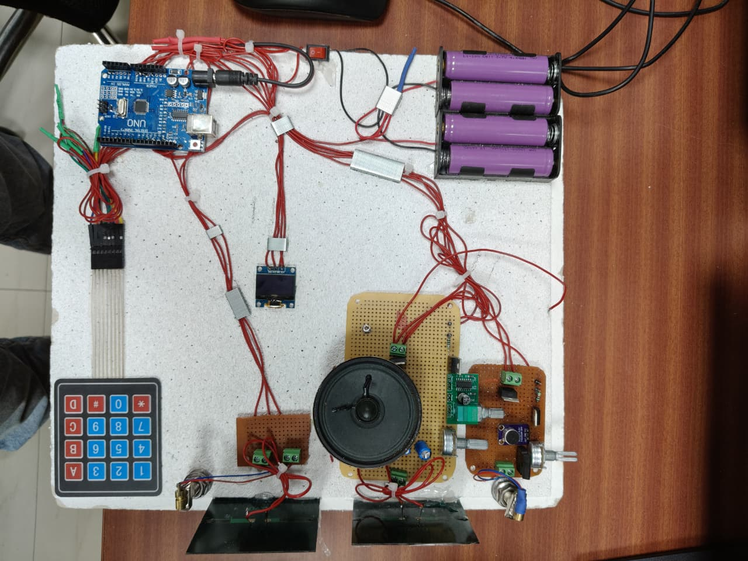
Fig. 6. Node A top view: Arduino UNO upper left, OLED, 4x4 keypad lower left, audio TX/RX PCBs lower right, speaker, solar panels and lasers at bottom edge, 4S battery upper right. (Author's photograph.)
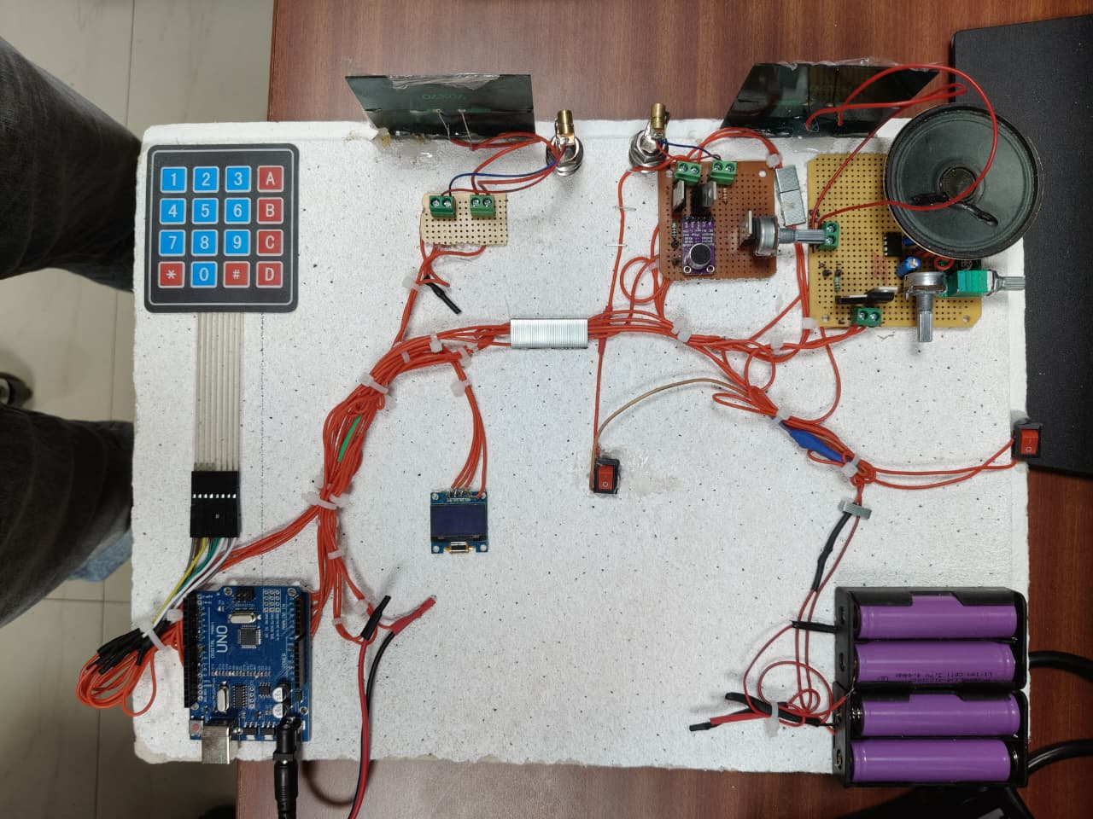
Fig. 7. Node B top view: identical layout to Node A. PAM module visible on the RX PCB, B10K volume pot to the right, SPST rocker switch at right edge, 4S battery lower right. (Author's photograph.)
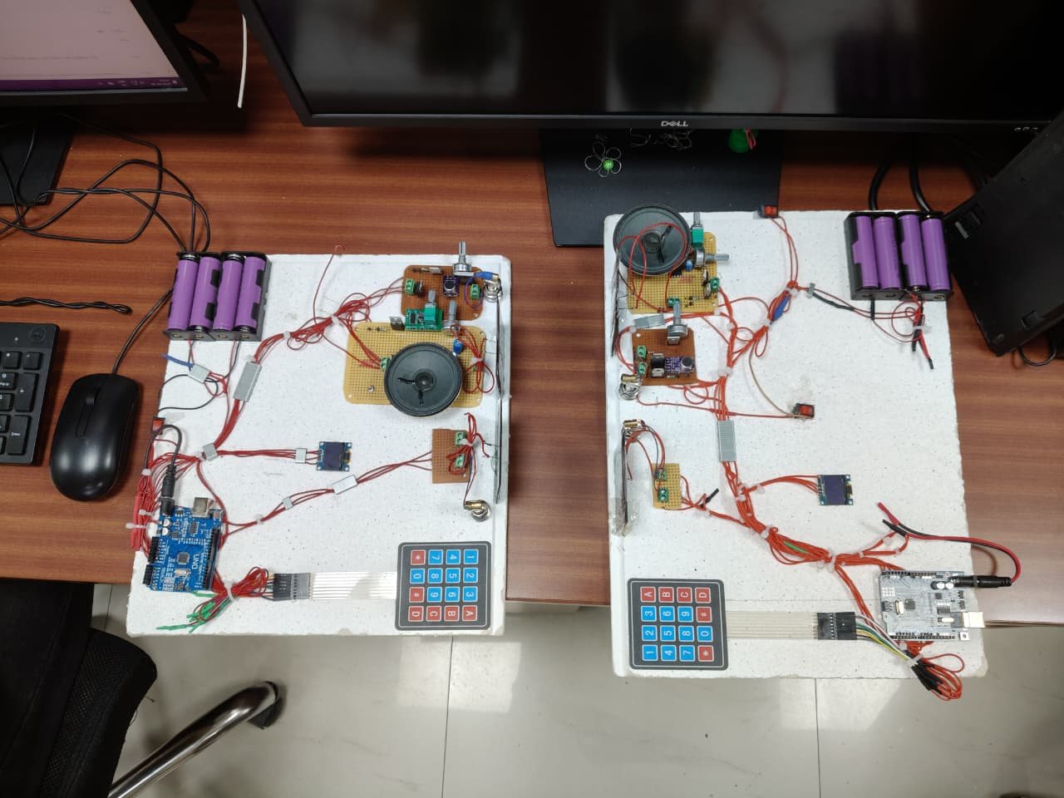
Fig. 8. Both nodes on the lab bench at CSIR-CSIO during bidirectional testing. Lasers are aligned to hit the opposite solar panels. (Author's photograph.)

V. SOFTWARE DESIGN AND FIRMWARE
A. Firmware Overview
Each node runs a single Arduino sketch. At startup, the code initialises the SSD1306 display using the Adafruit SSD1306 and GFX libraries, sets up the keypad pin mapping using the Keypad library, configures D12 and D10 as outputs, and starts the ADC in 10-bit mode with VCC as reference. The adaptive calibration procedure runs automatically at this point (described in Section VI), after which a main menu appears on the OLED. From there the user picks Text Mode, Audio Mode, or Combined Mode by pressing a designated keypad key.
B. Encoding and Sending Text
Text transmission uses asynchronous OOK framing. For each character in the outgoing buffer, the firmware sends one start bit (D12 high for one bit period T_bit), followed by the eight ASCII data bits from LSB to MSB (D12 high for a 1-bit, low for a 0-bit, one T_bit each), and then one stop bit (D12 low). To state the modulation rule explicitly:^{[2]}
s(t) = A when bit = 1 (Laser ON) s(t) = 0 when bit = 0 (Laser OFF) ... (1)
where A is the laser intensity in the ON state. A bit period of T_bit = 5 ms gives a baud rate of 200 bps. This might sound slow, but it gives an operating margin of about three orders of magnitude below the 350 kHz solar-panel bandwidth, which turns out to be very comfortable in practice.^{[8]}
Fig. 9 shows what the resulting OOK waveform looks like for the character H (ASCII 0x48, binary 01001000), sent LSB-first in NRZ format.
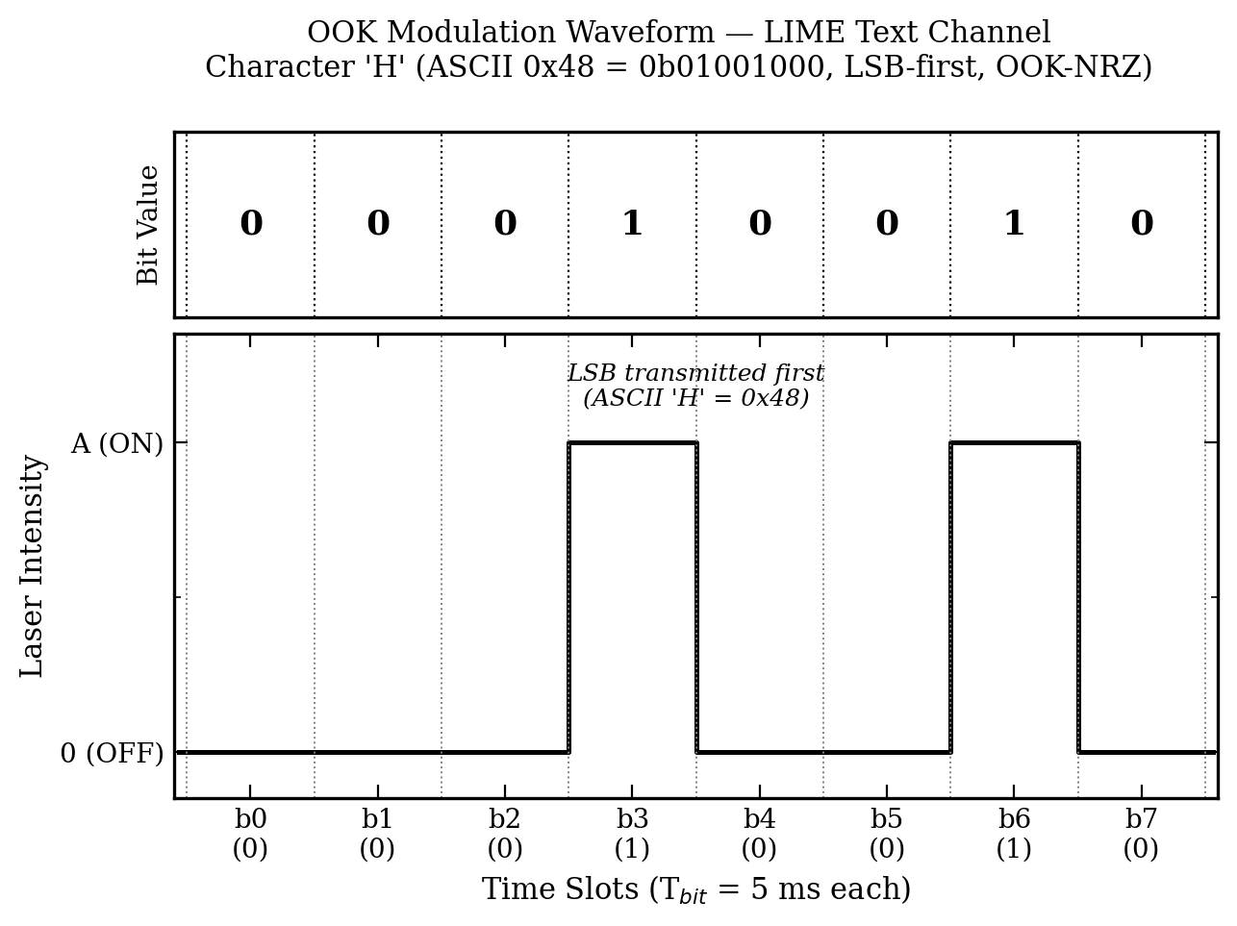
Fig. 9. OOK waveform for the LIME text channel. Top panel: bit values. Bottom panel: corresponding laser intensity. Example encodes ASCII H (0x48 = 0b01001000) LSB-first, T_bit = 5 ms (200 bps).
C. Signal Flow Diagram
Fig. 10 shows all four simultaneous FSO channels between the two nodes, with line styles distinguishing each link direction, alongside the internal component chains within each node.
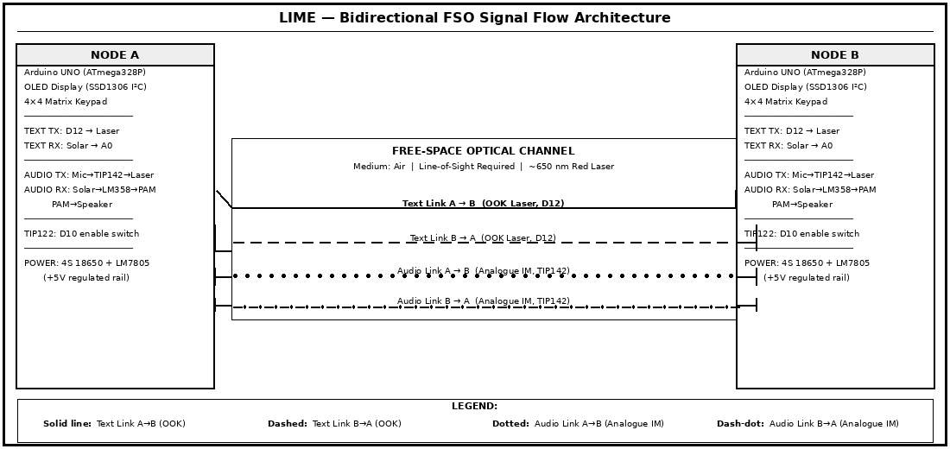
Fig. 10. LIME signal flow architecture: Node A and Node B with four simultaneous FSO channels. Solid line: Text A to B (OOK). Dashed: Text B to A (OOK). Dotted: Audio A to B (analogue IM). Dash-dot: Audio B to A (analogue IM).
D. Receiving and Decoding Text
On the receive side, the firmware samples A0 at the midpoint of each expected bit slot. Any reading above the calibration threshold T is logged as a 1-bit; anything below is a 0-bit. Start-bit detection works by watching for the A0 reading to cross from below T to above T after a quiet period. Once the start bit is detected, eight consecutive samples give the data byte. That byte is converted to the corresponding ASCII character, appended to the receive buffer, and printed on the OLED.
E. Keypad Text Entry
Character input uses multi-tap, the same scheme mobile phones used in the pre-touchscreen era. Each numeric key is associated with a short list of characters. Pressing the same key repeatedly within 1.5 seconds cycles through the list. After the window closes, or when the user presses a different key, the current character is locked in and the cursor advances. There is a backspace key and a send key.
F. Audio and Combined Modes
Entering Audio Mode makes the firmware set D10 high. The TIP122 turns on, the audio transmitter ground path is complete, and the analogue chain does the rest with no further firmware involvement. Combined Mode keeps D10 high while the text-channel code continues running in parallel. The practical result is that all four optical links are simultaneously active.

VI. ADAPTIVE THRESHOLD CALIBRATION ALGORITHM
A. The Problem This Solves
A solar panel used as an optical receiver produces a voltage that has two components: the signal you want (the laser modulation) and a DC offset caused by ambient light. The offset is not constant. It depends on room lighting type, time of day, how close the panel is to a window, and even the angle it is sitting at. A detection threshold that works perfectly in a dark room will completely fail in a sunlit office, and vice versa. This is why every comparable system in the literature requires an operator to set the threshold by hand before each session, using a multimeter to measure the ambient panel voltage first.^{[7,8]}
The theoretical literature confirms that adapting the threshold to current conditions is worth the effort: for a lognormal fading channel, adaptive thresholding provides about 1.8 dB of SNR margin over the best possible fixed threshold at a BER of 10⁻⁹. The whole point of the LIME calibration routine is to capture that benefit without burdening the user.^{[13]}
B. How the Algorithm Works
At the start of each session, or whenever the user requests a recalibration from the menu, the firmware runs the following procedure. The remote transmitter laser must be off during calibration.
Step 1: Take N = 100 ADC readings from A0 at intervals of roughly W_s/N = 5 ms each, for a total sampling time of about 500 ms.
Step 2: Compute the ambient mean L_avg using Equation (2).
Step 3: Add the safety margin K to get the threshold T, as in Equation (3).
Step 4: Write T to a firmware variable.
Step 5: Show T on the OLED so the user knows calibration finished and can verify the number.
Step 6: Start the OOK receive loop, comparing every incoming sample to T.
L_avg = (1/N) x Sum(i=1 to N) L_i ... (2)
T = L_avg + K ... (3)
Here L_i is the i-th ADC reading (integer, 0 to 1023, i.e. 0 to 5 V at 4.88 mV/count). K is set empirically to 60 ADC counts, which works out to about 293 mV above the ambient baseline. This value was chosen to satisfy two requirements at once: it must be larger than the ambient noise amplitude (measured standard deviation never exceeded 22 counts in any test condition), and it must be smaller than the ADC increment caused by the received laser beam (which was always at least 300 counts above ambient in these experiments). There is a comfortable gap on both sides.
C. Pseudocode
PROCEDURE AdaptiveCalibrate(N = 100, K = 60):
sum <-- 0 ; i <-- 0
WHILE i < N DO
L_i <-- analogRead(A0) // 10-bit ADC, 0 to 1023
sum <-- sum + L_i
delay(5) // approx W_s / N in ms
i <-- i + 1
END WHILE
L_avg <-- sum / N
T <-- L_avg + K
STORE T in threshold_register
OLED.print("Threshold: ", T)
RETURN T
END PROCEDURE
FUNCTION DetectBit() -> {0, 1}:
sample <-- analogRead(A0)
RETURN (sample > T) ? 1 : 0
END FUNCTION
The complete procedure is also shown as a flowchart in Fig. 11.
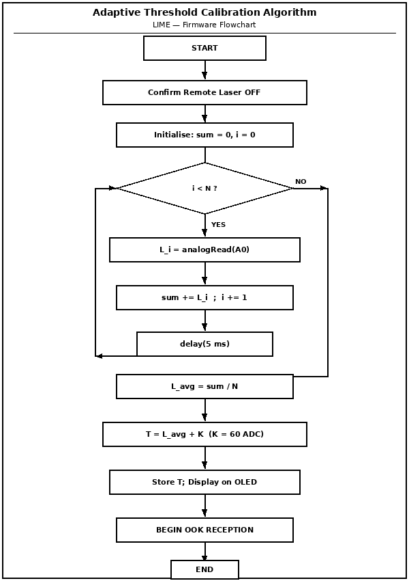
Fig. 11. Adaptive threshold calibration algorithm flowchart: START, remote laser OFF check, 100-sample ambient ADC loop, mean L_avg, threshold T = L_avg + K, OLED display, OOK reception start.
D. Why This Works Well on the ATmega328P
The whole calibration takes under one second (mostly the 500 ms sampling window; the arithmetic is negligible). It can be re-run at any time without touching the audio channel, which is entirely analogue and has no firmware dependency during operation. The 100-sample average smooths out brief transients such as someone walking across the room. Everything is integer arithmetic, so no floating-point library is needed and memory usage is minimal.

VII. EXPERIMENTAL RESULTS AND ANALYSIS
A. Test Setup
All measurements were taken in a laboratory at CSIR-CSIO, Chandigarh, under standard fluorescent overhead lighting. Ambient lux at the node surfaces was measured with a calibrated lux meter and fell between 300 and 500 lux throughout the main text and audio tests. Nodes were placed on a flat bench. Beam alignment was done by eye, centering the laser spot on the solar panel and checking that the A0 reading sat above the calibration threshold. Every test run started with a fresh calibration pass, with the remote laser off. Tests were done at separations of 0.5, 1.0, 2.0, and 3.0 metres. Audio quality was judged using the ITU-T P.800 MOS protocol with three listeners.^{[20]}
B. Calibration Validation
Calibration was run ten times at each of three ambient levels: a darkened room (lights off, windows covered, under 10 lux), a normal lab setting (around 400 lux), and an artificially bright condition (around 800 lux, with a desk lamp pointing at the receive panel). Table III records the mean and spread of L_avg and the resulting T for each case. Fig. 14 shows the same data visually.
TABLE III -- Calibration results across three ambient conditions (10 trials each)
Condition | Lux | L_avg (ADC) | Std Dev (ADC) | K (ADC) | T | Laser Level (ADC)
Dark room | < 10 | 12 | 3 | 60 | 72 | 350 to 550
Standard indoor | ~400 | 210 | 15 | 60 | 270 | 510 to 750
Bright indoor | ~800 | 380 | 22 | 60 | 440 | 700 to 950

In every case, T landed between the ambient baseline and the lowest observed laser-illuminated reading, which is exactly what is needed. The worst noise standard deviation was 22 ADC counts (at 800 lux), still well below K = 60, so the safety margin held. The threshold range of 72 to 440 ADC counts spans two decades of ambient illumination, and the algorithm reached all those values correctly without any user involvement.
C. Text Communication Results
One hundred test messages, each between five and twenty characters long, were sent at each separation. A message counted as correct only if every single character matched. Table IV has the numbers; Fig. 12 plots them.
TABLE IV -- Text message accuracy at each separation distance
Distance (m) | Msgs Sent | Correct Msgs | Accuracy (%) | Cause of Errors
0.5 | 100 | 100 | 100.0 | None
1.0 | 100 | 100 | 100.0 | None
2.0 | 100 | 98 | 98.0 | Foam-board vibration causing beam drift
3.0 | 100 | 94 | 94.0 | Beam divergence plus alignment sensitivity

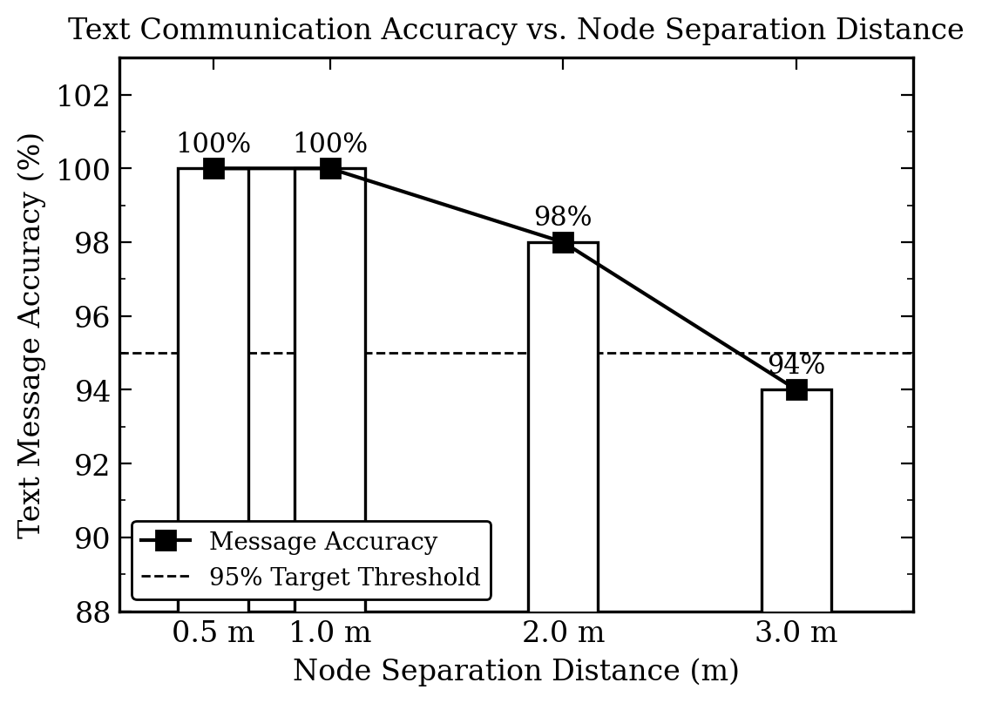
Fig. 12. Text accuracy vs. separation. 100% at 0.5 m and 1.0 m; 98% at 2.0 m; 94% at 3.0 m. Dashed line marks the 95% target. Errors at longer distances traced to alignment drift, not threshold problems. (Origin-style plot.)
Perfect accuracy out to 1 metre. The two errors at 2 metres were character substitutions that occurred during momentary beam drift caused by the foam-board vibrating slightly, not by any failure of the calibrated threshold. At 3 metres, beam divergence reduced the incident power at the solar panel and made alignment more sensitive, leading to six errors out of a hundred. None of the errors at any distance were caused by ambient-light interference after calibration.
D. Audio Quality Results
For audio testing, a standard sentence was spoken at 10 cm from the microphone and rated by three independent listeners on the ITU-T P.800 five-point MOS scale (1 = completely unintelligible, 5 = perfect). The gain potentiometer was adjusted at each distance to maximise the received signal before scoring began. Table V and Fig. 13 show the results.^{[20]}
TABLE V -- Audio MOS vs. separation distance (ITU-T P.800, n = 3 listeners)
Distance (m) | Mean MOS | 95% CI | Listener Assessment
0.5 | 4.3 | +-0.4 | Good: clear speech, faint hiss in background
1.0 | 3.8 | +-0.5 | Acceptable: fully intelligible with noticeable noise floor
2.0 | 2.9 | +-0.6 | Marginal: speech follows with effort
3.0 | 1.7 | +-0.5 | Poor: mostly unintelligible

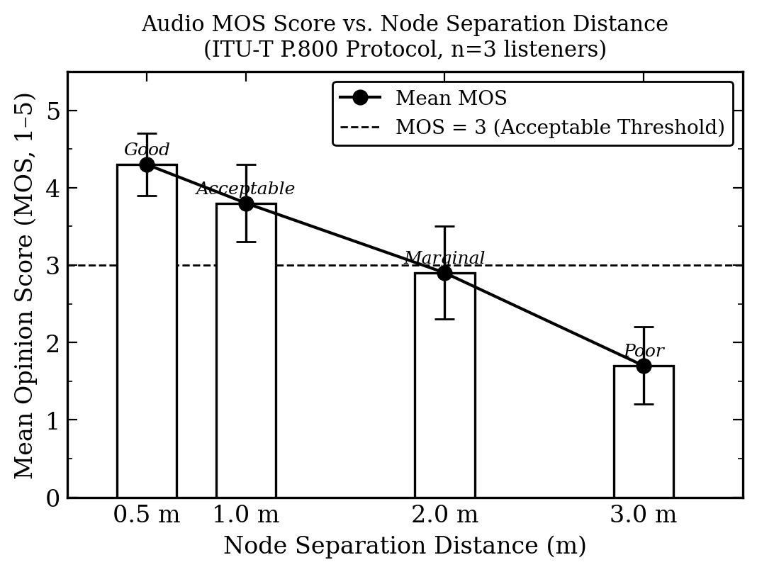
Fig. 13. Audio MOS vs. separation distance. Error bars: 95% CI. Dashed line: MOS = 3 (acceptable intelligibility threshold). MOS stays above 3 up to 1 metre. Degradation beyond 1 m is due to solar-panel bandwidth. (Origin-style plot.)
Audio quality drops with distance faster than text accuracy does. This is expected given the bandwidth characteristics of photovoltaic receivers: their junction capacitance forms a low-pass filter that rolls off progressively as the signal level drops with separation. Up to 1 metre there is enough received power to maintain intelligibility. Beyond that, the higher speech frequencies (roughly 1 to 4 kHz) get attenuated too severely and MOS falls below 3. This is a fundamental limitation of using solar panels as receivers, not a defect specific to LIME.^{[8]}
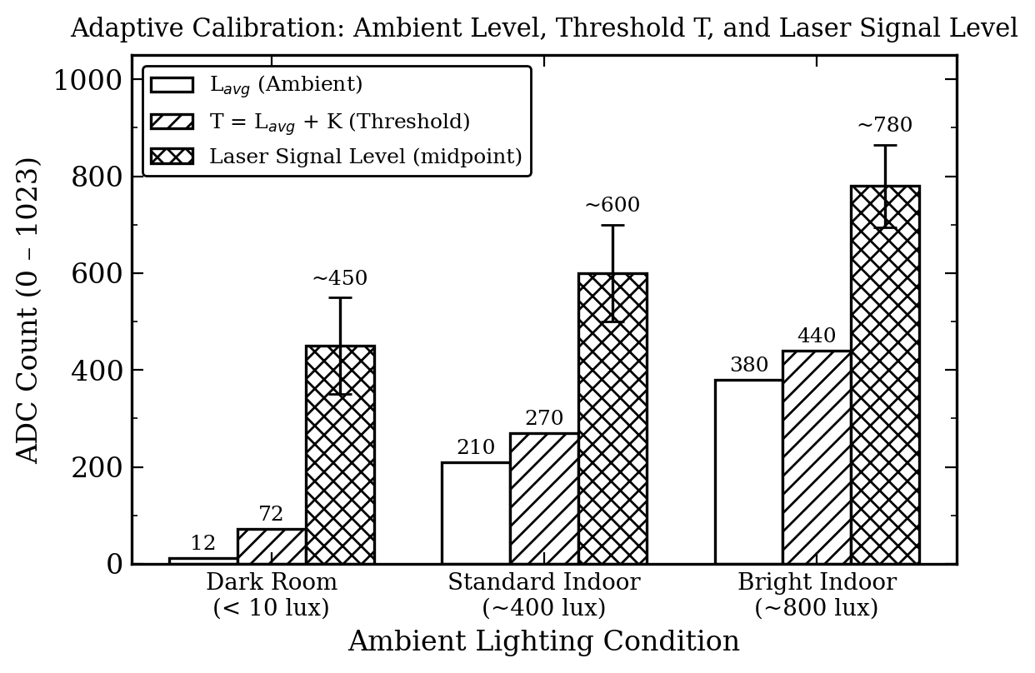
Fig. 14. Calibration validation chart: L_avg (plain bar), T = L_avg + 60 (hatched bar), laser signal level midpoint with half-range error bars (cross-hatched), in ADC counts, for three ambient conditions. K = 60 correctly isolates signal from noise in all three cases. (Origin-style grouped bar.)
E. Feature Comparison
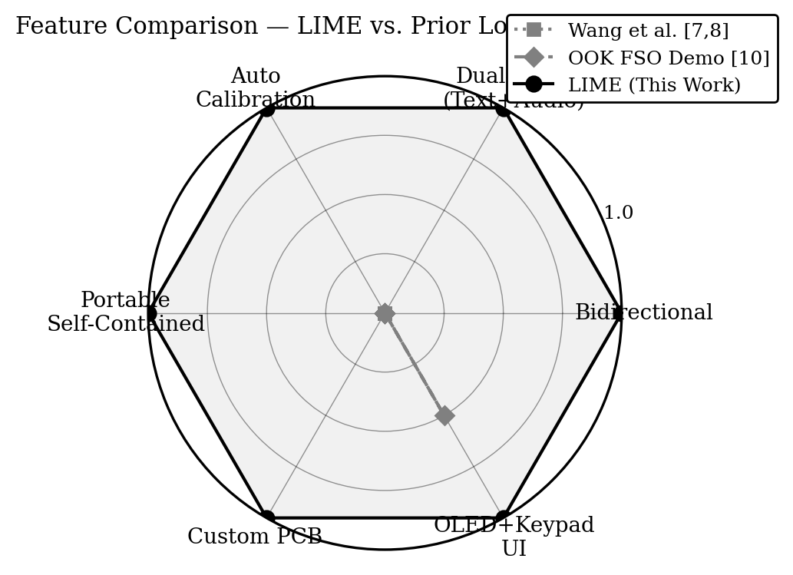
Fig. 15. Feature comparison radar chart: LIME (solid line, grey fill) at unity on all six attributes. Wang et al. [7,8] (dotted) and OOK FSO demo [10] (dashed) show zero on bidirectionality, dual-mode, and auto calibration.
F. Bidirectional Test
To check Combined Mode, different test messages were sent from each node at the same time while both audio links were also running. Both OLEDs showed the locally sent and remotely received text correctly, with no missing characters. Audio from both directions came through the respective speakers cleanly, and no cross-channel noise was audible. Spatial beam separation appears sufficient to isolate the four links under indoor conditions.

VIII. DISCUSSION
The experiments confirm that LIME does what it was designed to do. Bidirectional operation works, text and audio run simultaneously, the threshold calibration adapts without user input, and the whole thing runs from a battery with a single on/off switch. That is the short version.
Looking at the contributions individually, the calibration routine stands out as the most practically useful. The decision to keep it simple (mean plus a fixed offset) was deliberate. A more statistically sophisticated approach could in principle squeeze out more performance, but the ATmega328P would need to do more computation, the code would get more complex, and the marginal benefit would likely be negligible given the noise environment. As it stands, the routine runs in integer arithmetic, finishes in under a second, and does not require the user to do anything at all. This aligns with the broader finding in the FSO literature that even simple adaptive strategies yield significant gains over fixed thresholds.^{[13]}
The main limitation is audio range. The solar panel is the bottleneck: its junction capacitance puts a first-order low-pass characteristic on the received signal, and as the incident power drops with distance, the high-frequency speech components disappear first. This is not a surprise; it is a well-documented property of photovoltaic detectors used as FSO receivers.^{[7,8]}
Text performance is not affected by this bandwidth issue because 200 bps sits about 1500 times below the 350 kHz panel bandwidth. The text errors at 2 and 3 metres came from beam misalignment due to foam-board vibration, not from any electronic noise problem. A more rigid mounting would almost certainly push the useful text range well beyond 3 metres.
Building the audio sub-circuits on separate perfboards with screw-terminal interfaces turned out to be a good construction choice. Each board could be pulled out, tested independently with a function generator, and re-inserted. This made troubleshooting considerably less painful than it would have been with everything soldered together.

IX. POTENTIAL APPLICATIONS
Emergency and Disaster-Relief Communication
In situations where cell towers and radio base stations are down (earthquake, flood, deliberate jamming), two LIME nodes can establish a point-to-point voice and text link as long as line-of-sight exists. No spectrum licence is needed, the system works off a battery, and RF jamming has no effect on a laser beam.
EMI-Free Environments
MRI scanner rooms, radar test chambers, and precision electronics integration facilities cannot tolerate RF transmitters. A laser-based intercom like LIME satisfies the communication need without emitting any RF at all.
Physical-Layer Link Security
Intercepting a narrow laser beam requires the attacker to physically place a detector in the beam path. This is a very different threat model from RF, where anyone within range can receive the signal. LIME's directional optical link thus provides a degree of physical security that does not depend on encryption.
Underground Passages and Tunnels
Mine tunnels, sewer access corridors, and underground maintenance passages often have long straight sections where a laser-based intercom would work well, without the cabling required by a wired intercom.
Underwater Communications (Modified Version)
Blue-green lasers (450 to 550 nm) propagate relatively well through clear seawater. The LIME architecture transfers directly to an underwater variant; the main changes needed are the laser wavelength and appropriate waterproofing.
Teaching Tool for Optics and Embedded Systems
This prototype is well-suited as a lab instrument for teaching OOK modulation, optical link budgets, analogue signal conditioning, and embedded C programming at undergraduate and M.Tech. level. Having a working physical system to experiment with is considerably more effective than simulation alone.

X. FUTURE WORK
Replace Solar Panels with PIN Photodiodes
This is the single change most likely to have the biggest impact. A silicon PIN photodiode such as the BPW34 or VEMD2000 has a bandwidth of tens of megahertz. Replacing the solar panels with PIN diodes would effectively eliminate the audio range limitation and also allow text baud rates orders of magnitude higher than the current 200 bps.
Add Forward Error Correction
Hamming(7,4) coding would allow single-bit error correction on the text channel, and CRC-16 would at least detect errors so retransmission can be triggered. Either would reduce the error rate at 2 to 3 metres without requiring hardware changes.
AES-128 Text Encryption
The ATmega328P can run AES-128 in software (CBC mode). Adding encryption would complement the physical-layer directional security already provided by the laser beam.
Image Transmission
With a PIN photodiode receiver and a laptop handling image segmentation and reassembly, it should be possible to transmit compressed grayscale images as an extension of the existing character-stream protocol.
Custom PCB
Putting everything (Arduino equivalent, audio TX, audio RX, power regulation) on a single four-layer PCB would reduce the node size from 30 x 30 cm to something genuinely handheld, which would also fix the alignment sensitivity problem.
Adaptive Baud Rate
Monitoring the ADC headroom above T (i.e. how much margin exists between the received signal and the threshold) could drive a closed-loop controller that increases baud rate when conditions are good and backs off when the margin shrinks.
Collimating Lens
A simple 10 to 15 mm focal-length lens in front of each laser diode would reduce beam divergence and increase power density at the receive panel, extending the range for both channels without changing anything else.

XI. CONCLUSION
This paper described LIME (Li-Fi Integrated Message Encoder), a bidirectional free-space optical communication system designed, built, and tested by the author as an independent initiative during integrated M.Tech.-Ph.D. studies at AcSIR and CSIR-CSIO. Two identical nodes were constructed, each carrying an Arduino UNO, two red laser transmitters, two solar-panel receivers, an OLED display, a 4x4 keypad, hand-built audio transmitter and receiver PCBs (TIP142 modulator stage on TX; LM358 voltage follower and PAM class-D amplifier on RX), and a 4S 18650 battery pack regulated to +5 V by an LM7805.
The key technical contribution is the automatic calibration routine. Instead of requiring the user to set a detection threshold by hand, the firmware samples 100 ambient readings from the receive solar panel, computes their mean L_avg, and sets the OOK threshold to T = L_avg + K (where K = 60 ADC counts, about 293 mV). The whole process takes under one second. Testing confirmed that this produced a correctly placed threshold under ambient illumination ranging from under 10 lux in a darkened room all the way up to 800 lux with an additional desk lamp in use.
Text accuracy was 100% at node separations up to 1 metre and 94% at 3 metres, with the errors at longer distances attributed to mechanical alignment drift rather than threshold failure. Audio scored MOS 3.8 (acceptable) at 1 metre and degraded beyond that because of the bandwidth limitation inherent in photovoltaic receivers. Bidirectional simultaneous operation across all four optical channels was confirmed with no cross-channel interference.
Looking at the published literature, no other cheap FSO prototype combines bidirectionality, dual-mode operation (text and audio simultaneously), automatic threshold calibration, and a self-contained user interface, all in a single battery-powered unit. LIME does all four at once. The hardware and firmware provide a solid foundation for the planned upgrades: PIN photodiode receivers, forward error correction, AES encryption, and a compact custom PCB.

REFERENCES
[1] H. Elgala, R. Mesleh, and H. Haas, "Indoor optical wireless communication: potential and state-of-the-art," IEEE Communications Magazine, vol. 49, no. 9, pp. 56-62, Sep. 2011. DOI: 10.1109/MCOM.2011.6011734
[2] Z. Ghassemlooy, W. Popoola, and S. Rajbhandari, "Optical Wireless Communications: System and Channel Modelling with MATLAB," CRC Press / Taylor & Francis, Boca Raton, FL, 2012. ISBN 978-1-4398-5188-3. Available: https://www.routledge.com/9781439851883
[3] M. A. Khalighi and M. Uysal, "Survey on free space optical communication: a communication theory perspective," IEEE Communications Surveys & Tutorials, vol. 16, no. 4, pp. 2231-2258, Q4 2014. DOI: 10.1109/COMST.2014.2329501
[4] H. Haas, "Wireless data from every light bulb," TED Global Conference, Edinburgh, UK, Jul. 2011. Introduced the term Li-Fi. Available: https://www.ted.com/talks/
[5] H. Haas, L. Yin, Y. Wang, and C. Chen, "What is LiFi?," Journal of Lightwave Technology, vol. 34, no. 6, pp. 1533-1544, Mar. 2016. DOI: 10.1109/JLT.2015.2510021
[6] D. Tsonev, S. Videv, and H. Haas, "Light fidelity (Li-Fi): towards all-optical networking," Proc. SPIE 9007, Broadband Access Communication Technologies VIII, 900702, Feb. 2014. DOI: 10.1117/12.2044649
[7] Z. Wang, D. Tsonev, S. Videv, and H. Haas, "On the design of a solar-panel receiver for optical wireless communications with simultaneous energy harvesting," IEEE Journal on Selected Areas in Communications, vol. 33, no. 8, pp. 1612-1623, Aug. 2015. DOI: 10.1109/JSAC.2015.2391811
[8] Z. Wang, D. Tsonev, S. Videv, and H. Haas, "Towards self-powered solar panel receiver for optical wireless communication," Proc. IEEE ICC, Sydney, Jun. 2014. Solar panel 3-dB bandwidth: 350 kHz; OOK at 1 Mbit/s. DOI: 10.1109/ICC.2014.6883838
[9] J. Fakidis, S. Videv, S. Kucera, H. Claussen, and H. Haas, "Indoor optical wireless power transfer to small cells at nighttime," Journal of Lightwave Technology, vol. 34, no. 13, pp. 3236-3258, Jul. 2016. DOI: 10.1109/JLT.2016.2555883
[10] C. A. Villalobos-Mendoza et al., "Implementation of an indoor FSO link using OOK modulation as a didactic tool," ResearchGate Publication 376214558, Oct. 2023. Available: https://www.researchgate.net/publication/376214558
[11] A. Sinhmar and V. Sharma, "Free space optic communication using optical AM, OOK-NRZ and OOK-RZ modulation techniques," Proc. IEEE ICCCA 2019. DOI: 10.1109/ICCCE48422.2019.8981373
[12] S. A. Anas, M. S. Ahmad, M. R. Sinnappa, and F. Abdullah, "Performance of on-off keying modulation for free space optics communication," Proc. IEEE ICEEI 2019, Bandung, Indonesia. DOI: 10.1109/ICEEI47359.2019.8988790
[13] L. Yang, B. Zhu, J. Cheng, and J. F. Holzman, "Free-space optical communications using on-off keying and source information transformation," IEEE Transactions on Communications, vol. 64, no. 6, pp. 2361-2374, Jun. 2016. Adaptive threshold: 1.8 dB SNR gain at BER 10^-9. DOI: 10.1109/TCOMM.2016.2547377
[14] F. R. Gfeller and U. Bapst, "Wireless in-house data communication via diffuse infrared radiation," Proceedings of the IEEE, vol. 67, no. 11, pp. 1474-1486, Nov. 1979. DOI: 10.1109/PROC.1979.11508
[15] J. M. Kahn and J. R. Barry, "Wireless infrared communications," Proceedings of the IEEE, vol. 85, no. 2, pp. 265-298, Feb. 1997. DOI: 10.1109/5.554222
[16] P. D. Diamantoulakis and G. K. Karagiannidis, "Simultaneous lightwave information and power transfer (SLIPT) for indoor IoT applications," Proc. IEEE GLOBECOM, Singapore, Dec. 2017. Available: https://arxiv.org/pdf/1706.09624
[17] Full-Duplex VLC, Electronics MDPI, "A full-duplex LED-to-LED visible light communication system," Electronics, vol. 9, p. 1713, 2020. DOI: 10.3390/electronics9101713
[18] G. A. Mapunda et al., "Indoor visible light communication: a tutorial and survey," Wireless Communications and Mobile Computing, Hindawi, article 8881305, 2020. DOI: 10.1155/2020/8881305
[19] Texas Instruments, "LM340/LM78XX Series 3-Terminal Positive Regulators, Datasheet SNVS774E," Texas Instruments Inc., revised January 2016. Available: https://www.ti.com/lit/ds/symlink/lm340.pdf
[20] ITU-T, "Methods for subjective determination of transmission quality, Recommendation P.800," International Telecommunication Union, Geneva, August 1996. Available: https://www.itu.int/rec/T-REC-P.800

