Intelligent Systems (2802ICT) Assignment 2
Roman Green (s5369389)

Task 1 – Learning Decision Trees

Software Design

Results

Discussion

Conclusion

Task 2 – Classification using a Neural Network

Software Design

Experiments

Base Case
The baseline model was trained over 30 epochs in 13.4 seconds with a learning rate of 3 and a batch size of 20.
Figure 1 illustrates the learning progression of the model. Both the training and validation accuracy increase rapidly within the first 5 epochs, indicating that the model is effectively learning underlying patterns in the data. After the initial phase, the curves begin to plateau.
Following the initial rapid progression, the training accuracy shows a relatively smooth, monotonic increase, eventually reaching approximately 86%. In contrast, the validation accuracy (blue line) exhibits significant oscillations after its initial climb, fluctuating between roughly 80% and 85%. This volatility suggests that the chosen learning rate of 3.0 is quite high for a mini-batch size of 20. A high learning rate can cause the model's weights to "overshoot" the optimal point in the loss landscape during updates, leading to instability rather than smooth convergence.
Despite the oscillations, there is no significant divergence between the training and validation curves, which suggests that the model is not severely overfitting the training data. The model generalises reasonably well, achieving a peak validation accuracy of 85%.
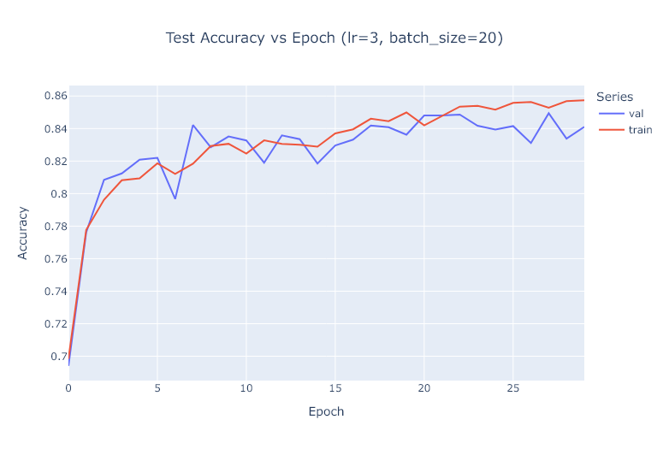
Figure 1 Training and Validation Accuracy vs. Epoch for the Baseline Model. Performance of a fully connected network (784, 30, 10) over 30 epochs with a learning rate (η) of 3.0 and a mini-batch size of 20. The model achieved a maximum validation accuracy of 85%.

Varying Learning Rate
The model was trained over 30 epochs in 1 minute 4 seconds with a fixed batch size of 20 and learning rates of 0.001, 0.01, 1.0, 10, and 100.
Figure 2 illustrates the impact of learning rate on model performance. The results can be categorised into three distinct behaviours:
Learning too slowly  (η= 0.001, 0.01) | With a learning rate of 0.001, the model learns very slowly, and the accuracy curve has not yet plateaued after 30 epochs, reaching only 73%. Weight updates are likely too small to allow for convergence across each example. Increasing η to 0.01 yields a much better result, with a smooth and stable learning curve that reaches a respectable accuracy of 86%.
Optimal learning  (η= 1.0) | At η = 1.0 the learning rate appears optimal for the implemented model. Initial epochs show rapid learning and quick convergence to the highest maximum accuracy of 88%. This rate is large enough for fast convergence but not so large that it causes the instability seen in the baseline model (η=3.0).
Learning too fast  (η= 10, 100) | At η = 10 and η = 100, the learning rate is high enough that each weight update overshoots the minimum of the loss function, causing divergence. The accuracy flatlines at a very low level (20% for η=10 and 10% for η=100), which is equivalent to or worse than random guessing for a 10-class problem.
In summary, a learning rate of 1.0 provided the best performance, achieving a maximum accuracy of 88%.
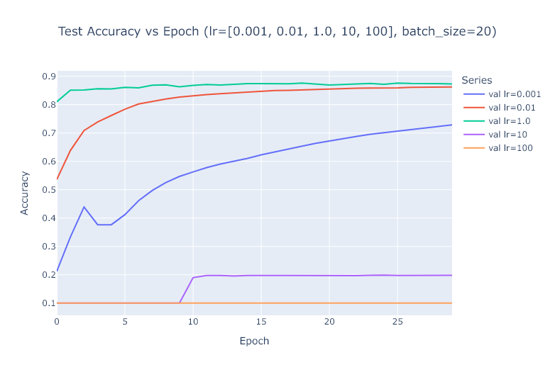
Figure 2 Impact of Learning Rate on Validation Accuracy. Performance of a fully connected network (784, 30, 10) over 30 epochs with a fixed mini-batch size of 20, across five different learning rates (η) (0.001, 0.01, 1.0, 10, 100). The results show a clear optimal range for the learning rate, with η=1.0 achieving the highest accuracy of 88%.

Varying Batch Size
The model was trained over 30 epochs in 3 minutes 59 seconds with a learning rate of 3.0 and minibatch sizes of 1, 5, 20, 100 and 300.
Figure 3 illustrates the impact of mini-batch size on model performance.
Smaller batch sizes introduce more noise into the gradient estimate for each weight update. With a batch size of 1 (Stochastic Gradient Descent), the updates are extremely noisy, and combined with a high learning rate, the model fails to converge, flatlining at 10% accuracy. As the batch size increases to 5 and 20, the model learns, but the accuracy curves are highly volatile. The noise in the gradient causes the learning process to be unstable.
As the mini-batch size increases, the gradient estimate for each update becomes more accurate (i.e., closer to the true gradient of the entire training set). This reduction in variance has a stabilising effect on training. The curves for 100 and 300 are much smoother and converge quickly to high accuracy levels. The larger batches effectively average out the noise, allowing the high learning rate to take confident steps toward the minimum.
The highest maximum accuracy of 88% was achieved with a mini-batch size of 300. Regarding computational speed, smaller batch sizes require more weight updates per epoch, making each epoch take longer in terms of wall-clock time. Therefore, the training with mini-batch size = 1 was the slowest computationally. This experiment demonstrates that for a given learning rate, there is an optimal range of batch sizes, and larger batches can help stabilise training when using a high learning rate. ADD COMPUTATION TIME
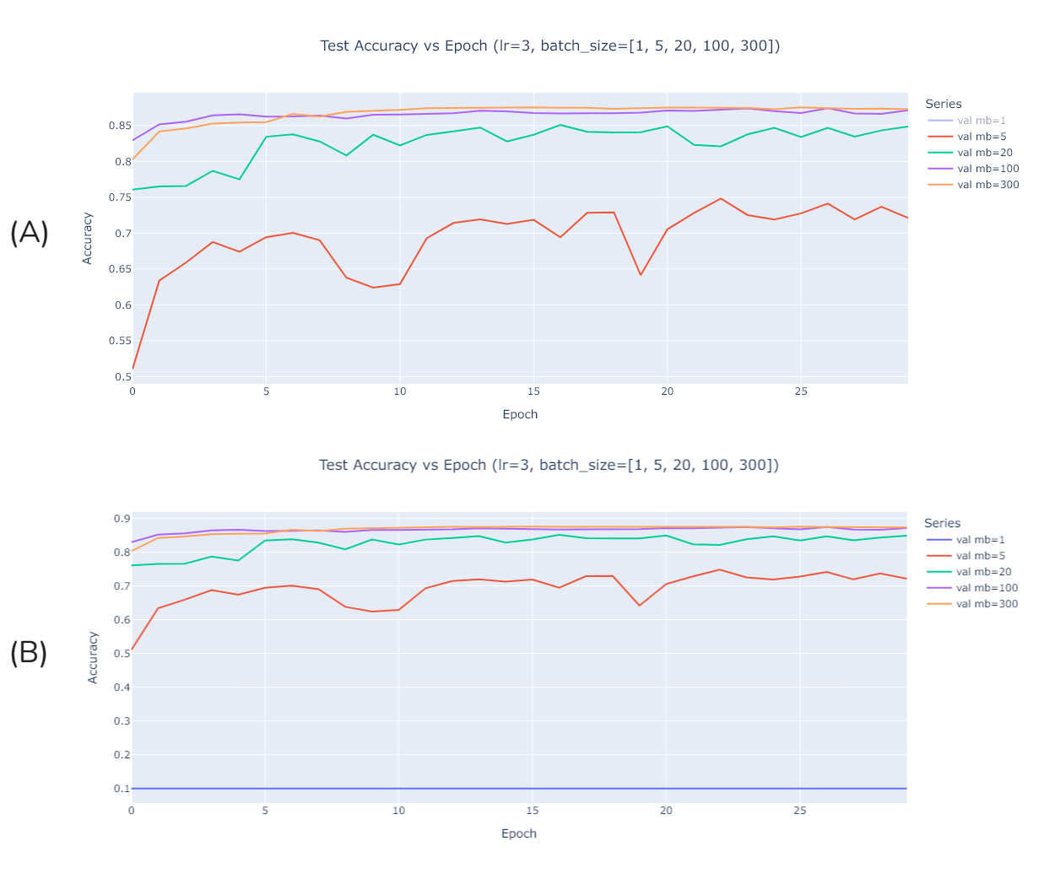
Figure 3 Impact of Minibatch size on Validation Accuracy. Performance of a fully connected network (784, 30, 10) over 30 epochs with a fixed learning rate (η=3.0), across five different minibatch sizes. Graph A shows performance across sizes 5, 20, 100 and 300. Graph B shows performance across sizes 1, 5, 20, 100, 300. Larger mini-batch sizes lead to more stable learning and higher final accuracy, with a size of 300 achieving the best result of 88%.

Hyperparameter Tuning

Conclusion

