Intelligent Systems (2802ICT) Assignment 2
Roman Green (s5369389)

Task 1 – Learning Decision Trees

Software Design

Overview
The Iterative Dichotomiser 3 (ID3) algorithm was implemented to learn a decision tree from a sample dataset of car valuations.
The python data loading library polars (modern pandas equivalent) was used for csv loading, inspection and manipulation.
Two python files were created:
decision_tree.py | Implements the core methods for creating the decision tree.
helpers.py | Implements helper methods for metric computation.
Source code for both python files may be found in Appendix 1 Task 1 Source Code.
In addition, the following Jupyter notebook was created:
eval.ipynb | Used to complete experimentation requirements. Contains python blocks for loading the dataset, randomising the dataset into training and testing subsets and graphing. A copy of the Jupyter notebook is available in Appendix 3 Task 1 eval.ipynb.

Data Structures
The following data structures were defined:
Status | Type variable that defines the outcome class values, used for ensuring type safety:  Literal["unacc", "acc", "good", "vgood"]
InteriorNode | Dataclass variable used as an interior node when building the decision tree. Contains three member variables:  - attribute: the attribute column of the data for decision making.  - plurality_prediction: the outcome class value to use when the example attribute value does not exist in the node’s internal decision tree.  - decision_tree: a dictionary mapping values for the given attribute to other nodes.
LeafNode | Dataclass variable used as a leaf node when building the decision tree. Contains one member variable:  - value: the outcome class value to use when this node is reached.
Node | A union type containing LeafNode and InteriorNode.
Metric | Dataclass variable used to keep track of true positives (TP), false positives (FP), true negatives (TN) and false negatives (FN) when computing accuracy, precision, recall and f1 score.  A Metric dataclass will be instantiated for each outcome class value.  Contains four member variables:  - TP  - FP  - TN  - FN
Metrics | Class used to manage multiple Metric variables. Contains methods to compute macro and weighted precision, recall and f1 scores.

Key Functions

decision_tree.py
The following functions were implemented:
- entropy(examples: pl.DataFrame) -> float
Calculates the entropy of a given polars dataframe. First the probabilities of each outcome class are calculated, then total entropy is calculated as follows:
$$H\left(V\right)=-\sum_{k}{P\left(v_{k}\right)\log_{2}\left(P\left(v_{k}\right)\right)}$$
Where $V$ represents car valuation and $P\left(v_{k}\right)$ represents the probability of valuation $k$.
- remainder(examples: pl.DataFrame, attribute: str) -> float
Calculates the expected entropy in the dataset when partitioned by a given attribute. The dataframe is split into subsets for each unique value of the specified attribute, then the entropy of each subset dataframe is computed by calling the entropy function. Finally, average entropy weighted by height of each subset dataframe.
- importance(examples: pl.DataFrame, attribute: str)
Calculates the reduction in entropy in the dataset when partitioning by a given attribute by computing the difference entropy(examples) and remainder(examples, attribute).
- plurality_value(examples: pl.DataFrame) -> Status
Determines the most common outcome class for the given dataframe.
- ID3(examples: pl.DataFrame, attributes: set[str], parent_examples: pl.DataFrame) -> Node
A recursive function that returns a Node for construction of the decision tree. If the given examples have know row, returns a LeafNode with value equal to the plurality value of parent_examples. If the given examples only have one outcome class value, returns a LeafNode with value equal to the one outcome class value. If the attribute set is empty, returns a LeafNode with value equal to the plurality value of the examples.
Otherwise, the ID3 will select the attribute with the highest value given by importance and construct an InteriorNode. The plurality_value of the interior node is set to the plurality_value of the given examples. Then for every value of the attribute, a new subtree is computed by calling ID3 and the internal decision tree of the InteriorNode is updated with each value:subtree pair. The InteriorNode is then returned.
- classify(row: dict[str, Any], node: Node) -> Status
Recursive function to traverse the decision tree and return the predicted outcome class value.
- pretty_print_tree(node: Node, indent: str = "")
Prints a decision tree to the console for debugging.
- main()
Entry point to the program.
While the program supports command line invocation, experiments were done through a Jupyter notebook.

helpers.py
The following functions were implemented:
- Metric.total(self) -> int
Returns the number of examples processed by this class: $TP+FP+TN+FN$.
- Metric.accuracy(self) -> float
Returns the accuracy of the metric: $\left(TP+TN\right)/total$.
- Metric.precision(self) -> float
Returns the precision of the metric: $(TP+FP)/total$.
- Metric.recall(self) -> float
Returns the recall of the metric: $TP/(TP+FN)$.
- Metric.f1_score(self) -> float
Returns the f1 score of the metric: $\frac{2⋅\text{precision}⋅\text{recall}}{precision + recall}$.
- Metrics.update(self, model_prediction: str, ground_truth: str)
Takes a model prediction and the ground truth label, and iterates over each metric for each outcome class to update their internal TP, TN, FP, FN counts.
- Metrics.print_summary(self)
Computes metrics and returns as an ascii table:
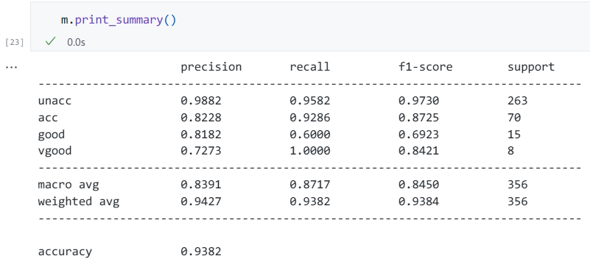
- Metrics.total(self) -> int
Returns the number of examples processed by this class. Equivalent to Metric.total().
- Metrics.accuracy(self) -> float
Returns the accuracy of classifications processed by the class. Internally it sums the TP of each metric and divides by total.
- Metrics.average_results(self) -> dict[str, float]
TODO

Optimisations
The implementation was optimised primarily by leveraging the polars library. The Rust-based engine executes vectorized operations on data columns, which is faster than iterative Python approaches for the frequent data filtering and grouping.

Screenshots Showing Program Execution
While the model implementation supports execution via command line invocation, Jupyter notebooks were used for conducting experiments and graphing. As screenshots of Jupyter notebook consume a large amount of space, they have been included separately in Appendix ????.
Figure 1 shows command line invocation.
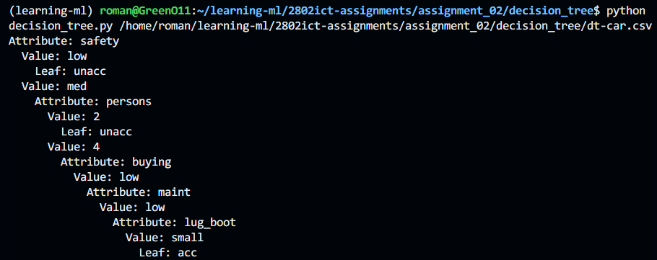
Figure 1 Screenshot showing decision_tree.py command line invocation.

Experiments

Base Case
The dataset (n=1728) was randomly partitioned using polars into train (n=1380) and test (n=348) subsets with a partitioning ration of 0.8.
A decision tree was then computed for the train dataset.
Table 2 shows decision tree performance evaluations. The model demonstrated a high overall accuracy of 92.24%. However, due to a class imbalance in the test dataset, model performance is skewed by its ability to predict the majority class unacc (F1 score=0.9631). The model shows poor performance on minority classes, the F1 score for acc, good and vgood is 0.8477, 0.7586 and 0.7857 respectively. The macro average (0.8060) provides a more practical assessment of model performance by weighting all classes equally.
Table 1 Learned Decision Tree Performance Evaluation
 | Precision | Recall | F1-score | Support
unacc | 0.9671 | 0.9592 | 0.9631 | 245
acc | 0.8767 | 0.8205 | 0.8477 | 78
good | 0.6471 | 0.9167 | 0.7586 | 12
vgood | 0.7333 | 0.8462 | 0.7857 | 13
macro avg | 0.8060 | 0.8856 | 0.8388 | 348
weighted avg | 0.9271 | 0.9224 | 0.9236 | 348

Accuracy vs Training Size
The model was trained repeatedly on increasing fractions of the training data and evaluated on a hold-out test set (n=348). Figure 1 Shows the impact of training dataset size on validation accuracy. There is a consistent positive correlation between the training dataset size and the model's accuracy. The curve trends upwards from approximately 70% with very few examples to over 90% as the full dataset is utilized. The steady increase in performance with no plateau (shown on Figure 1 Graph A) suggests the model is successfully generalising and may benefit from a larger training set size.
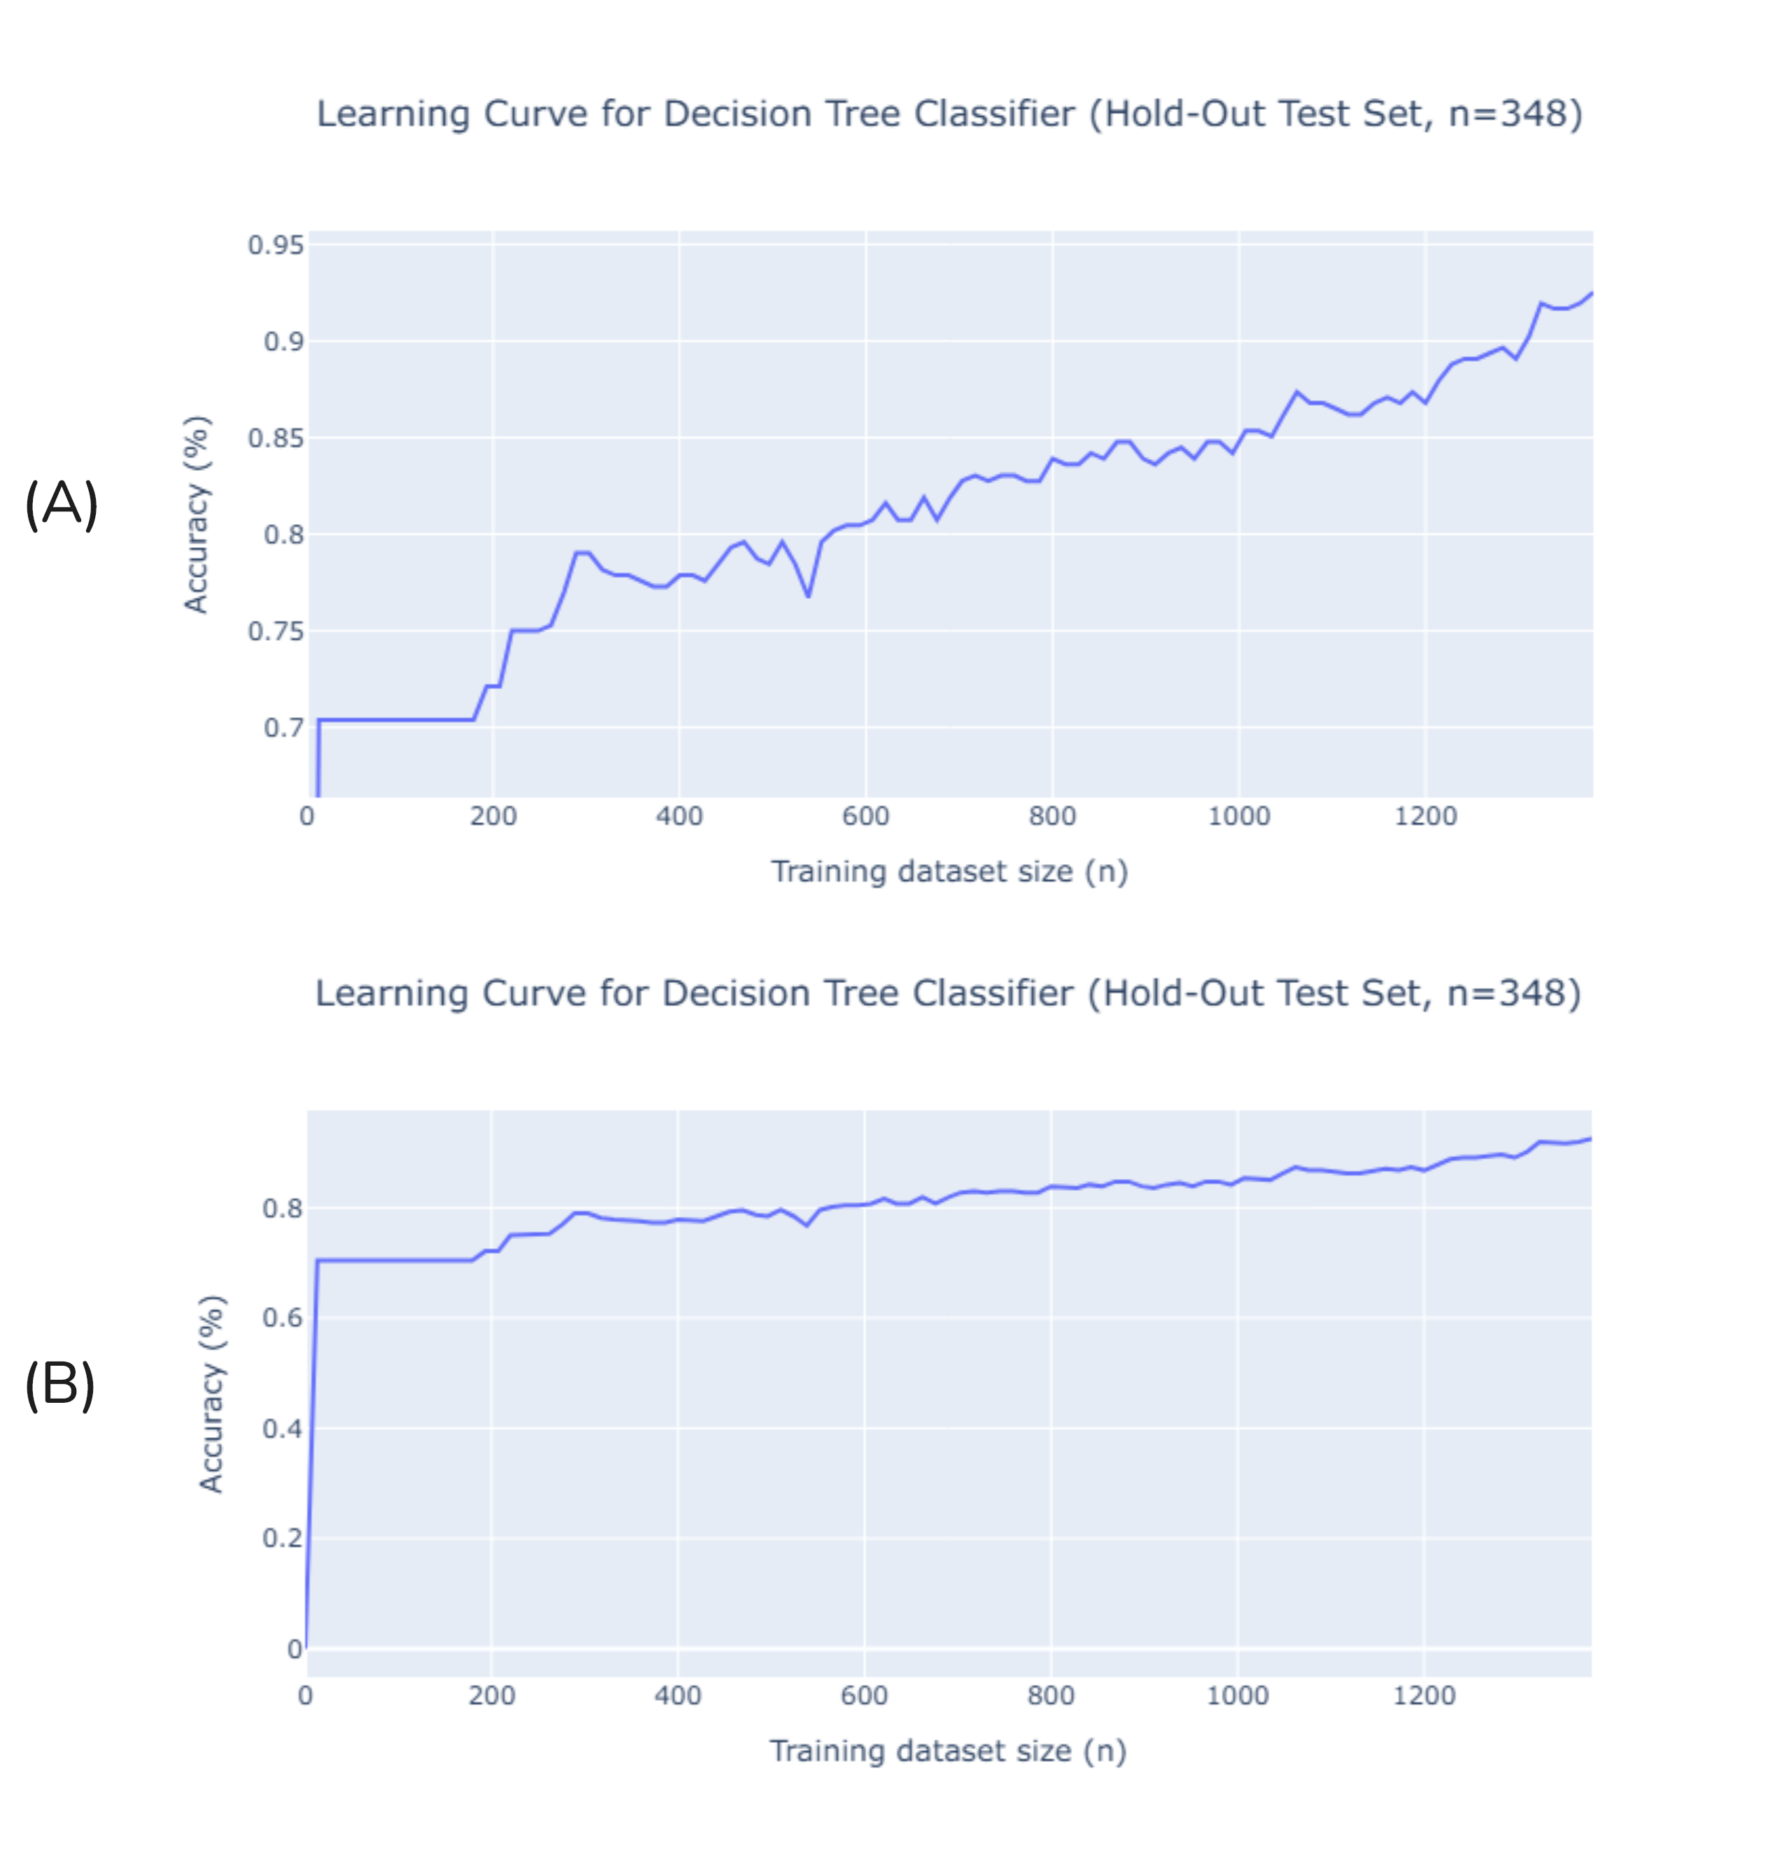
Figure 2 Impact of training dataset size on validation accuracy. A decision tree was repeatedly learnt for increasing fractions (x) of the training data (n=1380; x=0.00, 0.01, …, 1.00) and evaluated on a hold-out test set (n=348). Graph A shows performance over a constrained y-axis (0.6 – 0.96). Graph B shows performance over an unconstrained y-axis (0.0 – 1.0).

Conclusion

Task 2 – Classification using a Neural Network

Software Design

Overview
A fully connected 2-layer (input layer hidden layer output layer) neural network was implemented for arbitrary classification tasks. The implemented model supports adjustment of parameters such as input neuron count, hidden neuron count, output neuron count, number of training epochs, mini-batch size and learning rate. Each trainable layer utilises the sigmoid activation function and no weight decay or neuronal dropout was used.
SoftMax is applied to model outputs to determine prediction probabilities of each class. The model is trained to optimise cross entropy loss, that is:
Cross entropy loss was chosen namely due to the simple calculation requirements (show derivative here).
Two python files were created:
nn.py | Implements the forward and backward passes for training the neural network.
nn_accelerated.py | Reimplementation of nn.py in JAX for GPU acceleration.
Source code for both python files may be found in Appendix 2 Task 2 Source Code.
In addition, the following Jupyter notebooks was created:
planning.ipynb | Jupyter notebook for planning out the forward and backward passes in vectorised, batch-level form.
running_nn.ipynb | Rrd
benchmarking-nn.ipynb | Rds
benchmarking-nn-accelerated.ipynb | rd
Hyperparameter-tuning.ipynb | rd

Data Structures
Please note that the implementation of these data structures may differ between the nn.py and nn_accelerated.py files. Because nn_accelerated.py makes use of JAX and

For nn.py a object oriented approach was used however
Model | Dataclass variable used to keep track of true positives (TP), false positives (FP), true negatives (TN) and false negatives (FN) when computing accuracy, precision, recall and f1 score.  A Metric dataclass will be instantiated for each outcome class value.  Contains four member variables:  - TP  - FP  - TN  - FN
Metrics | Class used to manage multiple Metric variables. Contains methods to compute macro and weighted precision, recall and f1 scores.

Key Functions

Optimisations
All model computations (forward pass and backward pass) are performed in highly efficient NumPy operations. Minibatch stochastic gradient descent is used during training due to its quicker and higher reliability in model convergence. The implemented NumPy operations are vectorized across the entire minibatch to support quick forward and backward passes.
Labels are one-hot-encoded to simplify computations during backpropagation.
In addition, the NumPy operations used in nn.py were recreated using JAX operations in nn-accelerated.py. JAX allows all previous NumPy operations to be compiled into highly optimised GPU-compatible machine code using XLA. The accelerated variant of nn.py supports GPU vectorisation across a single minibatch, a single epoch and across n epochs.
Only JAX NumPy utilities and XLA capabilities are utilised. To achieve maximum parity with the NumPy only implementation JAX automatic differentiation utilities were not used. All experiments detailed in Section 2 were performed using the NumPy only version.
Table 1 shows runtime across the various implementations. Per-minibatch GPU acceleration leads to a slower execution time compared to the original NumPy version due to overhead resulting from CPU-GPU transfer operations (tops) (1 min 16 s vs. 9.22 s). Over 30 epochs and a batch size of 32, there will be 112500 ($30⋅1875⋅2$) tops significantly inflating runtime. Per-epoch GPU acceleration reduces tops to only 60. All-epoch GPU acceleration reduces tops to only 2. The tops improvement from Per-minibatch GPU accelerated to Per-epoch GPU accelerated or All-epoch GPU accelerated reduces runtime by a factor of $≈50$ (76 s vs. 1.57 s). Per-epoch GPU acceleration reduced runtime compared to NumPy by a factor of $≈6$ (9.22 s vs. 1.57 s).
While the JAX implementation compiles successfully with the configuration outlined in Table 1, modifying some parameters (e.g., increasing hidden neuron count to 128) caused compilation errors when targeting the GPU. Strangely those compilation errors were not present when targeting the CPU. Despite this unresolved compilation issue, the performance gains achieved are considerable.
Table 2 Runtime comparison of various model optimisations for a fully connected network (784, 30, 10) over 30 epochs with a learning rate (η) of 3.0 and a mini-batch size of 32.
Training Approach | Time
NumPy only version¹ | 9.22 s ± 82.4 ms per loop (mean ± std. dev. of 2 runs, 5 loops each)
All-epoch GPU accelerated² | 1.57 s ± 30.7 ms per loop (mean ± std. dev. of 2 runs, 5 loops each)
Per-epoch GPU accelerated² | 1.54 s ± 26.3 ms per loop (mean ± std. dev. of 2 runs, 5 loops each)
Per-minibatch GPU accelerated² | 1min 16s ± 627 ms per loop (mean ± std. dev. of 2 runs, 5 loops each)
¹ Benchmarking code available in benchmarking-nn.ipynb. Screenshots available separately in ???. PDF export of the Jupyter notebook available in Appendix ???
² Benchmarking code available in benchmarking-nn-accelerated.ipynb. Screenshots available in separately in ???. PDF export of the Jupyter notebook available in Appendix ???

Screenshots Showing Program Execution
While the model implementation supports execution via command line invocation, Jupyter notebooks were used for conducting experiments and graphing. As screenshots of Jupyter notebook consume a large amount of space, they have been included separately in Appendix ????.
Figure 3 shows command line invocation.
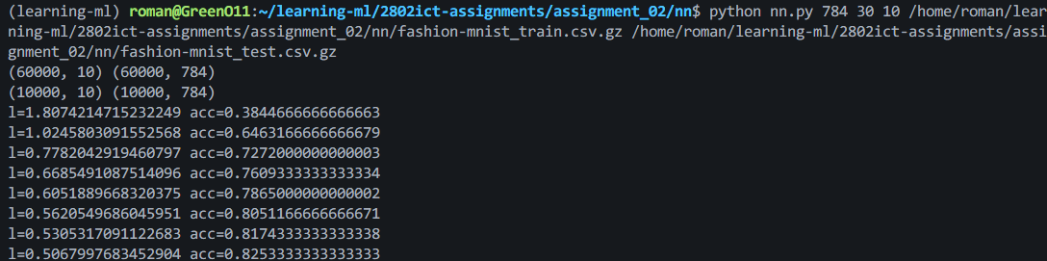
Figure 3 Screenshot showing nn.py command line invocation.

Experiments

Base Case
The baseline model was trained over 30 epochs in 13.4 seconds with a learning rate of 3 and a batch size of 20.
Figure 4 illustrates the learning progression of the model. Both the training and validation accuracy increase rapidly within the first 5 epochs, indicating that the model is effectively learning underlying patterns in the data. After the initial phase, the curves begin to plateau.
Following the initial rapid progression, the training accuracy shows a relatively smooth, monotonic increase, eventually reaching approximately 86%. In contrast, the validation accuracy (blue line) exhibits significant oscillations after its initial climb, fluctuating between roughly 80% and 85%. This volatility suggests that the chosen learning rate of 3.0 is quite high for a mini-batch size of 20. A high learning rate can cause the model's weights to "overshoot" the optimal point in the loss landscape during updates, leading to instability rather than smooth convergence.
Despite the oscillations, there is no significant divergence between the training and validation curves, which suggests that the model is not severely overfitting the training data. The model generalises reasonably well, achieving a peak validation accuracy of 85%.
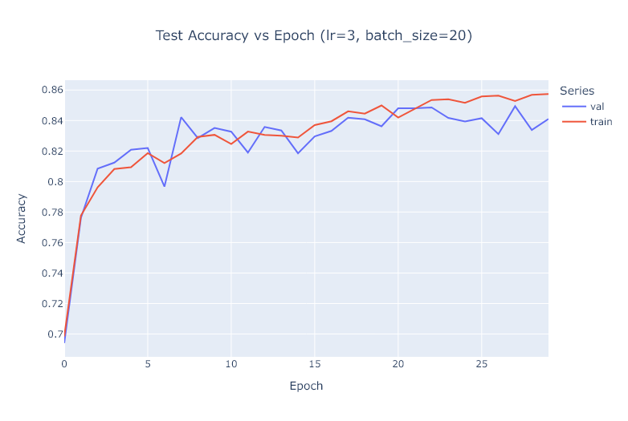
Figure 4 Training and Validation Accuracy vs. Epoch for the Baseline Model. Performance of a fully connected network (784, 30, 10) over 30 epochs with a learning rate (η) of 3.0 and a mini-batch size of 20. The model achieved a maximum validation accuracy of 85%.

Varying Learning Rate
The model was trained over 30 epochs in 1 minute 4 seconds with a fixed batch size of 20 and learning rates of 0.001, 0.01, 1.0, 10, and 100.
Figure 5 illustrates the impact of learning rate on model performance. The results can be categorised into three distinct behaviours:
Learning too slowly  (η= 0.001, 0.01) | With a learning rate of 0.001, the model learns very slowly, and the accuracy curve has not yet plateaued after 30 epochs, reaching only 73%. Weight updates are likely too small to allow for convergence across each example. Increasing η to 0.01 yields a much better result, with a smooth and stable learning curve that reaches a respectable accuracy of 86%.
Optimal learning  (η= 1.0) | At η = 1.0 the learning rate appears optimal for the implemented model. Initial epochs show rapid learning and quick convergence to the highest maximum accuracy of 88%. This rate is large enough for fast convergence but not so large that it causes the instability seen in the baseline model (η=3.0).
Learning too fast  (η= 10, 100) | At η = 10 and η = 100, the learning rate is high enough that each weight update overshoots the minimum of the loss function, causing divergence. The accuracy flatlines at a very low level (20% for η=10 and 10% for η=100), which is equivalent to or worse than random guessing for a 10-class problem.
In summary, a learning rate of 1.0 provided the best performance, achieving a maximum accuracy of 88%.
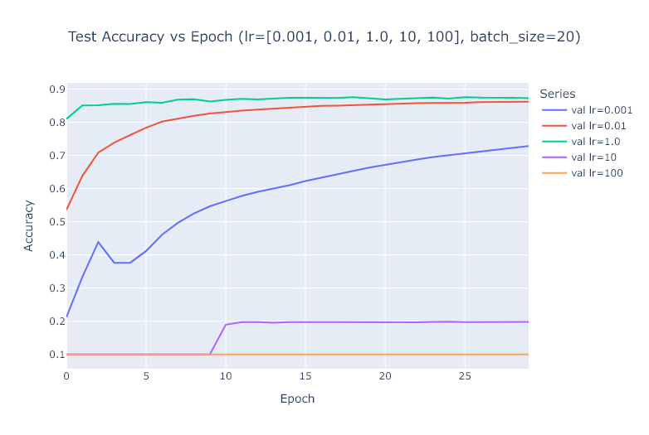
Figure 5 Impact of Learning Rate on Validation Accuracy. Performance of a fully connected network (784, 30, 10) over 30 epochs with a fixed mini-batch size of 20, across five different learning rates (η) (0.001, 0.01, 1.0, 10, 100). The results show a clear optimal range for the learning rate, with η=1.0 achieving the highest accuracy of 88%.

Varying Batch Size
The model was trained over 30 epochs in 3 minutes 59 seconds with a learning rate of 3.0 and minibatch sizes of 1, 5, 20, 100 and 300.
Figure 6 illustrates the impact of mini-batch size on model performance.
Smaller batch sizes introduce more noise into the gradient estimate for each weight update. With a batch size of 1 (Stochastic Gradient Descent), the updates are extremely noisy, and combined with a high learning rate, the model fails to converge, flatlining at 10% accuracy. As the batch size increases to 5 and 20, the model learns, but the accuracy curves are highly volatile. The noise in the gradient causes the learning process to be unstable.
As the mini-batch size increases, the gradient estimate for each update becomes more accurate (i.e., closer to the true gradient of the entire training set). This reduction in variance has a stabilising effect on training. The curves for 100 and 300 are much smoother and converge quickly to high accuracy levels. The larger batches effectively average out the noise, allowing the high learning rate to take confident steps toward the minimum.
The highest maximum accuracy of 88% was achieved with a mini-batch size of 300. Regarding computational speed, smaller batch sizes require more weight updates per epoch, making each epoch take longer in terms of wall-clock time. Therefore, the training with mini-batch size = 1 was the slowest computationally. This experiment demonstrates that for a given learning rate, there is an optimal range of batch sizes, and larger batches can help stabilise training when using a high learning rate. ADD COMPUTATION TIME
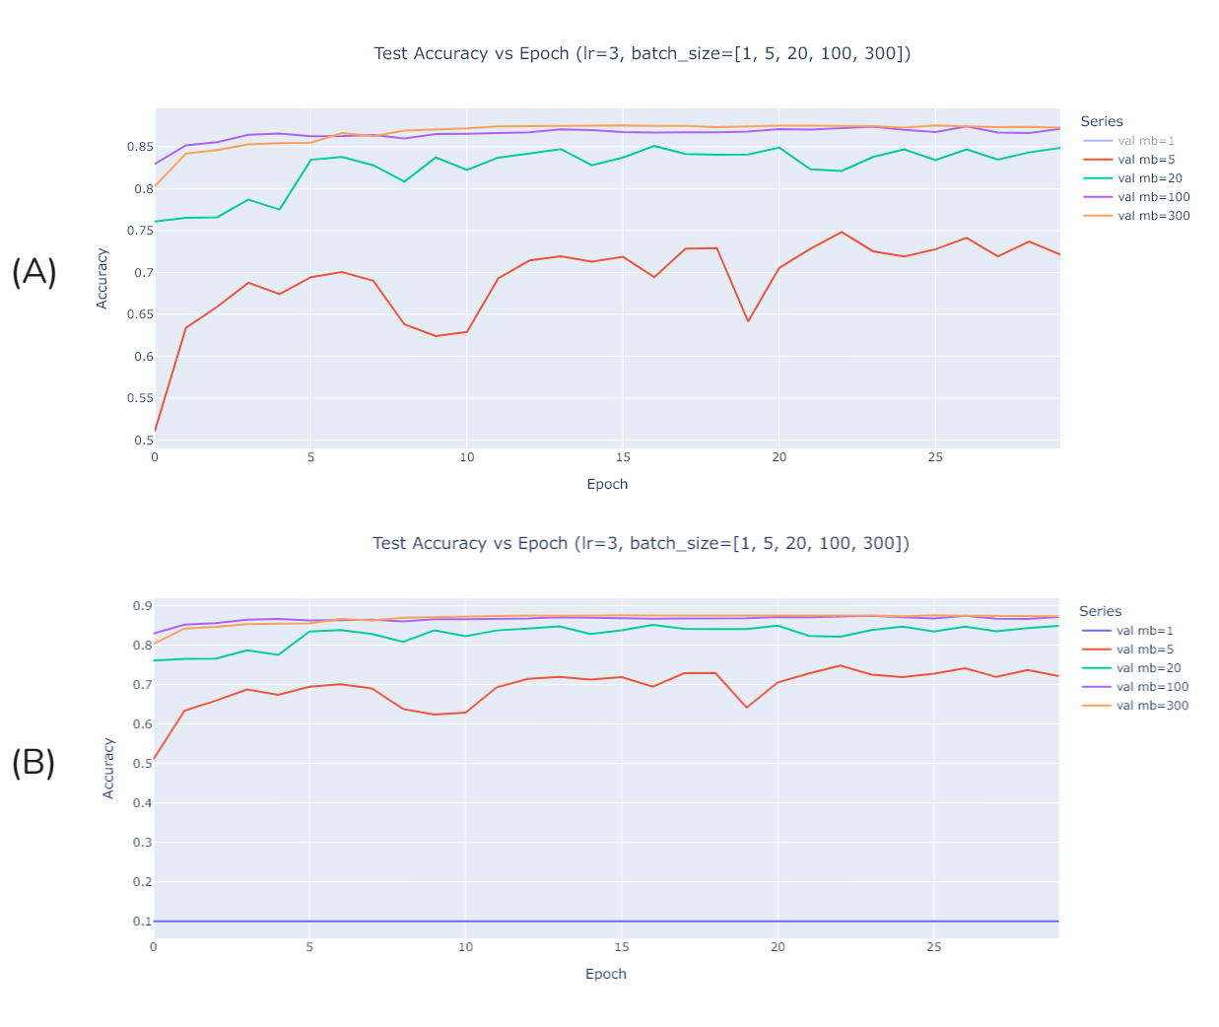
Figure 6 Impact of Minibatch size on Validation Accuracy. Performance of a fully connected network (784, 30, 10) over 30 epochs with a fixed learning rate (η=3.0), across five different minibatch sizes. Graph A shows performance across sizes 5, 20, 100 and 300. Graph B shows performance across sizes 1, 5, 20, 100, 300. Larger mini-batch sizes lead to more stable learning and higher final accuracy, with a size of 300 achieving the best result of 88%.

Hyperparameter Tuning

Conclusion

Appendix 1 Task 1 Source Code

decision_tree.py
import sys
import polars as pl
import math
from dataclasses import dataclass, field
from typing import Any, Literal, Union, cast

Status = Literal["unacc", "acc", "good", "vgood"]

CAR_COLUMNS = {
"buying": pl.Enum(["low", "med", "high", "vhigh"]),
"maint": pl.Enum(["low", "med", "high", "vhigh"]),
"doors": pl.Enum(["2", "3", "4", "5more"]),
"persons": pl.Enum(["2", "3", "4", "more"]),
"lug_boot": pl.Enum(["small", "med", "big"]),
"safety": pl.Enum(["low", "med", "high"]),
"class": pl.Enum(["unacc", "acc", "good", "vgood"]),
}
OUTCOME_CLASS = "class"

@dataclass
class InteriorNode:
attribute: str
plurality_prediction: Status # used when processing example and value for the attribute is not in the decision_tree
decision_tree: 'dict[str, Node]' = field(default_factory=dict)

@dataclass
class LeafNode:
value: Status

type Node = Union[InteriorNode, LeafNode]

def entropy(examples: pl.DataFrame) -> float:
outcomes = examples[OUTCOME_CLASS].unique()
total = examples.height
chances = list(map(lambda k: examples.filter(pl.col(OUTCOME_CLASS) == k).height / total, outcomes))
return -sum(p * math.log(p, 2) for p in chances if p > 0)

def remainder(examples: pl.DataFrame, attribute: str) -> float:
total = examples.height
final = 0
## Weighted average of entropy when filtered by each attribute value
for attr in examples[attribute].unique():
subset_examples = examples.filter(pl.col(attribute) == attr)
final += (subset_examples.height/total)*entropy(subset_examples)
return final

def importance(examples: pl.DataFrame, attribute: str):
## The size of the reduction in entropy
return entropy(examples) - remainder(examples, attribute)

def plurality_value(examples: pl.DataFrame) -> Status:
mode_value = examples[OUTCOME_CLASS].mode().first()
return cast(Status, mode_value) # polars return types make me sad

def ID3(examples: pl.DataFrame, attributes: set[str], parent_examples: pl.DataFrame) -> Node:
if examples.height == 0:
return LeafNode(plurality_value(parent_examples))
elif examples[OUTCOME_CLASS].n_unique() == 1:
return LeafNode(plurality_value(examples))
elif len(attributes) == 0:
return LeafNode(plurality_value(examples))
else:
## Find best attribute

# decision_attribute = max(attributes, key=lambda x: importance(examples, x))

current_entropy = entropy(examples)
decision_attribute = max(attributes, key=lambda x: current_entropy - remainder(examples, x))
# this is slightly quicker than using the importance function as it
# avoids recomputing entropy for examples over and over

## Construct tree
tree = InteriorNode(decision_attribute, plurality_value(examples))

for value in examples[decision_attribute].unique():
filtered_examples = examples.filter(pl.col(decision_attribute) == value)
subtree = ID3(filtered_examples, attributes - {decision_attribute}, examples)
tree.decision_tree[value] = subtree

return tree

def classify(row: dict[str, Any], node: Node) -> Status:
if isinstance(node, LeafNode):
return node.value
elif isinstance(node, InteriorNode):
value = row[node.attribute]
if value not in node.decision_tree: return node.plurality_prediction
else: return classify(row, node.decision_tree[value])

def pretty_print_tree(node: Node, indent: str = ""):
if isinstance(node, LeafNode):
print(f"{indent}Leaf: {node.value}")
elif isinstance(node, InteriorNode):
print(f"{indent}Attribute: {node.attribute}")
for value, subtree in node.decision_tree.items():
print(f"{indent} Value: {value}")
pretty_print_tree(subtree, indent + " ")

def main():
dataset_name = sys.argv[1]

df_csv = pl.read_csv(dataset_name, schema_overrides=CAR_COLUMNS)

tree = ID3(df_csv, set(df_csv.columns) - {OUTCOME_CLASS}, df_csv)

pretty_print_tree(tree)

if __name__ == "__main__":
main()

helpers.py
from dataclasses import dataclass, field
from functools import reduce

@dataclass
class Metric:
TP: int = 0
FP: int = 0
TN: int = 0
FN: int = 0

def total(self) -> int: ## equal to the total number of samples in the test set
return self.TP + self.FP + self.TN + self.FN

def accuracy(self) -> float:
if self.total() == 0: return 0.0
return (self.TP + self.TN) / self.total()

def precision(self) -> float:
denominator = self.TP + self.FP
if denominator == 0: return 0.0
return self.TP / denominator

def recall(self) -> float:
denominator = self.TP + self.FN
if denominator == 0: return 0.0
return self.TP / denominator

def f1_score(self) -> float:
prec = self.precision()
recall = self.recall()
denominator = prec + recall
if denominator == 0: return 0.0
return 2 * prec * recall / denominator

def support(self) -> int: # the count of this class (ie unacc)
return self.TP + self.FN

class Metrics():
def __init__(self, classes: list[str]):
self.metrics = {i:Metric() for i in classes}

def update(self, model_prediction: str, ground_truth: str):
for cls in self.metrics:
if model_prediction == cls and cls == ground_truth: # model predicted class and was class was right
self.metrics[cls].TP += 1
elif model_prediction != cls and cls != ground_truth: # model did not predict class and class was not right
self.metrics[cls].TN += 1
elif model_prediction == cls and model_prediction != ground_truth: # model predicted class and class was not right
self.metrics[cls].FP += 1
elif model_prediction != cls and cls == ground_truth: # model did not predict class and class was right
self.metrics[cls].FN += 1

def print_summary(self):
print(f"{'':<20} {'precision':<15} {'recall':<15} {'f1-score':<15} {'support':<15}")
print("-" * 80)

for key, value in self.metrics.items():
print(f"{key:<20} {value.precision():<15.4f} {value.recall():<15.4f} {value.f1_score():<15.4f} {value.support():<15}")

print("-" * 80)

avg_results = self.average_results()
total = self.total()

print(f"{'macro avg':<20} {avg_results['macro_precision']:<15.4f} {avg_results['macro_recall']:<15.4f} {avg_results['macro_f1_score']:<15.4f} {total:<15}")
print(f"{'weighted avg':<20} {avg_results['weighted_precision']:<15.4f} {avg_results['weighted_recall']:<15.4f} {avg_results['weighted_f1_score']:<15.4f} {total:<15}")

print("-" * 80)

print()

print(f"{"accuracy":<20} {self.accuracy():.4f}")

def total(self) -> int:
return next(iter(self.metrics.values())).total()
# this also works but would be slower:
# return sum(map(lambda k: k.support(), self.metrics.values()))

def accuracy(self) -> float:
return sum(map(lambda k: k.TP, self.metrics.values())) / self.total()

def average_results(self) -> dict[str, float]:
scores: dict[str, float] = {}

total = self.total()

scores["macro_precision"] = sum([k.precision() for k in self.metrics.values()])/len(self.metrics)
scores["weighted_precision"] = sum([k.precision()*k.support() for k in self.metrics.values()])/total

scores["macro_recall"] = sum([k.recall() for k in self.metrics.values()])/len(self.metrics)
scores["weighted_recall"] = sum([k.recall()*k.support() for k in self.metrics.values()])/total

scores["macro_f1_score"] = sum([k.f1_score() for k in self.metrics.values()])/len(self.metrics)
scores["weighted_f1_score"] = sum([k.f1_score()*k.support() for k in self.metrics.values()])/total

return scores

Appendix 2 Task 2 Source Code

nn.py
import numpy as np
import sys
from typing import Iterator
from dataclasses import dataclass, field

def sigmoid(x):
return 1 / (1 + np.exp(-x))

def one_hot(y: np.ndarray, n_classes: int) -> np.ndarray:
y_onehot = np.zeros((y.shape[0], n_classes))
for i, label in enumerate(y):
y_onehot[i, int(label)] = 1
return y_onehot

# I'm just more used to working with training data in this format
# normalise and one hot encode
def sep_labels(x: np.ndarray, n_classes: int) -> tuple[np.ndarray, np.ndarray]:
labels = one_hot(x[:, 0], n_classes)
features = x[:, 1:] / 256
print(labels.shape, features.shape)
return (features, labels)

def batch(data: tuple[np.ndarray, np.ndarray], batch_size: int) -> Iterator[tuple[np.ndarray, np.ndarray]]:
for start in range(0, data[0].shape[0], batch_size):
end = min(data[0].shape[0], start + batch_size)
yield (data[0][start:end], data[1][start:end])

@dataclass
class Model:
W_1: np.ndarray
B_1: np.ndarray
W_2: np.ndarray
B_2: np.ndarray

@dataclass
class RunningAverage:
value: float = 0.0
count: int = 0

def update(self, new_value):
self.value = (self.value * self.count + new_value)/(self.count+1)
self.count += 1
def reset(self):
self.value = 0.0
self.count = 0

@dataclass
class ModelMetrics:
loss: RunningAverage = field(default_factory=RunningAverage)
accuracy: RunningAverage = field(default_factory=RunningAverage)

def update(self, y: np.ndarray, y_hat: np.ndarray):
# loss
L = y * y_hat
L = L.sum(axis=1)
L = -np.log(L)
L = L.mean()
self.loss.update(L)

# accuracy
pred = y_hat.argmax(axis=1)
true = y.argmax(axis=1)
accuracy = (pred == true).mean()
self.accuracy.update(accuracy)

def reset(self):
self.loss.reset()
self.accuracy.reset()

def init_model(n_input, n_hidden, n_output) -> Model:
W_1 = np.random.normal(0, 0.01, (n_hidden, n_input))
B_1 = np.random.normal(0, 0.01, n_hidden)
W_2 = np.random.normal(0, 0.01, (n_output, n_hidden))
B_2 = np.random.normal(0, 0.01, n_output)
return Model(W_1, B_1, W_2, B_2)

def train(batch: tuple[np.ndarray, np.ndarray], m: Model, mm: ModelMetrics, lr: float):
# the logic behind this function can be found in planning.ipynb/planning.pdf

n_examples = batch[0].shape[0]
X = batch[0]
y = batch[1]

# forward pass
Z_1 = X@m.W_1.T+m.B_1
H_1 = sigmoid(Z_1)
Z_2 = H_1@m.W_2.T+m.B_2

# softmax
adj_Z_2 = np.exp(Z_2 - Z_2.max(axis=1)[:, np.newaxis])
adj_Z_2_sum = np.sum(adj_Z_2, 1)[:, np.newaxis]
y_hat = adj_Z_2 / adj_Z_2_sum

# backprop layer 2
Delta_2 = y_hat - y
grad_W2 = (Delta_2.T @ H_1) / n_examples
grad_B2 = Delta_2.mean(axis=0)

# backprop layer 1
S_1 = sigmoid(Z_1)
Delta_1 = (Delta_2 @ m.W_2) * S_1 * (1 - S_1)
grad_W1 = (Delta_1.T @ X) / n_examples
grad_B1 = Delta_1.mean(axis=0)

# update weights
m.W_2 = m.W_2 - lr * grad_W2
m.B_2 = m.B_2 - lr * grad_B2
m.W_1 = m.W_1 - lr * grad_W1
m.B_1 = m.B_1 - lr * grad_B1

mm.update(y, y_hat)

return

def eval(batch: tuple[np.ndarray, np.ndarray], m: Model, mm: ModelMetrics):
X = batch[0]
y = batch[1]

# forward pass
Z_1 = X@m.W_1.T+m.B_1
H_1 = sigmoid(Z_1)
Z_2 = H_1@m.W_2.T+m.B_2

# softmax
adj_Z_2 = np.exp(Z_2 - Z_2.max(axis=1)[:, np.newaxis])
adj_Z_2_sum = np.sum(adj_Z_2, 1)[:, np.newaxis]
y_hat = adj_Z_2 / adj_Z_2_sum

mm.update(y, y_hat)

return

if __name__ == "__main__":

n_input = int(sys.argv[1])
n_hidden = int(sys.argv[2])
n_output = int(sys.argv[3])

classes = 10
lr = 0.02
epochs = 100

d_train = sep_labels(np.loadtxt(sys.argv[4], delimiter=',', skiprows=1), classes) # (60000, 785) first col is label
d_test = sep_labels(np.loadtxt(sys.argv[5], delimiter=',', skiprows=1), classes) # (10000, 785) first col is label

model = init_model(n_input, n_hidden, n_output)

metrics = ModelMetrics()

for i in range(epochs):
loss = 0
# mb mini batch
for mb in batch(d_train, 32):
train(mb, model, metrics, lr)
print(f"l={metrics.loss.value} acc={metrics.accuracy.value}")
metrics.reset()

nn_accelerated.py
import numpy as np
import sys
from typing import Iterator
from dataclasses import dataclass, field

import jax
from jax import numpy as jnp
from jax import random
from functools import partial

def sigmoid(x):
return 1 / (1 + jnp.exp(-x))

def one_hot(y: np.ndarray, n_classes: int) -> np.ndarray:
y_onehot = np.zeros((y.shape[0], n_classes))
for i, label in enumerate(y):
y_onehot[i, int(label)] = 1
return y_onehot

# I'm just more used to working with training data in this format
# normalise and one hot encode
def sep_labels(x: np.ndarray, n_classes: int) -> tuple[jax.Array, jax.Array]:
labels = one_hot(x[:, 0], n_classes)
features = x[:, 1:] / 256
return (jnp.array(features), jnp.array(labels))

def batch(data: tuple[jax.Array, jax.Array], batch_size: int) -> Iterator[tuple[jax.Array, jax.Array]]:
for start in range(0, data[0].shape[0], batch_size):
end = min(data[0].shape[0], start + batch_size)
yield (data[0][start:end], data[1][start:end])

def to_device_batches(x_np, y_np, batch_size): # will drop any remainder
x = jnp.array(x_np, dtype=jnp.float32)
y = jnp.array(y_np, dtype=jnp.float32)
n = (x.shape[0] // batch_size) * batch_size
x = x[:n]
y = y[:n]
xb = x.reshape(n // batch_size, batch_size, -1) # (B, N, D)
yb = y.reshape(n // batch_size, batch_size, -1) # (B, N, C)
return xb, yb

@jax.tree_util.register_dataclass
@dataclass
class Model:
W_1: jax.Array
B_1: jax.Array
W_2: jax.Array
B_2: jax.Array

@jax.tree_util.register_dataclass
@dataclass
class RunningAverage:
value: jax.Array = field(default_factory=lambda: jnp.array(0.0, jnp.float32))
count: jax.Array = field(default_factory=lambda: jnp.array(0, jnp.int32))

def update(self, new_value):
n_value = (self.value * self.count + new_value)/(self.count+1)
n_count = self.count + 1
return RunningAverage(n_value, n_count)
def reset(self):
return RunningAverage(jnp.array(0.0, jnp.float32), jnp.array(0, jnp.int32))

@jax.tree_util.register_dataclass
@dataclass
class ModelMetrics:
loss: RunningAverage = field(default_factory=RunningAverage)
accuracy: RunningAverage = field(default_factory=RunningAverage)

def update(self, y: jax.Array, y_hat: jax.Array):
# loss
L = y * y_hat
L = L.sum(axis=1)
L = -jnp.log(L + 1e-8)
L = L.mean()
loss = self.loss.update(L)

# accuracy
pred = y_hat.argmax(axis=1)
true = y.argmax(axis=1)
accuracy = (pred == true).mean()
accuracy = self.accuracy.update(accuracy)

return ModelMetrics(loss, accuracy)

def reset(self):
return ModelMetrics(RunningAverage(), RunningAverage())

def init_model(key, n_input, n_hidden, n_output) -> Model:
key1, key2, key3, key4 = random.split(key, 4)
W_1 = jax.random.normal(key1, (n_hidden, n_input)) * 0.01
B_1 = jax.random.normal(key2, (n_hidden)) * 0.01
W_2 = jax.random.normal(key3, (n_output, n_hidden)) * 0.01
B_2 = jax.random.normal(key4, (n_output)) * 0.01
return Model(W_1, B_1, W_2, B_2)

@jax.jit
def train_step(batch: tuple[jax.Array, jax.Array], m: Model, mm: ModelMetrics, lr: float):
print("compiling train_step")
# the logic behind this function can be found in planning.ipynb/planning.pdf
n_examples = batch[0].shape[0]
X = batch[0]
y = batch[1]

# forward pass
Z_1 = X@m.W_1.T+m.B_1
H_1 = sigmoid(Z_1)
Z_2 = H_1@m.W_2.T+m.B_2

# softmax
adj_Z_2 = jnp.exp(Z_2 - Z_2.max(axis=1)[:, jnp.newaxis])
adj_Z_2_sum = jnp.sum(adj_Z_2, 1)[:, jnp.newaxis]
y_hat = adj_Z_2 / adj_Z_2_sum

# backprop layer 2
Delta_2 = y_hat - y
grad_W2 = (Delta_2.T @ H_1) / n_examples
grad_B2 = Delta_2.mean(axis=0)

# backprop layer 1
S_1 = sigmoid(Z_1)
Delta_1 = (Delta_2 @ m.W_2) * S_1 * (1 - S_1)
grad_W1 = (Delta_1.T @ X) / n_examples
grad_B1 = Delta_1.mean(axis=0)

# update weights
W_2 = m.W_2 - lr * grad_W2
B_2 = m.B_2 - lr * grad_B2
W_1 = m.W_1 - lr * grad_W1
B_1 = m.B_1 - lr * grad_B1
m = Model(W_1, B_1, W_2, B_2)

mm = mm.update(y, y_hat)

return (m, mm)

@jax.jit
def eval(batch: tuple[jax.Array, jax.Array], m: Model, mm: ModelMetrics):
print("compiling eval")
X = batch[0]
y = batch[1]

# forward pass
Z_1 = X@m.W_1.T+m.B_1
H_1 = sigmoid(Z_1)
Z_2 = H_1@m.W_2.T+m.B_2

# softmax
adj_Z_2 = jnp.exp(Z_2 - Z_2.max(axis=1)[:, jnp.newaxis])
adj_Z_2_sum = jnp.sum(adj_Z_2, 1)[:, jnp.newaxis]
y_hat = adj_Z_2 / adj_Z_2_sum

mm = mm.update(y, y_hat)

return mm

@jax.jit
def run_all_evals(m, mm, xb, yb):
print("compiling run_evals")
def body(carry, t):
mm = carry
x = xb[t]
y = yb[t]
mm = eval((x, y), m, mm)
return mm, None
mm, _ = jax.lax.scan(body, mm, jnp.arange(xb.shape[0]))
return mm

@jax.jit
def run_epoch(m, mm, xb, yb, lr):
print("compiling run_epoch")
def body(carry, t):
m, mm = carry
x = xb[t]
y = yb[t]
m, mm = train_step((x, y), m, mm, lr)
return (m, mm), None
(m, mm), _ = jax.lax.scan(body, (m, mm), jnp.arange(xb.shape[0]))
return m, mm

@partial(jax.jit, static_argnames=("epochs"))
def run_all_epochs(m, mm, xb, yb, epochs, lr):
print("compiling run_all_epochs")
def body(carry, t):
m, mm = carry
m, mm = run_epoch(m, mm, xb, yb, lr)
return (m, mm), None
(m, mm), _ = jax.lax.scan(body, (m, mm), jnp.arange(epochs))
return m, mm

if __name__ == "__main__":

n_input = int(sys.argv[1])
n_hidden = int(sys.argv[2])
n_output = int(sys.argv[3])

classes = 10
lr = 0.02
epochs = 100

d_train = sep_labels(np.loadtxt(sys.argv[4], delimiter=',', skiprows=1), classes) # (60000, 785) first col is label
d_test = sep_labels(np.loadtxt(sys.argv[5], delimiter=',', skiprows=1), classes) # (10000, 785) first col is label

key = random.key(0)
model = init_model(key, n_input, n_hidden, n_output)

metrics = ModelMetrics()

batched_d_train = to_device_batches(d_train[0], d_train[1], 32)
print(batched_d_train[0].shape, batched_d_train[1].shape)

# model, metrics = run_all_epochs(model, metrics, batched_d_train[0], batched_d_train[1], epochs, lr)
# print(f"l={metrics.loss.value} acc={metrics.accuracy.value}")
# metrics = metrics.reset()

for i in range(epochs):
loss = 0
# mb mini batch
model, metrics = run_epoch(model, metrics, batched_d_train[0], batched_d_train[1], lr)
print(f"l={metrics.loss.value} acc={metrics.accuracy.value}")
metrics = metrics.reset()

Appendix 3 Task 1 eval.ipynb

Appendix 4 Tast 2 planning.ipynb

Appendix 5 Task 2 running_nn.ipynb

Appendix 6 Task 2 benchmarking-nn.ipynb

Appendix 7 Task 2 benchmarking-nn-accelerated.ipynb

Appendix 8 Task 2 hyperparameter-tuning.ipynb

