**What initial problems would you like to solve using AI and big data?**

I am part of the Paint industry. As part of the Finance transformation project, our department has been piloting robotic process automation (RPA) to improve specific tasks' speed, efficiency, and accuracy. Our Target is to make the finance S2P cycle (Source to Pay) and Order to cash more digitally enabled and generated advanced analytics using some intelligent tool. This will help us to automate end-to-end processes.

The RPA to rigid rules can’t execute decision-oriented tasks. Machine learning (ML) uses past data to make predictions. Companies are looking to ML to complement RPA because it can address some limitations and derive more value. We are using Ceolins (Process Mining tool) with RPA to achieve these requirements.

**Business Value:  Improve DSO**

* **Opportunity:** Reduced daily unapplied cash by automating the cash application process. Implement composable enterprise (Integrated Receivables System) .
  + Cash application is a manual, labor-intensive process
  + Different customer-specific application rules
  + Many remit types from different sources
* **RPA Usage and its Limitation:**
* Automate the electronic transfer of Bank remittance data to Oracle Receivables applications through Lockbox
* **RPA with AI Technologies**:
* Based on past data to make predictions, this new start of the art technologies will help to identify exceptions/errors in this process and automate that process.

**Business Value # Achieve higher Productivity**

* + **Key Objective**: Which steps in a process can we speed up or eliminate?
  + **RPA Role**: Consolidates data from specific systems or documents to reduce manual work
  + **RPA with ML System**: Decides what data a human need to make a decision and pulls it.

[https://www.celonis.com/resources/collection/rpa-automation/ (Links to an external site.)](https://www.celonis.com/resources/collection/rpa-automation/ (Links%20to%20an%20external%20site.))

**What data would you need? How would you source, clean, and process these data?**

In order to add more value to this process we are working to cleanse / source following data:

**Master Data:**

* Customer / supplier data
* Supplier contract
* Payment terms (Customer / Supplier)
* Bank / customer Remittance file
* Remit address

**Transactional Data:**

* Customer Open Invoices
* Customer Payment / Receipt
* Deduction/ On account Reason
* Receipt Image

**What would the data-driven decision-making process look like?**

Business Value 1 : **Improve DSO**

implement a third party AI based solution where bank receipts are processed automatically. Business users will also have an exception handling functionality to manage those receipts that do not process automatically or need to be changed prior to application in Oracle AR.

This solution is also scalable to accommodate both the Valspar acquisition as well as organic customer growth. Implementation of the Valspar business (banks, customers, configurations) will be handled under a separate Expense.

We are sending customer file / Invoice file / Bank remittance files to High Radius (Cash Applications System). High radius has a powerful, intelligent OCR system. / Using OCRR functionality, High radius can read and scan remit files and apply available Cash with Invoices.

We are using these data to generate some good intelligent reports using our reporting tool like Tableau.

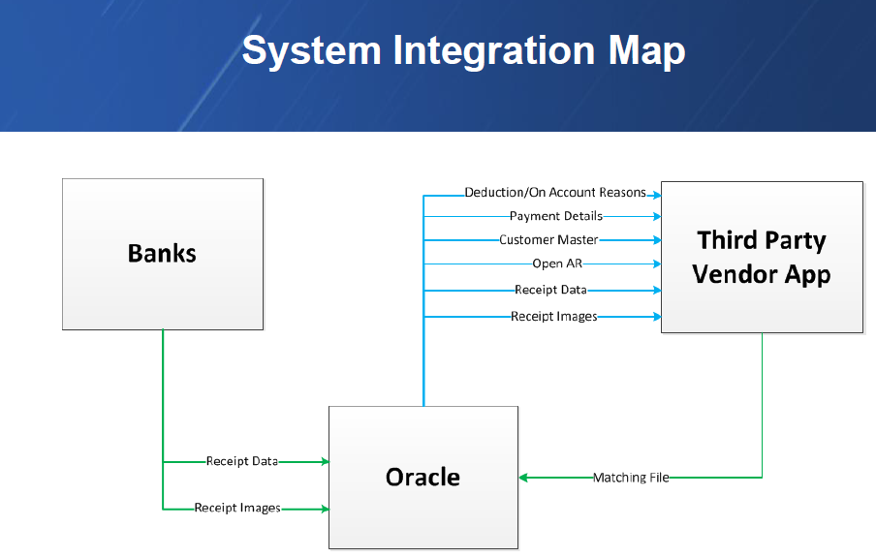

**How would you create trust and build a suitable talent base for your AI initiatives?**

My initial proposal would be to pick a group of superuser / Talented resources from both business and IT and provide them good training on state-of-the-art AI technologies.

I am a firm believer in retaining and upgrading existing resources than hiring fresh from the market. But still, I also think instead of building anything from scratch, we should work with the established players / Consulting firm to leverage their expertise to develop and expand the platform within the company.

My comment is

Hi Abhishek,

It seems you have a great plan already ready for the application. I strongly encourage you to apply immediately. However, paying more attention to doing some more preparations will boost the effects of this plan. Like analyzing how much time you save for the company and how AI accurately and fast on the processing of matching the invoice and cash, create some numbers! … As per my previous experiences, considering office politics is equally important doing the job itself, thus, sometimes you need to translate the language of AI or ML into finance tables or strategic outlook or sales figures so that those guys will understand how this technology is beneficial for their departments and the company as a whole. So that they will give you an initial credit that you will spend later on creating a “data-driven culture” in your organization. After successfully completing this first part than another step might be encouraging other teams to reach the data and imitate your success, that’s all you are good to go. Awesome job.