Q.No.01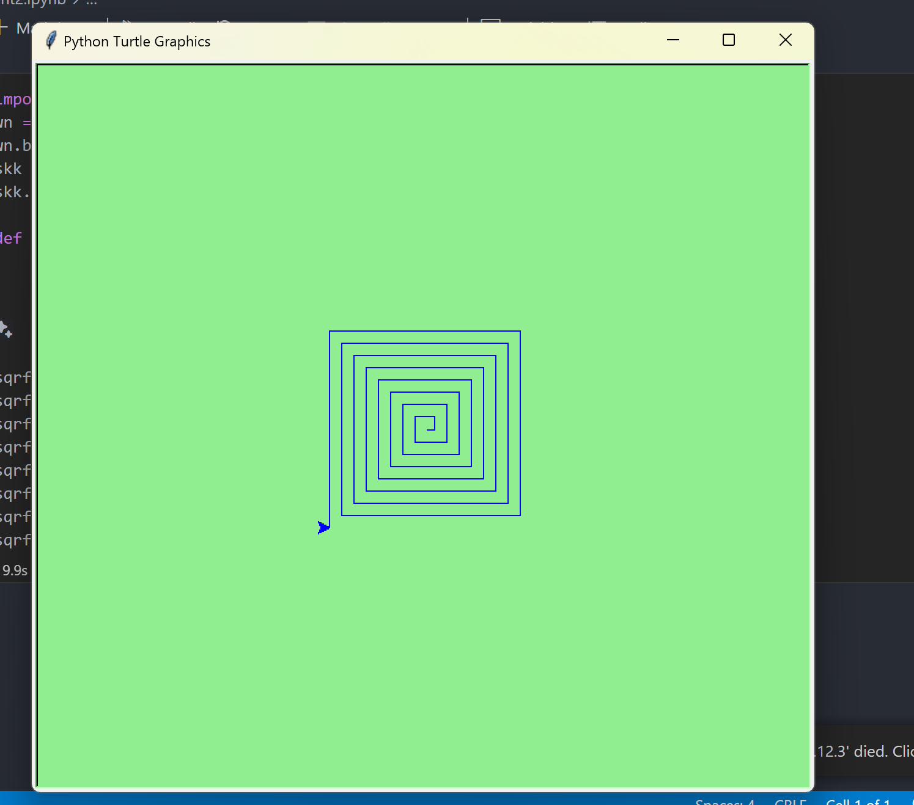

Q.No.02

Q.No.03

Q.No.04

Q.No.05

