

BLM432E MIDTERM

Yavuz Selim Gügen
1621221028

H0: Average life time increases as electricity usage increases.
H1: Average life time not increases as electricity usage increases.

My research topic is find that there is a correlation between electricity usage per person and median age which means life expectancy of countries. I aiming to prove that life expectancy increases as rate of electricity usage per person increases. I suppose that high rate of electricity usage per person point to high life quality. Therefore i assume that electricity usage per person increases life expectancy.

This correlation reveal that electricity which is an energy source has directly impact on lifespan. That is interesting because it analysis prove that if a country enhance electricity supply, it enhance lifetime of citizens.

My data sources are data.worldbank.org and population.un.org so this organizations are reliable.

Electricity use per person ranges from 6.68 and to 51400.0
Name: Elec_usage, dtype: float64

count | 872.000000
mean | 3270.140115
std | 4805.859468
min | 6.680000
25% | 314.000000
50% | 1175.000000
75% | 4567.500000
max | 51400.000000

Median Age ranges from 14.3 and to 44.7
Name: Median_Age, dtype: float64

count | 872.000000
mean | 25.344839
std | 7.639786
min | 14.300000
25% | 18.500000
50% | 23.250000
75% | 31.800000
max | 44.700000

Visual Datas:

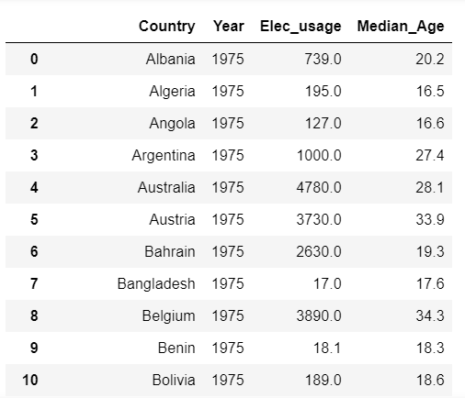

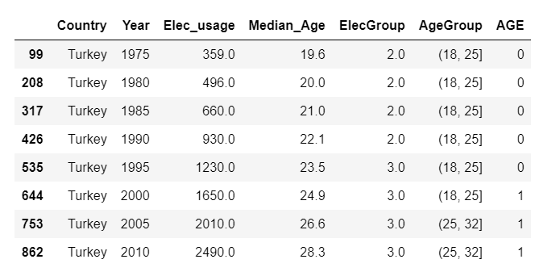

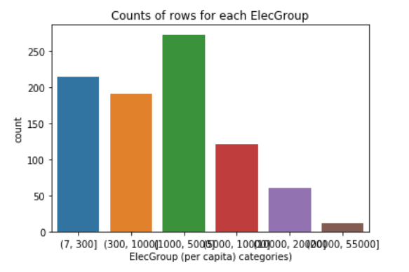
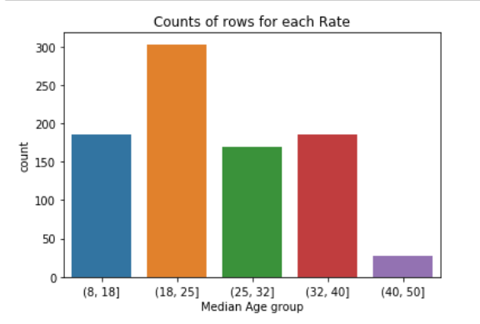

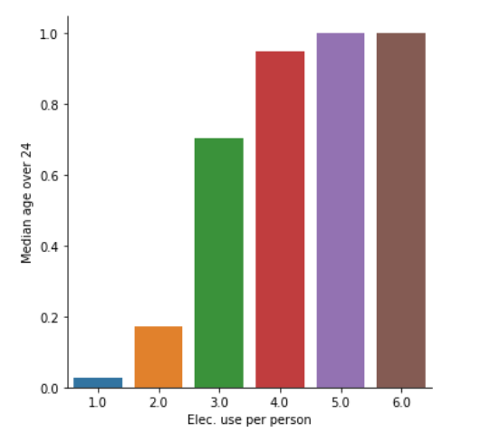

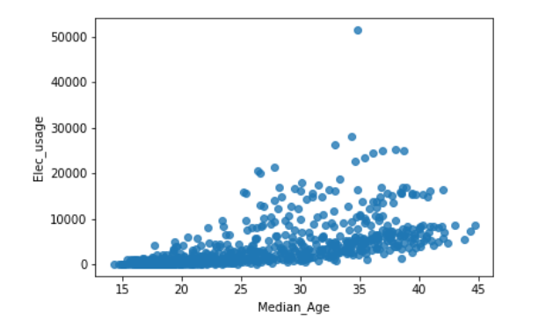

ANALYSIS:
Anova: Used to prove there is correlation between data sets. If there is, other test will be applied to figure out which data sets correlated.

OLS Regression Results
==============================================================================
Dep. Variable: Median_Age R-squared: 0.636
Model: OLS Adj. R-squared: 0.634
Method: Least Squares F-statistic: 302.0
Date: Mon, 01 Apr 2019 Prob (F-statistic): 6.38e-187
Time: 01:14:26 Log-Likelihood: -2566.7
No. Observations: 871 AIC: 5145.
Df Residuals: 865 BIC: 5174.
Df Model: 5
Covariance Type: nonrobust
=======================================================================================
coef std err t P>|t| [0.025 0.975]
---------------------------------------------------------------------------------------
Intercept 18.1972 0.315 57.695 0.000 17.578 18.816
C(ElecGroup)[T.2.0] 2.5452 0.460 5.535 0.000 1.643 3.448
C(ElecGroup)[T.3.0] 9.7108 0.422 23.028 0.000 8.883 10.539
C(ElecGroup)[T.4.0] 16.4268 0.526 31.254 0.000 15.395 17.458
C(ElecGroup)[T.5.0] 15.5161 0.675 22.979 0.000 14.191 16.841
C(ElecGroup)[T.6.0] 15.9755 1.430 11.175 0.000 13.170 18.781
==============================================================================
Omnibus: 2.739 Durbin-Watson: 2.198
Prob(Omnibus): 0.254 Jarque-Bera (JB): 2.859
Skew: 0.047 Prob(JB): 0.239
Kurtosis: 3.264 Cond. No. 10.0

By these information we understand that there is a correlation. So we continue other tests.

POST-HOC TESTS: Which categories are different than others?

Multiple Comparison of Means - Tukey HSD,FWER=0.05
==============================================
group1 group2 meandiff lower upper reject
----------------------------------------------
1.0 2.0 2.5452 1.1862 3.9042 True
1.0 3.0 9.7108 8.4646 10.9571 True
1.0 4.0 16.4268 14.8735 17.98 True
1.0 5.0 15.5161 13.5206 17.5116 True
1.0 6.0 15.9755 11.7506 20.2004 True
1.0 nan 1.2028 -12.4962 14.9018 False
2.0 3.0 7.1657 5.8764 8.4549 True
2.0 4.0 13.8816 12.2936 15.4696 True
2.0 5.0 12.9709 10.9483 14.9936 True
2.0 6.0 13.4303 9.1925 17.6682 True
2.0 nan -1.3424 -15.0454 12.3606 False
3.0 4.0 6.7159 5.2233 8.2085 True
3.0 5.0 5.8053 3.8566 7.754 True
3.0 6.0 6.2647 2.0616 10.4677 True
3.0 nan -8.5081 -22.2003 5.1842 False
4.0 5.0 -0.9106 -3.0686 1.2474 False
4.0 6.0 -0.4512 -4.7553 3.8528 False
4.0 nan -15.224 -28.9476 -1.5004 True
5.0 6.0 0.4594 -4.0233 4.9421 False
5.0 nan -14.3133 -28.094 -0.5327 True
6.0 nan -14.7727 -29.0477 -0.4978 True

Apply chi square for each pair (all combinations of them); test with adjusted p value (bonferroni adjustment p-value: p-value / number_of_comparions)
One of them:
Elec_1v2 1.0 2.0
AGE
0 209 158
1 6 33
Elec_1v2 1.0 2.0
AGE
0 0.972093 0.827225
1 0.027907 0.172775
chi-square value, p value, expected counts
(22.806297143283068, 1.7917765380037851e-06, 1, array([[194.34729064, 172.65270936],
[ 20.65270936, 18.34729064]]))

This test applied for every combinations.

Finally we have got pearson correlation between two numeric variables:
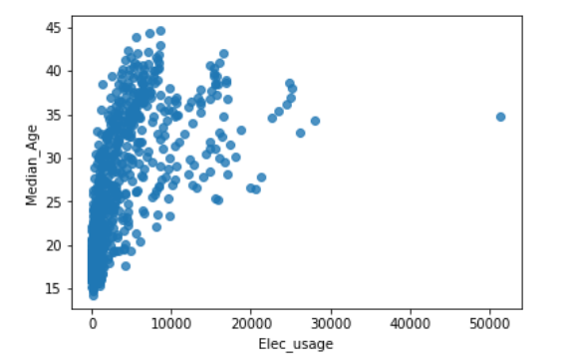

association between Elec. usage pre person and Median Age
(0.617638613515279, 7.588818646419762e-93)

As first parameter which is correlation coefficient goes to 1, -1 means there is correlation and as goes to positive that means there is linear correlation. So we can say there is linear correlation between median age and electricity usage per person.
And second parameter which is 2 tailed p-value. p-value tells you if your correlation was significant at a chosen alpha level. So if we choose alpha 0.5 as default this p-value indicate the correlation is very significant.

