

BLM320E TERM PROJECT

Yavuz Selim Gügen
1621221028

Pushdown Automata
- The PDA is an automaton equivalent to the CFG in language-defining power.
- Only the nondeterministic PDA defines all the CFL’s.
- But the deterministic version modelsparsers.
- Most programming languages have deterministic PDA’s

JS code of our example PDA which accepts Strings Of (0^n)(1^n)\n sample below:
let st = new Array();
let topOfStack = -1;
for (let i = 0; i < input.length; i++) {
if (input[i] == '0' || input[i] == '1') {
if (input[i] == '0') {
st.push(input[i]);
console.log("st push 0" + i)
topOfStack++;
}
else {
st.pop(input[i]);
console.log("st pop" + input[i] + " - " + i)
topOfStack--;
}
} else {
break;
}

I made an animation for ‘0011’ input. The animation tries to animate below image:
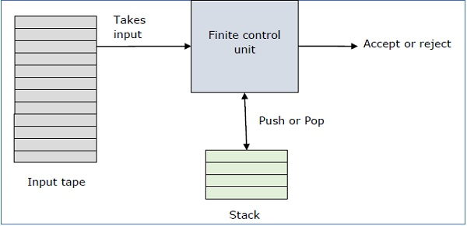

References:
infolab.stanford.edu
cppcodez.blogspot.com/2017/03/pushdown-automata-pda.html

