Face Detection Using U-Net-based Skin Filtering and ML -based Triplet Scoring
Yu-Wei Hsu, National Taiwan University
May 2026
Abstract
This project implements and improves existing face feature detection method for locating the eye and mouth positions from an input image. The original method uses skin filtering, ellipse matching, eye maps, mouth maps, and hand-crafted geometric rules to select the best eye-eye-mouth triplet. However, traditional skin filtering is sensitive to illumination, background noise, and skin color variations, while rule-based triplet scoring relies on manually designed weights that may not generalize well across different images. To address these limitations, this project introduces a U-Net-based skin filtering model to generate a more robust skin mask for ellipse matching. Based on the detected face ellipse, eye and mouth candidates are extracted from the eye map and mouth map. Candidate triplets are then constructed by combining two eye candidates and one mouth candidate. Instead of using only hand-crafted scoring rules, this project formulates triplet selection as a machine learning-based scoring problem. For each triplet, ellipse-relative geometric features are extracted, including normalized positions in the ellipse coordinate system, normalized distances, angular relationships, ellipse shape and orientation, and eye/mouth map responses. A classifier is trained to predict whether a candidate triplet forms a valid facial structure. Experimental observations show that the proposed improvements increase the flexibility of triplet selection and reduce the dependency on manually tuned geometric scoring rules.
- Introduction
Face detection is an important task in the field of Computer Vision, aiming to find the facial region of an input image and locate the facial features such as eyes and mouth. Such technologies can be applied in scenarios such as face recognition, emotion analysis, semantic understanding and human-machine interaction. However, robust face detection remains challenging in real-world situations because of illumination changes, background noise, skin color variations, facial rotation, and inaccurate candidate points.
This project is based on a previous face detection method proposed in an earlier thesis. The original method first applied skin filtering on an input image to extract possible skin regions, then performs PCA on each region to estimate each region as an approximate ellipse. Based on the detected face ellipse, eye maps and mouth maps are computed to generate candidate eye and mouth points. Finally, two eye candidates and one mouth candidate are combined into an eye-eye-mouth triplet, and a hand-crafted geometric scoring function is used to select the most plausible facial structure. Although the original method utilized meaningful facial geometry, it still has several limitations. The original method relies on classical skin filtering and fixed-weight triplet scoring, which may be inaccurate under illumination changes and background noise.
To address those limitations, this project improves two main components of the original method. First, a U-Net model is introduced for skin filtering, converting the input RGB image into a skin mask. Second, a ML-based scoring system is introduced for triplet selection. For each candidate eye-eye-mouth triplet, ellipse-relative geometric features are extracted, including normalized distances, normalized positions in the ellipse coordinate system, angular relationships, ellipse shape, orientation, and eye/mouth map response values. A classifier is then trained to predict whether a candidate triplet forms a valid facial structure.
Overall, this project does not propose a completely new face detection pipeline from scratch. Instead, we implement, analyze and extend an existing ellipse-based feature detection method. The main contributions are the integration of U-Net-based skin filtering and the use of machine learning-based triplet scoring to reduce the dependency on manually tuned geometric scoring rules.
- System overview
The pipeline of this project is shown in the figure below. First, the system applies skin filtering on the input image using a pre-trained U-Net model and extract a skin mask. Based on the original method, the skin mask is segmented into clusters, and each cluster is estimated as an ellipse with parameters such as centers, major axis and minor axis. Then, the system computes the eye-map and mouth-map, selecting most possible position of eyes and mouths on each ellipse. Finally, the system computes every combination of eye-mouth triplet through a machine learning-based scoring method to select the most plausible face detection.
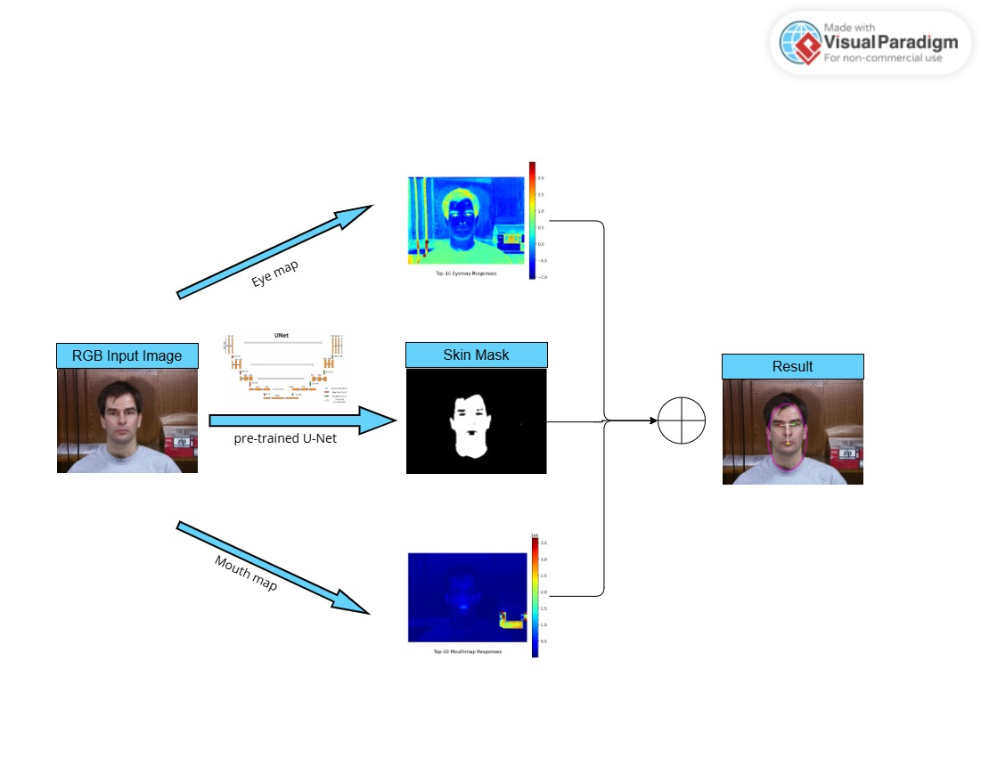
- Original Method
The original Method proposed in earlier thesis detects the position of eyes and mouth based classical image filtering and geometry rules. The pipeline consists of four stages: skin filtering, ellipse matching, eye/mouth map and geometry-based triplets’ detection. First, the system extracts possible skin-like regions. Then, for each region, the system estimates the approximate ellipse for each region. Second, the system computes the eyemap and mouthmap of the input image and selects the several candidates of eye-candidates and mouth-candidates. Finally, the system find the most plausible eye-mouth triplet inside the ellipse and determine as a face if it is found.
  - Skin Filtering
In the original method, the skin filter filters out pixels that don’t look like skin, so the system only needs to process information inside the ellipse of each skin-like region.
Classical skin-filtering usually evaluates pixels based on the color space information, such as RGB, YCbCr or HSV, to produce a skin mask. The pixels inside the skin mask are highly possible to be a skin pixel, thus can be the input of next stage.
  - Ellipse Matching
- Proposed Improvements
This project extends the original ellipse-based face feature detection method by improving two major components: skin filtering and triplet scoring. Instead of relying only on traditional color-based skin filtering, a U-Net model is used to generate a more robust skin mask. In addition, the original hand-crafted triplet scoring function is replaced with a machine learning-based scoring model that learns from labeled triplet data.
  - U-Net based skin-filtering
4.1.1 Motivation
Traditional skin filtering is sensitive to lighting conditions. The algorithm used in original method is SVM, which is sensitive to shadows, different races and lighting conditions. Furthermore, fixed color thresholds may fail under different skin tones or backgrounds. Therefore, the precision and recall of this method is usually low. Poor skin masks affect ellipse matching and later facial feature detection, so it is essential to address this problem.
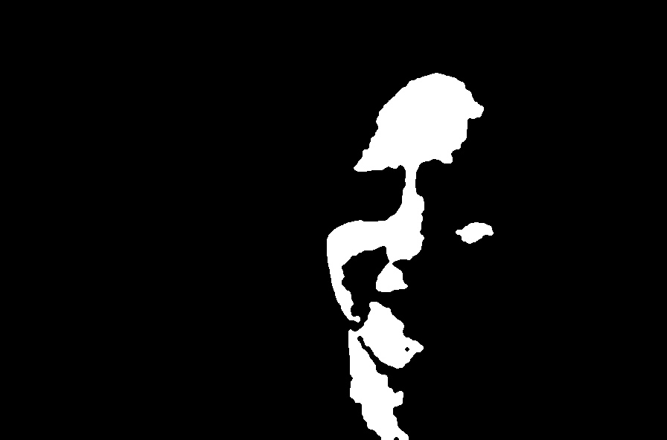
Skin tones
Shadows
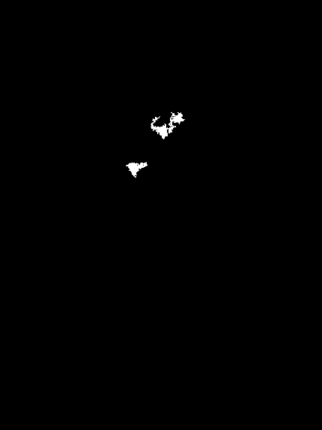

4.1.2 Architecture
The skin filtering model used in this project is a simplified U-Net architecture for image segmentation. The model takes a 3-channel RGB image as input and outputs a single-channel skin mask. It follows an encoder-decoder structure with skip connections.
In the encoder path, the input image is passed through several convolution blocks. Each convolution block contains two convolutional layers, followed by batch-normalization and ReLU activation. After each block, max pooling is applied to reduce the spatial resolution. As the network goes deeper, the number of feature channels increases from 64 → 128 → 256 → 512, allowing the model to learn increasingly abstract and high-level features.
In the decoder path, transposed convolution is used to up-sample the feature maps and gradually recover the original spatial resolution. At each decoding stage, the up-sampled feature map is concatenated with the corresponding encoder feature map through a skip connection. These skip connections help preserve low-level spatial details, which is important for producing accurate segmentation boundaries.
Finally, a 1 × 1 convolution is used to reduce the feature channels to one output channel, producing the final skin segmentation mask.
4.1.3 Role in the pipeline
An RGB image and a pretrained weight will be fed as an input into the U-Net model. The model will output a binary image as skin mask, where 1 represents skin-like pixel and 0 otherwise.
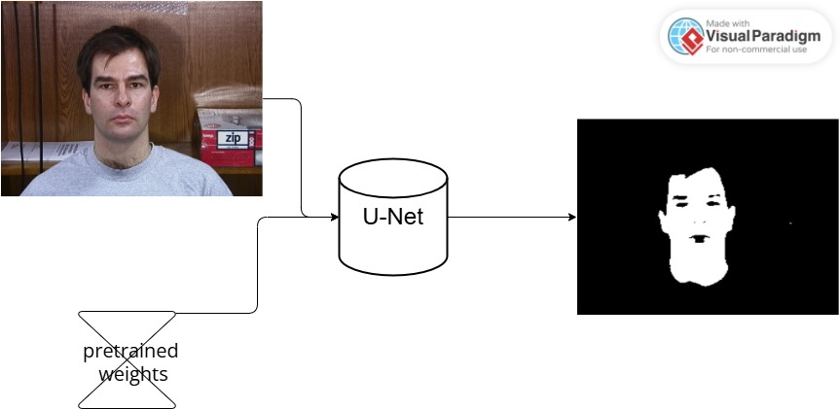

  - Machine Learning-based Triplet Scoring
    - Limitation of Rule-based Scoring
The original method uses manually designed weights and a rule-based method to select the most plausible triplets. Because thresholds and penalties may not generalize well, different images may require different scoring behavior.
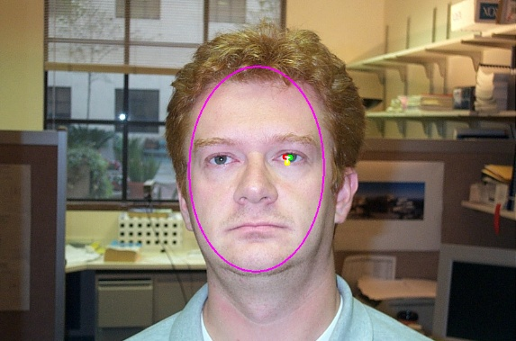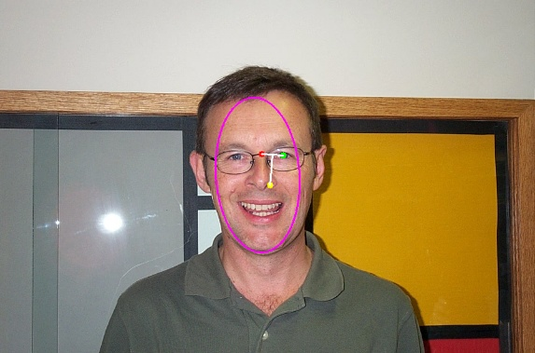
    - Triplet Classification Formulation
Input:
A candidate triplet consisting of left eye, right eye, and mouth.
Output:
Probability that the triplet is a valid facial structure.
Label:
1 = valid triplet
0 = invalid triplet
    - Feature Categories
1. Normalized distances between eyes and mouth
2. Ellipse-normalized positions of eyes and mouth
3. Distances from ellipse center
4. Angular relationships between long-axis and eyes-mouth
5. Eye map and mouth map response values
    - Model Training and Triplet Selection
Candidate triplets are generated from each image. Then, Triplets are manually labeled as valid or invalid. A classifier (in this project we used random forest) is trained to predict triplet validity. During testing, the triplet with the highest predicted score is selected.
After all possible candidate triplets are generated, the features are extracted for each triplet. The trained model predicts a validity score, which all triplets will be sorted by. Then, the top-ranked triplet is selected as the result.
  - Summary of Improvements
Component | Original Method | Improved Method
Skin filtering | Color/pixel-based filtering | U-Net-based skin filtering
Triplet scoring | Hand-crafted geometric score | Machine learning-based score
- Experiments
  - Experimental Objective
The goal of the experiments is to evaluate whether the proposed improvements can enhance the robustness of the original face feature detection method. Specifically, the experiments focus on two parts: the quality of U-Net-based skin filtering and the effectiveness of machine learning-based triplet scoring for selecting the correct eye-eye-mouth configuration.
  - Dataset Preparation
For the training of U-Net, this project used Face and Skin Detection (FSD) Database. It contains 4,000 color images designed to support research in skin segmentation, used to develop models for classifying and quantifying skin pixels, as well as detecting face regions.
For triplet scoring, each triplet consists of two eye candidates and one mouth candidate. The triplets generated were manually labeled as valid or invalid:
label = 1: valid eye-eye-mouth triplet
label = 0: invalid triplet
label = -1: unlabeled, not used for training
  - Feature Extraction
For each candidate triplet, features were extracted based on the detected face ellipse. The features include normalized distances, ellipse-relative coordinates, distances from the ellipse center, angular relationships, ellipse shape and orientation, and eye/mouth map response values. These features were used as the input to the machine learning classifier.

- Results
6.1 Skin Filtering
The U-Net-based skin filtering model was able to extract major skin regions from the input images. The resulting skin masks provided the basis for ellipse matching and reduced the search region for facial feature detection.
Input Image | Original | Improved
 |  | 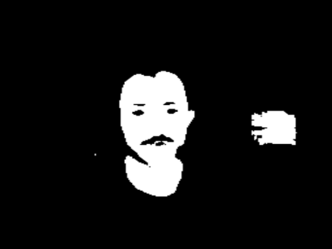
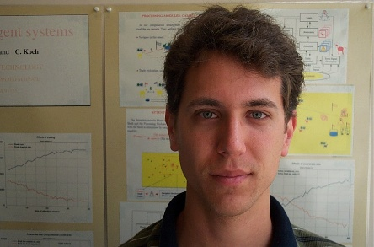 |  | 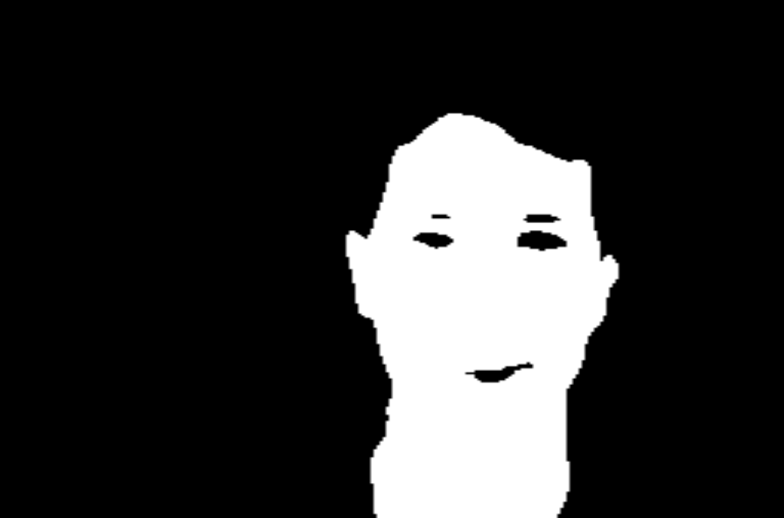
6.2 Triplet Scoring Results
The machine learning-based scorer ranks candidate triplets based on their ellipse-relative geometric features and map response values. In many cases, the correct eye-eye-mouth configuration receives a higher score than geometrically unreasonable candidates.
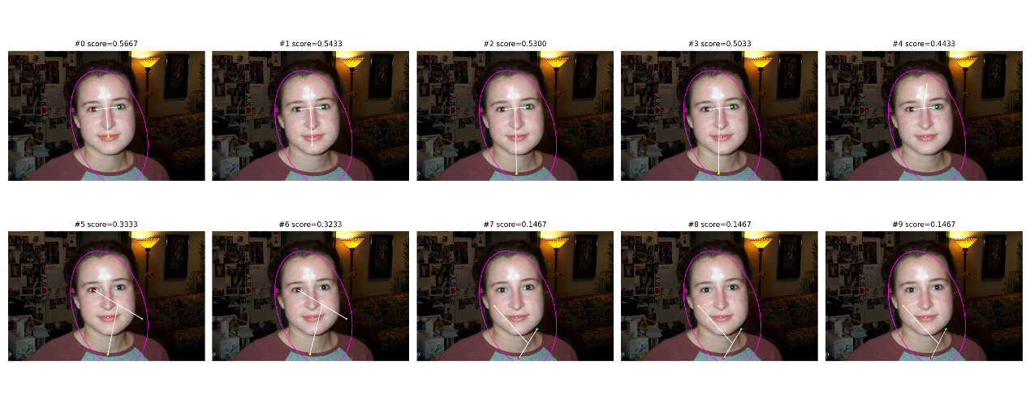
Input Image | Original | Improved
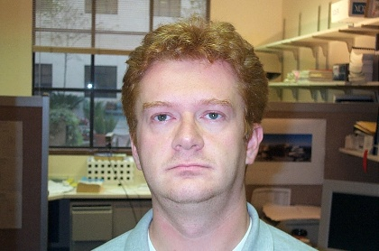 | 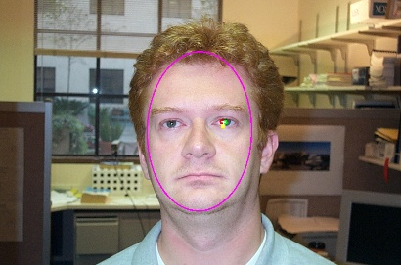 | 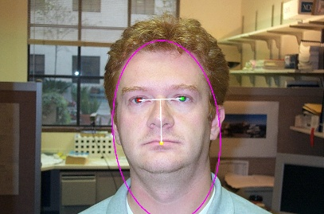
 | 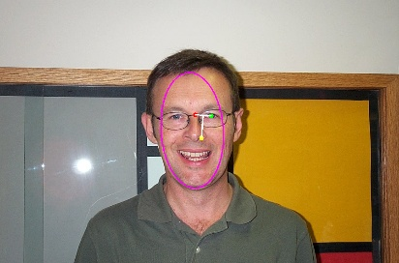 | 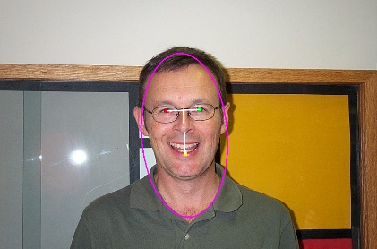
6.3 Comparison with original method
Method | Scoring Strategy | Strength | Limitation
Original method | Pixel-based skin filter, Hand-crafted geometric score | Simple and interpretable | Requires manually tuned weights
Improved method | DL-based skin filter, ML-based triplet score | Learn from labeled data | Depends on training data quality

Method | Precision | Recall | F1 Score
Original method | 31/39=79.49% | 41/72=56.94% | 66.35%
Improved method | 64/70=91.43% | 64/74=86.49% | 88.89%

