Mapping Sacred Infrastructure: Spatial Distribution and Discursive Construction of Foreign Cults in the Hellenistic and Roman Greek World
Introduction
During the Hellenistic to Roman Imperial period (c. 4th century BCE–3rd century CE), the traditional self-sufficient polis system declined, and Greece and the Aegean entered a period of increased mobility and social change. Foreign cults from Egypt, Syria, and other regions spread widely across the Greek world, especially in ports and key trade hubs. In contrast, local Greek cults were mainly located within urban centres and were more evenly distributed across mainland Greece and the Aegean, forming a stable regional religious network. While traditional scholarship often relies on close reading of individual inscriptions or sites, this makes it difficult to identify broader spatial and textual patterns. This project uses QGIS and Voyant Tools to examine both the spatial distribution of foreign cults and their representation in contemporary texts. The project argues that foreign cults were more concentrated in ports and transport nodes. In textual sources, foreign deities are often described through ritual language and cross-cultural comparison, giving them a more distinct cultural identity. By combining geographic information systems with digital text analysis, the project suggests that religious integration in this period was not a rapid process of assimilation. Instead, foreign cults were incorporated into Greek urban networks but continued to retain a degree of separation.

Methodology
- Research Material and Data
This project focuses on the Hellenistic to Roman Imperial period, with particular attention to the spatial distribution and textual analysis of foreign cults in mainland Greece and the Aegean. I selected 65 religious sites from over 70, filtering out vague ruins and duplicate cults. The dataset includes 15 foreign cult sites and 50 local Greek sanctuaries as a control group. Foreign cults mainly include Egyptian deities (such as Isis and Serapis), Syrian deities, and the Mithras cult, while local cults cover the Olympian pantheon and broader Pan-Hellenic local religious traditions.
This project uses two main types of data: spatial data and textual data. The spatial dataset is organised into three CSV files: local cults, foreign cults, and ports. Each cults dataset includes the site name, cult category, and geographic coordinates. The data is ordered from mainland Greece to the islands. The ports dataset includes major trade hubs from the Hellenistic and Roman periods, such as Piraeus, Corinth, Delos, Rhodes, and Thessaloniki. These ports are included because the central aim of the project is to examine the relationship between foreign cults and trade networks, making them an important spatial reference for analysis. The cult data is based on digital gazetteers such as Pleiades, ToposText, Wikidata, and GeoNames. All coordinates were carefully checked to remove duplicates, unclear site identifications, and obvious spatial errors. The final dataset was standardised using the WGS84 (EPSG:4326) coordinate system to ensure compatibility with GIS analysis. During data cleaning, entries without reliable archaeological evidence or with unclear location information were removed, and inconsistent naming was harmonised. The textual dataset consists of Strabo’s Geographica and Pausanias’ Description of Greece. These texts were selected because they cover a wide geographical range of the Greek world and frequently describe ports, cities, sanctuaries, and regional religious practices, making them suitable for comparison with spatial data. The texts were downloaded from the Perseus Digital Library and ToposText, then converted into .docx format for use in Voyant Tools. Before analysis, stopwords such as “the”, “and”, “people”, “many”, “said”, and “son” were removed in order to reduce noise and highlight words relevant to religion and space. The overall design of the dataset aims to ensure comparability and mutual validation between spatial patterns and textual representations.
- Tools and Methods
This project combines QGIS and Voyant Tools for spatial and textual analysis, using both methods to strengthen the argument through mutual comparison.
QGIS is used to build a spatial model of the distribution of foreign and local cults. First, cult and port CSV files were imported into QGIS and converted into point layers using the “Add Delimited Text Layer” function based on latitude and longitude coordinates. On this basis, the project applies the following methods:
- Spatial Visualisation
Categorised mapping is used to distinguish local cults from foreign cults, allowing comparison of their distribution patterns across mainland Greece, islands, and port regions.
- Heatmap Analysis
A heatmap is generated to show the density of foreign cult sites and to identify clusters around ports and maritime routes. All sites are given equal weight (weight = 1) to avoid bias caused by uneven archaeological preservation. By setting the Radius to 10, the analysis identifies high-density clusters of foreign cult sites, such as Corinth and Delos. Since this project focuses on broader regional patterns rather than the distribution of individual sites, a moderate level of smoothing is applied to highlight overall spatial structures.
Buffer Analysis
- A 2000 m buffer was created around major ports and coastal nodes from the Hellenistic to Roman period to measure the spatial relationship between religious sites and port areas. This distance is based on the walking range in ancient cities and the typical spatial extent of port activity zones. In ancient Greek urban settings, daily movement and religious practices were usually concentrated within walking distance. Therefore, a 2000 m buffer can reasonably represent the social and economic influence area around ports. The “Select by Location” tool is then used to calculate how many foreign and total cults fall within these zones, to test the spatial relationship between cult sites and maritime trade networks.
- Comparative Spatial Analysis
The distribution of foreign and local cults is compared across inland areas, islands, and ports, in order to identify structural differences between the two religious systems.

Voyant Tools is used to examine Strabo’s Geographica and Pausanias’ Description of Greece, with the aim of analysing differences in how foreign and local cults are described in ancient texts. The project uses a distant reading approach, which relies on computational analysis of large texts rather than close reading of individual passages. In this study, textual analysis is used to show patterns of religious representation, which complements the spatial structures identified in QGIS. The following methods are applied:
- Word Frequency Analysis
The Cirrus word cloud and Terms tools are used to identify common words. These reflect the strong spatial focus of the texts.
- Trend Analysis
Keywords such as Isis, Serapis, Syrian, and cults are tracked across the texts to examine how their frequency changes in different sections. This helps to identify whether foreign cults are concentrated in specific narrative contexts or geographic descriptions.
- Collocation Analysis
This method examines words that frequently appear near the names of foreign deities. For example, Isis often appears with words such as sanctuary, mysteries, and Serapis.
- Context Analysis
Keywords are studied in their original sentence context to support and refine the statistical results.
However, this method has several limitations. Many ancient site locations remain uncertain and can only be identified approximately. Differences between modern maps and ancient coastlines may also affect spatial accuracy. In addition, word frequency and collocation patterns do not directly reflect cultural meaning and must be interpreted in their historical context. Ancient texts also reflect authorial bias, as writers such as Strabo and Pausanias tend to focus on major political and geographic centres, while smaller local cults may be underrepresented. Finally, spatial and textual data belong to different systems of representation, so their relationship should be understood as a structural correlation rather than a strict one-to-one mapping.

Discussion
This project combines QGIS and Voyant Tools to examine the spread patterns and cultural positioning of foreign cults during the Hellenistic to Roman Imperial periods. The overall results show that although foreign cults were widely present in the Greek world, both their spatial distribution and textual representation reveal clear structural separation, reflecting a pattern of “limited integration”.
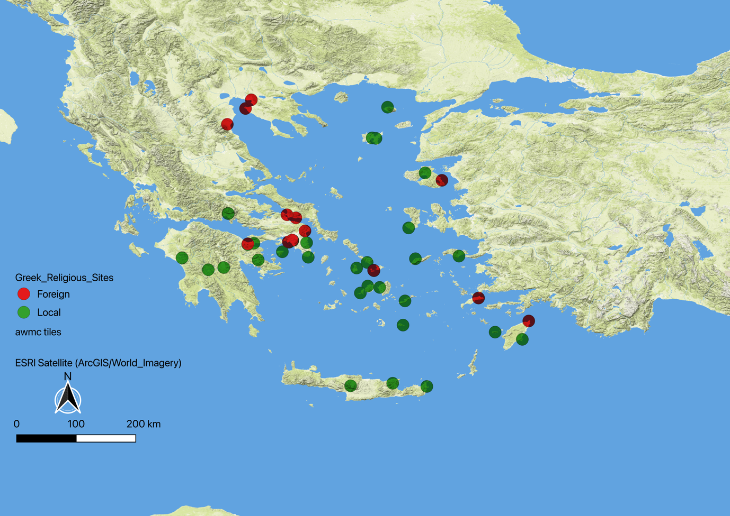
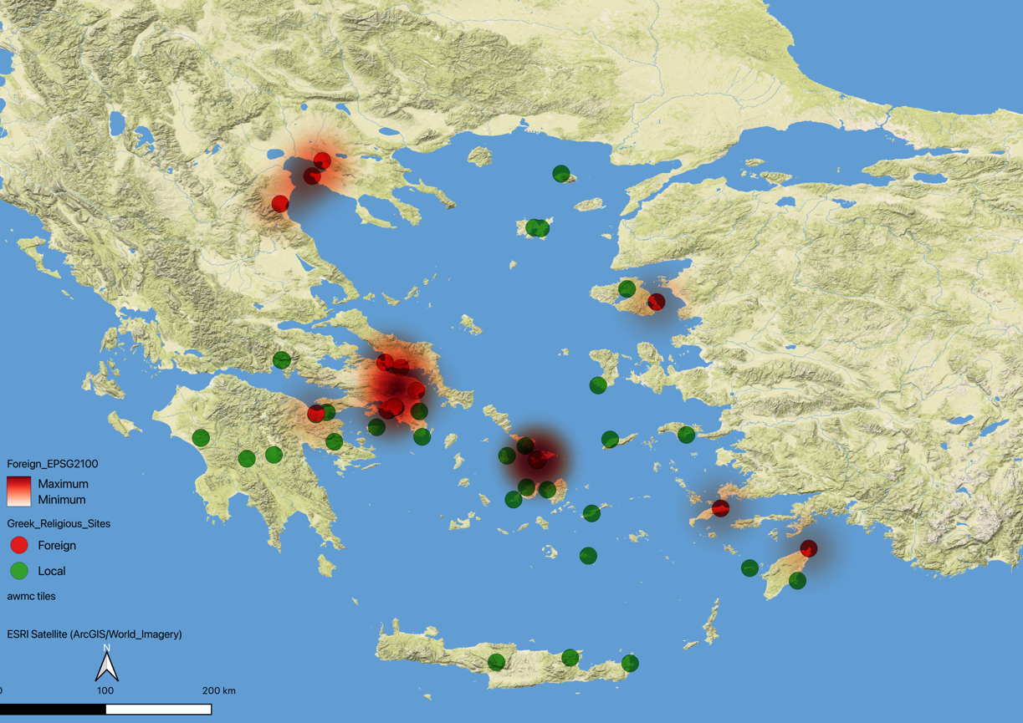
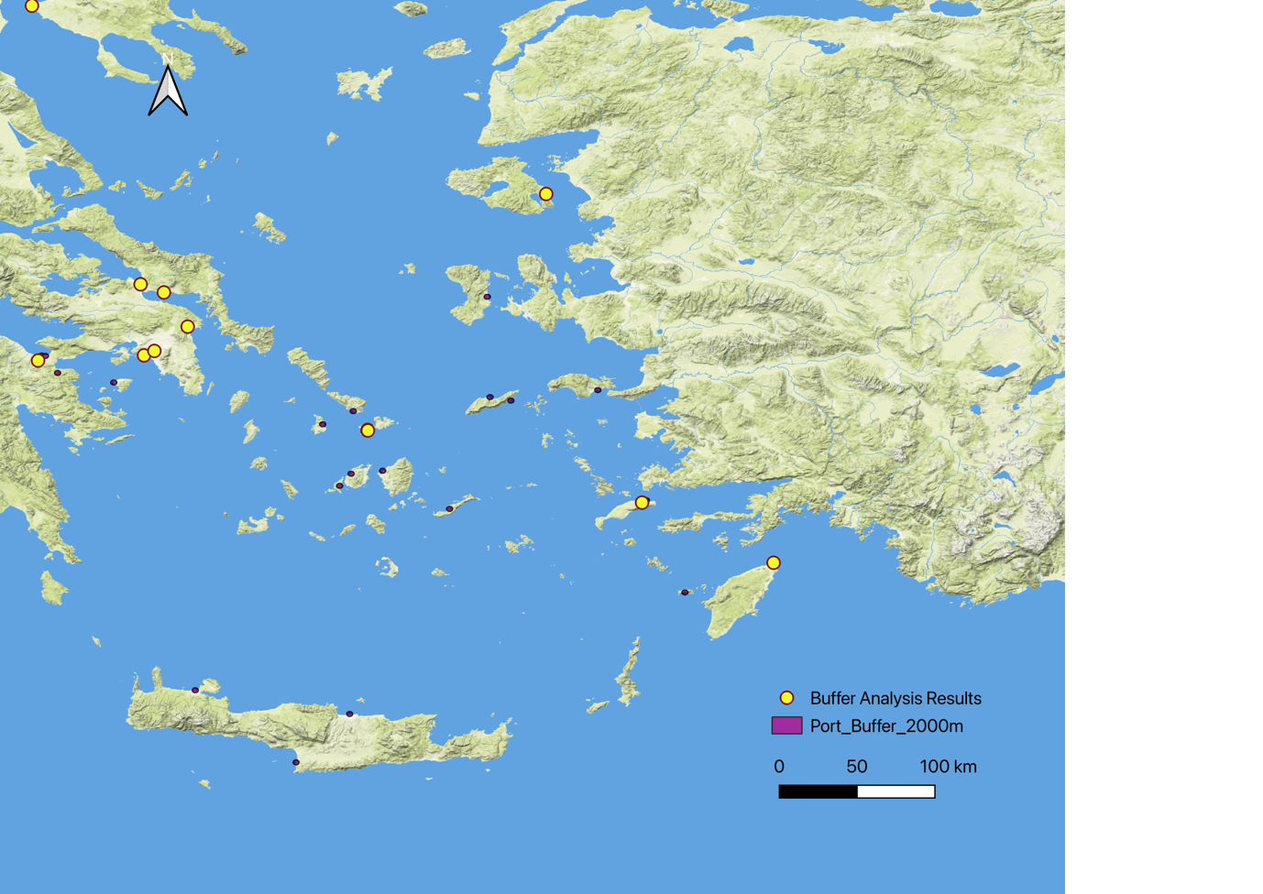
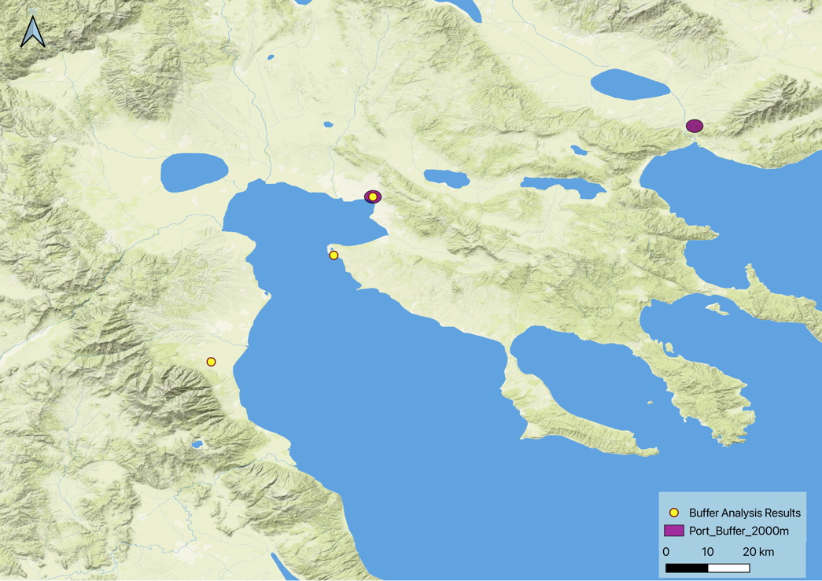
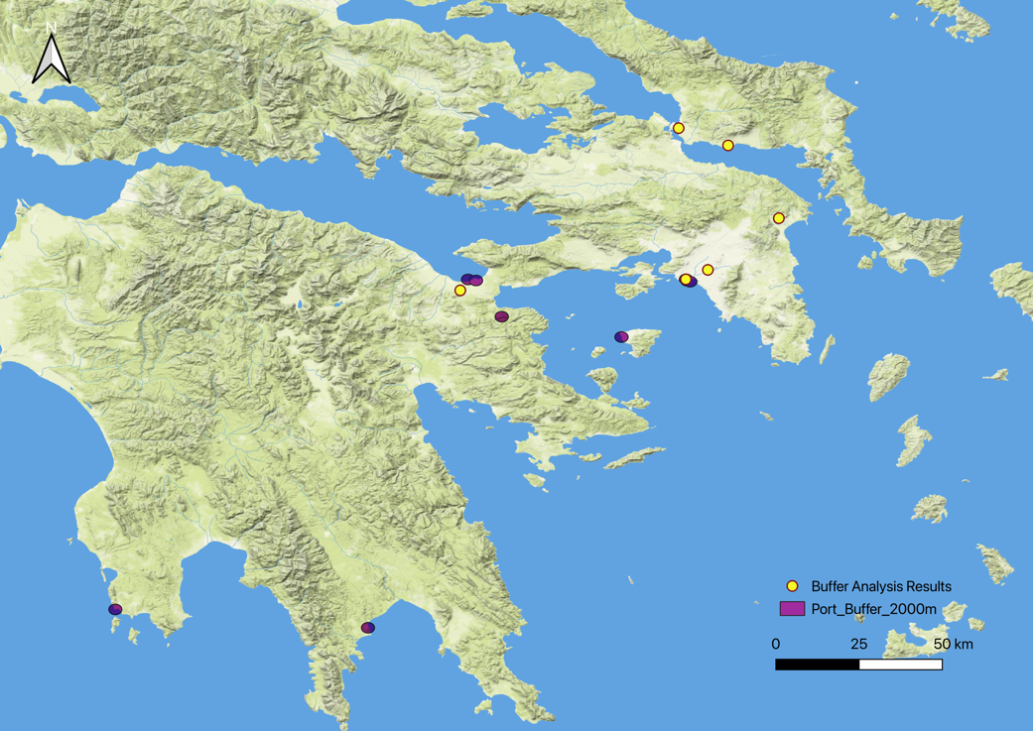
In spatial terms, the QGIS analysis shows that local and foreign cults follow very different spatial logics. As shown in the map (Figure 1), local cults display a clear “Pan-Hellenic distribution”. From Athens, Delphi, and Olympia to the Peloponnese, Crete, and the Aegean islands, local sanctuaries are widely and evenly distributed. These sites are usually located in city centres, major Pan-Hellenic sanctuaries, inland political centres, and traditional local sacred sites. It suggests that the local religious system was deeply embedded in the political structure and local identity of the polis. Religion was therefore not only a form of worship but also part of the city’s spatial organisation and public infrastructure. By contrast, foreign cults show a much more uneven distribution. The heatmap (Figure 2) shows strong clusters in Corinth, Delos, and Piraeus, all of which are major port cities or maritime trade hubs. Buffer analysis (Figure 3) also shows that most foreign cults are located near ports, while far fewer appear in inland or traditional political centres. Local cults, on the other hand, are more evenly spread across inland cities, sanctuaries, and political centres. Statistical results (Figure 4) further support this pattern: out of 65 sites, 16 are located within port buffer zones, including 7 foreign sanctuaries. While 24.62% of all sanctuaries are near ports, the figure rises sharply to around 46.67% for foreign cults, showing a strong link with ports and maritime transport networks. This result suggests that foreign cults follow a network-based pattern of spread, likely moving along trade routes and sea travel rather than spreading evenly into inland regions. This is further supported by case evidence from Delos, which was one of the most important free trade ports in the Aegean during the Hellenistic period and also one of the main centres of foreign cult activity. Egyptian sanctuaries such as those of Isis and Serapis, along with Syrian cult sites, are all concentrated there. This strong clustering suggests that trade networks did not only move goods, but also played a key role in the movement of religious practices. So, the QGIS results show that although foreign cults were present in the Greek world, their spread mainly followed maritime commercial routes and did not fully integrate into inland city structures.
Figure 1 Distribution of Religious Sites in the Greek World
Figure 2 The heatmap of Foreign Cults
Figure 3 Buffer Analysis of Foreign Cults and Port Proximity
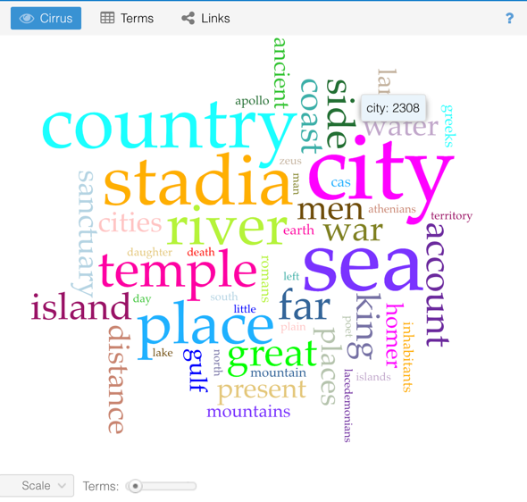
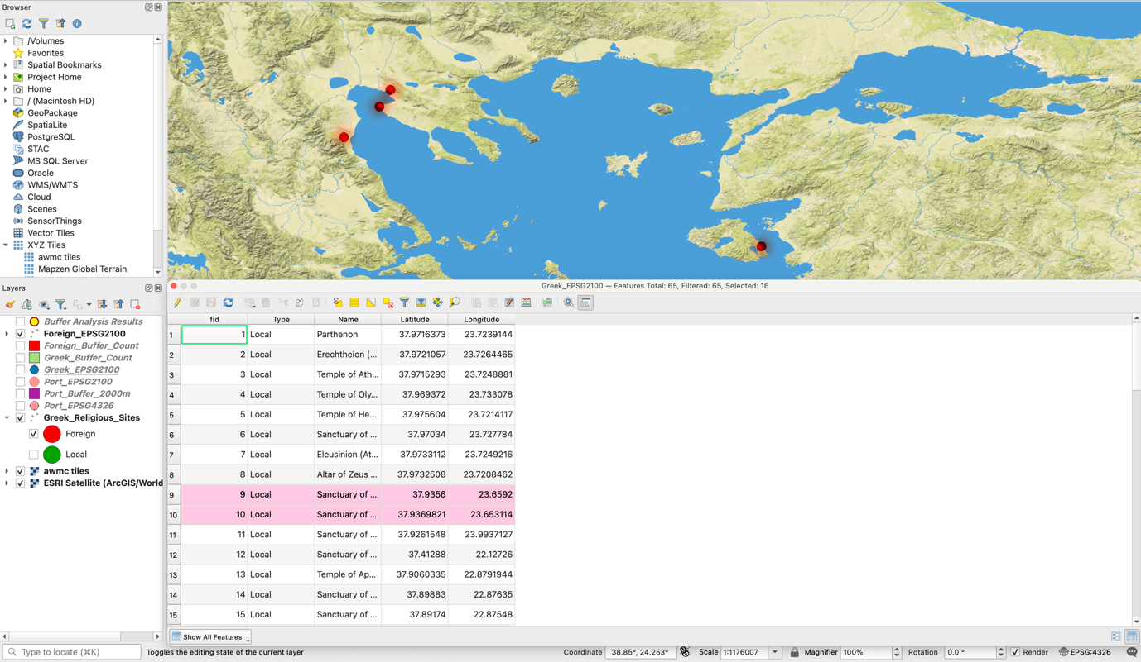
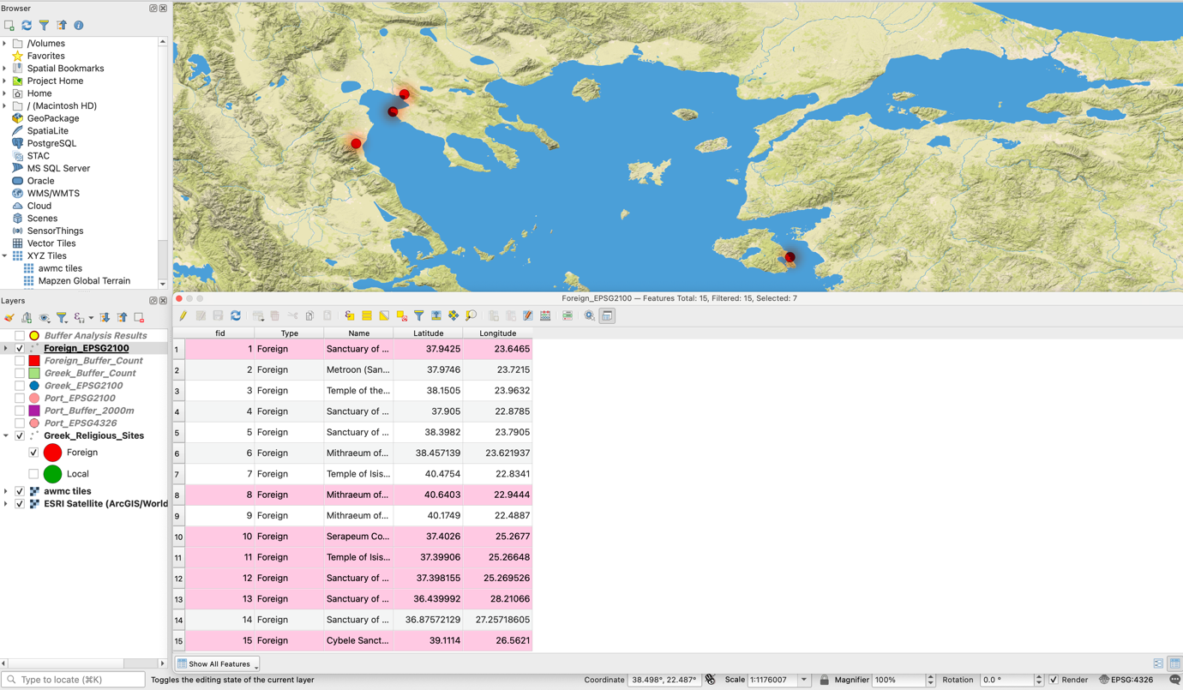
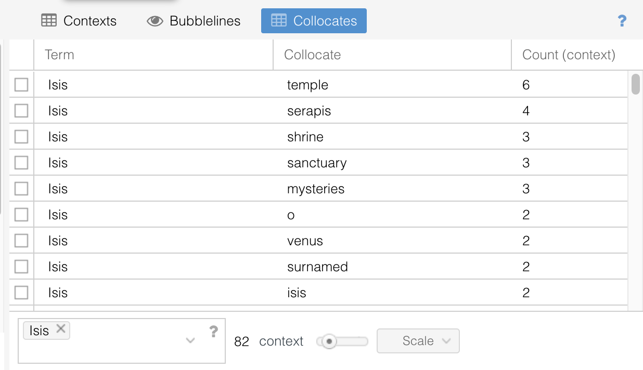
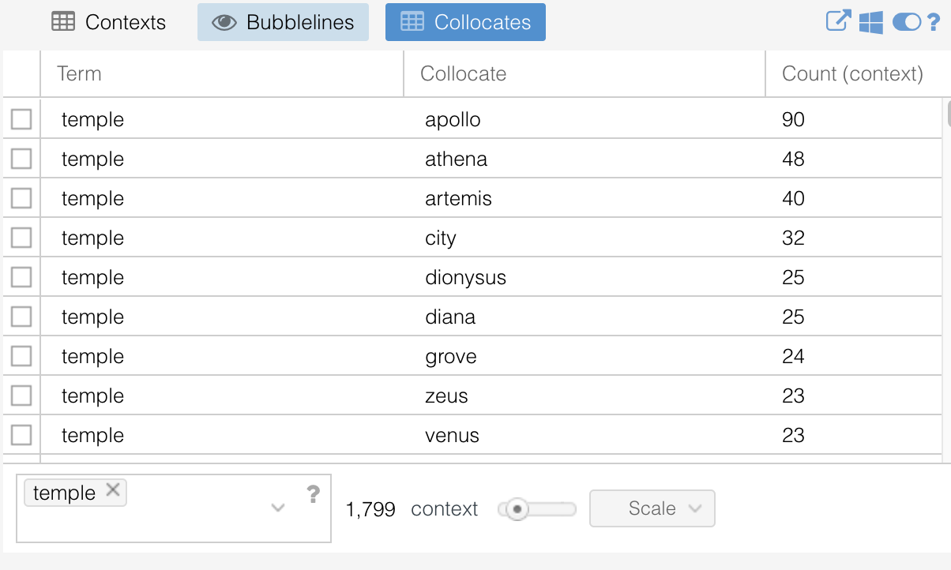
In the textual analysis section, Voyant Tools was used to analyse Strabo’s Geographica and Pausanias’ Description of Greece in order to explore differences in textual use. These texts were chosen because they cover the wider Greek world and frequently describe ports, cities, sanctuaries, trade routes, and religious practices. Word frequency analysis (Figure 5) shows that the most common terms include city, temple, sea, island, coast, river, and country, which reflects a strong geographical focus in the narrative. In relation to local cults, the word “temple” (Figure 6) most often appears alongside Apollo, Athena, Artemis, Zeus, city, and grove. This shows that local gods are closely linked with urban space, local identity, and natural sacred sites. For example, Apollo is strongly associated with Delphi and Athena with Athens. These connections form a stable cultural geography. In ancient texts, these sanctuaries are not treated as exceptional cases, but as a normal part of city structure. In this sense, local religion can be understood as a kind of “native sacred infrastructure”. By contrast, foreign gods appear in a different linguistic context. Collocation analysis shows that “Isis” most often appears with Serapis, mysteries, sanctuary, shrine, and Venus. The most important of these is “mysteries”, which suggests that foreign cults were often described as involving special rituals, secret initiation, and unusual religious experiences. This clearly differs from traditional public Greek worship. The frequent pairing of Isis and Serapis also reflects the combined spread of Egyptian deities in the Greek world. The link between Isis and Venus further reflects the common practice of Interpretatio Graeca, where foreign gods were explained through comparison with Greek and Roman deities. This shows that foreign cults were included within Greek cultural understanding, but still needed explanation in order to be fully understood.
Figure 5 Word Frequency
Figure 4 Foreign and Overall Cult Statistics

Figure 6 Top: Collocates of Temple; Below; Collocates of Isis
Combining spatial and textual analysis, this project argues that although foreign cults were widely present in the Greek world during the Hellenistic to Roman periods, their spread depended mainly on ports and trade networks and did not fully integrate into traditional religious structures. QGIS shows that they are located near cities but mainly concentrated in ports and commercial hubs. Voyant analysis shows that ancient authors still treated them as special religious forms. And, even though spatial data shows strong concentration in port areas, ancient texts such as those by Pausanias mention them less frequently than many small rural local sanctuaries. This suggests that elite writers may have continued to emphasise traditional religious structures while downplaying foreign cults. Therefore, foreign cults should not be seen simply as cultural invasion. Instead, they can be understood as a targeted religious service mainly linked to specific economic groups, especially maritime traders. This reflects a deeper economic logic behind religious spread. In this sense, cultural integration in this period can be described as limited integration. Foreign cults were accepted and became part of the urban network of a globalising world, but they did not replace or fully merge with local religious systems. This also shows that globalisation in the Greek world did not remove cultural boundaries, but instead produced a long-term process of coexistence, negotiation, and distinction.
However, these results should be interpreted with caution. The concentration of foreign cults in port areas may not only reflect trade networks, but also archaeological bias, since coastal and island sites are often better preserved and more frequently studied than inland rural sanctuaries. In addition, port cities are generally more urbanised and mobile, so higher concentrations of foreign cults may partly reflect overall population density rather than trade alone. Despite these limitations, these factors mainly affect precision rather than the overall pattern. The main finding remains stable: foreign cults show strong spatial links to ports and are consistently marked as special in textual sources. This supports the idea of a structural form of “limited integration”, where foreign cults were included in the religious and urban systems of the Greek world, but still maintained a degree of separation in both space and discourse.

Conclusion
In conclusion, foreign cults were closely connected to ports and trade networks, while local cults were more evenly distributed across traditional urban and religious centres. And textual analysis shows that ancient authors often described foreign deities through ritual language and cross-cultural comparison, which gave them a sense of cultural “difference” or “specialness”. Therefore, this project argues that religious integration during this period was not a process of complete assimilation, but rather a form of limited integration. By using QGIS and Voyant Tools, this project was able not only to turn religious spread into visible spatial patterns, but also to identify word frequency, collocations, and narrative trends within large texts. This made it possible to analyse how ancient authors described different religious systems from a broader perspective. However, the project also faced several challenges, such as archaeological research bias and the fact that religious spread was likely influenced by many factors, including trade, population movement, and urban development. Future research could expand the dataset by including more sanctuaries, inscriptions, and archaeological material, as well as extending the study to the wider Mediterranean world to compare the spread of foreign cults in different regions. It would also be useful to examine more ancient authors and texts from different time periods to explore how the cultural image of foreign cults changed over time. This could help develop a deeper understanding of religious spread and cultural exchange during this period.
Word counts: 2455
Data and materials are available at: https://github.com/Yawen51/Greek-Religion-QGIS-Voyant.git

Bibliography
- Barker, Elton, Chiara Palladino, and Shai Gordin. 2024. “Digital Approaches to Investigating Space and Place in Classical Studies.” The Classical Review 74 (1): 1–19. https://doi.org/10.1017/S0009840X23002858.
- Barker, Elton, Leif Isaksen, and Jessica Ogden. 2015. “Telling Stories with Maps.” In New Worlds from Old Texts: Revisiting Ancient Space and Place, edited by Elton Barker, Leif Isaksen, Stefan Bouzarovski, and Christopher Pelling, 123–145. Oxford: Oxford University Press. https://doi.org/10.1093/acprof:oso/9780199664139.003.0009.
- Barrett, Caitlín E. "Chapter Four. The Eye of the Sun and the Inundation of the Nile: Iconographic Evidence for Egyptian Theology on Delos". In Egyptianizing Figurines from Delos, (Leiden, The Netherlands: Brill, 2011) doi: https://doi.org/10.1163/9789004222663_005
- Boardman, John, Jasper Griffin, and Oswyn Murray. 1991. The Oxford History of Greece and the Hellenistic World. Oxford: Oxford University Press.
- Glomb, Tomas, Adam Mertel, Zdeněk Pospíšil, and Aleš Chalupa. 2020. “Ptolemaic Political Activities on the West Coast of Hellenistic Asia Minor Had a Significant Impact on the Local Spread of the Isiac Cults: A Spatial Network Analysis.” PLOS ONE 15: e0230733. https://doi.org/10.1371/journal.pone.0230733.
- Graml, C. 2020. The Sanctuary of Artemis Soteira in the Kerameikos of Athens. Wiesbaden: Reichert Verlag.
- Hegedus, T. 1998. “The Urban Expansion of the Isis Cult: A Quantitative Approach.” Studies in Religion/Sciences Religieuses 27 (2): 161–178.
- Mazurek, L. A. 2013. “Review of Egyptianizing Figurines from Delos.” Journal of Roman Archaeology 26: 503–512. https://doi.org/10.1017/S1047759413000342.
- Rockwell, Geoffrey, and Stéfan Sinclair. 2016. Hermeneutica: Computer-Assisted Interpretation in the Humanities. Cambridge, MA: MIT Press. https://doi.org/10.7551/mitpress/9522.001.0001.
- Smith, P. J. 2008. The Archaeology and Epigraphy of Hellenistic and Roman Megaris, Greece. London: Routledge.

Barker, Palladino and Gordin, 2024
Rockwell and Sinclair, 2016
Hegedus, 1998, 163-165
Graml, 2020
Glomb et al., 2020
Mazurek, 2013, 506-510
Boardman et al., 1991, 310-312
Barrett, 2011, 120-124
Smith, 2008

