PDF BOM Extraction & Assembly
Association System
High-Level System Design
Objective Automatically extract the Bill of Material table from the top-left of every drawing page, extract the ASSEMBLY value from the bottom-right title block, associate the two by page, validate the result, and export a clean Excel workbook.
Recommended core stack: Python • PyMuPDF • OpenCV • PaddleOCR • Pandas • openpyxl

1. Problem and Design Goal
Each engineering drawing page contains two pieces of structured information that must be linked: a Bill of Material (BOM) table in the top-left corner and an ASSEMBLY field in the bottom-right title block. For the example page, the assembly value is TRANSOM. The system should process every PDF page independently, extract both regions, attach the page-level assembly value to every BOM row from that page, and then combine all pages into a master spreadsheet.
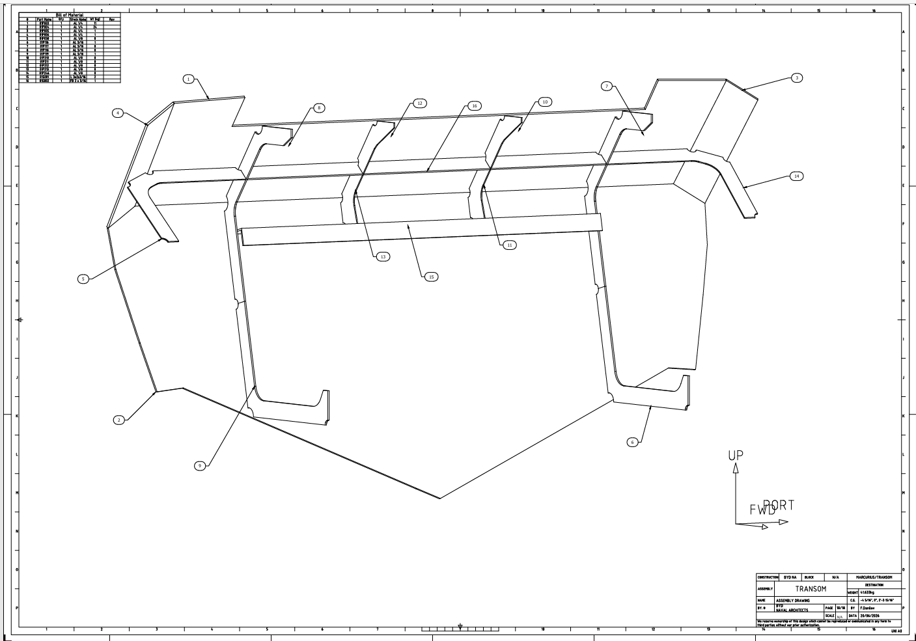 | 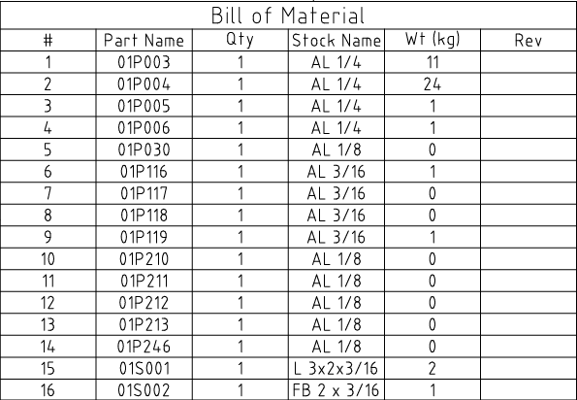
Reference example: full drawing page and its Bill of Material table.

Design principle
The page is the unit of processing. The system should not extract all BOMs in one pass and all title blocks in another. Instead, each page produces one structured PageResult containing the assembly value and that page's BOM rows. This makes the association deterministic and prevents cross-page mismatches.
PageResult {
pdf_name
page_number
assembly
bom_rows[]
extraction_status
}

2. High-Level Architecture
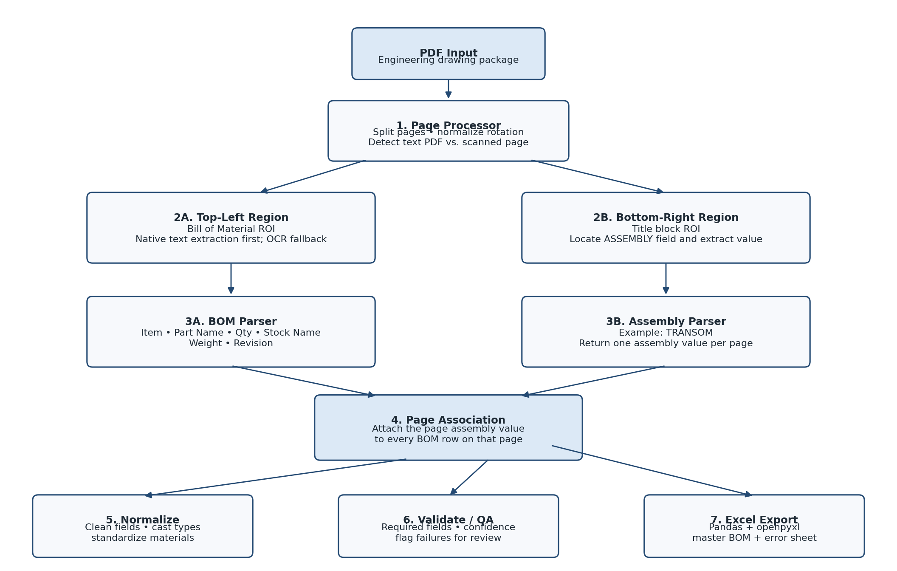
Figure 1. End-to-end extraction pipeline.

3. Component Responsibilities

3.1 PDF Page Processor
The page processor opens the drawing package and creates an independent job for each PDF page. It also normalizes the page before extraction so downstream logic sees a consistent coordinate system.
- Split and enumerate pages. Track the source PDF name and 1-based page number for traceability.
- Detect page geometry. Read width, height, rotation, and orientation.
- Normalize rotation and scale. Convert page coordinates into a consistent frame before defining regions of interest.
- Detect native text availability. If the PDF contains CAD-exported text objects, use them before OCR.
Recommended technology: Python with PyMuPDF (fitz); pdfplumber can be used as a secondary PDF/table extraction library.

3.2 Region Extraction
Only the two relevant areas of each page should be processed. This avoids interference from geometry, leaders, callout bubbles, dimensions, borders, and other drawing annotations.
- Top-left ROI. Contains the Bill of Material table.
- Bottom-right ROI. Contains the drawing title block and the ASSEMBLY field.
- Relative coordinates. Define the regions as percentages of page width and height so the same logic can tolerate multiple paper sizes.
bom_region = (0.00*W, 0.00*H, 0.20*W, 0.20*H)
title_region = (0.78*W, 0.82*H, 1.00*W, 1.00*H)

Recommended technology: PyMuPDF for clipping native PDF content; OpenCV for raster crops, deskewing, thresholding, and line detection when OCR is required.

3.3 BOM Extractor
The BOM extractor converts the top-left table into structured rows. Native PDF text extraction should be attempted first because CAD-generated PDFs often preserve text and coordinates. OCR is a fallback for scanned or flattened pages.
Priority | Method | Role
1 | PyMuPDF native text | Extract words and their bounding boxes; reconstruct rows/columns by coordinates.
2 | pdfplumber | Secondary table/word extraction when layout is favorable.
3 | PaddleOCR | Fallback for image-only or rasterized drawing pages.
4 | OpenCV | Preprocess crop for OCR: scale, threshold, deskew, and isolate table lines.
Target BOM fields: Item #, Part Name, Qty, Stock Name, Wt (kg), and Rev.
{
"item": 1,
"part_name": "01P003",
"qty": 1,
"stock_name": "AL 1/4",
"weight_kg": 11,
"revision": ""
}

3.4 Assembly Extractor
The title-block parser extracts a single page-level assembly value. It searches the bottom-right crop for the ASSEMBLY label and reads the value in the corresponding field. In the example page, the result is TRANSOM.
- Primary path. Search native PDF words for the label ASSEMBLY, then use nearby coordinates or the expected title-block cell to retrieve its value.
- Fallback path. OCR only the title-block crop and locate ASSEMBLY in the recognized text boxes.
- Output. One normalized assembly string per page, e.g., TRANSOM, HULL, or PILOTHOUSE.

3.5 Page Association
After the BOM rows and assembly value are extracted from the same page, the system adds the assembly value to every BOM row before moving on. This is the most important data-integrity rule in the design.
Page 1: assembly = "TRANSOM"
BOM row 1 -> Assembly = TRANSOM
BOM row 2 -> Assembly = TRANSOM
...
BOM row 16 -> Assembly = TRANSOM

3.6 Data Normalization
The normalization layer converts extracted strings into a consistent schema and corrects safe formatting differences before export.
- Whitespace cleanup. Collapse repeated spaces and trim leading/trailing whitespace.
- Type conversion. Convert Qty to integer and weight to numeric values where possible.
- Material standardization. Normalize formatting such as AL 1 / 4 -> AL 1/4.
- Part-number cleanup. Remove accidental spaces only when a known format or confidence rule makes the correction unambiguous.
- Assembly cleanup. Trim and standardize case without changing the semantic value.

3.7 Validation and QA
The system should never silently write low-confidence or malformed data into the master workbook. Each page receives a validation status and any failed checks are written to a review log.
- ASSEMBLY value found
- Bill of Material heading/table found
- Expected BOM columns recognized
- At least one valid BOM row extracted
- Qty values are numeric
- Weight values are numeric or intentionally blank
- Part names match expected formatting rules
- OCR confidence is above the configured threshold when OCR is used
Suggested status values: PASS, WARNING, and FAIL. FAIL pages should be excluded from the trusted master BOM until reviewed.

3.8 Structured Data Layer
Validated page records are flattened into a Pandas DataFrame. Keep source PDF and page number even if they are not part of the final business-facing spreadsheet because they provide a direct audit trail back to the drawing.
PDF | Page | Assembly | Item | Part Name | Qty | Stock Name | Wt (kg) | Rev
drawing.pdf | 1 | TRANSOM | 1 | 01P003 | 1 | AL 1/4 | 11
drawing.pdf | 1 | TRANSOM | 2 | 01P004 | 1 | AL 1/4 | 24
drawing.pdf | 1 | TRANSOM | 3 | 01P005 | 1 | AL 1/4 | 1

3.9 Excel Export
The final stage writes the validated master BOM into an Excel workbook and creates a separate review sheet for pages that need human attention.
- BOM sheet. All successfully extracted and normalized rows, including Assembly, PDF, and Page.
- Extraction_Errors sheet. Source PDF, page, failure reason, confidence, and any raw extracted values needed for review.
Recommended technology: Pandas for the in-memory table and openpyxl for workbook formatting, filters, column widths, freeze panes, and styling.

4. Recommended Extraction Strategy
Use a deterministic extraction pipeline instead of sending every page to a general-purpose AI model. The document structure is consistent enough that coordinates, native text, OCR, and validation rules should be faster, cheaper, and easier to audit.
Step | Action | Why | Fallback
1 | Open page with PyMuPDF | Preserves CAD text and coordinates | Render page image if needed
2 | Clip top-left and bottom-right ROIs | Removes drawing noise | Use layout anchors if page format shifts
3 | Try native text extraction | Highest accuracy for CAD PDFs | OCR cropped regions
4 | Parse BOM by X/Y coordinates | Deterministic table reconstruction | Line detection + OCR cell parsing
5 | Parse ASSEMBLY field | One simple page-level value | OCR title block
6 | Associate within PageResult | Prevents cross-page mismatches | Do not export until association succeeds
7 | Normalize + validate | Creates trustworthy typed data | Flag uncertain rows
8 | Write Excel | Business-readable deliverable | Also create error/review sheet

5. Technology Stack
Component | Technology | Purpose
Application / orchestration | Python | Page-by-page extraction pipeline and business logic
PDF reading | PyMuPDF (fitz) | Native text, word coordinates, page dimensions, region clipping
Secondary PDF parser | pdfplumber | Optional table/word extraction alternative
Image processing | OpenCV | Cropping, deskewing, thresholding, line/cell detection
OCR fallback | PaddleOCR | Read rasterized/scanned tables and title blocks
Data model | Pandas | Build and combine normalized BOM rows
Excel generation | openpyxl | Write and format final workbook
Schema validation | Pydantic / Python rules | Validate types, required fields, and confidence state
Optional API | FastAPI | Upload PDF and download generated workbook
Optional persistence | SQLite / PostgreSQL | Store job history, errors, and audit records

6. Proposed Output Schema
Field | Type | Required | Description
pdf_name | string | Yes | Source drawing package
page_number | integer | Yes | 1-based source page number
assembly | string | Yes | Value from the ASSEMBLY title-block field
item | integer | Yes | BOM item/index number
part_name | string | Yes | Part identifier
qty | integer | Yes | Quantity
stock_name | string | Yes | Material/stock description
weight_kg | decimal | No | Weight as extracted from BOM
revision | string | No | Part revision when present
extraction_method | string | Yes | native_text or OCR
confidence | decimal | No | OCR or parser confidence score
status | string | Yes | PASS / WARNING / FAIL

7. End-to-End Processing Logic
for pdf in input_files:
for page_number, page in enumerate(pdf.pages, start=1):
page = normalize_page(page)
bom_roi = crop_top_left(page)
title_roi = crop_bottom_right(page)
bom_rows = extract_bom_native(page, bom_roi)
if not bom_rows:
bom_rows = extract_bom_ocr(bom_roi)
assembly = extract_assembly_native(page, title_roi)
if not assembly:
assembly = extract_assembly_ocr(title_roi)
page_result = associate(page_number, assembly, bom_rows)
page_result = normalize(page_result)
page_result = validate(page_result)
if page_result.status == "FAIL":
review_log.append(page_result)
else:
master_rows.extend(page_result.bom_rows)
export_excel(master_rows, review_log)

8. Suggested Implementation Sequence
Build the smallest deterministic version first, then add OCR and automation around it.
- Phase 1 - Native-text prototype. Process known CAD-generated PDFs using PyMuPDF only. Verify that the BOM and ASSEMBLY value can be recovered reliably from fixed relative regions.
- Phase 2 - Table parser. Reconstruct BOM rows using word X/Y coordinates and column boundaries.
- Phase 3 - Page association and Excel. Create PageResult objects, flatten them to Pandas, and export the first production workbook.
- Phase 4 - Validation. Add field rules, status values, source traceability, and an Extraction_Errors sheet.
- Phase 5 - OCR fallback. Add OpenCV preprocessing and PaddleOCR for scanned or rasterized pages.
- Phase 6 - Operational interface. Optionally add a simple desktop UI, folder watcher, or FastAPI service for batch processing.

9. Core Recommendation
Start with PyMuPDF coordinate-based extraction and make OCR a fallback. For CAD-exported drawings, native text is generally more deterministic than OCR. Keep the assembly value and BOM rows inside the same page-level object from the moment they are extracted, and only flatten the data after validation. This gives the system a simple, auditable data path from PDF page to Excel row.

