THE BRITISH COLLEGE
FINAL PROJECT OF ITP



CYBER SECURITY AND DIGITAL FORENSICS
LEVEL 3
SUBMITTED BY : Pramish Gurung
SUBMITTED TO : The British College
DATE OF SUBMISSION : 10 January 2023

# Bank-Management-System

Aim:
To develop a C++ program for Bank Management System using Object Oriented Programming concepts such as Class and Object, Switch case, File Handling and many other features C++ that we have learned in class and independent research.

About C++:
C++ is a general purpose programming language that was developed as an enhancement of the C language to include object-oriented paradigm. It is an imperative and a compiled language. C++ is a middle-level language rendering it the advantage of programming low-level (drivers, kernels)
and even higher-level applications (games, GUI, desktop apps etc.). The basic syntax and code structure of both C and C++ are the same. It’s key features are : It is a simple language in the sense that programs can be broken down into logical units and parts, has a rich library support and a variety of data-types, It is a mid-level language as we can do both systems-programming (drivers, kernels, networking etc.) and build large-scale user applications (media players, photoshop, game engines etc.), it has a rich library support (both standard ~ built-in data structures, algorithms etc.) as well as 3rd party libraries (e.g. boost libraries) .

Objective:
To explore principles of programming.
To use the object oriented paradigm in program design.
To lay foundation to advanced programming.

Essential Information required for the implementation of the program:

Bank:
A bank is a financial institution licensed to receive deposits, allow withdraws and make loans. Banks may also provide financial services such as wealth management, currency exchange, and safe deposit boxes. It also provides interest for money we deposit and also charges for the services or facilities that we use of the bank.

Bank Account:
A bank account is a financial account maintained by a bank or other financial institution in which the financial transactions between the bank and a customer are recorded. Each financial institution sets the terms and conditions for each type of account it offers, which are classified in commonly understood types , such as deposit accounts, credit card accounts, current
accounts, loan accounts or many other types of account. A customer may have more than one account. Once an account is opened, funds entrusted by the customer to the financial institution on deposit are recorded in the account designated by the customer, funds can also be withdrawn . This banking system project in C++ is a simple program. It is more of a database project in C++, and is built using the language’s file
handling mechanism. It is suitable for beginners who want to learn how to add, edit, search, delete or modify records in a file, and how to use file as database overall .

Figure : Transaction

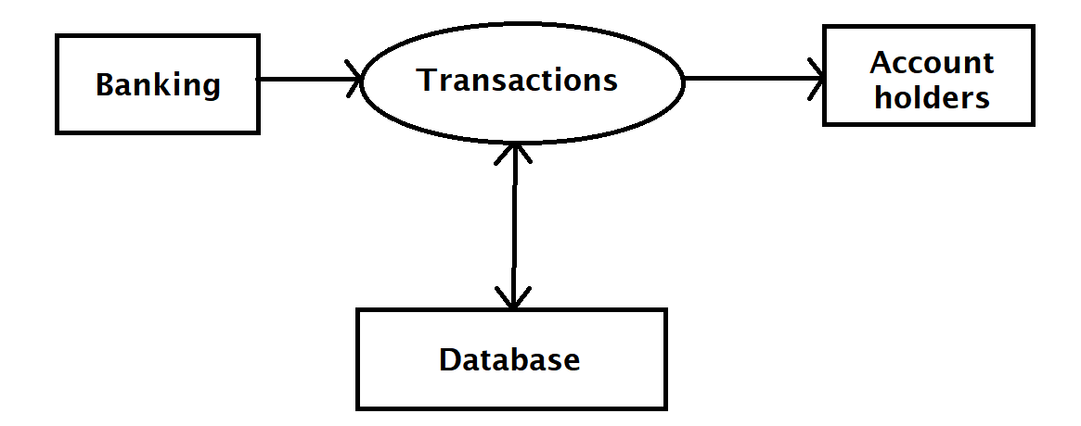

FIGURE : Bank Management System
For general use
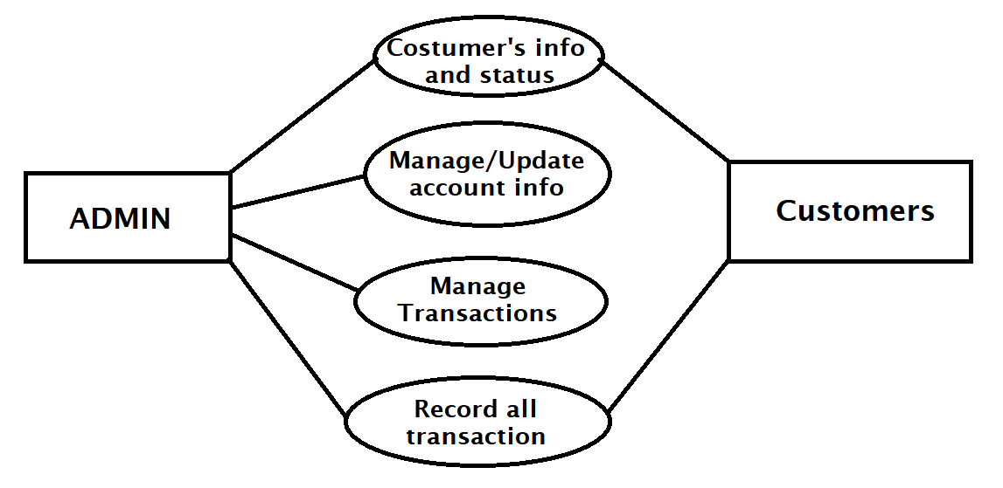

The source code for this project is just over 500 lines. The coding has been presented in a very understandable manner. The source code needs to be compiled in CodeBlocks 16.01 with Mingw Compiler setup. You can use this application to keep the records such as Account number, Account Holder Name, Interest, Account Type and Balance etc. of your regular costumer. Moreover, if you have a new customer, you can add and edit the account at any time. Many banks need an effective and accurate record system to be able to assure their records.
The record involves receiving banking records from various systems, determining the record rates associated with the customer’s records, calculating the amount for each customers, aggregating these records periodically to generate invoices, showing invoices to the customer, and collecting balance received from the customer Banking record System program is so simple to use.

This project provides the following functionalities:

Header file used:
#include<iostream>
To perform input and output operations .

#include<string>
To use a variable that has type std::string.

#include<fstream>
It is a library functions for files that provides templates and types that enable inter-operation between stream buffers and string objects.

#include<cctype>
It declares a set of functions to classify (and transform) individual characters.

#include<iomanip>
It is used to set basefield flag, fill character, decimal precision and field width.

#include<string.h>
It contains macro definitions, constants and declarations of functions and types used not only for string handling but also various memory handling functions. The equivalent of <string.h> in C++ is <string>, although both will work. The difference is: <string> wraps everything in the std namespace whereas <string.h> puts everything in the global namespace.

#include<time.h>
It contains definitions of functions to get and manipulate date and time information.

I created a class Bank and it has different data types, access specifiers, functions , features like file handling and so on.
Inside class following functions are created:

- Create new Account :
Allows to create a new bank account with account number, name, type, balance and annual interest rate. It also displays monthly interest amount and Balance after monthly Interest is added.

- Deposit amount to Account :
Performs calculation for depositing amount to the account on the basis of account number.

- Withdraw amount from Account :
Performs calculation for withdrawing amount to the account on the basis of account number. It also keeps record of number of withdraws made. It also charges service charge of $1 per withdraw for withdraw made more than 4 times in a month.

- Balance Enquiry
Displays the information of account specified by account number. It also shows account status.

- Display list of Account Holders
Shows all account information in a table with information like account number, name, monthly interest amount and balance.

- Delete an Account
Removes the specified account from the data stored.

- Modify the existing Account
Major work of taking new interest rate and calculating Interest amount, name and type modification is done if the user wants to change it.

- Monthly process C
It charges $15 fine for the users whose amounts becomes 0 or less after the withdraw. It also calls function withdraw {draw(x)}.

- Monthly Process I
It converts annual interest rate to monthly interest rate and calculates monthly interest amount and adds it to the balance.

- Report
This function is a member function of the Bank class, that returns the value of the account number, account holder name, balance and monthly interest amount data member in the specified format with the gap specified by set width manipulator (I.e. function). The const at the end of the function indicates that this function is a constant member function, which means that it promises not to modify the object on which it is called.

- Return account number
This member function returns the account number and doesn’t change the object as it is a constant member function.

- Return deposited amount
This function returns the amount deposited and doesn’t change the object as it is a constant member function.

- Return type of account
This function returns the account type and doesn’t change the object as it is a constant member function.

- Main page
This fuction displays page with introduction stating Bank Management System final project topic, creator, date and loading…..effect.

- Menu list
Displays varieties of options we can choose from. It displays options of activities that can be carried out along with numbers by which we can select those option and carry out desired task.

- Time
This function displays local and universal time and date in the login screen.

- Login screen
This function checks login credentials and allows one to try up-to 3 times and allows to access the system if the credentials are correct else it doesn’t allow to access system.
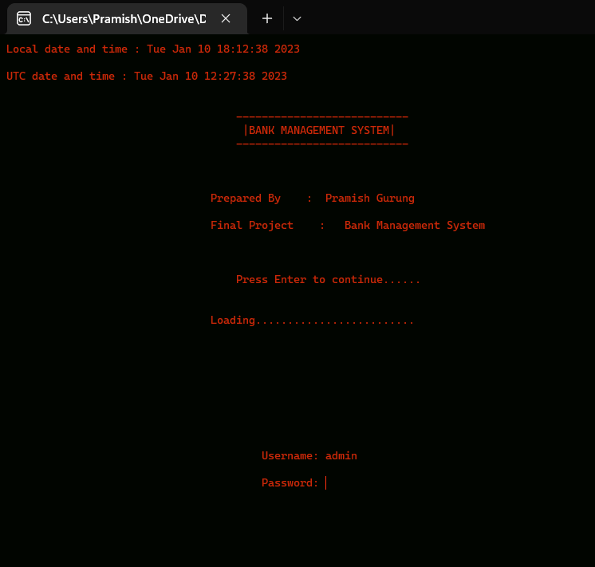
Screenshot : LogScreen

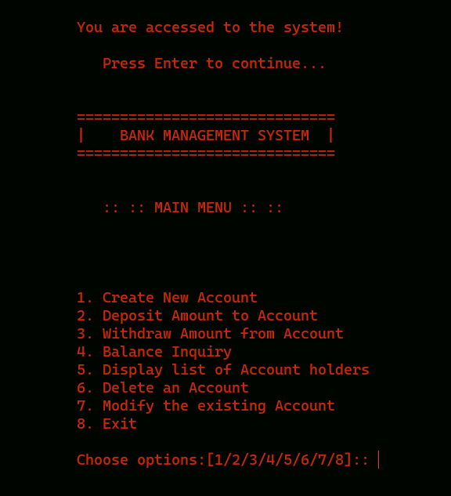
Screenshot : Menu page

This was my project of menu driven program about “Banking Management System”. Development of this System
took a lot of efforts and I have tried to meet all the conditions and requirements to the best of my knowledge. I think this system gave a lot of satisfaction. Though every task is never said to be perfect in this development field even more improvement may be possible in this system. I learnt many new things and gained a lot of knowledge about development field.
I hope this will prove fruitful.

References :
- E Balagurusamy 2021.
- https://www.programiz.com/
- https://www.google.com/ for word suggestions.

