Q2



Q4 & then ./q3

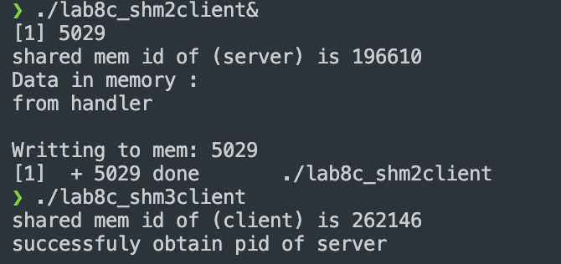

Q5.1

A

Q5.2

(int \*)

Q5.3

count[0] = temp

Q5.4

Final answer is 5