Artificial Intelligence Course Project
AI-Based Disease Prediction System
Breast Cancer Diagnosis Prediction Using Machine Learning

Student Name | AHMAD YOUSEF NEMER AYAAD
Student ID | 243039
Instructor | Dr. Abdullah AlQammaz
Submission | AI Course Project / 30 Marks

2026

Abstract
This project develops a complete machine learning application for disease prediction using the Breast Cancer Wisconsin Diagnostic dataset. The goal is to classify a tumor as benign or malignant based on numerical features computed from cell nuclei measurements. The project follows the full AI workflow: problem definition, dataset understanding, exploratory data analysis, preprocessing, model training, evaluation, and discussion. Logistic Regression, Random Forest, and Support Vector Machine models were implemented and compared using accuracy, precision, recall, F1 score, cross-validation, and confusion matrices. The best result was achieved by Logistic Regression and Support Vector Machine, both reaching an F1 score of 0.986 on the test set, while Random Forest achieved an F1 score of 0.966. The results show that machine learning can provide a strong decision-support tool for early cancer diagnosis, while still requiring medical validation and expert interpretation before real-world use.

1. Introduction
Breast cancer is one of the most important health problems worldwide, and early diagnosis is essential for improving patient outcomes. Medical diagnosis often depends on patterns in clinical measurements, images, or laboratory results. Machine learning can help discover relationships between input features and disease labels, then use these relationships to support classification decisions. In this project, the disease prediction task is modeled as a supervised binary classification problem: the system receives diagnostic measurements and predicts whether the tumor is malignant or benign.
The selected dataset is appropriate for an Artificial Intelligence course project because it is clean, widely used, and contains numeric features that allow clear preprocessing, visualization, model training, and evaluation. The project focuses on explainability and understanding rather than only trying to maximize accuracy.

2. Problem Statement and Objectives
The problem is to build a machine learning system that predicts breast cancer diagnosis from diagnostic measurements. The target output has two classes: malignant and benign. The system is not intended to replace doctors; it is a learning project and a demonstration of how supervised machine learning can support medical classification tasks.

Objectives
- Load and understand a real medical dataset from a trusted source.
- Perform exploratory data analysis to identify class balance, feature distributions, correlations, and important patterns.
- Preprocess the data correctly, including train-test splitting and feature scaling when needed.
- Implement and compare at least two machine learning algorithms.
- Evaluate the models using accuracy, precision, recall, F1 score, cross-validation, and confusion matrices.
- Save the best trained model and generate organized project outputs.

3. Literature Review
Cortez and Silva showed that educational and real-world prediction problems can be effectively studied with data mining workflows that include data preparation, model development, and evaluation. Although their domain was student performance prediction, their methodology is useful for structuring supervised learning projects.
The UCI Machine Learning Repository provides trusted benchmark datasets for teaching and research. The Breast Cancer Wisconsin Diagnostic dataset is commonly used for binary classification and has numeric features extracted from digitized images of breast mass cell nuclei. The dataset has also been included in scikit-learn, making it easy to reproduce experiments in Python.
Logistic Regression is a strong baseline for binary classification because it estimates class probability using a linear decision boundary with regularization. It is useful when features are informative and approximately separable after scaling. Random Forest is an ensemble method that trains many decision trees and combines their predictions, which helps capture nonlinear patterns and reduce overfitting compared with a single tree. Support Vector Machines can create strong separating boundaries, especially when combined with feature scaling and nonlinear kernels.
Recent studies on academic and health-related prediction tasks continue to use supervised machine learning methods such as Random Forest, SVM, and logistic models because they provide clear baselines and measurable performance. These studies support the importance of comparing more than one algorithm and using appropriate evaluation metrics rather than relying on accuracy alone.

4. Dataset Description
The dataset used in this project is the Breast Cancer Wisconsin Diagnostic dataset available in scikit-learn and originally associated with the UCI Machine Learning Repository. It contains 569 samples and 30 numeric input features. The target variable has two classes: malignant and benign. In the scikit-learn version, malignant is coded as 0 and benign is coded as 1.
The features describe characteristics of cell nuclei, such as radius, texture, perimeter, area, smoothness, compactness, concavity, concave points, symmetry, and fractal dimension. For each type of measurement, mean, standard error, and worst value are provided. These variables are suitable for classification because they represent measurable diagnostic properties.
The project script saves a copy of the dataset as dataset/breast_cancer_dataset.csv so that the submitted ZIP includes the dataset used in the experiment.
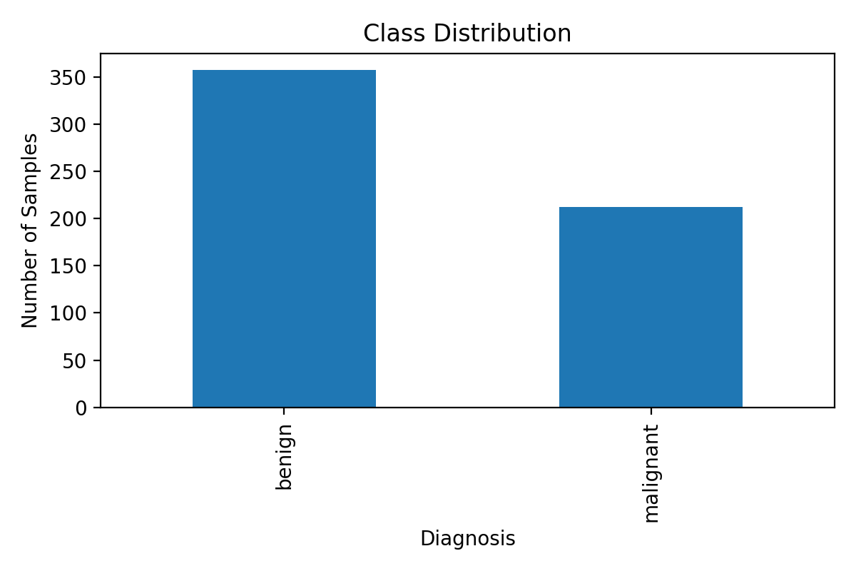
Figure 1. Class distribution for malignant and benign diagnosis.

5. Exploratory Data Analysis
Exploratory data analysis was performed to understand the structure and quality of the dataset before model training. The dataset contains no missing values, which means no imputation was required. The class distribution shows that benign cases are more frequent than malignant cases, but the imbalance is not extreme. Descriptive statistics were generated and saved in results/data_summary.csv.
Correlation analysis was used to identify features strongly related to the target. Measurements involving radius, perimeter, area, concavity, and concave points were among the most informative features. Boxplots also showed that several features have visibly different distributions between malignant and benign cases.
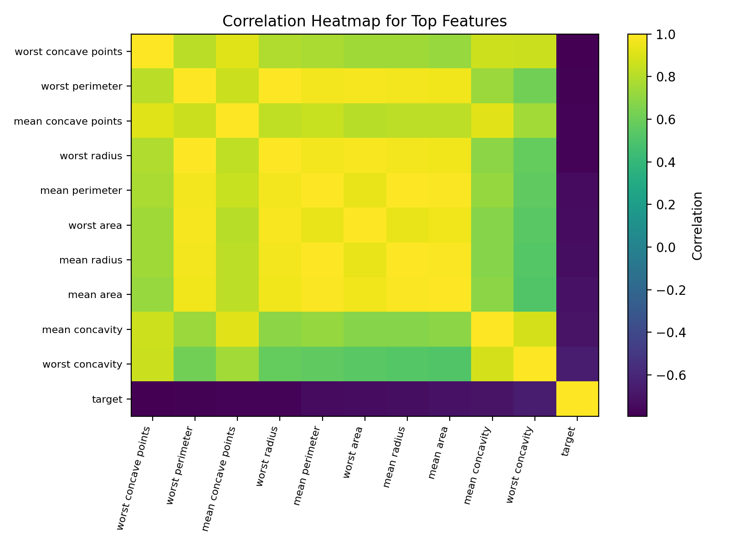
Figure 2. Correlation heatmap for top features related to the target.
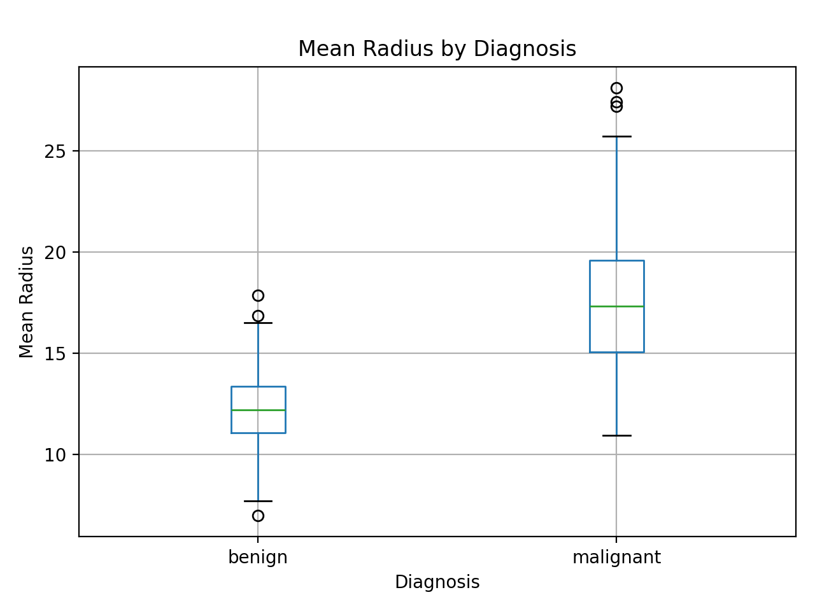
Figure 3. Mean radius distribution by diagnosis.

6. Data Preprocessing
The preprocessing workflow included separating input features from the target variable, splitting the dataset into training and testing sets, and applying scaling for algorithms that are sensitive to feature magnitudes. The test size was 20%, and stratified splitting was used to preserve the class distribution in both training and testing sets. A fixed random_state value was used for reproducibility.
StandardScaler was used inside a Pipeline for Logistic Regression and Support Vector Machine. This is important because both models are affected by the scale of numerical variables. Random Forest does not require scaling because decision trees split features based on thresholds, so it was trained directly on the original numeric feature values.

7. Machine Learning Models

7.1 Logistic Regression
Logistic Regression was used as a baseline linear classifier. It is easy to interpret and works well when the classes can be separated by a linear boundary after scaling. The model was trained with max_iter=1000 to ensure convergence.

7.2 Random Forest Classifier
Random Forest was used as an ensemble learning method. It builds many decision trees and combines their outputs. This can improve predictive performance and reduce overfitting compared with a single tree. In this project, 200 trees were used.

7.3 Support Vector Machine
Support Vector Machine was included as an additional comparison model using the RBF kernel. It is often effective for binary classification when the data may not be perfectly linearly separable. Scaling was applied before training.

8. Experimental Results
The models were evaluated using accuracy, precision, recall, F1 score, and 5-fold cross-validation on the training data. Precision measures how many predicted benign cases were actually benign, recall measures how many actual benign cases were found, and F1 score balances precision and recall. Confusion matrices were also generated for detailed error analysis.
Model | Accuracy | Precision | Recall | F1 Score | CV F1 Mean | CV F1 Std
Logistic Regression | 0.9825 | 0.9861 | 0.9861 | 0.9861 | 0.9843 | 0.0101
Support Vector Machine | 0.9825 | 0.9861 | 0.9861 | 0.9861 | 0.9773 | 0.0140
Random Forest | 0.9561 | 0.9589 | 0.9722 | 0.9655 | 0.9684 | 0.0151
Based on the test-set F1 score, Logistic Regression and Support Vector Machine achieved the strongest performance. Random Forest also achieved strong results but produced slightly lower scores on this split.
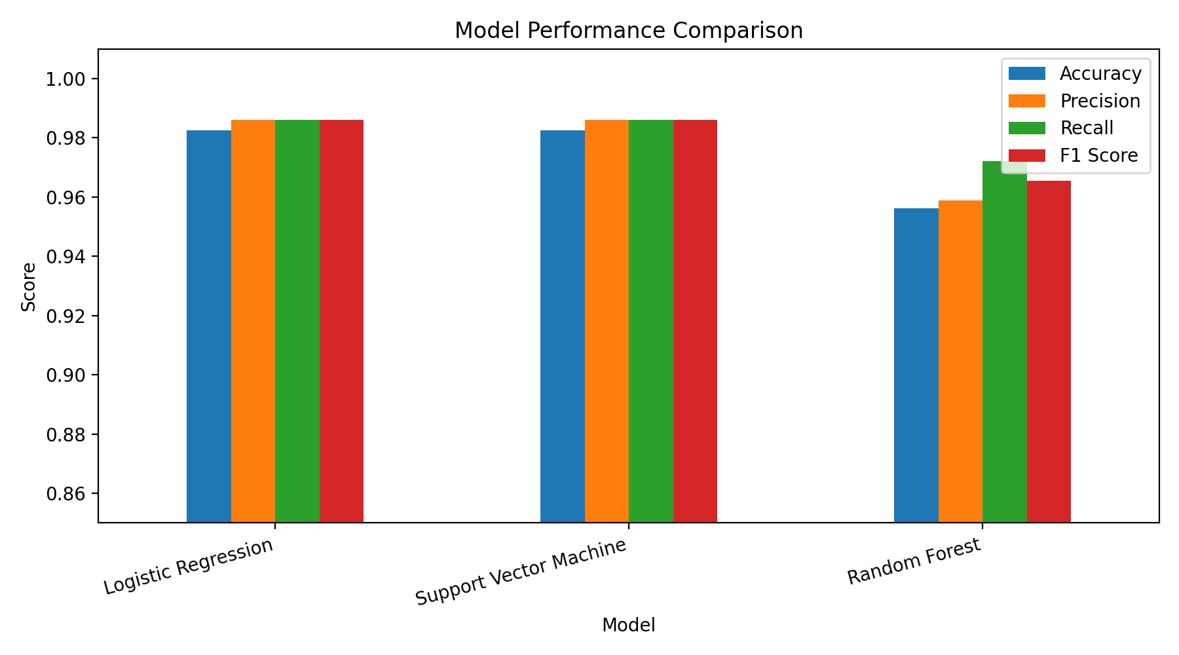
Figure 4. Comparison of model performance metrics.
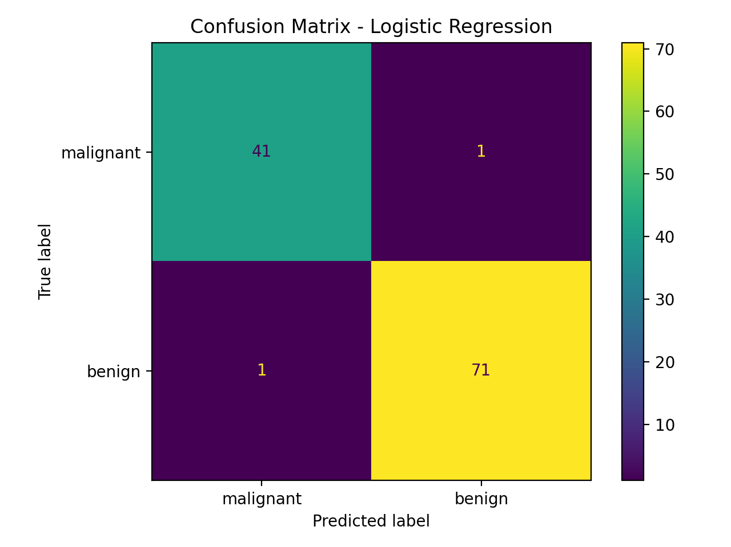
Figure 5. Confusion matrix for Logistic Regression.
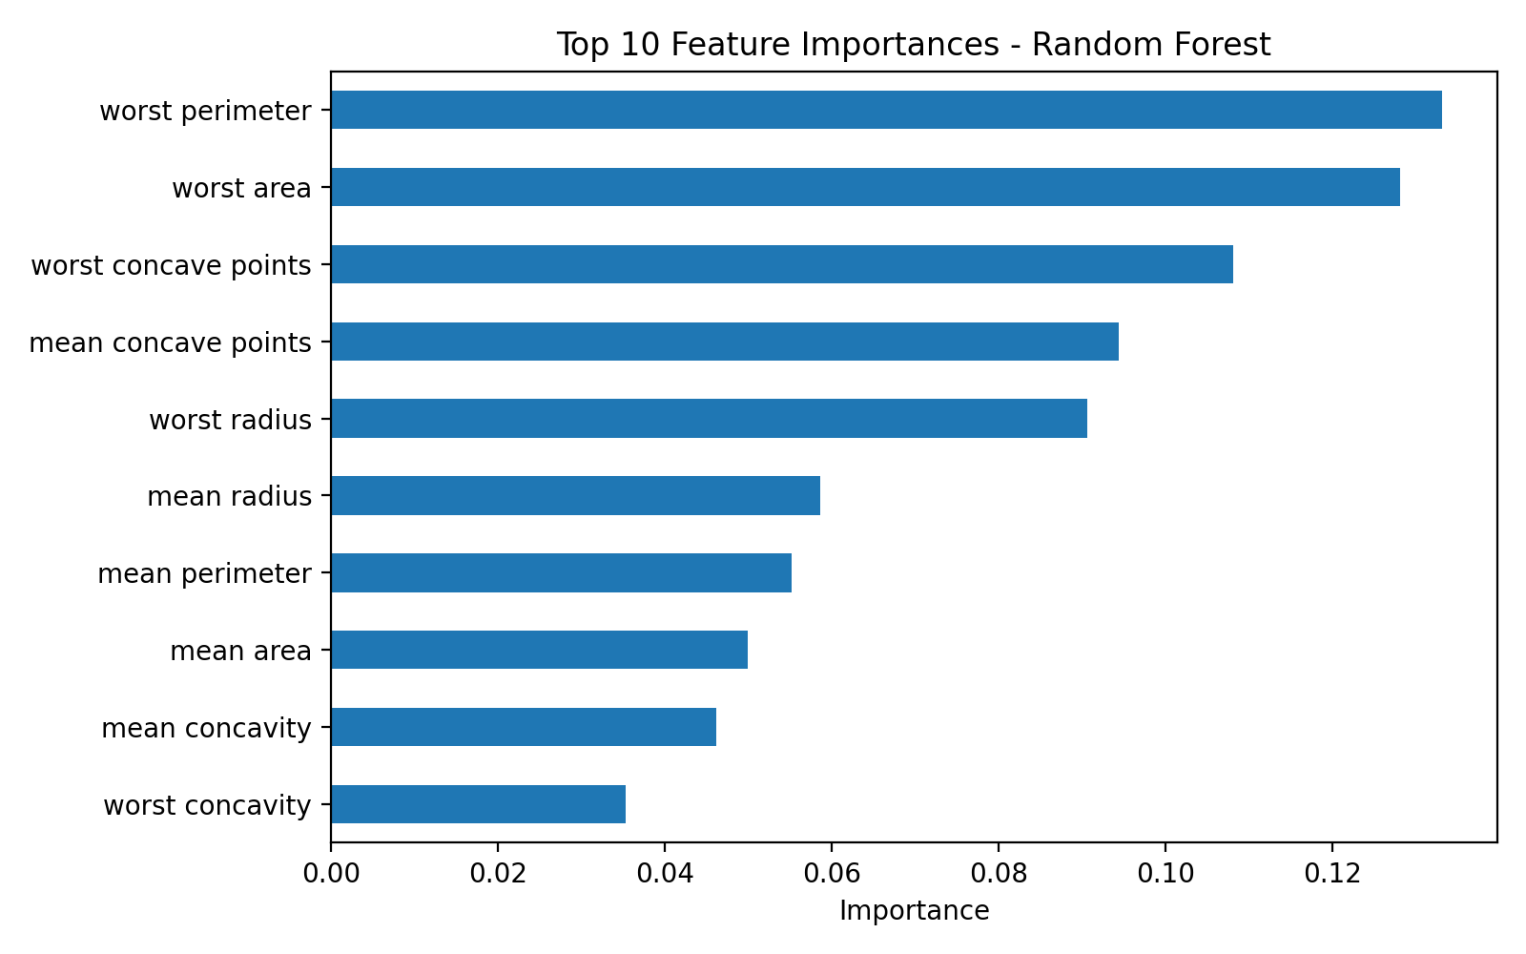
Figure 6. Top Random Forest feature importances.

9. Discussion
The results show that the dataset contains strong predictive patterns. Logistic Regression performed extremely well, suggesting that the feature space is highly informative and that the classes are close to linearly separable after scaling. Support Vector Machine achieved a similar score, which confirms that scaling and margin-based classification are suitable for this task. Random Forest provided useful feature importance information and strong performance, but it was slightly behind the other models on the selected train-test split.
A key observation is that high accuracy alone is not enough for medical classification. In disease-related tasks, false negatives can be serious because a malignant case incorrectly classified as benign may delay treatment. Therefore, recall and F1 score are important metrics. Confusion matrices should be studied carefully to understand the types of mistakes each model makes.
The project has limitations. The dataset is clean and relatively small, so real-world medical data may be more difficult. Also, the model should not be used for actual diagnosis without clinical testing, external validation, and approval by medical experts. However, the project successfully demonstrates the AI workflow required for the course.

10. Conclusion and Future Work
This project implemented a complete AI-based disease prediction system using the Breast Cancer Wisconsin Diagnostic dataset. The workflow included problem definition, dataset loading, exploratory analysis, preprocessing, model training, evaluation, and output generation. Logistic Regression and Support Vector Machine achieved the best results with an F1 score of 0.986, while Random Forest also produced reliable performance and useful feature importance insights.
Future work could include hyperparameter tuning with GridSearchCV, testing additional algorithms such as Gradient Boosting or XGBoost, creating a simple graphical interface, and validating the model on external hospital datasets. Another improvement would be to focus on reducing false negatives because they are particularly important in disease diagnosis.

11. References
- UCI Machine Learning Repository. Breast Cancer Wisconsin Diagnostic Dataset. University of California, Irvine.
- Scikit-learn Developers. sklearn.datasets.load_breast_cancer documentation.
- Scikit-learn Developers. LogisticRegression documentation.
- Scikit-learn Developers. RandomForestClassifier documentation.
- Scikit-learn Developers. SVC documentation.
- W. H. Wolberg, W. N. Street, and O. L. Mangasarian. Breast cancer diagnosis and prognosis via linear programming. Operations Research, 1995.
- P. Cortez and A. Silva. Using data mining to predict secondary school student performance, 2008.

