**TruSeq RNA Library Prep 1/2: Purify and Fragment mRNA, First & Second Strand cDNA Synthesis, and End Repairs**

Author: [Opentrons](http://www.opentrons.com/)

Links:

* [Part 1: Purify and Fragment mRNA, First & Second Strand cDNA Synthesis, and End Repairs](https://protocol-delivery.protocols.opentrons.com/protocol/1559-part1)
* [Part 2: Adenylate 3' Ends, Ligate Adapters, PCR Amplification](https://protocol-delivery.protocols.opentrons.com/protocol/1559-part2)

With this protocol, your robot can perform the TruSeq RNA Library Prep Kit as described in the [Illumina TruSeq® RNA Sample Preparation v2 Guide](https://support.illumina.com/content/dam/illumina-support/documents/documentation/chemistry_documentation/samplepreps_truseq/truseqrna/truseq-rna-sample-prep-v2-guide-15026495-f.pdf).

This is part 1 of the protocol, which includes (1) Purify and Fragment mRNA, (2) First Strand cDNA Synthesis, (3) Second Strand cDNA Synthesis, and (4) End Repairs. See Additional Notes for more information on robot setup.

After these four steps carried out in this protocol, you can safely stop work and return to it at a later point. If you are stopping, seal the plate with an adhesive seal and store at -25°C to -15°C for up to 7 days.

You will need:

* P10 Multi-channel Pipette
* P300 Multi-channel Pipette
* 8-well PCR Strips
* [FrameStar® 96 Well Semi-Skirted PCR Plates](https://www.brookslifesciences.com/products/framestar-96-well-semi-skirted-pcr-plate-abi-style)
* 12-well Trough
* [Magnetic Module](https://shop.opentrons.com/products/magdeck)
* [Temperature Module + Aluminum Block](https://shop.opentrons.com/products/tempdeck)
* 10 uL Tip Racks
* 200 uL Tip Racks

**Process**

1. Download your protocol.
2. Upload your protocol into the [OT App](https://opentrons.com/ot-app).
3. Set up your deck according to the deck map.
4. Calibrate your labware, tiprack and pipette using the OT App. For calibration tips, check out our [support article](https://support.opentrons.com/ot-2/getting-started-software-setup/deck-calibration).
5. Hit "Run".

**Additional Notes**

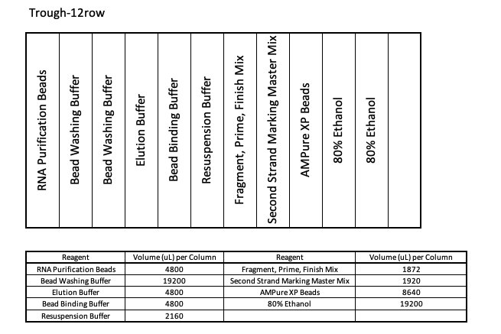

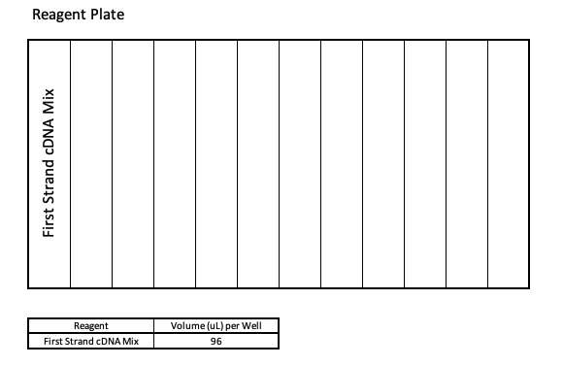

To start your protocol, follow Configuration 1. Your sample plate needs to be placed in slot 1. Throughout the protocol, you will need to move certain labware around. Please follow the instructions in the Run log on the App carefully before resuming the protocol.

