**TruSeq RNA Library Prep 2/2: Adenylate 3' Ends, Ligate Adapters, PCR Amplification**

Author

[Opentrons](http://www.opentrons.com/)

Links:

* [Part 1: Purify and Fragment mRNA, First & Second Strand cDNA Synthesis, and End Repairs](https://protocol-delivery.protocols.opentrons.com/protocol/1559-part1)
* [Part 2: Adenylate 3' Ends, Ligate Adapters, PCR Amplification](https://protocol-delivery.protocols.opentrons.com/protocol/1559-part2)

With this protocol, your robot can perform the TruSeq RNA Library Prep Kit as described in the [Illumina TruSeq® RNA Sample Preparation v2 Guide](https://support.illumina.com/content/dam/illumina-support/documents/documentation/chemistry_documentation/samplepreps_truseq/truseqrna/truseq-rna-sample-prep-v2-guide-15026495-f.pdf).

This is part 2 of the protocol, which includes (5) Adenylate 3' Ends, (6) Ligate Adapters, and (7) PCR Amplification. See Additional Notes for more information on robot setup.

After these three steps carried out in this protocol, you can safely stop work and before moving on the Validate Library. If you are stopping, seal the plate with an adhesive seal and store at -25°C to -15°C for up to 7 days.

You will need:

* P10 Multi-channel Pipette
* P300 Multi-channel Pipette
* 8-well PCR Strips
* [FrameStar® 96 Well Semi-Skirted PCR Plates](https://www.brookslifesciences.com/products/framestar-96-well-semi-skirted-pcr-plate-abi-style)
* 12-well Trough
* [Magnetic Module](https://shop.opentrons.com/products/magdeck)
* [Temperature Module + Aluminum Block](https://shop.opentrons.com/products/tempdeck)
* 10 uL Tip Racks
* 200 uL Tip Racks

**Process**

1. Download your protocol.
2. Upload your protocol into the [OT App](https://opentrons.com/ot-app).
3. Set up your deck according to the deck map.
4. Calibrate your labware, tiprack and pipette using the OT App. For calibration tips, check out our [support article](https://support.opentrons.com/ot-2/getting-started-software-setup/deck-calibration).
5. Hit "Run".

**Additional Notes**

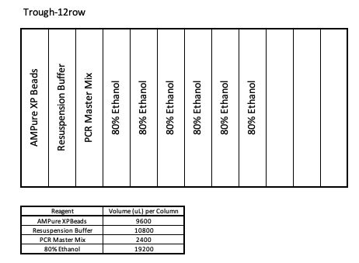

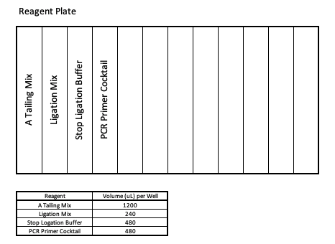

To start your protocol, follow Configuration 1. The output plate from Part 1 of this protocol needs to be placed on the Magnetic Module in slot 4. Throughout the protocol, you will need to move certain labware around. Please follow the instructions in the Run log on the App carefully before resuming the protocol.

