Table of Contents
Introduction & Problem Statement 2
Dataset Description & Imbalance Analysis 2
GAN Architectures & Training 3
Classifier Setup 3
Experimental Results & Discussion 4
Observations and Conclusions 6

Exploring GAN Variants for Balancing Imbalanced Datasets

Introduction & Problem Statement
Many real-world classification tasks suffer from class imbalance, where one class has significantly more samples than the other classes. In such settings, a classifier can achieve seemingly high accuracy by simply predicting the majority class most of the time, while almost ignoring the minority class. This leads to poor performance on the minority class, which is often the class of real interest, and makes simple metrics such as overall accuracy misleading as indicators of model quality.​
In this project, the class imbalance problem is studied in the context of binary image classification between cats and dogs, where dog images form the minority class compared to cat images. The main objective is to explore the use of Generative Adversarial Networks (GANs) to generate additional synthetic samples for the minority class in order to balance the dataset and improve classifier performance. To this end, a baseline Vanilla GAN is first implemented and trained, followed by a more advanced Deep Convolutional GAN (DCGAN), and both models are used to synthesize new dog images that are combined with the original data; the impact of these generated samples is then evaluated using a CNN classifier and metrics such as accuracy, precision, recall, and F1-score.

Dataset Description & Imbalance Analysis
In this project, a cats vs. dogs image dataset was used, obtained from Kaggle as a derivative of the well-known Dogs vs. Cats competition, which is widely adopted for binary image classification experiments.​
The data was manually split into separate training and test sets, with an intentionally imbalanced class distribution in the training split to study the impact of class imbalance on classifier performance.​Before applying any GAN-based balancing, the class distribution in the training and test sets was as follows:
Split | Class | Images
Train | Cats | 4001
Train | Dogs | 732
Test | Cats | 1011
Test | Dogs | 1012
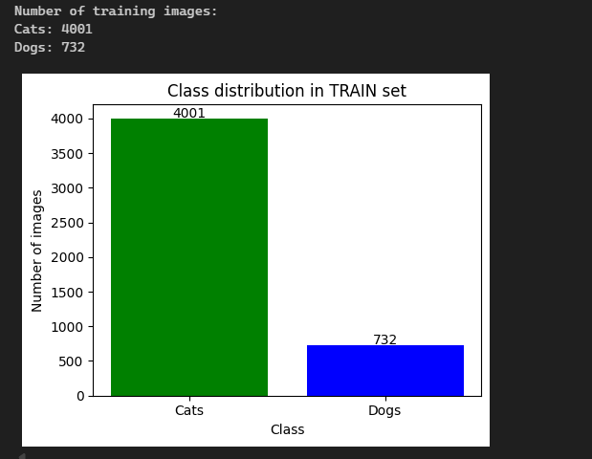

This table shows that the training data is heavily skewed toward cats, while the test set is approximately balanced between the two classes. As a result, a naive classifier that always predicts “cat” can achieve very high training accuracy, but will perform poorly on the test set, especially on the dog class, which is clearly reflected later in metrics such as recall and F1-score for the minority class.

GAN Architectures & Training
two types of Generative Adversarial Networks (GANs) were employed to augment the minority dog class in the training set. The first model is a standard Vanilla GAN, while the second is a (DCGAN) specifically designed for image data using convolutional layers.​
For the Vanilla GAN, a fully connected architecture was adopted, with the final activations reshaped into $64×64$ RGB images, whereas the DCGAN used a deeper convolutional architecture based on ConvTranspose2d layers in the generator and Conv2d layers in the discriminator, following the standard DCGAN design for image generation. After training, a large number of synthetic dog images were generated and added to the training folders to construct two new datasets: train_vanilla_balanced (augmented with Vanilla GAN images) and train_variant_balanced (augmented with DCGAN images).

Classifier Setup
To evaluate the impact of GAN-based balancing, a visual classifier based on ResNet-18 was used as the core CNN model for distinguishing between cat and dog images. The network was initialized without pre-trained weights, and the final fully connected layer was modified to produce two output logits (cat vs. dog). Training was performed using the Adam optimizer with a fixed learning rate and a limited number of epochs to ensure a fair comparison across all experimental settings.

Experimental Results & Discussion
After training ResNet-18 under the three scenarios (original, Vanilla-GAN-balanced, DCGAN-balanced), the model was evaluated on the same test set using accuracy, precision, recall, and F1-score. The following table summarizes the numerical results obtained from the scripts
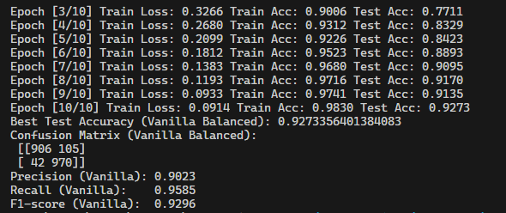
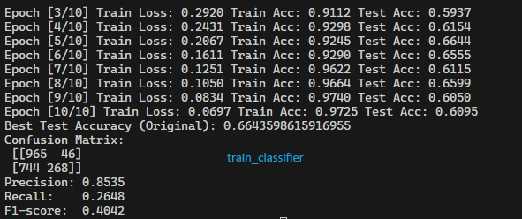

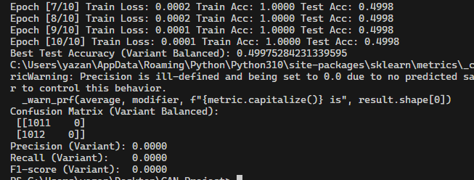

Scenario | Test Accuracy | Precision | Recall | F1-score
Original (imbalanced train) | 0.6644 | 0.8535 | 0.2648 | 0.4042
Vanilla GAN balanced train | 0.9273 | 0.9023 | 0.9585 | 0.9296
DCGAN Variant balanced train | 0.4998 | 0.0000 | 0.0000 | 0.0000
The results show that training on the original imbalanced data leads to a moderate test accuracy of around 66%, with relatively high precision but very low recall for the dog class, indicating that the classifier strongly favors the majority class and misses many minority examples. In contrast, using synthetic dog images generated by the Vanilla GAN significantly improves all metrics: test accuracy rises to about 93%, and both precision and recall are high and well balanced, yielding a strong F1-score and demonstrating that GAN-based augmentation can effectively enhance minority class recognition when the generated samples are of reasonable quality.
For the DCGAN Variant, however, the classifier collapses to near-random behavior: test accuracy hovers around 50%, and precision, recall, and F1-score for the dog class drop to zero, as confirmed by the confusion matrix where almost all test samples are predicted as a single class. This suggests that, under the current training setup, the DCGAN-generated images did not match the true distribution of dog images well and may have misled the classifier, highlighting that more advanced GAN architectures do not automatically guarantee better downstream performance unless the training process and sample quality are carefully controlled.
Some of Output :
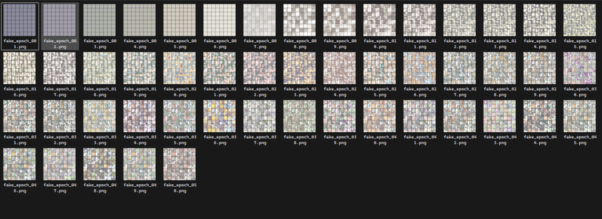
1dcgan_dogs
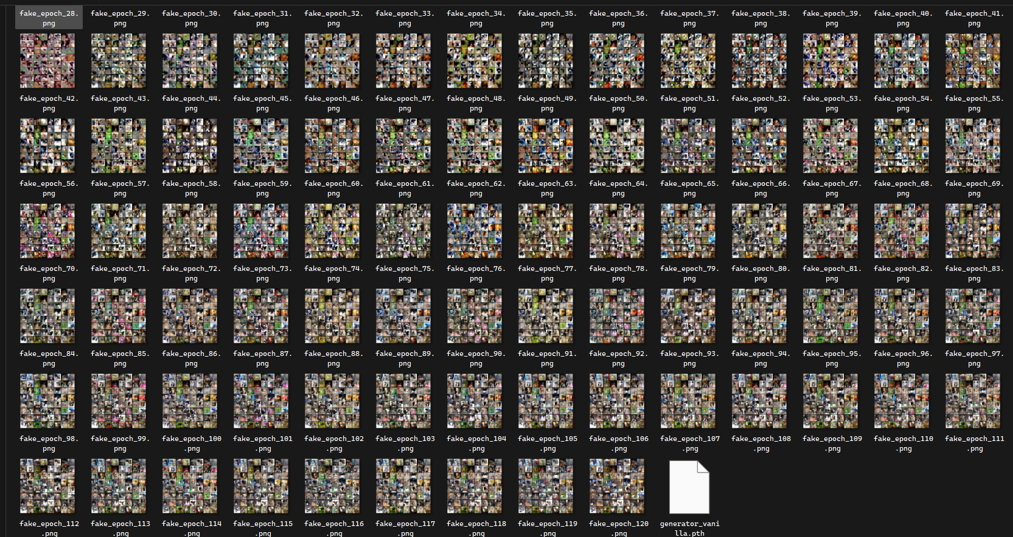
2vanilla_gan

Observations and Conclusions

The results show that training the classifier on the original imbalanced dataset produced a model that appears strong on the training data but fails to adequately recover dog examples in the test set, as indicated by moderate overall accuracy but very low recall and F1-score for the minority class due to the dominance of cat samples during training.

