Princess Sumaya University for Technology

King Abdullah II Faculty of Engineering



**Microprocessors & Embedded Systems 22442– Spring 2023**

**Project: Smart Fire Alarm System**

|  |  |  |
| --- | --- | --- |
| **Student name** | **Student ID** | **major** |
| **Yazan Masalha** | **20200736** | **NIS engineering** |
| **Anfal Alqudah** | **20200793** | **NIS engineering** |
| **Abdelmajid Bader** | **20201039** | **NIS engineering** |

**Instructor: Dr. Belal Sababha**

**Group: 2**

5 / June / 2023

***Abstract***

A vending machine is an automated device that gives customers packaged and portable goods of any kind, in exchange for cash.

We have built a small vending machine using the 16F877A pic microcontroller.

**TABLE OF CONTENTS**

***Introduction*** 3

***Background*** 3

➢ **The Micro-controller PIC16f877A** 3

➢ **Water pump** 4

➢ **The Flame sensor** 5

➢ **H-Bridge** 6

➢ **HC-06** 7

➢ **Buzzer** 7

**Design** 8

***Problems and recommendations*** 10

➢ **Software problems** 10

➢ **Hardware problems** 11

***Recommendations*** 11

***Conclusion*** 11

**TABLE OF FIGURES**

Figure 1: pic microcontroller 16F877A 4

Figure 2: Water Pump 4

Figure 3: Flame Sensor 5

Figure 4: LCD 5

Figure 5: H-Bridge 6

Figure 6: HC-06 7

Figure 7: Buzzer 7

Figure 8: Schematic Electrical Design 8

Figure 9: Flow Chart 9

Figure 10: Final Result 10

# ***Introduction***

*In our project we have been working with the 16F877A pic microcontroller to build a smart fire alarm system that reads a flame in the surrounding.*

*Our advanced system uses a flame sensor to detect different flame strengths, making fire detection and response more effective. It adjusts the buzzer sound and water pressure based on the flame's intensity for a customized firefighting approach. It also sends immediate notifications to a connected phone through serial communication and an LCD display that sends different messages depending on the presence of the flame. This seamless integration ensures quick and personalized action in case of a fire.*

# ***Background***

## **The Micro-controller PIC16f877A**

It is one of the most well-known micro-controllers on the market. This micro-controller is incredibly simple to operate, and programming it is also quite straightforward. One of the major advantages is that it may be write-erased as many times as necessary since FLASH memory technology is used. It has 40 pins altogether, 33 of which are used for input and output. The PIC16F877A is used in many pic micro controller applications. Additionally, PIC16F877A is frequently utilized in digital electrical circuits. There is a PIC16f877a in many kinds of electronics. It is used by smart sensors, safety equipment, home automation systems, and a range of industrial instruments. Additionally, it features an EEPROM, which enables it to permanently store some information. as well as other related data, such receiver frequencies and transmitter codes. This controller is inexpensive and straightforward to use. Because of its adaptability, it may be used in applications for microprocessors and timers that haven't previously used microcontrollers. A smaller set of 35 instructions are included. It has a maximum operating frequency of 20 MHz. The operating voltage ranges between 4.2 and 5.5 volts. If it receives more voltage over 5.5 volts, it might be permanently damaged. It, like with other PIC18F46K22 and PIC18F4550 chips, lacks an inbuilt oscillator. Approximately 100mA of maximum current can be sinked or sourced by each PORT. As a result, the PIC16F877A's GPIO pins each have a 10-mile range.

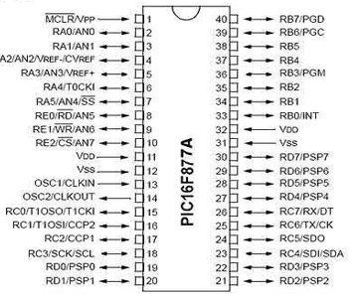

Figure 1: pic microcontroller 16F877A

## **Water pump**

A water pump DC motor is a special motor that runs water pumps. It uses electricity to make the pump move and push water. Inside the motor, there are magnets and coils of wire that create a magnetic field. When electricity flows through the motor, it makes the magnets and coils interact, causing the motor to spin. This spinning motion is then used to make the water pump work and move water from one place to another. Water pump DC motors are small, efficient, and reliable, and they are commonly used in things like irrigation systems and home water supplies.

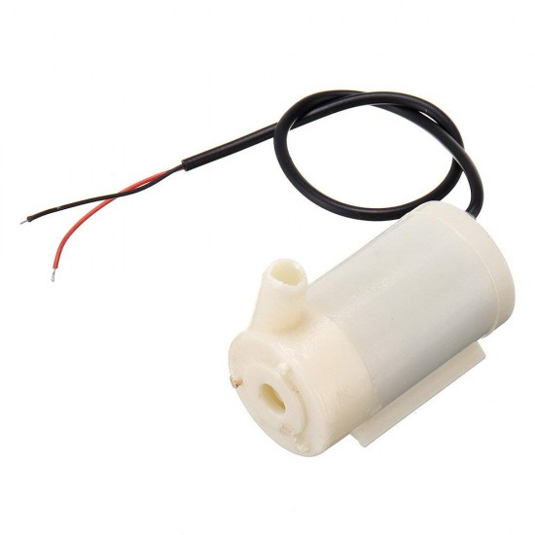

Figure 2: Water Pump

## **The Flame sensor**

The KY-026 flame sensor is a simple electronic component designed to detect the presence of flames or fire. It consists of a small sensor module that contains an infrared (IR) receiver and a comparator circuit. When exposed to flames, the sensor module detects the infrared light emitted by the flames.

It can also be used in 2 modes: Analog and Digital.

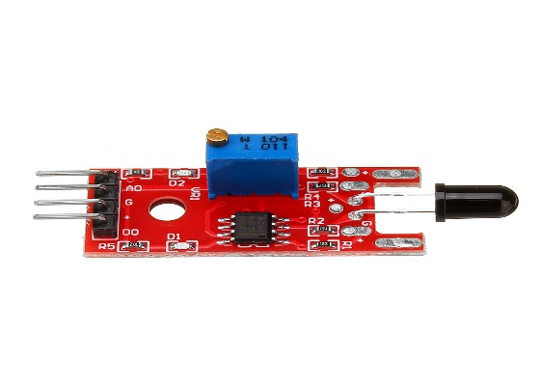

Figure 3: Flame Sensor

**A liquid-crystal display (LCD)**

LCDs are available to display arbitrary images (as in a general-purpose computer display).

There are two modes in the LCD the 4-bit mode and the 8-bit mode, in our project we have used the 4-bit mode that takes 4 pins (data pins) only.

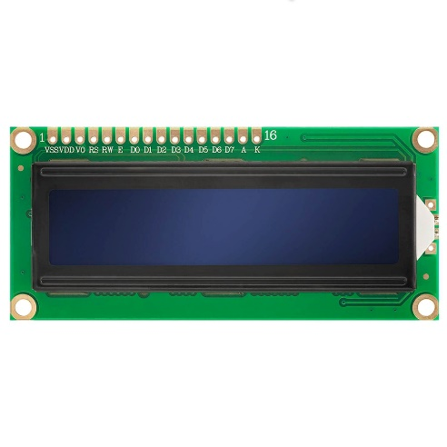

Figure 4: LCD

## **H-Bridge**

An H-bridge is an electronic circuit commonly used to control the direction of a motor. It consists of four switches arranged in a specific configuration, resembling the letter "H". By selectively turning on and off these switches, the H-bridge can control the flow of current through the motor, enabling it to rotate in either the forward or backward direction.

When two specific switches are closed, the positive and negative polarities of the power supply are applied to the motor, causing it to rotate forward. Conversely, closing the other two switches reverses the polarities, making the motor rotate backward. This switching mechanism allows precise control over the motor's direction of rotation.

To regulate the speed of the motor, a technique called Pulse-Width Modulation (PWM) is often employed. By varying the width of the electrical pulses sent to the motor, the effective voltage and speed can be adjusted, providing finer control over its operation.

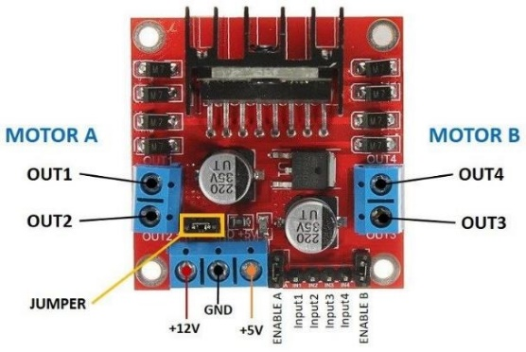

Figure 5: H-Bridge

## **HC-06**

The HC-06 is a popular Bluetooth module used for wireless communication. It acts as a serial communication link between devices, allowing them to exchange data wirelessly over Bluetooth.

The HC-06 module operates in slave mode, which means it can be paired with a master device (such as a smartphone) that initiates the connection. Once paired, data can be transmitted back and forth between the master and slave devices using a simple serial communication protocol.

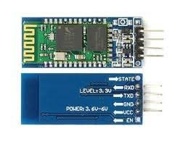

Figure 6: HC-06

## **Buzzer**

A buzzer is a small electronic device that produces sound when an electric current pass through it. It is commonly used to generate audible alerts, signals, or simple tones in various applications.

The basic design of a buzzer consists of a coil of wire (known as an electromagnet) and a vibrating diaphragm or a small speaker. When an electric current is applied to the coil, it creates a magnetic field that interacts with the diaphragm, causing it to vibrate rapidly. These vibrations produce sound waves in the air, creating the audible sound that we hear.

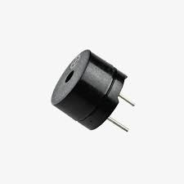

Figure 7: Buzzer

# **Design**

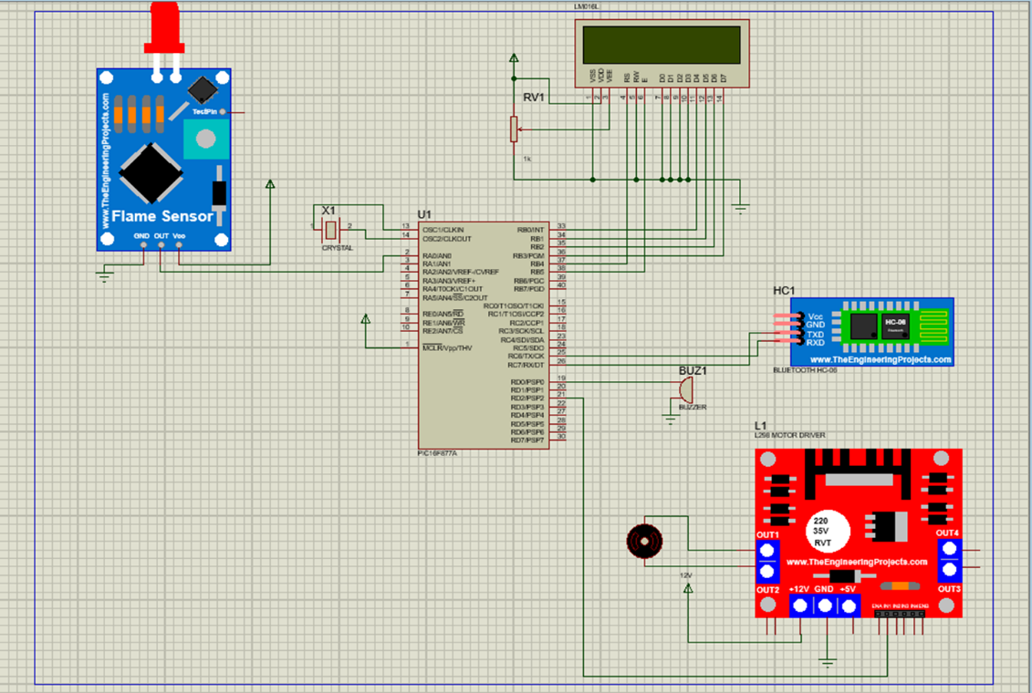

Figure 8: Schematic Electrical Design

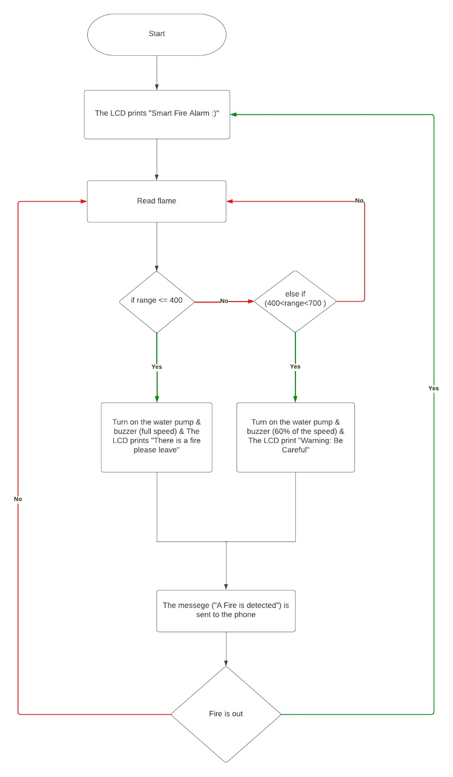

Figure 9: Flow Chart

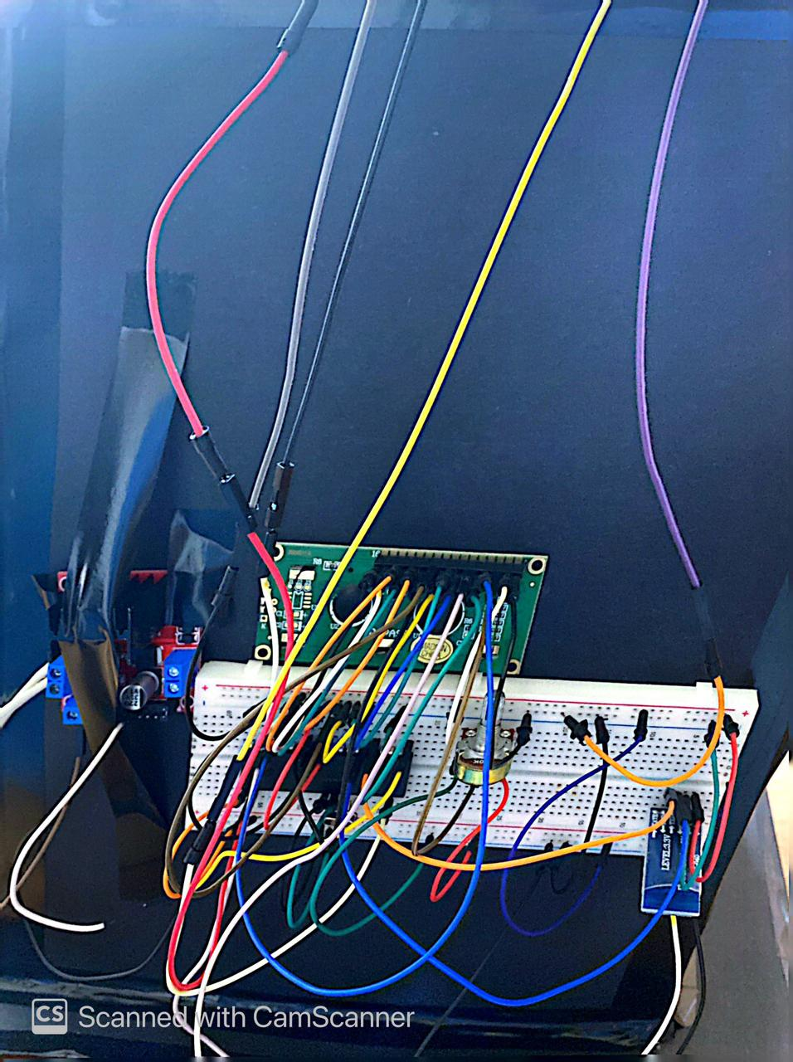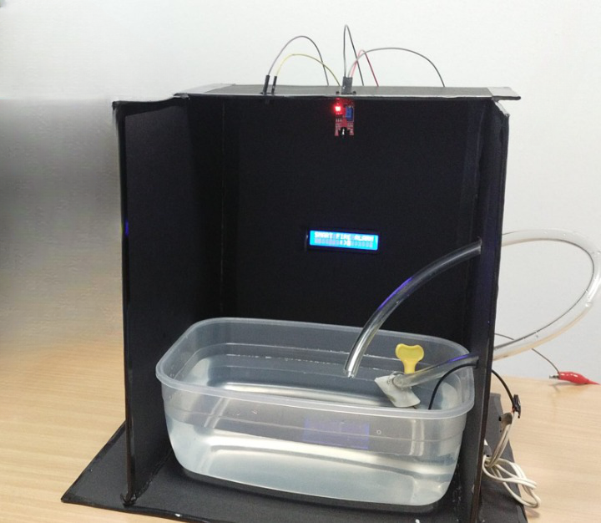

Figure 10: Final Result

# ***Problems and recommendations***

We faced several problems when designing our project, some were hardware problems and the others were software problems.

## **Software problems**

**LCD:**

LCD modules require proper initialization before use. We faced difficulties in configuring the module's settings, such as the number of display lines, or cursor position. Troubleshooting initialization code and verifying compatibility between the LCD module and microcontroller were crucial to resolve this issue.

**Flame sensor:**

The analog pin in the flame sensor works in a certain way that we weren’t familiar with it at the beginning. It was basically reading a voltage and then converting it to a number of 10 bits with the help of the Analog-to-Digital code we have written were a small number indicates a higher flame and vice versa. However, we thought the opposite therefore we spent a significant amount of time trying to solve the problem

* **Hardware problems**

**LCD:**

The pins that were not defined in the code were floating and then we figured out that they must be connected to ground. This made the LCD not work at the beginning and display what it was supposed to show.

**H-Bridge:**

Even though we understood how the H-Bridge works we faced a problem while connecting it to the breadboard and the water pump. We connected the 5V pin and the 12V pin which lead to overheating the microcontroller therefore it got ruined. It was also difficult to keep the wires inside the small blocks since they needed to be tightened.

# ***Recommendations***

* Make sure the code is carefully done without any infinite loops that doesn’t move you back to the main program.
* Check each component code and hardware implementation alone before testing the whole code of the project.
* Test each component on both -the ready for the pic board- and the -breadboard- to make sure nothing is wrong.
* Make sure the power is suitable for each component and current sink and current source is considered.

# ***Conclusion***

Working with 16F877A pic is not easy as dealing with the Arduino, however dealing with the pic microcontroller is used for many applications and we needed to learn how to use it and how to deal with it in this embedded systems course.

By applying embedded system course principles, we used pic16F778A to build a smart fire alarm from scratch also we’ve used different types of motors and sensors and how to implement the code and the hardware design for each of them.