Towards a Low-Fidelity Prototyping Method

for Augmented Reality

Eva Krapp, María López Garro, Maryam Mehreen, Yazan Aljaloudi Information Systems and New Media

[eva.krapp | maria.lopezgarro | maryam.mehreen | [yazan.aljaloudi@student.uni-siegen.de](mailto:yazan.aljaloudi@student.uni-siegen.de)]

**Abstract.** Citizen participation can be an effective and important tool for legitimizing political decisions and democratic processes. With traditional approaches technology showing marked weaknesses, technology is opening innovative avenues for engaging citizens throughout the political process. A promising new technology, Augmented Reality, merges the real and virtual to create immersive experiences. The research project CreativeCitizen explores the potentials of new technologies like Augmented Reality for citizen participation in infrastructure projects, which may particularly draw benefits from spatial and contextual cues. A highly limiting challenge to Augmented Reality applications development is the lack of efficient, low-cost low-fidelity methods, as are already established in traditional screen design. This renders the development highly inflexible and limits the possible scope for user-centered approaches. Although there are some attempts to explore low fidelity prototyping and testing in AR, methods remain rudimentary and lack validation. The project aims to explore possible approaches for low-fidelity prototyping and evaluation translated to the AR context, grounded in citizen participation infrastructure projects. Lego prototyping is proposed as a highly promising tool for AR development, providing spatial awareness, flexibility, and familiar common ground in contrast to 2D prototyping methods. Proving a new promise to AR development, Lego prototyping enables collaboration in interdisciplinary teams providing an option for engaging users. Nevertheless, further validation is required, while an empirical performance validation was planned as cooperative evaluation, due to health concerns regarding the ongoing COVID-pandemic, the method is not yet confirmed and would work as proposed. Overall, there are still unanswered questions, similar projects provide further discussion and exploration in the AR-field, confirming the potential for innovation in research, design, and software development areas.

# Introduction

Citizen participation in political processes and decisions is a topic that has been gaining interest in both local and general politics over the past decades. When implemented thoughtfully, citizen participation can be an effective tool for legitimizing political decisions, holding politicians accountable for their actions, and increasing overall citizen satisfaction (Irvin & Stansbury, 2004; Michels & Graaf, 2017) and can, consequently be invaluable in supporting democratic processes. Nonetheless, citizen participation has historically been time and resource-intensive and therefore not available to all governments, and much less all citizens equally (Ianniello et al., 2019). Traditional forms of citizen participation, such as town hall meetings and public forums, typically require physical attendance and are heavily

discussion focussed. While these can be a great format for some topics, they are not equally suitable for all issues, particularly not those requiring some degree of tangibility or spatial reference. Furthermore, they pose a high barrier for entry into political participation and for this reason may only be used by a small fraction of the concerned population.

However, as part of the third and fourth wave of the industrial revolution, the wide availability of networked technology has opened a myriad of new opportunities for engaging citizens in participative processes. From online tools and mobile applications to ubiquitous technologies embedded in the “smart” cityscape, many new avenues of supporting participation through technology are currently being explored in research and design. One promising emerging technology is Augmented Reality, which supplements reality with an additional layer of information, for instance by superimposing imagery on a display. This merging of the real and virtual marks AR as particularly interesting for political projects involving physical transformations, such as changes to the cityscape. AR has the potential of making alternative ideas for improving the city visible, not only in virtual representations but in a way that includes spatial experience and contextual information.

The research project *CreactiveCitizen* conducted by the University of Siegen aims to explore the potential of new technologies in citizen participation, including possible uses of Augmented Reality. Nonetheless, research and design of AR tools encounter one highly limiting challenge – the lack of efficient, low-cost, low-fidelity prototyping, and testing options. With the establishment of frameworks such as Design Thinking, User-Centered Design, and Scrum, the current approach to product design is to “fail fast”. It is widely accepted that the most effective and efficient method of developing a useful product is to prototype and test as early as possible and to subsequently iterate through several cycles of adapting and re-testing. For classical screen-based products, this approach is easily implemented. Paper prototypes and Click Dummies are an extremely low-cost way of gaining valuable insights into basic product features early in the development process.

For AR, the situation is more difficult. Even relatively simple prototypes in AR are expensive and time-intensive to develop. This makes the development process rather inflexible and closes off the opportunity of making changes throughout the various stages. Through this limitation, the potential for exploration and innovation is greatly diminished. In the past years, some attempts have been made to explore lower fidelity prototyping and testing methods but the methods remain rudimentary and lack validation.

This project aims to address the observed lack of actionable methods for prototyping AR applications in low fidelity. In order to explore possible approaches, established prototyping and evaluation methods for other media are reflected upon and translated to an AR context. To ground the project in the context of citizen participation in infrastructure projects, a case study connected to an actual city project is devised. A strong human-centered approach ensures that the development of the method stays true to the contextual commitment of current HCI research.

In the following, the process and insights gained from the project are detailed. The report first gives an overview of the related work which shaped the focus of the project. Next, the evolution of the project is demonstrated through the sequence of methods used throughout.

Subsequently, the derived concept for a new prototyping and testing method for AR is described in detail. A proposal is presented on how the suggested method may be validated to ensure sufficient scientific rigor and transferability. Finally, the insights gained throughout the project are reflected in reference to the initial expectations, challenges, failures, and successes. In closing, an outlook is given as to how the method could be developed further in future projects.

# Related Work

With governments across the globe being more focused on ICT-supported citizen participation, interest in novel approaches has increased. Many pilot projects and research studies have been initiated, using emerging technologies to involve citizens in planning activities, providing an opportunity for direct participation, and the engagement in policy-making processes to shape civil life.

In majority, citizens are unable to participate due to the lack of knowledge, the inadequate usage of information platforms, and the ability to truly understand the problem. Conventional information such as posters, vote polls, online forums does not create discussions or debate. Existing technology and digital elements tend to be more static and simply behave as a replacement for the real need for real results from the local entities. At the same time participatory information, events, and communication channels are not sufficient, information is still untenable for the population, and does not inspire citizens to be a part of the activities. Nevertheless, technology can facilitate participation through mapping tools to support planning and understanding of the actual citizen challenges. Focusing on creating additional opportunities, raising awareness, promoting discussion and debate as well as sharing and gathering information without any local government direct involvement required.

Computer technology throughout the years has provided several visualization techniques that focus on the interaction of citizens with design. A project by Al/Kodmany focused on the planning process in a Chicago’s neighborhood, using Geographic Information System (GIS) in collaboration with artists’ workshops, allowing the residents to participate in the design co-creation of the space (Al-Kodmany, 1999). While the Geographic Information System provided location information in the form of maps and landscape, the artist was in charge of bringing participants ideas to life, combining real-time sketches and images, the participants were able to share ideas and understand the future visualization of the space, facilitating communication and decision making through the creation process.

New developing technology, such as the ChangeExplorer (Wilson et al., 2019) wearable, mobile application, and a web platform designed in England. Using situated technology and interactions in a specific location, the application asked multiple-choice questions and comments focusing on the user what kind of improvements can be done in the area. When a user enters a specific area a notification is sent to the wearable, establishing categories help the user reduce time selection in the answers, all comments are valid and there is no need for additional knowledge of how the local entities work in the city. The application involves

citizen participation in local planning, without overwhelming the user with the formal procedures that need to be done to put the changes into motion. For local entities, this process can help understand the real user needs of space and difficulties the community faces at the early stages. The app facilitates citizen participation reducing obstacles of formal process and motivates users to engage in participation.

The combination of citizen participation and city planning in Augmented Reality has not yet been fully explored. AR applications are relatively new and expensive to build, as well as expensive to test. So far, there are only a few attempts at developing efficient methods of low-fidelity prototyping and testing for AR, combining users’ imagination, Wizard of Oz techniques, paper prototyping, and usability testing (Hunsucker et al., 2017). By providing already existing objects that simulated the real AR objects, individuals could move around the object, add a paper poster to simulate walls, and sign information. To mimic real movement, existing devices such as televisions or computers could be used to stream video animation during the experience.

Understanding the problems in the area and talking into consideration diverse applications and technology to facilitate participation through mapping tools, can help planning and recognition of the current challenges that the citizens face. Providing citizens with all the information on the area can help to raise consciousness about problems or projects. Through the added value of spatial interaction and contextualization, virtual, augmented, and mixed reality can be powerful tools for architecture and city planning.

# Methodology

In order to ensure that the developed method addresses the challenges encountered in a real-life design process, a representative design project was devised. Since the focus of *CreactiveCitizen* rests on using AR for citizen participation, a city planning project was chosen to serve as a point of reference for the development of a new prototyping method for AR. The project was approached using the Design Thinking framework as scaffolding while implementing it in novel ways to address the particular challenges of designing for AR. Although there is no clear-cut agreed-upon definition of Design Thinking, it is understood as an approach that aims to foster a deep understanding of the user and their needs, challenge preconceived notions and assumptions, create novel solutions and test them with actual users. It is highly flexible and provides the possibility of exploring new avenues while remaining firmly grounded in the users’ perspective. Commonly used steps in the Design Thinking process are *Empathizing* with the user, *Defining* the challenges, *Ideating* possible solutions, *Prototyping* design concepts, and *Testing* them with potential users.

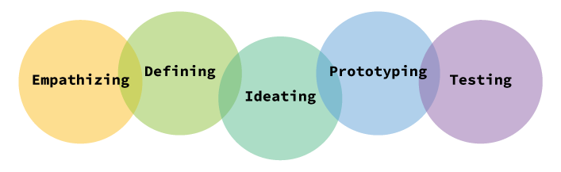

Figure 1: Design Thinking Methodology

While the focus of the project was clearly on developing a method that would be beneficial in the *Prototyping* and *Testing* stages, all steps of the process were used to gain contextual grounding.

## Case Study

Before beginning user focussed research activities, a meaningful and realistic design challenge had to be chosen. As the aim of the project was to develop a method of AR prototyping that would work specifically in collaborative work on infrastructure projects, situating our research in a fitting context was indispensable for gaining valuable insights. Unfortunately, due to external constraints, exploring citizen participation in a natural context was not possible in the scope of this research project. In order to still provide a context that was as ecologically achievable, an actual ongoing infrastructure project in the city of Siegen was chosen as a case study in which to ground the research activities.

The infrastructure project chosen as a context was the remodeling of the “Herrengarten” area in the city center of Siegen. Today the Herrengarten is a large shopping complex housing various stores and restaurants. However, it has a tumultuous history involving many drastic changes. The Herrengarten was originally built in 1669 by the monarch Johann Moritz von Nassau-Siegen as a pleasure garden housing exotic plants (Figure 2). After the house of Nassau-Siegen had perished, the Herrengarten was opened up to the citizens and was eventually acquired by the city as a public park (*Herrengarten [ZEIT.RAUM]*, n.d.).

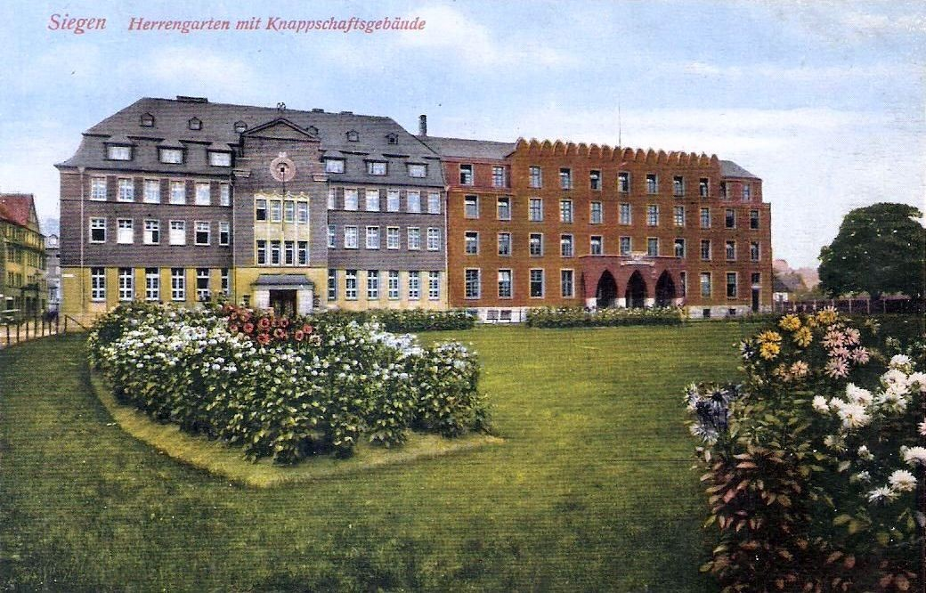 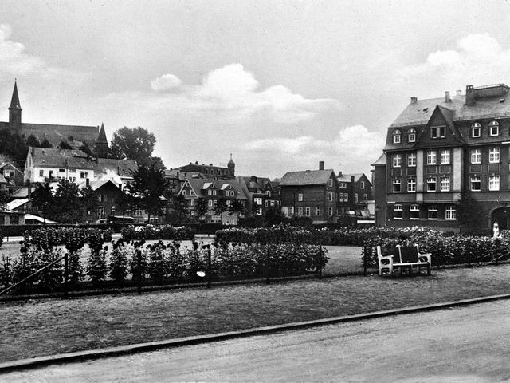

Figure 2: Herrengarten, City of Siegen

After the destruction of Siegen during World War II, the Herrengarten area was repurposed as a parking space until the current shopping complex was built during the seventies (*Geschichte*

*| Aktionsbündnis-Herrengarten*, n.d.).

With the inception of the large scale remodeling of the Siegen city center -- known under its project name “Siegen zu Neuen Ufern” -- the question of what should become of the Herrengarten arose again. While investors pushed for new building plans, citizens demanded the area be reconverted into a public park once again (*unser Ziel | Aktionsbündnis-Herrengarten*, n.d.). Particularly involved citizens founded the “Aktionsbündnis Herrengarten”, a sort of citizen task force, with the aim of realizing the reconversion of the Herrengarten. Open letters reached Siegen newspapers in which citizens criticized the building plans for the area. After lengthy debates between the local government, citizen initiatives, and private investors, the Siegen city council finally voted in favor of the reconversion of the Herrengarten area into a public green space in 2016.

Shortly after the vote, a competition for the design of the new Herrengarten was issued, to which landscaping bureaus could submit their concepts. Opportunities for citizen participation in the planning of the garden however remained sparse. The only real call for citizen engagement in the project was the “Tag der Städtebauförderung” in May of 2018. Within a four hour window, people had the opportunity to receive information on the Herrengarten and voice their opinions and wishes for the re-design. This was structured through three portable panels which were installed at the site of the Herrengarten -- one provided information on the project, one presented various possible aspects of the new park for dot voting, and one provided space for open suggestions as well as templates for sketching. While the day yielded some interesting results, as pictured below, the format was severely limited.

The short time-frame and the need to be physically present at the site meant that only a small fraction of the citizens had the opportunity to participate. For instance, parents having to take care of their children, elderly people and people with disabilities who don’t have free mobility, as well as citizens who quite simply weren’t available on this day, did not get a chance to partake in the activities and voice their opinions. This is reflected in the small number of responses that were generated: only 69 people participated in the dot voting, and only 137 suggestions in total were made on the open panel (Figure 3).

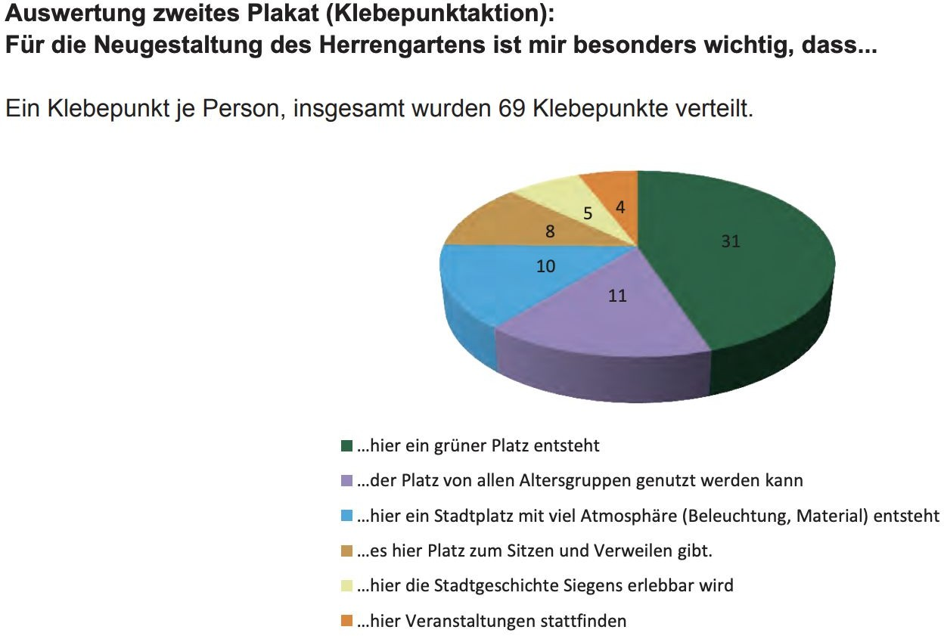

Figure 3: User’s evaluation for the new Herrengarten, (Der Bürgermeister, Abteilung Stadtentwicklung und

-planung. “Wettbewerb Herrengarten,” May 2018).

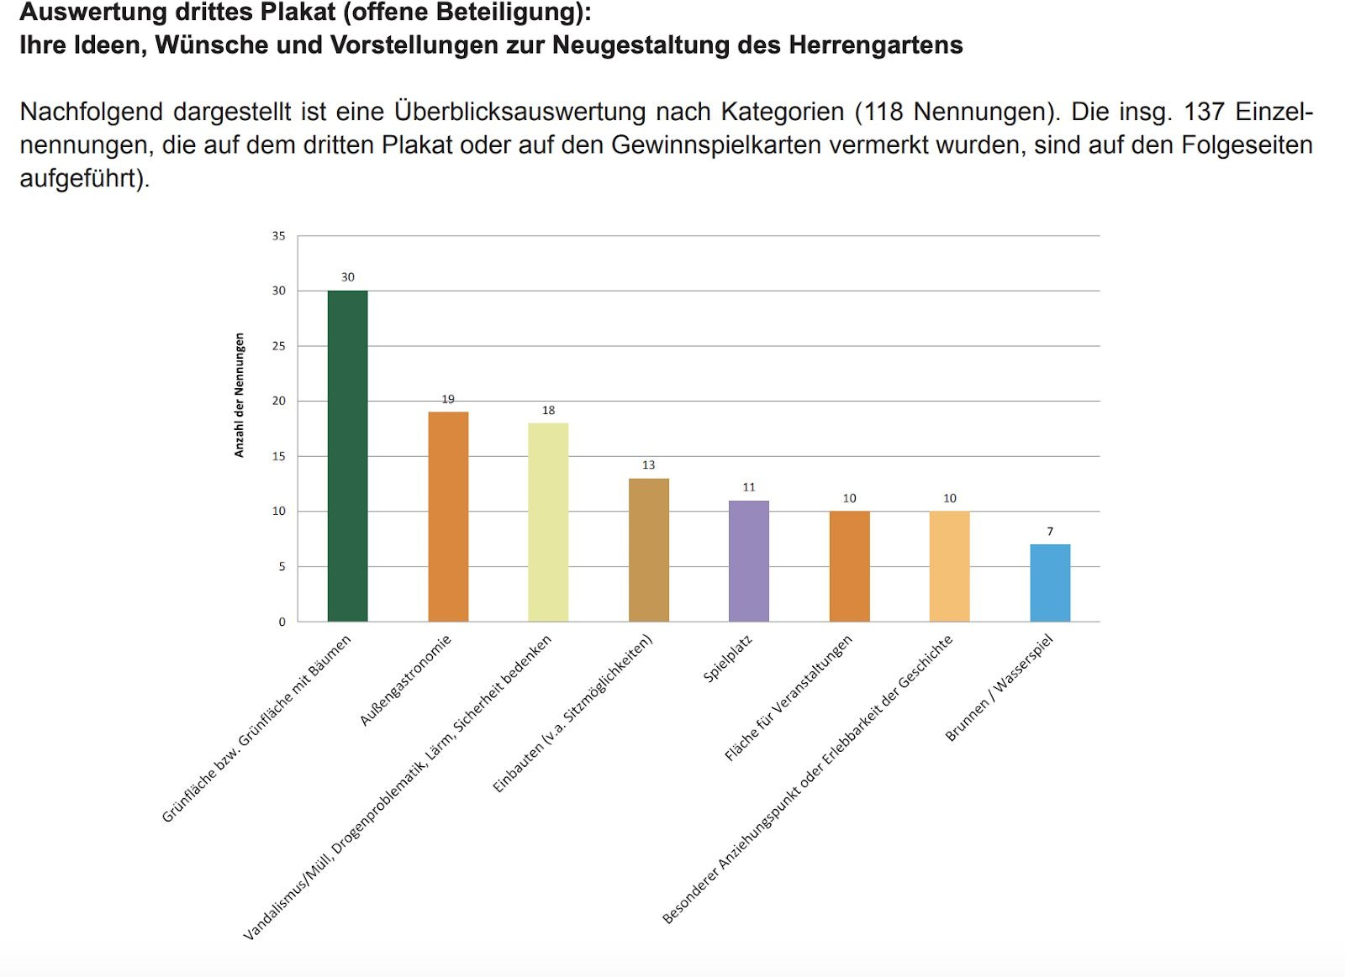

Figure 4: Ideas and wishes for the new Herrengarten redesign, (Der Bürgermeister, Abteilung Stadtentwicklung und -planung. “Wettbewerb Herrengarten,” May 2018).

This analysis of the Herrengarten project reveals it as an ideal case study into which to ground a research project on facilitating citizen participation in infrastructure projects through AR. The Herrengarten, located in the heart of Siegen, is known by citizens of all ages, and the redesign as a public park was actually driven by citizen demand. People across a wide range of social groups profit from a well-designed park or public garden -- it is thoroughly inclusive. The salience and relevance of the project are therefore extremely high for virtually all residents of the city.

Moreover, most people have experiences with using parks and have a concept of what a “good” park would be for them; which aspects they enjoy, which they dislike. This facilitates the recruitment of participants for human-centered research activities. There is no particular background or skill set needed to reasonably relate to the project and it thus becomes easier to observe quasi-natural citizen participation even in an artificially constructed context.

Since AR is particularly promising with regard to spatial cues, it is a further advantage that the site of the Herrengarten project is easily accessible. This provides an opportunity for spatial grounding of research activities, as was done at the “Tag der Städtebauförderung”. This presents another advantage of the Herrengarten case study: there is a basis of citizen participation that can be evolved and improved through novel technologies. The participation activities conducted by the city of Siegen, particularly the analysis of their advantages and limitations, served as inspiration for the development of human-centered research activities described in the following sections.

## Contextual Inquiry

For the first step of the Design Thinking framework, *Empathizing* with the users, a workshop was planned to observe how participants would develop, materialize, express, and share their ideas to collaborate on a city planning project. The different workshop activities were created with a particular focus on spatial situatedness, as this is a particularly promising benefit of using AR in a city planning context.

Five residents of Siegen were recruited using convenience sampling through social media, instant messenger groups, and friends and acquaintances. As an aiding case study for the workshop, the task of redesigning Herrengarten in the center of Siegen was chosen. Throughout the workshop, participants explored the location, collected ideas, and created a concept for a public park. A hypothetical scenario was given in the beginning, in order to give more context information and they were asked to design a proposal for the new park in Herrengarten.

The workshop was divided into three main activities, Walking interview (area exploration), individual concepting, and collaborative concepting to present a final collective concept to the

hypothetical government along with a reflective interview and brainstorming session at the end.

In the first session, the walking interviews enabled participants to move through and familiarize themselves with the actual park location. Materials such as a clipboard, paper, and a printed map for notations were given. They explored the space, while their actions were observed and interviewed upon later on. Participants were seen taking walks around the area while taking pictures and making notes and small sketches.

During the walking interview, participants had overlapping and similar ideas, as well as unique ones all the while prioritizing different aspects in their approach of selecting items for the park. They took into consideration some factors such as senior citizens’ accessibility, possible noise problems for the neighborhood, children’s safety among other collective areas designated for the people's entertainment. Many of them resorted to taking down notes in order to refer back to them and extend onto them in the later tasks.

During the individual concepting session, each participant worked on their own concept for a park. They were provided with a variety of different materials to express and materialize their own ideas. There were no constraints or instructions given on how to approach the process except a rough deadline of around 35 to 45 minutes to finish this task. They were also given an option to work in separate rooms but they chose to stay in the same room, which can be attributed to the fact that some of them knew each other and were well acquainted. The goal was to find out which materials and strategies participants naturally gravitated towards, and drawbacks of the current prototyping material that could translate into design opportunities for the method. The participants were given an A3 sized two-dimensional blueprint of Herrengarten as a basis to work on. All participants utilized the materials with the exception of one who chose to work digitally on their own computer. Some participants used color coding as the main mechanism for making their ideas comprehensible while some were seen more comfortable explaining their ideas in an extensive manner verbally. All participants were interviewed one by one in isolation in an effort to reduce any potential bias or influence. The questions varied from the rationale behind their material choice and ideas to any difficulties they faced during the process as well as about the potential influence of later collaborative tasks on their current ideas. While explaining their individual design concepts, the participants were seen using hand gestures excessively. One common attribute of the various designs was the subdivision of the park in different areas or categories, meant for particular audiences or types of activity.

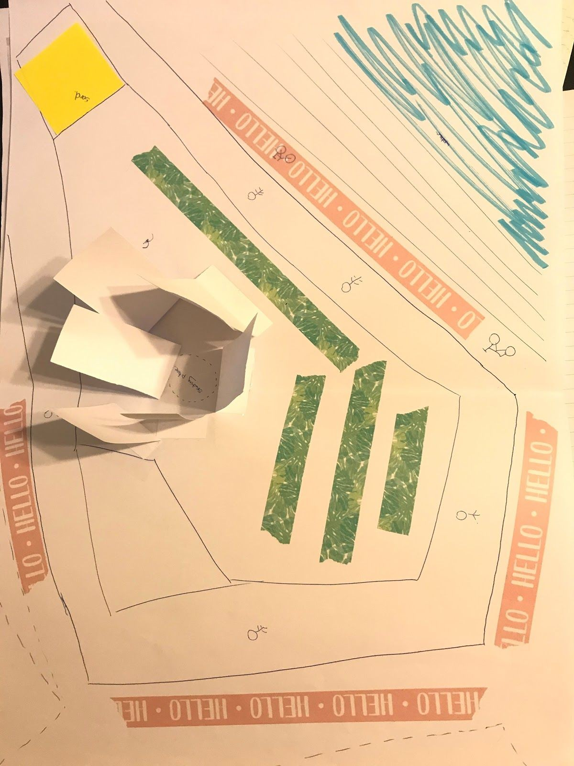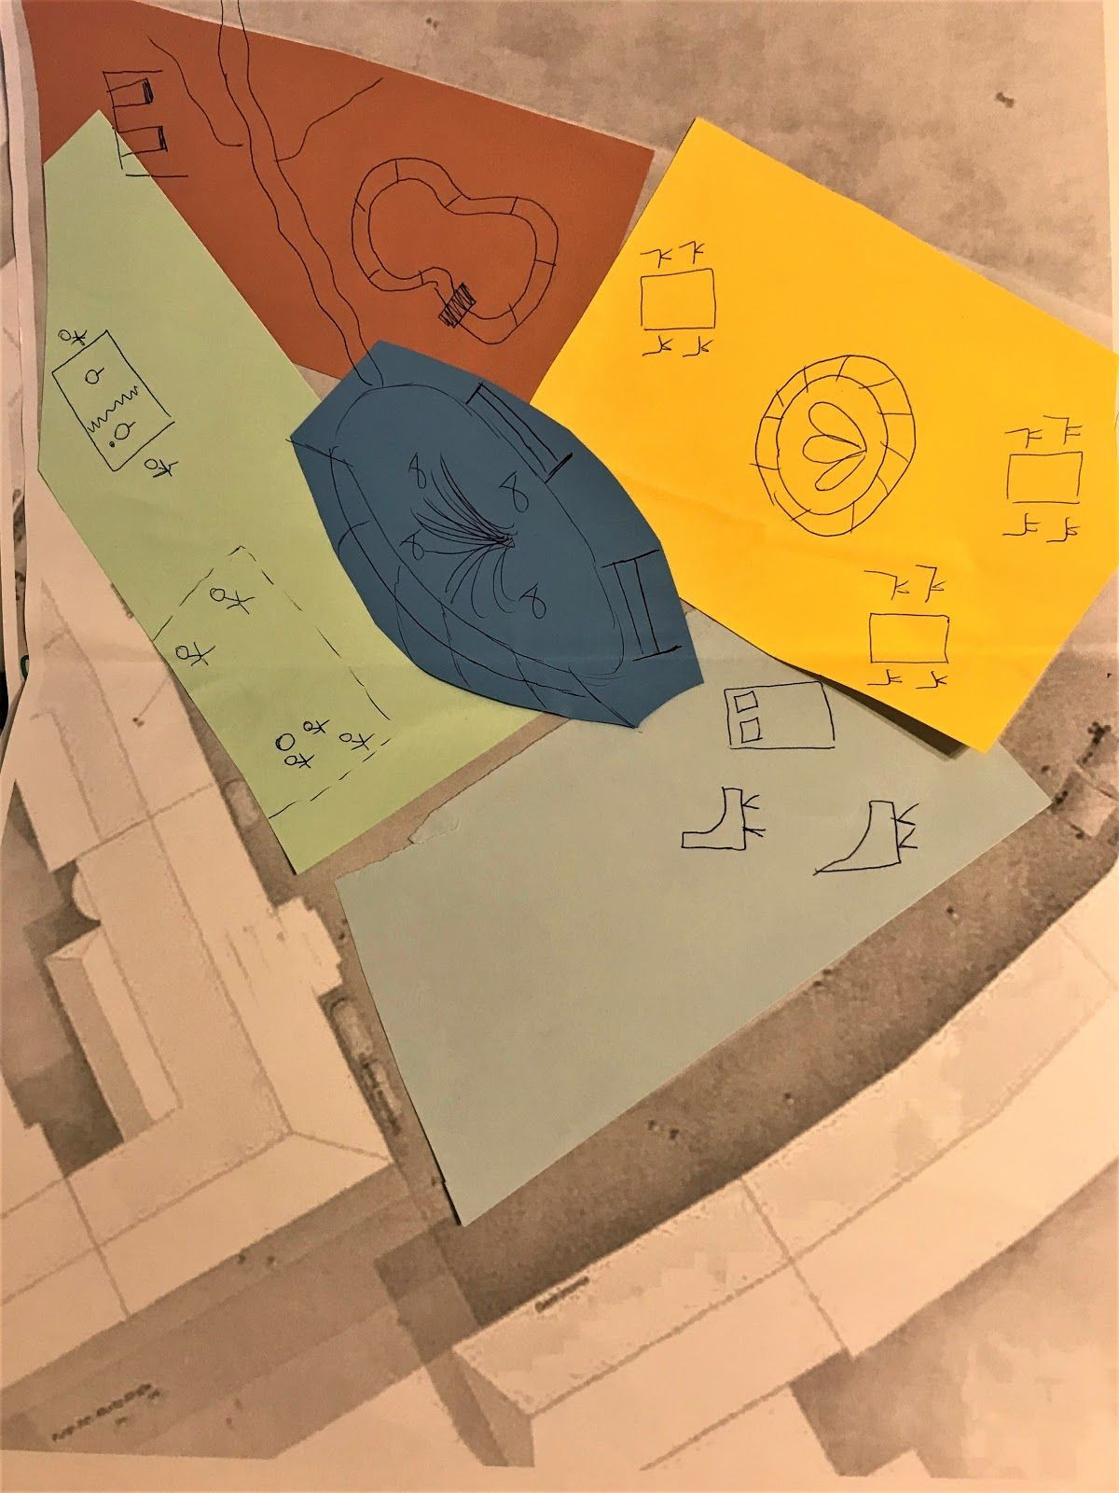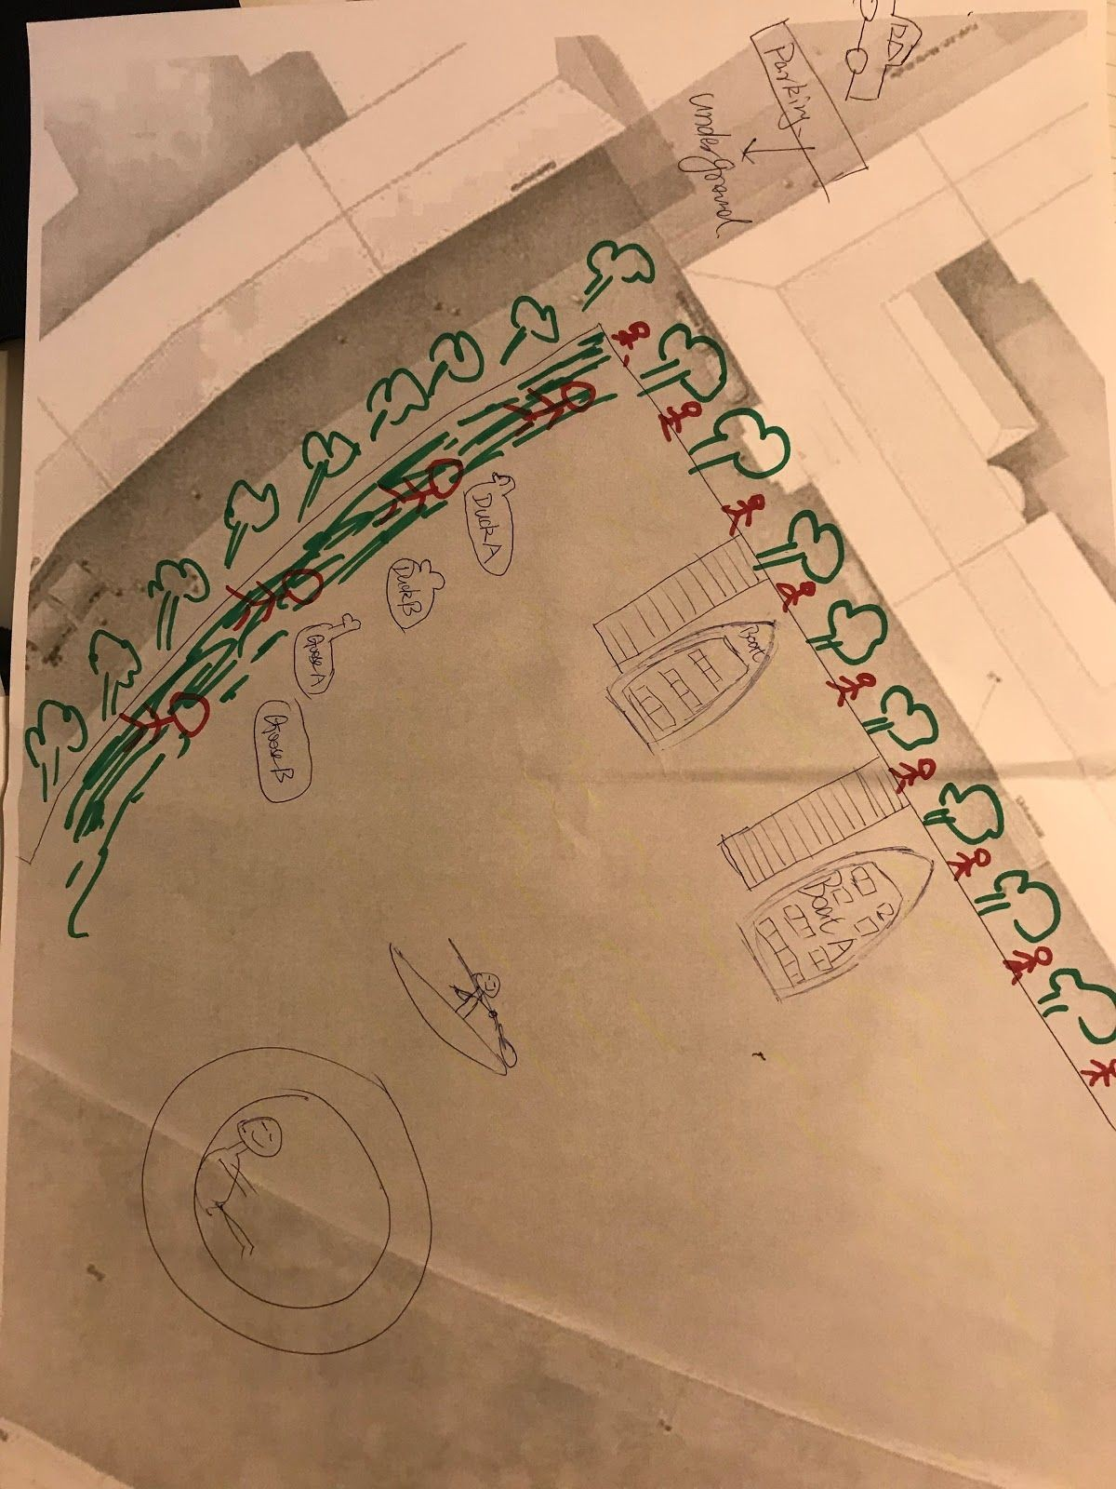

Figure 5. Individual concepting results

One of the individuals expressed their noteworthy idea about an application that enables users to build such a park in an augmented reality environment where multiple users can see the same view. Another participant voiced their opinion about the visibility and expression issues they faced during the task due to the materialization being in two dimensions rather than three

i.e. a flat sketch is easier to develop but difficult to explain and consequently a three-dimensional view would be easier to view and explain to others.

After each participant had created their own concept, they were tasked to work together on combining their ideas and coming up with a collaborative concept. An A1 sized blueprint was provided this time for all participants to collaborate on. There were no additional instructions given since the focus of this part was on understanding how the participants interacted to explain their ideas and how they managed to merge their concepts into one. In the beginning, participants were observed explaining their individual concepts to each other one by one in a similar way they did while being separately interviewed before. A voting round was tacitly started where each unique feature of the individual concepts were scrutinized and was either decided to be included or excluded in the final design. The transition from individual concepts into the final one was quite smooth and conflicts were scarce and short-lived. Each participant was seen working on a particular feature of the park design while still being observant about what others were doing. They were seen engaging in discussions and more voting schemes if a conflict was to emerge. Following the final design, a collective interview session was held to better understand the collaboration process. Questions regarding material usage, idea explanation, and merging of concepts were asked in addition to their opinions about the advantages and disadvantages of collaboration.

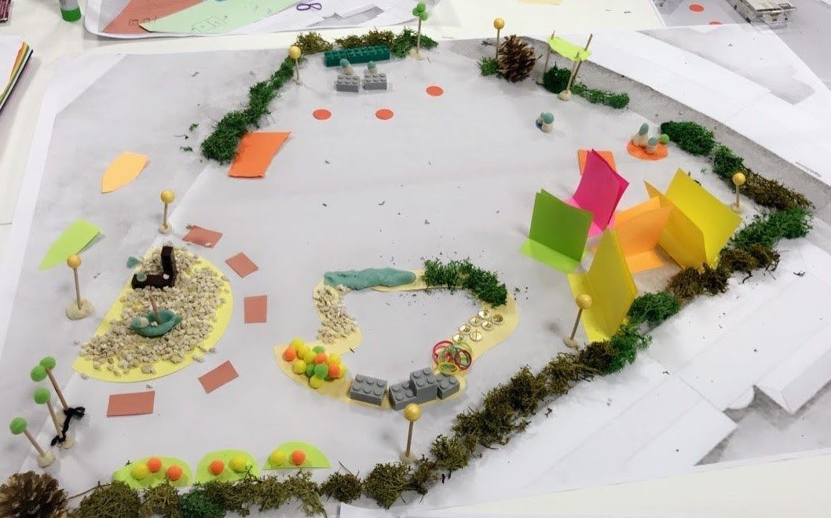

Figure 6. Final collaborative design for Herrengarten Park

In the end, a reflective brainstorming session was carried out where participants were told about the actual study details and were asked for feedback and suggestions. As far as the limitations and missing elements are concerned, individuals agreed that more contextual information such as demographics of the target audience, budget range, and general constraints and requirements would be helpful in coming up with ideas for an infrastructure project. They pointed out that in a real infrastructure project, an authority figure e.g. a municipality member designing alongside citizens could help by making the activity authentic and somewhat reliable. Moreover, realistic scaling was desired by one of the participants. When asked about their preference to either work digitally or model with physical materials, the participants had opposing opinions with three participants favoring physical modeling.

Workshop attendees were drawn towards collaboration and felt more comfortable in presenting a collective design. They were all of the opinions that citizens might probably be eager to participate in such projects if they know their contribution is meaningful and is heard. However, they mentioned the expected probability of serious conflicts in case of strangers working together where collaboration can be gravely affected. According to the participants, the structure of the workshop was intuitive to develop and refine ideas starting from abstract idea generation in walking interviews to the translation of ideas into design concepts in further tasks.

## Example Concept for an AR Park Planning Tool

In order to *Define* the challenges, a low-fidelity prototyping method would need to address the insights gained from the design workshop, which were analyzed to create an example

concept for an AR park planning tool. Various creative methods, such as mind mapping and brainstorming were used to structure data and generate a rough example product. In this step, the project diverged more strongly from the traditional Design Thinking route, which focuses on developing products, shifting focus towards the features which would be necessary, and sufficient for developing and evaluating a new prototyping method.

The selected format for the example concept is a screen-based AR application for tablets. Similar to other screen-based AR tools like Adobe Aero, the application would overlay on the camera view of any clear surface, such as a table or even the floor. This would make it highly flexible and accessible to a wide range of users. The application would be manipulated through touch gestures as well as spatial movement, allowing for multiple views and improved spatial perception. Collaboration could be implemented by synchronizing devices, however, this is out of scope for the current project. The screen-based AR modality was chosen to provide a grounds for discussion for the development of a new prototyping method, however, the method is not necessarily limited to this type of AR application, as will be discussed further on.

The layout of the application would consist of a work area, representing the plot of the park and the surrounding location, and a catalog of objects to be placed in the park scene. The work area would scale and anchor to the real-world surface, allowing the user to move around it and view the model from different perspectives.

The core feature of the object catalog was derived from the grouping of areas and activities which was seen in the different park ideas created in the workshop. Reflecting on the user’s mental model, the catalog would enable an easy and intuitive design process. Furthermore, it could address the need for clearer constraints, as was requested by the participants. In the catalog, related objects would be grouped in predefined categories to allow both for exploratory browsing and aimed search. To achieve meaningful clusters for the catalog, a card sorting activity was conducted, which will be explained in further detail in the subsequent section.

During the design process, users would choose from the categories and add each item to the main work area to create their ideal park configuration. Properties such as color, size, and position would be adaptable in each item within the given limitations, allowing for both creative use and feasible design ideas for further development. Once the user is satisfied with their park model, they can save and publish their design to share it with other citizens as well as local government officials. Published designs can be viewed, rated, and possibly commented on.



Figure 7. Ideal tablet design AR concept for citizen participation

## Card Sorting

In the course of developing a method to evaluate an AR application, an abstraction of such an application was required at least up to an extent where the features to be evaluated are conceptualized. For this purpose, the conceptual application was decided to be an AR tabletop interactive application for small scale infrastructure planning. Since the application would have a catalog of objects to choose from, it was essential to sort the objects in a way that would mimic a real AR application. The said conceptual application concept will be defined in later sections. For simplicity reasons, the case study of designing an outdoor public park was utilized. The method of card sorting was employed as part of a user-centered design methodology to discover the users mental model and come up with a user grounded catalog of objects related to a park accordingly, the findings of the method will be used as a basis for the next design activity, which was planned to be a workshop based on Lego Prototyping, in order to apply the method and validate the research outcome using it. No sampling strategy was used; 4 participants were chosen randomly, And open card sorting determined as the best approach, due to the fact that the categories were not defined and are highly subjective, this allowed the users to sort the cards into categories that make sense to them and label the categories by themselves. Index cards were labeled with 34 varied objects, some blank cards were also provided to give individuals the option to label the groups, duplicate objects, or add missing objects. The participants were asked to sort the cards under categories that they could choose from within the card pile or create ones if necessary. They were also given the freedom to make sub-categories, add or delete items as well as put one item in multiple categories. After sorting, the participants were asked relevant questions and requested to elaborate on their arrangement. The four sorting arrangements were analyzed using a combination of both exploratory (qualitative) and statistical analysis (quantitative), the analysis was started with exploratory analysis with an overall goal of determining and identifying the most consistent patterns, using a card sorting analysis application xSort, that makes use of hierarchical cluster analysis as a basis, a single linkage, average linkage and complete linkage dendrograms (Figures 8, 9 and 10 respectively) were generated from the sessions.

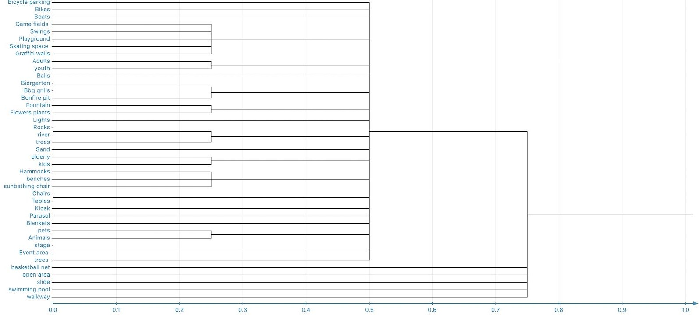

Figure 8. Hierarchical Cluster Analysis, Single linkage dendrogram

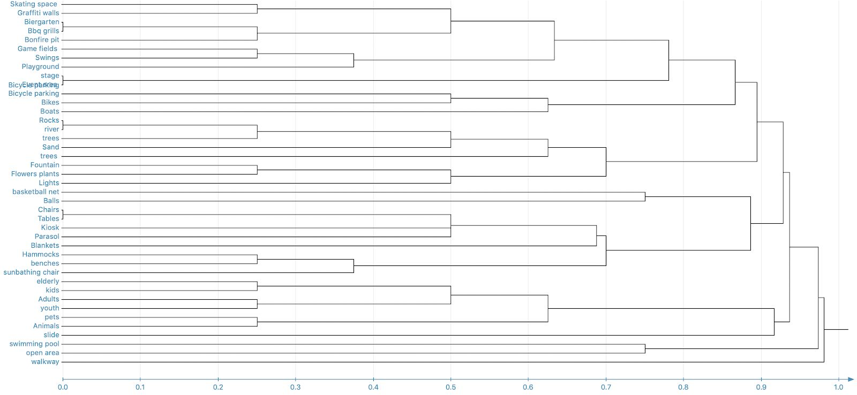

Figure 9. Hierarchical Cluster Analysis, Average linkage dendrogram

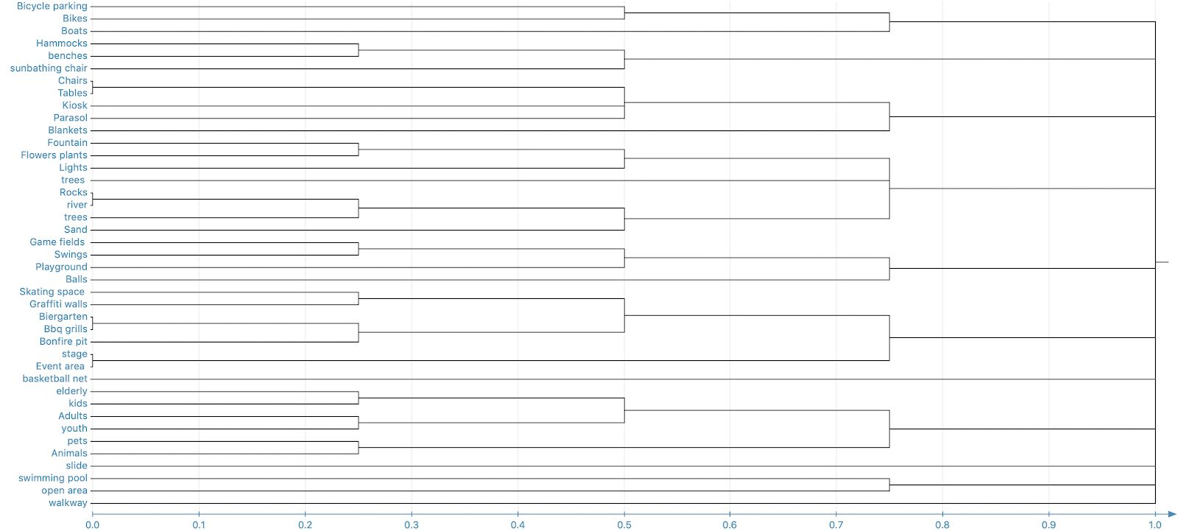

Figure 10. Hierarchical Cluster Analysis, Complete linkage dendrogram

Some consistent and interesting patterns already emerged from the generated trees and statistical analysis. The most prominent findings included the number of groups created by the participants that averaged around 6 with a very low deviation, the second major finding was the small distance score, thus the strong correlation between Tables and Chairs, Rocks and River, Biergarten and Bbq grill and lastly Stage and Event area, where these cards were grouped up in consensus and clustered together in all analyses, and finally the overall grouping of Elderly, Kids, Adults, Youth, Pets, and Animals.

Due to the low number of arrangements statistical analysis deemed insufficient on its own, consequently, an exploratory analysis was conducted to gain more insight, given the small scale of the activity, a semantic approach was adopted where the researcher’s judgment using results of the previous analysis, participants reflection and raw data to understand the users mental model and establish shared understanding behind the grouping. Following an analysis framework (Spencer, 2009).

The exploratory analysis part was initiated by group analysis, where the groups created by the participants were examined, a list of actual user groups was created, similarities and differences were noted, this resulted in expectations and hypotheses. Consecutively the groups were analyzed on a deeper level, where group labels, contents, and relationships were the focus, some major findings were that some participants created the groups under the same name but with different card placements, and some have opted with a different name grouping for similar items; another major finding was the different approaches followed by the participants, e.g., one approach was grouping the cards according to age, and the relevant items that associate to a certain age group, another approach was according to the activities and their relation to the context or environment such as outdoor activities.

Finally, the results from both approaches were combined to generate a cluster tree (Figure 11),

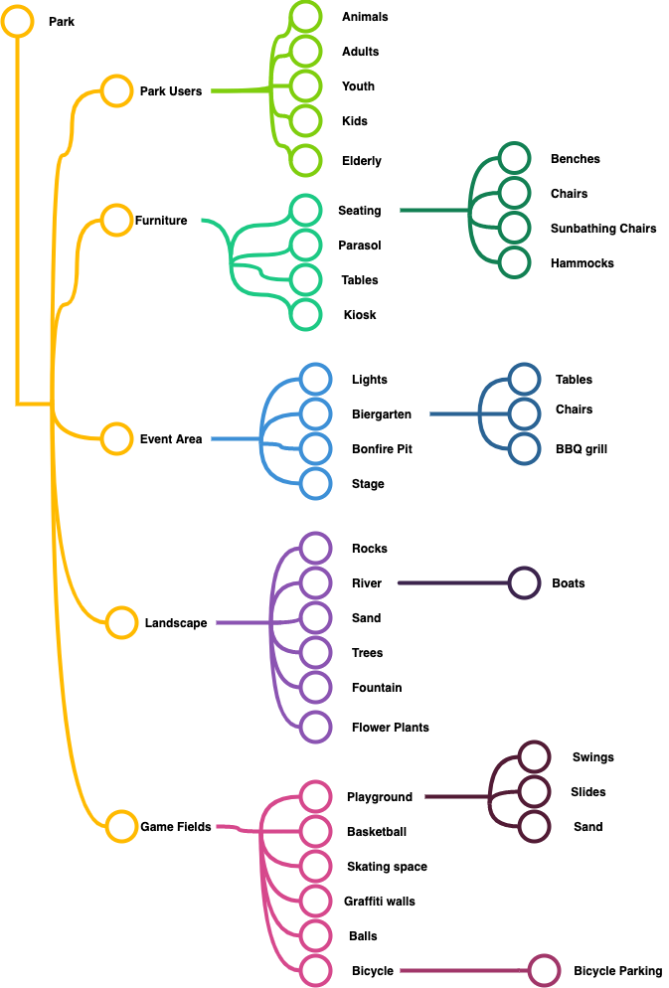

Figure 11. Cluster tree, Cardsorting results

that demonstrates the final results and grouping of the items that will be used as the basis for the Lego prototyping proposal.

# The Lego Prototyping Method

For the purpose of designing an augmented reality tool for public participation in infrastructure projects, Lego prototyping can be used to gain insights on structural aspects and potential features. In the course of this study, the Lego prototyping method was inspired by a combination of Lego bricks and existing usability methods such as low fidelity, paper prototyping, and Wizard of Oz. The Lego prototyping method suggests emulating the virtual objects as Lego pieces, that are embedded in the physical environment, the activity starts with a tabletop surface, an open canvas for the user to start building with the Legos bricks (Figure 12).

In addition, during the workshop analysis, it was observed that flexibility, as an option of an easily modifiable framework, was essential for a spatial interaction system. Incorporating the insights gathered during previous design activities e.g. since the participants voiced their opinions against designing on a blank canvas, the prototype would include some basic objects on the table-top related to the ongoing design in order to provide context that can be expanded upon. Initially, the tool would incorporate an interactive table-top that will be manipulatable by the user using basic commands such as select, pick, rotate, move, or remove an object and if another method is also incorporated e.g. Wizard of Oz when touching an item, the researcher can take control and show the user a menu of possible actions, and this can also be achieved in many ways depending on the degree of fidelity.

Simultaneously, the Lego bricks offer the opportunity to combine different pieces together, allowing the user to build and create new figures. An existing categorized collection of objects made by Lego blocks would be available for participants to utilize as is or to modify before placing it in the design space on the table. Moreover, the participants would be encouraged to build new objects on their own, that would be included in the collection of existing objects. In this particular case, they would be required to submit a name for the new object and designate it to a category.

During the design process, participants would be motivated to think aloud, at the same time, their gestures and interactions would be observed. In the end, participants would present their designs and respond to relevant additional questions about their respective designs.

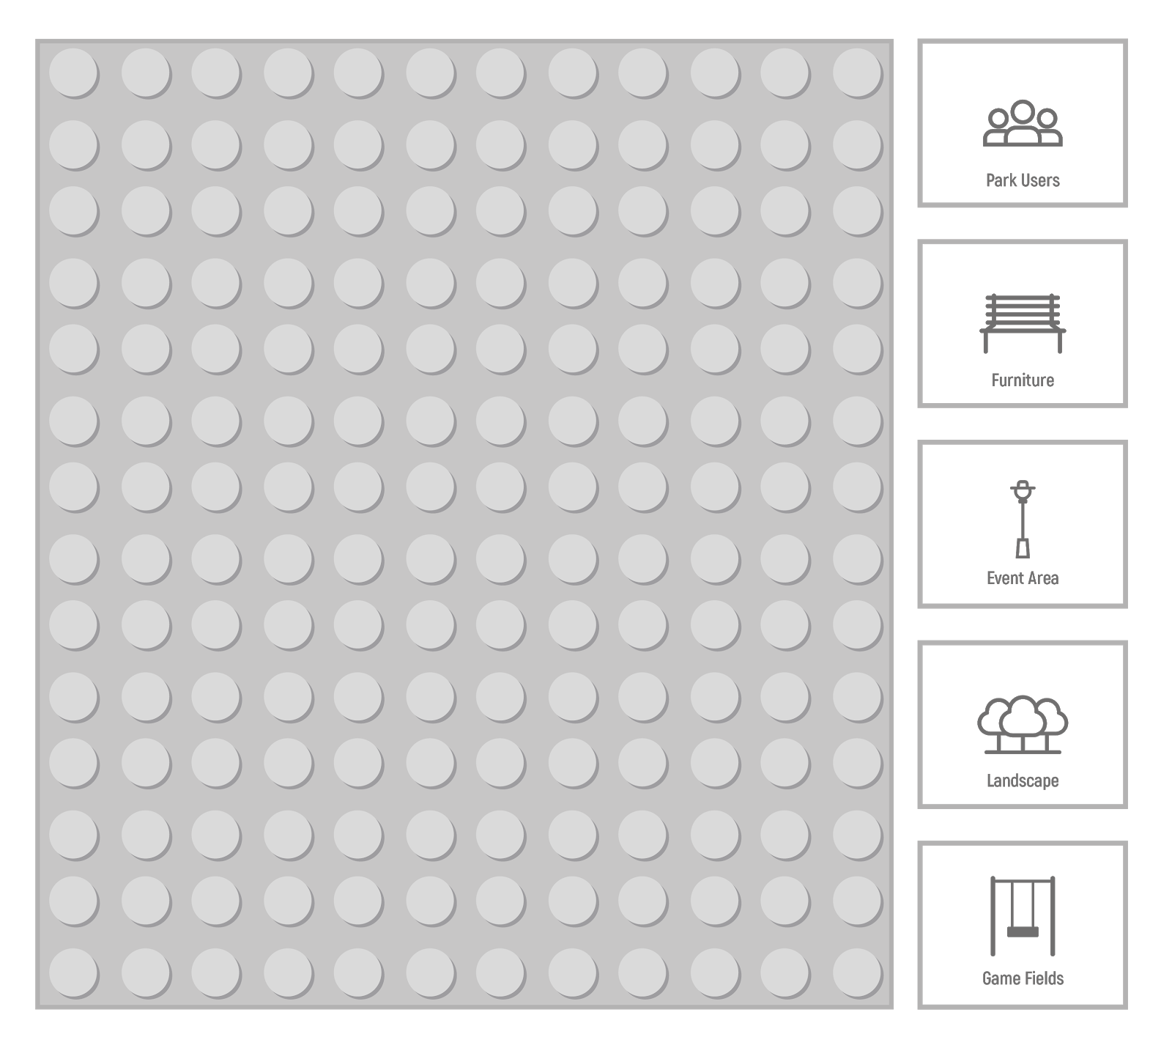

Figure 12. Lego Prototyping idea

Within this specific case study, from the results of card sorting a library was constructed and the elements categorized accordingly. This proves the ability of the method to embody user research results, by applying the previous card sorting results in the new interface. Moreover, the method exhibits the ability to test research findings and design decisions, especially in

combination with other methods, e.g. observation and thinking aloud methods. Incorporating Lego Prototyping exhibits a validation method that allows the early testing of behavioral and interaction-based data.

Even though paper prototyping and low fidelity prototypes provide a more simplistic and affordable way to test design ideas in early stages; these methods are flexible and affordable enough to allow the user to change, draw and use the tool in different ways. Additionally, it was observed in the study that the users’ ability to rapidly express their ideas and reflect on these in real-time is another key aspect of spatial interaction design.

On the contrary, the most notable shortcoming of the already existing methods is the lack of scale, which was observed and deduced in the design workshop phase. During this activity, participants struggled and expressed frustration in dealing with unscaled objects that limited their creative approach. Lego prototyping fixes this problem because the nature of Lego pieces can create a more realistic scale relative to the other existing objects.

In combination with the Wizard of Oz method, Lego prototyping allows the researcher to play the role of the “computer” to control and manipulate the tool and respond accordingly to the user's action. Generally, user imagination and collaboration are essential to creative processes, improving the experience and the capacity of the user to imagine a more accurate final design. Even though the process is not contributing to real results, the user’s behavior, reactions, and comments can make a difference in the future functionalities of the tool. Finally, Lego prototyping method provides not only useful and interactive features but also a considerable decrease in the redevelopment costs.

## Outlook on Evaluation

Lego prototyping as a method to extract potentially useful insights and possible features for an augmented reality application is proposed based on the findings of initial case study research, contextual inquiry, and example AR tool conception. Since this method has not been applied, it is required to be evaluated. A possible approach for evaluating such design methods is using a Validation Square (Pedersen et al., 2000). It is a framework that systematically and sequentially evaluates a design method on the basis of its logic, plausibility of the example used, its performance for that example, and its applicability to other design problems.

The Validation Square technique encompasses six statements distributed across four quadrants (Figure 13) of the square namely: Theoretical Structural Validity, Empirical Structural ValidityEmpirical Performance Validity, and Theoretical Performance Validity.

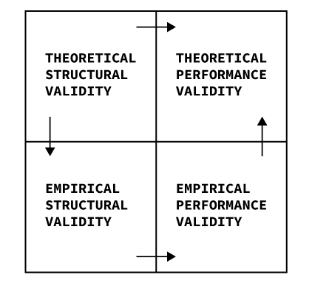

Figure 13. Based on the original, Validation Square from Pedersen et al,.2000

The first quadrant, *Theoretical Structural Validity*, aims to evaluate the constructs and assumptions upon which the method is built. Prototyping and testing products during development have been an integral part of human-centered design and are included in virtually every modern design framework. It is widely recognized as facilitating communication between designers, developers, and prospective users (Pfauth et al., 1985).

A “Prototype” is loosely defined as any representation of particular product features generated in the design process and used in order to gather insights for further design activities. While it may at first glance be assumed as commonly understood, interdisciplinary research has shown that the understanding of what constitutes a valid prototype may vary greatly between disciplines and even corporate cultures (Schrage, 1996).

This makes validating the construct of “The Prototype” a challenging task. It is often approached by classifying prototypes according to particular attributes. The most commonly used classification pertains to a prototype’s so-called fidelity. Virzi suggests conceptualizing prototype fidelity analogously to a Turing test, putting the focus on the user’s perception (Virzi, 1989). As such, a prototype perceived by the user as a functioning product -- regardless of whether any actual functionality is implemented -- can be categorized as “high fidelity”. On the other end of the spectrum, a “low-fidelity” prototype is clearly recognized by the user as merely being a limited representation of features. Using this conceptualization, the Lego Prototype can quite easily be placed at the low end of the fidelity spectrum. It is no way attempts to fool the user into thinking they are interacting with an actual AR application. The discrepancies between the conceptualized AR planning application and the Lego blocks constituting the prototype could hardly be more obvious.

This begs the question of what value can even be generated by a “low-fidelity” prototype -- and indeed, the discussion around this topic has been lively within the design community (Rudd et al., 1996; Juergen Sauer & Sonderegger, 2009). Often the choice of low fidelity is

made simply for pragmatic reasons. Producing, testing, and iterating over high-fidelity prototypes is plainly neither temporally nor economically feasible. Low fidelity prototypes allow designers and developers to gain real user insights in the earliest stages of the design process, while decisions are still open and modifications are still possible. The question of economic viability is particularly relevant to AR application design. At this point in time, the development and testing of AR applications are still incredibly time-consuming and expensive. Cost-effectivity is therefore a central value not only of low-fidelity prototyping in general but of the suggested Lego prototyping method in particular, as it aims to address the lack of inexpensive prototyping approaches in AR.

Besides the obvious cost advantage, established low-fidelity prototyping methods offer several benefits that can reasonably be expected from Lego prototyping. Many studies comparing lower-fidelity prototypes to higher fidelity ones have found that both are equally suitable for identifying major usability flaws (Jürgen Sauer et al., 2010; Walker et al., 2002). Additionally, (Virzi, 1989) found that lower-fidelity prototypes are particularly useful for focussing on higher-order aspects of an interface. Since they typically do not express detailed design of components, the users are better able to evaluate structurally and feature aspects in low-fidelity prototypes than in their higher fidelity counterparts.

Building upon these insights, Lego Prototyping is conceptualized as a method to be used primarily in the early stages of development for supporting higher-level design decisions. It can be assumed to aid in evaluating structural aspects, communicating concepts, and eliciting user requirements.

Furthermore, it adds to the canon of low-fidelity prototyping methods by addressing the lack of options for prototyping in 3D, as may be necessary for AR and VR development. Lego Prototyping enables the evaluation of the spatial structure of AR and VR applications by translating them into the real world. This promises the possibility of gaining insights into the configuration of AR environments with respect to the configuration of components and interactions in 3 dimensions.

The second quadrant, *Empirical Structural Validity,* on the other hand, refers to verifying whether the employed example problem is applicable/appropriate for validating the design method. Lego prototyping is, in its essence, a flexible and adaptive method and can be used by participants for many different scenarios without requiring any particular knowledge and skills. These scenarios primarily involve designing or evaluating an interaction concept with close correspondence to the interface that users use to communicate with the system in subject. For the purpose of this project, Lego prototyping is being suggested for designing/evaluating an augmented reality application particularly for infrastructure design (by citizens). The application incorporates modeling, for example, a park, using augmented reality elements on a design canvas where the output is a 3d design of a finished park. This modeling process can be mimicked by utilizing Lego objects as the said elements.

Similar use cases where Lego prototyping is utilized for modeling purposes can be found in the literature regarding participatory design (Tawalbeh et al., 2017). In two of the three case studies mentioned, Lego is utilized for prototyping purposes in the field of factory planning. Apart from modeling context, other similarities between these examples of factory planning

case studies and infrastructure design can be found. Both examples involve participants assuming a fictitious role of architect or infrastructure designer, creating their models and presenting their finished products, in the end, using storytelling. Interestingly, the case study also employed the transition from individual models to a final collaborative model taking the features from each model accepted by all.

The cost of bad design can be translated in many ways, economically and otherwise which is why design is deemed as a critical aspect in technology (Shariat & Saucier, 2017). An inexpensive, easier, and faster way to tackle this is to prototype. Prototypes are not only more economical and convenient, but they can also be utilized as a medium for further research and inquiry, and as an experimental component (Wensveen & Mathews, 2014).

Usage and development of Augmented Reality are growing exponentially and so are the costs related to it (Golosovskaya, 2019). Several prototyping methods are being employed for augmented reality that exhibits prototypes of varying fidelity such as simple and economical paper prototypes (Lauber et al., 2014) and others higher on the fidelity scale being interactive, integrating software and hardware (Nam & Lee, 2003). Similarly, Lego prototyping for an infrastructure design tool attempts to serve as an experimental component and medium for communication among designers and developers, to extract insightful interaction features for the prospective tool, avoid costs related to re-developments, and therefore, prevents inadequate design.

Based on the above instances and examples, it can be asserted that the augmented reality design application is an appropriate example to validate the soundness of Lego prototyping method.

The third quadrant, The *Empirical Performance Validity* addresses the functionality and practicality of the Lego Prototype tool. This tool was initially thought to be further assessed in a cooperative evaluation in which the participant will have the opportunity to plan and design a more realistic version of a community park.

The Lego prototype tool has a more flexible, immerse, and tridimensional approach, consisting of two elements: the design workspace and the three-dimensional objects. The first element, the design workspace simulates the parking area, where participants will add objects in order to build a new space according to their needs.

The second element, three-dimensional objects, materialize landscape, furniture, game fields 3D figures such as trees, flowers, lights, and benches, that participants can place in the workspace to simulate real-life items that can be added, moved or eliminated, creating a more realistic design experience.

In comparison with other prototyping tools, the Lego prototype tool gives a more realistic experience, as the participant is able to manipulate and scale models of predefined physical objects that can be combined and arranged into the workspace (Boa et al., 2017), granting a reconfigurable space and a clear perspective of how the final design would look in the future. Paper prototyping, on the other hand, is a low fidelity technique used in the early stages. It is highly used because of the capacity to allow better visualization of the design, it requires less time to construct and is limited to a two-dimension view of the space (Sefelin et al., n.d.), but making the final result hard to imagine for the users involved in the process.

Boa and colleagues established some important advantages and disadvantages of using Lego as a prototyping resource. Advantages, recognize Lego is a well-known construction model mechanism, used even by small children, allowing simple connection and distribution of elements in a variety of positions. At the same time, this resource focuses on interchangeability, objects placed in the design workplace can change position, which provides flexibility to reconfigure the layout, by moving, adding, and removing the elements. Moreover, Lego prototyping is a creative interactive, and alternative form for involving people’s participation during the design process.

On the contrary, disadvantages for the Lego prototyping include limited design workspace, as figures and elements are scaled the representation of real dimensions is restrained. Similarly, the construction of preexisted elements is also contrast gain, which implies that usage of alternative materials, such clay or plastic figures to recreate existing objects, might create confusion in some of the participants, because of the mixing of material and objects lacking consistency during the design process.

Even though there are some limitations regarding planning, building the 3D model objects and additional materials, the Lego prototyping tool can become an affordable and practical, dynamic approach to test AR without investing additional time and resources building a real low-fidelity AR prototype.

As the third part of validation which also relates to validating the method based on usefulness, specifically whether the method produces or suggests “correct” design solutions based on quantitative evaluation “efficiency”.

The overall aim of the last quadrant, *Theoretical Performance Validity* is to test the generalization ability of the method i.e. reviewing utility of the design method beyond the example scenarios. And the Validation Square suggests doing so, through connecting the proposed case study to analytic generalization and theory development, which the paper refers to as a leap of faith. Carrying on from the previous section Empirical Performance Validity, which demonstrated the methods usefulness in regards to the case study, this section aims to prove the methods usefulness beyond the demonstrated case study in this paper. And to support and validate this claim the following is argued.

As has been discussed in the section on Theoretical Structural Validity, for a design method to be theoretically structurally valid, it should be possible to evaluate its likelihood of producing the desired outcome of using this method, and since the “constructs” of Lego Prototyping incorporate methods like paper prototyping and think-aloud method, to evaluate or design an interaction system; in addition to the added dimensionality aspect which has been deemed not only important but a key aspect of reality-based interactions, especially when dealing with design cases that mimic real-life characteristics. Fundamentally, the incorporated individual constructs have been proven valid through other countless studies where these methods were able to produce the desired outcome of either suggesting design solutions or validating them, and the fact that these constructs have been applied to many varying contexts and different design case studies, the addition of the mentioned “attributes” of this method like dimensionality does not detach the ability of these constructs to be generalized and applied to other methods.

Another important aspect of proving the generalization of a design method is that the constructs are applied within their range, and this criterion is especially made clear when observing the possibilities of applying Lego Prototyping. Theoretically in a reductionist approach, the range of applying Lego Prototyping is the sum range of the constructs, Lego Prototyping could only be applied to validate or to elicit design related data, and accordingly, the constructs are also only being applied to their range.

Finally, the Validation Square suggests that for a method to fulfill the criterion of Theoretical Performance Validity, an inference should be feasible towards its general use of the collected results, hence drawing back again on the constructs of Lego Prototyping that provide useful design data, which once again have been proven through other case studies; the data generated from these methods, that make the big picture of Lego Prototyping will only be shaped by interaction “restrictions”, that restrict the participants in acting in a way that only imitates real-life interactions, and at the same time, provides the users with the ability to see a more realistic outcome of their actions in terms of scale and feasibility, which was also derived from the design workshop conducted through the case study. The participant’s ability to rearrange the building blocks, demonstrates greatly the flexibility that is also an important aspect of AR, accordingly these added attributes to the methods, merely enable or restrict actions and thus the collected or generated data, can be proven useful by referring to the usefulness of these methods.

# Conclusion

Augmented Reality is more accessible and growing at a rate faster than ever, at the time of writing this paper, the AR and VR industry and the market size is approximately USD 18.8 Billion (Statista, 2020), and is projected to reach a staggering USD 571.42 Billion with a compound annual growth rate of 60% (Valuates Reports, 2019). According to Tim Brown “Prototypes speed up the process of innovation because it is only when we put our ideas out into the world that we really start to understand their strengths and weaknesses. And the faster we do that, the faster our ideas evolve” (Brown, 2014). In order to foster innovation and bring user-centered design methods into AR development, the development of affordable rapid prototyping methods is indispensable.

To address this demand, this project made a first exploration of how Lego could be used to prototype and test AR applications, grounding the method in an applied Case Study. Lego prototyping is highly promising as a method for AR development, as it can depict important spatial information in a way that traditional 2D-prototyping methods cannot. Despite the case study method being built upon referred to a park design scenario, many other application areas may benefit from the method as well. Lego prototyping is fast, affordable, and flexible, and provides a familiar common ground for people from different backgrounds. It is intuitive to use and provides spatial anchors for the discussion of product features. This promises new possibilities for AR development, as it enables collaboration in interdisciplinary teams as well as providing options for engaging users throughout the development cycle.

However, both Lego prototyping and the project as a whole are not without their limitations. Lego prototyping is low-fidelity prototyping and thus inherits the accompanying drawbacks. Although this prototype form is highly useful for discussing high-level aspects, more fine-grained design choices cannot be adequately depicted. This pertains for instance to visual design aspects, specific interactions, haptics, and timings; constraints that have to be kept in mind when choosing the right prototyping modality for a particular design question.

Furthermore, the proposed method is still lacking validation. While an empirical performance validation for the case study of an AR park design tool was planned in the form of a cooperative evaluation, this plan could unfortunately not be executed due to health concerns in connection with the ongoing COVID-19 pandemic (Sahu, 2020). It is therefore not yet confirmed whether the method would work as proposed. Moreover, the transferability of the method to other areas of application for AR tools needs to be tested through further empirical study, as it was developed from a specific application case.

In summary, the nascent field of user-centered AR development shows great promise for new avenues of research and design. Many questions are still unanswered and provide room for innovation at the intersection of design, research, and software development. Projects similar to this one can help in adding to the developing toolkit of novel methods and providing grounds for further discussion and exploration.

# References

Al-Kodmany, K. (1999). Using visualization techniques for enhancing public participation in planning and design: Process, implementation, and evaluation. *Landscape and Urban Planning*, *45*(1), 37–45. https://doi.org/10.1016/S0169-2046(99)00024-9

Boa, D., Mathias, D., & Hicks, B. (2017). *Evolving lego: Prototyping requirements for a customizable construction kit*. 397–306.

Brown, T. (2014). *Designers—Think big!*

*Geschichte | Aktionsbündnis-Herrengarten*. (n.d.). Retrieved May 14, 2020, from <http://aktionsbuendnis-herrengarten.de/geschichte/>

Golosovskaya, A. (2019, May 10). *How Much Does Augmented Reality App Development Cost in 2019?* Invisible Toys.

https://invisible.toys/create-augmented-reality-apps/augmented-reality-app-developme nt-cost/

*Herrengarten [ZEIT.RAUM]*. (n.d.). Retrieved May 14, 2020, from https://wiki.zeitraum-siegen.de/orte/herrengarten

Hunsucker, A. J., McClinton, K., Wang, J., & Stolterman, E. (2017). Augmented Reality Prototyping For Interaction Design Students. *Proceedings of the 2017 CHI Conference Extended Abstracts on Human Factors in Computing Systems - CHI EA ’17*, 1018–1023. https://doi.org/10.1145/3027063.3053684

Ianniello, M., Iacuzzi, S., Fedele, P., & Brusati, L. (2019). Obstacles and solutions on the ladder of citizen participation: A systematic review. *Public Management Review*, *21*(1), 21–46. https://doi.org/10.1080/14719037.2018.1438499

Irvin, R. A., & Stansbury, J. (2004). Citizen Participation in Decision Making: Is It Worth the

Effort? *Public Administration Review*, *64*(1), 55–65. https://doi.org/10.1111/j.1540-6210.2004.00346.x

Lauber, F., Böttcher, C., & Butz, A. (2014). *PapAR: Paper Prototyping for Augmented Reality*.

Michels, A., & Graaf, L. D. (2017). Examining citizen participation: Local participatory policymaking and democracy revisited. *Local Government Studies*, *43*(6), 875–881. https://doi.org/10.1080/03003930.2017.1365712

Nam, T.-J., & Lee, W. (2003). *Integrating Hardware and Software: Augmented Reality Based Prototyping Method for Digital Products*.

Pedersen, K., Emblemsvåg, J., Consulting, C., Bailey, R., Allen, J. K., & Mistree, F. (2000). *VALIDATING DESIGN METHODS & RESEARCH: THE VALIDATION SQUARE*. 13.

Pfauth, M., Hammer, A., & Fissel, J. (1985). Software Prototyping as a Human Factors Tool.

*Proceedings of the Human Factors Society Annual Meeting*, *29*(5), 467–469. https://doi.org/10.1177/154193128502900514

Rudd, J., Stern, K., & Isensee, S. (1996). Low vs. High-fidelity prototyping debate.

*Interactions*, *3*(1), 76–85. https://doi.org/10.1145/223500.223514

Sahu, P. (2020). Closure of Universities Due to Coronavirus Disease 2019 (COVID-19): Impact on Education and Mental Health of Students and Academic Staff. *Cureus*. https://doi.org/10.7759/cureus.7541

Sauer, Juergen, & Sonderegger, A. (2009). The influence of prototype fidelity and aesthetics of design in usability tests: Effects on user behaviour, subjective evaluation and emotion. *Applied Ergonomics*, *40*(4), 670–677. https://doi.org/10.1016/j.apergo.2008.06.006

Sauer, Jürgen, Seibel, K., & Rüttinger, B. (2010). The influence of user expertise and prototype fidelity in usability tests. *Applied Ergonomics*, *41*(1), 130–140. https://doi.org/10.1016/j.apergo.2009.06.003

Schrage, M. (1996). Cultures of prototyping. In T. Winograd (Ed.), *Bringing design to software* (pp. 191–213). ACM. https://doi.org/10.1145/229868.230045

Sefelin, R., Tscheligi, M., & Giller, V. (n.d.). Paper Prototyping—What is it good for? A Comparison of Paper- and Computer-based Low-fidelity Prototyping. *NEW HORIZONS*, 2.

Shariat, J., & Saucier, C. S. (2017). *Tragic Design: The Impact of Bad Product Design and How to Fix It*.

Spencer, D. (2009). *Card sorting: Designing usable categories*. Rosenfeld Media.

Statista. (2020, March 20). *Forecast augmented (AR) and virtual reality (VR) market size worldwide from 2016 to 2020* [Data Platform]. Forecast Augmented (AR) and Virtual Reality (VR) Market Size Worldwide from 2016 to 2020. https://www..com/statistics/591181/global-augmented-virtual-reality-market-size/

Tawalbeh, M., Riedel, R., Horler, S., & Müller, E. (2017). *Case Studies of Participatory Design: Comparison of Methodologies in Factory Planning*.

*Unser Ziel | Aktionsbündnis-Herrengarten*. (n.d.). Retrieved May 14, 2020, from <http://aktionsbuendnis-herrengarten.de/unser-ziel/>

Valuates Reports. (2019). *Augmented Reality and Virtual Reality (AR & VR) Market Size is Expected to Reach USD 571.42 Billion by 2025*.

https://reports.valuates.com/market-reports/ALLI-Auto-4J205/-mixed-reality-market Virzi, R. A. (1989). What can you Learn from a Low-Fidelity Prototype? *Proceedings of the*

*Human Factors Society Annual Meeting*, *33*(4), 224–228.

https://doi.org/10.1177/154193128903300405

Walker, M., Takayama, L., & Landay, J. A. (2002). High-Fidelity or Low-Fidelity, Paper or Computer? Choosing Attributes when Testing Web Prototypes. *Proceedings of the Human Factors and Ergonomics Society Annual Meeting*, *46*(5), 661–665. https://doi.org/10.1177/154193120204600513

Wensveen, S., & Mathews, B. (2014). *Prototypes and Prototyping in Design Research*.

Wilson, A., Tewdwr-Jones, M., & Comber, R. (2019). Urban planning, public participation and digital technology: App development as a method of generating citizen involvement in local planning processes. *Environment and Planning B: Urban Analytics and City Science*, *46*(2), 286–302. https://doi.org/10.1177/2399808317712515