Campus Mini Mart
Requirements and Modeling Package
Software Engineering Course Project
Project Type | Web-based mini market system for campus users
Prepared By | Yazan Hijazi (12401471) / Yazan Zaghlol (12217530)
Team Size | 2 members
Submission Date | 12 May 2026

Project Summary: Campus Mini Mart is a simple campus e-commerce web application that allows customers to browse products, search by name, filter by category, add items to a shopping cart, update quantities, and complete a simulated checkout process. The proposed full system also includes an administrator role for maintaining products and reviewing orders.

Table of Contents
- Introduction and Project Background
- Stakeholders / Target Users
- Scope
- Functional Requirements
- Non-Functional Requirements
- Constraints and Assumptions
- Glossary
- User Stories / Backlog
- Use Cases
- UI Wireframes / Mockups
- Modeling Package :
  - Context Diagram
  - UML Class Diagram
  - Sequence Diagram
  - Activity Diagram
- Planning and Risk Management
  - Project Plan
  - Roles and Responsibilities
  - Risk Register
- Quality and Testing
  - Test Plan
  - Test Cases
  - Traceability Matrix
- Team Contribution
- Conclusion

1. Introduction and Project Background
Campus Mini Mart is a web-based mini market system designed for university students, staff members, and campus visitors. The system provides a fast and simple way to browse products such as snacks, drinks, desserts, and light meals.
Many students face difficulty finding products quickly during short breaks or between lectures. Traditional shopping inside small stores may waste time because customers need to browse manually.
This system solves the problem by providing an online catalog with search, filtering, shopping cart management, and checkout simulation.
The project is suitable for software engineering because it has:
- Clear users
- Clear system boundaries
- Testable functions
- Easy-to-understand interfaces
- Expandable future features

2. Stakeholders / Target Users
Stakeholder | Role | Interest in the System
Customers | Primary user | Browse products, search items, add items to cart, and complete checkout quickly.
Store Administrator | System manager | Update products, prices, categories, stock, and review customer orders in the planned full system.
Course Instructor | Evaluator | Assess completeness of requirements, modeling quality, and interface clarity.
Development Team | Project team | Analyze, design, document, and refine the system.

The main target users are customers and the store administrator. Customers focus on shopping tasks, while the administrator focuses on maintaining the product catalog and order information.

3. Scope

Scope Definition
What the system will do
- Display products with image, name, price, and description
- Search products by name
- Filter products by category
- Add products to cart
- Update quantities
- Remove products
- Calculate total price
- Checkout order
- Allow future admin management
What the system will not do
- Real online payment
- Real delivery tracking
- AI recommendations
- Multi-branch inventory management
- Full database integration in current version

4. Functional Requirements
ID | Functional Requirement
FR-1 | The system shall display a list of available products on the main page.
FR-2 | The system shall display for each product its name, image, category, short description, and price.
FR-3 | The system shall allow the customer to search for products by product name.
FR-4 | The system shall allow the customer to filter products by category.
FR-5 | The system shall allow the customer to add a selected product to the shopping cart.
FR-6 | The system shall store cart data locally so that the cart remains available during the browsing session.
FR-7 | The system shall allow the customer to increase or decrease the quantity of a cart item.
FR-8 | The system shall allow the customer to remove an item from the cart.
FR-9 | The system shall calculate and display cart subtotal and total values automatically.
FR-10 | The system shall allow the customer to clear the cart completely.
FR-11 | The system shall allow the customer to complete a simulated checkout operation.
FR-12 | The planned full system shall allow the administrator to add, edit, and delete product records, and review order entries.

5. Non-Functional Requirements
ID | Category | Requirement
NFR-1 | Performance | The system should load the product page in less than 3 seconds under normal local usage conditions.
NFR-2 | Usability | A new user should be able to browse products and add an item to the cart without training.
NFR-3 | Reliability | Cart totals should always be recalculated correctly after every add, remove, or quantity update action.
NFR-4 | Availability | The front-end pages should remain accessible whenever the site files are opened in a supported browser.
NFR-5 | Maintainability | Product data, category labels, and interface text should be easy to update by developers.
NFR-6 | Portability | The system should run correctly on modern desktop and mobile browsers.
NFR-7 | Security | Administrative functions in the full system should be protected by authentication.

6. Constraints and Assumptions
Constraints and Assumptions
- The milestone is prepared as a front-end web system using HTML, CSS, and JavaScript.
- The current prototype uses simulated checkout rather than real payment processing.
- The project is limited by milestone time, team size, and course scope.
- It is assumed that users have browser access on a computer or mobile device.
- It is assumed that product images and descriptions are maintained by the administrator.

7. Glossary
Term | Definition
Cart | A temporary collection of products selected by the customer before checkout.
Checkout | The final step where the customer confirms selected items and total amount.
Category | A label used to group similar products such as drinks, snacks, meals, or desserts.
Administrator | A user responsible for maintaining products and monitoring orders.
Local Storage | A browser feature used to save cart information on the user device.

8. User Stories / Backlog
Epics
- Epic 1: Product Browsing and Search
- Epic 2: Cart Management
- Epic 3: Checkout Flow
- Epic 4: Product Administration

ID | Epic | User Story | Acceptance Criteria | Priority
US-1 | Product Browsing and Search | As a customer, I want to view the available products so that I can choose items to buy. | The main page shows a complete list of products with image, price, and category. | Must
US-2 | Product Browsing and Search | As a customer, I want to search products by name so that I can find a specific item quickly. | When the user types a product name, matching products remain visible and non-matching products are hidden. | Must
US-3 | Product Browsing and Search | As a customer, I want to filter products by category so that I can narrow the catalog to relevant items. | Clicking a category button updates the product list to show only items in the selected category. | Must
US-4 | Cart Management | As a customer, I want to add products to my cart so that I can purchase multiple items later. | Selecting Add to Cart stores the selected product in the cart and updates the cart count. | Must
US-5 | Cart Management | As a customer, I want to change item quantities in my cart so that I can control how many units I buy. | The cart page provides quantity controls and the totals update correctly after every change. | Must
US-6 | Cart Management | As a customer, I want to remove items from my cart so that I can correct my selection. | Removing an item deletes it from the cart and updates the total instantly. | Should
US-7 | Checkout Flow | As a customer, I want to complete checkout so that I can finish my shopping session. | Clicking Checkout shows confirmation feedback and clears the cart after completion. | Must
US-8 | Product Administration | As an administrator, I want to manage products so that the catalog remains accurate and updated. | The full system should allow the administrator to add, edit, or delete product entries and review orders. | Could

9. Use Cases

Use Case Diagram
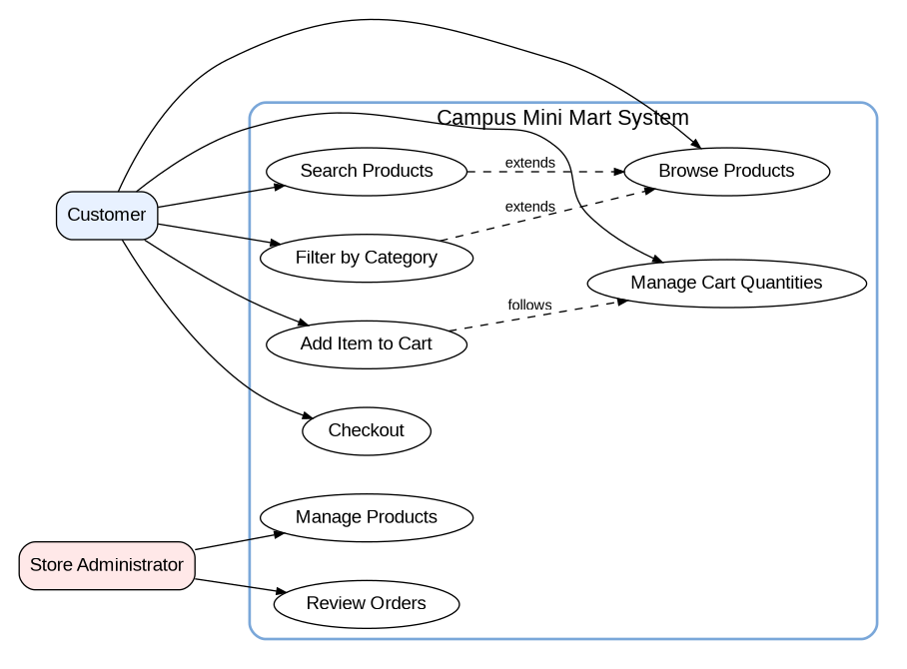
Figure 1. Use Case Diagram

Detailed Use Case Specifications

UC-1 Browse and Search Products
Field | Specification
Primary Actor | Customer
Preconditions | The user has opened the home page in a supported browser.
Trigger | Customer starts the action from the interface.
Main Flow | 1. The customer opens the product page.  2. The system displays the available product list.  3. The customer enters text into the search box or selects a category filter.  4. The system updates visible products according to the entered criteria.  5. The customer reviews the matching products.
Alternative / Exception Flows | If no products match the search text, the system displays a no-results message.  If an image fails to load, the product remains visible with its textual data.
Postconditions | The customer sees the relevant product list that matches the selected search or filter criteria.

UC-2 Add Item to Cart and Manage Quantities
Field | Specification
Primary Actor | Customer
Preconditions | At least one product is visible on the product page.
Trigger | Customer clicks Add to Cart or quantity controls.
Main Flow | 1. The customer clicks Add to Cart for a selected product.  2. The system stores the item in the cart and increases the cart count.  3. The customer opens the cart page.  4. The system displays selected items with quantity controls and totals.  5. The customer increases, decreases, or removes cart items.  6. The system recalculates subtotal and total values after each change.
Alternative / Exception Flows | If a quantity becomes zero, the system removes the item from the cart.  If the cart becomes empty, the system shows the empty-cart message.
Postconditions | The cart reflects the updated set of items and correct total cost.

UC-3 Checkout
Field | Specification
Primary Actor | Customer
Preconditions | The cart contains one or more products.
Trigger | Customer clicks the Checkout button.
Main Flow | 1. The customer reviews items on the cart page.  2. The customer clicks Checkout.  3. The system calculates the final total.  4. The system displays a confirmation message.  5. The system clears the cart after the checkout action is completed.
Alternative / Exception Flows | If the cart is empty, the system prevents checkout and shows an empty-cart message.
Postconditions | The customer receives confirmation and the cart returns to the empty state.

10. UI Wireframes / Mockups

Wireframe 1: Home Page
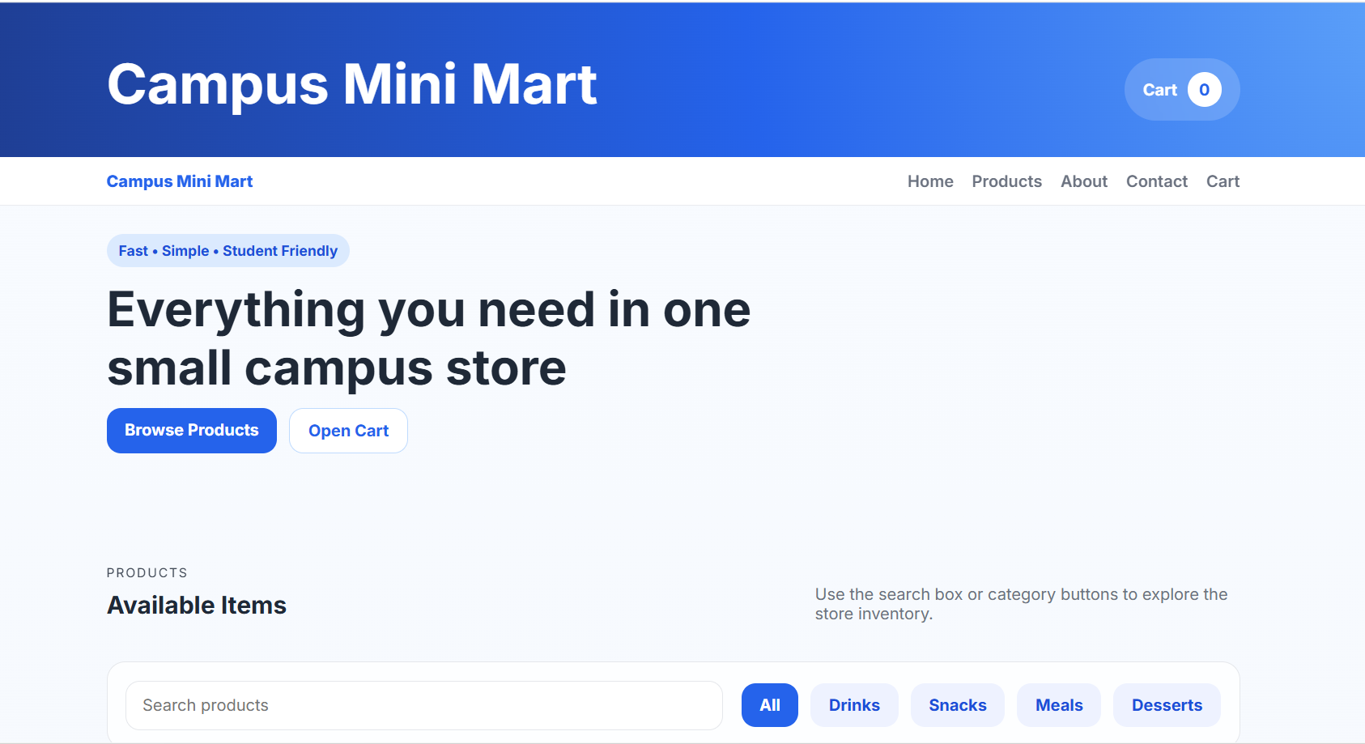
Figure 2. Home Page wireframe

Wireframe 2: Product Catalog / Search Page
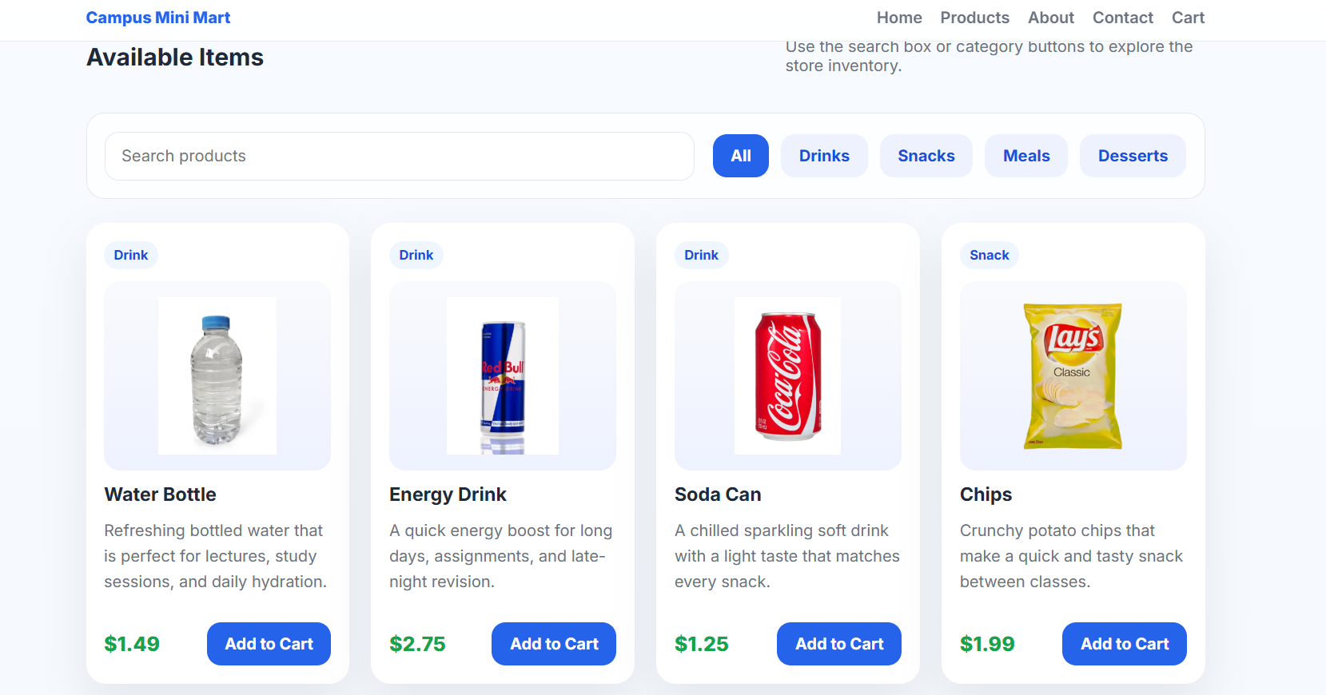
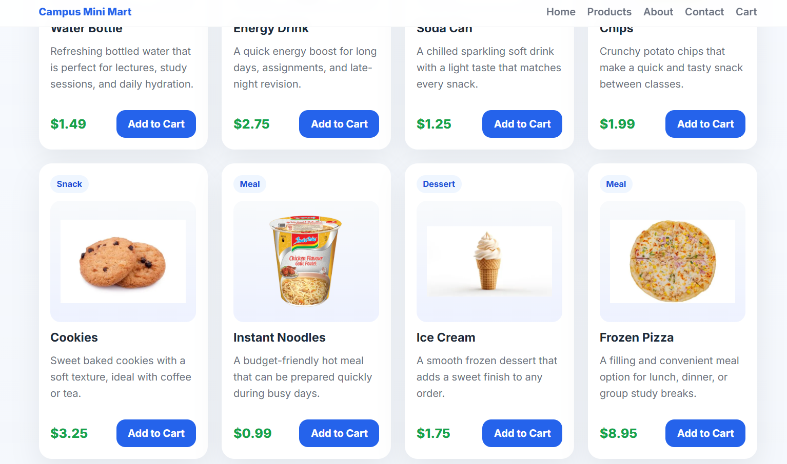
Figure 3. Product Catalog / Search Page wireframe

Wireframe 3: Shopping Cart Page
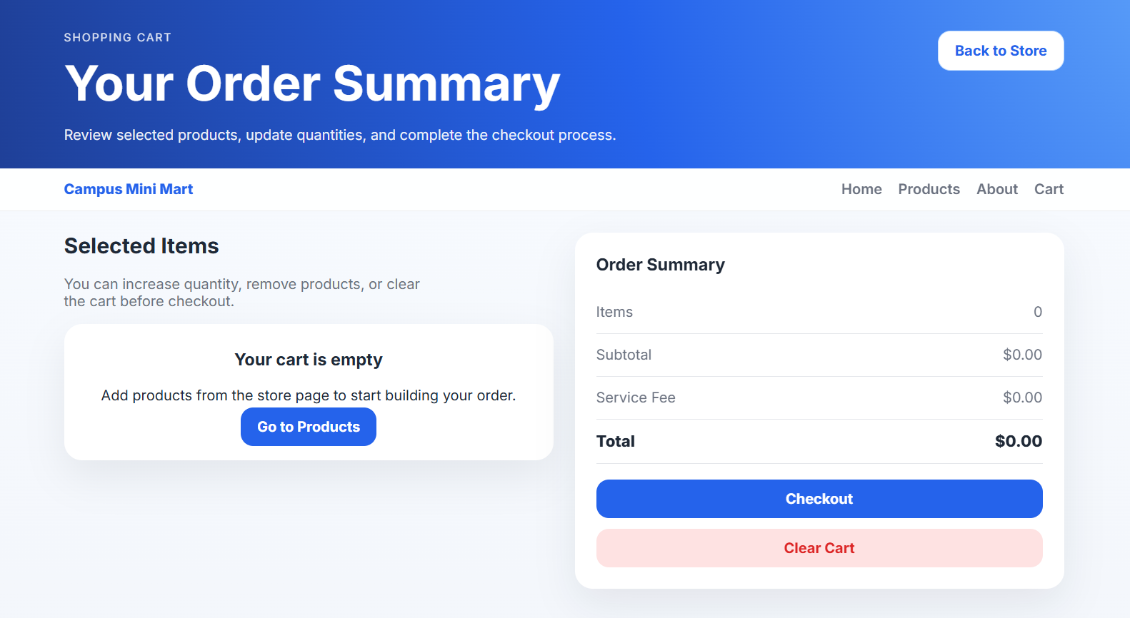
Figure 4. Shopping Cart Page wireframe

11. Modeling Package

11.1 Context Diagram
The context diagram defines the system boundary, the external actors, and the external technical environment that interacts with the system. It highlights that customers and administrators communicate with the web-based store system, while browser local storage is used to persist cart data.
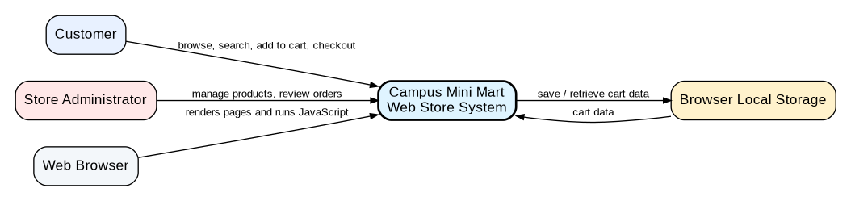
Figure 5. Context Diagram

11.2 UML Class Diagram
The class diagram models the main structural elements of the system. It includes the user hierarchy, product-related entities, cart composition, order generation, and service classes used to complete the checkout flow.
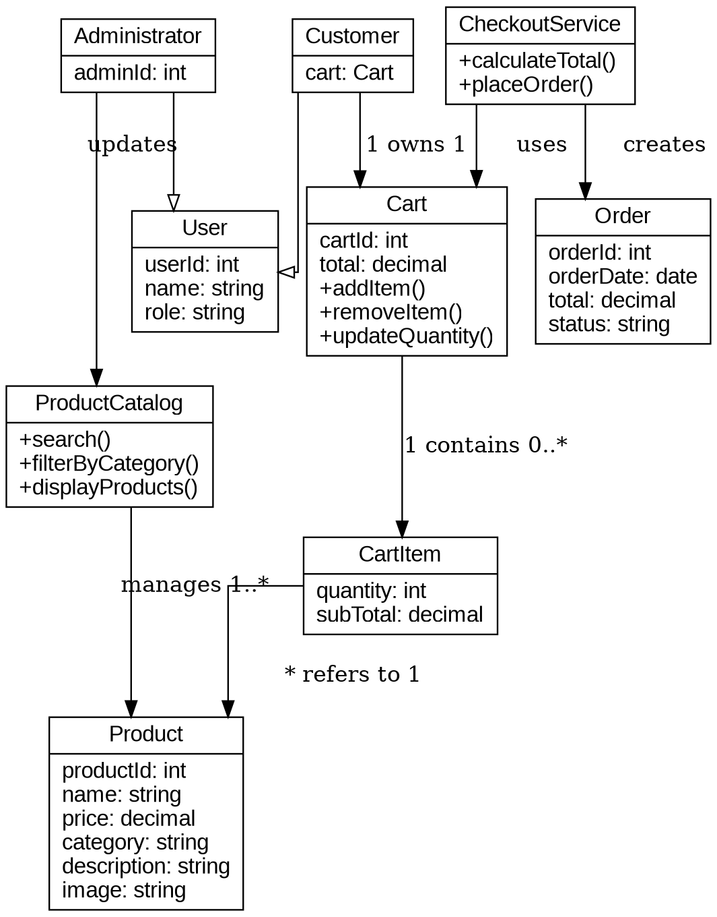
Figure 6. UML Class Diagram

11.3 Sequence Diagram
The sequence diagram below illustrates the checkout scenario, which is one of the most important interactions in the system. It shows how the customer, interface pages, checkout logic, and browser storage collaborate to complete an order session.
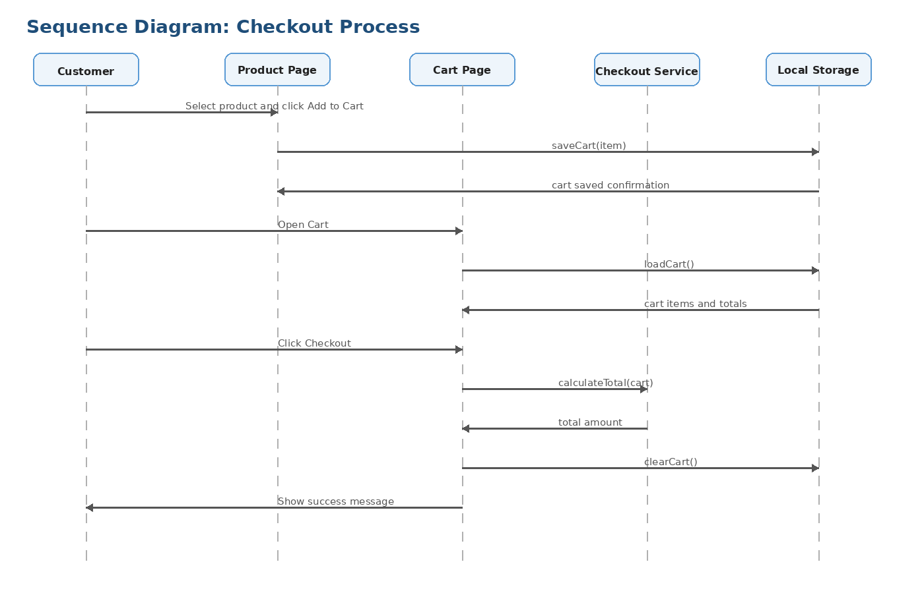
Figure 7. Sequence Diagram - Checkout Process

11.4 Behavioral Diagram (Activity Diagram)
The activity diagram models the behavior of the customer shopping flow. It begins when the user enters the system, continues through browsing and cart updates, and ends when checkout is confirmed and the cart is cleared.
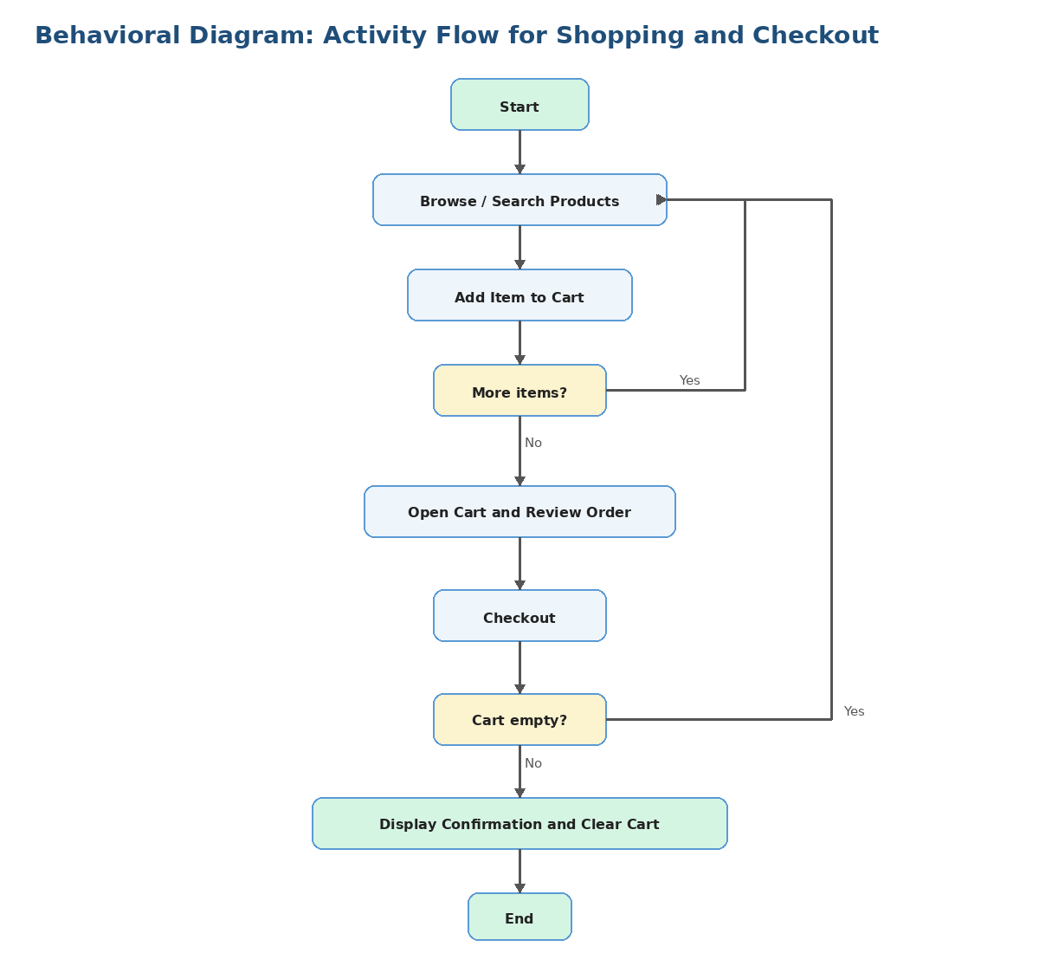
Figure 8. Activity Diagram

12. Planning and Risk Management

12.1 Project Plan
The following project execution plan shows the major phases followed by the team, including planned dates, main tasks, and completion status. The plan demonstrates how the work was organized from requirements analysis to final delivery.
Phase | Main Tasks | Start Date | End Date | Planned / Actual Output
1. Idea Selection and Team Setup | Select project topic, define team members, agree on general scope. | 17 Apr 2026 | 17 Apr 2026 | Campus Mini Mart idea approved and team formed.
2. Requirements Analysis | Identify stakeholders, scope, functional requirements, non-functional requirements, constraints, and assumptions. | 18 Apr 2026 | 22 Apr 2026 | Requirements package completed.
3. User Stories and Use Cases | Write user stories, acceptance criteria, priorities, and detailed use case specifications. | 23 Apr 2026 | 25 Apr 2026 | Backlog and use cases completed.
4. Modeling and Wireframes | Prepare UI wireframes, context diagram, use case diagram, class diagram, sequence diagram, and activity diagram. | 26 Apr 2026 | 30 Apr 2026 | Modeling package completed.
5. Prototype Development | Implement product catalog, search, filtering, cart page, quantity management, and checkout simulation. | 01 May 2026 | 05 May 2026 | Working front-end prototype completed.
6. Testing and Quality Review | Prepare test plan, run black-box functional tests, check UI behavior, review source files, and verify cart calculations. | 06 May 2026 | 08 May 2026 | Test cases executed and main features validated.
7. Risk and Final Documentation | Prepare risk register, traceability matrix, README summary, demo plan, and final presentation outline. | 09 May 2026 | 10 May 2026 | Final milestone sections completed.
8. Final Review and Submission | Review consistency, organize deliverables, verify file names, and prepare final package for submission. | 11 May 2026 | 12 May 2026 | Final project package ready for submission.

12.2 Roles and Responsibilities
The following table clearly defines the contribution of each team member. Although responsibilities were divided to organize the work, both members participated in discussion, review, testing, and final improvement of the project.
Team Member | Student ID | Main Responsibilities | Shared Responsibilities
Yazan Hijazi | 12401471 | Front-end implementation of the main store page; product catalog layout; search and category filtering; UI styling support; README and delivery organization. | Requirements discussion, prototype review, testing, final documentation review, and final package preparation.
Yazan Zaghlol | 12217530 | Shopping cart functionality; localStorage behavior; cart totals and checkout simulation; SRS documentation; UML/modeling support; test cases and traceability matrix. | Requirements discussion, prototype review, testing, final documentation review, and final package preparation.

12.3 Risk Register
The risk register identifies possible project risks, estimates their likelihood and impact, and defines mitigation actions. The risks are related to requirements, implementation, testing, coordination, and delivery.
Risk ID | Risk Description | Likelihood | Impact | Mitigation Action
R-1 | Requirements may be unclear or changed late in the milestone. | Medium | High | Review instructor instructions carefully and update the document before final submission.
R-2 | Implementation may be delayed because of limited time or team workload. | Medium | High | Divide tasks into small activities, use a clear schedule, and complete critical features first.
R-3 | Product images may be missing, broken, or placed in the wrong folder. | Medium | Medium | Keep all images inside the images/products folder and test image paths before submission.
R-4 | Cart data may not be saved correctly between pages. | Medium | High | Use localStorage consistently and test adding items, opening cart, and clearing cart.
R-5 | Search or filter functions may hide products incorrectly. | Low | Medium | Test different search keywords and all category buttons using normal and edge cases.
R-6 | Total price may be calculated incorrectly after quantity changes. | Medium | High | Recalculate subtotal and total after every add, remove, increase, and decrease action.
R-7 | Team coordination issues may cause duplicated or inconsistent work. | Low | Medium | Use meetings, calls, and shared review sessions to agree on final changes.
R-8 | The project may not run correctly on another device or browser. | Medium | Medium | Use relative paths, standard HTML/CSS/JS, and test on at least one modern browser.
R-9 | Repository or submission package may contain unnecessary or missing files. | Medium | Medium | Prepare a clean folder structure and review the final ZIP before uploading.
R-10 | Testing evidence may be incomplete or not linked to requirements. | Low | High | Prepare test cases and a traceability matrix linking functional requirements to tests.

13. Quality and Testing

13.1 Test Plan
The purpose of this test plan is to verify that the Campus Mini Mart prototype satisfies its main functional requirements and provides a usable shopping experience for customers.
Test Plan Item | Description
Features to be Tested | Product display, search, category filtering, add to cart, cart persistence, quantity update, remove item, clear cart, subtotal/total calculation, checkout simulation, responsive layout.
Features Not Tested in Prototype | Real online payment, delivery tracking, full database integration, and administrator authentication because these are outside the current front-end prototype scope.
Testing Approach | Black-box functional testing is used to check user-visible behavior. Basic white-box review is used to check JavaScript functions, event handling, and localStorage usage.
Test Types Used | Functional testing, usability testing, boundary/edge testing, negative testing, compatibility checking, and simple code review.
Test Environment | Modern web browser on a desktop/laptop device. The project is opened from local HTML files using relative paths.
Testing Responsibility | Both team members participate in testing. Yazan Hijazi focuses on product page behavior and layout, while Yazan Zaghlol focuses on cart behavior, calculations, and checkout.
Testing Time | Testing is performed after prototype implementation and again before final submission.
Pass Criteria | A test case passes when the actual result matches the expected result and no blocking UI or calculation issue appears.

13.2 Test Cases
The following test cases cover normal cases, edge cases, and negative cases. They reflect the real functionality of the current prototype.
TC ID | Requirement / Feature Tested | Input / Steps | Expected Result | Actual Result
TC-01 | FR-1 Product list display | Open the main store page. | All available products appear with names, images, categories, descriptions, and prices. | Pass
TC-02 | FR-3 Search by name | Type "Water" in the search box. | Only matching products such as Water Bottle remain visible. | Pass
TC-03 | FR-3 Search no result | Type an unavailable product name such as "Laptop". | No matching products are displayed and the user understands that no product matches. | Pass
TC-04 | FR-4 Filter by category | Click the Drinks category button. | Only drink products are displayed. | Pass
TC-05 | FR-4 Reset filter | Click All after selecting a specific category. | All products become visible again. | Pass
TC-06 | FR-5 Add to cart | Click Add to Cart for Chips. | The product is stored in the cart and the cart count increases. | Pass
TC-07 | FR-6 Cart persistence | Add an item, then open the cart page. | The added item appears in the cart page using saved localStorage data. | Pass
TC-08 | FR-7 Increase quantity | Click the increase quantity control for an item in the cart. | The item quantity increases and subtotal/total values update correctly. | Pass
TC-09 | FR-7 Decrease quantity | Click the decrease quantity control for an item with quantity greater than 1. | The item quantity decreases and totals update correctly. | Pass
TC-10 | FR-8 Remove item | Remove a selected product from the cart. | The product is deleted from the cart and the total is recalculated. | Pass
TC-11 | FR-10 Clear cart | Click Clear Cart when the cart contains items. | All cart items are removed and the empty-cart message appears. | Pass
TC-12 | FR-9 Total calculation | Add two different products and change quantities. | The displayed subtotal and total match the sum of item prices multiplied by quantities. | Pass
TC-13 | FR-11 Checkout with items | Add at least one item and click Checkout. | A confirmation message appears and the cart is cleared after checkout. | Pass
TC-14 | FR-11 Checkout empty cart | Open an empty cart and click Checkout. | The system prevents meaningful checkout and keeps the cart empty. | Pass
TC-15 | NFR-6 Portability / responsive use | Open the website in a browser and reduce the window width. | The layout remains readable and usable on a smaller screen. | Pass

13.3 Traceability Matrix
The traceability matrix links requirements to related test cases. This shows that the main functional requirements are covered by testing.
Requirement ID | Requirement Summary | Related Test Case(s) | Coverage Status
FR-1 | Display list of available products. | TC-01 | Covered
FR-2 | Display product name, image, category, description, and price. | TC-01 | Covered
FR-3 | Search products by product name. | TC-02, TC-03 | Covered
FR-4 | Filter products by category. | TC-04, TC-05 | Covered
FR-5 | Add selected product to shopping cart. | TC-06 | Covered
FR-6 | Store cart data locally during browsing session. | TC-07 | Covered
FR-7 | Increase or decrease cart item quantity. | TC-08, TC-09 | Covered
FR-8 | Remove an item from the cart. | TC-10 | Covered
FR-9 | Calculate and display subtotal and total values. | TC-08, TC-09, TC-12 | Covered
FR-10 | Clear the cart completely. | TC-11 | Covered
FR-11 | Complete a simulated checkout operation. | TC-13, TC-14 | Covered
FR-12 | Administrator can manage products and review orders in the planned full system. | Not tested in current prototype | Future scope

14. Team Contribution
This project was completed through continuous teamwork and collaboration between both team members. The team did not work as completely separate individuals on isolated parts. Instead, both members worked together through university meetings, phone calls, and Zoom sessions to discuss the project idea, analyze the requirements, review the diagrams, test the prototype, and improve the final documentation.

Yazan Hijazi and Yazan Zaghlol both participated in the main project activities, including planning, requirements analysis, user stories, use case discussions, modeling review, prototype testing, documentation improvement, and final package preparation.

Although the work was organized to make progress easier, all major decisions and final project parts were discussed, reviewed, and improved collaboratively by both members to ensure consistency, completeness, and quality.

15. Conclusion
Campus Mini Mart is a suitable Software Engineering project because it has a clear problem, defined target users, measurable requirements, realistic use cases, and visual system models. The project demonstrates the main software engineering activities, including requirements analysis, user stories, use case modeling, UI wireframes, UML diagrams, planning, risk management, and testing.

The current version provides a functional front-end MVP that allows users to browse products, search and filter items, add products to a shopping cart, update quantities, remove items, calculate totals, and complete a simulated checkout. The prototype focuses on the main customer shopping flow and intentionally excludes advanced features such as real online payment, delivery tracking, full database integration, and administrator authentication.

The project also includes a project plan, roles and responsibilities, risk register, test plan, test cases, and a traceability matrix to show that the main requirements were organized, reviewed, and tested. These sections help demonstrate that the project was developed in a structured and consistent way, not only as a web prototype but as a complete Software Engineering process.

Future improvements may include adding a real database, user authentication, an administrator dashboard, online payment integration, order history, and delivery or pickup tracking. Overall, Campus Mini Mart presents a clear, organized, and testable software system that connects requirements, design, implementation, and testing in a consistent final package.

