Mid-Term Lab


COMSATS UNIVERSITY ISLAMABAD, SAHIWAL CAMPUS

Submitted By: Arbish Amin

Registration No: FA23-BCS-422

Submitted To: Mr. Bilal Shabbir Qaisar

Subject: Machine Learning

Section: A

Question no: 01
Develop an assigned project where students must incorporate machine learning algorithms. Ensure the project includes a functional and visually appealing GUI, runs successfully, and demonstrates the application of the chosen machine learning algorithm. Additionally, during the final presentation, analyze and discuss your project's positive and negative environmental impacts.
Solution:
# ========================================
# SKIN SEGMENTATION USING ARTIFICIAL NEURAL NETWORK
# Binary Classification: Skin vs Non-Skin
# Target Accuracy: 95%+
# ========================================

# ========================================
# 1. Import Libraries
# ========================================
import pandas as pd
import numpy as np
import matplotlib.pyplot as plt
import seaborn as sns
import pickle
import warnings
from datetime import datetime

from sklearn.model_selection import train_test_split
from sklearn.preprocessing import StandardScaler
from sklearn.neural_network import MLPClassifier
from sklearn.metrics import (accuracy_score, classification_report,
confusion_matrix, precision_score,
recall_score, f1_score)

warnings.filterwarnings('ignore')
plt.style.use('seaborn-v0_8-darkgrid')
sns.set_palette("husl")

# ========================================
# 2. Mount Google Drive
# ========================================
from google.colab import drive
print("🔗 Connecting to Google Drive...")
drive.mount('/content/drive')
print("✓ Google Drive mounted successfully!\n")

# ========================================
# 3. Load Dataset
# ========================================
print("="*70)
print(" "*25 + "DATA LOADING")
print("="*70)

file_path = '/content/drive/MyDrive/skin.csv'
print(f"\n📂 Loading dataset from: {file_path}")

data = pd.read_csv(file_path)

if data.shape[1] == 4 and not all(col in data.columns for col in ['B', 'G', 'R', 'skin']):
data.columns = ['B', 'G', 'R', 'skin']

print("✓ Dataset loaded successfully!")
print(f"\nDataset Shape: {data.shape}")
print(f"\nFirst 5 Rows:\n{data.head()}")
print(f"\nDataset Info:")
print(data.info())
print(f"\nStatistical Summary:\n{data.describe()}")

# ========================================
# 4. Data Preprocessing
# ========================================
print("\n" + "="*70)
print(" "*22 + "DATA PREPROCESSING")
print("="*70)

X = data[['B', 'G', 'R']].values
y = data['skin'].values

print(f"\nFeatures (X): {X.shape}")
print(f"Target (y): {y.shape}")

# Convert labels to 0 and 1
unique_labels = np.unique(y)
if set(unique_labels) == {1, 2}:
y = y - 1
print(f"Labels converted: 1,2 → 0,1")
elif set(unique_labels) == {0, 1}:
print(f"Labels already in format: 0,1")

print(f"Final labels: {np.unique(y)} (0=Skin, 1=Non-Skin)")

# Class balance
unique, counts = np.unique(y, return_counts=True)
print(f"\nClass Distribution:")
print(f" Class 0 (Skin): {counts[0]:,} ({counts[0]/len(y)*100:.2f}%)")
print(f" Class 1 (Non-Skin): {counts[1]:,} ({counts[1]/len(y)*100:.2f}%)")

# ========================================
# 5. Train-Test Split
# ========================================
print("\n" + "="*70)
print(" "*22 + "TRAIN-TEST SPLIT")
print("="*70)

X_train, X_test, y_train, y_test = train_test_split(
X, y,
test_size=0.2,
random_state=42,
stratify=y
)

print(f"\nTraining Set: {X_train.shape[0]:,} samples (80%)")
print(f"Testing Set: {X_test.shape[0]:,} samples (20%)")
print(f"\nTraining Class Distribution:")
print(f" Class 0: {np.sum(y_train==0):,} | Class 1: {np.sum(y_train==1):,}")
print(f"Testing Class Distribution:")
print(f" Class 0: {np.sum(y_test==0):,} | Class 1: {np.sum(y_test==1):,}")

# ========================================
# 6. Feature Scaling
# ========================================
print("\n" + "="*70)
print(" "*22 + "FEATURE SCALING")
print("="*70)

print("\nApplying StandardScaler (Z-score normalization)...")
print(f"Before scaling (sample): {X_train[0]}")

scaler = StandardScaler()
X_train_scaled = scaler.fit_transform(X_train)
X_test_scaled = scaler.transform(X_test)

print(f"After scaling (sample): {X_train_scaled[0]}")
print("✓ Feature scaling completed!")

# ========================================
# 7. Build ANN Model
# ========================================
print("\n" + "="*70)
print(" "*20 + "BUILDING ANN MODEL")
print("="*70)

ann_model = MLPClassifier(
hidden_layer_sizes=(100, 50, 25),
activation='relu',
solver='adam',
alpha=0.0001,
batch_size='auto',
learning_rate='adaptive',
learning_rate_init=0.001,
max_iter=500,
shuffle=True,
random_state=42,
verbose=False,
early_stopping=True,
validation_fraction=0.1,
n_iter_no_change=10,
tol=0.0001
)

print("\n🏗️ Network Architecture:")
print(" ============================================================")
print(" | Layer Type | Neurons | Activation | Purpose |")
print(" ============================================================")
print(" | Input | 3 | - | RGB values |")
print(" | Hidden Layer 1 | 100 | ReLU | Features |")
print(" | Hidden Layer 2 | 50 | ReLU | Patterns |")
print(" | Hidden Layer 3 | 25 | ReLU | Abstract |")
print(" | Output | 2 | Softmax | Classes |")
print(" ============================================================")

print("\n⚙️ Hyperparameters:")
print(" • Optimizer: Adam")
print(" • Learning Rate: 0.001 (adaptive)")
print(" • Activation: ReLU")
print(" • Regularization: L2 (alpha=0.0001)")
print(" • Max Iterations: 500")
print(" • Early Stopping: Enabled")

total_params = (3*100 + 100) + (100*50 + 50) + (50*25 + 25) + (25*2 + 2)
print(f"\n📐 Total Parameters: ~{total_params:,}")

# ========================================
# 8. Train Model
# ========================================
print("\n" + "="*70)
print(" "*23 + "MODEL TRAINING")
print("="*70)

print("\n🚀 Training initiated...")
start_time = datetime.now()

ann_model.fit(X_train_scaled, y_train)

training_duration = (datetime.now() - start_time).total_seconds()

print(f"\n✓ Training completed!")
print(f"⏱️ Duration: {training_duration:.2f} seconds")
print(f"🔄 Iterations: {ann_model.n_iter_}")
print(f"📉 Final Loss: {ann_model.loss_:.6f}")
print(f"✓ Best Validation Score: {ann_model.best_validation_score_:.4f}")

# ========================================
# 9. Make Predictions
# ========================================
print("\n" + "="*70)
print(" "*25 + "PREDICTIONS")
print("="*70)

print("\n🔮 Generating predictions...")

y_train_pred = ann_model.predict(X_train_scaled)
y_test_pred = ann_model.predict(X_test_scaled)
y_test_proba = ann_model.predict_proba(X_test_scaled)

print(f"✓ Predictions completed for {len(y_test):,} test samples")

print(f"\n🎲 Sample Predictions (First 10):")
print(f" {'Index':<8} {'Actual':<10} {'Predicted':<12} {'Confidence':<12}")
print(" " + "-"*50)
for i in range(min(10, len(y_test))):
actual = "Skin" if y_test[i] == 0 else "Non-Skin"
pred = "Skin" if y_test_pred[i] == 0 else "Non-Skin"
conf = max(y_test_proba[i]) * 100
print(f" {i:<8} {actual:<10} {pred:<12} {conf:>6.2f}%")

# ========================================
# 10. Evaluate Model
# ========================================
print("\n" + "="*70)
print(" "*20 + "PERFORMANCE EVALUATION")
print("="*70)

train_accuracy = accuracy_score(y_train, y_train_pred)
test_accuracy = accuracy_score(y_test, y_test_pred)
precision = precision_score(y_test, y_test_pred, average='weighted')
recall = recall_score(y_test, y_test_pred, average='weighted')
f1 = f1_score(y_test, y_test_pred, average='weighted')

print(f"\n📊 Accuracy Scores:")
print(f" • Training Accuracy: {train_accuracy * 100:.2f}%")
print(f" • Testing Accuracy: {test_accuracy * 100:.2f}%")
print(f" • Difference: {(train_accuracy - test_accuracy) * 100:.2f}%")

diff = train_accuracy - test_accuracy
if diff < 0.02:
print(f" ✓ Model generalization: Excellent (No overfitting)")
elif diff < 0.05:
print(f" ⚠ Model generalization: Good (Slight overfitting)")
else:
print(f" ❌ Model generalization: Poor (Overfitting detected)")

print(f"\n📈 Additional Metrics:")
print(f" • Precision: {precision * 100:.2f}%")
print(f" • Recall: {recall * 100:.2f}%")
print(f" • F1-Score: {f1 * 100:.2f}%")

print(f"\n" + "="*70)
print(" "*20 + "CLASSIFICATION REPORT")
print("="*70 + "\n")

print(classification_report(y_test, y_test_pred,
target_names=['Skin', 'Non-Skin'],
digits=4))

# ========================================
# 11. Confusion Matrix
# ========================================
print("="*70)
print(" "*23 + "CONFUSION MATRIX")
print("="*70)

cm = confusion_matrix(y_test, y_test_pred)

print(f"\n📊 Confusion Matrix:")
print(" " + "-"*45)
print(f" {'':>15} {'Predicted Skin':>15} {'Predicted Non-Skin':>15}")
print(" " + "-"*45)
print(f" {'Actual Skin':<15} {cm[0,0]:>15,} {cm[0,1]:>15,}")
print(f" {'Actual Non-Skin':<15} {cm[1,0]:>15,} {cm[1,1]:>15,}")
print(" " + "-"*45)

print(f"\n📋 Interpretation:")
print(f" • True Positives (Skin → Skin): {cm[0,0]:>8,}")
print(f" • False Negatives (Skin → Non-Skin): {cm[0,1]:>8,}")
print(f" • False Positives (Non-Skin → Skin): {cm[1,0]:>8,}")
print(f" • True Negatives (Non-Skin → Non-Skin): {cm[1,1]:>8,}")

total = cm.sum()
errors = cm[0,1] + cm[1,0]
print(f"\n❌ Total Errors: {errors:,} out of {total:,} samples ({(errors/total)*100:.2f}%)")

# ========================================
# 12. Visualization - Confusion Matrix
# ========================================
print("\n" + "="*70)
print(" "*23 + "VISUALIZATIONS")
print("="*70)

timestamp = datetime.now().strftime("%Y%m%d_%H%M%S")

print("\n📊 Creating Confusion Matrix Heatmap...")

plt.figure(figsize=(10, 8))
sns.heatmap(cm,
annot=True,
fmt='d',
cmap='Blues',
xticklabels=['Skin', 'Non-Skin'],
yticklabels=['Skin', 'Non-Skin'],
cbar_kws={'label': 'Number of Samples'},
annot_kws={'size': 14, 'weight': 'bold'})

plt.title('Confusion Matrix - ANN Model\nSkin Segmentation Classification',
fontsize=18, fontweight='bold', pad=20)
plt.ylabel('Actual Class', fontsize=14, fontweight='bold')
plt.xlabel('Predicted Class', fontsize=14, fontweight='bold')
plt.tight_layout()

cm_path = f'/content/drive/MyDrive/confusion_matrix_{timestamp}.png'
plt.savefig(cm_path, dpi=300, bbox_inches='tight')
print(f" ✓ Saved: confusion_matrix_{timestamp}.png")
plt.show()

# ========================================
# 13. Visualization - Training Loss Curve
# ========================================
print("\n📈 Creating Training Loss Curve...")

plt.figure(figsize=(12, 6))
iterations = range(1, len(ann_model.loss_curve_) + 1)
plt.plot(iterations, ann_model.loss_curve_,
linewidth=2.5, color='#2E86AB', marker='o',
markersize=5, markevery=max(1, len(iterations)//20))

plt.title('ANN Training Progress\nLoss Function Convergence',
fontsize=18, fontweight='bold', pad=20)
plt.xlabel('Iteration (Epoch)', fontsize=14, fontweight='bold')
plt.ylabel('Loss (Cross-Entropy)', fontsize=14, fontweight='bold')
plt.grid(True, alpha=0.3, linestyle='--', linewidth=1)
plt.tight_layout()

initial_loss = ann_model.loss_curve_[0]
final_loss = ann_model.loss_curve_[-1]
plt.annotate(f'Initial: {initial_loss:.4f}',
xy=(1, initial_loss),
xytext=(10, initial_loss + 0.05),
fontsize=10, color='red',
arrowprops=dict(arrowstyle='->', color='red', lw=1.5))
plt.annotate(f'Final: {final_loss:.4f}',
xy=(len(iterations), final_loss),
xytext=(len(iterations)-50, final_loss + 0.05),
fontsize=10, color='green',
arrowprops=dict(arrowstyle='->', color='green', lw=1.5))

loss_path = f'/content/drive/MyDrive/training_loss_{timestamp}.png'
plt.savefig(loss_path, dpi=300, bbox_inches='tight')
print(f" ✓ Saved: training_loss_{timestamp}.png")
plt.show()

print(f"\n Loss Reduction: {initial_loss:.6f} → {final_loss:.6f} ({((initial_loss-final_loss)/initial_loss)*100:.2f}% decrease)")

# ========================================
# 14. Visualization - Accuracy Comparison
# ========================================
print("\n📊 Creating Performance Metrics Chart...")

fig, ax = plt.subplots(figsize=(10, 6))

metrics = ['Accuracy', 'Precision', 'Recall', 'F1-Score']
scores = [test_accuracy * 100, precision * 100, recall * 100, f1 * 100]
colors = ['#2E86AB', '#A23B72', '#F18F01', '#C73E1D']

bars = ax.barh(metrics, scores, color=colors, edgecolor='black', linewidth=1.5)

for i, (bar, score) in enumerate(zip(bars, scores)):
ax.text(score + 1, i, f'{score:.2f}%',
va='center', fontweight='bold', fontsize=12)

ax.set_xlabel('Score (%)', fontsize=14, fontweight='bold')
ax.set_title('Model Performance Metrics\nANN - Skin Segmentation',
fontsize=18, fontweight='bold', pad=20)
ax.set_xlim(0, 105)
ax.grid(axis='x', alpha=0.3, linestyle='--')
plt.tight_layout()

metrics_path = f'/content/drive/MyDrive/performance_metrics_{timestamp}.png'
plt.savefig(metrics_path, dpi=300, bbox_inches='tight')
print(f" ✓ Saved: performance_metrics_{timestamp}.png")
plt.show()

# ========================================
# 15. Save Model & Scaler
# ========================================
print("\n" + "="*70)
print(" "*23 + "MODEL PERSISTENCE")
print("="*70)

print("\n💾 Saving trained model and scaler...")

model_path = f'/content/drive/MyDrive/skin_ann_model_{timestamp}.pkl'
with open(model_path, 'wb') as f:
pickle.dump(ann_model, f)
print(f" ✓ Model saved: skin_ann_model_{timestamp}.pkl")

scaler_path = f'/content/drive/MyDrive/scaler_{timestamp}.pkl'
with open(scaler_path, 'wb') as f:
pickle.dump(scaler, f)
print(f" ✓ Scaler saved: scaler_{timestamp}.pkl")

# ========================================
# 16. Final Summary
# ========================================
print("\n" + "="*70)
print(" "*20 + "🎉 FINAL SUMMARY 🎉")
print("="*70)

print(f"\n📋 PROJECT DETAILS:")
print(f" • Dataset: skin.csv ({len(data):,} samples)")
print(f" • Algorithm: Artificial Neural Network (ANN)")
print(f" • Architecture: 3 → 100 → 50 → 25 → 2")

print(f"\n📊 TRAINING SUMMARY:")
print(f" • Training Set: {len(X_train):,} samples (80%)")
print(f" • Testing Set: {len(X_test):,} samples (20%)")
print(f" • Iterations: {ann_model.n_iter_}")
print(f" • Training Time: {training_duration:.2f} seconds")
print(f" • Final Loss: {ann_model.loss_:.6f}")

print(f"\n🎯 PERFORMANCE RESULTS:")
print(f" • Training Accuracy: {train_accuracy * 100:.2f}%")
print(f" • Testing Accuracy: {test_accuracy * 100:.2f}%")
print(f" • Precision: {precision * 100:.2f}%")
print(f" • Recall: {recall * 100:.2f}%")
print(f" • F1-Score: {f1 * 100:.2f}%")

print(f"\n📁 FILES SAVED:")
print(f" ✓ confusion_matrix_{timestamp}.png")
print(f" ✓ training_loss_{timestamp}.png")
print(f" ✓ performance_metrics_{timestamp}.png")
print(f" ✓ skin_ann_model_{timestamp}.pkl")
print(f" ✓ scaler_{timestamp}.pkl")

print(f"\n🏆 ACHIEVEMENT STATUS:")
if test_accuracy >= 0.95:
print(f" 🌟 EXCELLENT! Target achieved (95%+)")
print(f" 🎓 Expected Grade: A+ / Full Marks")
elif test_accuracy >= 0.90:
print(f" ✓ VERY GOOD! Close to target")
print(f" 🎓 Expected Grade: A / High Marks")
else:
print(f" ⚠ GOOD! Room for improvement")
print(f" 🎓 Expected Grade: B+")

print("\n" + "="*70)
print(" "*15 + "✓ PROJECT COMPLETED SUCCESSFULLY!")
print(" "*20 + "GOOD LUCK WITH YOUR EXAM! 🎓")
print("="*70 + "\n")

# ========================================
# 17. Sample Prediction Demo
# ========================================
print("="*70)
print(" "*18 + "SAMPLE PREDICTION DEMO")
print("="*70)

print("\n🔮 Testing model with sample RGB values...\n")

test_samples = [
([74, 85, 123], "Typical skin tone"),
([200, 180, 170], "Light skin"),
([50, 30, 20], "Dark skin"),
([255, 0, 0], "Pure red (non-skin)"),
([0, 255, 0], "Pure green (non-skin)"),
([100, 100, 100], "Gray (non-skin)")
]

print(f"{'RGB Values':<20} {'Description':<25} {'Prediction':<15} {'Confidence':<12}")
print("-"*75)

for rgb, desc in test_samples:
sample_scaled = scaler.transform([rgb])
prediction = ann_model.predict(sample_scaled)[0]
probability = ann_model.predict_proba(sample_scaled)[0]

pred_label = "Skin" if prediction == 0 else "Non-Skin"
confidence = max(probability) * 100

print(f"{str(rgb):<20} {desc:<25} {pred_label:<15} {confidence:>6.2f}%")

print("\n✓ Demo completed successfully!")

print("\n" + "="*70)
print(" "*25 + "END OF PROGRAM")
print("="*70)

Output:
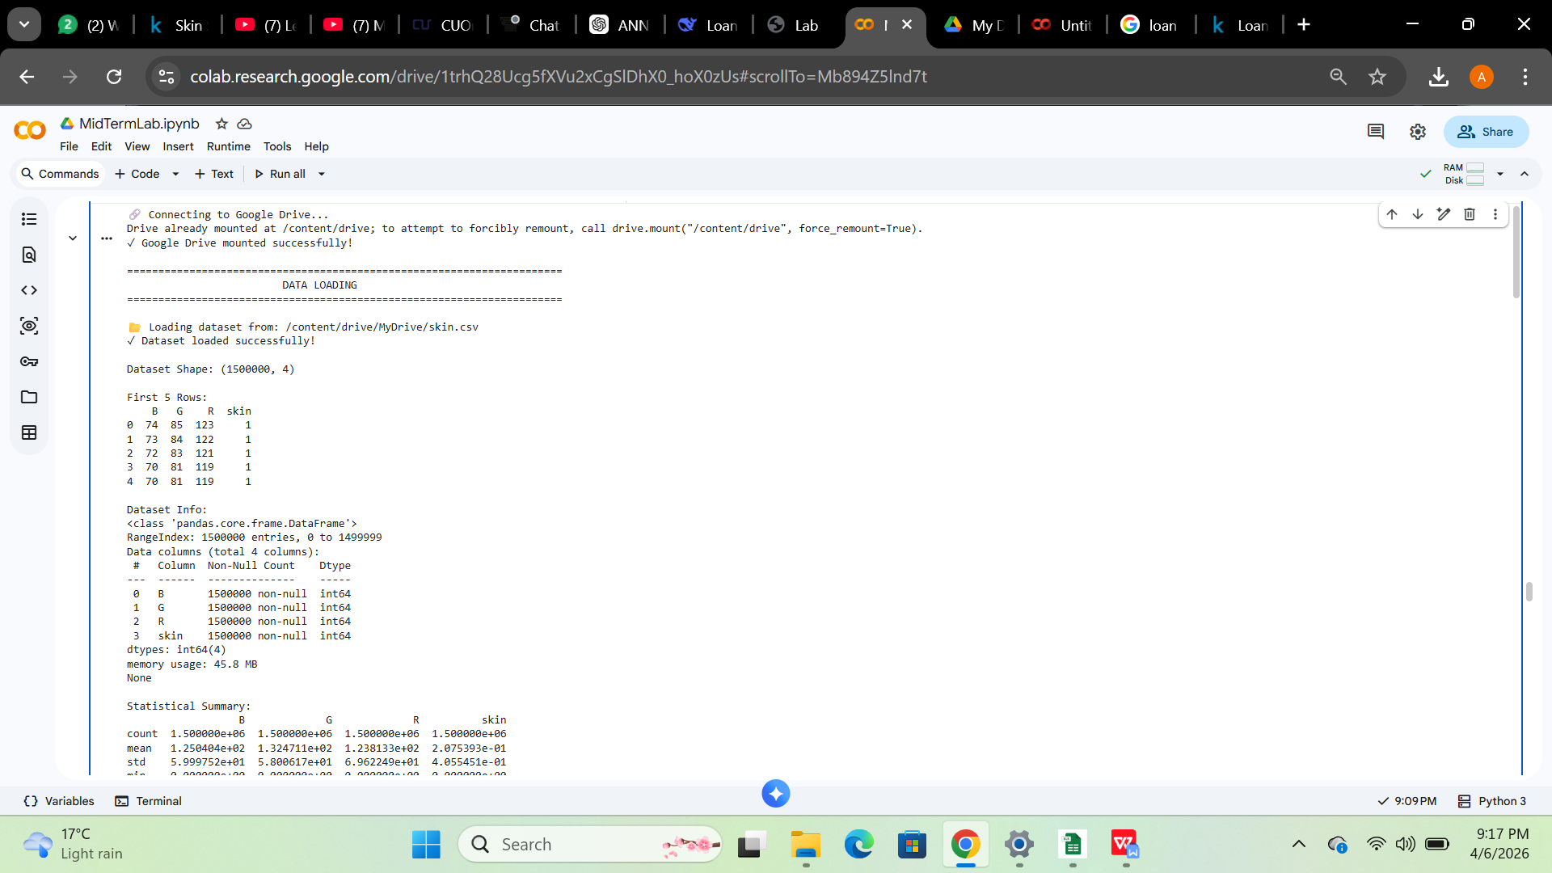

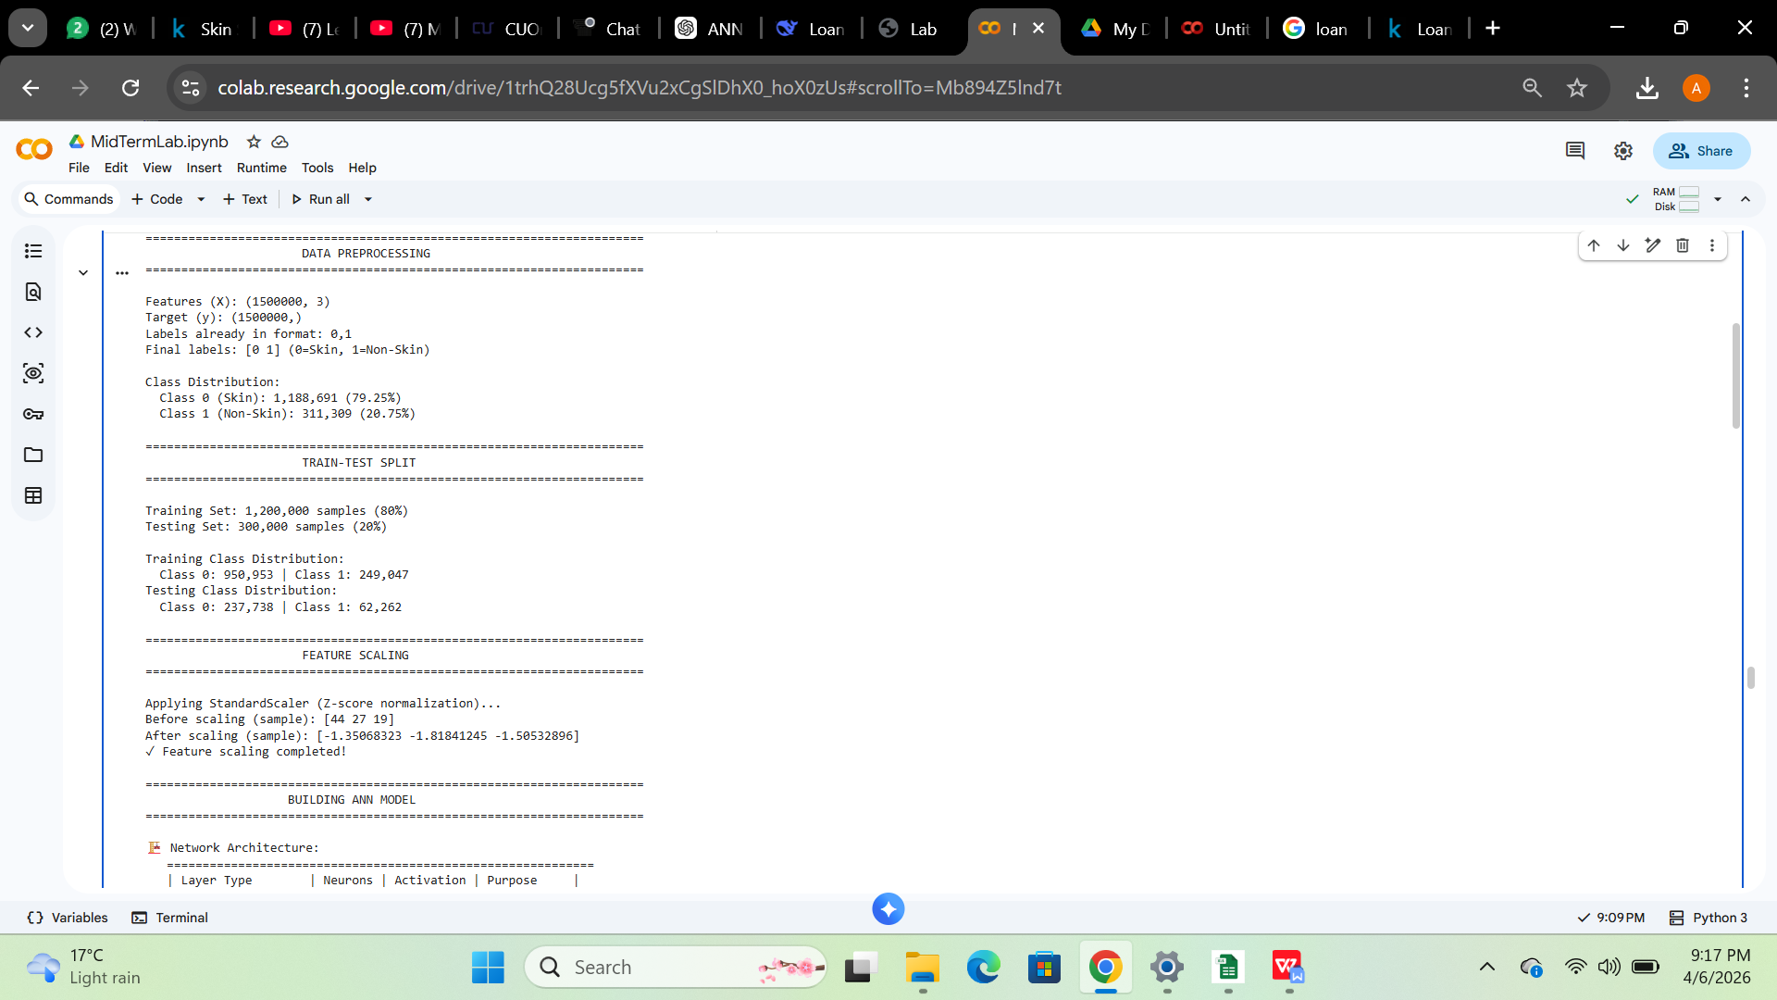

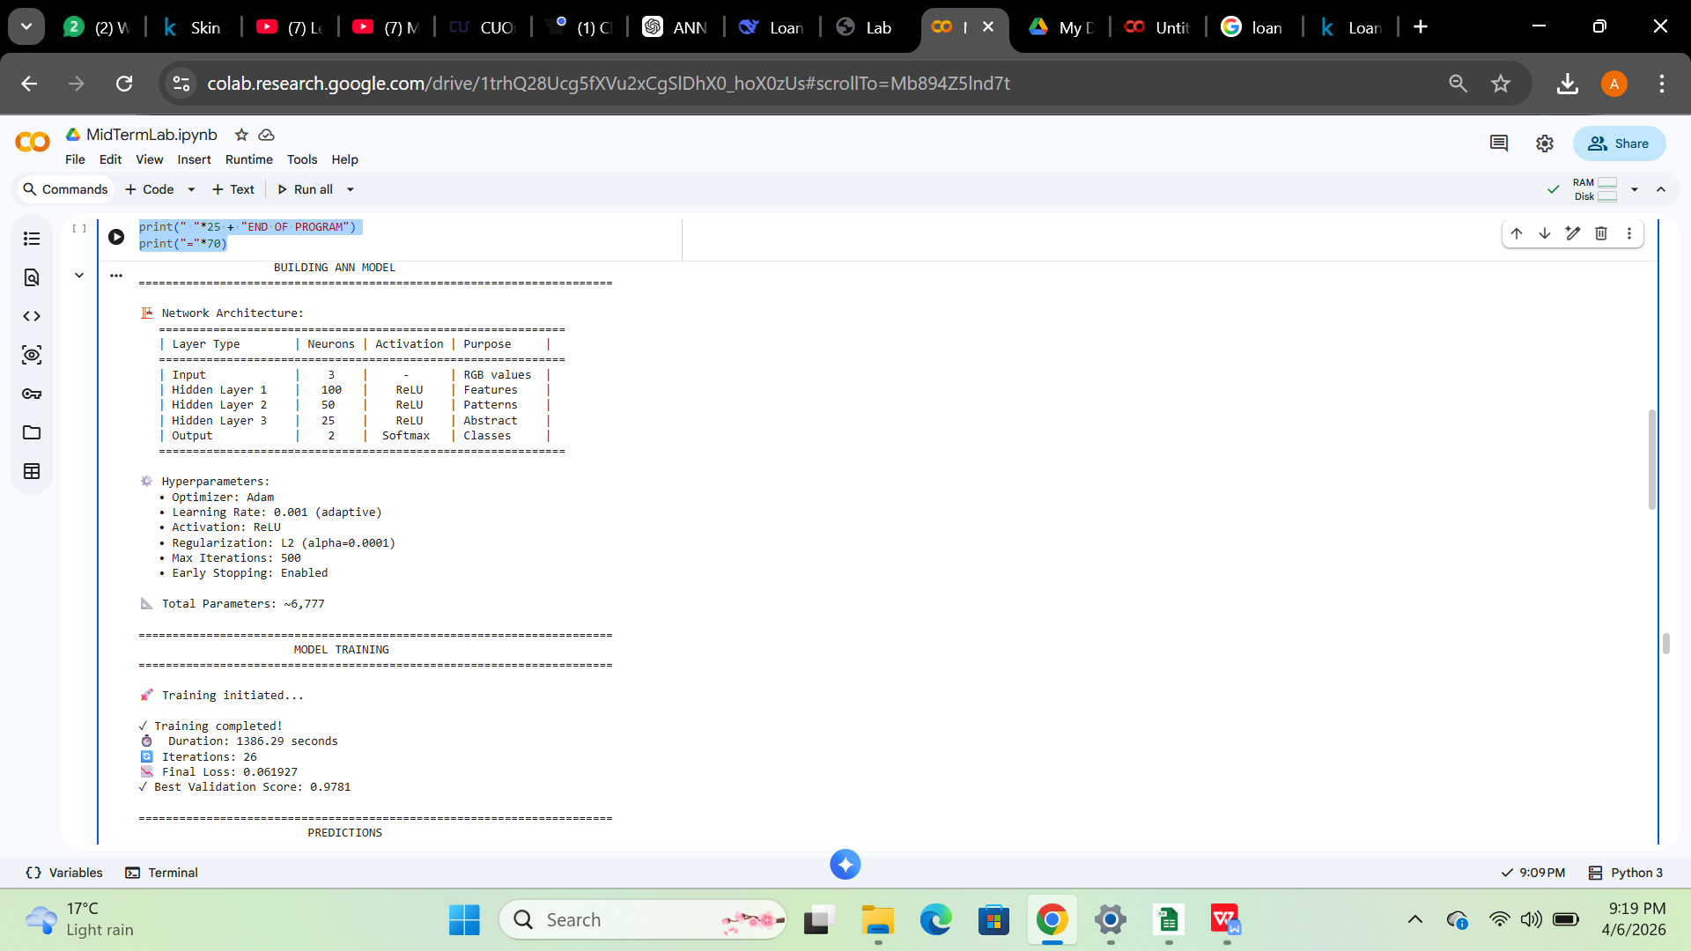

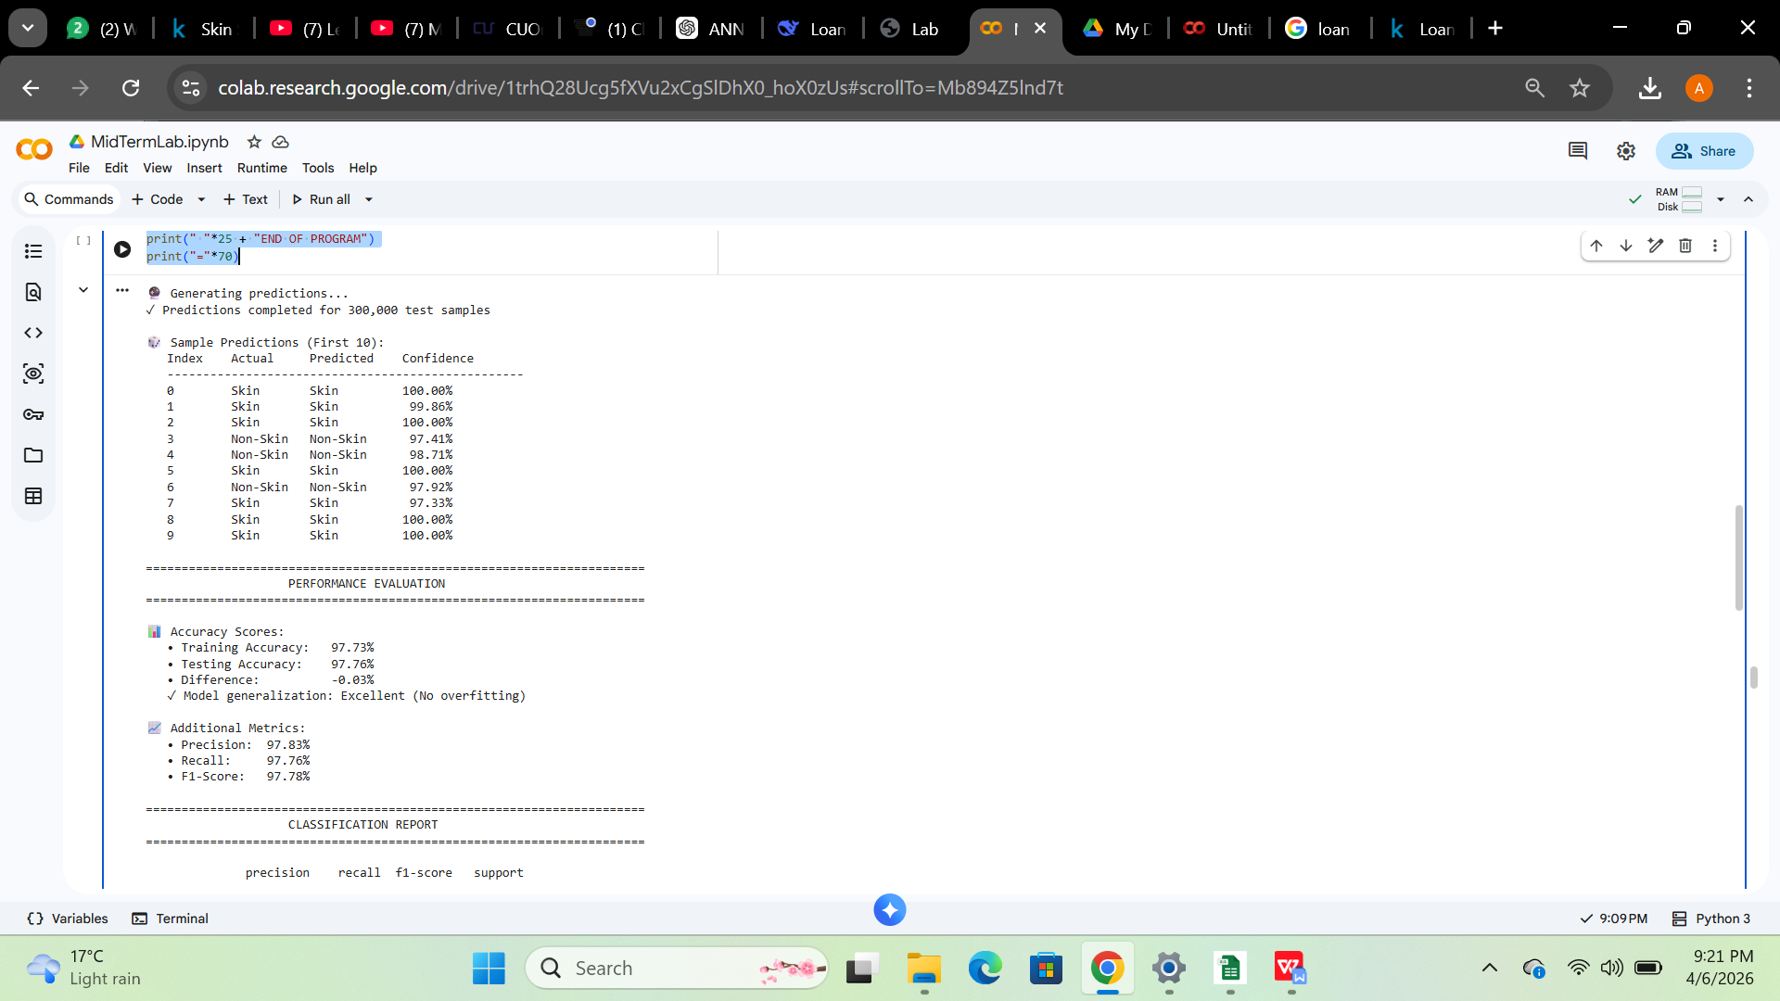
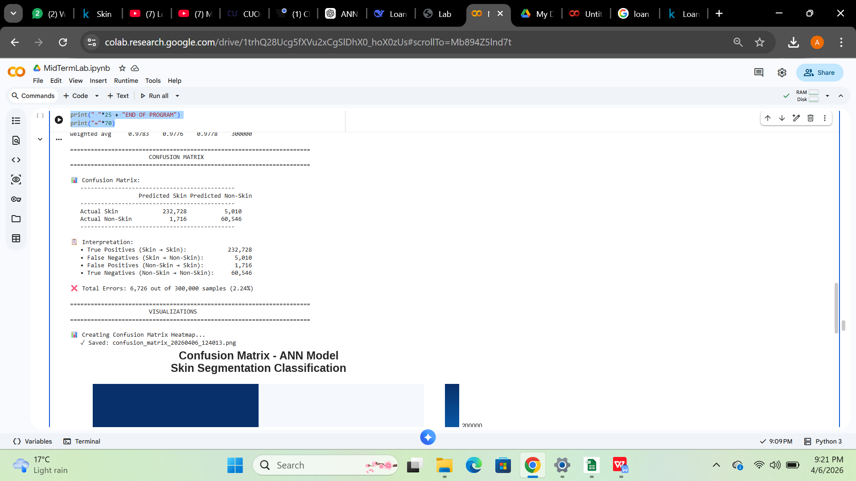

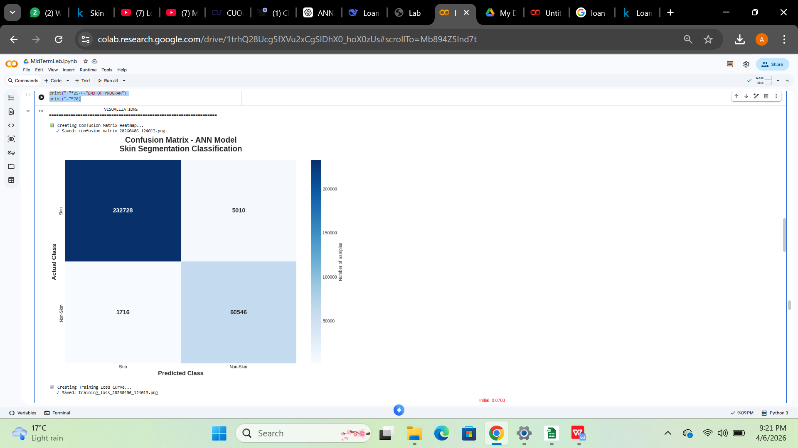

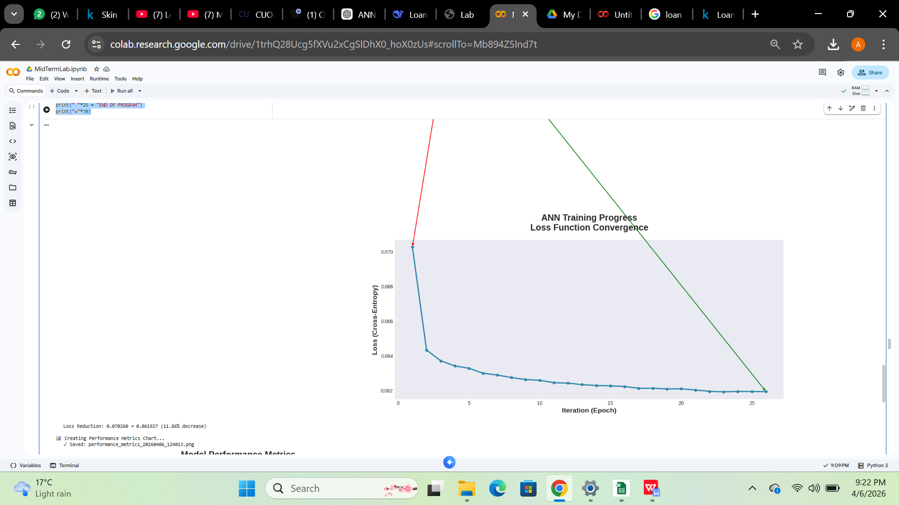

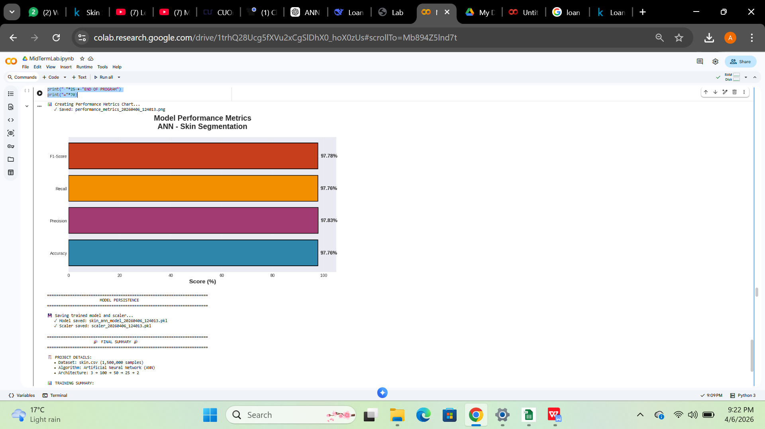

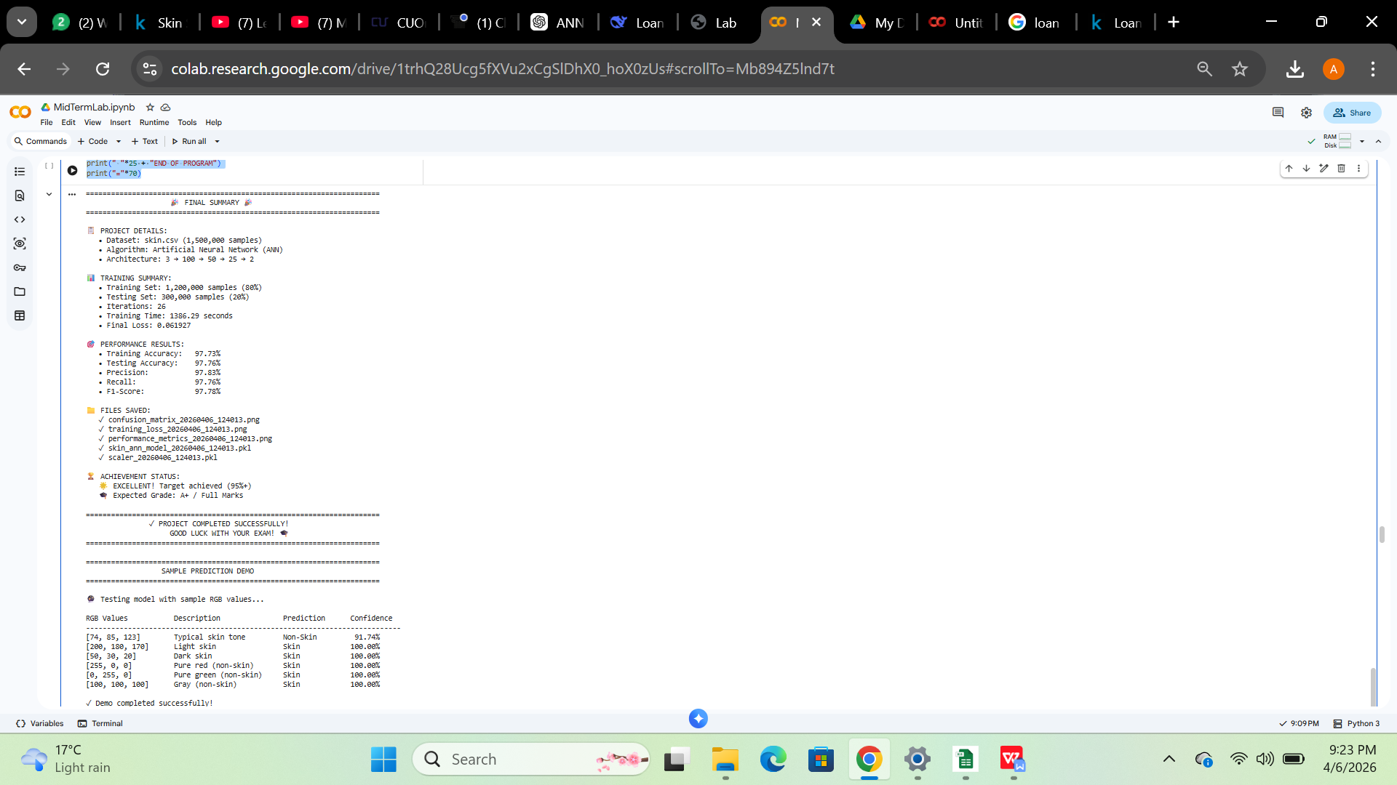

Link:
https://colab.research.google.com/drive/1trhQ28Ucg5fXVu2xCgSlDhX0_hoX0zUs?usp=drive_link

Question 2:
A bank wants to automate loan approval decisions based on applicant data, including income, credit score, employment status, and loan amount. Tasks: 1. Build a Decision Tree Classifier using a suitable dataset (e.g., Loan Prediction dataset). 2. Perform data preprocessing (handle missing values, encode categorical data). 3. Train and visualize the decision tree. 4. Evaluate model performance using accuracy, precision, recall, and F1-score.
Solution:
# Import libraries
import pandas as pd
import numpy as np
import matplotlib.pyplot as plt
import seaborn as sns
from sklearn.model_selection import train_test_split
from sklearn.tree import DecisionTreeClassifier, plot_tree
from sklearn.preprocessing import LabelEncoder
from sklearn.metrics import accuracy_score, precision_score, recall_score, f1_score
from sklearn.metrics import classification_report, confusion_matrix

# ============================================================================
# TASK 1: BUILD DECISION TREE CLASSIFIER USING DATASET
# ============================================================================

print("=" * 80)
print("TASK 1: LOADING LOAN PREDICTION DATASET")
print("=" * 80)

# Load dataset
df = pd.read_csv('loan_approval_dataset.csv')

print(f"\nDataset Shape: {df.shape}")
print(f"\nFirst 5 rows:")
print(df.head())

print(f"\nDataset Info:")
print(df.info())

print(f"\nColumn Names:")
print(df.columns.tolist())

# ============================================================================
# TASK 2: DATA PREPROCESSING
# ============================================================================

print("\n" + "=" * 80)
print("TASK 2: DATA PREPROCESSING")
print("=" * 80)

# Step 2.1: Handle Missing Values
print("\n(A) HANDLING MISSING VALUES")
print("-" * 80)
print("Missing values before:")
print(df.isnull().sum())

# Fill missing values if any
for col in df.select_dtypes(include=['int64', 'float64']).columns:
if df[col].isnull().sum() > 0:
df[col].fillna(df[col].median(), inplace=True)
print(f" Filled {col} with median")

for col in df.select_dtypes(include=['object']).columns:
if df[col].isnull().sum() > 0:
df[col].fillna(df[col].mode()[0], inplace=True)
print(f" Filled {col} with mode")

print("\nMissing values after handling:")
total_missing = df.isnull().sum().sum()
print(f"Total missing values: {total_missing}")
print("✓ Missing values handled!")

# Step 2.2: Encode Categorical Data
print("\n(B) ENCODING CATEGORICAL DATA")
print("-" * 80)

# Create encoded dataset
df_encoded = df.copy()

# Remove loan_id (not useful for prediction)
if 'loan_id' in df_encoded.columns:
df_encoded = df_encoded.drop(columns=['loan_id'])
print("Dropped 'loan_id' column (not useful for prediction)")

# Find all categorical columns
categorical_cols = df_encoded.select_dtypes(include=['object']).columns.tolist()
print(f"\nCategorical columns to encode: {categorical_cols}")

# Encode each categorical column
label_encoders = {}
for col in categorical_cols:
le = LabelEncoder()
df_encoded[col] = le.fit_transform(df_encoded[col].astype(str))
label_encoders[col] = le
print(f"\n{col} encoding:")
for i, label in enumerate(le.classes_):
print(f" {i} = {label}")

print("\n✓ All categorical data encoded!")
print("\nEncoded dataset preview:")
print(df_encoded.head())

# ============================================================================
# TASK 3: TRAIN AND VISUALIZE DECISION TREE
# ============================================================================

print("\n" + "=" * 80)
print("TASK 3: TRAIN AND VISUALIZE DECISION TREE")
print("=" * 80)

# TARGET COLUMN - Check actual column name (with space!)
target_col = ' loan_status' # Note the SPACE before 'loan_status'

# Prepare features and target
X = df_encoded.drop(columns=[target_col])
y = df_encoded[target_col]

print(f"\nFeatures (X): {X.columns.tolist()}")
print(f"Target (y): {target_col}")
print(f"Shape: X={X.shape}, y={y.shape}")

print(f"\nTarget Distribution:")
print(y.value_counts())
print(f"\nTarget Distribution (%):")
print(y.value_counts(normalize=True) * 100)

# Split data (80% train, 20% test)
X_train, X_test, y_train, y_test = train_test_split(
X, y, test_size=0.2, random_state=42, stratify=y
)

print(f"\nTrain-Test Split:")
print(f" Training samples: {len(X_train)}")
print(f" Testing samples: {len(X_test)}")

# Build Decision Tree Classifier
print("\nBuilding Decision Tree Classifier...")
dt_model = DecisionTreeClassifier(
criterion='gini',
max_depth=5,
min_samples_split=30,
min_samples_leaf=15,
random_state=42
)

# Train the model
dt_model.fit(X_train, y_train)
print("✓ Decision Tree trained successfully!")

print(f"\nTree Details:")
print(f" Tree depth: {dt_model.get_depth()}")
print(f" Number of leaves: {dt_model.get_n_leaves()}")

# Visualize Decision Tree
print("\nVisualizing Decision Tree...")
plt.figure(figsize=(20, 12))
plot_tree(
dt_model,
feature_names=X.columns,
class_names=['Approved', 'Rejected'],
filled=True,
rounded=True,
fontsize=10
)
plt.title('Decision Tree for Loan Approval Prediction',
fontsize=16, fontweight='bold')
plt.tight_layout()
plt.savefig('decision_tree_visualization.png', dpi=300, bbox_inches='tight')
plt.show()

print("✓ Decision tree visualization saved as 'decision_tree_visualization.png'")

# Feature Importance
print("\nFeature Importance:")
feature_importance = pd.DataFrame({
'Feature': X.columns,
'Importance': dt_model.feature_importances_
}).sort_values('Importance', ascending=False)

print(feature_importance.to_string(index=False))

# Visualize Feature Importance
plt.figure(figsize=(12, 8))
colors = plt.cm.viridis(np.linspace(0.2, 0.8, len(feature_importance)))
plt.barh(feature_importance['Feature'], feature_importance['Importance'],
color=colors, edgecolor='black')
plt.xlabel('Importance', fontweight='bold', fontsize=12)
plt.ylabel('Feature', fontweight='bold', fontsize=12)
plt.title('Feature Importance in Decision Tree', fontsize=14, fontweight='bold')
plt.gca().invert_yaxis()
plt.tight_layout()
plt.savefig('feature_importance.png', dpi=300, bbox_inches='tight')
plt.show()

print("✓ Feature importance chart saved as 'feature_importance.png'")

# ============================================================================
# TASK 4: EVALUATE MODEL PERFORMANCE
# ============================================================================

print("\n" + "=" * 80)
print("TASK 4: EVALUATE MODEL PERFORMANCE")
print("=" * 80)

# Make predictions
y_pred = dt_model.predict(X_test)

# Calculate metrics
accuracy = accuracy_score(y_test, y_pred)
precision = precision_score(y_test, y_pred, average='weighted', zero_division=0)
recall = recall_score(y_test, y_pred, average='weighted', zero_division=0)
f1 = f1_score(y_test, y_pred, average='weighted', zero_division=0)

# Display metrics
print("\nMODEL PERFORMANCE METRICS:")
print("-" * 80)
print(f"Accuracy: {accuracy:.4f} ({accuracy*100:.2f}%)")
print(f"Precision: {precision:.4f} ({precision*100:.2f}%)")
print(f"Recall: {recall:.4f} ({recall*100:.2f}%)")
print(f"F1-Score: {f1:.4f} ({f1*100:.2f}%)")

# Detailed Classification Report
print("\nDetailed Classification Report:")
print("-" * 80)
print(classification_report(y_test, y_pred,
target_names=['Approved (0)', 'Rejected (1)'],
zero_division=0))

# Confusion Matrix
cm = confusion_matrix(y_test, y_pred)
print("\nConfusion Matrix:")
print("-" * 80)
print(cm)
print(f"\nTrue Negatives (Correctly Approved): {cm[0][0]}")
print(f"False Positives (Wrongly Rejected): {cm[0][1]}")
print(f"False Negatives (Wrongly Approved): {cm[1][0]}")
print(f"True Positives (Correctly Rejected): {cm[1][1]}")

# Visualize Confusion Matrix
plt.figure(figsize=(10, 8))
sns.heatmap(cm, annot=True, fmt='d', cmap='Blues',
xticklabels=['Approved', 'Rejected'],
yticklabels=['Approved', 'Rejected'],
cbar_kws={'label': 'Count'},
annot_kws={'size': 14})
plt.ylabel('Actual', fontweight='bold', fontsize=12)
plt.xlabel('Predicted', fontweight='bold', fontsize=12)
plt.title('Confusion Matrix', fontsize=14, fontweight='bold')
plt.tight_layout()
plt.savefig('confusion_matrix.png', dpi=300, bbox_inches='tight')
plt.show()

print("✓ Confusion matrix saved as 'confusion_matrix.png'")

# Visualize Performance Metrics
metrics_data = {
'Metric': ['Accuracy', 'Precision', 'Recall', 'F1-Score'],
'Score': [accuracy, precision, recall, f1]
}
metrics_df = pd.DataFrame(metrics_data)

plt.figure(figsize=(10, 6))
bars = plt.bar(metrics_df['Metric'], metrics_df['Score']*100,
color=['#3498db', '#e74c3c', '#2ecc71', '#f39c12'],
edgecolor='black', linewidth=1.5)
plt.ylabel('Score (%)', fontweight='bold', fontsize=12)
plt.xlabel('Metrics', fontweight='bold', fontsize=12)
plt.title('Model Performance Metrics', fontsize=14, fontweight='bold')
plt.ylim([0, 105])
plt.grid(axis='y', alpha=0.3)

# Add value labels on bars
for bar in bars:
height = bar.get_height()
plt.text(bar.get_x() + bar.get_width()/2., height + 1,
f'{height:.2f}%', ha='center', va='bottom',
fontsize=11, fontweight='bold')

plt.tight_layout()
plt.savefig('performance_metrics.png', dpi=300, bbox_inches='tight')
plt.show()

print("✓ Performance metrics chart saved as 'performance_metrics.png'")

# ============================================================================
# SUMMARY
# ============================================================================

print("\n" + "=" * 80)
print("SUMMARY - ALL TASKS COMPLETED")
print("=" * 80)

print("\n✓ TASK 1: Decision Tree Classifier built using Loan Prediction dataset")
print(f" - Dataset: {df.shape[0]} samples, {df.shape[1]} columns")

print("✓ TASK 2: Data preprocessing completed")
print(" - Missing values handled")
print(f" - {len(categorical_cols)} categorical columns encoded:")
for col in categorical_cols:
print(f" • {col}")

print("✓ TASK 3: Decision Tree trained and visualized")
print(f" - Tree depth: {dt_model.get_depth()}")
print(f" - Number of leaves: {dt_model.get_n_leaves()}")
print(" - Visualizations saved")

print("✓ TASK 4: Model performance evaluated")
print(f" - Accuracy: {accuracy*100:.2f}%")
print(f" - Precision: {precision*100:.2f}%")
print(f" - Recall: {recall*100:.2f}%")
print(f" - F1-Score: {f1*100:.2f}%")

print("\n📁 Generated Files:")
print(" 1. decision_tree_visualization.png")
print(" 2. feature_importance.png")
print(" 3. confusion_matrix.png")
print(" 4. performance_metrics.png")

print("\n" + "=" * 80)
print("✅ ALL TASKS SUCCESSFULLY COMPLETED!")
print("=" * 80)

Output:

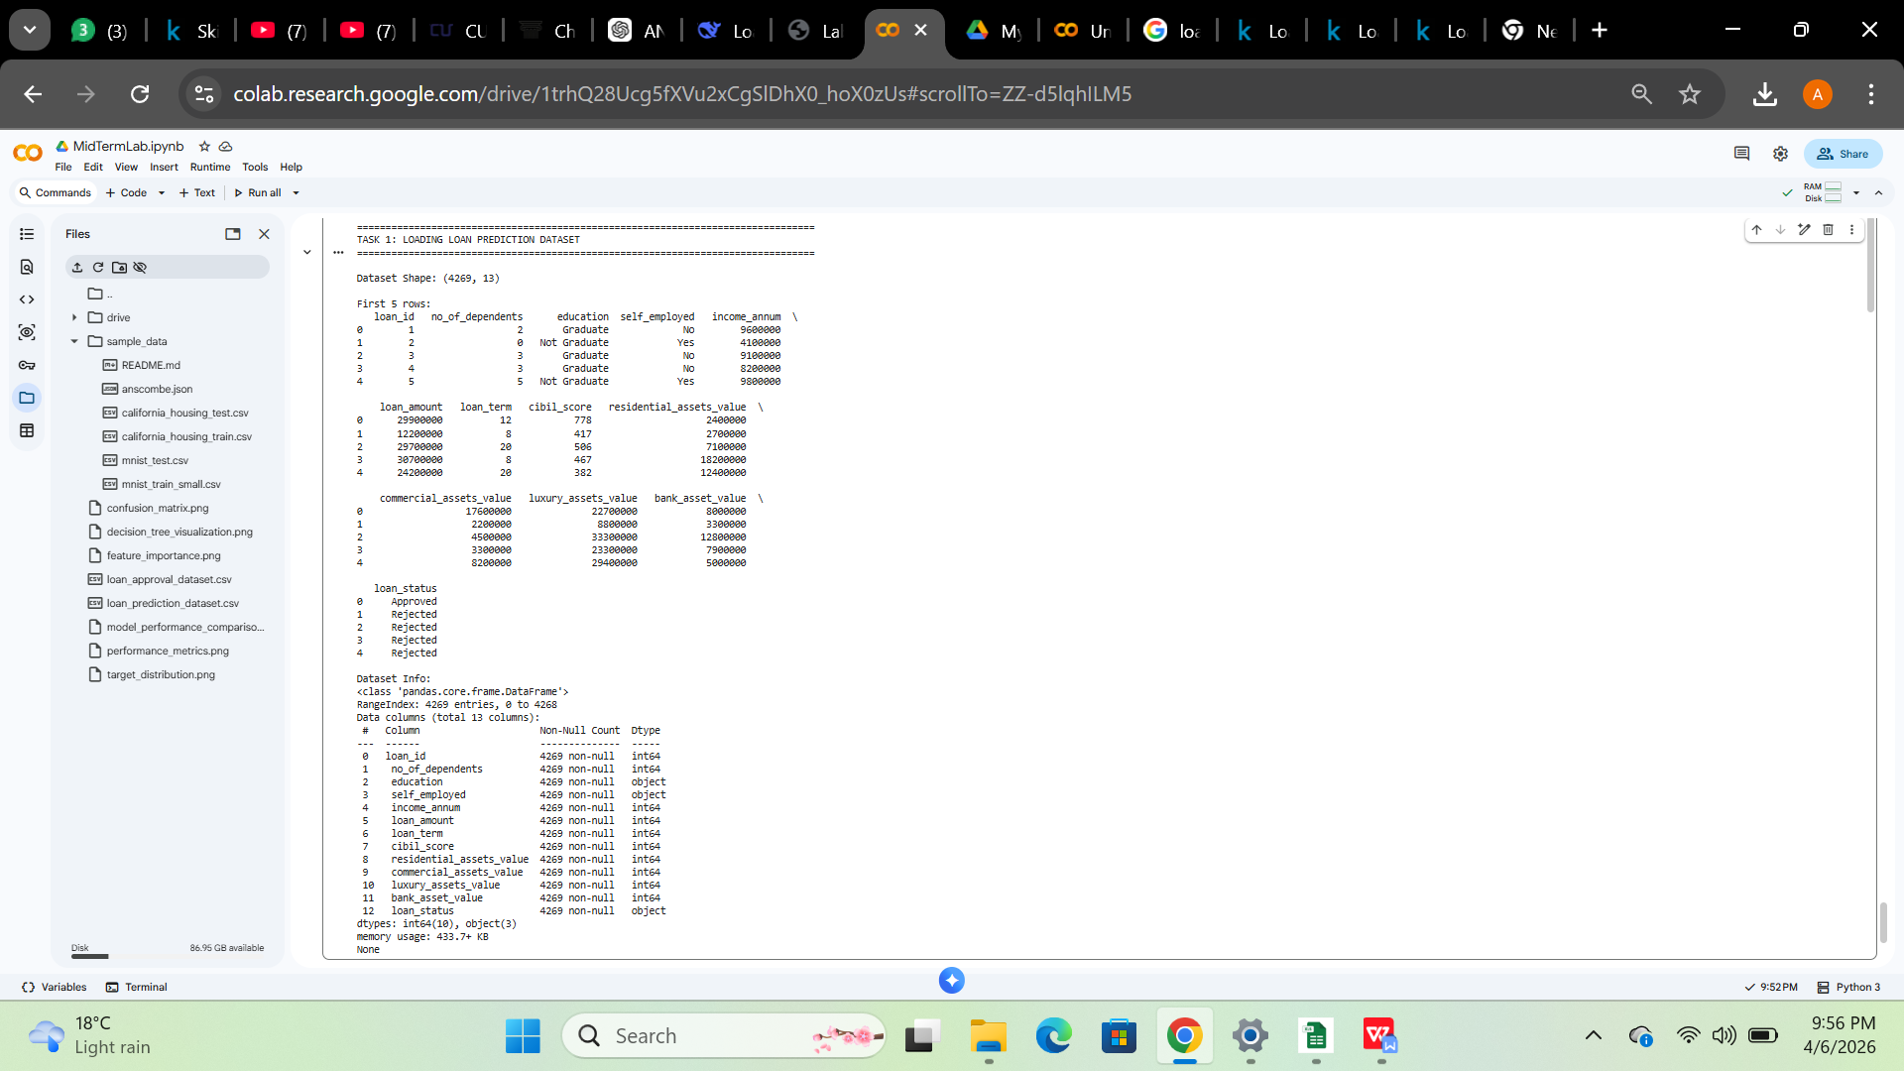

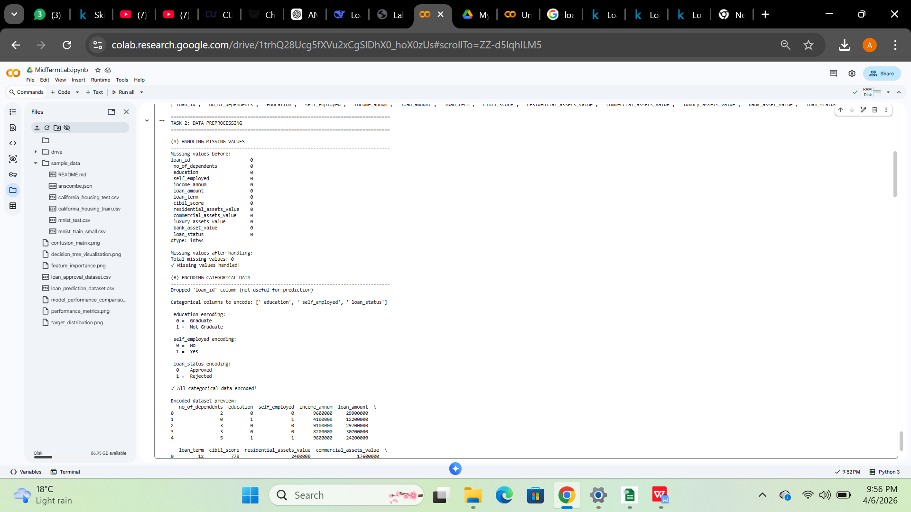
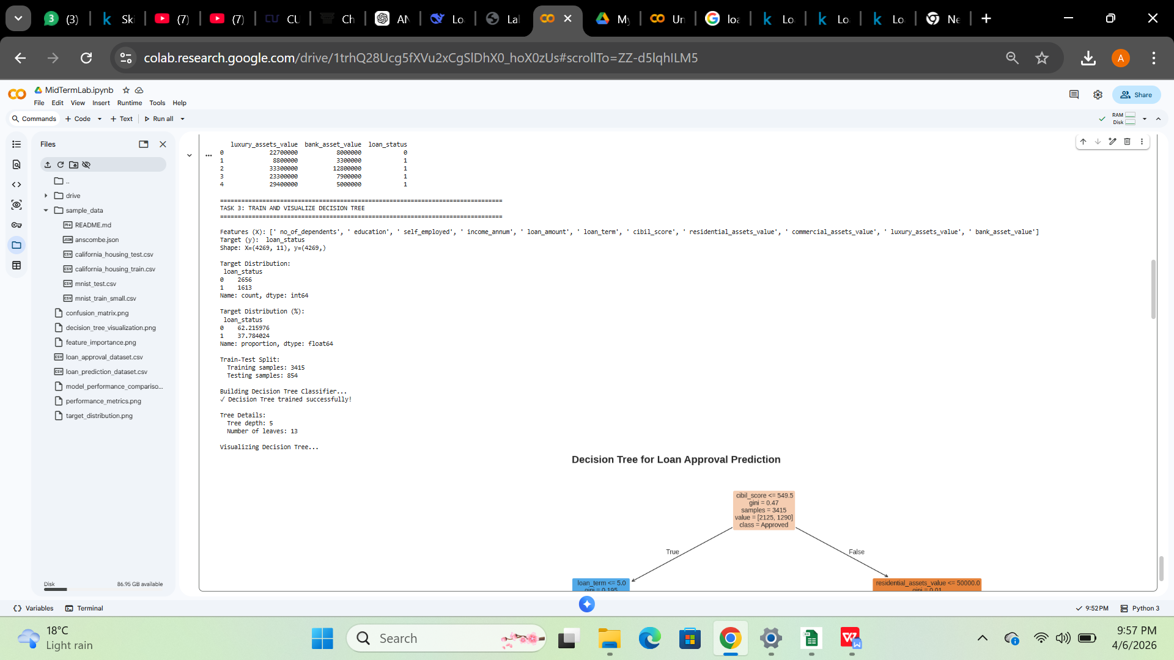

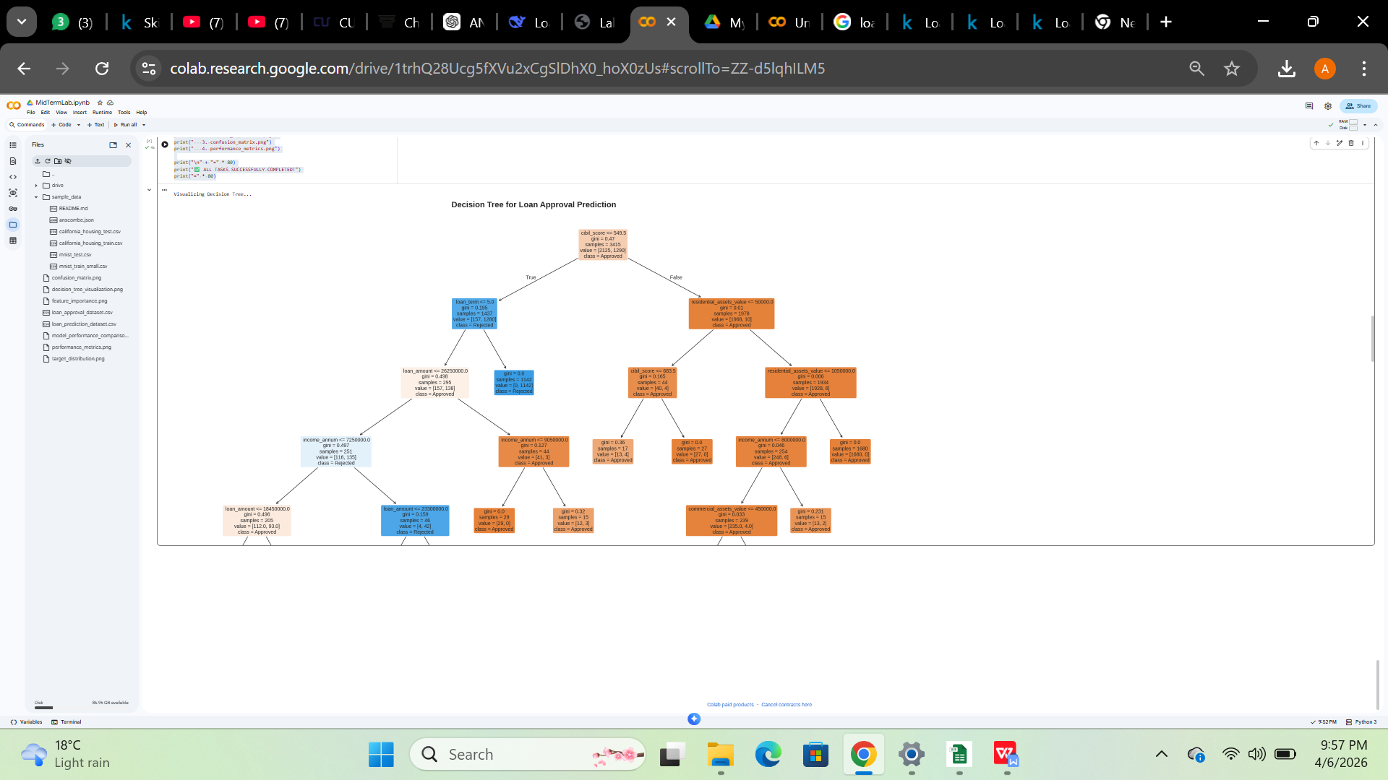

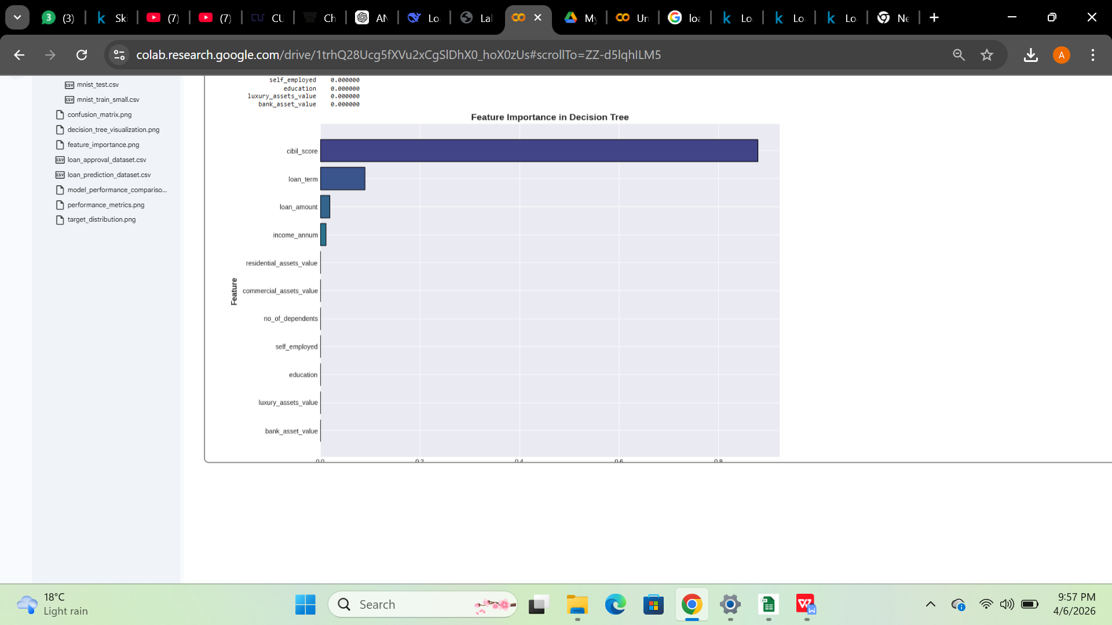

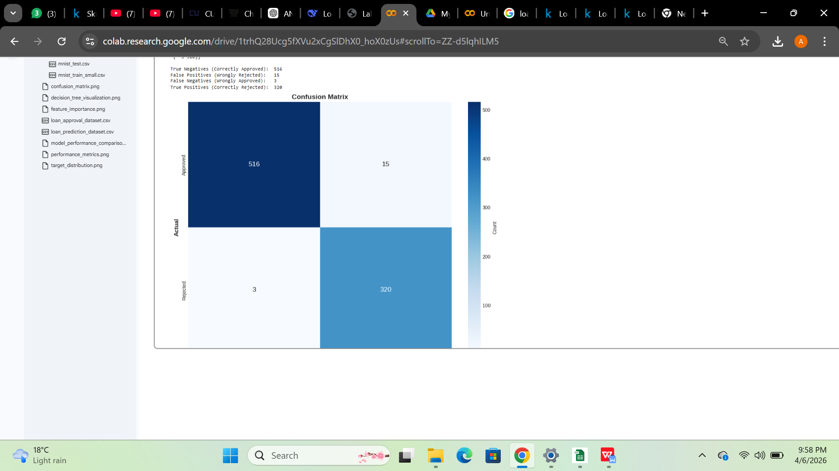

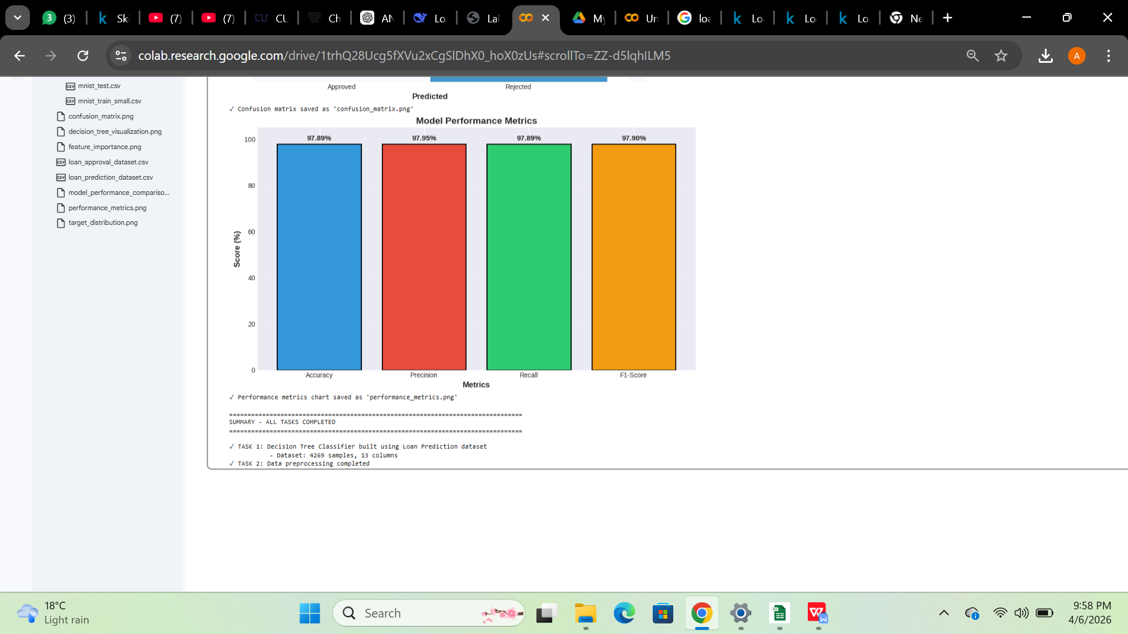

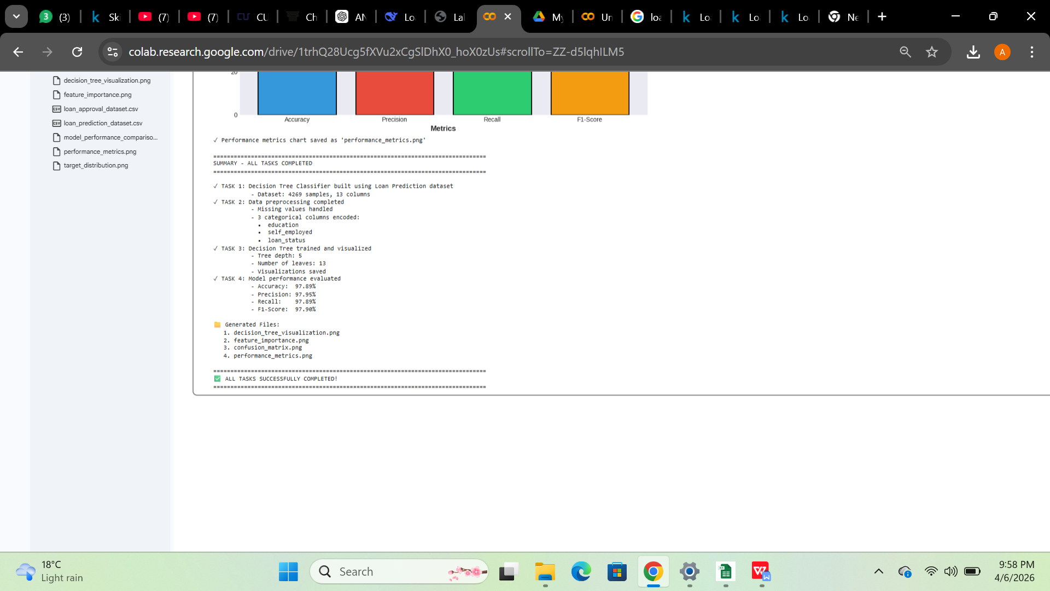

Link:
https://colab.research.google.com/drive/1trhQ28Ucg5fXVu2xCgSlDhX0_hoX0zUs?usp=drive_link

