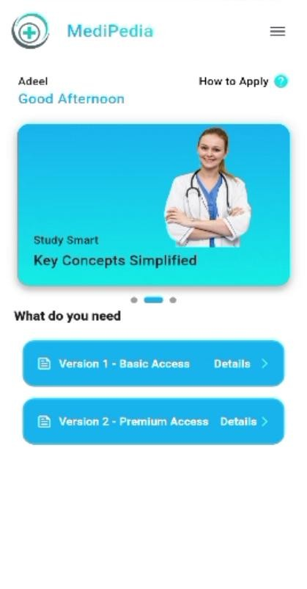

Yaha per 2 version ha first version basic acees jis my books ,mocktest ,and bundles ko seperatly purchase kar sakhty ha klaye ha aur version 2 premium acesss may one time pay kar k full app access ly skty ha.

version 1 jo ha na es ma jab user es ko open krta ha aur next screen ma jata ha tu yaha per kuch tabs show hoti ha aur user jab FCPS per click karta ha tu FCPS ki different books next screen ma show hoti ha aur user in per click karta ha tu sab se phly es book ko open karny k laye apply karna ha and after paying amount the book is open aur as books ke andr different papers ha aur user in per click kar ke test dey sakhtha aur prepration kr skta ha esi trah bki mock test and bunldes my be kr skta ha

version 2 premium access ka work flow version 1 jsa hi ha lakin version 2 ko open karny k laye user ko all books, mock test and bundles k laye one time apply and pay karna paray ga aur es k bad wo all books , mock test and bundles ko access kar skta ha faraq siraf itna ha k version 2 my during test dayty waqt google adds pops ho gi

home page ma aik drawer ha jis ma user ki profile ha as profile ko user edit kar skahtha ha changes password
Edit name and phone number also

Aur as ma quiz/mcqs jo test deye ha wo user save b kr skahtha ha uar user book price b dakh sakhtha ha aur book codes b aur apna feedback b send kar skahtha ha ya sab ha all feature of app

