Masterpiece

Project

Coding Academy by Orange

3D Printers Website  
PrintHouse

Yazeed Aldamen

30/3/2023

Table of content:

● INTRODUCTION PURPOSE.

● INTENDED AUDIENCE AND PERTINENT SECTIONS.

● PROJECT SCOPE.

● TECHNOLOGIES.

● REFERENCES

● DESCRIPTION

● OPERATING ENVIRONMENT

● FEATURES

● DOCUMENTATION

● FLOW CHART DIGRAM

● DATABASE SCHEMA

**INTRODUCTION PURPOSE**

• One-stop-shop for all their 3D printing needs

• Maintenance services to help customers keep their machines in excellent working condition

**INTENDED AUDIENCE AND PERTINENT SECTIONS.**

The website is designed to cater to a wide range of customers who are interested in 3D printing technology. This includes hobbyists, entrepreneurs, and professionals in various industries. Our target audience is anyone who is interested in the latest 3D printing technology, whether they are just starting or have been in the industry for years.

**PROJECT SCOPE**

The scope of our project is to develop an ecommerce website that specializes in selling 3D printers, consumables, and parts, as well as providing maintenance services. Our website will feature an intuitive design that allows users to search for products easily, view detailed product descriptions, and make purchases with minimal effort.

To simplify the registration process, we will only require our customers to provide their email address and name upon registration. This will ensure a seamless and hassle-free registration process that saves our customers time and effort.

In addition, we will provide a convenient contact us page that allows customers to communicate with us directly via messaging. This feature will enable us to provide timely and effective customer support, addressing any concerns or issues that customers may have. Payment for purchases will be made upon receipt, ensuring a secure and convenient transaction process for our customers.

Overall, our project scope is to develop an ecommerce website that provides a comprehensive range of 3D printing products and services while offering a user-friendly experience that simplifies the purchasing process for our customers.

**TECHNOLOGIES**:

● HTML.

● CSS.

● JS.

● BOOTSTRAP.

● ASP.NET MVC.

● SQL SERVER.

**REFERENCES:**

* HTML: <https://developer.mozilla.org/en-US/docs/Web/HTML>
* CSS: <https://developer.mozilla.org/en-US/docs/Web/CSS>
* JS: <https://developer.mozilla.org/en-US/docs/Web/JavaScript>
* C#: <https://learn.microsoft.com/en-us/dotnet/csharp/>
* ASP.NET MVC: <https://learn.microsoft.com/en-us/aspnet/mvc/overview/getting-started/introduction/getting-started>

**DESCRIPTION**

* The website will offer different user roles, including registered users who can complete purchases and unregistered users who can save items to their cart and return later to complete purchases.
* The website will also have a managerial perspective, allowing administrators to control the website and manage users, categories, subcategories, products, and comments.
* Visitors to the website can browse and search for 3D printing products that they are interested in buying.
* Administrators can access a dashboard by logging in to the website, which allows them to delete users, as well as delete, edit, and add categories, subcategories, products, and comments, as well as view statistical data of the website.

**OPERATING ENVIRONMENT**

Print House is designed to run on all modern browsers Microsoft Edge, Google Chrome, Mozilla Firefox, Safari, Opera with an active internet connection.

**FEATURES**

* The website will allow users to browse the public site without requiring them to log in. However, to make a purchase, users will be required to log in using their email and password.
* The website's home page is designed to minimize the time and effort required for visitors to make a purchase. The focus is on providing a user-friendly experience that captures the visitor's attention and streamlines the purchasing process.
* The Profile Screen displays the user's account information, including their order history. From this screen, users can view past orders, edit their account information and password. This feature enables users to easily manage their account and view their purchase history.

**Admin Dashboard:**

* Login Page: The administrative dashboard can only be accessed by admins, who must log in using their email and password.
* Dashboard Page: The dashboard provides admins with the ability to add categories, subcategories, and products to the website.
* Editing: Admins can edit categories, subcategories, and products on the website using the dashboard.
* Deleting: The dashboard also enables admins to delete categories, subcategories, and products as needed.
* User Deletion: Admins can use the dashboard to delete users who have registered on the public site.
* Order Monitoring: Admins can monitor and control all orders placed by users on the website.
* Contact Page Messages: The dashboard also provides admins with the ability to view messages sent via the contact page.

**DOCUMENTATION:**

All project files have been uploaded to GitHub and made available to all in order to share knowledge.

GitHub https: <https://github.com/YazeedAldamen/MasterPiece-PrintHouse>

**FLOW CHART DIGRAM:**

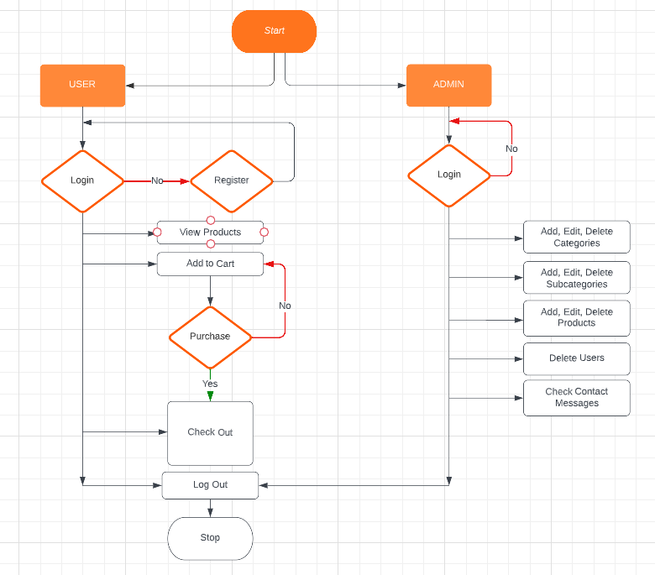

**DATABASE SCHEMA:**

