

**“MAY Case Store”**

**CRUD Project Report**

**By**

**Yazeed Ghazalat**

**Mohammad Almsedin**

**Ahmad Agha**

**Supervised By**

**Abed-Alraheem Alsaqqa**

**2022**

ABSTRACT

The smartphone and smart devices technology has exploded in the last few decades and became an integral part of our day-to-day life breaking through every aspect of it; entertainment wise, educational, social and the list go on to the degree that it and became an actual alerting problem to be considered and actions should take a place, this project puts the spot on a very important related social and behavioral issues that is especially harmful among the young generations which is the uncontrolled unresponsible time wasting and to some degree addictive usage of this technology. Utilizing the technology of wireless communication, mini computing, smartphone applications and database technologies where it basically limits and control the usage of the smartphone based on the change of a special sensor readings that is controlled using an Arduino which triggers the mobile app to take actions based on that; fetching the wirelessly communicated data using an Arduino controlled Wi-Fi module from the dedicated database. Our design can be installed on the back of any chair that we choose to dedicate for using smartphone. We are very confident that many households would benefit from the value that this device can offer which can change the bad habits of using this technology by kids which can affect their physical and mental health to a much better reality.

TABLE OF CONTENTS

**PAGE**

**ABSTRACT** 2

**LIST OF TABLES** 8

**LIST OF FIGURES** 9

**CHAPTER**

**1. INTRODUCTION** 11

**3. ANALYSIS AND DESIGN**  18

**4. IMPLEMENTATION**  35

**5. TESTING AND EVALUATION**  52

**6. CONCLUSION**

**REFERENCES**  57

**APPENDICES**  58

**APPENDIX A:** **Data Sheet of ESP8266**

**Data Sheet of GP2Y0D805Z0F Digital Distance Sensor**

LIST OF TABLES

**TABLE PAGE**

**Table (3.1): ESP8266 Specifications**…………………………………………………..20

**Table (4.1): pin table for the ESP**……………………………………………………..37

**Table (4.1): pin table for the ESP 2**…………………………………………………...45

LIST OF FIGURES

**FIGURE PAGE**

**Figure (1.1): agile development methodology scheme** ……………………………………..#

**Figure (3.1): Arduino Uno Board** …………………………………………………..#

**Figure (3.2): ESP8266 WIFI Module** …………………………………………………..#

**Figure (3.3): agile development methodology scheme**………………………………………..#

**Figure (3.4): Pololu carrier with 3×1 straight male header strip and 3×1 right-angle male header strip**…………………………………………………..#

**Figure (3.5): Pololu carrier with Sharp GP2Y0D805Z0F**………………………………..#

**Figure (3.6): Breadboard layout**………………………………..#

**Figure (3.7): Jumper wires types**………………………………..#

**Figure (3.8): USB-A to B Cable**………………………………..#

**Figure (3.9): Soldering kit**………………………………..#

**Figure (3.10): Arduino IDE**………………………………..#

**Figure (3.11): Firebase Arduino Client Library for ESP8266**………………………………..#

**Figure (3.12): Flutter SDK with Dart**………………………………..#

**Figure (3.13): Firebase Platform**………………………………..#

**Figure (3.14): The General System Work Flow**………………………………..#

**Figure (3.15): ESP8266 pin out**………………………………..#

**Figure (3.16): Pseudo code for the Arduino uno board and the sensor**

**Figure (3.17): Pseudo code for the ESP8266 Module** ………………………………..#

**Figure (3.18): System level diagram** ………………………………..#

**Figure (3.19): Architecture diagram first part**………………………………..#

**Figure (3.20): Architecture diagram second part**………………………………..#

**Figure (3.21): Architecture diagram for the flutter app**………………………………..#

**Figure (4.1): step 2**………………………………..#

**Figure (4.2): step 3**………………………………..#

**Figure (4.3): step 4**………………………………..#

**Figure (4.4): step 5**………………………………..#

**Figure (4.5): Fingerprints**………………………………..#

**Figure (4.6): FirebaseHttpClient**………………………………..#

**Figure (4.7): Circuit for ESP8266 (ESP-01) Programming**………………………………..#

**Figure (4.8): real view of the circuit 1**………………………………..#

**Figure (4.9): Preferences window**………………………………..#

**Figure (4.10): Additional Board Manager URLs field**………………………………..#

**Figure (4.11): install esp8266 platform**………………………………..#

**Figure (4.12): select ESP8266 board**………………………………..#

**Figure (4.13): Add .ZIP library**………………………………..#

**Figure (4.14): Firebase arduino master.zip**………………………………..#

**Figure (4.15): Verify that the library**………………………………..#

**Figure (4.16): Install ArduinoJson**………………………………..#

**Figure (4.17): Set our FIREBASE_HOST**………………………………..#

**Figure (4.18): Set our FIREBASE_AUTH**………………………………..#

**Figure (4.19): Verifying and uploading the code**………………………………..#

**Figure (4.20): Select Arduino Uno board and port**………………………………..#

**Figure (4.21): Circuit real view 2**………………………………..#

**Figure (4.22): Android Studio**………………………………..#

**Figure (4.23): The Flutter SDK**………………………………..#

**Figure (4.24): Application home Screen**………………………………..#

**Figure (4.25): Application lock Screen**………………………………..#

**Figure (4.26): Application notification Screen**………………………………..#

**Figure (4.27): Sensor disabled**………………………………..#

**Figure (4.28): Sensor enabled** ………………………………..#

**Figure (4.29): Serial monitor (sensor readings)** ………………………………..#

**Figure (4.30): Connected WIFI module** ………………………………..#

**Figure (4.31): Database receiving data 1**………………………………..#

**Figure (4.32): Database receiving data 0**………………………………..#

**Figure (4.33): Application response**………………………………..#

CHAPTER 1

introduction

**Preface**

In the last decade, smartphones have become an integral tool in our day-to-day life, and among all different levels of the community from elderly people to employees at their work and finally our children’s, and here a major concern arises.

Kids nowadays uses smartphones immaturely over a very long periods of time for fun, etc. with the absence of a constant and carful supervision over them, the problem is that a lot of them tend to set on an unhealthy way for a long-time which can lead eventually to many health issues on the long term in different parts of their body like the neck, the back, and the eyes, in addition to wasting their time on an unconstructive content. That's why we need some kind of supervision on our children while using smart phones. But parents can't keep an eye on the children 24 hours a day! they have jobs and work to be done.

This is where we face some challenges. We are talking about kids here, it's usually really hard to control their behavior directly, how many times you would ask them to stay away from the TV screens for instance, no matter how much they would always go back and set in front of the TV. they need continues supervision, someone to keep an eye on them, or in our case something.

From there we came up with an idea for a solution to keep the kids in a healthy posture while using their phones. The idea is basically to install the device that we are planning to create on the chair where the child is used to play, etc., the device will sense and determine if the child is sitting correctly and on a healthy way on the chair. If not, it will send a signal to the child's device to block the screen until the child corrects his posture.

* 1. **The Significance and Motivation**

Increased smartphone utilization by children will increase the risk of addiction which consequently affecting the physical and mental health status of children. This impact requires an appropriate 24/7 prevention technologies and strategy and involves the family or parents as important social support system for child's development.

* + 1. **Negative** **effects of smartphone usage on children's mental and psychological health**

In today’s globalized digital world, the usage of smartphones is rapidly increasing. This does not mean only adults, but also includes children of all ages. Children all around the globe have started using smartphones for various purposes. Whether for talking to their friends and relatives on video calls or playing games, or on social media or even for online education.

We now have more reason for concern over the excessive use of technology among the youngest of the young, as little kids’ smartphone usage has risen dramatically, according to many studies.

the drawbacks of smartphones and its negative impact on children’s development, health, and studies is a matter of concern. Therefore, we will look into some of the negative effects of smartphones on the development of your children in this project:

1. **DISRUPTED SLEEP PATTERN:**

Most children use their smartphones before going to bed. They could either be staying up late talking to their friends or playing games, watching videos or just scrolling through social media. This mindless staring at smartphones at late hours over a period of time causes fatigue and restlessness, as using any electronic devices late at night can lead to reduced sleep timing. This is caused due to the emission of blue light, which all digital devices emit and are known to be harmful to our eyes, and also trick our brain into thinking that it is still daytime.

These sleep disturbances even disrupt children’s academic life as when children are sleep deprived during the night, they are too sleepy to concentrate during classes, leading to the domino effect that seeps into all walks of their lives.

There have also been several recent studies which show that the lack of quality sleep in children not only affects their academic performance but also affects their physical development, productivity, attention, and energy levels. Therefore, it is essential for us to enforce strict rules about smartphone usage at night to ensure quality sleep for our children.

1. **AFFECTS THEIR ABILITY TO LEARN:**

Many researchers have confirmed that smartphones are detrimental to children’s social and economic development as the Child’s attention is diverted by the use of it. To be more specific, the use of interactive screen time on hand-held devices such as smartphones also impairs children’s development of the skills needed to learn math and science according to the findings of the research.

As most children carry phones along with them to their schools and classes these days, it is the smartphones that take precedence over what is being taught at school. The result of such behavior is an obvious impact on their academic performance as children increasingly become addicted to their smartphones and fail to pay attention during class and miss out on important chapters consequently being clueless about the same during examinations, causing low grades.

There is also a high chance of academic malpractice as smartphones are capable of storing a lot of educational information and give the children the ability to find any answer at their fingertips. As simple as storing screenshots or pictures of notes, to using the internet to search for an answer or using the inbuilt calculator in test where using a calculator is not allowed, to even exchanging answers with other students via chat during the exams are all behaviors that have been widely observed in various schools.

These kinds of activities not only lower their grade and reduce their learning capacity but also result in personality issues.

1. **AFFICTS THEIR GENERAL MENTAL HEALTH:**

The increased use of smartphones makes children addicted to social media as most children use social media as a platform to connect with friends and to be updated on the new trends today. It is commonplace for children to compare themselves with their peers and to even post content in a certain manner to gain more engagement.

The Internet is a very vast space and there is a high probability of children encountering a variety of inappropriate behavior which may have a negative effect on their mental health. Many kids who come in contact with cyberbullies and face harassment over the Internet only admit their experience much later in life when the damage has already been done to their mental health.

New studies also suggest that an hour a day spent with their smartphones plays a significant part in the rise of depression and anxiety among children. Kids and teens who use social media tend to have low self-esteem, anxiety, depression, and poor-quality sleep according to the British Psychological Society.

As parents, we need to teach our children the threats, dangers, and safety measures of social media and teach them how to block unwanted communication, as it is our responsibility to be watchful and keep track of our children’s activities. Have clear and friendly conversations about cyberbullying, and what is harassment to help children understand how they can prevent themselves from being bullied.

You can read our blog “Teaching safety measures to children in order to protect your privacy from social media”, for more in-depth information regarding social media safety.

* + 1. **Negative effects of smartphone usage on children's physical health**

1. **BACK, NECK ISSUES ON THE LONG TERM:**

Cervical pain in children usually can happen due to the following reasons:

1. Being in a fixed position for long hours.
2. Improper posture.

Smartphone addiction is making children spend hours hunched over the devices, damaging their necks and spines, leading to a rise in the cases of ‘text neck’ or ‘I-Posture’ or I-Slouch’.

“A human head weighs 10 pounds in a neutral position and when you hold it in this angle, it extensively strains your neck muscles. For every inch you tilt your head forward, the pressure on the spine doubles. Putting tremendous pressure on your spine, this can cause misalignment of the vertebrae and spinal discs. If not noted at a young age and continued like this, the figure itself turns hunched over a device even with the absence of the device. If left untreated, the condition can cause permanent damage, including flattening of the spinal curve, early onset of arthritis, spinal degenerations, loss of lung volume capacity and even gastrointestinal problems,” the doctor further warned.

1. **EYE DISCOMFORT AND DAMAGED EYESIGHT:**

Though there is currently no research yet to prove that looking at screens for long durations of time can cause permanent eye damage, it is certainly known to cause discomfort. While both adults and children who use excessive smartphones experience this discomfort, children are more susceptible to developing symptoms depending on the ways they use their devices. The term “digital eye strain” refers to symptoms caused by prolonged usage of smartphones that include pain, blurred vision, headaches, dry eyes, and fatigue.

Young children these days increasingly involve themselves in playing online games and watching YouTube videos for hours together, which can in fact affect their eyesight. Children aren’t very cautious about the use of smartphones and hold their phones too close to their eyes, which eye specialists all over the world have continuously advised as something to be avoided.

According to popular research from the Chonnam National University most children aged 7 to 16 who spent a significant amount of time on their smartphones were said to have become cross-eyed. The research concluded saying that spending 4 to 8 hours a day on smartphones is most likely to cause cross eye.

While these problems may be temporary, doctors suggest that smartphone usage must be limited to a certain amount of time every day or to take 30 minutes intervals as a break for the eyes now and then. It is also important to teach children to hold their phones further away from their eyes and to adjust their devices’ brightness to a necessary minimum.

* 1. **Aims and Objectives**

The objective of this project shortly is to harness modern wireless communication and computational technologies to provide a feasible dynamic hands-on solution for the problem and its consequences that we have stated earlier in the previous sections.

* 1. **Methodology**

For research and information gathering, we based that on what we have gather online from the different case studies and by investigating our surrounding environment in validating the feasibility and reliability of this project.

For this project, we attempted to use agile development methodology as it is more suitable for this project which uses both iterative and incremental development at the same time.

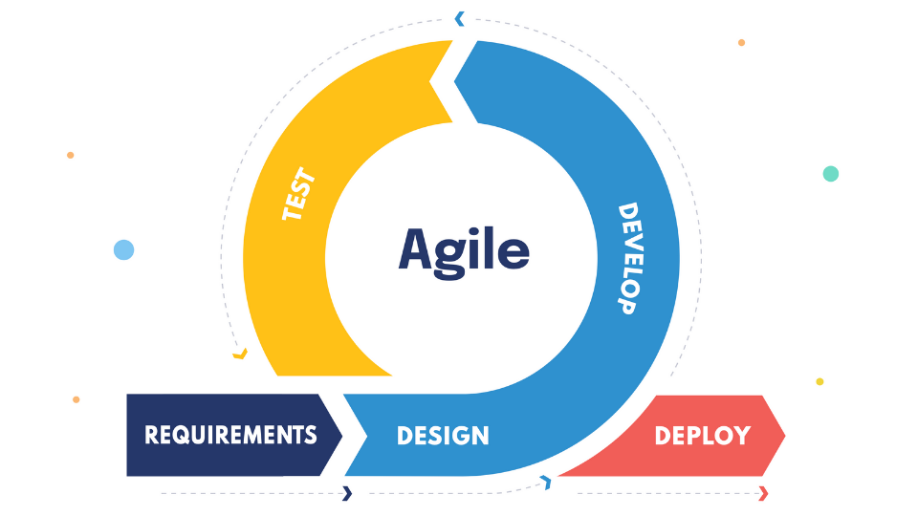

Figure (1.1): agile development methodology scheme

CHAPTER 2

REVIEW OF RELATED LITERATURE

**Introduction**

This project is going to provide an optimal solution to an issue that is very common now adays.

**2.1. Essential Preparations**

In the preparation process to start up our project we have attempted to follow these steps:

1. **Create and Analyze a Case Study.**
2. **Define Project Scope.**
3. **Set Project Goals and Objectives.**
4. **Determine Project Deliverables:**

We have determined and decided what would the deliverables expected from this project will be and who is responsible for both producing and receiving them.

1. **Create Project Schedule and Milestones:**

outlines when different tasks of a project are due to begin and end, along with major measurement milestones. To measure the progress of the project.

1. **Assignment of Tasks:**

Within our team everyone knew what their role is and who is responsible for different elements of the project (research, hardware part, software part, debugging and testing, documenting, etc..). By assigning tasks clearly any uncertainty is removed about roles and responsibilities on our team.

* 1. **Theoretical Background**

The theoretical basis of this project is rooted and based on the following background:

1. Smartphone addiction: smartphone addiction is a psychological condition that is defined as a disorder involving compulsive overuse of the mobile devices.
2. Excessive smartphone use is associated with physical, psychiatric, cognitive, addiction to social networking, shyness and low self-esteem., emotional, medical and brain changes that should be considered by health and education professionals.
3. The responsibility held by us towards the future and the young generation.
4. The need of a cheap dynamic on
   1. **The previous studies and works**

**2.3.1.** **Previous Studies 1**

Many studies have discussed the addictive usage of smartphones and the bad ways it affects all users among all different generations especially the young ones which is the root motivation behind our system idea.

**2.3.2. Previous Studies 2**

We haven’t found any devices or implantations similar to what we have come up with but among the devices that we found dedicated to help solve and address sort of the same problem.

CHAPTER 3

ANALYSIS AND DESIGN

* 1. **Design Requirements**
     1. **Problem Statement**

As we have mentioned previously in earlier sections the main problem that we intend to address the fact that smartphone usage especially among the young has become problematic and addictive and what consequences follows that on the physical and psychological aspects, which motivate our interest help and find a suitable technological solution to help reduce the effects of that therefor to achieve that the system would need to utilize the following hardware and software components and tools.

* + 1. **Overview on The Required Software Tools**

**3.1.3.2. Flutter SDK with Dart**

The Flutter SDK has the packages and command-line tools that you need to develop Flutter apps across platforms.



Figure (3.12): Flutter SDK with Dart

**3.1.3.3.** **Firebase Platform**

Firebase is a Cloud-hosted, NoSQL database that uses a document-model. It can be horizontally scaled while letting you store and synchronize data in real-time among users. This is great for applications that are used across multiple devices such as mobile applications. Firebase is optimized for offline use with strong user-based security that allows for serverless based apps as well.

Firebase is built on the Google infrastructure and is built to scale automatically. In addition to standard NoSQL database functionality, Firebase includes analytics, authentication, performance monitoring, messaging, crash reporting and much more. Because it is a Google product, there is also integration into a lot of other products. This includes integration with Google Ads, AdMob, Google Marketing Platform, the Play Store, Data Studio, BigQuery, Slack, Jira, and more.

The Firebase APIs are packaged into a single SDK that can be expanded to multiple platforms and languages. This includes C++ and Unity, which are both popular for mobile development.

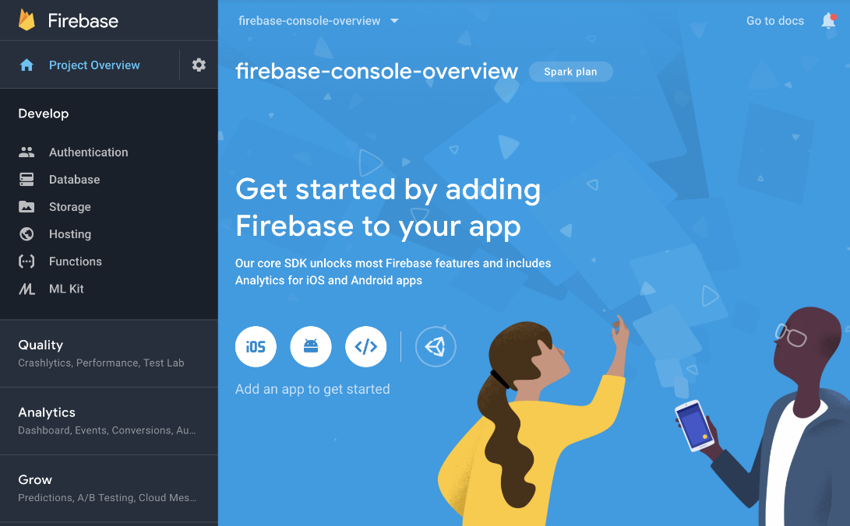

Figure (3.13): Firebase Platform

* 1. **Engineering Standards**

The standards used in of our project are the followings:

* Arduino UNO Rev3 [1].
* Wireless adapter unit (ESP-01 Wi-Fi Module) that supports 802.11 b/g/n networks.
* The Sharp (GP2Y0D805Z0F) digital distance sensor.
* Flutter 2.5 will be used as standard framework to develop the mobile application, with Dart 2.14 programing language.
* C programing language will be used to program the Arduino microcontroller and the ESP8266 WI FI Module.
* TCP/IP protocol stack integrated in the ESP8266 WI FI Module.
  1. **Realistic Constrains**

A general description of the constraints regarding our project:

**1. Economically:** the cost for our device is expected to be cheap in the making and pricing for the consumer.

**2. Environmentally:** the product wouldn’t have a bad impact on the environment.

**3. Health and Safety wise:** the technologies used in our design is believed not to have a bad impact on the human body even on a regular basis usage and it’s safe to use.

**4. Manufacturability and Sustainability:** it’s cost efficient to manufacture the design expected to be very small and light weighted and sustainable.

**5. Socially and ethically:** the design addresses a very important social issue that impacts the young generation and provide a valuable solution for it.

* 1. **Alternative/Different Designs Approaches/Choices**

We think that our approach is very suitable.

This project has the potential for further development in the future.

* 1. **Developed Design**

These are the, flow charts, schematic, pseudo codes and diagrams that we have based our work on:

**3.5.1. Flow charts**

* + - 1. **The General System Work Flow**

Briefly explaining, the sensor collects data about the child’s sitting position, if its regular, the system won’t take an action, if not, the Arduino sends a signal through the Wi Fi adapter to the app on the mobile phone to take an action by viewing an alert notification to block the screen. It won’t remove the block on the screen until the kid get back to a healthy sit. The app could also be programmed to perform some analytics on the collected data to manage a safe experience while using the phone such as safe usage time.

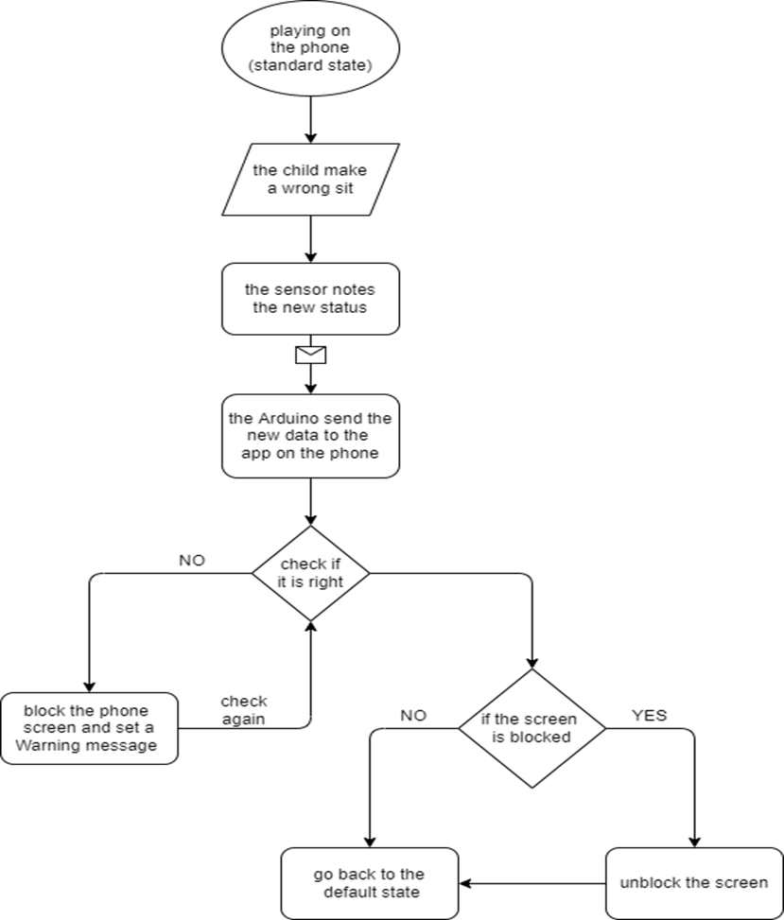

Figure (3.14): The General System Work Flow

**c**

**3.5.4. Architecture diagrams**

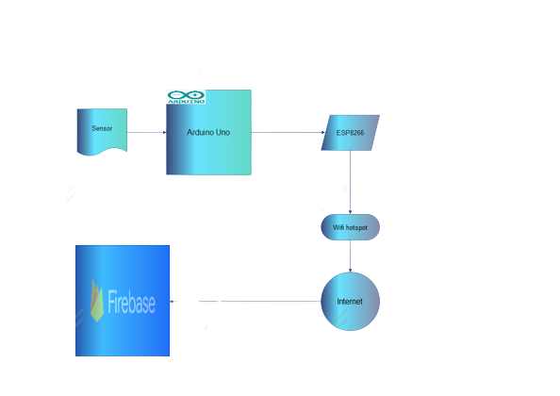

Figure (3.19): Architecture diagram first part

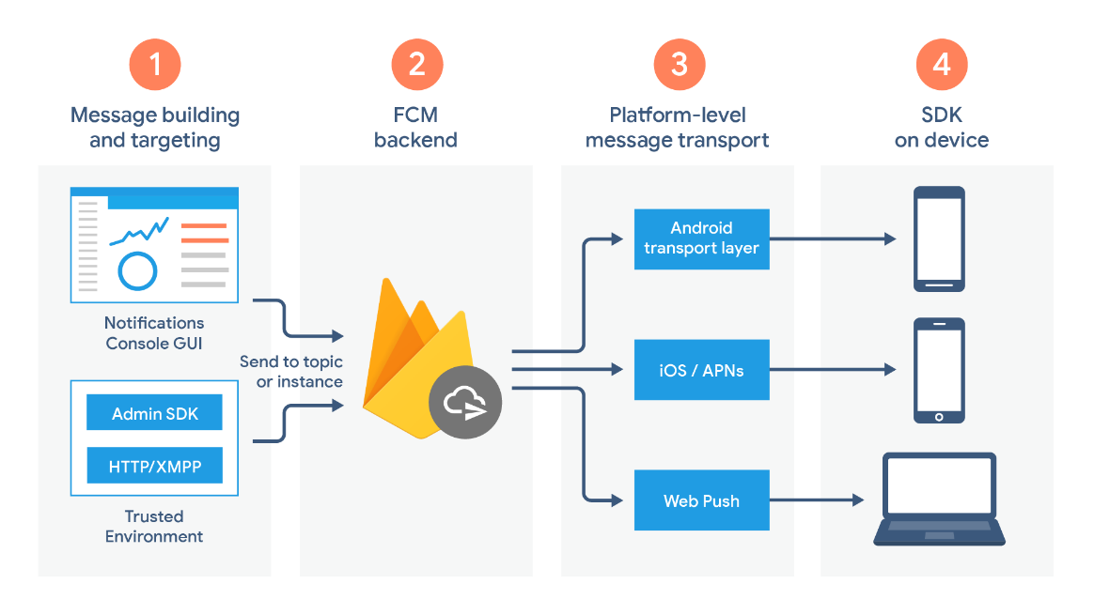

Figure (3.20): Architecture diagram second part

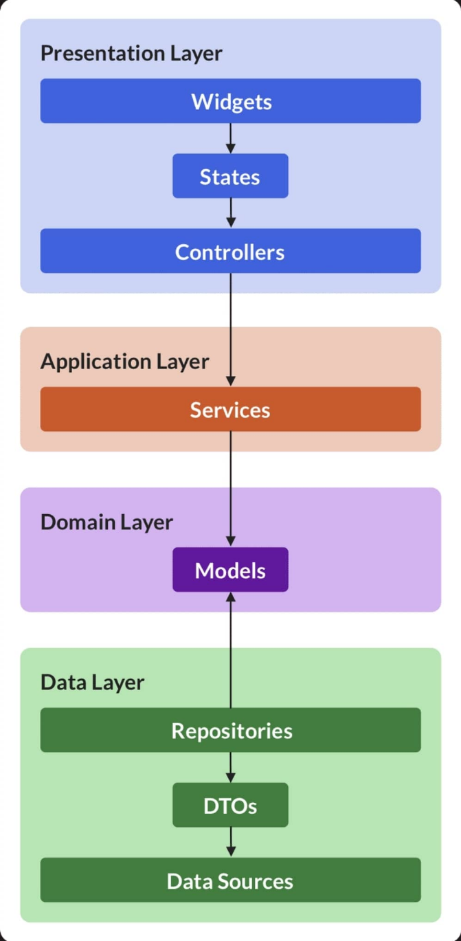

Figure (3.20): Architecture diagram for the flutter app

CHAPTER 4

**IMPLEMENTATION**

**Introduction**

This chapter covers the implementation process that went in to

**4.1. Setting up the Real Time Firebase**

a. First, we went to the firebase console from following link:

(<https://firebase.google.com/>).

b. Add project.

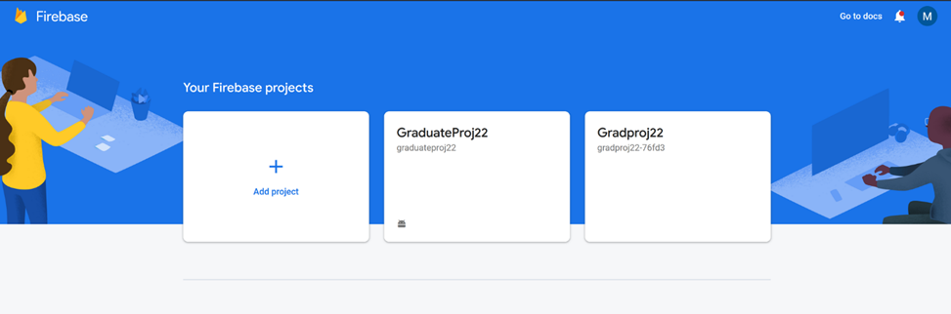

Figure (4.1): step 2

c. Enter the project name.

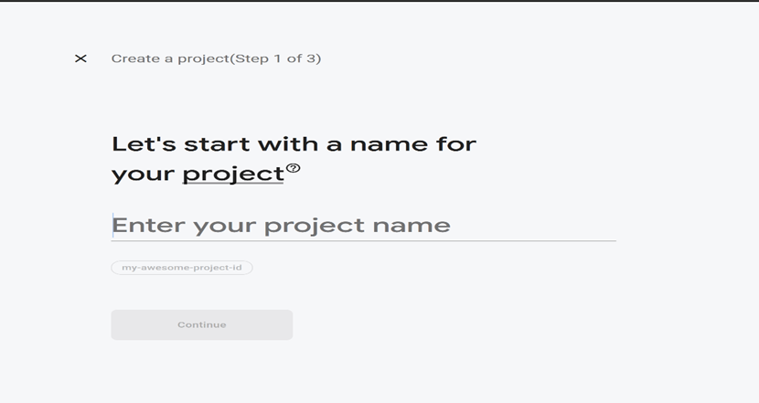

Figure (4.2): step 3

d. We create a Realtime Database.

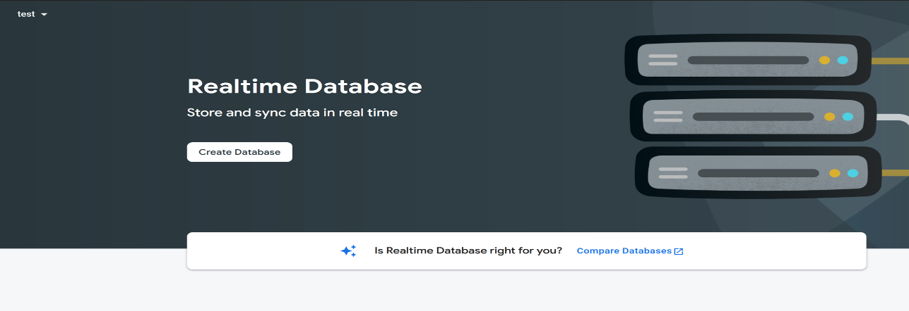

Figure (4.3): step 4

e. we use test mode as a security rule.

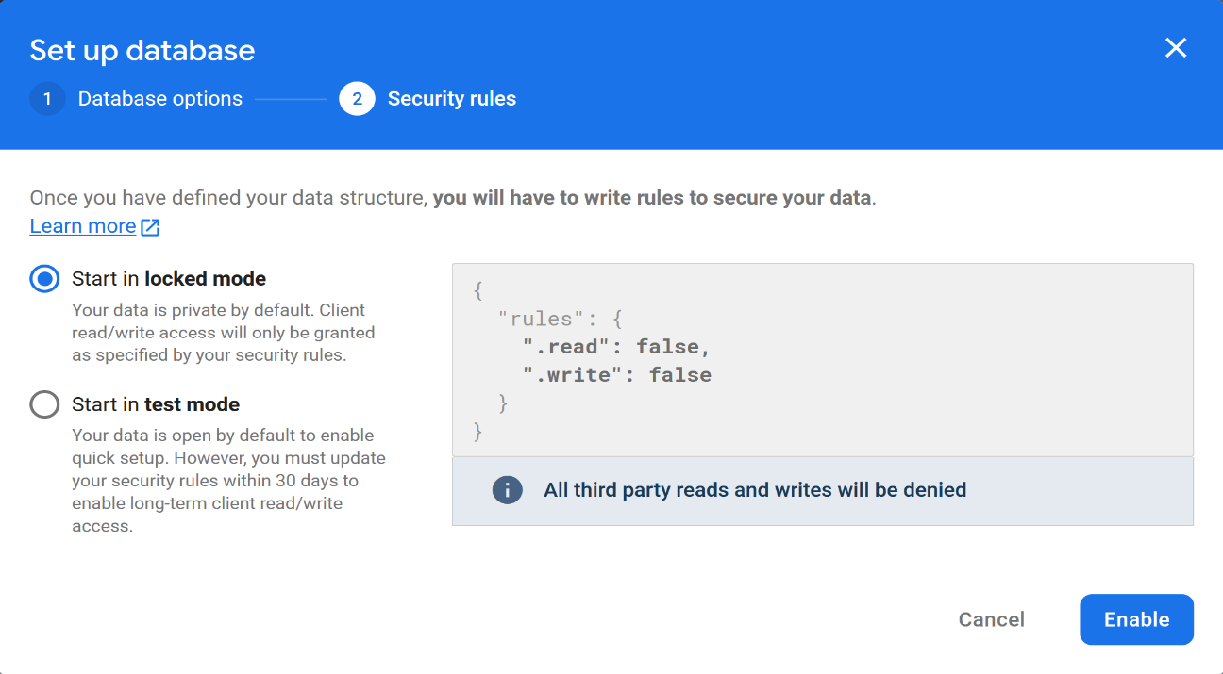



Figure (4.4): step 5

**4.4.** **The Flutter application**

**4.4.1. About the Application**

The application is developed using Flutter SDK [5]. Our application will be connected to the same firebase that the Arduino is connected to. It will read the real time database that is written from the Arduino and response to it. If the signal received is '0', it means the body "the person setting on the chair" is in the range of the sensor and everything is OK. And if the signal received is '1', it means that the body isn't on the range of the sensor and the person isn't sitting correctly, so he will send a notification for the phone that alarm you about it and show a popup window to nidificate the user.

**4.4.2. Development Process**

**4.4.2.1. The IDE (****Android Studio)**

The IDE we used to develop our app is the Android Studio [6], the official IDE to develop android applications. Provided by Google and built on JetBrains IntelliJ. The Flutter SDK and Flutter plugin is not installed by default on Android Studio. So, you need to add it manually before start working.

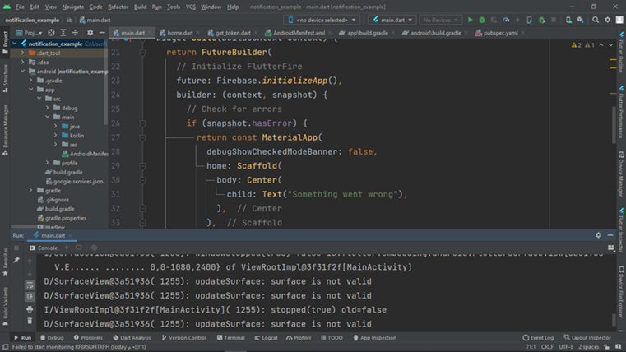

Figure (4.22): Android Studio

**4.4.2.2.** **The Flutter SDK and Dart programming language**

It's is used to develop a cross platform applications for Android, IOS, Desktop, and web apps. But for our project we need it to develop just an android app. The Flutter SDE is a UI tool used to handle the UI, so it used with Dart programming language to deliver the functionality to the app. Dart also developed by google and comes by default with Flutter.

Also, we will use the flutter packages that will help us speed up the work so we don't have to re-invent the wheel.



Figure (4.23): The Flutter SDK

**4.4.3. GUI Overview**

Our app will use one main Screen that has a Button to turn on and off the application. And a lock screen to prevent unauthorized user to access the app.

Also, it will provide a notification to inform the user of the different events and a popup window to inform user of different events (mainly to inform him about the state of his set).

**4.4.3.1.** **Home Screen**

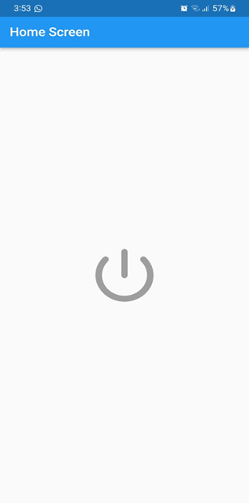

Figure (4.24): Application home Screen

**4.4.3.2. Lock Screen**

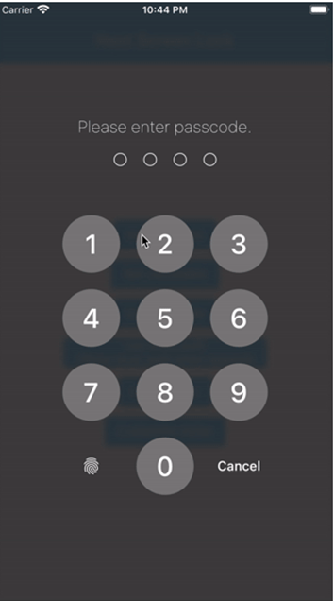

Figure (4.25): Application lock Screen

**4.4.3.3. Notifications**

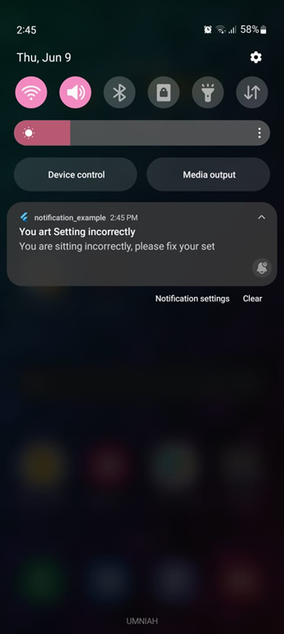

Figure (4.26): Application notification Screen

**4.4.4. Source Code**

The source code for the android applications consists of over 1000 lines of code and it is not included here for copyrights reasons.

**4.4.5. Setting up the Real Time Firebase**

To set up the real time database we will follow the steps bellow:

First, we have to create a new firebase project

Then you will go to the real time firebase section and enable real time firebase

And just that simple, now we have a real time database

Now to connect the firebase project to our app, we need to do the following:

* From the main window of the firebase project, we click on the "add app" button.
* Select android icon to set an android app.
* Now we have to set the Android package name that is found application on the "build.gradle" file.
* Now we will download the "google-services.json" file and add it to our app.
* Now to add the firebase SDK by editing the "build.gradle" file and add some lines of code to it.

And now our application and firebase project both ready to communicate together.

CHAPTER 5

TESTING AND EVALUATION

**Introduction**

We have tested every part of the system separately and all at once, its operating as intended and fully functional:

**5.1. Testing the Digital Distance Sensor**

CHAPTER 6

CONCLUSION

**Introduction**

In last but not least, smartphones have been an important part of our life, it has many advantages like it make our communication with others very easy and flexible. But also, it is a double-edged sword, so we need to handle our life to not be controlled by smartphones, especially the life of our kids, which our project is stand for. To control and monitor the usage of smartphones by kids.

**6.1. Achievements**

We achieve the main goal of our project which is build a device that monitor the kids' posture while using smartphone, we learned a new information about the Arduino world and how it works. Also learned a valuable lesson from the obstacles we faced in this exciting trip.

**6.2. Weakness and Strength points**

The strengths points are the project is a mobile device you can take it wherever you were, can work with any power source where it's a battery or by laptop and the sensor can be attached to any chair. But the weakness point is that if the kid changes his posture, it only sends a notification to get back to right posture.

References

Follow this style of referencing using single spacing for each entry and using normal line spacing between entries.

[1] The flutter official website: https://flutter.dev/

[2] The official Android Studio website: https://developer.android.com/studio

[3] The official Dart website and documents: <https://dart.dev/>

[4] <https://www.arduino.cc/reference/en/libraries/>

[5]<https://www.grc.com/fingerprints.htm?fbclid=IwAR2druxaCnFxNGKPjgKAtYafknHMEc_POYUxKj2_6x775nvEghp0v-rigFU>

[6] <https://create.arduino.cc/projecthub/>

[7] <https://www.elektor.com/>

[8] <https://blog.sparkfuneducation.com/>

[9] <https://www.sciencebuddies.org/>

[10] <https://wiki.seeedstudio.com/>

[11] <https://www.pololu.com/>

[12] <https://www.frontiersin.org/>

[13] <https://sherwoodhigh.com/>