Software Requirements Specification (SRS)

Revision History

1. Introduction
1.1 Purpose
This SRS mainly describes the Tenant Portal and Queries Maintenance System, a front-end web application designed to help tenants and admin to view and manage information such as tenant details, complaints, and rent status , payment status. The system demonstrates user interface design and front-end logic for property management, without server-side or database integration.
1.2 Document Conventions
“REQ-#” denotes requirement identifiers. Text in bold highlights important terms. “Static data” refers to sample values written directly in HTML files.
1.3 Intended Audience and Reading Suggestions
Developers – for front end implementation or for future expansion.
Instructors/Evaluators – to assess design and usability.
Students – to learn about UI design for tenant management systems .
1.4 Product Scope
The system serves as a prototype of a tenant management portal. It allows viewing tenant information, complaints, rent payment status, and a community chat section — all displayed through a static web interface clearly.
1.5 References
IEEE SRS Template (Karl E. Wiegers, 1999)
W3C HTML and CSS Standards
Local project file: AdminDashboard.html

2. Overall Description
2.1 Product Perspective
The Tenant Portal is a standalone HTML-based web application. All information displayed (tenant names, complaints, payments) is static , tenant details are displayed and payments are fixed by admin.
2.2 Product Functions
Display tenant information and details , complaint requests regarding issues , tenant rent payment status, and community chat for managing queries and overlooking into issues.
2.3 User Classes and Characteristics
Tenant (Viewer): Can view data shown on the dashboard.
Admin (Prototype): Represents management but currently simulated.
2.4 Operating Environment
Platform: Web browser (Google Chrome, Edge, Firefox).
Operating System: Windows, macOS, or Linux.
Tools Used: HTML, CSS, JavaScript.
2.5 Design and Implementation Constraints
Datas are not stored , Functionalities like update or delete new users , vacate home , return advance money like that are not implemented.
2.6 Assumptions and Dependencies
Runs on browsers without the need for the internet. Future upgrades may add backend and data persistence.

3. External Interface Requirements
3.1 User Interfaces
Admin Dashboard displays tables for tenants, complaints, rent, and community chat.
3.2 Hardware Interfaces
Desktop, laptop, or tablet with a web browser.
3.3 Software Interfaces
None — since no database or backend is connected.
3.4 Communications Interfaces
None — system is local and static (no HTTP or API communication).

4. System Features
4.1 Display Tenant Details
REQ-1: Tenant name, E-mail ID, Flat no.
REQ-2: It is in the table format.
4.2 Display Complaint Requests
REQ-3: Show tenant name, issue, and status. In table format Tenant name, Issue and status will be displayed in complaint request panel.
REQ-4: Status will be manually updated if the tenant changed it in their dashboard. In the same way they can enter issues.
4.3 Display Rent Payment Information
REQ-5: Display tenant, month, amount, and payment status.
REQ-6: Payment information static in HTML.
4.4 Community Chat (Embedded Iframe)
REQ-7: Load chat.html through iframe.
REQ-8: Static display only — no live chat.

5. Other Nonfunctional Requirements
5.1 Performance Requirements
Dashboard shall load instantly since all data is local.
5.2 Safety Requirements
There will be no data loss since all files are local.
5.3 Security Requirements
No authentication or data storage is required.
5.4 Software Quality Attributes
Usability, Portability, Maintainability, Reliability etc...
5.5 Business Rules
Admin and tenant data are for demo display only. Updates done manually in HTML files.

6. Other Requirements
Should support future backend additions. File structure must remain simple. Project folder must contain all HTML/CSS/JS files.

Appendix A: Glossary
Tenant – Resident listed in the system
Admin – Person managing property (simulated)
Query – Complaint or maintenance issue
Chat – Static section for community messages

Appendix B: Analysis Models
This section describes the analysis and design diagrams developed for the Tenant Portal and Queries Maintenance System.
These models visually represent the system’s functionality, structure, and data flow between the users (Admin and Tenant) and the system components.
They help in understanding, analyzing, and refining the requirements before implementation.

B.1 Use Case Diagram
The Use Case Diagram demonstrates mainly about the major interactions between the Tenant, Admin, and the System. It identifies key functionalities such as viewing tenant details, submitting complaints, checking rent payment status, and accessing the community chat section.
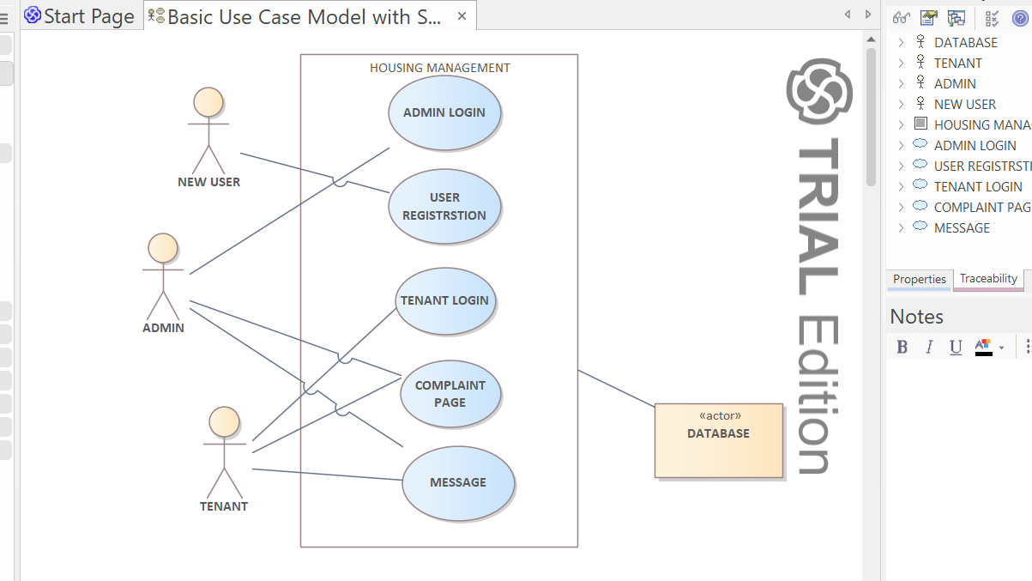

B.2 Class Diagram
The Class Diagram mainly represents the static structure of the system.
It shows the classes (such as tenant, admin, chat, rent) along with their attributes and relationships. This model helps in understanding how data is organized and how different parts of the system interact logically.
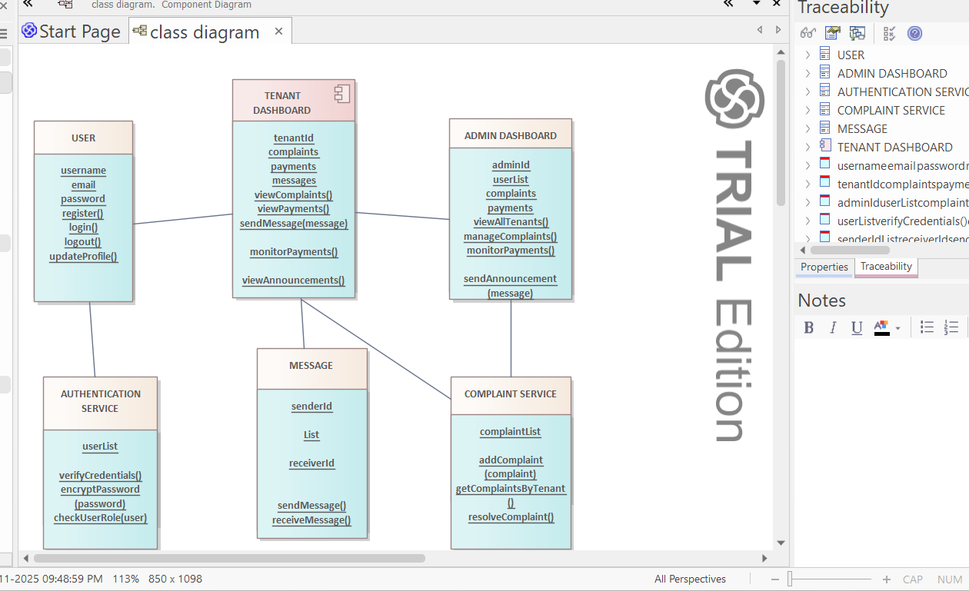

B.3 Data Flow Diagram (DFD)
The DFD depicts the flow of data within the system.It includes both Level 0 and Level 1 and Level 3diagrams to explain the processes, data stores, and data movements between entities like Tenant, Admin, and the System. It helps us to visualize better about how user input is transformed into output through various system processes.
LEVEL-0
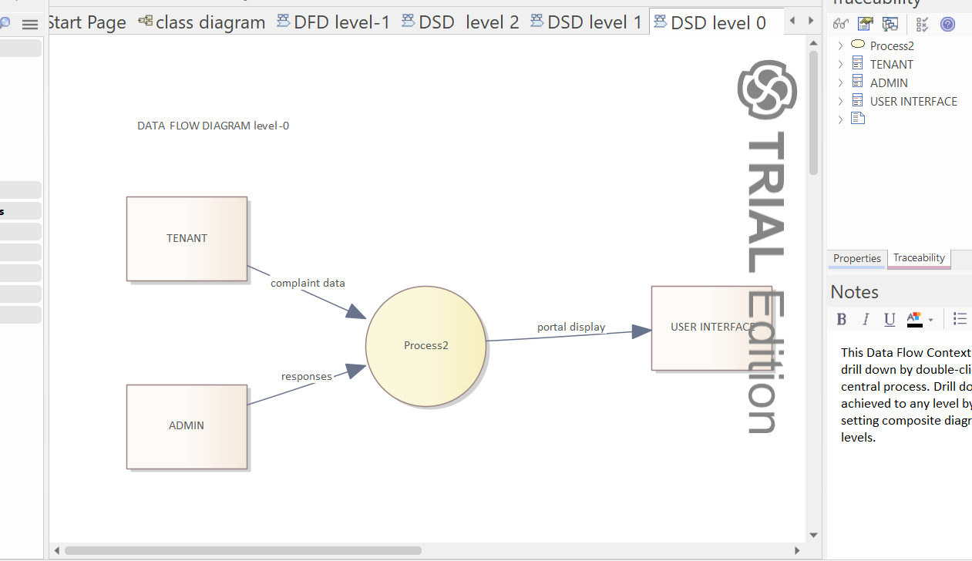
LEVEL-1
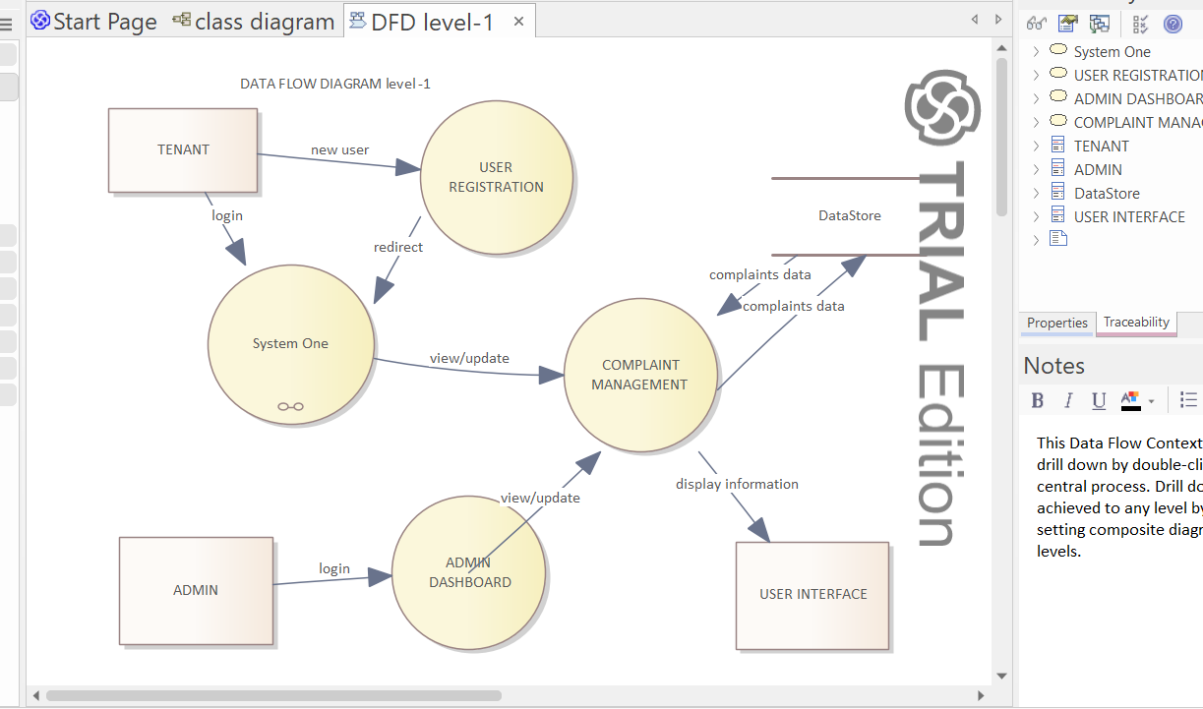

LEVEL-2
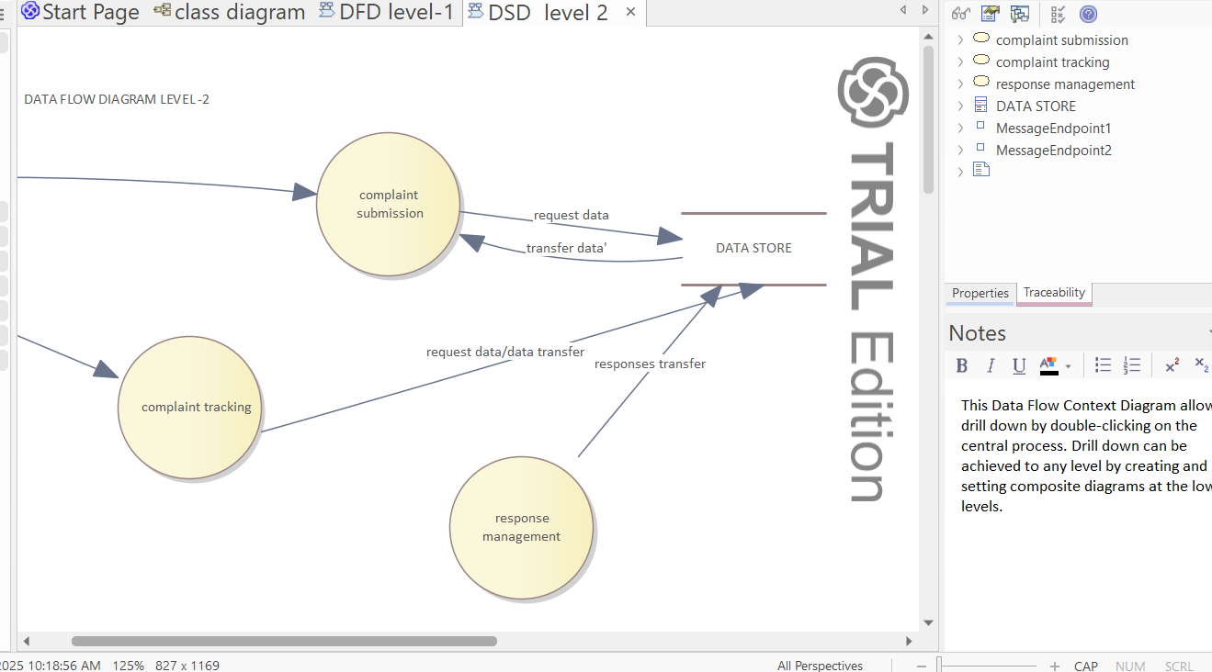

B.4 Activity Diagram
The Activity Diagram describes the workflow and control flow for specific system operations—such as handling tenant complaints or displaying rent information. It captures decision points, sequential and parallel actions, and shows how different activities are coordinated.

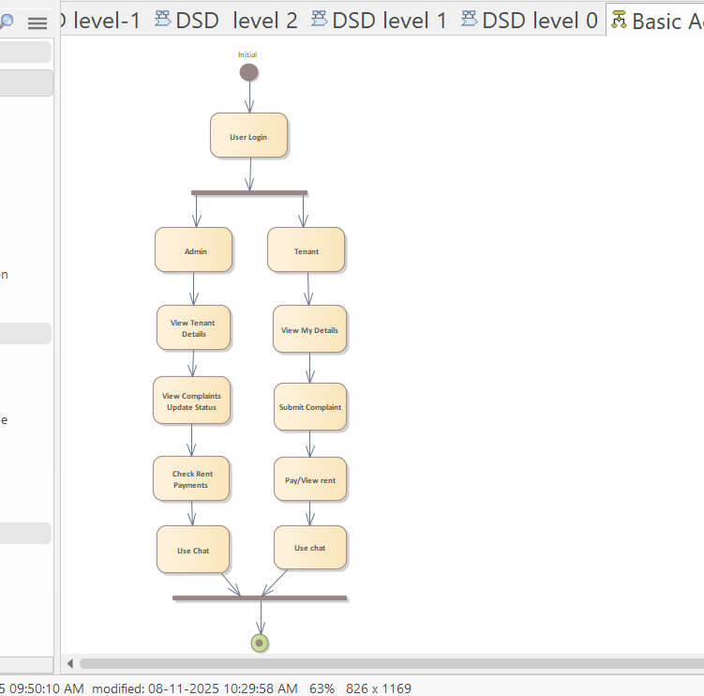

B.6 State Diagram
The State Diagram represents the different states of a tenant complaint or rent payment record throughout its lifecycle. This diagram helps to understand the dynamic changes and transitions that occur based on user or admin actions.
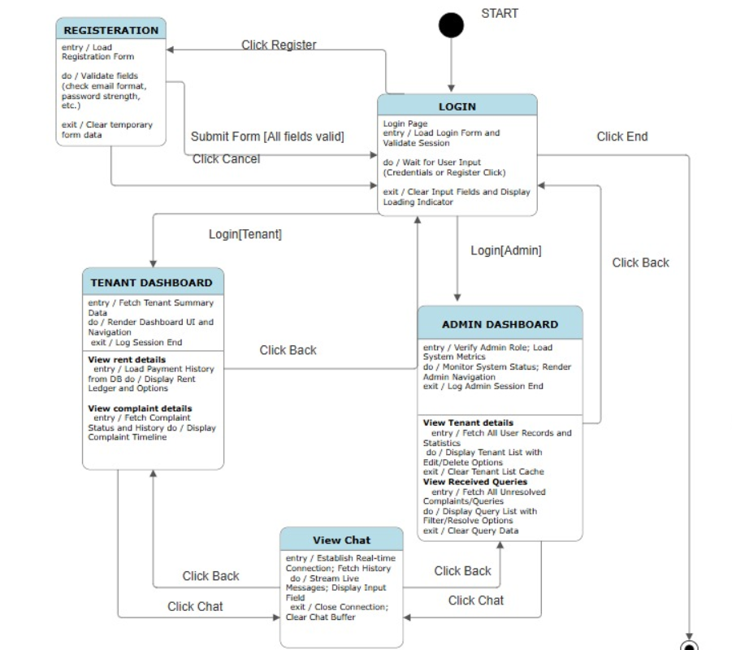

B.7 MVC Model Representation
The system follows the Model–View–Controller (MVC) architectural pattern to separate concerns and improve maintainability:
- Model: Represents the data and business logic (e.g., Tenant, Complaint, Rent classes).
- View: Represents the user interface built using HTML and CSS, displaying static data to users.
- Controller: Uses JavaScript to control user interactions and manage transitions between views.
This design structure ensures a clear separation of data representation, user interface, and control logic for future scalability.
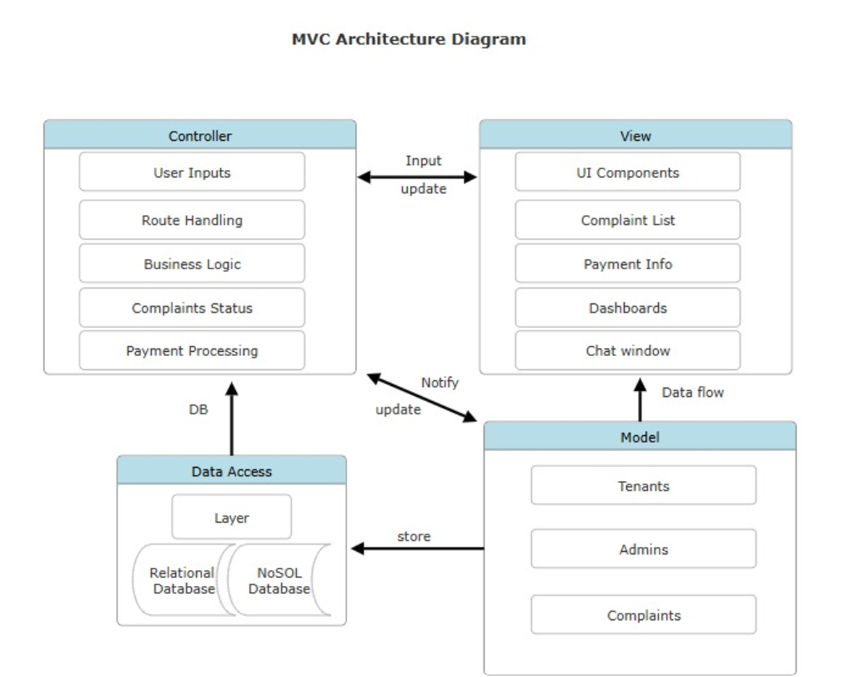

Appendix C: To Be Determined (TBD) List
TBD No. | Description
TBD-1 | Add backend for real-time chat.
TBD-2 | Add login and authentication module.
TBD-3 | Connect to database for dynamic tenant records.
JIRA Tool Usage – Project Management & Implementation

JIRA:
JIRA is an agile project management tool used for planning, tracking, and managing software development projects. It helps the team organize tasks, assign responsibilities, and monitor project progress efficiently.
Purpose of Using JIRA:
- Manage and track development activities
- Organize project sprints and epics
- Assign and monitor team member tasks
- Maintain transparency and improve collaboration
SDLC Phases Involved:
JIRA is primarily used during the following SDLC phases:
- Design Phase: To plan and document sprint goals
- Development Phase: To assign and track coding tasks
- Testing Phase: To monitor bug reports and fixes
- Implementation Phase: For deployment tracking and updates
Hence, JIRA mainly falls under the Implementation and Monitoring phases of SDLC.

FEATURES:
- DASHBOARD:
The dashboard provides an overall view of the project, including sprint progress, issue summary, and activity charts. It helps the team quickly understand the current project status.

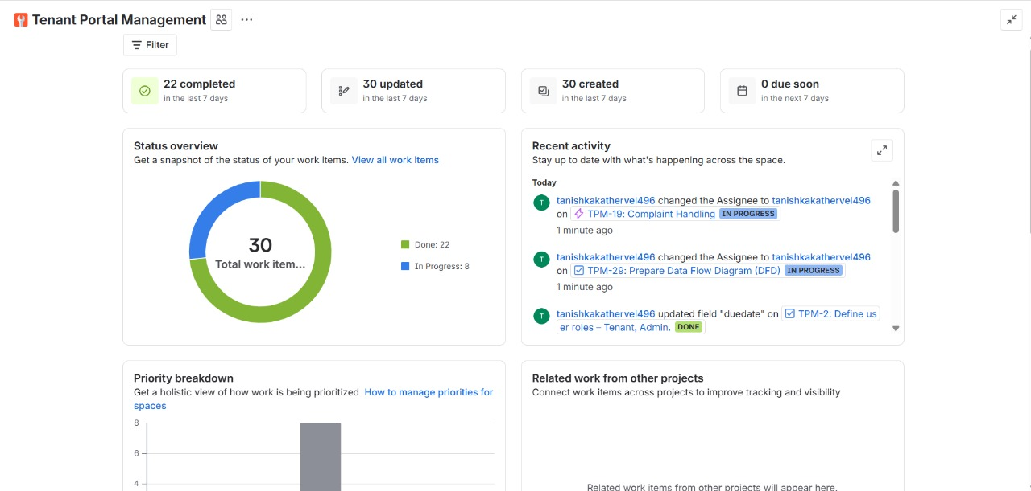

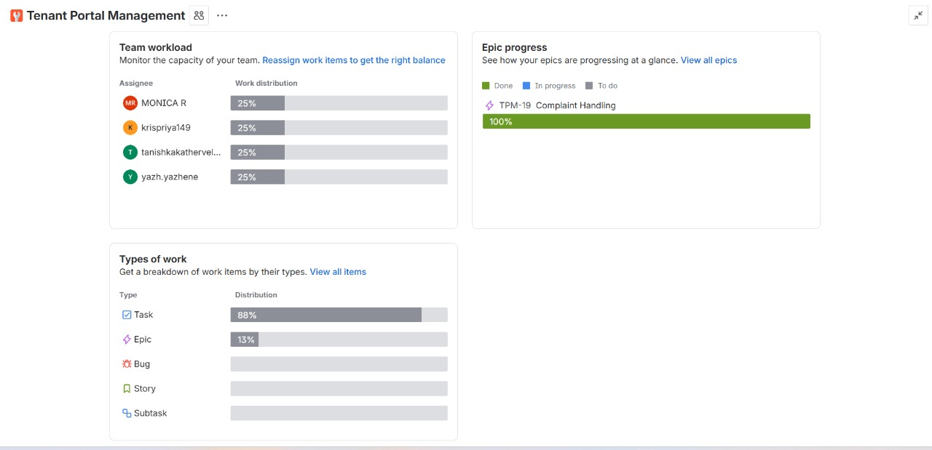
- BACKLOG:
The backlog contains all planned features, tasks, and future improvements for the tenant portal. It helps prioritize work items and prepare for upcoming sprints in an organized manner.

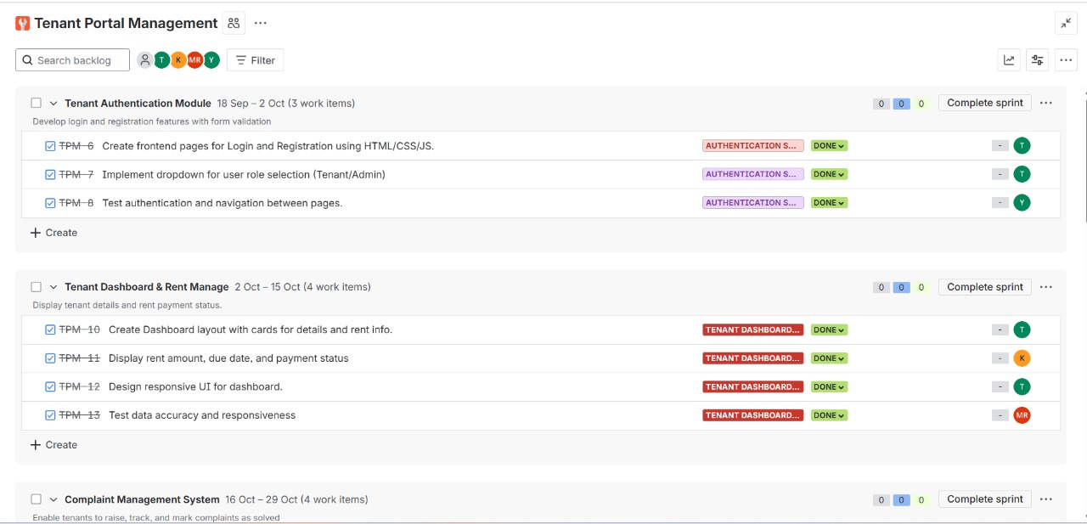

- ACTIVE SPRINTS(BOARD):
The active sprint board shows tasks across different workflow stages — To Do, In Progress, and Done. It helps visualize real-time task movement and teamwork efficiency.
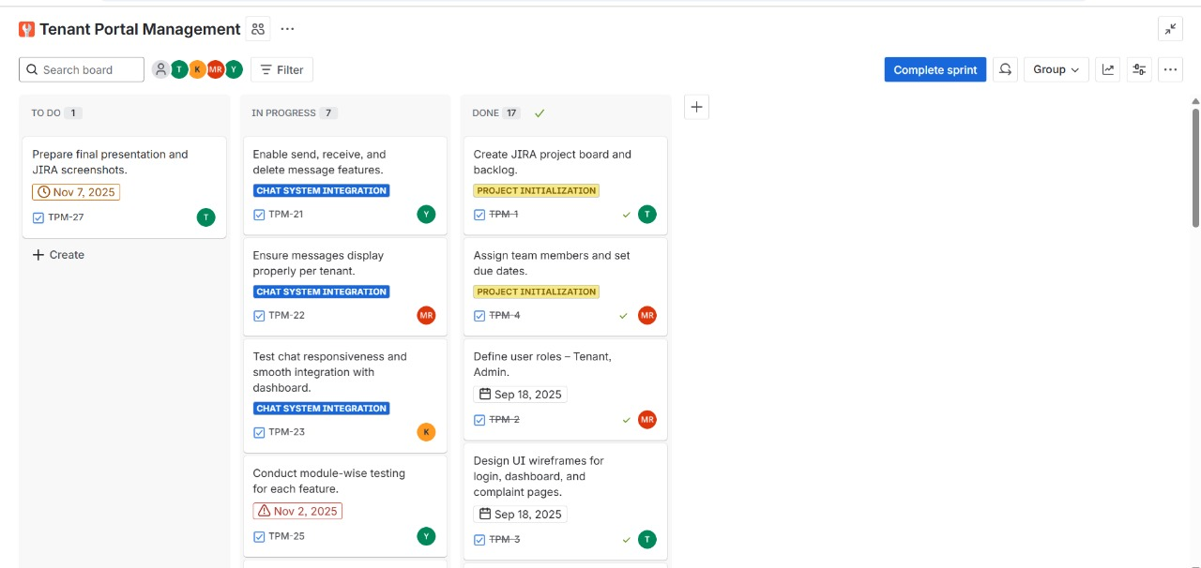

- All Work View:
Displays all project tasks, epics, and issues in one place, helping the team track progress and manage updates efficiently.
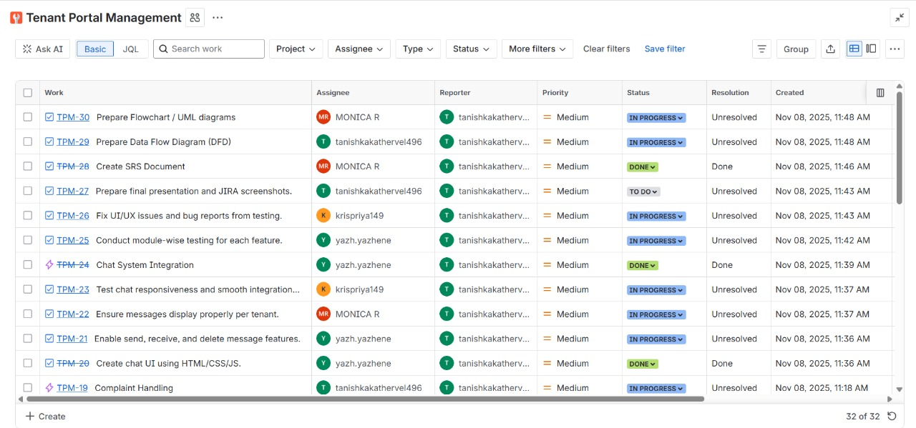
Using JIRA improved project organization, task tracking, and overall team productivity. It ensured every phase of the tenant portal development was properly planned and executed.
Tenant Portal Chat - Unit Test Report
Test Objective
To validate individual components of the Tenant Portal Chat System, focusing on input validation functions, message submission logic, and message deletion functionality.
The goal is to ensure data integrity, proper validation enforcement, and correct message handling within the front-end logic.

Test Environment
- Language: JavaScript (ES6)
- Testing Framework: Selenium WebDriver (Node.js)
- Browser: Google Chrome (latest)
- Test Type: Unit and Functional Component Testing (Front-end Validation)

Test Cases and Results
Test Case ID | Test Method | Description | Expected Result | Actual Result
TC_001 | validateName_Valid | Enter a name with only alphabets (3–20 chars) | Name accepted and validation passes | Validation passed; send button enabled
TC_002 | validateName  _InvalidChar | Enter a name with special characters (Jo@hn) | Validation fails; send button disabled | Validation correctly blocked; button disabled
TC_003 | validateName_Short | Enter a name shorter than 3 chars (Al) | Validation fails; send button disabled | Validation correctly blocked; button disabled
TC_004 | validateMessage  _TooShort | Enter a message shorter than 10 chars (Hi) | Validation fails; send button disabled | Validation correctly blocked; button disabled
TC_005 | validateMessage_Valid | Enter a valid message (10–100 chars) | Message accepted and ready to send | Validation passed; send button enabled
TC_006 | sendMessage | Submit a valid name and message | Message stored in localStorage and rendered in chat window | Message successfully sent and displayed
TC_007 | deleteMessage_  Within60Min | Delete the most recent message within 60 minutes | Message successfully deleted from list | Message deleted successfully
TC_008 | deleteMessage_  OlderThan60Min | Attempt to delete a message older than 60 minutes | Error message shown; deletion not allowed | Alert displayed: “Cannot delete message older than 60 minutes.”

Summary of Results
- Total Test Cases: 8
- Passed: 8
- Failed: 0
- Overall Status: PASS

Observations
- Validation logic for name and message fields correctly enforced input rules:
  - Names only accepted alphabets between 3 and 20 characters.
  - Messages respected the 10–100 character limit.
- Send button dynamically enabled/disabled based on input validity.
- LocalStorage correctly preserved chat history during runtime.
- Delete button functioned as intended — restricted message removal beyond 60 minutes.
- Front-end state updates and DOM rendering were consistent with validation outcomes.

Recommendations
- Implement additional feedback messages beside disabled buttons for improved user clarity (e.g., “Name must be 3–20 alphabets”).
- Consider adding automated boundary tests for input lengths (exactly 3, 20, 10, and 100 characters).
- Extend test suite with UI regression tests to ensure styling and layout remain stable across updates.

Testing Code
const { Builder, By } = require('selenium-webdriver');
const assert = require('assert');

(async function testChatValidation() {
let driver = await new Builder().forBrowser('chrome').build();

try {
await driver.get('http://127.0.0.1:3000/chat.html');

const nameInput = await driver.findElement(By.id('sender'));
const msgInput = await driver.findElement(By.id('content'));
const sendButton = await driver.findElement(By.id('sendButton'));
const deleteButton = await driver.findElement(By.id('deleteLatest'));

async function clearAndType(el, text) {
await el.clear();
await el.sendKeys(text);
}

async function logInputValues(nameVal, msgVal) {
console.log('\nTesting with inputs:');
console.log(' Name →', `"${nameVal}"`);
console.log(' Message→', `"${msgVal}"`);
}

// Invalid name (special characters)
let nameVal = 'Jo@hn';
let msgVal = 'This is a valid message length';
await logInputValues(nameVal, msgVal);
await clearAndType(nameInput, nameVal);
await clearAndType(msgInput, msgVal);
await driver.sleep(1000);
let isSendEnabled = await sendButton.isEnabled();
console.log('Send enabled (invalid name):', isSendEnabled);
assert.strictEqual(isSendEnabled, false);

// Short name (<3 chars)
nameVal = 'Al';
msgVal = 'This is a valid message length';
await logInputValues(nameVal, msgVal);
await clearAndType(nameInput, nameVal);
await clearAndType(msgInput, msgVal);
await driver.sleep(1000);
isSendEnabled = await sendButton.isEnabled();
console.log('Send enabled (too short name):', isSendEnabled);
assert.strictEqual(isSendEnabled, false);

// Valid name but short message (<10 chars)
nameVal = 'Alice';
msgVal = 'Hi';
await logInputValues(nameVal, msgVal);
await clearAndType(nameInput, nameVal);
await clearAndType(msgInput, msgVal);
await driver.sleep(1000);
isSendEnabled = await sendButton.isEnabled();
console.log(' Send enabled (too short message):', isSendEnabled);
assert.strictEqual(isSendEnabled, false);

// Valid name & valid message
nameVal = 'Alice';
msgVal = 'Hello everyone, this is a valid message!';
await logInputValues(nameVal, msgVal);
await clearAndType(nameInput, nameVal);
await clearAndType(msgInput, msgVal);
await driver.sleep(1000);
isSendEnabled = await sendButton.isEnabled();
console.log('Send enabled (valid fields):', isSendEnabled);
assert.strictEqual(isSendEnabled, true);

// Click send and confirm message appears
await sendButton.click();
console.log('Message sent successfully.');
const chatMessages = await driver.findElement(By.id('chatMessages'));
const text = await chatMessages.getText();
assert(text.includes('Alice'));

// Delete last message (should work because it’s <60 min old)
await deleteButton.click();
console.log('Delete button clicked.');
await driver.sleep(1000);
const chatTextAfterDelete = await chatMessages.getText();
console.log('Chat after delete:', chatTextAfterDelete);

console.log('\nAll test cases passed successfully!');
} catch (err) {
console.error('Test failed:', err);
} finally {
await driver.quit();
}
})();

Output in console
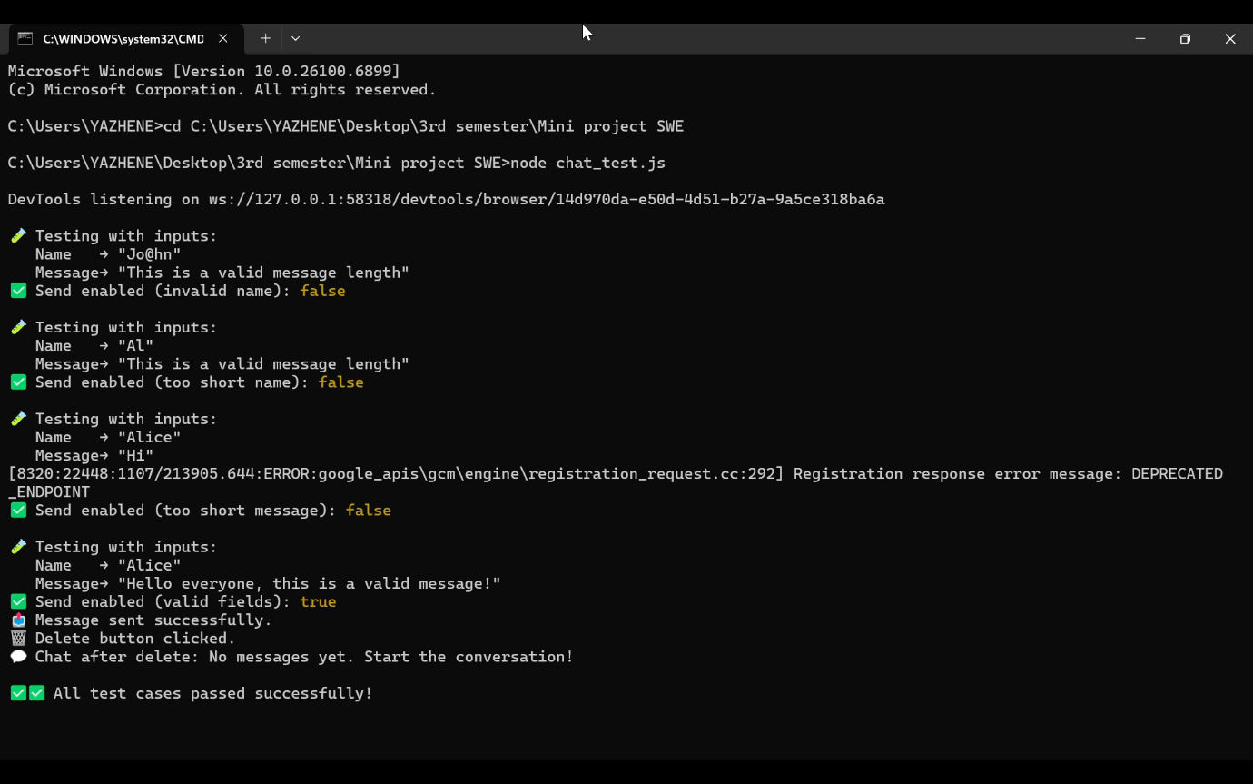

COCOMO
CONSTRUCTIVE COST MODEL
COCOMO Model is a procedural cost estimate model for Software Projects and is often used as a process of reliably predicting the various parameters associated with making a project such as size, effort, cost, time, and quality.

The key parameters that define the quality of any Software Product, which are also an outcome of COCOMO, are primarily effort and schedule.

Constant values:
  - Labor Months(LM)
  - Development Time(DT)

Three levels of model:
- Basic
- Intermediate
- Detailed

Three modes:
  - Organic (<50000 SLOC)
  - Semi-detached (upto 300000 SLOC)
  - Embedded (300000 -1000000 SLOC)

Basic COCOMO:
The Basic COCOMO model is a straightforward way to estimate the effort needed for a software development project. It uses a simple mathematical formula to predict how many person-months of work are required based on the size of the project, measured in thousands of lines of code (KLOC).

Organic :
The problem is well understood and has been solved in the past and also the team members have a nominal experience regarding the problem.
LM=2.4 * (KSLOC) ^1.05
DT=2.5 * (LM) ^0.38

Semidetached:
The projects classified as Semi-Detached are comparatively less familiar and difficult to develop compared to the organic ones and require more experience better guidance and creativity.
LM=3.0 * (KSLOC) ^ 1.12
DM=2.5 * (LM) ^0.35

Embedded:
A software project requiring the highest level of complexity, creativity, and experience requirement falls under this category
LM =3.6 * (KSLOC) ^ 1.20
DT = 2.5 * (LM) ^0.32

Intermediate:
The basic COCOMO model assumes that the effort is only a function of the number of lines of code and some constants evaluated according to the different software systems. However, in reality, no system's effort and schedule can be solely calculated based on Lines of Code. For that, various other factors such as reliability, experience, and Capability. These factors are known as Cost Drivers (multipliers) and the Intermediate Model utilizes 15 such drivers for cost estimation.
EAF is the Effort Adjustment Factor (EAF)

15 variables:

Product attributes:
RELY: Quantifies the effect of the required software reliability.
DATA: Quantifies the effect of the size of the database used.
CPLX: Quantifies the effect of the complexity of the software product.

Computer system attributes:
TIME: Quantifies the effect of the execution time constraints.
STOR: Quantifies the effect of the main storage.
VIRT: Quantifies the effect of the virtual machine volatility.
TURN: Quantifies the effect of the computer turnaround time.

Project personnel attributes:
ACAP: Quantifies the effect of the analyst and capabilities.
AEXP: Quantifies the effect of the team’s experience.
PCAP: Quantifies the effect of the Programmer’s capabilities.
VEXP: Quantifies the experience of the programming team with the host virtual machine.
LEXP: Quantifies the effect of programmer’s experience with the programming language being used.

Project attributes:
MODP: Quantifies the effect of the use of the modern programming practice by the team.
TOOL: Quantifies the effect of the use of the advanced software development tolls.
SCED: Quantifies the effect of the schedule constraints.

Rating range: Very low, Low, Nominal, High, Very high, Extra High

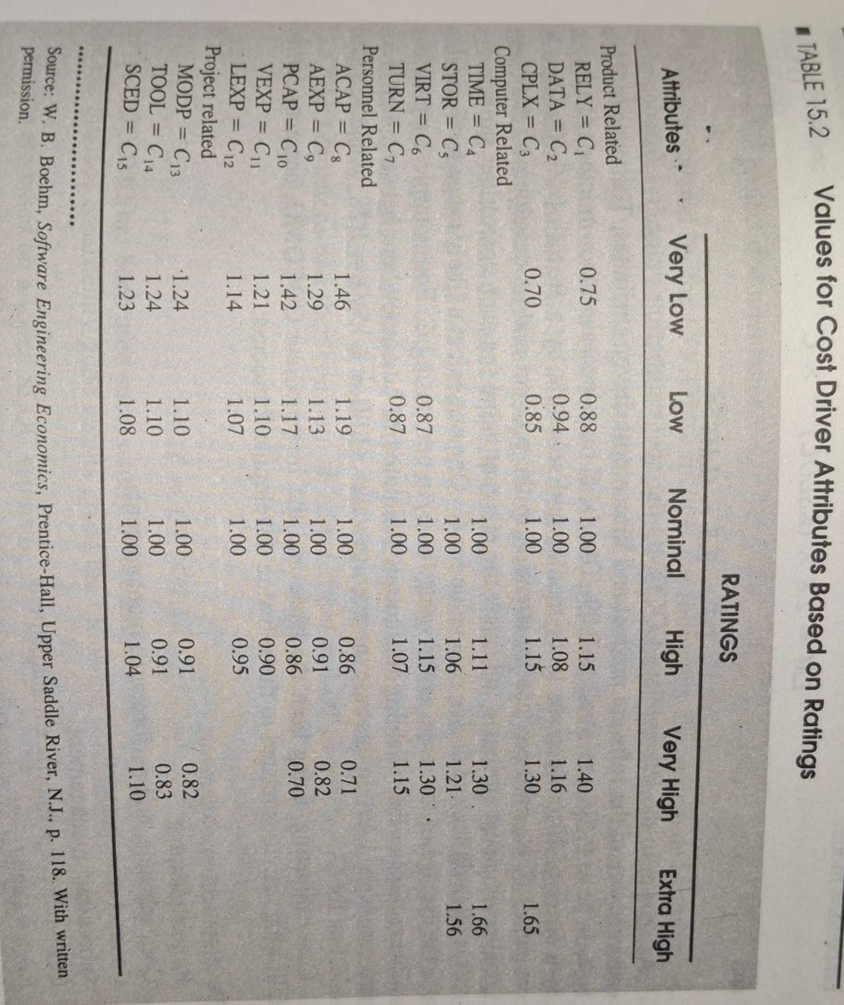
Very variable is denoted as c1,c2,….,c15.
Overall cost driver attributes
C=c1*c2*c3*……*c14*c15

Organic :
LM=2.4 * (KSLOC) ^1.05 *C
DT=2.5 * (LM) ^0.38
Semidetached:

LM=3.0 * (KSLOC) ^ 1.12 *C
DM=2.5 * (LM) ^0.35
Embedded:

LM =3.6 * (KSLOC) ^ 1.20 * C
DT = 2.5 * (LM) ^0.32

Detailed COCOMO:
Detailed COCOMO goes beyond Basic and Intermediate COCOMO by diving deeper into project-specific factors. It considers a wider range of parameters, like team experience, development practices, and software complexity. By analyzing these factors in more detail, Detailed COCOMO provides a highly accurate estimation of effort, time, and cost for software projects. It's like zooming in on a project's unique characteristics to get a clearer picture of what it will take to complete it successfully.

