HackMatrix 2026 — Round 2
Project Documentation

Team Name
Team Perihelion

Team Leader
Name: Nandika Yazhini A E
Email: [nandikayazhiniarunothayakumar@gmail.com]
Phone: [9003313492]

Event Name
HackMatrix 2026 — Round 2

Project Name / Title
Pramaan (प्रमाण) — Digital Evidence Readiness & Admissibility Platform

Links
Link | URL
GitHub Repository (public) | https://github.com/Yazhini0128/pramaan-hackmatrix
Live Deployed Link | https://adorable-platypus-c56e82.netlify.app
Demo Video | https://drive.google.com/file/d/11K5P13aXcjwap3AP-X6ZHHpx22NtEIjY/view?usp=drivesdk

Your Problem Statement
Indian courts reject digital evidence in nearly 4 out of 10 cases — not because it's fake, but because investigators can't prove it wasn't altered. Missing cryptographic hashes, broken chains of custody, understaffed forensic labs, and missing Section 63 certificates (under the Bharatiya Sakshya Adhiniyam, 2023) cause strong cases to collapse on procedure rather than facts. Investigators today juggle disconnected tools, manual reporting, and legal paperwork — a slow, error-prone process that judges without technical training struggle to interpret.

Problem Being Solved
Digital evidence in the Indian legal system frequently fails admissibility not due to authenticity issues, but due to procedural gaps: no cryptographic proof of integrity, no verifiable chain of custody, and missing legal certification. Pramaan directly targets this procedural failure point rather than the underlying forensic science, which is where most existing tools stop short.

Summary
Pramaan turns any raw digital file into court-ready evidence in one click: it fingerprints the file cryptographically, extracts and analyzes its metadata, builds a tamper-evident chain of custody, scores its legal readiness, and generates a signed Section 63 certificate — all running entirely offline, in the browser, with no cloud dependency. This makes it usable in air-gapped forensic environments and by police units with no dedicated IT infrastructure.

USP (Unique Selling Point)
- Fully offline, zero-dependency architecture — runs entirely client-side via the Web Crypto API; no server, database, or internet connection required after first load.
- Genuinely blockchain-style chain of custody — each custody event is a cryptographically hash-linked block, giving real tamper-evidence without the cost or complexity of a distributed ledger.
- Built directly around Indian law — targets Section 63 of the Bharatiya Sakshya Adhiniyam (BSA) 2023 specifically.
- Dual-audience design — a technical Investigator view and a plain-English Judge view.
- Multi-agency ready — case management scoped by police unit with real access-control boundaries, not just cosmetic labels.

Key Features
Feature | What it does
Evidence fingerprinting | SHA-256 hash generated client-side on upload via the Web Crypto API
Metadata extraction | File type, size, and timestamps captured on intake
Tamper detection | Re-verification recomputes the hash and flags any mismatch instantly
Blockchain-style Chain of Custody | Every action stored as a hash-linked block; Verify Chain Integrity proves tampering
Legal Readiness / Trust Score (0–100) | Weighted score combining hash integrity, metadata completeness, and custody chain validity
Section 63 Certificate Generator | One click generates a formatted, downloadable PDF certificate
Judge / Investigator toggle | Investigator view shows full technical detail; Judge view shows plain-English explanation
Live Tamper Simulator | Demonstrates the system live — modifies evidence, shows hash and trust score change in real time
Multi-Agency Case Management | Cases tagged by police unit and incident type, shared pipeline across agencies
Real EXIF metadata analysis | Camera metadata extracted and cross-checked for anomalies
Legal Compliance Checklist | Every evidence item scored against 8 procedural requirements
Full Case Report export | Bundles hash, score, anomalies, compliance results, and custody history into one PDF
Case-wide unified timeline | Custody events from every evidence item merged into one view
Backup / Restore | Downloads/reloads the case database as JSON, without browser storage APIs
Multi-Agency Access Control | Viewing-as selector scopes the dashboard to one unit, or an Oversight view
Incident Response Workflow | 5-stage response pipeline from Incident Reported to Case Closed

Tech Stack
- Frontend/App: Single-page vanilla HTML + JavaScript (no build step, no framework)
- Cryptography: Browser-native Web Crypto API (crypto.subtle.digest, SHA-256)
- PDF Certificate & Report Generation: jsPDF (via CDN)
- EXIF Metadata Extraction: exif-js (via CDN)
- Styling: Custom CSS (navy #01386A / gold #F5A623), no external CSS framework
- Data: In-memory state, with manual Backup/Restore as a safety net
- Deployment: Netlify

Platform Preview
Pramaan opens with an animated boot-sequence splash screen, followed by a Secure Access Terminal login gate, before revealing the dashboard. The interface uses a dark cyber-forensics identity — navy/black background, teal and amber accents, monospace type for hashes, glowing status indicators, and animated radial trust-score rings.

Dashboard — unified multi-agency case pipeline
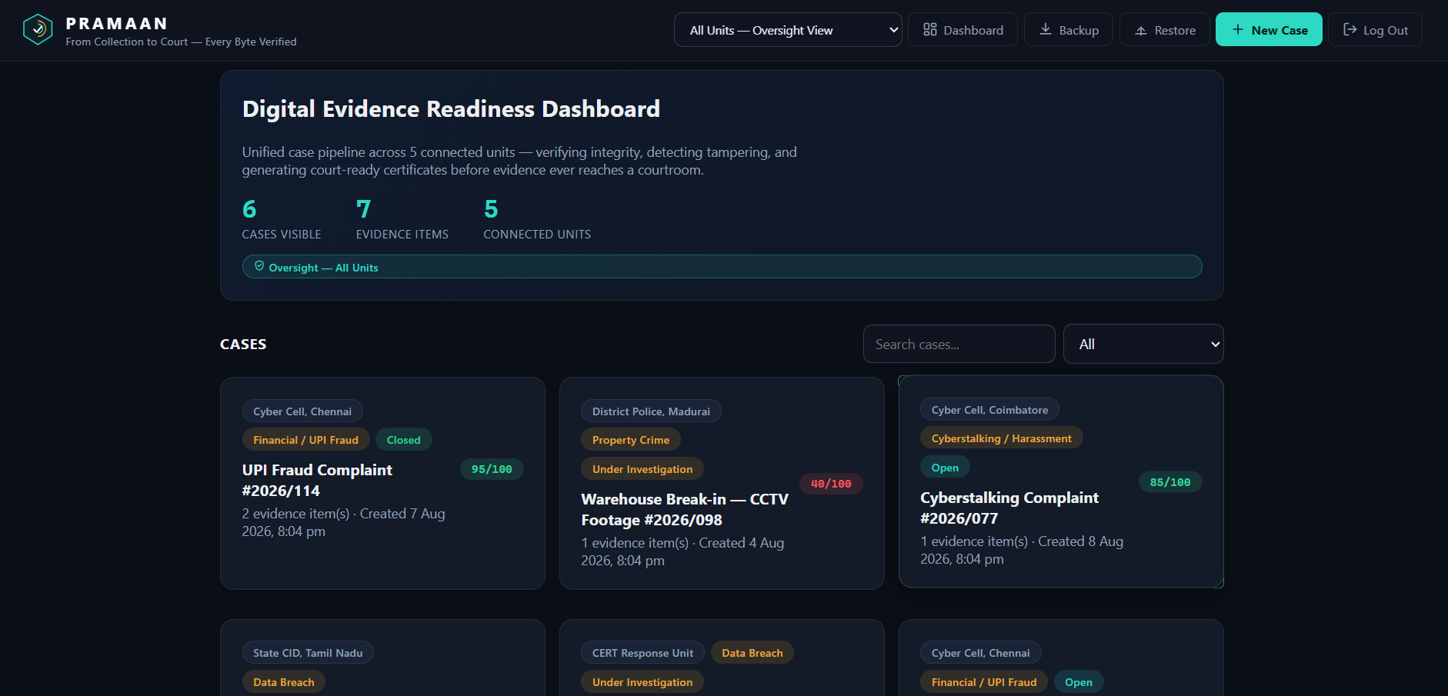
Fig 1. Digital Evidence Readiness Dashboard with cases across 5 connected units

Evidence detail — flagged case
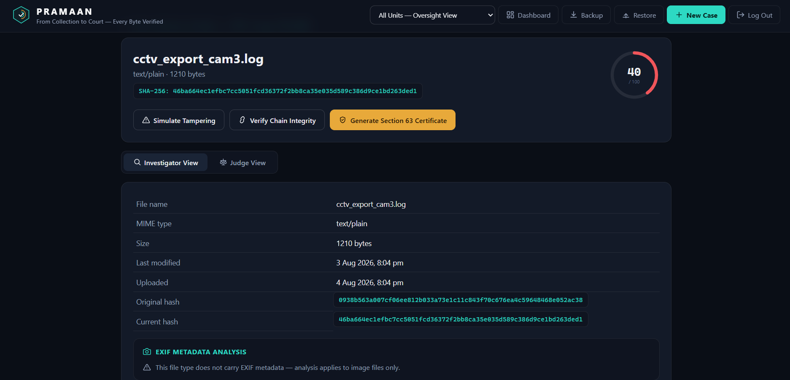
Fig 2. Evidence detail view showing a low trust score and hash mismatch

Legal Compliance Checklist
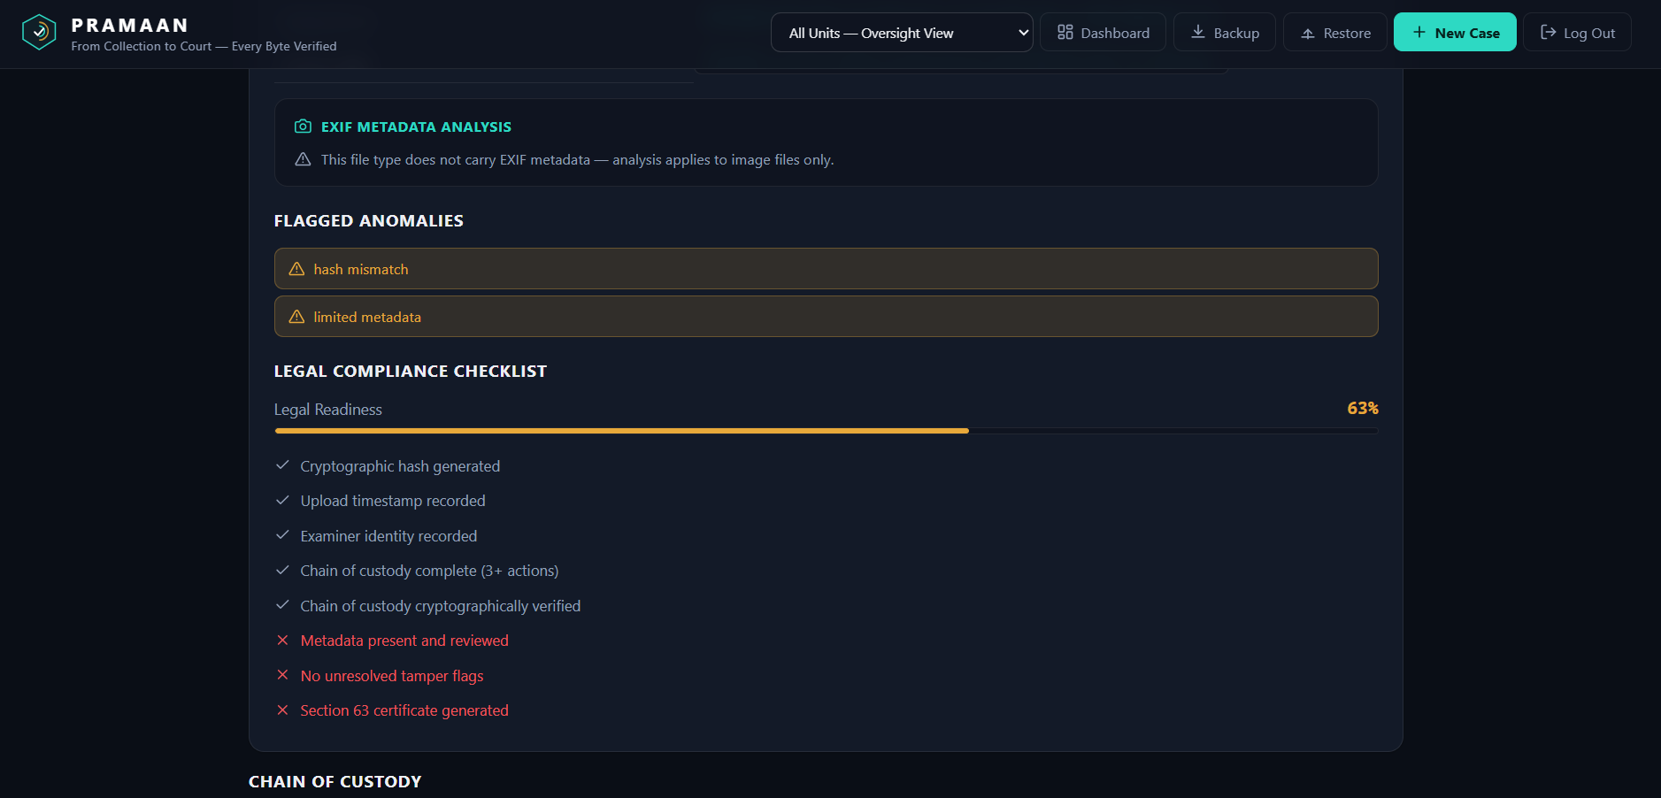
Fig 3. Legal Readiness scoring against 8 procedural requirements

Chain of Custody
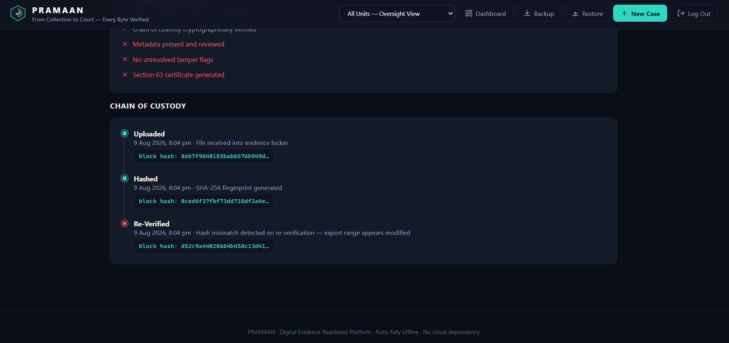
Fig 4. Hash-linked custody block timeline showing a re-verification failure

Judge View
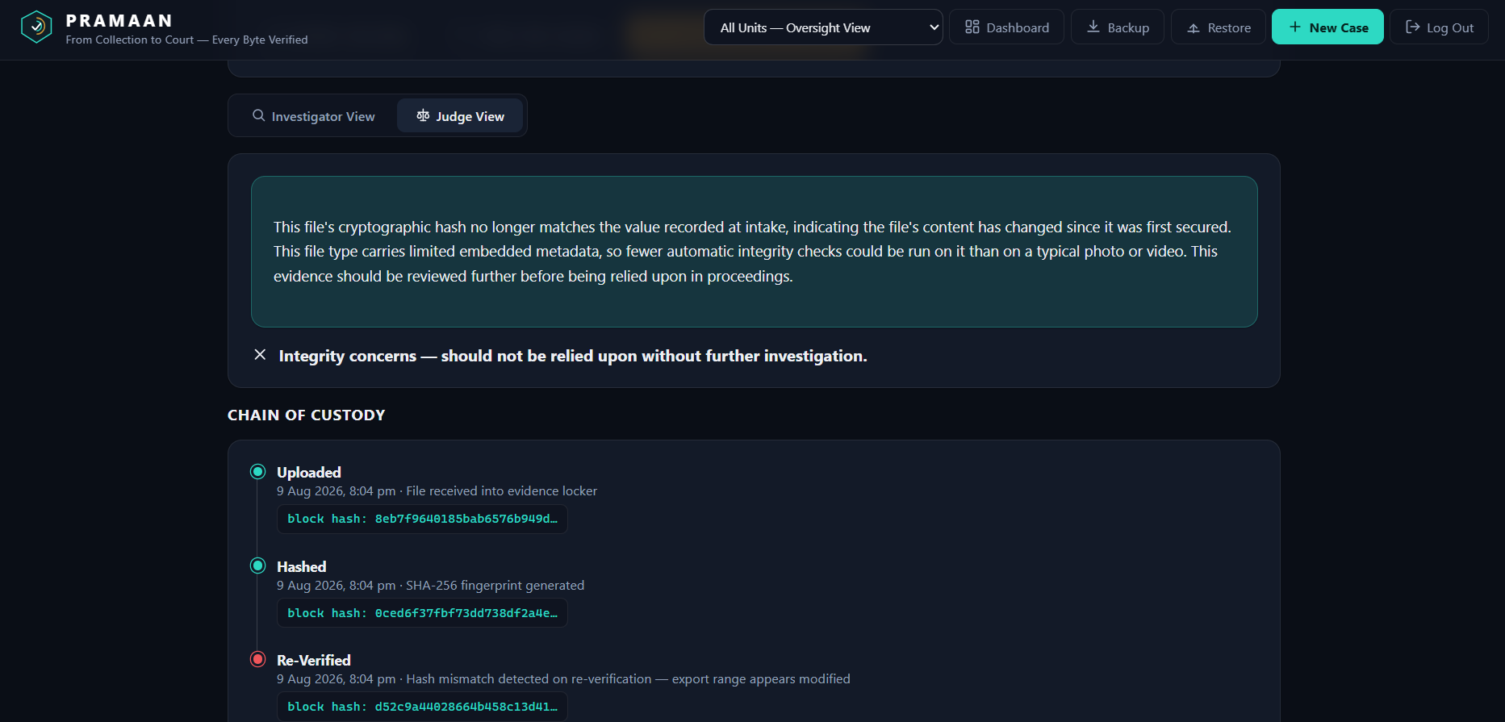
Fig 5. Plain-English explanation for non-technical review

Section 63 Certificate
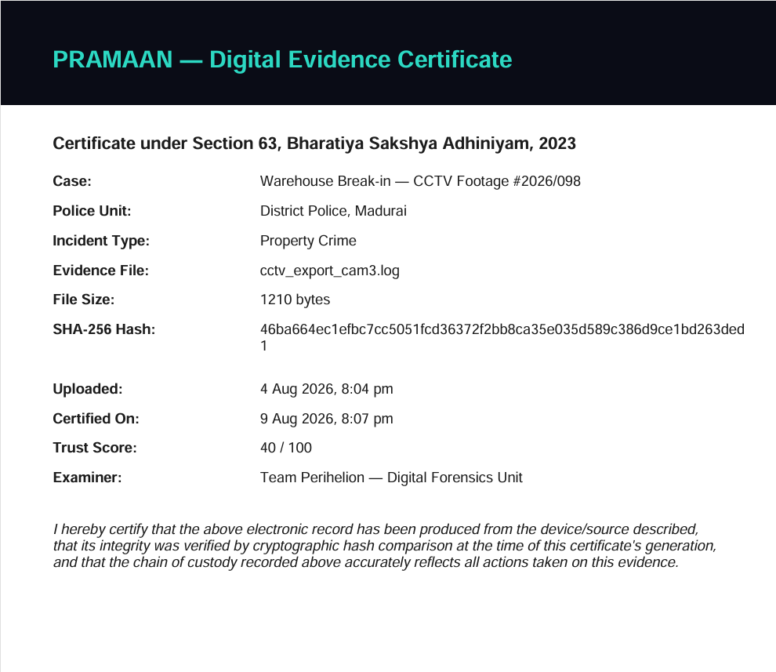
Fig 6. Generated Section 63 Certificate PDF output

Future Scope
- Persist data to a real database (SQLite/Postgres) instead of in-memory state
- Real EXIF/document metadata parsing extended to PDFs and DOCX
- Full case management system with role-based access per police unit
- Incident Response integration — direct evidence intake from a first-responder mobile app
- Optional offline AI explanation engine (local LLM) for richer plain-English summaries for judges

